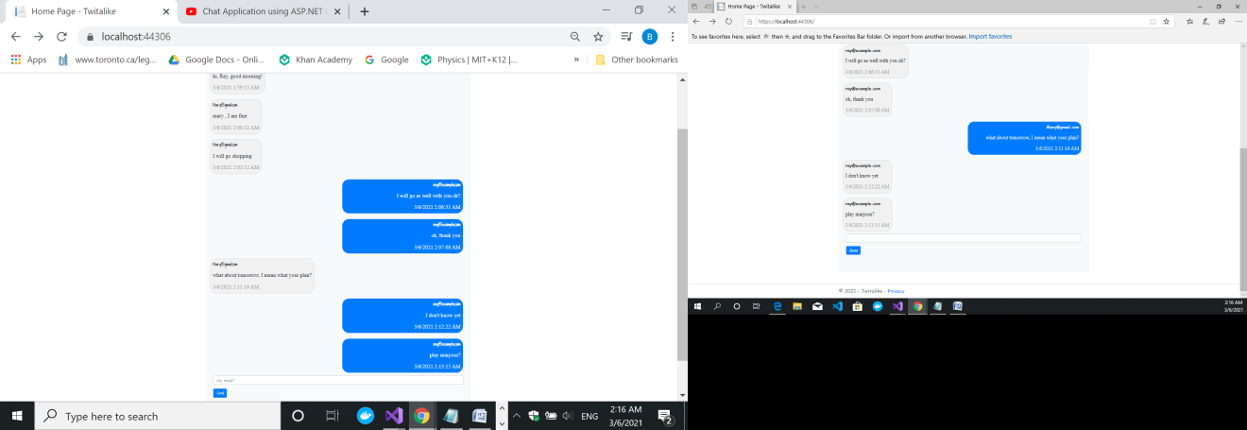

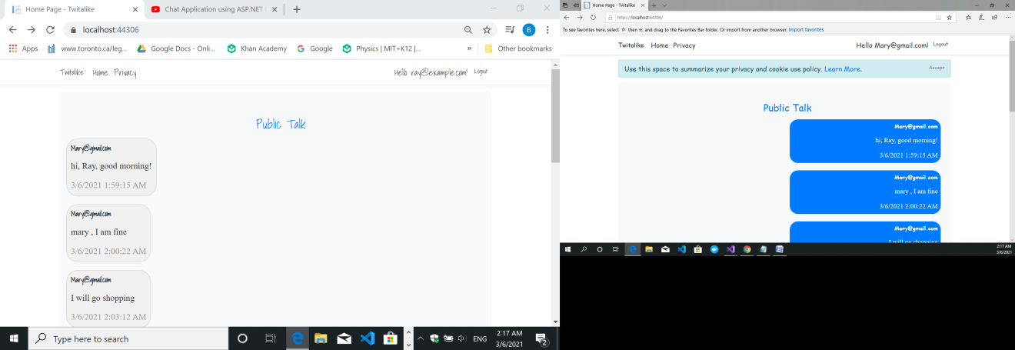

The following is the user table who just registered:

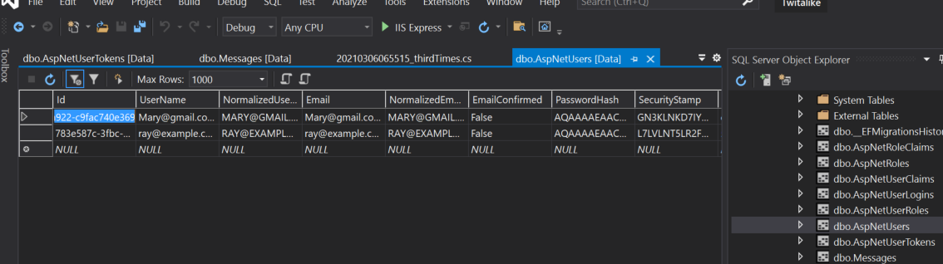

The following table showing the message table which has the real-time communication’s contents.

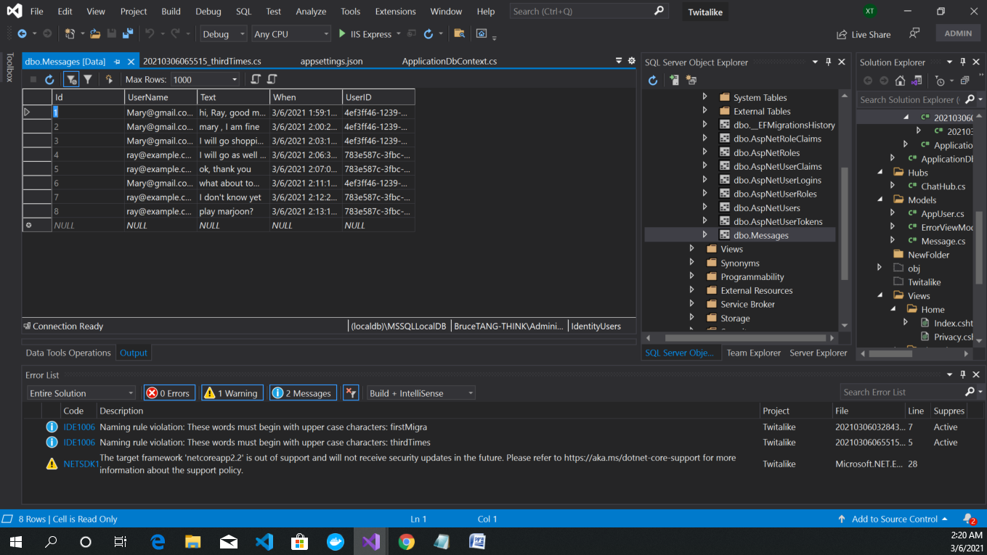

Testing :

1. Register Ray and Mary separately, I set the same password –“ Exp/127890” for both of them for easy operation purpose.
2. Ray and Mary login separately from two Visual Studio instance but from the same laptop.
3. Then they may chat.