RISING LIVING COSTS ACROSS CANADA: TAILOR YOUR OWN SIMPLE COST OF LIVING INDEX

**TECHNIQUES OF DATA ANALYSIS**

Gaurav Dewan1, Halilou Junior Tmite1, John Tsang1, Tangbufan Wei1

**Executive Summary**



Due to rising inflation rates, about 53% of Canadians worry about keeping up with the rising living costs (Kozinski 2022). The accelerated inflation has been eating into Canadians’ purchasing power more quickly than in the last decade when the average year-on-year inflation rates were about 2% on average. As a result, Canadians face significant challenges in maintaining their living standards. Therefore, with the use of Consumer Price Index (CPI) data from Statistics Canada, this project

uses machine learning models to predict inflation rates,

develops a cost of living index to better reflect individual hardship in face of rising living costs in Canada, and

develops a prototype dashboard to help readers calculate their own realized and predicted (two months ahead) cost of living index required to maintain their living standards.

This project does not use Statistics Canada’s CPI because of individual basket differences. The impact of such differences can tremendously affect the individual’s experience when encountering inflation. Therefore, we use a cost of living index that measures the cost required to maintain an individual’s living standards.

With the design of the user-input motivated by stylized facts of living costs in Canada, this prototype dashboard provides users with ad-hoc data analysis and visualization to self-assess the impact of rising living costs on their everyday life. This interactive dashboard is available online at [https://uottawa-statistics.shinyapps.io/](https://uottawa-statistics.shinyapps.io/Cost-Living-Index/) [Cost-Living-Index/](https://uottawa-statistics.shinyapps.io/Cost-Living-Index/). Reasers can use this dashboard to compute their own cost of living index and develop an understanding of inflation for different products at the provincial and the national levels, helping manage inflation expectation and prepare for future expenses.

1Department of Mathematics and Statistics, University of Ottawa, Ottawa

**Email**: [John.Tsang@uottawa.ca [](mailto:John.Tsang@uottawa.ca)](mailto:John.Tsang@uottawa.ca)

# Contents

**TECHNIQUES OF DATA ANALYSIS**

1. Introduction 3
2. Stylized Facts of Living Costs Across Canada 3
   1. Rising Living Costs in Canada 3
   2. More Significant Inflation on Essential Items 3
   3. Effects of the COVID-19 Pandemic and the Ukrainian War 3
3. The Cost of Living Index 4
   1. Dimensions of Our Cost of Living Index 4
   2. Construction and Interpretation of the Cost of Living Index 5
4. Cost of Living Index Predictions 5
   1. The Prediction Workflow 5
   2. A Common Characteristic among all Predictions: A Persistent High Level of Inflation 6
5. Prototype Dashboard for the Cost of Living Index 6
   1. Personalized Cost of Living Index on the Dashboard 6
   2. Consumer Price Index Inflation on the Dashboard 6
6. Discussion 7
7. Development Potentials 7
   1. Extension 1: Prediction Model 7
   2. Extension 2: More Visually Appealing Visualization and More Efficient Dashboard 8
   3. Extension 3: Automatic Updates of the Dashboard 8
   4. Extension 4: Incorporate Budget Management Tools 8
8. Conclusion 8
9. References 8
10. Appendix A: Prediction Models 8
11. Appendix B: Work Allocation 9

# 1. Introduction

**TECHNIQUES OF DATA ANALYSIS**

Due to rising inflation rates, about 53% of Canadians worry about keeping up with the rising living costs (Kozinski 2022). The accelerated inflation has been eating into Cana- dians’ purchasing power more quickly than in the last decade when the average year-on-year inflation rates were about 2% on average. As a result, Canadians face significant challenges in maintaining their living standards. Therefore, with the use of Consumer Price Index (CPI) data from Statis- tics Canada, this project develops a prototype dashboard to help Canadians calculate their own cost of living index with two-month ahead predicted movement in the living costs required to maintain their living standards.

With the design of the user-input motivated by stylized facts of living costs in Canada, this prototype dashboard provides users with ad-hoc data analysis and visualization to self-assess the impact of rising living costs on their every- day life. This interactive dashboard is available online at

**Figure 1.** Monthly Year-on-Year Inflation Rates, All Items, Canada, January 2019 – October 2022, per cent

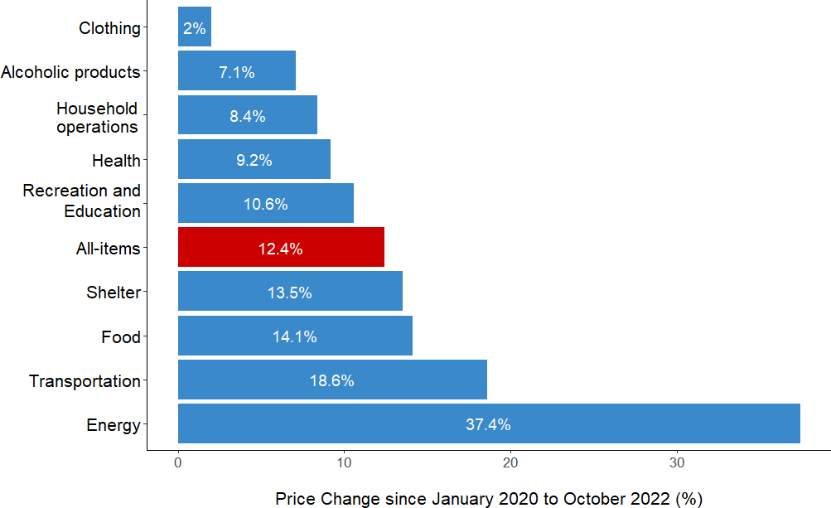[https://uottawa-statistics.shinyapps.io/](https://uottawa-statistics.shinyapps.io/Cost-Living-Index/) [Cost-Living-Index/](https://uottawa-statistics.shinyapps.io/Cost-Living-Index/). Reasers can use this dash- board to compute their own cost of living index and develop

an understanding of inflation for different products at the provincial and the national levels, helping manage inflation expectation and prepare for future expenses. At the end of this report, there are two appendices explaining how we

use machine learning models to predict inflation rates and our work allocation.

1. **Stylized Facts of Living Costs Across Canada**

This section highlights and justifies key characteristics of living costs in Canada from January 2019 to October 2022. In essence, Canadians are facing tremendous living cost challenges, particularly on essential goods. Unpredictable global events further worsen the living cost problem.

* 1. **Rising Living Costs in Canada**

From February 2021 to June 2021, the all-item year-on-year inflation rates1 rose eight-fold from about one per cent to more than eight per cent (Figure 1). The inflation rates after June 2021 remained at a historical high compared with the historical average of two per cent.

This persistence of high-level inflation puts a tremen- dous burden on Canadians and worsens their living standards.

* 1. **More Significant Inflation on Essential Items**

Inflation has recently been increasing at an unprecedented rate and seems to be present everywhere in the day-to-day lives of Canadians. However, looking at CPI data from

1A year-on-year inflation rate is the percentage change in prices be- tween the same month from two consecutive years.

**Figure 2.** Inflation is Everywhere, But Not Equally,

Canada, Inflation Rate between January 2020 and October 2022, per cent

January 2020 (beginning of the COVID-19 pandemic) to October 2022 (Figure 2), it can be seen that inflation is not affecting all goods and services equally. Energy prices, which are considered volatile, increased by 37.4 per cent whereas non-volatile goods, such as clothing, increased in price by two per cent during the same time period.

Rising prices of food and energy put greater finan- cial strain on Canadians as they are essential items and therefore comprise a larger component of per- sonal budgets.

* 1. **Effects of the COVID-19 Pandemic and the Ukrainian War**

Recent events have had a profound impact on inflation in Canada, particularly energy and food prices (Figure 3). At the beginning of 2020, COVID-19 cases began to in- crease worldwide, prompting governments, including in Canada, to implement stay-at-home orders in order to slow the spread of the virus. This had a significant impact on the travel industry as most people avoided travelling. Work in factories was also impacted. The sudden drop in demand caused energy prices, especially oil, to decrease substan- tially. In April 2020, U.S. crude oil prices turned negative

for the first time in history (Dunn 2020). Around the same time, however, Bank of Canada reduced interest rates to

**TECHNIQUES OF DATA ANALYSIS**

0.25 per cent, the lowest level in decades (Bayat 2022). The Federal Reserve in the U.S. similarly reduced interest rates as well. This resulted in commodity prices, including energy and food, to increase steadily after.

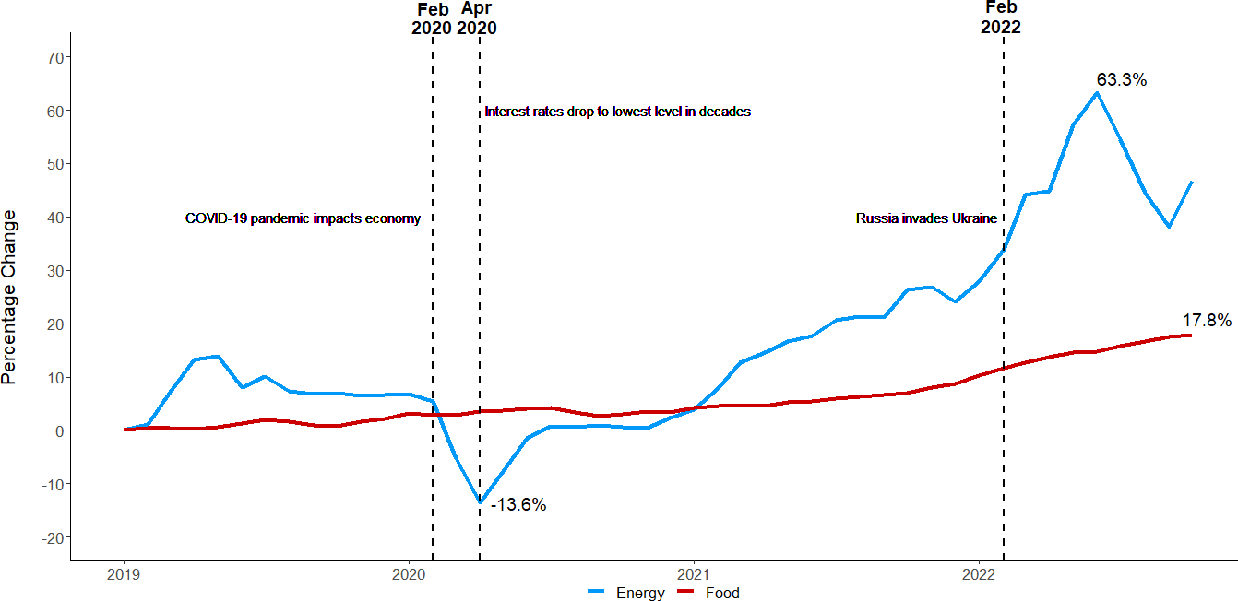

**Figure 3.** Monthly Food and Energy Prices Compared to January 2019 at the National Level, January 2019 to October 2022, per cent

Many economists believe that sustained low interest rates for a long period of time, along with supply-chain issues were key in causing persistent inflation. In Febru- ary 2022, Russia invaded Ukraine, causing energy prices to skyrocket further worldwide, including Canada. Food prices also increased as both Ukraine and Russia were major exporters of wheat and other grains, with Ukraine being the largest exporter of sunflower oil (Vesoulis 2022). From January 2019 levels in Canada, energy prices increased

63.3 per cent before cooling down recently, whereas food prices keep steadily rising, currently at 17.8 per cent. Rising energy and food prices have been the top concern for many Canadians who have had to adjust their lifestyles to keep up with the increased cost of living.

Unpredictable global events further worsen Canada’s problems of rising living costs.

Implications of these three stylized facts motivates the design of the user input panels of the prototype dashboard. Specifically, we should provide categories specific to food

project develops a dashboard to help Canadians calculate their own cost of living index with two-month ahead pre- dicted movement in the living costs required to maintain their living standards.

**What is a Cost of Living Index?** A cost-of-living index shows changes in expenditures needed to maintain a liv- ing standard. A notable example of a cost-of-living index is the U.S. Social Security Administration’s Cost-of-Living Adjustment (COLA) for retirees.2 The COLA index reflects the required social benefit adjustments to price changes for keeping retirees’ living standards constant. Indeed, this project’s cost of living index serves a similar purpose to the COLA index. Section 3.2 of this project’s cost of living index further.

**Consumer Price Index (CPI) vs. Cost of Living Index: Fixed National Basket vs Personal Basket** Statistics Canada reg- ularly releases the Consumer Price Index (CPI) each month throughout the year with a delay of almost two months. The CPI and the cost of living index reflect price changes in goods and services. While the CPI assumes this bas- ket of goods and services the same for the entire country throughout, a cost of living index allows individuals to switch between alternative products to maintain their liv- ing standards.

**Why do we need a Cost of Living Index?**

*A cost of living index with a personalized basket of goods and services can better reflect the impact of infla- tion on an individual’s livelihood than the Consumer Price Index (CPI).*

* 1. **Dimensions of Our Cost of Living Index**

This project’s cost of living index considers the following nine components of a Canadian.

* + - Food ■ Health and personal care
    - Shelter ■ Recreation, education and reading

and energy. Moreover, it would be of users’ interest to observe the costs required to have their current living stan- dards before the COVID-19 pandemic and the Ukrainian

* Household operations, furnishings and equipment
* Alcoholic beverages, tobacco products

and recreational cannabis

war.

# 3. The Cost of Living Index

Due to rising inflation rates, about 53% of Canadians worry about keeping up with the rising living costs (Kozinski 2022). The accelerated inflation has been eating into Cana- dians’ purchasing power more quickly than in the last decade when the average year-to-year inflation rates were about 2% on average. As a result, Canadians face significant chal- lenges in maintaining their living standards. Therefore, this

* + Clothing and footwear ■ Energy
  + Transportation

These nine components are the same as the nine major com- ponents of Statistics Canada’s CPI. Therefore, this project adopts the definitions of these nine components from Statis- tics Canada’s CPI.3

2The official web page of the COLA index discusses this index furthe:

<https://www.ssa.gov/cola/>.

3The Canadian Consumer Price Index Reference Paper contains de- tailed definitions of the components: [www150.statcan.gc.ca/](http://www150.statcan.gc.ca/n1/pub/62-553-x/62-553-x2019001-eng.htm)

* 1. **[Construction and Interpretation of the Cost of Living](http://www150.statcan.gc.ca/n1/pub/62-553-x/62-553-x2019001-eng.htm)** [**Index**](http://www150.statcan.gc.ca/n1/pub/62-553-x/62-553-x2019001-eng.htm)

**TECHNIQUES OF DATA ANALYSIS**

[This project’s cost of living index focuses on assessing the](http://www150.statcan.gc.ca/n1/pub/62-553-x/62-553-x2019001-eng.htm) [effects of inflation on an individual’s living costs, holding](http://www150.statcan.gc.ca/n1/pub/62-553-x/62-553-x2019001-eng.htm) [the living standard constant. The index calculation requires](http://www150.statcan.gc.ca/n1/pub/62-553-x/62-553-x2019001-eng.htm) [two pieces of information: one from the user and another](http://www150.statcan.gc.ca/n1/pub/62-553-x/62-553-x2019001-eng.htm) [from Statistics Canada’s CPI:](http://www150.statcan.gc.ca/n1/pub/62-553-x/62-553-x2019001-eng.htm)

 [user-provided expenditures on each of the nine com-](http://www150.statcan.gc.ca/n1/pub/62-553-x/62-553-x2019001-eng.htm) [ponents and](http://www150.statcan.gc.ca/n1/pub/62-553-x/62-553-x2019001-eng.htm)

 [the respective month-on-month inflation rates from](http://www150.statcan.gc.ca/n1/pub/62-553-x/62-553-x2019001-eng.htm) [Statistics Canada’s CPI.4](http://www150.statcan.gc.ca/n1/pub/62-553-x/62-553-x2019001-eng.htm)

[Given the above data, we can provide the user with their](http://www150.statcan.gc.ca/n1/pub/62-553-x/62-553-x2019001-eng.htm) [personalized cost-of-living index. The base month of this](http://www150.statcan.gc.ca/n1/pub/62-553-x/62-553-x2019001-eng.htm) [cost of living index is the month of the latest CPI release](http://www150.statcan.gc.ca/n1/pub/62-553-x/62-553-x2019001-eng.htm) [from Statistics Canada. The cost of living index in the base](http://www150.statcan.gc.ca/n1/pub/62-553-x/62-553-x2019001-eng.htm) [month is always equal to 100.](http://www150.statcan.gc.ca/n1/pub/62-553-x/62-553-x2019001-eng.htm)

[**Assumptions** The following highlights key assumptions](http://www150.statcan.gc.ca/n1/pub/62-553-x/62-553-x2019001-eng.htm) [of this cost of living index.](http://www150.statcan.gc.ca/n1/pub/62-553-x/62-553-x2019001-eng.htm)

 [**Constant Living Standards**: The individual’s living](http://www150.statcan.gc.ca/n1/pub/62-553-x/62-553-x2019001-eng.htm) [standard remains constant with the same basket of](http://www150.statcan.gc.ca/n1/pub/62-553-x/62-553-x2019001-eng.htm) [goods and services corresponding to the expenditures](http://www150.statcan.gc.ca/n1/pub/62-553-x/62-553-x2019001-eng.htm) [provided.5](http://www150.statcan.gc.ca/n1/pub/62-553-x/62-553-x2019001-eng.htm)

 [**Representativeness of the CPI**: The price movement](http://www150.statcan.gc.ca/n1/pub/62-553-x/62-553-x2019001-eng.htm) [from the CPI sufficiently represents the *price move-*](http://www150.statcan.gc.ca/n1/pub/62-553-x/62-553-x2019001-eng.htm)[*ment* of the individual’s basket for each of the nine](http://www150.statcan.gc.ca/n1/pub/62-553-x/62-553-x2019001-eng.htm) [components.](http://www150.statcan.gc.ca/n1/pub/62-553-x/62-553-x2019001-eng.htm)

 [**Substitutability and Exchangeability**: This index](http://www150.statcan.gc.ca/n1/pub/62-553-x/62-553-x2019001-eng.htm) [assumes the individual will switch between alterna-](http://www150.statcan.gc.ca/n1/pub/62-553-x/62-553-x2019001-eng.htm) [tive products to maintain their living standards, hold-](http://www150.statcan.gc.ca/n1/pub/62-553-x/62-553-x2019001-eng.htm) [ing their real (inflation-adjusted) expenditure on the](http://www150.statcan.gc.ca/n1/pub/62-553-x/62-553-x2019001-eng.htm) [corresponding component constant.](http://www150.statcan.gc.ca/n1/pub/62-553-x/62-553-x2019001-eng.htm)

[**Formulation of the Cost of Living Index**](http://www150.statcan.gc.ca/n1/pub/62-553-x/62-553-x2019001-eng.htm)

 [**Step 1**: Users provide their expenditures on each of](http://www150.statcan.gc.ca/n1/pub/62-553-x/62-553-x2019001-eng.htm) [the nine components in the base month.](http://www150.statcan.gc.ca/n1/pub/62-553-x/62-553-x2019001-eng.htm)

 [**Step 2**: Apply the month-on-month inflation rates for](http://www150.statcan.gc.ca/n1/pub/62-553-x/62-553-x2019001-eng.htm) [each of the nine components calculated from Statis-](http://www150.statcan.gc.ca/n1/pub/62-553-x/62-553-x2019001-eng.htm) [tics Canada’s CPI.](http://www150.statcan.gc.ca/n1/pub/62-553-x/62-553-x2019001-eng.htm)

 [**Step 3**: For each month adjusted to the CPI inflation](http://www150.statcan.gc.ca/n1/pub/62-553-x/62-553-x2019001-eng.htm) [from Step 2, add up the nine adjusted expenditures](http://www150.statcan.gc.ca/n1/pub/62-553-x/62-553-x2019001-eng.htm) [at the component level to obtain the total adjusted](http://www150.statcan.gc.ca/n1/pub/62-553-x/62-553-x2019001-eng.htm) [expenditure.](http://www150.statcan.gc.ca/n1/pub/62-553-x/62-553-x2019001-eng.htm)

[n1/pub/62-553-x/62-553-x2019001-eng.htm](http://www150.statcan.gc.ca/n1/pub/62-553-x/62-553-x2019001-eng.htm).

 **Step 4**: Divide the total adjusted expenditure each month from Step 3 by the total expenditure in the base month. Multiplying these ratios by 100 gives us the cost of living index. Mathematically, the cost of living index in month *t* at the aggregate level (*It* ) is

*Ea*

*It* = *t ×* 100 (1)

*E*base month

where *Ea* represents the sum of all nine adjusted ex- penditures to price changes in month *t* and *E*base month denotes the sum of the nine unadjusted user-provided expenditures.

*t*

Applying formula (1) above to each of the nine components yields the cost of living indices at the component level.

**How to Interpret the Cost of Living Index?**

 An index higher than 100 means it was more costly than the base month to have the living standard in the base month. An index lower than 100 means it was less expensive to have the living standard in the base year.

 The percentage change in the aggregate-level index between two months quantifies the effects of inflation on the individual during the period.

 The percentage change in the index for each compo- nent between two months is the CPI inflation between these two months.

# 4. Cost of Living Index Predictions

Providing the cost of living index retrospectively is not help- ful to maintain living standards. Therefore, this project also predicts the cost of living indices two months after the base month.6 This section briefly explains this project’s workflow to predict the indices and highlights some common char- acteristics of the predictions. Section 10 in the Appendix discusses our forecasts further.

* 1. **The Prediction Workflow**

Instead of directly predicting the value of the cost of liv- ing index, this project predicts the CPI inflation rates two months ahead. With these predicted inflation rates, this project then follows the procedure outlined in section 3.2 to calculate the predicted cost of living indices.

**CPI Inflation Forecasting**

The prediction procedure consists of two layers. The first layer uses four base machine learning models to forecast

4These inflation rates are calculated from seasonally unadjusted CPI

data on Statistics Canada Table 18-10-0004-01.

5In economic theory, this assumption is equivalent to a constant utility level (living standard) and the cost function unchanged over time. Hence, this index is an approximate measure of the expected compensating varia- tion (CV) – the changes in the budget to compensate for the decline in utility level from a price rise.

6We have attempted to forecast the index for three months. However, our experimentation shows that the accumulation of forecasting errors in the third month will sometimes lead to unreliable forecasts. Moreover, given the active policy intervention targeting inflation rates in Canada, longer-term inflation forecasts do not serve our purpose of preparing Canadians to mitigate the effect of rising inflation.

CPI inflation rates for each of the nine components. The second layer combines predictions from these four models to deliver an improved predicted inflation rate. Figure 4 summarizes the procedure this project uses to predict inflation rates.

**TECHNIQUES OF DATA ANALYSIS**

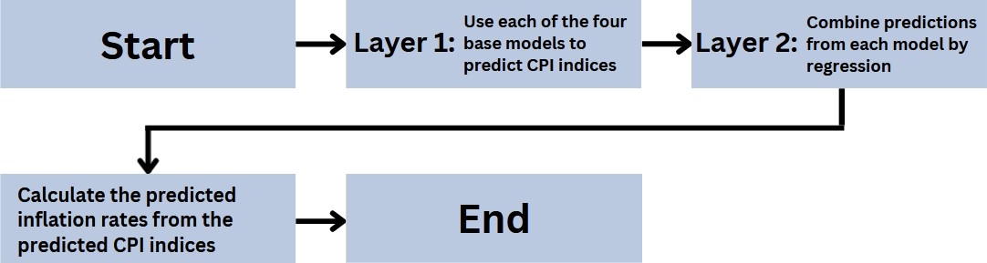

**Figure 4.** CPI Inflation Rate Prediction Workflow

**Layer 1: Predictions with Base Models** The following lists the four base models for the first layer.

 the *k*-nearest neighbour regression  the support vector regression

 the decision tree regression  the linear regression

Each of these four models uses the CPI in the previous 12 months to predict the CPI index for each of the nine components two months after the base month. Then, this project calculates the predicted inflation rates and applies them to calculate the index accordingly Steps 3 and 4 of the formulation of the cost of living index in section 3.2.

**Layer 2: Combination of Predictions through Stacking** We combine predictions from the above models through lin- ear regression with the model estimation criterion being to minimize the forecasting error.

* 1. **A Common Characteristic among all Predictions: A Persistent High Level of Inflation**

Given the number of inflation time series for the nine goods and services at the provincial and the national levels to be predicted for this project, it is hard to find something in common among all predictions. The only thing in common is the predicted inflation rates remain at a level much higher than before the COVID-19 pandemic.

**5. Prototype Dashboard for the Cost of Living Index**

The dashboard consists of two parts. The first part allows users to enter their data and calculate their own cost of living index. In contrast, the second part illustrates the general price movements at the national and provincial levels. The prototype dashboard is hosted on the R-Shiny server at this [link](https://uottawa-statistics.shinyapps.io/Cost-Living-Index/).

* 1. **Personalized Cost of Living Index on the Dashboard** The prototype allows users to select the geographical region and enter expenditures corresponding to the nine compo- nents (Figure 5). The server will calculate the total budget and update all data visualizations as the user updates each expenditure.

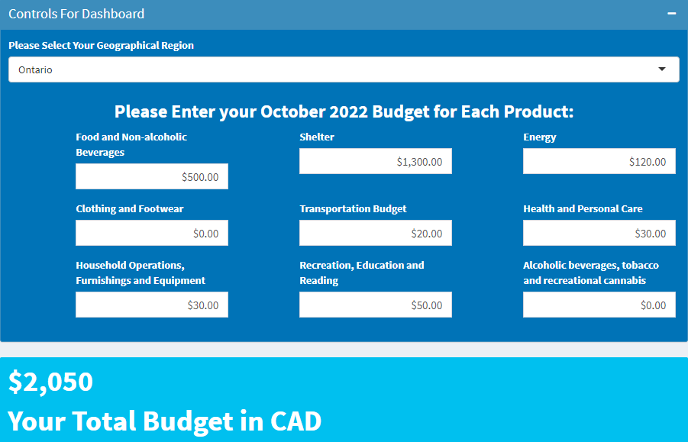

**Figure 5.** Panel for Users to Enter their Expenses for Each of the Nine Components of the Cost of Living Index

The prototype provides an interactive time series plot of the realized and the predicted cost of living indices from January 2019 to December 2022 according to user inputs (Figure 6). Hovering on each data point, users will see a pop-up showing the date and the corresponding value of the index.

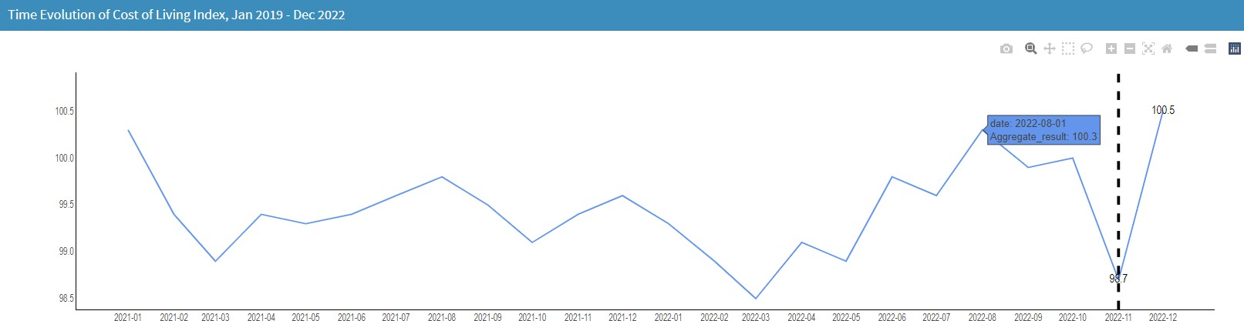

**Figure 6.** Interactive Time Series Plot of the Personalized Cost of Living Index with Inputs from Figure 5

Note: the vertical black dash indicates the point after which corresponds to our predictions.

The prototype also provides users with a tree map (Fig- ure 7). By selecting different months (October 2022, Novem- ber 2022 and December 2022), this treemap shows the per- centage breakdown of expenses inflated by the predicted inflation rates and the percentage changes between October 2022 and the selected month. This data visualization aims to facilitate users’ understanding of how inflation affects the allocation of their expenses, holding living standard constant.

* 1. **Consumer Price Index Inflation on the Dashboard** Aside from illustrating the cost of living at the personal level, this prototype also shows the evolution of inflation at the provincial and the national levels.

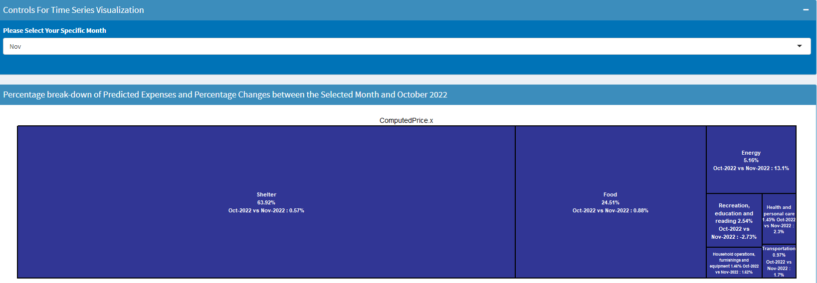

**Figure 7.** A Tree Map of the Percentage break-down of Predicted Expenses and the Percentage Changes between the November 2022 and October 2022

Similar to the data visualizations for the personalized cost of living index, users can select observe the evolu- tion in the price level of different goods and services at the provincial and the national level by selecting different geographical regions and items (Figure 8).

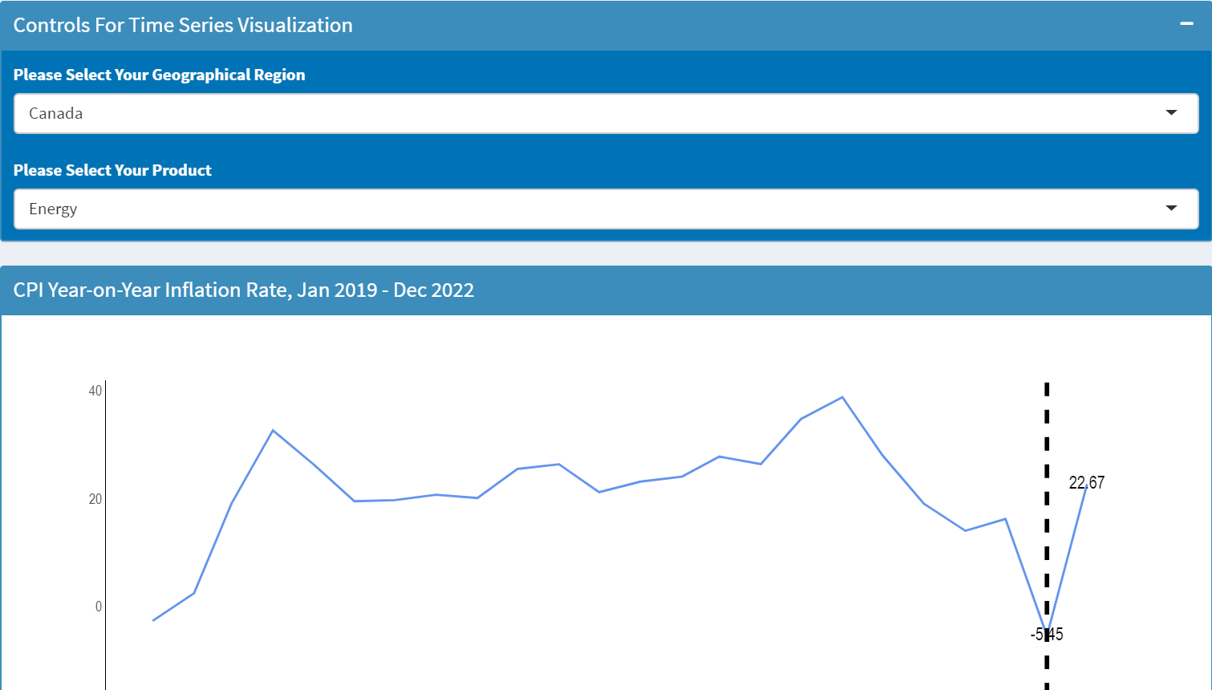

Note: the vertical black dash indicates the point after which corresponds to our predictions.

**Figure 8.** An Interactive Time Series Plot of the Realized and the Predicted CPI Year-on-Year Inflation Rate, January 2019 – December 2022

The prototype also provides users with a map to com- pare and contrast year-on-year inflation rates for different goods and services in different months at the provincial level (Figure 9). Different colours on the map signifies the severity of the inflation (or deflation) compared with other provinces.

# 6. Discussion

**Different Inflation Experiences between an Individual and the CPI Basket**

**TECHNIQUES OF DATA ANALYSIS**

With a personalized basket of

 Food and Non-alcoholic Beverages: $300  Shelter: $1,500

 Energy: $100

 Clothing and Footwear: $10  Transportation Budget: $10

 Health and Personal Care: $10

 Household Operations, Furnishings and Equipment:

$0

 Recreation, Education and Reading: $0

 Alcoholic beverages, tobacco and recreational cannabis:

$0

in Ontario, the individual experiences a very different infla- tion compared with the much smoother CPI basket (Figure 10). Therefore, the CPI is not a one-size-fit-all measure to every Canadian’s situation facing the rising inflation rates. A personalized cost of living index will be useful at the personal level.

* + 1. **Personalized Cost of Living Index**

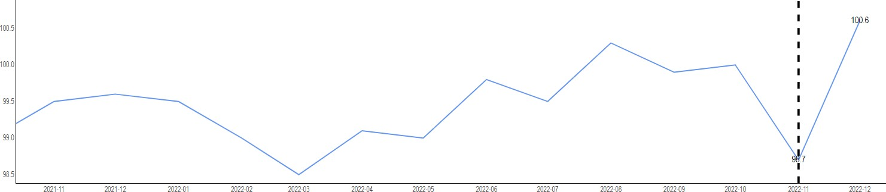

* + 1. **All-items CPI Inflation Rates**

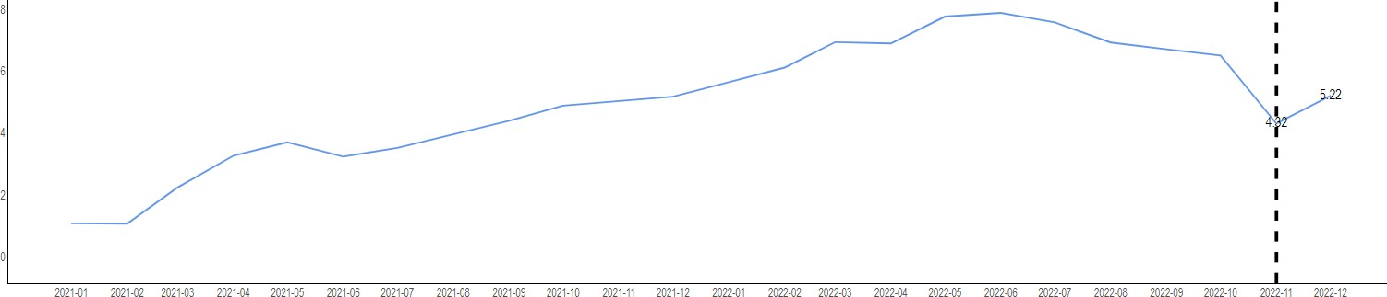

**Figure 10.** Personalized Cost of Living Index Vs. All-items CPI Inflation Rates

**Limitation** A limitation of our cost of living index is that it does not consider government welfare transfer. These transfers, such as the goods and services tax rebate, can increase an individual’s budget, raise his living standard and potentially compensate for the living standard loss from rising inflation.

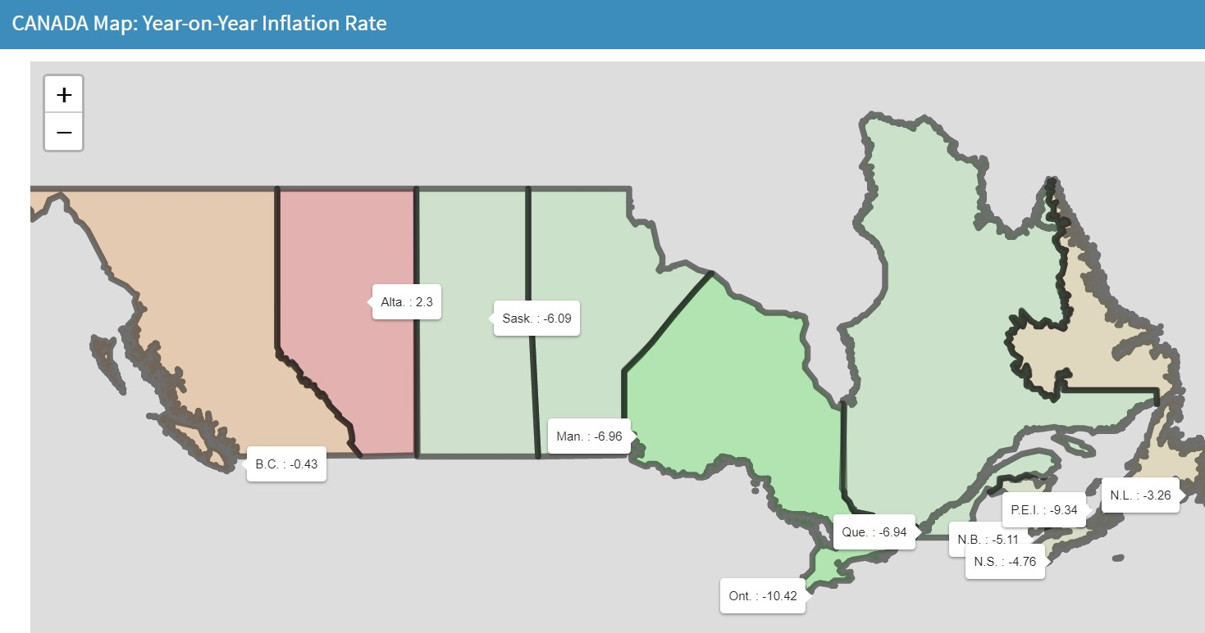**Figure 9.** A Tree Map of the Percentage break-down of Predicted Expenses and the Percentage Changes between the November 2022 and October 2022

# 7. Development Potentials

* 1. **Extension 1: Prediction Model**

We can improve the prediction model by considering pre- dictors other than past inflation rates and leading economic

variables such as the core personal consumption expendi- ture. Notably, this prototype dashboard is ready for incor- porating any inflation forecasting models to improve the cost of living index predictions.

**ECHNIQUES OF DATA ANALYSIS**

**T**

* 1. **Extension 2: More Visually Appealing Visualization and More Efficient Dashboard**

We build the current prototype dashboard with only free data visualization libraries. With commercial libraries such as the paid version of the library plotly, the dashboard will be more visually appealing. Moreover, programs for implementing the dashboard were not efficient, so updates upon changes in user inputs are slow. Therefore, a program- wise redesign can improve the run-time efficiency.

* 1. **Extension 3: Automatic Updates of the Dashboard** The data behind this prototype dashboard is static. How- ever, with local programs written to retrieve new data from Statistics Canada through its application programming in- terface (API) upon the availability of new data and a pro- gram scheduler, we can automate the data set update and automatically obtain new predictions.
  2. **Extension 4: Incorporate Budget Management Tools** We can combine our predictions with budget management tools. This combination of tools will facilitate uses’ budget management while maintaining their standard of living.

# 8. Conclusion

In summary, in face of the rising living costs in Canada, we develop a simple cost of living index to better reflect impact on each individual. To further facilitate this purpose, we develop a prototype dashboard for readers to calculate their own cost of living index. With a hypothetical example and our prototype dashboard, we illustrate that Statistics Canada’s CPI cannot accurately reflect the inflation experi- ence at the individual level. Therefore, a personalized cost of living index is necessary to assist Canadians to combat challenges from rising living costs.

# 9. References

Canada’s Personal Finance Encyclopedia (n.d.). *Bank of Canada Interest Rate 1935-2022 & 2022 forecast*. Retrieved December 19, 2022, from https://wowa.ca/bank-of-canada- interest-rate

Dunn, K. (2020, April 20). *’unreal’: Oil prices go negative for the first time in history*. Fortune. Retrieved December 19, 2022, from https://fortune.com/2020/04/20/oil-prices- negative-crash-price-crude-market/

James, G., Witten, D., Hastie, T., & Tibshirani, R. (2013).

*An introduction to statistical learning* (Vol. 112, p. 18). New

York: springer.

Korzinski, D. (2022, March 23). *Falling behind: 53% of Canadians say they can’t keep up with the cost of living*. An- gus Reid Institute. Retrieved December 19, 2022, from https://angusreid.org/canada-cost-of-living-inflation/

Social Security. SSA. (n.d.). *Cost-of-Living Adjustment (COLA) Information*. Retrieved December 19, 2022, from https://[www.ssa.gov/cola/](http://www.ssa.gov/cola/)

Statistics Canada (2019). *The Canadian Consumer Price Index Reference Paper*. Retrieved December 19, 2022, from https://www150.statcan.gc.ca/n1/pub/62-553-x/62-553- x2019001-eng.htm

x4uz/Intra_day_Bitcoin_Price_Prediction_Report_John_Tsa ng.pdf?dl=0

Vesoulis, A. (2022, March 7). *Why Ukraine-russia conflict will spike sunflower oil prices*. Time. Retrieved December 19, 2022, from https://time.com/6155095/sunflower-oil- russia-ukraine/

# 10. Appendix A: Prediction Models

This section provides more technical details pertinent to the forecasting model. Specifically, this section briefly describes each base model and the cross-validation procedure to iden- tify hyperparameters. At the end, this section provides summary tables to evaluate the forecasting performance.

**Base Prediction Models and Hyperparameters**

**The** *k***-nearest neighbour regression** Forecasts from this model is the simple average CPI of the closest *k* observa- tions.

**The support vector regression** This model only accounts for certain observations outside a band for prediction.

**The decision tree regression** This model generates a fore- cast by checking if it fulfills a series of conditions. The same sequence of conditions gives the same prediction. There- fore, the decision tree imitates human decision-making.

**The linear regression** This model assumes a linear rela- tionship between predictors and the CPI to be predicted. This project estimates model parameters by minimizing the sum of squared errors.

**Cross-validation for Hyperparameter Identification**

Each of the above four models uses the rolling window strategy with a fixed window size of 12 months to perform out-of-sample forecasts as if observations following the win- dow were unknown. This project shifts the rolling window one observation forward after each prediction. Figure 11

illustrates the rolling window strategy with a window size of 12 and *T* total observations.

**TECHNIQUES OF DATA ANALYSIS**

**Forecasting Performance Evaluation**

This project evaluates the forecasting performance through back-testing (also know as the pseudo-out-of-sample fore-

Window Forecast # 1 # 1

*↑*

*↑*

*t* = 1 2 12 12+1 12+2

*↓*

...

...

...

Window Forecast

# *T/*12 # *T/*12

*T* - 1 - 12 *T* - 1 *T*

casts) from January 2013 to October 2022. The average absolute percentage error is about 3% for all predictions.

Window Forecast # 2 # 2

# 11. Appendix B: Work Allocation

**Figure 11.** Illustration of the Rolling Window Strategy with Window Size 12 and *T* Total Observations

Within each rolling window, the optimal hyperparame- ter is associated with the lowest absolute percentage fore- cast error by cross-validation. The cross-validation proce- dure is as follows.

* + 1. This project creates a sub-window. This sub-window starts from the first observation in the rolling window and has the size 90% of the rolling window.
    2. Within the sub-window, this project estimates the model with each hyperparameter from a pre-specified list and then predicts the observation immediately following the sub-window.
    3. This project calculates the absolute percentage error of the prediction from step (ii).
    4. This project expands the sub-window created in step

(i) to include the observation immediately following the sub-window. Repeat steps (ii) to (iii) until the size of the sub-window is the same as that of the rolling window.

Figure 12 illustrates the first expanding sub-window in the first rolling window. The optimal hyperparameter is the one with the lowest average absolute percentage error.

**G.Dewan**: stylized facts

**H.J.Tmite**: Dashboard development

**J.Tsang**: report-writing, index design and implemen- tation, data cleaning, predictive modelling, helped with the development of the dashnboard

**T.Wei**: stylized facts

Window # 1

Forecast # 1

*↑*

*t* = 1 2 *· · ·* 11 11 + 1 11 + 2 12

*↓*

Window # 2

Forecast # 2

...

**Figure 12.** Illustration of the First Expanding Sub-window in the First Size-12 Rolling Window

After identifying the optimal hyperparameter, this project estimates the model with the hyperparameter and samples in the corresponding rolling window. Ultimately, we use the estimated model to generate the one-month-ahead forecast. We repeat the same procedure to forecast the second month as if the first predicted month were actual.