1 Project Description

Object:
Develop A Simple Instant Messenger System

Team Member:
Name | TUT code | UQAC code | Work
Gao Long | 20106176 | GAOL05088808 | Material and Idea
Tang LuPing | 20106190 | TANL23059201 | Team Leader
Wang WenPeng | 20106191 | WANW19099100 | Do presentation
Xue JiPeng | 20106192 | XUEJ19029203 | Do document
Zheng ZhiYu | 20106199 | ZHEZ19109106 | PHP programming

Abstract:
The Project we decided to do is A Simple Instant Messenger System
For the typical 3-Tier Architecture,
1) we use PHP+HTML to design a Web Page as a GUI client front,
2) and use WampServer 2 as localhost Server,
3) and use Phpmyadmin as the database.

This system mainly demo the message transmission between 2 or more processes on a host computer, and shows the time when it happens.

2 System Architecture

This architecture (Figure 1) describes the application as consisting of three logically-distinct sets of functionalities.
Each tier consists of system entities with a very specific role, and the architecture is an extension of the server-client architecture,as the dependencies between the tiers are unidirectional.
That is, the third tier acts as server for the second one, while the second provides services to the entities in the first tier.

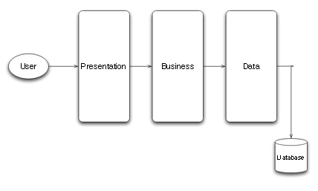

Figure 1: Three-tier Architecture

The architecture defines three tiers.
In the software-specific context, they can also be referred as functionally-distinct software layers:
1)Presentation.
The entities in this layer are responsible for the functionality
that interacts with the user. They are lightweight software components that
present data to the user (via an interface) and allow the user control and data
validation.
2)Logic or Business.
This layer is responsible for the implementation of the
main functionality of the application, such as the algorithms that process
data, and provide the features requested by the user.
3)Data
The entities in this layer are responsible for managing the persistent
data objects manipulated by the business layer. It usually implies a database
that stores the information, and consists of the software entities that model
the stored data (as object-oriented data abstractions, for instance).

3 Programming implementation

Introduction:
We implement two dierent chat programs:
the first uses aconnection-oriented protocol between a client and a server (i.e., TCP);
the second uses aconnectionless protocol (i.e., UDP), in which case the \client" and \server" are exactly the same.
Since we are not be familiar with PHP and multithreading, our chat programs will be synchronous.
This means that users on both ends will not be able to send multiple messages, and instead have to take turns. So, the first user writes, than the second user writes, then it's the first user's turn again, and so on.

ChatServer
The server program is given a port number and does the following:
1. accept a connection
2. while the connection is active, do the following:
(a) read a message from the connection
(b) print the message onto the console
(c) read a message from the console
(d) write the message onto the connection
3. close the connection
4. go back to step 1

ChatClient
The client program must know the server address and port in order to connect to it. Other than that,
it is similar to the server.
1. connect to the given address and port number
2. while the connection is active, do the following:
(a) read a message from the console
(b) write the message onto the connection
(c) read a message from the connection
(d) print the message onto the console
3. close the connection

However, for the Security of Login web page, we don’t have some idea of it.
So we ignore them in the first stage of System Analysis, and try to deal with it in the stage of Implementation.

4 Some Print Shots for presentation

The Web Page of login.php is as follow:
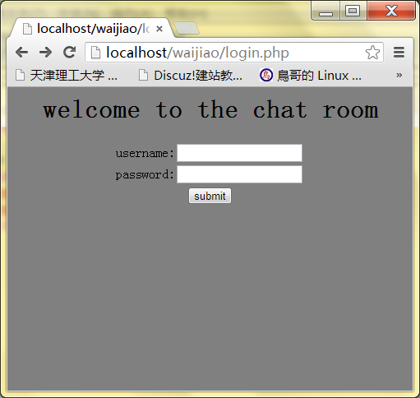

Typing username, password and then enter the Web page of friendList:
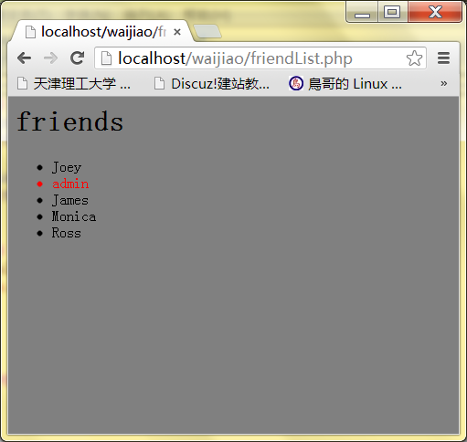

Here, We start a process and Login as Monica,
And choose to chat to Joey, and Begin to send a message to him:
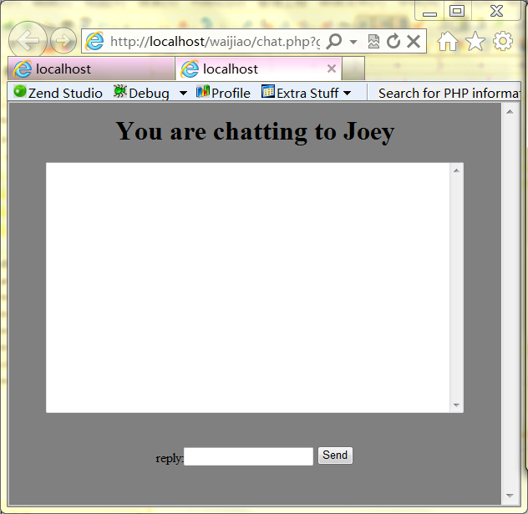

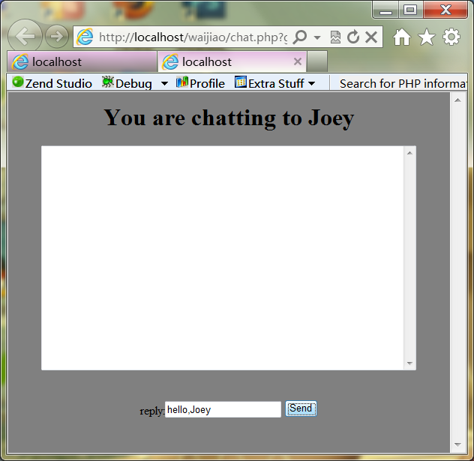

Next, We start another process and Login as Joey,
And choose to chat to Monica, and Begin to send a message to her:

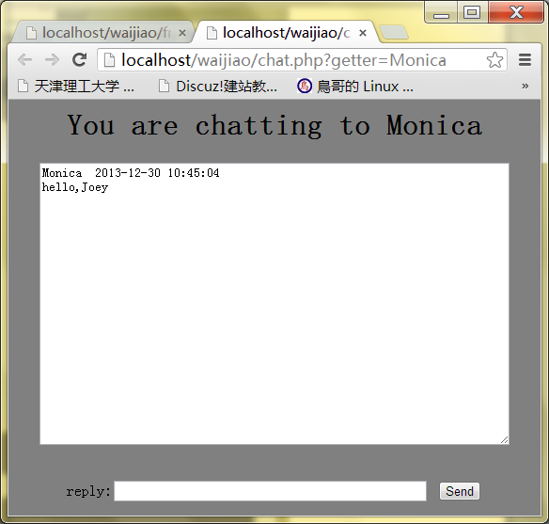

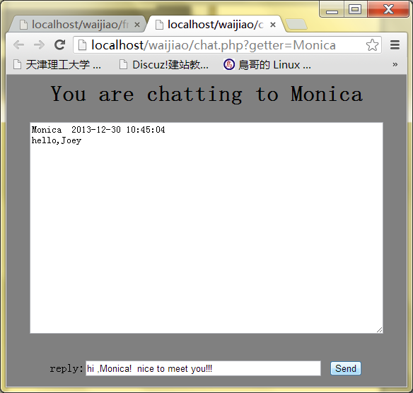

Then, In Monica’s Process of chatting, She gets the message from Joey,
And then the chat will be continue...

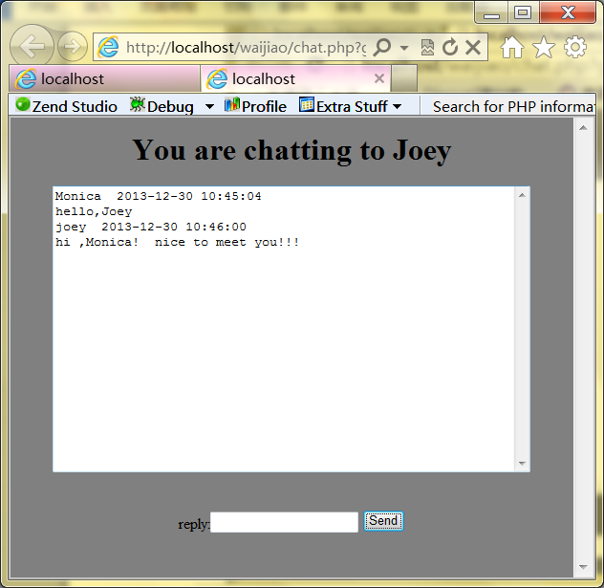

5 Some References
1) Distributed Systems: Concepts and Design,(5th Edition), by Coulouris
2) Programming the World Wide Web (6th Edition), by Robert W. Sebesta
3) Fundamentals Of Database Systems (4th Edition), by Elmasri and Navathe
- Reverse Engineering Object-Oriented Distributed Systems, by Dan-Calin Cosma
- How to Create A Simple Web-based Chat Application
http://net.tutsplus.com/tutorials/javascript-ajax/how-to-create-a-simple-web-based-chat-application/
- Chat Application in PHP
http://www.codeproject.com/Articles/649771/Chat-Application-in-PHP
7) Step 4: Creating a Web Chat Application
http://msdn.microsoft.com/en-us/library/vstudio/hh297106(v=vs.100).aspx

