1) Description
TEAM MEMBER: 20106190 Tang Luping
USER ID: ex00176
PASSWORD: 64SUyS
SERVER: dimensxcn1.uqac.ca
SUBDIRECTORY: /home/users/ex00176/lab1

2) The List of Source Programs
for “client_ftp.c” and “server_ftp.c”

“client_ftp.c”
/*
* Program: client_base.c
* Author: Paul Girard Ph.D., DIM, UQAC
* Date: Sept 2011
*
* Objective: Show how to use a tcp socket
* on a client program running on
* Sun/ Solaris ; this program transmits
* a message to a server and receives
* an acknowledge each time. A delay of
* one second is introduced between messages.
*
* Options to compile on Solaris:
* ===> gcc client_base.c -lsocket -lnsl -o client_base
* Options to compile on Linux:
* ===> gcc client_base.c -lnsl -o client_base
*
* Execution: 3 parameters: program_name server_name server port_number
* =========> client_base server_machine port_number
* ex. client_base dimensxcn1.uqac.ca 5001
*
*
* Files to include
*/
#include <errno.h>
/* #include <strings.h> */
#include <string.h>
#include <sys/types.h>
#include <sys/socket.h>
#include <netinet/in.h>
#include <netdb.h>
#include <time.h>
#include <stdio.h>

#include <stdlib.h>

/*
* The following functions are used in this program
*
* socket, gethostbyname, connect,
* read, write, close.
*/

#define TRUE 1

#define bufsize 128

main(argc,argv)
int argc;
char *argv[]; /* argv[0] pointer to program name
argv[1] pointer to server name
argv[2] pointer to tcp port number*/
{
int sock2, msgsock; /* socket descriptor */
struct sockaddr_in server2; /* structure used to assign a name
to a socket sccording internet format*/
size_t length; /* #octets in structure sockadr_in */
struct hostent *hp,*gethostbyname(); /* structure to associate the
server name and its address */
struct hostent hpstruct; /* structure to access the server address*/
char buf[bufsize]; /* message buffer*/
int rval; /* status code for read */
int n, i; /* temporary */
/*
* 1. Validation of the parameters read on the command line
*/
if (argc != 3)
{
printf("Call the program : client_base server_name port_number\n");
return 0;
}
/*
* 2. Socket creation parameters:
* - AF_INET is the internet format
* - SOCK_STREAM specifies a TCP type socket
* - 0 specifies to use the default protocol.
*/
sock2 = socket(AF_INET, SOCK_STREAM, 0);
if (sock2 < 0)
{
perror("Error in creating a TCP socket");
return 0;
}
/*
* 3. Get a pointer to the network server address structure.
* The server name is taken from the command line (argv[1]):
* ex. "sunens.uqac.ca"
*/
server2.sin_family = AF_INET; /* internet format*/
hp = gethostbyname(argv[1]); /* pointer to the network structure
of the server listening on port
argv[1] */
if (hp == 0)
{
fprintf(stderr, "%s: unknown host ===>", argv[1]);
return 0;
}
hpstruct = *hp; /* save hostent data */

/*
* 4. Fill in the remote address part
*/
server2.sin_family = hpstruct.h_addrtype;
server2.sin_port = htons(atoi(argv[2])); /* char port # ==>integer port #
====> network 16 bits format */
server2.sin_addr = * ((struct in_addr *) hpstruct.h_addr);

/* 5. Try a connection with the server
*/
if (connect(sock2, (struct sockaddr *)&server2, sizeof(server2)) < 0)
{
perror("Error at connect time");
return 0;
}

/*
* 6.
*
*/

FILE *fptr; /*pointer to file descriptor*/
char filename_local[20],filename_remote[20];
do
{
puts("Enter the name of the local file to transfer:");
scanf("%s",filename_local);
if((fptr=fopen(filename_local,"r"))==NULL)
{
perror("error opening this file");
exit(0);
}
puts("Enter the given name of this file on the remote server:");
scanf("%s",filename_remote);

if(write(sock2, filename_remote, sizeof (filename_remote)) < 0)
perror("Error in the transmission of message");
else {
/* read a message from the server */
if ((rval = read(sock2, buf, sizeof(buf))) < 0)
perror("Error in reading a message");
if (rval == 0)
printf("End of connection\n");

}
} while (buf=="ACK");

struct timespec time1,time2,temp; /*time_t tv_sec; seconds*/ /*long tv_nsec; nanoseconds*/
double delay;

clock_gettime(CLOCK_PROCESS_CPUTIME_ID,&time1); /*read the timer1 nanosec*/

int nline=0,noctets=0;
while(fgets(buf,sizeof(buf),fptr)) /*read a file record*/
{

noctets+=strlen(buf);
nline++;

if(write(sock2, buf, sizeof(buf)) < 0)
perror("Error in the transmission of message");

//printf("%s\n",buf);
if(feof(fptr))break;

}
fclose(fptr);

close(sock2);

clock_gettime(CLOCK_PROCESS_CPUTIME_ID,&time2); /*read the timer2 nanosec*/ /*Statistics*/

if((time2.tv_nsec-time1.tv_nsec)<0)
{
temp.tv_sec=time2.tv_sec-time1.tv_sec-1;
temp.tv_nsec=1000000000+time2.tv_nsec-time1.tv_nsec;
}
else
{
temp.tv_sec=time2.tv_sec-time1.tv_sec;
temp.tv_nsec=time2.tv_nsec-time1.tv_nsec;
}
delay=(double)((temp.tv_sec*1000))+(temp.tv_nsec/1000000); //dalay in msec

printf("File %s had %d lines and a total of %d octets\n",filename_local,nline,noctets);
printf("Transfer rate: %9.5fKo/sec \t\t Transfer TCP dalay : %9.5f msec\n",(double)(noctets*1000)/(1024*delay),delay);

puts("End of client program\n");
return 0;; /* end of client program */
}

“server_ftp.c”
/*
* Program: server_base.c
* Author: Paul Girard Ph.D., DIM, UQAC
* Date: Sept 2011
*
* Objective: Show how to use a tcp socket
* on a server program running on
* Sun/Solaris ; after the connection,
* this program receives a client message
* and sends back an acknowledge each time.
*
* Options to compile and link on Solaris:
* ===> gcc server_base.c -lsocket -o server_base
* Options to compile and link on Linux:
* ===> gcc server_base.c -o server_base
*
* Execution: server_base no_port
* (ex. server_base 5001)
*
* Files to include
*/

#include <errno.h>
/* #include <strings.h> */
#include <string.h>
#include <sys/types.h>
#include <sys/socket.h>
#include <netinet/in.h>
#include <netdb.h>
#include <sys/time.h>
#include <stdio.h>

/*
* The following functions are used in this program
*
* socket, bind, getsockname, listen,
* accept, read, write, close.
*/

#define TRUE 1

#define ACK "ACK"
#define NAK "NAK"

#define bufsize 128

main(argc,argv)
int argc;
char *argv[]; /* argv[0] pointer to program name
argv[1] pointer to tcp port number*/
{
int sock1, msgsock; /* socket descriptors */

struct sockaddr_in server1; /* structure used to assign a name
to a socket sccording internet format*/
/* size_t length; for Solaris: #octets in the structure sockadr_in */
int addrlen, length; /* Linux: #octets in the structure sockadr_in */
char buf[bufsize]; /* buffer for transmission */
int rval; /* status code for read */
int n; /* temporary */
/*
* 1. Validation of the 2 parameters read on the command line
*/
if (argc != 2)
{
printf("Call the program this way : server_base port_number\n");
return 1;
}
/*

/*
* 2. Socket creation parameters:
* - AF_INET is the internet format
* - SOCK_STREAM specifies a TCP type socket
* - 0 specifies to use the default protocol.
*/
sock1 = socket(AF_INET, SOCK_STREAM, 0);
if (sock1 < 0)
{
perror("Error in creating a TCP socket ");
return 1;
}

/*
* 3. Specify the local part of the address :
* 1)the local port number in network format and
* 2)the local IP address. INADDR_ANY is used on a server
* because many ip addresses may be used on the same machine.
*
* Client connections will be redirected to other temporary sockets.
* Use your own port number.
*/
server1.sin_family = AF_INET; /* internet format */
server1.sin_addr.s_addr = INADDR_ANY; /* under-specified address */
server1.sin_port = htons(atoi(argv[1])); /* char port # ==>integer port #
====> network 16 bits format */
if (bind(sock1, (struct sockaddr *) &server1, sizeof(server1)) < 0)
{
perror(" The function bind did not work properly");
return 1;
}

/*
* 4. Simple validation: find the name associated to this socket
* and print its port number
*/
length = sizeof(server1);
if (getsockname(sock1, (struct sockaddr *)&server1, &length) < 0 )
{
perror("Error in getsockname()");
return 1;
}
printf("The port number used by the tcp socket is #%d\n", ntohs(server1.sin_port));

/*
* 5. Fix the maximum number of clients waiting connection and
leave the server in passive mode
*/
listen(sock1, 5);
puts("server ready for connection");

/*
* 6. Waiting for a client TCP connection
*
* The second and third parameters are useless.
* A new temporary socket (msgsock) is created
* for each client connection (msgsock).
*/
do
{
/* Solaris
msgsock = accept(sock1, (struct sockaddr *) 0, (size_t *) 0);
*/
FILE *fptr;
char filename_given[20];

msgsock = accept(sock1, (struct sockaddr *) 0, NULL);
puts("\nClient connection");
if (msgsock == -1 ) perror("accept");
else do
{

/* 7. Client message is read in a 1K octets buffer. rval returns
* the number of octets received.
*/
rval = read(msgsock, buf, sizeof(buf));
if (rval <= 0)
{
printf("End of client connection\n");
close(msgsock);
}

else /* Printing of message and transmission of the acknowledge */
{

if((fptr=fopen(buf,"w"))==NULL)
{
if (write(msgsock, NAK, sizeof(NAK)) < 0)
perror("Error in transmitting the NAK");
}
else
{
if (write(msgsock, ACK, sizeof(ACK)) < 0)
perror("Error in transmitting the ACK");
//save the remote file from the client
strcpy(filename_given,buf);
break;
}

}
} while(rval > 0); /* read until EOF data available */

printf("=====>%s\n",filename_given);
int noctets=0;
while(TRUE)
{
rval = read(msgsock, buf, sizeof(buf)); /*read a file record*/
if (rval <= 0){
//perror("Error in the transmission of message");
break;}

noctets+=strlen(buf);

fputs(buf,fptr);
}
fclose(fptr);
puts("End of client file transfer");
printf("File %s has %d octets\n",filename_given,noctets);

} while(TRUE); /* my server never stops */

/* This program will never end; so the close() will never be done.
* If you cancel this program (kill) the O/S will close this socket automatically.
* We would need a special command to stop this service
*/

close(sock1);
return 0;
} /* end of server program */

3) An Example of Execution
for “client_ftp” and “server_ftp”

“client_ftp”
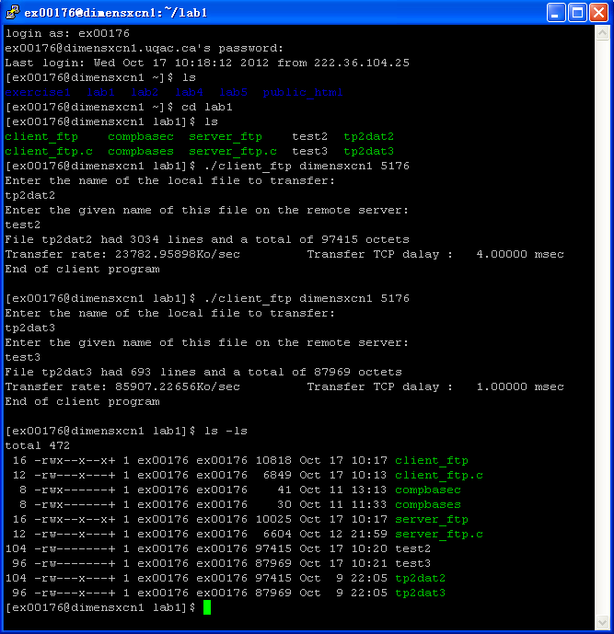

login as: ex00176
ex00176@dimensxcn1.uqac.ca's password:
Last login: Wed Oct 17 10:18:12 2012 from 222.36.104.25
[ex00176@dimensxcn1 ~]$ ls
exercise1 lab1 lab2 lab4 lab5 public_html
[ex00176@dimensxcn1 ~]$ cd lab1
[ex00176@dimensxcn1 lab1]$ ls
client_ftp compbasec server_ftp test2 tp2dat2
client_ftp.c compbases server_ftp.c test3 tp2dat3
[ex00176@dimensxcn1 lab1]$ ./client_ftp dimensxcn1 5176
Enter the name of the local file to transfer:
tp2dat2
Enter the given name of this file on the remote server:
test2
File tp2dat2 had 3034 lines and a total of 97415 octets
Transfer rate: 23782.95898Ko/sec Transfer TCP dalay : 4.00000 msec
End of client program

[ex00176@dimensxcn1 lab1]$ ./client_ftp dimensxcn1 5176
Enter the name of the local file to transfer:
tp2dat3
Enter the given name of this file on the remote server:
test3
File tp2dat3 had 693 lines and a total of 87969 octets
Transfer rate: 85907.22656Ko/sec Transfer TCP dalay : 1.00000 msec
End of client program

[ex00176@dimensxcn1 lab1]$ ls -ls
total 472
16 -rwx--x--x+ 1 ex00176 ex00176 10818 Oct 17 10:17 client_ftp
12 -rw---x---+ 1 ex00176 ex00176 6849 Oct 17 10:13 client_ftp.c
8 -rwx------+ 1 ex00176 ex00176 41 Oct 11 13:13 compbasec
8 -rwx------+ 1 ex00176 ex00176 30 Oct 11 11:33 compbases
16 -rwx--x--x+ 1 ex00176 ex00176 10025 Oct 17 10:17 server_ftp
12 -rw---x---+ 1 ex00176 ex00176 6604 Oct 12 21:59 server_ftp.c
104 -rw-------+ 1 ex00176 ex00176 97415 Oct 17 10:20 test2
96 -rw-------+ 1 ex00176 ex00176 87969 Oct 17 10:21 test3
104 -rw---x---+ 1 ex00176 ex00176 97415 Oct 9 22:05 tp2dat2
96 -rw---x---+ 1 ex00176 ex00176 87969 Oct 9 22:05 tp2dat3
[ex00176@dimensxcn1 lab1]$

“server_ftp”
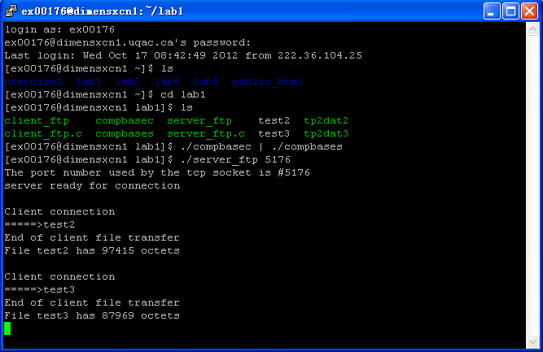

login as: ex00176
ex00176@dimensxcn1.uqac.ca's password:
Last login: Wed Oct 17 08:42:49 2012 from 222.36.104.25
[ex00176@dimensxcn1 ~]$ ls
exercise1 lab1 lab2 lab4 lab5 public_html
[ex00176@dimensxcn1 ~]$ cd lab1
[ex00176@dimensxcn1 lab1]$ ls
client_ftp compbasec server_ftp test2 tp2dat2
client_ftp.c compbases server_ftp.c test3 tp2dat3
[ex00176@dimensxcn1 lab1]$ ./compbasec | ./compbases
[ex00176@dimensxcn1 lab1]$ ./server_ftp 5176
The port number used by the tcp socket is #5176
server ready for connection

Client connection
=====>test2
End of client file transfer
File test2 has 97415 octets

Client connection
=====>test3
End of client file transfer
File test3 has 87969 octets

