1) Description
TEAM MEMBER: 20106190 Tang Luping
USER ID: ex00176
PASSWORD: 64SUyS
SERVER: dimensxcn1.uqac.ca CLIENT: dimensxcn2.uqac.ca
SUBDIRECTORY: /home/users/ex00176/lab5
EMAIL: stu20106190@163.com

2) The List of “server_web.c”
/*
* Program: server_web120.c
* Author: Paul Girard Ph.D., DIM, UQAC
* Date: Sept 2011
* Version: 1.2
*
* Objective: This basic web program supports http 1.0 et 1.1 :
* - GET method from a client commercial web navigator
* - validates the request GET for error codes 400 and 404
* - and generates a response following http protocol rules
* (code 200). html pages are coded in the program source.
*
* This version doesn't support access to external files.
* Most http client header parameters are ignored :
* (User_Agent, From, Referer, Connection, Accept, ...)
*
* Compilation and link options : (Solaris)
* gcc server_web120.c -lsocket -lnsl -o server_web120 or
*
* gcc server_web120.c -lsocket -lnsl -w -o server_web120
* to suppress "warnings"

Compilation and link options : (Linux)
* gcc server_web120.c -lnsl -o server_web120 or
*
* gcc server_web120.c -lnsl -w -o server_web120
* to suppress "warnings"
*
* Execution: 2 formal parameters to run the server :
* server_name and port #
* dimenszxcn1% server_web120 port#
* (note: port 80 is assigned to a commercial http server
* ex. dimenszxcn1% server_web120 5001
*
* The following html pages are coded directly in the source
* : HOME_PAGE and TIME. They can be called
* like this by a telnet client or a web client navigator
*
* 1. with a telnet client using http 1.0 protocol:
* telnet sunense.uqac.ca port# (no_port: port # used)
* GET / HTTP/1.0 to get HOME_PAGE and an empty
* cr/lf line to terminate the request
* telnet sunense.uqac.ca port#
* GET /time HTTP/1.0 to get TIME
* cr/lf
*
* 2. with telnet using HTTP/1.1 protocol and Apache:
* telnet sunense.uqac.ca 80
* GET / HTTP/1.1
* Host: dimensxcn1.uqac.ca
* cr/lf
* telnet dimensxcn1.uqac.ca 80
* Host: dimensxcn1.uqac.ca
* GET /time HTTP/1.1
* Host: dimensxcn1.uqac.ca
* cr/lf
*
* 3. with Netscape or Explorer client
* http://dimensxcn1.uqac.ca :no_port to get Home_Page
* http://dimensxcn1.uqac.ca :no_port/time to get time
*/

/*
* Files to include
*/

#include <stdio.h>
#include <errno.h>
#include <string.h>

#include <sys/types.h>
#include <sys/socket.h>

//include the head file to use stat
#include <sys/stat.h>

#include <netinet/in.h>
#include <netdb.h>
#include <time.h>

#define BUFFSIZE 256
#define SERVER_NAME "Mini web server V1.0 (Paul Girard, Ph.D., UQAC)"

#define ERROR_400 "<head></head><body><html><h1>Error 400</h1><p>Th\
e server couldn't understand your request.</html></body>\n"

#define ERROR_404 "<head></head><body><html><h1>Error 404</h1><p>Do\
cument not found.</html></body>\n"

//
//
//the #define HOME_PAGE was deleted, and replace by the index.html
//

#define TIME_PAGE "<head></head><body><html><h1>The actual date is : \
<br><br>%s</h1></html></body>\n"

int wait_connection(short); /* wait for a client connection */
int recvln(int, char *, int); /* read a client http line */

void send_header(int, int, int,char *); /* send a http header to client*/
void send_eof(int); /* close a client connection */

int init = 0; /* initialization */

//the version of http
char http_vers[32];

int sock; /* socket */

/* ***************************************************************************
* Main Program
* ***************************************************************************
*/

int main(int argc, char *argv[]) /* argv[0] pointer to program name
argv[1] pointer to port number */
{
int conn; /* socket descriptor */
int n;
char buff[BUFFSIZE], cmd[16], path[64], vers[16];
char *timestr;
struct timeval tv; /* delay in sec since 1/1/1970 */
time_t a; /* function time */
if (argc != 2)
{
fprintf(stderr, "usage : %s <no_port_TCP>\n", argv[0]);
return 1;
}

while(1)
{

/* Wait for a client connection on the known port # */

conn = wait_connection(atoi(argv[1]));
if (conn < 0) return 1;

/* Reads & validates the request client */

n = recvln(conn, buff, BUFFSIZE);
sscanf(buff, "%s %s %s", cmd, path, vers);

//
//show the cmd , path , and version of each line
printf("Request type: %s\t path:%s\t version: %s\n",cmd, path, vers);
//

/* Ignore other client header parameters until \r\n on a line */

while((n = recvln(conn, buff, BUFFSIZE)) > 0)
{
if (n == 2 && buff[0] == '\r' && buff[1] == '\n')
break;
}

/* Check if there is an unexpected EOF */

if (n < 1)
{
send_eof(conn);
continue;
}

/* Validates the http client request */

if (strcmp(cmd, "GET") != 0 &&
(strcmp(vers, "HTTP/1.0") != 0 ||
strcmp(vers, "HTTP/1.1") != 0))
{
send_header(conn, 400, strlen(ERROR_400),"html");
send(conn, ERROR_400, strlen(ERROR_400),0);
send_eof(conn);
continue;
}

/* Transmit back the requested html page or
* the message "not found" error */

if (strcmp(path, "/") == 0) /* HOME_PAGE by default*/
{
//
strcpy(path,"/index"); //filename without extension of html
//
//
}
else if (strcmp(path, "/time") == 0) /* time page */
{
/* Solaris ==> if (gettimeofday(&tv, NULL) == -1)
puts("Error with gettimeofday()");
timestr = ctime(&tv.tv_sec); */

/* testtime.c: test of time function*/

time(&a); /* sec since 1970 */
timestr = ctime(&a); /* formatted date-time */
sprintf(buff, TIME_PAGE, timestr);
send_header(conn, 200, strlen(buff),"html");
send(conn, buff, strlen(buff), 0);

//
//
send_eof(conn); /* close the client socket */
continue;
//
}

//
//copy the version of http
strcpy(http_vers,vers);

//
//if the file extension is not entered,use the default extension .html
if ( strstr( strrchr(path,'/') ,".")==NULL )
{
strcat(path,".html"); //concatenate the extension of html
printf("filename: %s \n",strrchr(path,'/')+1); //echo the filename from the path
}

//
//if the path contains a backward reference,send a error message 400
if ( strstr(path,"..")!=NULL )
{
send_header(conn, 400, strlen(ERROR_400),"html");
send(conn, ERROR_400, strlen(ERROR_400),0);
}

//
//determine the content_type from the file extension
int is_html,is_jpeg,is_gif;
is_html=
( strstr( strrchr(path,'/'),".html")!=NULL || strstr( strrchr(path,'/'),".Html")!=NULL
|| strstr( strrchr(path,'/'),".hTml")!=NULL || strstr( strrchr(path,'/'),".htMl")!=NULL
|| strstr( strrchr(path,'/'),".htmL")!=NULL || strstr( strrchr(path,'/'),".HTml")!=NULL
|| strstr( strrchr(path,'/'),".HtMl")!=NULL || strstr( strrchr(path,'/'),".HtmL")!=NULL
|| strstr( strrchr(path,'/'),".hTMl")!=NULL || strstr( strrchr(path,'/'),".hTmL")!=NULL
|| strstr( strrchr(path,'/'),".htML")!=NULL || strstr( strrchr(path,'/'),".hTML")!=NULL
|| strstr( strrchr(path,'/'),".HtML")!=NULL || strstr( strrchr(path,'/'),".HTml")!=NULL
|| strstr( strrchr(path,'/'),".HTMl")!=NULL || strstr( strrchr(path,'/'),".HTML")!=NULL);
is_jpeg=
( strstr( strrchr(path,'/'),".jpeg")!=NULL || strstr( strrchr(path,'/'),".Jpeg")!=NULL
|| strstr( strrchr(path,'/'),".jPeg")!=NULL || strstr( strrchr(path,'/'),".jpEg")!=NULL
|| strstr( strrchr(path,'/'),".jpeG")!=NULL || strstr( strrchr(path,'/'),".JPeg")!=NULL
|| strstr( strrchr(path,'/'),".JpEg")!=NULL || strstr( strrchr(path,'/'),".JpeG")!=NULL
|| strstr( strrchr(path,'/'),".jPEg")!=NULL || strstr( strrchr(path,'/'),".jPeG")!=NULL
|| strstr( strrchr(path,'/'),".jpEG")!=NULL || strstr( strrchr(path,'/'),".jPEG")!=NULL
|| strstr( strrchr(path,'/'),".JpEG")!=NULL || strstr( strrchr(path,'/'),".JPeG")!=NULL
|| strstr( strrchr(path,'/'),".JPEg")!=NULL || strstr( strrchr(path,'/'),".JPEG")!=NULL
//
|| strstr( strrchr(path,'/'),".jpg")!=NULL || strstr( strrchr(path,'/'),".Jpg")!=NULL
|| strstr( strrchr(path,'/'),".jPg")!=NULL || strstr( strrchr(path,'/'),".jpG")!=NULL
|| strstr( strrchr(path,'/'),".JPg")!=NULL || strstr( strrchr(path,'/'),".JpG")!=NULL
|| strstr( strrchr(path,'/'),".jPG")!=NULL || strstr( strrchr(path,'/'),".JPG")!=NULL);
is_gif=
( strstr( strrchr(path,'/'),".gif")!=NULL || strstr( strrchr(path,'/'),".Gif")!=NULL
|| strstr( strrchr(path,'/'),".gIf")!=NULL || strstr( strrchr(path,'/'),".giF")!=NULL
|| strstr( strrchr(path,'/'),".GIf")!=NULL || strstr( strrchr(path,'/'),".GiF")!=NULL
|| strstr( strrchr(path,'/'),".gIF")!=NULL || strstr( strrchr(path,'/'),".GIF")!=NULL);

//printf("%d %d %d",is_html,is_jpeg,is_gif);

if(is_html || is_jpeg || is_gif)
{
struct stat path_buff;
char fname[64];

//get the filename from the path
strcpy(fname,strstr(path,"/")+1);
strcpy(strchr(fname,'.'),"");

if(is_html)strcat(fname,".html");
else if(is_jpeg)strcat(fname,".jpg");
else if(is_gif)strcat(fname,".gif");

//printf("%d\n",stat(fname,&path_buff));

if(stat(fname,&path_buff)==0) // stat successful
{

FILE *fptr; //pointer to the file
if((fptr=fopen(fname,"r"))==NULL)exit(0);

int noctets=0;

if(is_html==1)
{
send_header(conn, 200, (path_buff).st_size, "html");

while(fgets(buff,sizeof(buff),fptr)) //read a record
{
noctets+=strlen(buff);

send(conn, buff, strlen(buff), 0);
//not works : send(conn, buff, sizeof(buff), 0); //some unsensible characters
if(feof(fptr))break;
}

//not works : send(conn, path, (path_buff).st_size, 0); //some unsensible characters

}

else if(is_jpeg==1 || is_gif==1)
{

if(is_jpeg==1)
send_header(conn, 200, (path_buff).st_size,"jpeg");
else
send_header(conn, 200, (path_buff).st_size,"gif");

while(feof(fptr)==0) //not end of file
{
int rval=fread(buff,sizeof(char),256,fptr);
if(rval>0) noctets+=rval;

//send(conn, buff, strlen(buff), 0); //no sensible characters
//not works :
send(conn, buff, sizeof(buff), 0); //some unsensible characters
}

//not works : send(conn, path, (path_buff).st_size, 0); //some unsensible characters
}

fclose(fptr);

printf("Number of octets sent %d,\n",noctets);
printf("File read\n");

}
else if(stat(fname,&path_buff)==-1) // stat error
{
printf("Error opening file %s\n",fname);

//Error not found
send_header(conn, 404, strlen(ERROR_404),"html");
send(conn, ERROR_404, strlen(ERROR_404),0);
}

}
// Error for other file extensions
else
{
//Error not found
send_header(conn, 404, strlen(ERROR_404),"html");
send(conn, ERROR_404, strlen(ERROR_404),0);
}

send_eof(conn); /* close the client socket */

} /* end of infinite loop */
} /* ==== end of main program */

/* *************************************************************************
* Function wait_connection() returns a client connection
* *************************************************************************
*/

int wait_connection(short no_port)
{
struct sockaddr_in sockaddr; /* internet format */
int newsock; /* socket descriptor */
size_t length; /* #octets in sockadr_in structure*/

/*
* Tcp socket creation
*/

switch (init)
{
case 0 :
sock = socket(AF_INET, SOCK_STREAM, 0);
if (sock < 0)
{
perror("Error in socket creation");
return 1;
}

/*
* 2. Specify the local part of the address :
* 1)the local port number in network format and
* 2)the local IP address. INADDR_ANY is used on a server
* because many ip addresses may be used on the same machine.
*/
sockaddr.sin_family = AF_INET;
sockaddr.sin_addr.s_addr = INADDR_ANY;
sockaddr.sin_port = htons(no_port);

if (bind(sock, (struct sockaddr *)&sockaddr, sizeof(sockaddr)) < 0)
{
perror("The bind socket did not work");
close(sock);
return 1;
}

/*
* Simple validation: find the name associated to this socket
* and print its port number
*/
length = sizeof(sockaddr);
if (getsockname(sock, (struct sockaddr *)&sockaddr, &length ) < 0 )
{
perror("Error in getsockname()");
exit(1);
}
printf("The socket tcp port # is #%d\n", ntohs(sockaddr.sin_port));

/*
* Fix the maximum number of clients waiting connection and
* leave the server in passive mode
*/
listen(sock, 5);
puts("Server ready for client connections\n");
init = 1; /* end of initialization */

case 1: /* after initialization continue here */
newsock = accept(sock, (struct sockaddr *) 0, (size_t *) 0);
//
puts("Client connection");
//
return newsock;
}
}
/* ==== End of wait_connection ================================================ */

/* *************************************************************************
* Function recvlin() reading a socket connection with recv()
* until newline (\n) or EOF is read. A flush of the remaining characters
* is done until newline or EOF if the buffer is full. It returns a full
* buffer.
*
* conn: socket # (input)
* *buff: address of the buffer receiving a complete line (input)
* buffsz: buffer size in octets (input)
* ==> recvln returns the length in octets of read characters in buff
* **************************************************************************
*/

int recvln(int conn, char *buff, int buffsz)
{
char *bp = buff, c;
int n; /* #octets read by recv() */

/* While buffer not full and we can read characters
* different from \n, octets are saved in buff
*/
while (bp - buff < buffsz &&
(n = recv(conn, bp, 1, 0)) > 0)
{
if (*bp++ == '\n') return (bp - buff);
}

if (n < 0) /* read has failed */
return -1;

/* If the buffer is full, ignore the rest until \n */
if (bp - buff == buffsz)
while (recv(conn, &c, 1, 0) > 0 && c != '\n');
return (bp - buff);
}

/* ==== End de recvln ====================================================== */

/* *************************************************************************
* Function send_header() sending the http 1.0 header to client
* with the status, server name, content type and content length
* *************************************************************************
*/

void send_header(int conn, int stat, int len,char content_type[])
{
char *statstr, buff[BUFFSIZE];

/* change the status code to a character string message */

switch(stat)
{
case 200:
statstr = "OK";
break;
case 400:
statstr = "Bad Request";
break;
case 404:
statstr = "Not Found";
break;
default:
statstr = "Unknown";
break;
}

/*
* send the parameter server header
* "HTTP/1.0 Server Content-Length Content-Type" to client
*/

//
//sprintf(buff, "HTTP/1.0 %d %s\r\n", stat, statstr);
sprintf(buff, "%s %d %s\r\n",http_vers, stat, statstr);

send(conn, buff, strlen(buff), 0);

sprintf(buff, "Server: %s\r\n", SERVER_NAME);
send(conn, buff, strlen(buff), 0);

sprintf(buff, "Content-Length: %d\r\n", len);
send(conn, buff, strlen(buff), 0);

//
//
if(content_type=="html")sprintf(buff, "Content-Type: text/html\r\n");
else if(content_type=="JPEG"||content_type=="jpeg"||content_type=="JPG"||content_type=="jpg")
sprintf(buff, "Content-Type: image/jpeg\r\n");
else if(content_type=="gif"||content_type=="GIF")
sprintf(buff, "Content-Type: image/gif\r\n");

//
//

send(conn, buff, strlen(buff), 0);

sprintf(buff, "\r\n");
send(conn, buff, strlen(buff), 0);
}
/* ===================== end of send_header ================================ */

/* ****************************************************************************
* Function send_eof() closes the connection from this end
* by using a shutdown() call which shuts down all or part of a full-duplex
* connection on the associated socket .
* 0 : further receives will be disallowed,
* l : further sends will be disallowed (this mode is used),
* 2: further sends and receives will be disallowed
* *****************************************************************************
*/

void send_eof(int conn)
{
//
//
printf("End of client connection\n\n");

shutdown(conn,1);

close(conn);
return;
}

/*===================== end of send_eof =================================== */

3) A Sequential Execution
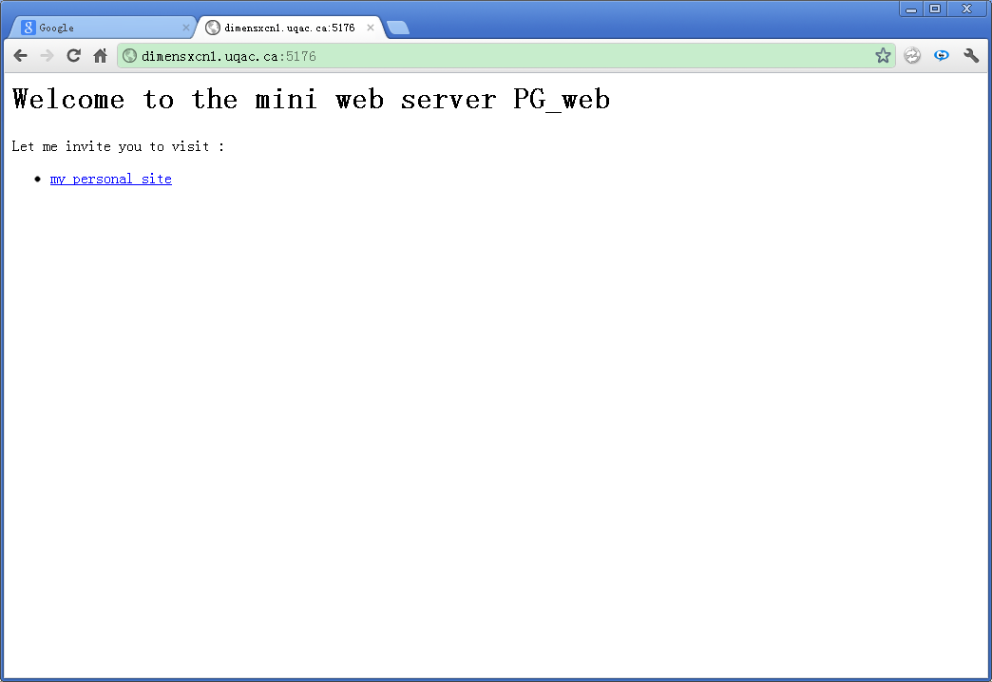

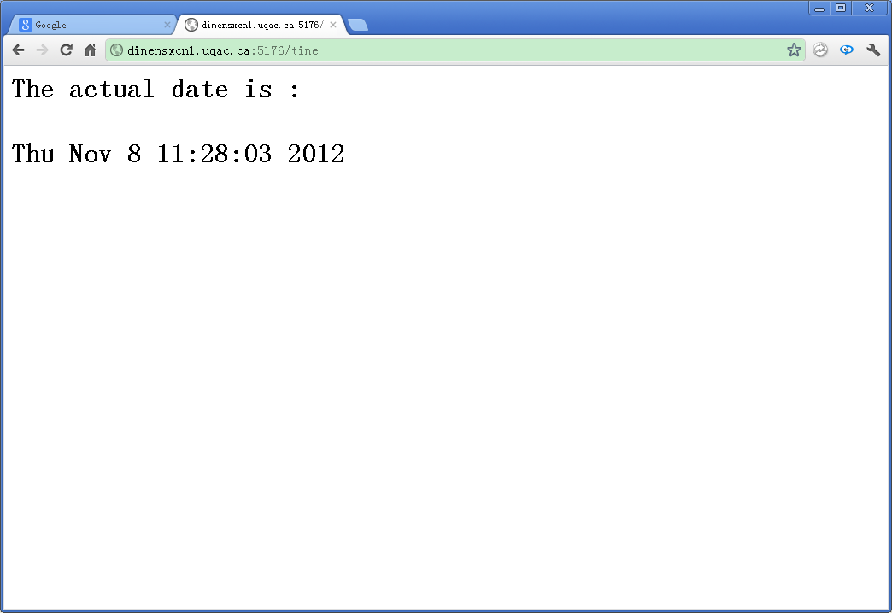

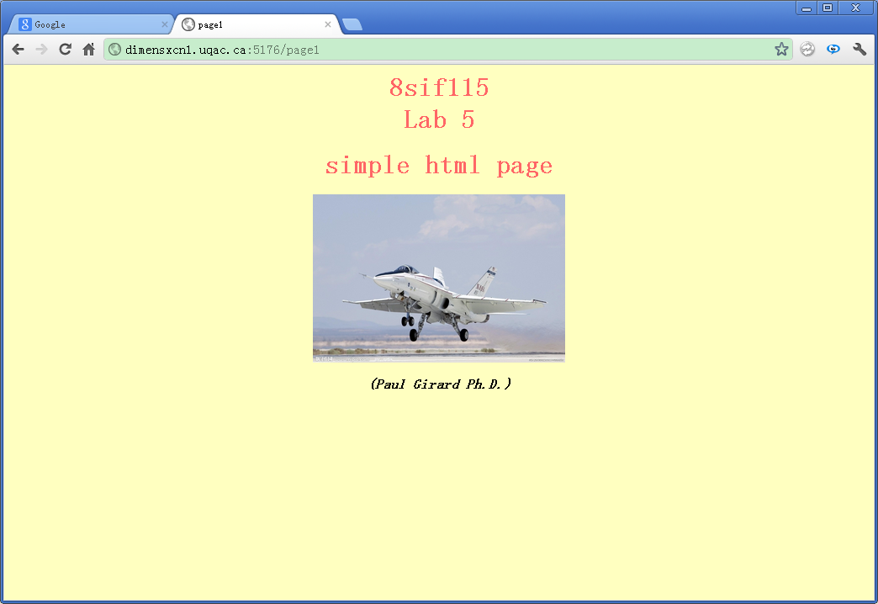

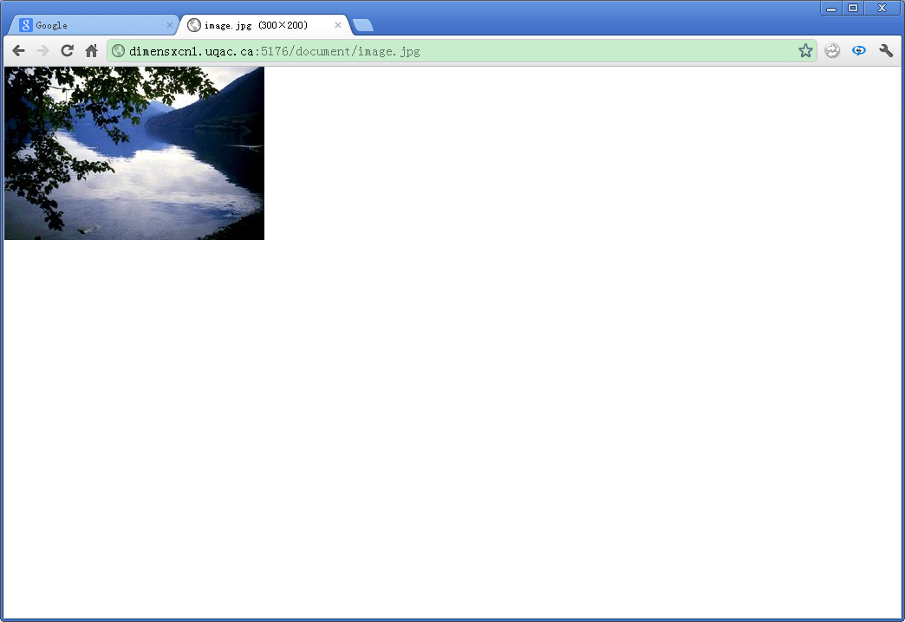

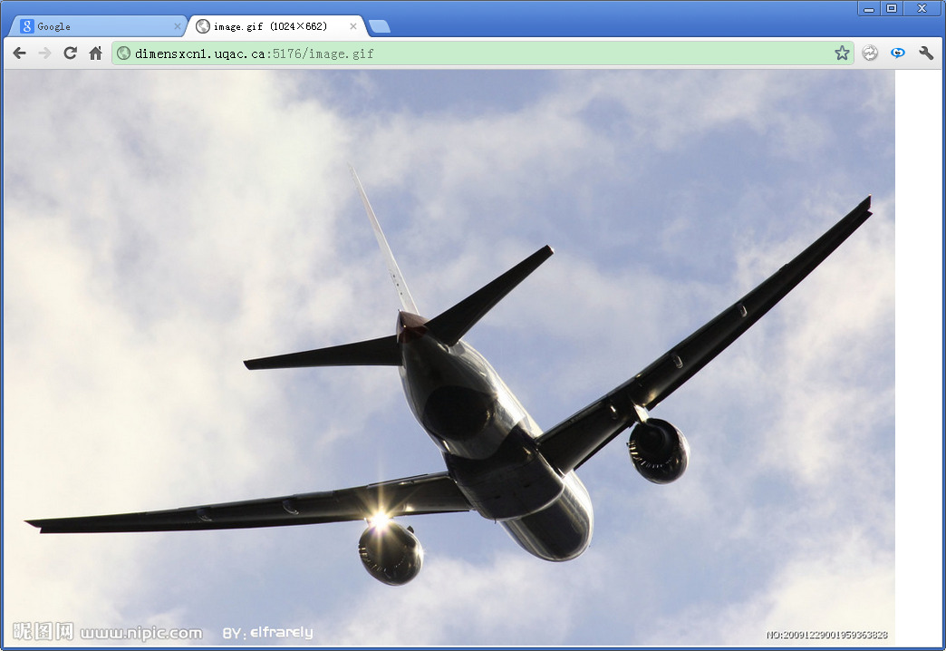

server_web part:
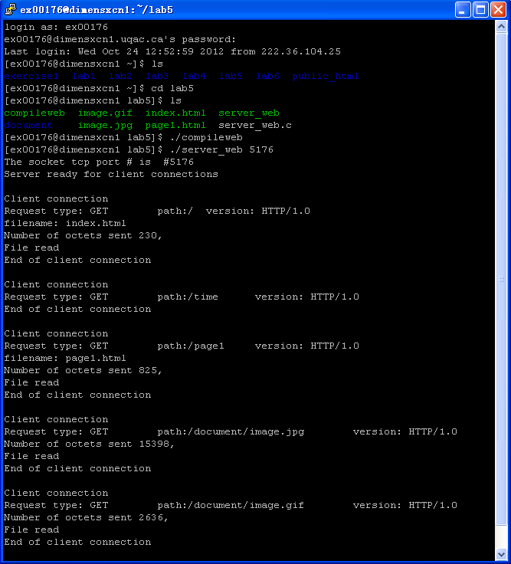login as: ex00176
ex00176@dimensxcn1.uqac.ca's password:
Last login: Wed Oct 24 12:52:59 2012 from 222.36.104.25
[ex00176@dimensxcn1 ~]$ ls
exercise1 lab1 lab2 lab3 lab4 lab5 lab6 public_html
[ex00176@dimensxcn1 ~]$ cd lab5
[ex00176@dimensxcn1 lab5]$ ls
compileweb image.gif index.html server_web
document image.jpg page1.html server_web.c
[ex00176@dimensxcn1 lab5]$ ./compileweb
[ex00176@dimensxcn1 lab5]$ ./server_web 5176
The socket tcp port # is #5176
Server ready for client connections

Client connection
Request type: GET path:/ version: HTTP/1.0
filename: index.html
Number of octets sent 230,
File read
End of client connection

Client connection
Request type: GET path:/time version: HTTP/1.0
End of client connection

Client connection
Request type: GET path:/page1 version: HTTP/1.0
filename: page1.html
Number of octets sent 825,
File read
End of client connection

Client connection
Request type: GET path:/document/image.jpg version: HTTP/1.0
Number of octets sent 15398,
File read
End of client connection

Client connection
Request type: GET path:/document/image.gif version: HTTP/1.0
Number of octets sent 2636,
File read
End of client connection

client part:
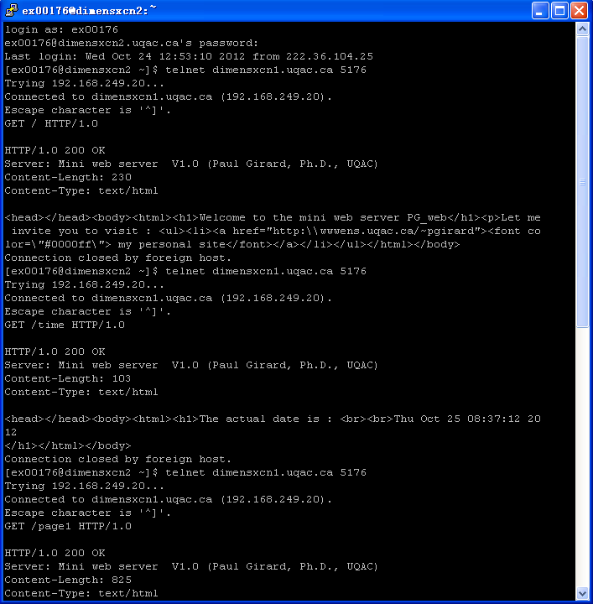
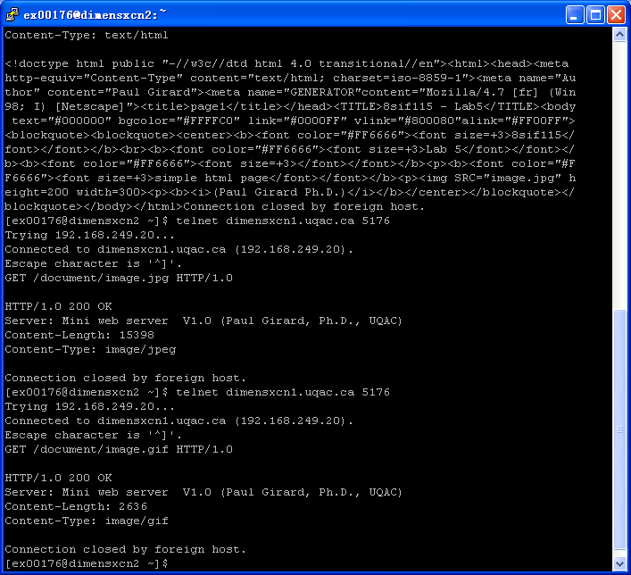
login as: ex00176
ex00176@dimensxcn2.uqac.ca's password:
Last login: Wed Oct 24 12:53:10 2012 from 222.36.104.25
[ex00176@dimensxcn2 ~]$ telnet dimensxcn1.uqac.ca 5176
Trying 192.168.249.20...
Connected to dimensxcn1.uqac.ca (192.168.249.20).
Escape character is '^]'.
GET / HTTP/1.0

HTTP/1.0 200 OK
Server: Mini web server V1.0 (Paul Girard, Ph.D., UQAC)
Content-Length: 230
Content-Type: text/html

<head></head><body><html><h1>Welcome to the mini web server PG_web</h1><p>Let me invite you to visit : <ul><li><a href="http:\\wwwens.uqac.ca/~pgirard"><font co lor=\"#0000ff\"> my personal site</font></a></li></ul></html></body>
Connection closed by foreign host.
[ex00176@dimensxcn2 ~]$ telnet dimensxcn1.uqac.ca 5176
Trying 192.168.249.20...
Connected to dimensxcn1.uqac.ca (192.168.249.20).
Escape character is '^]'.
GET /time HTTP/1.0

HTTP/1.0 200 OK
Server: Mini web server V1.0 (Paul Girard, Ph.D., UQAC)
Content-Length: 103
Content-Type: text/html

<head></head><body><html><h1>The actual date is : <br><br>Thu Oct 25 08:37:12 20 12
</h1></html></body>
Connection closed by foreign host.
[ex00176@dimensxcn2 ~]$ telnet dimensxcn1.uqac.ca 5176
Trying 192.168.249.20...
Connected to dimensxcn1.uqac.ca (192.168.249.20).
Escape character is '^]'.
GET /page1 HTTP/1.0

HTTP/1.0 200 OK
Server: Mini web server V1.0 (Paul Girard, Ph.D., UQAC)
Content-Length: 825
Content-Type: text/html

<!doctype html public "-//w3c//dtd html 4.0 transitional//en"><html><head><meta http-equiv="Content-Type" content="text/html; charset=iso-8859-1"><meta name="Au thor" content="Paul Girard"><meta name="GENERATOR"content="Mozilla/4.7 [fr] (Win 98; I) [Netscape]"><title>page1</title></head><TITLE>8sif115 - Lab5</TITLE><body text="#000000" bgcolor="#FFFFC0" link="#0000FF" vlink="#800080"alink="#FF00FF"> <blockquote><blockquote><center><b><font color="#FF6666"><font size=+3>8sif115</ font></font></b><br><b><font color="#FF6666"><font size=+3>Lab 5</font></font></ b><b><font color="#FF6666"><font size=+3></font></font></b><p><b><font color="#F F6666"><font size=+3>simple html page</font></font></b><p><img SRC="image.jpg" h eight=200 width=300><p><b><i>(Paul Girard Ph.D.)</i></b></center></blockquote></ blockquote></body></html>Connection closed by foreign host.
[ex00176@dimensxcn2 ~]$ telnet dimensxcn1.uqac.ca 5176
Trying 192.168.249.20...
Connected to dimensxcn1.uqac.ca (192.168.249.20).
Escape character is '^]'.
GET /document/image.jpg HTTP/1.0

HTTP/1.0 200 OK
Server: Mini web server V1.0 (Paul Girard, Ph.D., UQAC)
Content-Length: 15398
Content-Type: image/jpeg

Connection closed by foreign host.
[ex00176@dimensxcn2 ~]$ telnet dimensxcn1.uqac.ca 5176
Trying 192.168.249.20...
Connected to dimensxcn1.uqac.ca (192.168.249.20).
Escape character is '^]'.
GET /document/image.gif HTTP/1.0

HTTP/1.0 200 OK
Server: Mini web server V1.0 (Paul Girard, Ph.D., UQAC)
Content-Length: 2636
Content-Type: image/gif

Connection closed by foreign host.
[ex00176@dimensxcn2 ~]$

