Final Report

for Advanced Database

Date:2013-06-20

Student_name | UQAC_code | TUT_code | Username | Password
ZHANG YUE | ZHAY28059200 | 20106121 | ora00120 | 6tY29y
TANG LUPING | TANL23059201 | 20106190 | ora00176 | RFy7qP
ZHENG ZHIYU | ZHEZ19109106 | 20106199 | ora00182 | vCsaT4
CAO YUE | CAOY17539202 | 20106124 | ora00123 | nGMvQF
FENG XIAOMENG | FENX16589108 | 20106125 | ora00124 | U4TQUs

Evaluation of team member
(10 ==> normal collaboration et 0 ==> no collaboration)
student name | lab1 | lab2 | lab3 | lab4
ZHANG YUE | 10 | 10 | 10 | 10
TANG LUPING | 10 | 10 | 10 | 10
ZHENG ZHIYU | 10 | 10 | 10 | 10
CAO YUE | 10 | 10 | 10 | 10
FENG XIAOMENG | 10 | 10 | 10 | 10
 | /10 | /10 | /10 | /10

Contents
Final Report for Adcanced Database 0
0 Logical Data Model under Oracle 11g Environment 2
0.1 Global conceptual E/R data model (lab1) 2
0.2 Global relational data model (lab2) 3
0.3 Graphical representation (lab2) 4
0.4 List and Execution of Creation and Loading (lab2) 5
1 Technician 21
1.1 Transaction table (lab1) 21
1.2 Partial Conceptual E/R data model (lab1) 22
1.3 Partial relational data model (lab2) 23
1.4 Execution of transactions (lab3) 24
1.5 List and execution in C (lab4) 27
1.6 List and result in html and PHP with URL (lab6) 34
2 PA 35
2.1 Transaction table (lab1) 35
2.2 Partial Conceptual E/R data model (lab1) 36
2.3 Partial relational data model (lab2) 37
2.4 Execution of transactions (lab3) 38
2.5 List and execution in C (lab4) 42
2.6 List and result in html and PHP with URL (lab6) 49
3 PDS 50
3.1 Transaction table (lab1) 50
3.2 Partial Conceptual E/R data model (lab1) 51
3.3 Partial relational data model (lab2) 52
3.4 Execution of transactions (lab3) 53
3.5 List and execution in C (lab4) 56
3.6 List and result in html and PHP with URL (lab6) 63
4 SK 64
4.1 Transaction table (lab1) 64
4.2 Partial Conceptual E/R data model (lab1) 65
4.3 Partial relational data model (lab2) 66
4.4 Execution of transactions (lab3) 67
4.5 List and execution in C (lab4) 71
4.6 List and result in html and PHP with URL (lab6) 77
5 SKS 78
5.1 Transaction table (lab1) 78
5.2 Partial Conceptual E/R data model (lab1) 79
5.3 Partial relational data model (lab2) 80
5.4 Execution of transactions (lab3) 81
5.5 List and execution in C (lab4) 84
5.6 List and result in html and PHP with URL (lab6) 88
PS: You can trace the links above by using Ctrl+Click.

0 Logical Data Model

under Oracle 11g Environment

0.1 Global conceptual E/R data model (lab1)
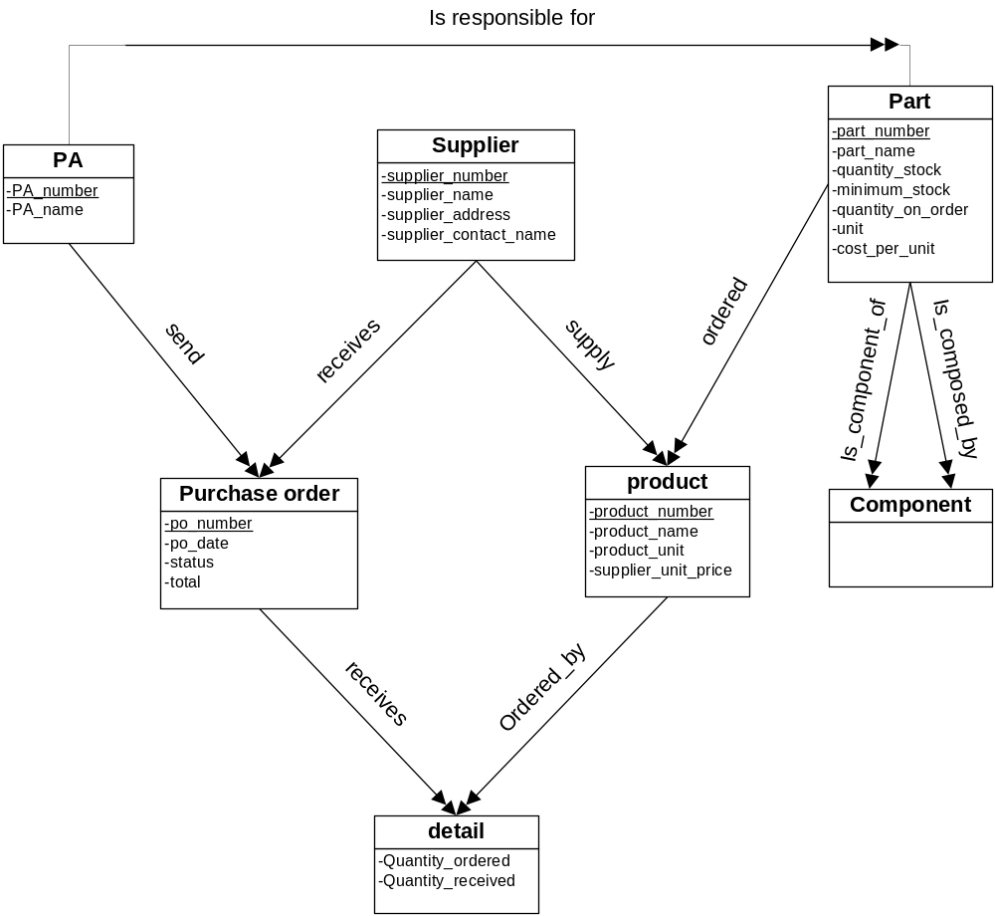

0.2 Global relational data model (lab2)
PA ( employee_ number , PA_ name )
part ( part_ number, part_ name, qty_ stock, qty_ minimum, qty_ ordered, unit, unit_ price )
component ( part_ number, part_ number_ component )

supplier ( supplier_ number, supplier_ name , supplier_ address , supplier_ contact_ name )
product ( product_ number, product_ name , product_ unit , supplier_ unit_ price )

PO ( po_ number, po_ date, status, total )
detail ( po_ number, product_ number, qty_ ordered , qty_ received )

responsible(employee_ number, part_ number)
task ( purchase_ order_ number, employee_ number )

business ( purchase_ order_ number, supplier_ number )
potential(part_ number, supplier_ number, product_ number)

0.3 Graphical representation (lab2)
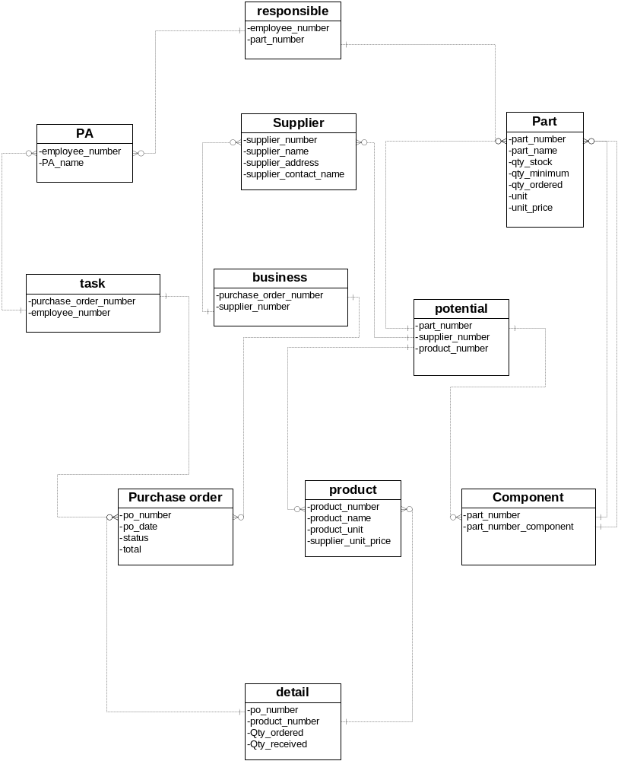

0.4 List and Execution of Creation and Loading (lab2)
crelab2.sql:
home/users/ora00176/lab2/crelab2.sql

-- Incomplete example of table creation for TUT-Lab2 8trd157
-- Paul Girard Ph.D. UQAC
--
-- modified by ora00176 in may,2013

--drop tables
drop table potential;
drop table business;
drop table task;

drop table responsible;

drop table detail;

drop table product;
drop table component;
drop table part;

drop table pa_agent;
drop table purchase_order;
drop table supplier;

--drop views
drop view purchase_pds;
drop view sks;

--pa_agent, purchase_order, supplier
create table pa_agent
(emp_num number(4) primary key,
pa_name char(15) not null);
create table purchase_order
(po_number number(4) primary key,
po_date char(8) not null,
total number(6,2) default 0,
status char(15) default 'not_completed');
create table supplier
(supplier_id number(4) primary key,
supplier_name char(15) not null,
addr char(20) not null,
contact char(15) not null);

--part and component
create table part
(part_number number(4) primary key,
part_name char(15) not null,
qty_stock number(6) default 0,
qty_minimum number(6) default 0,
qty_ordered number(6) default 0,
unit char(15) not null,
unit_price number(5,2) default 0
);

create table component
(part_number number(4) not null references part(part_number),
part_number_component number(4) not null references part(part_number),
constraint pk_component primary key(part_number,part_number_component)
);

--product
create table product
(product_number number(4) unique,
supplier_number number(5) not null references supplier(supplier_id),
product_name char(15) not null,
product_unit number(4) not null,
supplier_unit_price number(4,2) default 0,
constraint pk_product primary key(supplier_number,product_number)
);

--detail
create table detail
(po_number number(4) not null,
product_number number(4) not null,
qty_ordered number(4) not null,
qty_received number(4) not null,
constraint con_det_or check(qty_ordered>=qty_received),
constraint pk_detail primary key(po_number,product_number)
);

--responsible
create table responsible
(emp_num number(5) not null references pa_agent(emp_num),
part_number number(5) not null references part(part_number),
constraint pk_responsible primary key(emp_num, part_number)
);

--task, business, potential
create table task
(po_number number(5) not null references purchase_order(po_number),
emp_num number(5) not null references pa_agent(emp_num),
constraint pk_task primary key(po_number, emp_num)
);

create table business
(po_number number(5) not null references purchase_order(po_number),
supplier_id number(5) not null references supplier(supplier_id),
constraint pk_business primary key(po_number, supplier_id)
);

create table potential
(part_number number(5) not null references part(part_number),
supplier_id number(5) not null references supplier(supplier_id),
product_number number(5) not null references product(product_number),
constraint pk_potential primary key(part_number,supplier_id,product_number)
);

--view for purchase_pds
create or replace view purchase_pds as
select po_number,total from purchase_order;

--view for sks
create or replace view sks as
select part_number,qty_stock,unit,unit_price from part;

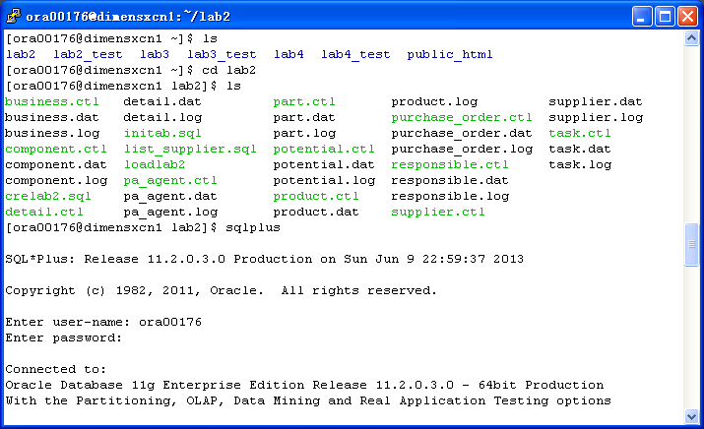
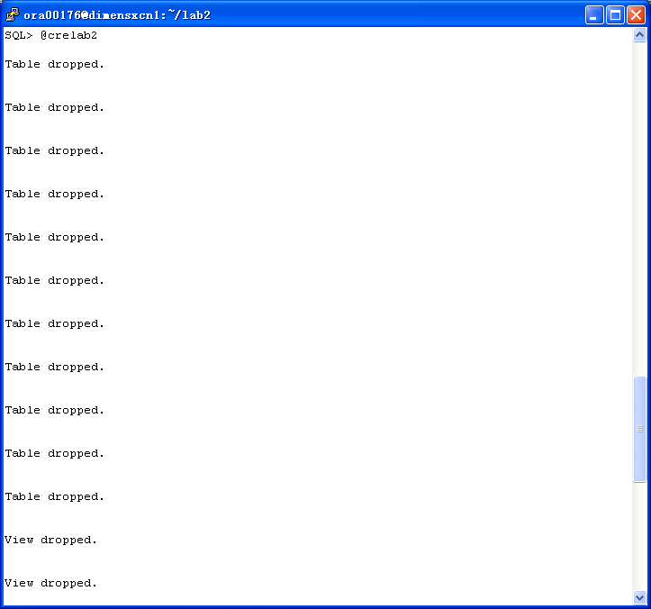
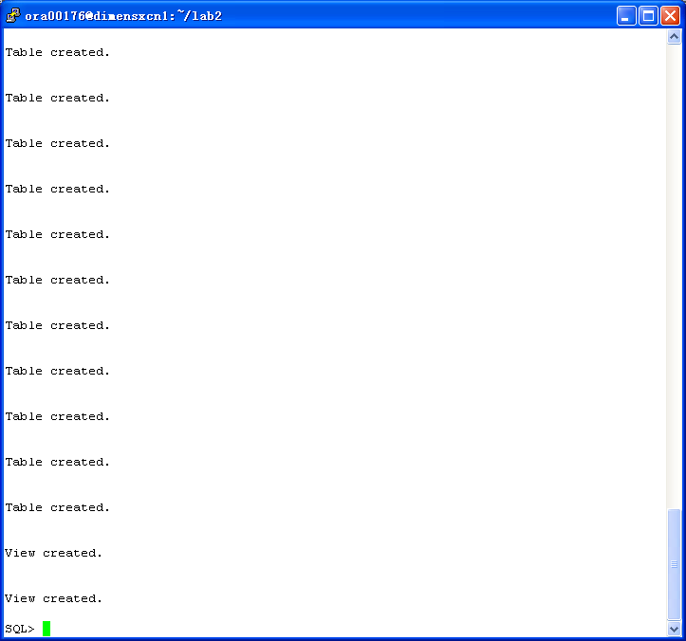

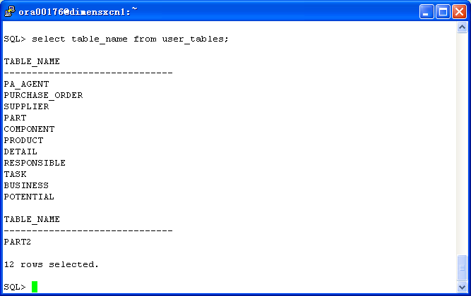

.ctl and .dat:

pa_agent
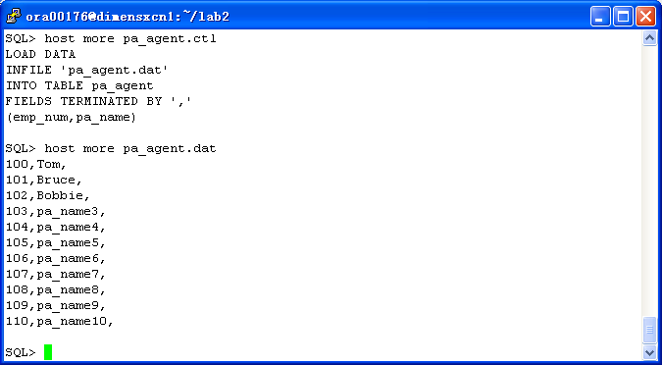

purchase_order
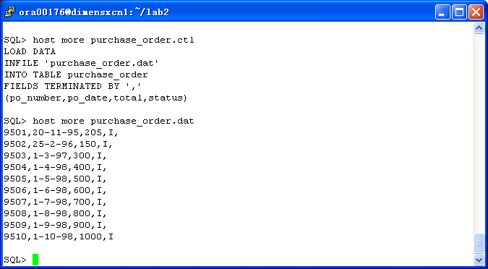

supplier
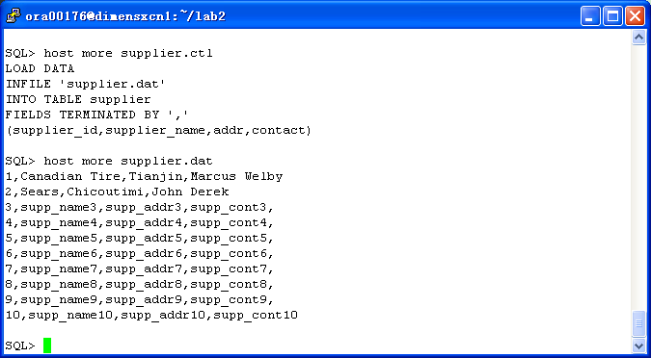

part
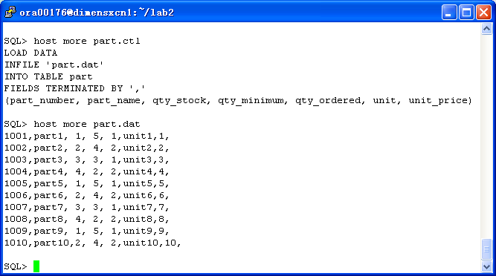

component
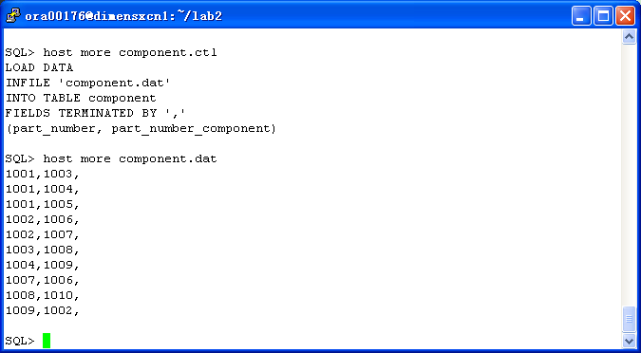

detail
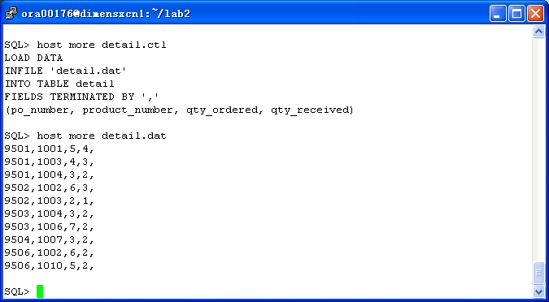

responsible
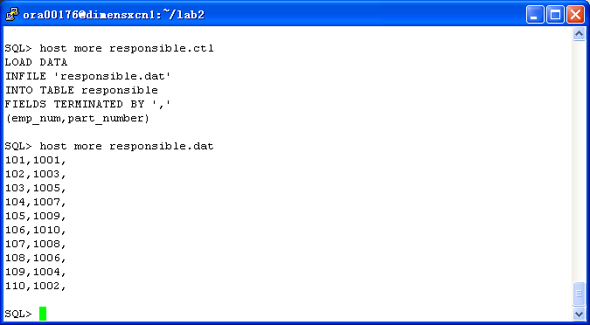

task
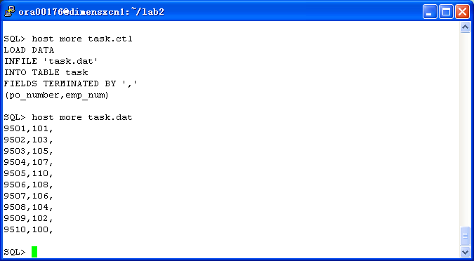

business
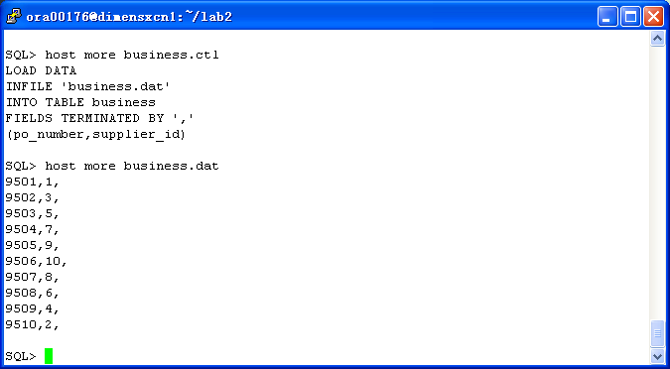

potential
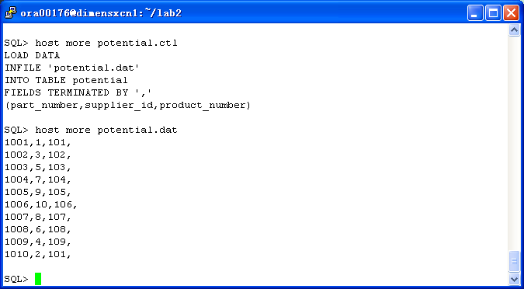

loadlab2:
home/users/ora00176/lab2/loadlab2
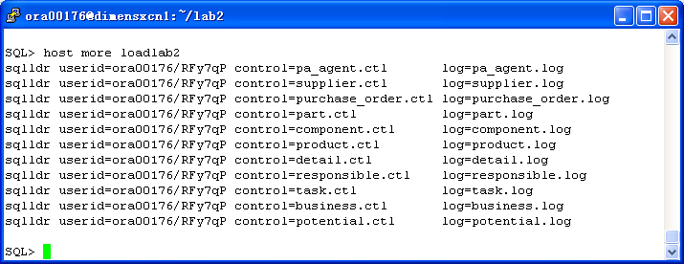
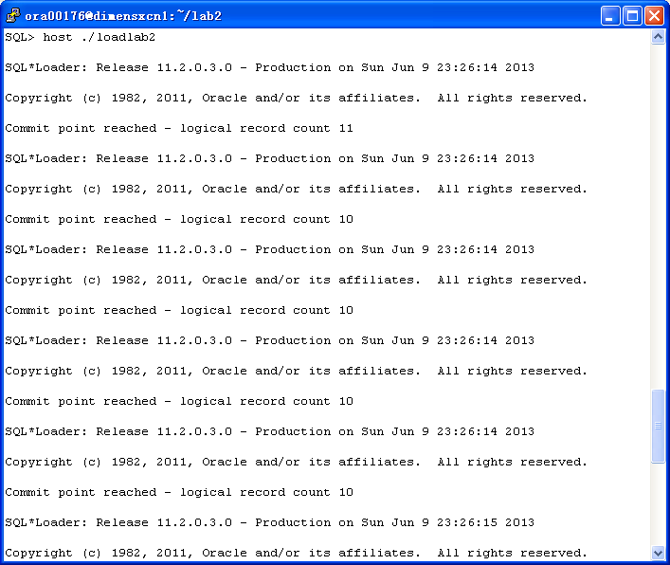
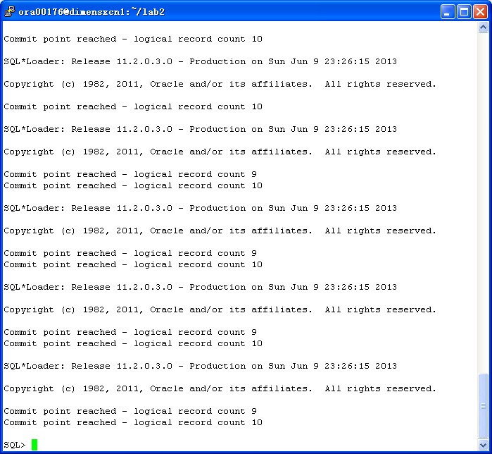

initab.sql:
home/users/ora00176/lab2/initab.sql

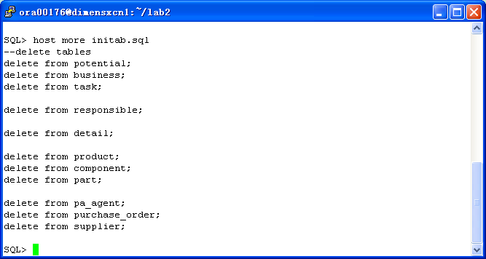
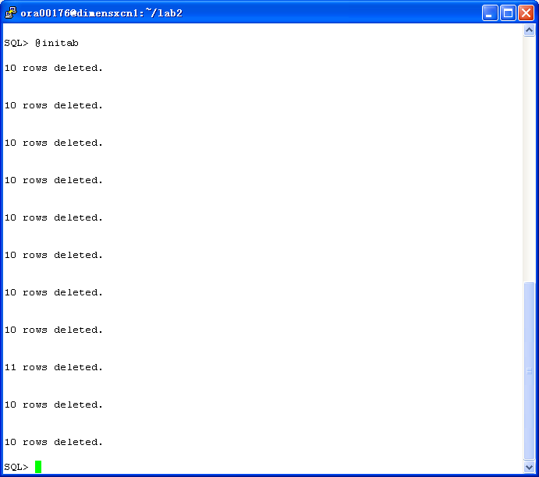

privilege.sql:
home/users/ora00176/lab3/privilege.sql
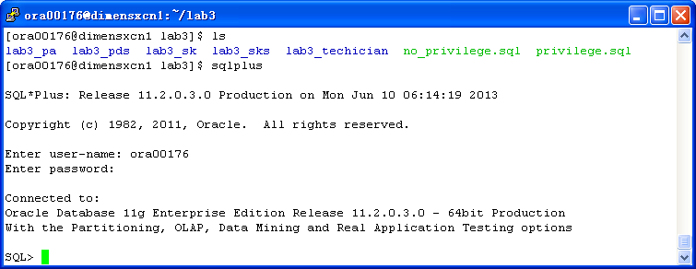
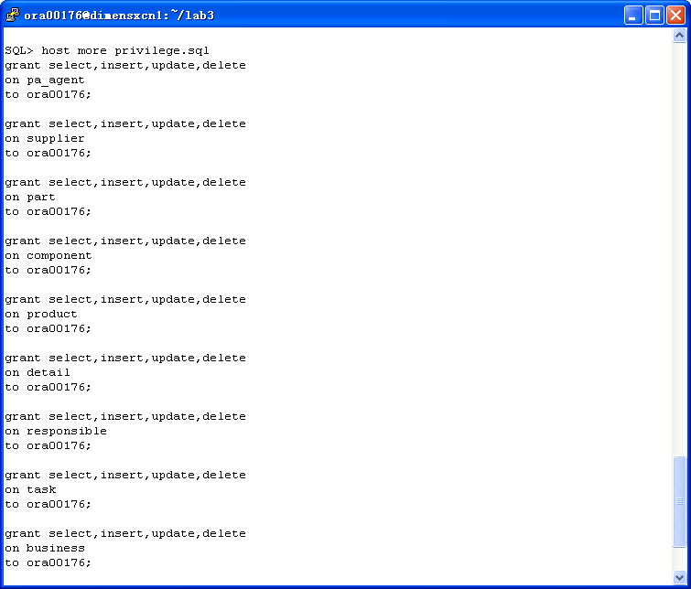
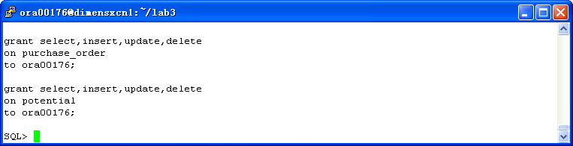

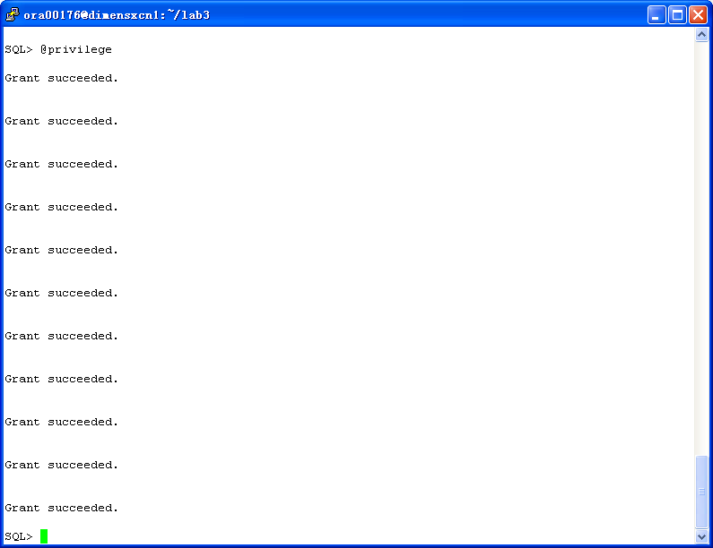

no_privilege.sql:
home/users/ora00176/lab3/no_privilege.sql
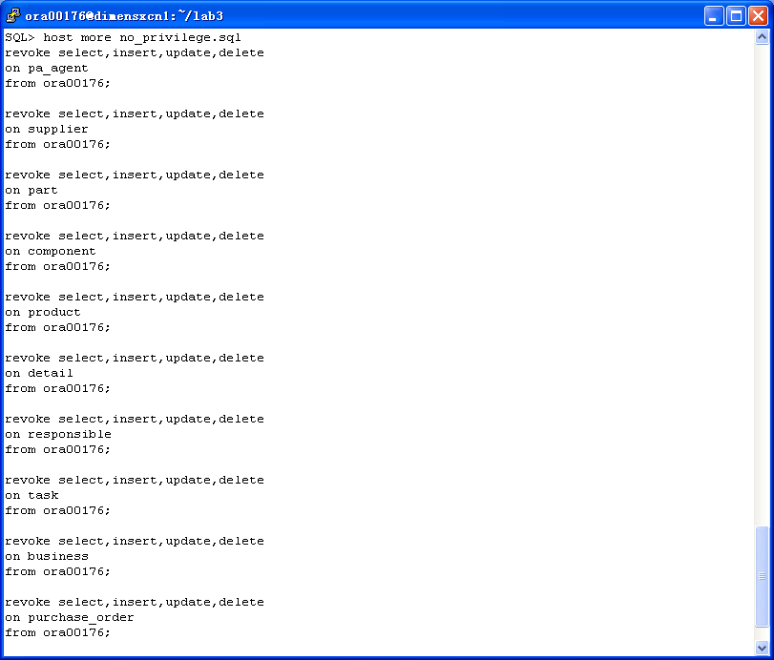
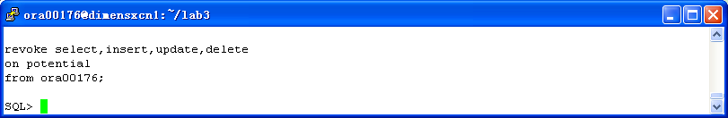

1 Technician

1.1 Transaction table (lab1)
Transaction | Description | Entity | Access | Key | Freq. | Response
 |  |  | type |  |  | time
listpart | Display all attributes | part | read | part_id | 1/day | <3 sec
 | (part_id, part_name, unit, unit_price,
 | stock_qty, ordered_qty, min_qty) of a given part(part_id)
explosion | Display all components(part_id, part_name) of a given | part | read | part_id | 1/week | <3 sec
 | part (part_id) | component | read | part_id
implosion | Display all parts(part_id, part_name) | part | read | part_id | 1/week | <3 sec
 | where a given part(part_id) is a component | component | read | part_id
crecomp | Creation of a component(part_id) of a | part | read | part_id | 1/month | <3 sec
 | given part(part_id) | component | read | part_id
cancomp | Cancel component(part_id) of a given | part | read | part_id | 1/month | <3 sec
 | part(part_id) | component | read | part_id

1.2 Partial Conceptual E/R data model (lab1)
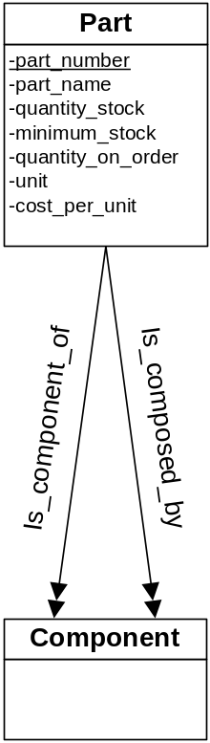

1.3 Partial relational data model (lab2)
part ( part_ number, part_ name, qty_ stock, qty_ minimum, qty_ ordered, unit, unit_ price )
component ( part_ number, part_ number_ component )

1.4 Execution of transactions (lab3)
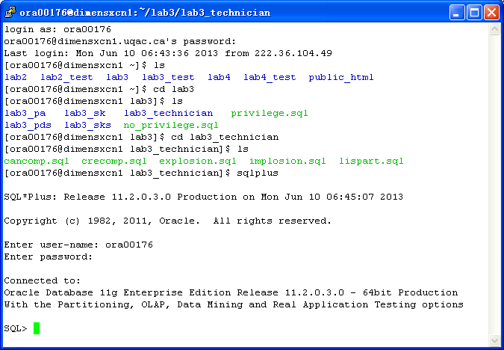

lispart.sql
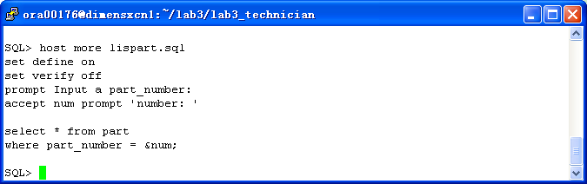
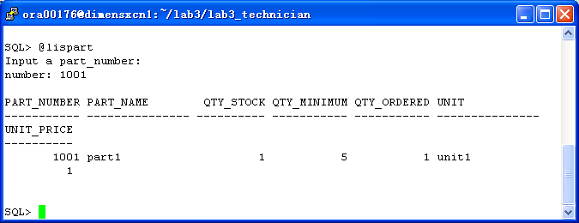

explosion.sql
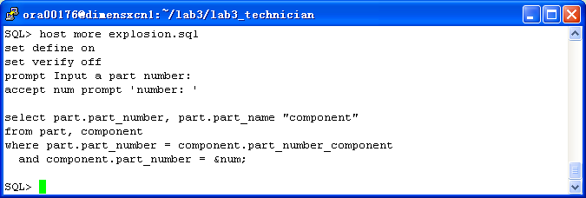
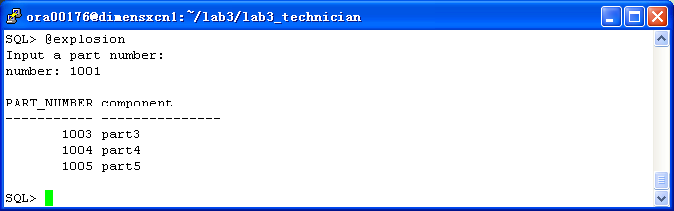

implosion.sql
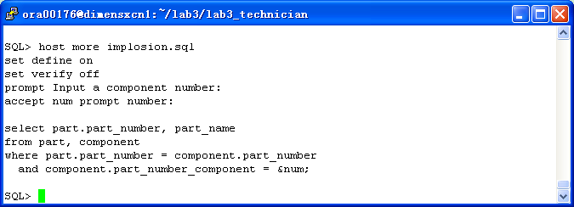
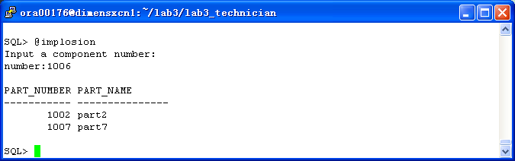

crecomp.sql
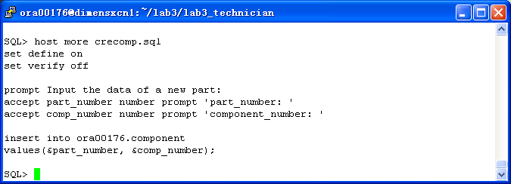
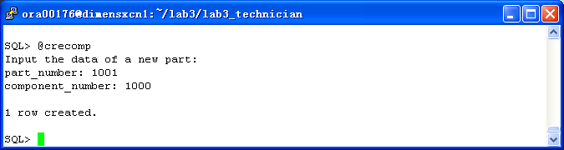

cancomp.sql
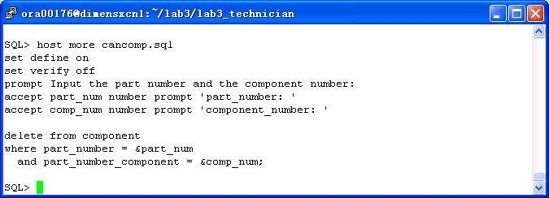
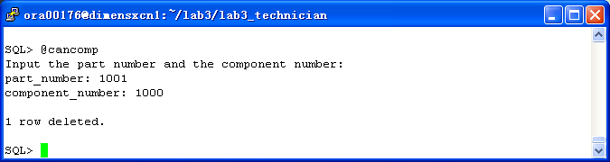

1.5 List and execution in C (lab4)
/*
* Author: Paul Girard Ph.D., UQAC
* Date: March 2008
* Objective: Program using Pro*C/C++ and gcc to show how to use
* different type of PL/SQL blocks & SQL in a C PGM
*
* Step 1: Precompilation with Pro*C/C++
* proc INAME=lab4base.pc CODE=ANSI_C SQLCHECK=semantics MODE=oracle DBMS=v8 USERID=user/password CHAR_MAP=charz
*
* Step 2: Compilation with gcc
* gcc lab4base.c -o lab4base -include /$ORACLE_HOME/precomp/public/sqlca.h -lclntsh -L$ORACLE_HOME/lib/ -B$ORACLE_HOME/lib
*
* modified by ora00176 in may,2013
*/

#include <stdio.h>
#include <stdlib.h>

void sql_error();
void do_connect();
void lispart();
//
void explosion();
void implosion();
void crecomp();
void cancomp();
//
int print_menu();

int main()
{
EXEC SQL WHENEVER SQLERROR do sql_error("Error at connect");

do_connect(); /* connection to Oracle instance */

/* Display the program menu
* and execution of the transaction
*/

while (1) /* infinite loop */
{
switch (print_menu())
{
case 1: lispart();
break;
case 2: explosion();
break;
case 3: implosion();
break;
case 4: crecomp();
break;
case 5: cancomp();
break;
case 6: puts("\nBye!");
exit(0);
default: puts("\n =====> Enter a digit from the menu please ?");
break;
}
}

EXEC SQL COMMIT WORK RELEASE; /* lib鑢e les verroux et d閏onnecte */

exit(0);
} /* end of main() program */

/* ******************************************************************************************
* Function to display the original error Oracle message
* ******************************************************************************************
*/

void sql_error(char *msg)
{
char ora_msg[512]; /* buffer for Oracle error message */
int buf_len, msg_len;

EXEC SQL WHENEVER SQLERROR continue; /* Prevent an infinite loop */

printf("\n%s\n",msg); /* print the local program message */
buf_len=sizeof(ora_msg);

sqlglm(ora_msg,&buf_len, &msg_len); /* read the Oracle error message */
printf("\n%.*s\n",msg_len, ora_msg); /* print this message */

EXEC SQL ROLLBACK RELEASE; /* free locks */
exit(1);
} /* fin de sql_error */

/* ******************************************************************************************
* Function to do a connection to an Oracle user schema
* ******************************************************************************************
*/

void do_connect()
{
char *uid="ora00176/RFy7qP";

EXEC SQL CONNECT :uid;
printf("Connected to Oracle schema\n");
}

/* ******************************************************************************************
* Function to display the contents of a given part
* ******************************************************************************************
*/

void lispart()
{
char description[16]; /* C needs 1 more octet than Oracle for binary 0
at the end of a C character type */
int my_partid, none=1;
for (;;) /* infinite loop until user enter a 0 */
{
printf("Number of the part (0 to quit )? ");
scanf("%d",&my_partid);

printf("Part Number : %d\n",my_partid);
if (my_partid == 0)
{
EXEC SQL COMMIT;
printf("End of this transaction\n");
break;
}

/*-------------- Beginning the PL/SQL block -----------------*/

EXEC SQL EXECUTE
BEGIN
SELECT part_name INTO :description /* note: description needs 1 octet more */
FROM part WHERE part_number = :my_partid;
EXCEPTION
WHEN NO_DATA_FOUND THEN
:none:=0;
END;
END-EXEC;

/*-------------- end of PL/SQL block -----------------*/

if (none==0)
{
printf("Record not found \n");
none=1;
}
else
{
printf("Name of the part\n");
printf("---------------\n");
printf("%s\n",description);
}
EXEC SQL COMMIT;
} /* end of infinite loop */
return;
}

void explosion()
{
int none = 1;
int my_partid;
int num;
char part[16];
char comp[16];

for (;;) /* infinite loop until user enter a 0 */
{
printf("Number of the part? (0 to quit)");
scanf("%d",&my_partid);

printf("Part Number : %d\n",my_partid);
if (my_partid == 0)
{
EXEC SQL COMMIT;
printf("End of this transaction\n");
break;
}

printf("Number and Name of the Components\n");
printf("---------------\n");

EXEC SQL DECLARE c CURSOR for
SELECT part.part_number, part_name
FROM part,component
WHERE part.part_number=component.part_number_component
AND component.part_number = :my_partid;
EXEC SQL OPEN c;
EXEC SQL WHENEVER NOTFOUND do break;
for(;;)
{
EXEC SQL FETCH c INTO :num,:comp;
printf("%d,%s\n",num,comp);
}

if (none==0)
{
printf("Record not found \n");
none=1;
}
EXEC SQL COMMIT;
}
return;
}

void implosion()
{
printf("This function has not been completed...");
return;
}

/* *************************************************************
* Function to display each part with the responsible agent
* *************************************************************
*/

void crecomp()
{
printf("This function has not been completed...");
return;
}

/* ******************************************************************************************
* Function modifying the status of a part
* ******************************************************************************************
*/

void cancomp()
{
printf("This function has not been completed...");
return;
}

/* ************************************************************
* Function print the menu and choose the transaction
* ************************************************************
*/

int print_menu()
{
int choice; /* id of menu */
printf("\n\t Choose a transaction by entering a number \n");
printf("\t *****************************************\n");
printf("\t (1) LIST PART\n");
printf("\t (2) EXPLOSION\n");
printf("\t (3) IMPLOSION\n");
printf("\t (4) CREATE COMPONENT\n");
printf("\t (5) CANCEL COMPONENT\n");
printf("\t (6) QUIT\n");
printf("Enter your choice ? ");
scanf("%d",&choice); /* read the choice */
return choice;
}
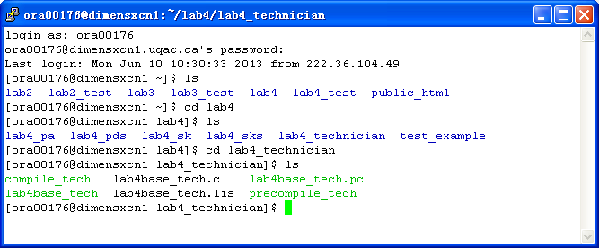
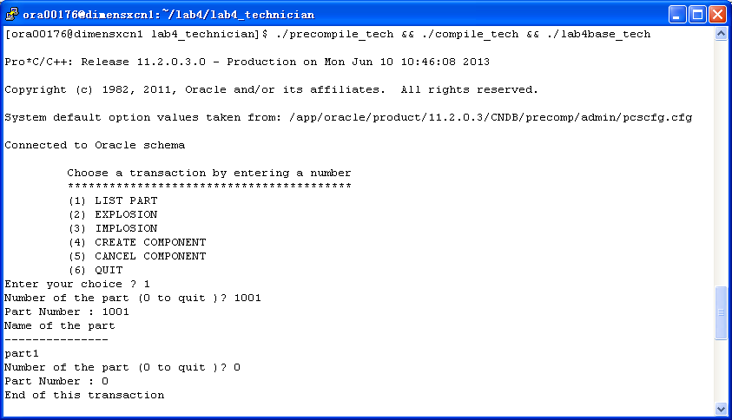
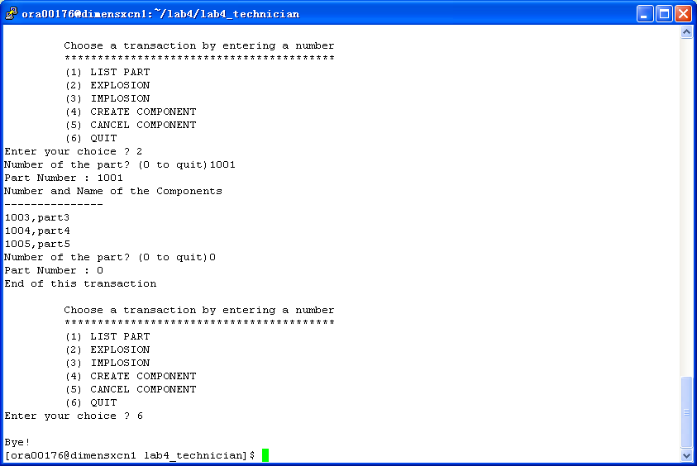

1.6 List and result in html and PHP with URL (lab6)

http://dimensxcn1.uqac.ca/~ora00176/technician/

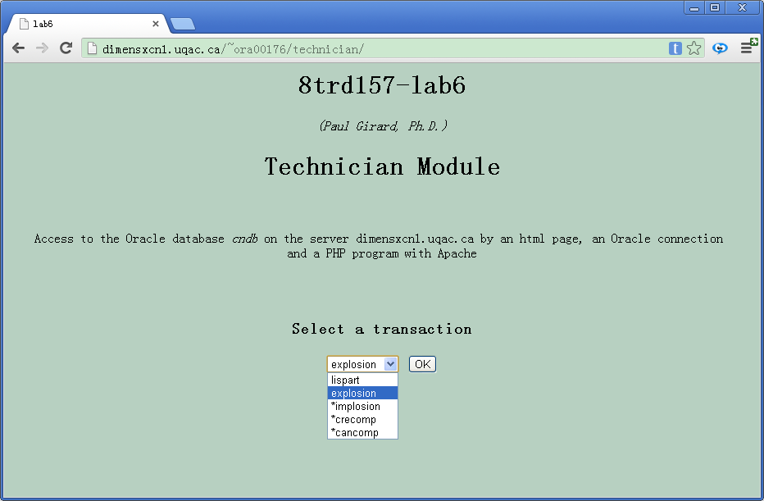

2 PA

2.1 Transaction table (lab1)
Transaction | Description | Entity | Access | Key | Freq. | Response
 |  |  | type |  |  | time
crepart | Creation of a part | part | write | / | 1/month | <3 sec
 | (part_id, part_name, unit, unit_price,
 | stock_qty, order_qty, min_qty).
 | Appropriate default values to some attributes.
lispart | Display all attributes (part_id, part_name, unit, | part | read | part_id | 1/hour | <3 sec
 | unit_price, stock_qty, order_qty, min_qty) of
 | a given part(part_id)
cresupp | Creation of a supplier(supplier_number, supplier_name, | supplier | read | / | 1/month | < 3 sec
 | supplier_address, supplier_contact)
creprod | Creation of a product(prod_number, prod_name, unit_prod, | product | write | / | 1/month | <3 sec
 | unit_prod_cost) of a given supplier(supplier_number) | supplier | read | supplier_number
 | that could be ordered for a given part(part_id) | part | read | part_id
low_part | Display the list of parts(part_id, part_name) under the | part | read | / | 1/day | < 3 sec
 | responsibility of a given purchasing agent(emp_num) | PA | read | emp_num
 | and having, stock_qty + ordered_qty <= min_qty
pot_supp | Display the list of potential suppliers products | supplier | read | / | 1/week | < 3 sec
 | (supplier_number, product_number, unit_prod, unit_prod_cost) | product | read | /
 | for a given part(part_id) | part | read | part_id
cre_po | Creation of a purchasing order | purchase order | write | po_number | 1/week | <3 sec
 | (po_number, pa_name, po_date, supplier_number)
 | and for each product(product_number, qty_ordered); | product | write | product_number
 | calculate the total of the purchase order.
 | The status is a default(not completed) | detail | write

2.2 Partial Conceptual E/R data model (lab1)
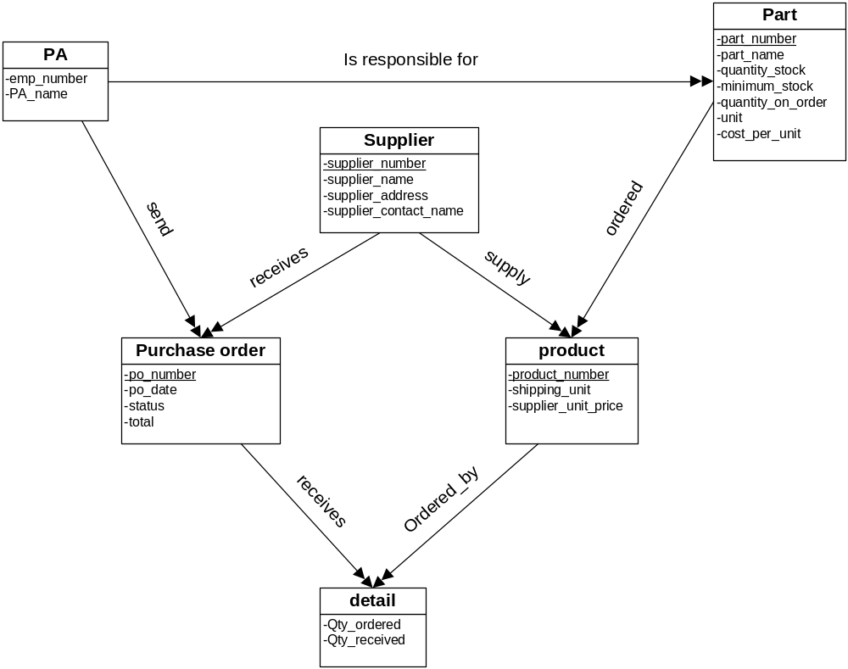

2.3 Partial relational data model (lab2)
PA ( employee_ number , PA_ name )
part ( part_ number, part_ name, qty_ stock, qty_ minimum, qty_ ordered, unit, unit_ price )

supplier ( supplier_ number, supplier_ name , supplier_ address , supplier_ contact_ name )
product ( product_ number, product_ name , product_ unit , supplier_ unit_ price )

PO ( po_ number, po_ date, status, total )
detail ( po_ number, product_ number, qty_ ordered , qty_ received )

responsible(employee_ number, part_ number)
task ( purchase_ order_ number, employee_ number )
business ( purchase_ order_ number, supplier_ number )

potential(part_ number, supplier_ number, product_ number)

2.4 Execution of transactions (lab3)
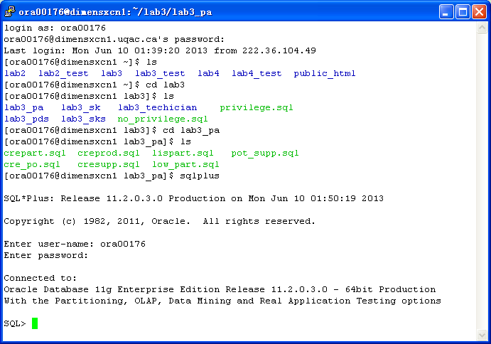

lispart.sql
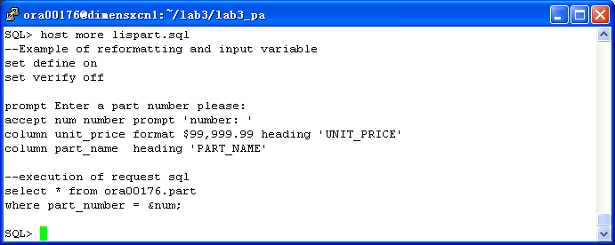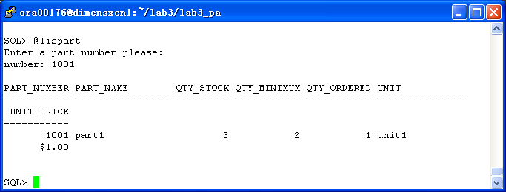

crepart.sql
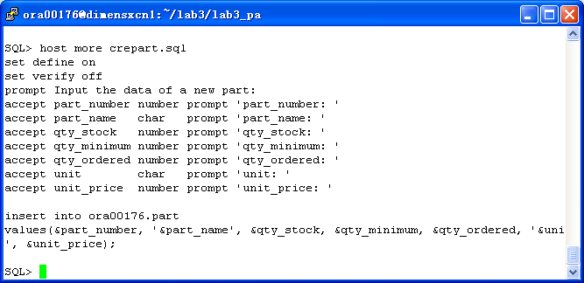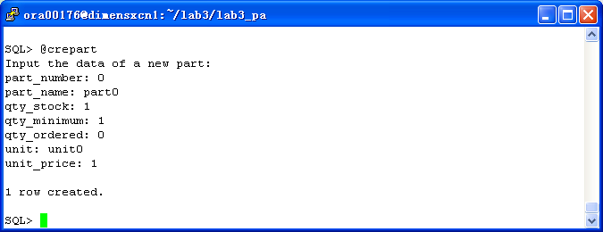

cresupp.sql
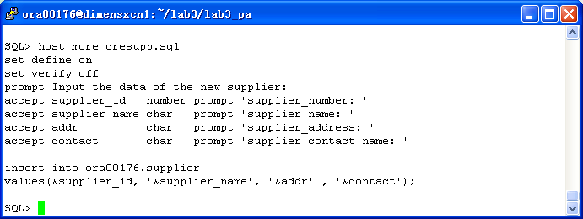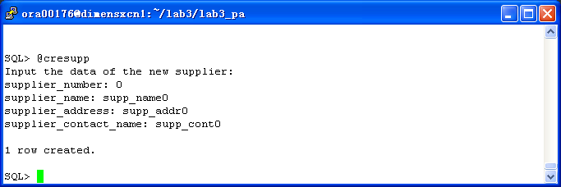

creprod.sql
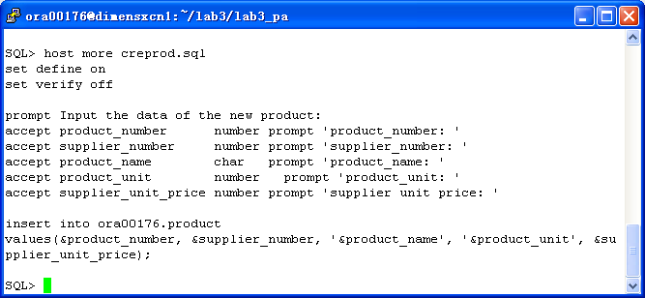
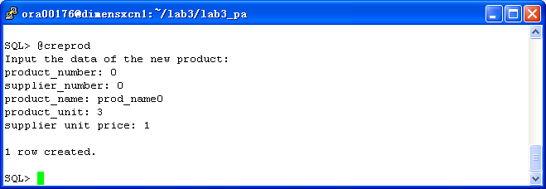

low_part.sql
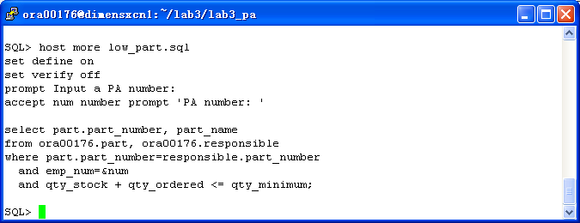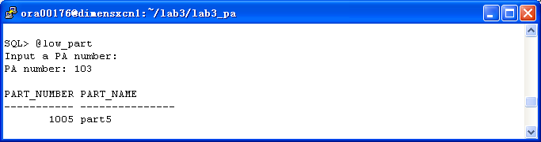

pot_supp.sql
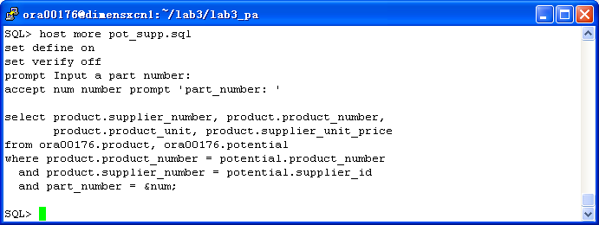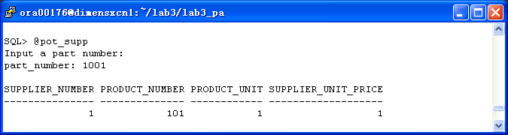

cre_po.sql
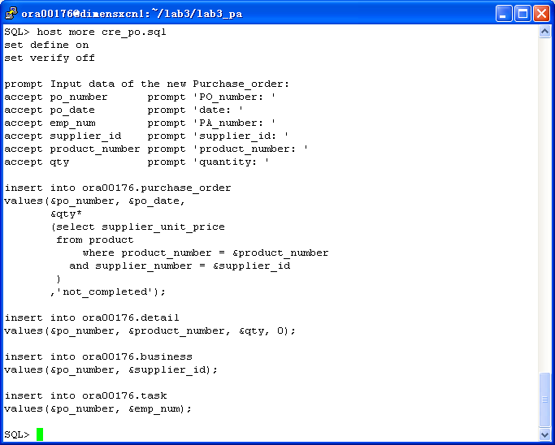
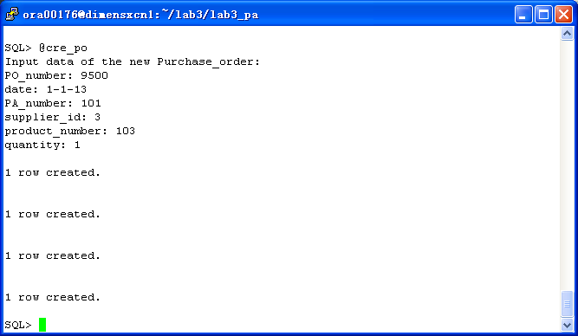

2.5 List and execution in C (lab4)
/*
* Author: Paul Girard Ph.D., UQAC
* Date: March 2008
* Objective: Program using Pro*C/C++ and gcc to show how to use
* different type of PL/SQL blocks & SQL in a C PGM
*
* Step 1: Precompilation with Pro*C/C++
* proc INAME=lab4base.pc CODE=ANSI_C SQLCHECK=semantics MODE=oracle DBMS=v8 USERID=user/password CHAR_MAP=charz
*
* Step 2: Compilation with gcc
* gcc lab4base.c -o lab4base -include /$ORACLE_HOME/precomp/public/sqlca.h -lclntsh -L$ORACLE_HOME/lib/ -B$ORACLE_HOME/lib
*
* modified by ora00176 in may,2013
*/

#include <stdio.h>
#include <stdlib.h>

void sql_error();
void do_connect();
void lispart();
//
void crepart();
void cresupp();
void creprod();
void low_part();
void pot_supp();
void cre_po();
//
int print_menu();

int main()
{
EXEC SQL WHENEVER SQLERROR do sql_error("Error at connect");

do_connect(); /* connection to Oracle instance */

/* Display the program menu
* and execution of the transaction
*/

while (1) /* infinite loop */
{
switch (print_menu())
{
case 1: lispart();
break;
case 2: crepart();
break;
case 3: cresupp();
break;
case 4: creprod();
break;
case 5: low_part();
break;
case 6: pot_supp();
break;
case 7: cre_po();
break;
case 8: puts("\nBye!");
exit(0);
default: puts("\n =====> Enter a digit from the menu please ?");

break;
}
}

EXEC SQL COMMIT WORK RELEASE; /* lib鑢e les verroux et d閏onnecte */

exit(0);
} /* end of main() program */

/* ******************************************************************************************
* Function to display the original error Oracle message
* ******************************************************************************************
*/

void sql_error(char *msg)
{
char ora_msg[512]; /* buffer for Oracle error message */
int buf_len, msg_len;

EXEC SQL WHENEVER SQLERROR continue; /* Prevent an infinite loop */

printf("\n%s\n",msg); /* print the local program message */
buf_len=sizeof(ora_msg);

sqlglm(ora_msg,&buf_len, &msg_len); /* read the Oracle error message */
printf("\n%.*s\n",msg_len, ora_msg); /* print this message */

EXEC SQL ROLLBACK RELEASE; /* free locks */
exit(1);
} /* fin de sql_error */

/* ******************************************************************************************
* Function to do a connection to an Oracle user schema
* ******************************************************************************************
*/

void do_connect()
{
char *uid="ora00176/RFy7qP";

EXEC SQL CONNECT :uid;
printf("Connected to Oracle schema\n");
}

/* ******************************************************************************************
* Function to display the contents of a given part
* ******************************************************************************************
*/

void lispart()
{
char description[16]; /* C needs 1 more octet than Oracle for binary 0
at the end of a C character type */
int my_partid, none=1;
for (;;) /* infinite loop until user enter a 0 */
{
printf("Number of the part (0 to quit )? ");
scanf("%d",&my_partid);

printf("Part Number : %d\n",my_partid);
if (my_partid == 0)
{
EXEC SQL COMMIT;
printf("End of this transaction\n");
break;
}

/*-------------- Beginning the PL/SQL block -----------------*/

EXEC SQL EXECUTE
BEGIN
SELECT part_name INTO :description /* note: description needs 1 octet more */
FROM ora00176.part WHERE part_number = :my_partid;
EXCEPTION
WHEN NO_DATA_FOUND THEN
:none:=0;
END;
END-EXEC;

/*-------------- end of PL/SQL block -----------------*/

if (none==0)
{
printf("Record not found \n");
none=1;
}
else
{
printf("Name of the part\n");
printf("---------------\n");
printf("%s\n",description);
}
EXEC SQL COMMIT;
} /* end of infinite loop */
return;
}

void crepart()
{
int num;
char name[16];
int stock;
int min;
int ordered;
char unit[16];
int price;

printf("part_number: "); scanf("%d",&num);
printf("part_name: "); scanf("%s",&name);
printf("qty_in_stock: ");scanf("%d",&stock);
printf("qty_minimum: "); scanf("%d",&min);
printf("qty_ordered: "); scanf("%d",&ordered);
printf("unit: "); scanf("%s",&unit);
printf("unit_price: "); scanf("%d",&price);

EXEC SQL insert into ora00176.part values(:num,:name,:stock,:min,:ordered,:unit,:price);
EXEC SQL COMMIT;

printf("The creation has been completed!");
return;
}

void cresupp()
{
printf("This function has not been completed...");
return;
}

void creprod()
{
printf("This function has not been completed...");
return;
}

void low_part()
{
printf("This function has not been completed...");
return;
}

void pot_supp()
{
printf("This function has not been completed...");
return;
}

/* *************************************************************
* Function to display each part with the responsible agent
* *************************************************************
*/

void cre_po()
{
printf("This function has not been completed...");
return;
}

/* ************************************************************
* Function print the menu and choose the transaction
* ************************************************************
*/

int print_menu()
{
int choice; /* id of menu */
printf("\n\t Choose a transaction by entering a number \n");
printf("\t *****************************************\n");

printf("\t (1) LIST PART\n");
printf("\t (2) CREATE PART\n");
printf("\t (3) CREATE SUPPLIER\n");
printf("\t (4) CREATE PRODUCT\n");
printf("\t (5) LOW PART\n");
printf("\t (6) POTENTIAL SUPPLIER\n");
printf("\t (7) CREATE PURCHASE ORDER\n");
printf("\t (8) QUIT\n");

printf("Enter your choice ? ");
scanf("%d",&choice); /* read the choice */
return choice;
}

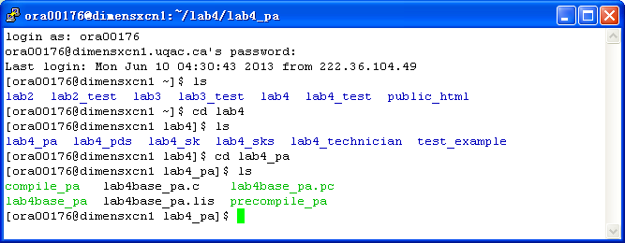

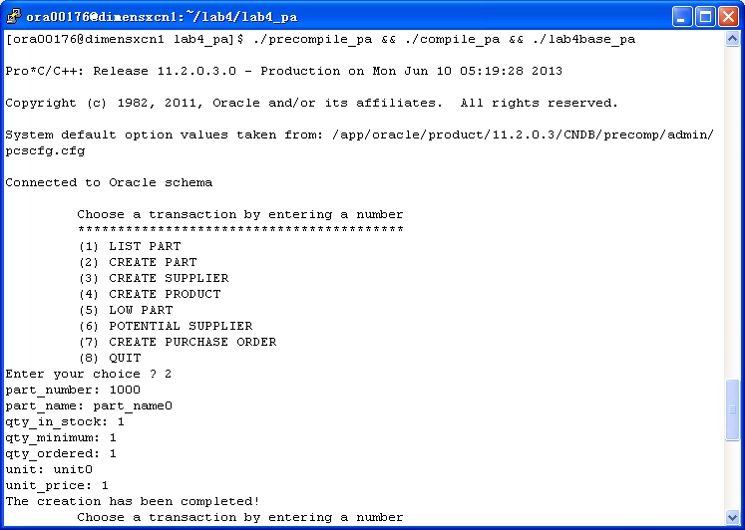
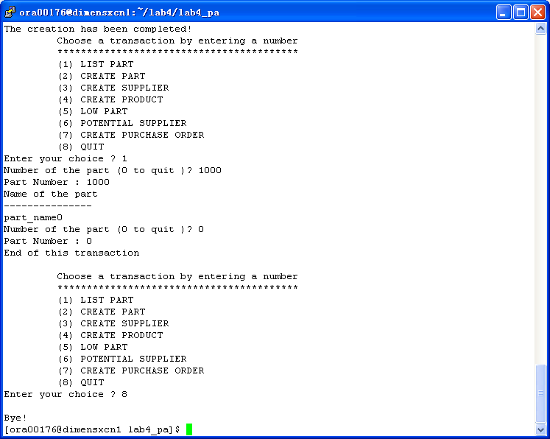

2.6 List and result in html and PHP with URL (lab6)

http://dimensxcn1.uqac.ca/~ora00176/pa_agent/

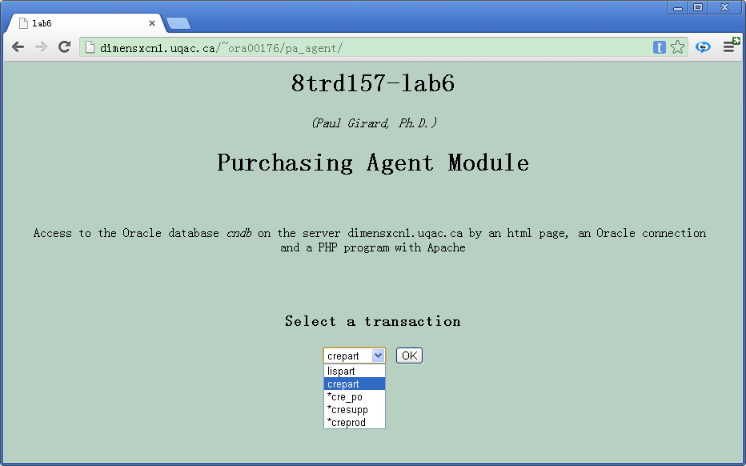

3 PDS

3.1 Transaction table (lab1)
Transaction | Description | Entity | Access | Key | Freq. | Response
 |  |  | type |  |  | time
lisagent | Display all purchase agents(emp_num,emp_name) | PA | read | emp_num | 1/month | <3 sec
creagent | Create a new agent(emp_num, emp_name) | PA | write | / | 1/month | <3 sec
quant | Display the number of purchase orders |  |  |  | 1/week | <3 sec
 | done by a given agent(emp_num) and the total value of | PA | read | emp_num
 | these purchase orders. | PO | read | /
respon | Display for each agent(emp_num, emp_name) the list | PA | read | / | 1/week | <3 sec
 | of all parts(part_id, part_name) under his responsibility | part | read | /
modresp | Change the responsibility of a given part(part_id) from | part | read | part_id | 1/month | <3 sec
 | an agent(emp_num1) to another agent(emp_num2) | PA | read | emp_num

3.2 Partial Conceptual E/R data model (lab1)
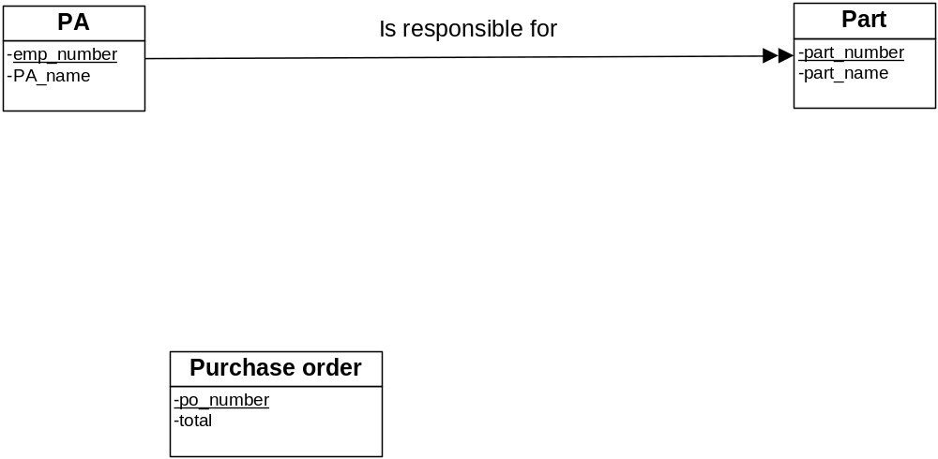

3.3 Partial relational data model (lab2)
PA ( employee_ number , PA_ name )
part ( part_ number, part_ name )
responsible(employee_ number, part_ number)

PO ( po_ number, total )

3.4 Execution of transactions (lab3)
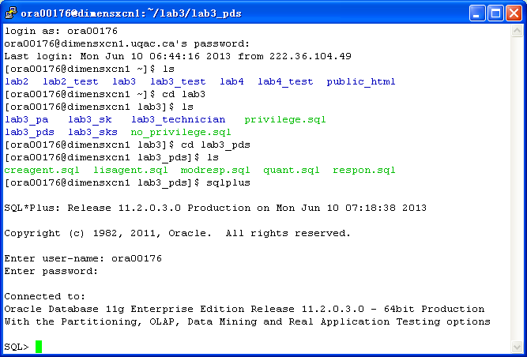

lisagent.sql
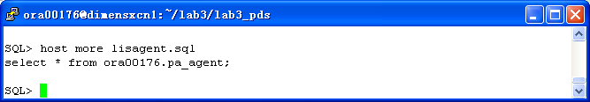
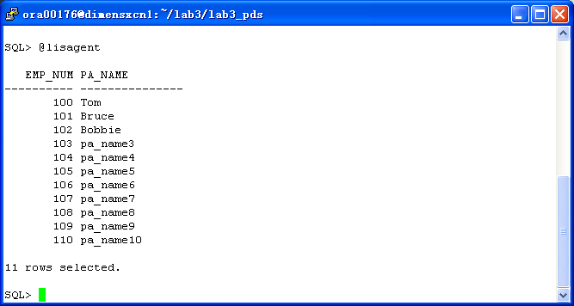
creagent.sql
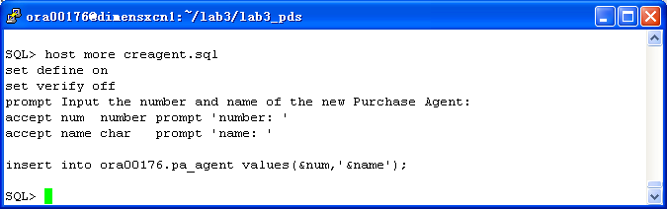
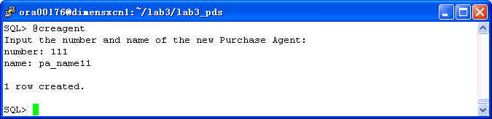

quant.sql
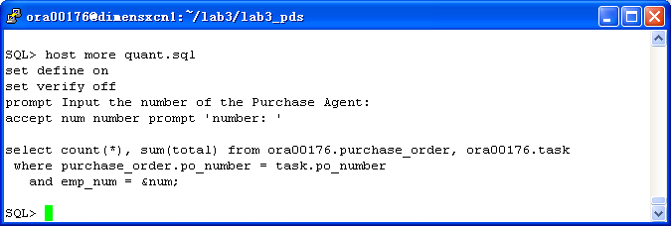
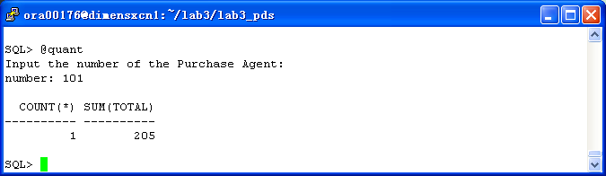

respon.sql
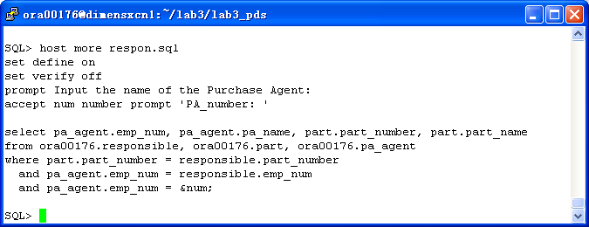
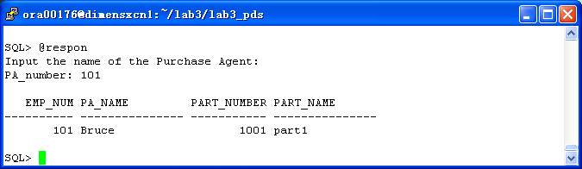

modresp.sql
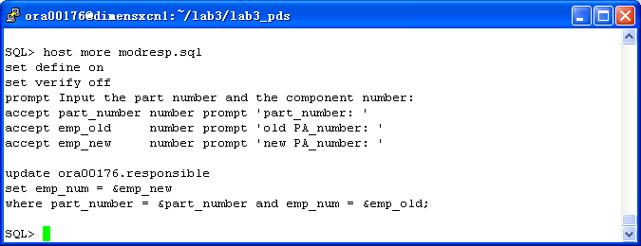
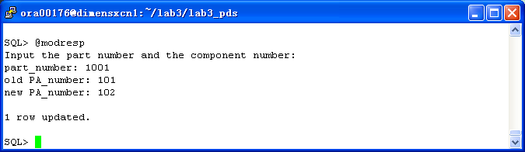

3.5 List and execution in C (lab4)
/*
* Author: Paul Girard Ph.D., UQAC
* Date: March 2008
* Objective: Program using Pro*C/C++ and gcc to show how to use
* different type of PL/SQL blocks & SQL in a C PGM
*
* Step 1: Precompilation with Pro*C/C++
* proc INAME=lab4base.pc CODE=ANSI_C SQLCHECK=semantics MODE=oracle DBMS=v8 USERID=user/password CHAR_MAP=charz
*
* Step 2: Compilation with gcc
* gcc lab4base.c -o lab4base -include /$ORACLE_HOME/precomp/public/sqlca.h -lclntsh -L$ORACLE_HOME/lib/ -B$ORACLE_HOME/lib
*
* modified by ora00176 in may,2013
*/

#include <stdio.h>
#include <stdlib.h>
#include <string.h>

void sql_error();
void do_connect();
//
void lisagent();
void creagent();
void quant();
void respon();
void modrespon();
//
int print_menu();

int main()
{
EXEC SQL WHENEVER SQLERROR do sql_error("Error at connect");

do_connect(); /* connection to Oracle instance */

/* Display the program menu
* and execution of the transaction
*/

while (1) /* infinite loop */
{
switch (print_menu())
{
case 1: lisagent();
break;
case 2: creagent();
break;
case 3: quant();
break;
case 4: respon();
break;
case 5: modrespon();
break;
case 6: puts("\nBye!");
exit(0);
default: puts("\n =====> Enter a digit from the menu please ?");
break;
}
}

EXEC SQL COMMIT WORK RELEASE; /* lib鑢e les verroux et d閏onnecte */

exit(0);
} /* end of main() program */

/* ******************************************************************************************
* Function to display the original error Oracle message
* ******************************************************************************************
*/

void sql_error(char *msg)
{
char ora_msg[512]; /* buffer for Oracle error message */
int buf_len, msg_len;

EXEC SQL WHENEVER SQLERROR continue; /* Prevent an infinite loop */

printf("\n%s\n",msg); /* print the local program message */
buf_len=sizeof(ora_msg);

sqlglm(ora_msg,&buf_len, &msg_len); /* read the Oracle error message */
printf("\n%.*s\n",msg_len, ora_msg); /* print this message */

EXEC SQL ROLLBACK RELEASE; /* free locks */
exit(1);
} /* fin de sql_error */

/* ******************************************************************************************
* Function to do a connection to an Oracle user schema
* ******************************************************************************************
*/

void do_connect()
{
char *uid="ora00176/RFy7qP";

EXEC SQL CONNECT :uid;
printf("Connected to Oracle schema\n");
}

/* ******************************************************************************************
* Function to display the contents of a given part
* ******************************************************************************************
*/

void lisagent()
{
char description[16]; /* C needs 1 more octet than Oracle for binary 0
at the end of a C character type */
int my_emp_num, none=1;
for (;;) /* infinite loop until user enter a 0 */
{
printf("Number of the Purchasing Agent (0 to quit )? ");
scanf("%d",&my_emp_num);

if (my_emp_num == 0)
{
EXEC SQL COMMIT;
printf("End of this transaction\n");
break;
}

/*-------------- Beginning the PL/SQL block -----------------*/

EXEC SQL EXECUTE
BEGIN
SELECT pa_name INTO :description /* note: description needs 1 octet more */
FROM ora00176.pa_agent WHERE emp_num = :my_emp_num;
EXCEPTION
WHEN NO_DATA_FOUND THEN
:none:=0;
END;
END-EXEC;

/*-------------- end of PL/SQL block -----------------*/

if (none==0)
{
printf("Record not found \n");
none=1;
}
else
{
printf("Name of the PA\n");
printf("---------------\n");
printf("%s\n",description);
}
EXEC SQL COMMIT;
} /* end of infinite loop */
printf("\n");
return;
}

void creagent()
{
int my_emp_num;
char my_pa_name[16];

printf("Please enter new PA_number: ");
scanf("%d",&my_emp_num); getchar();
printf("Please enter new PA_name: ");
gets(my_pa_name);

EXEC SQL INSERT INTO ora00176.pa_agent VALUES(:my_emp_num,:my_pa_name);
EXEC SQL COMMIT;

printf("INSERT COMPELETED!\n");
return;
}

void quant()
{
printf("This function has not been completed...");
return;
}

/* *************************************************************
* Function to display each part with the responsible agent
* *************************************************************
*/

void respon()
{
int my_emp_num, my_partid;
char description[16]; /* 1 more octet for the binary 0 */
char my_pa_name[16]; /* 1 more octet for the binary 0 */

EXEC SQL declare c1 cursor for
select p.part_number, p.part_name, pa_agent.emp_num, pa_agent.pa_name
from ora00176.part p, ora00176.responsible r, ora00176.pa_agent
where pa_agent.emp_num = r.emp_num and p.part_number = r.part_number;

EXEC SQL open c1;

EXEC SQL WHENEVER NOT FOUND do break;

printf("\tPart ID\tName of Part\t\tEmp Number\tAgent\n");
for (;;)
{
EXEC SQL fetch c1 into :my_partid, :description, :my_emp_num, :my_pa_name ;

printf("\t%4d\t%s\t\t%4d\t%s\n",my_partid, description,my_emp_num,my_pa_name);
}
printf("\n");

printf("End of this transaction\n");
EXEC SQL close c1;
EXEC SQL COMMIT; /* free locks and keep the connection */
return;
}

/* ******************************************************************************************
* Function modifying the status of a part
* ******************************************************************************************
*/

void modrespon()
{
printf("This function has not been completed...");
return;
}

/* ************************************************************
* Function print the menu and choose the transaction
* ************************************************************
*/

int print_menu()
{
int choice; /* id of menu */
printf("\n\t Choose a transaction by entering a number \n");
printf("\t *****************************************\n");
printf("\t (1) LIST AGENT\n");
printf("\t (2) CREATE AGENT\n");
printf("\t (3) QUANT\n");
printf("\t (4) RESPONSIBLE\n");
printf("\t (5) MODIFY RESPONSIBLE\n");
printf("\t (6) QUIT\n");
printf("Enter your choice ? ");
scanf("%d",&choice); /* read the choice */
return choice;
}

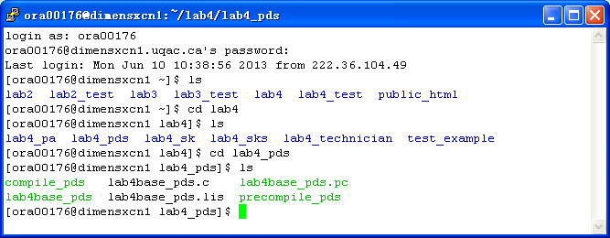
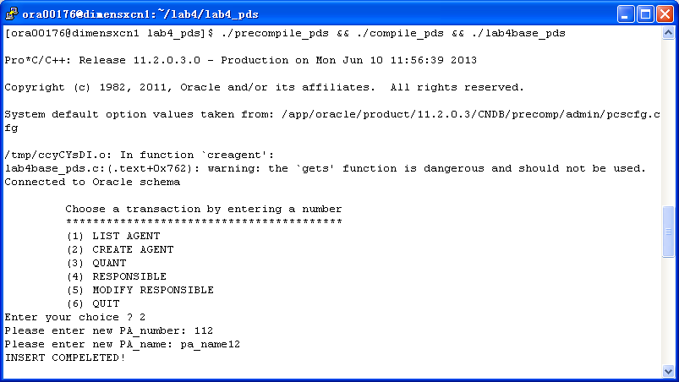
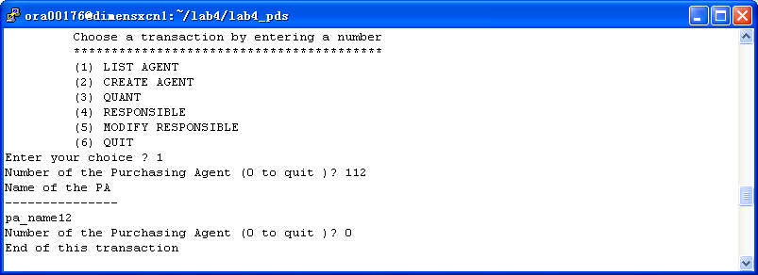
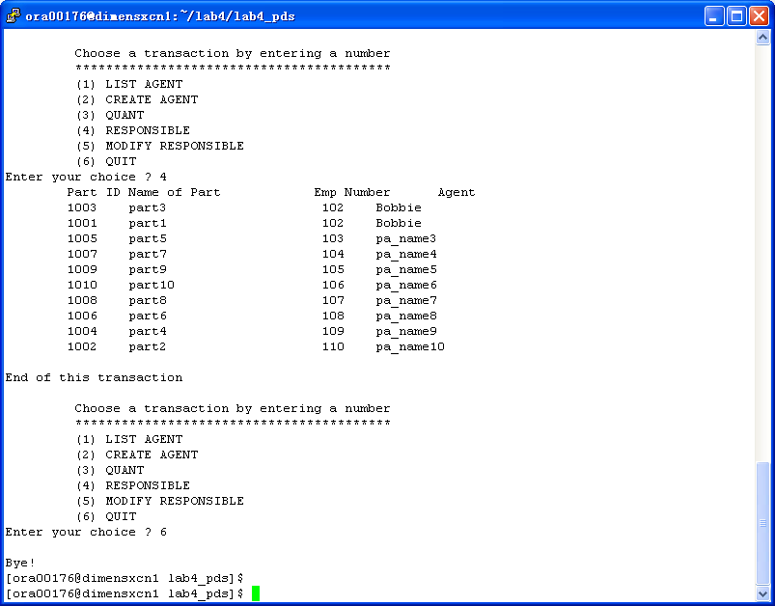

3.6 List and result in html and PHP with URL (lab6)

http://dimensxcn1.uqac.ca/~ora00176/pds/

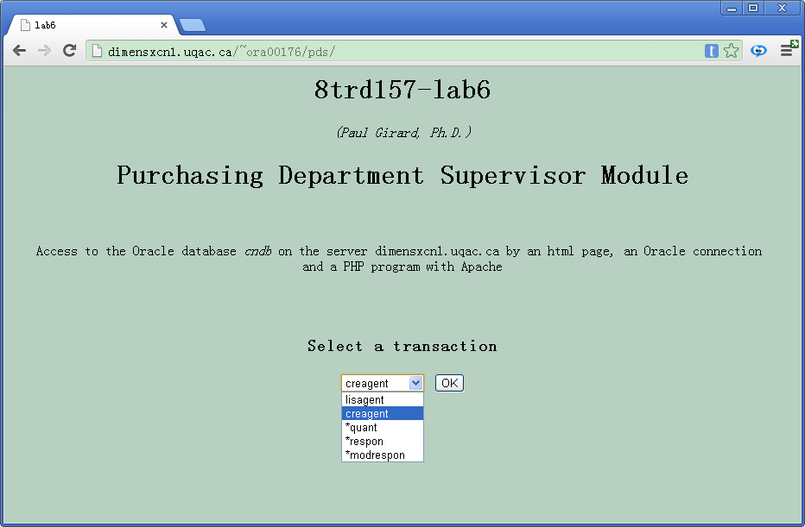

4 SK

4.1 Transaction table (lab1)
Transaction | Description | Entity | Access | Key | Freq. | Response
 |  |  | type |  |  | time
listpart | Display all attributes | part | read | part_id | 1/day | < 3 sec
 | (part_id, part_name, unit, unit_price, stock_qty,
 | order_qty, min_qty) of a given part(part_id)
part_out | part(part_id, qty) is updated when some parts(n) are | part | write | part_id | 1/day | < 3 sec
 | taken out from the store to the technician
prod_in | products (product_number, qty_receiced) is | product | write | product_number | 1/week | < 3 sec
 | delivered by the supplier
 | following a purchase order (purchase_order_number); | purchase order | write | po_number
 | the corresponding part is | part | write | part_id
 | updated (stock_qty, order_qty)
list_po | Display the contents of a purchase_order(po_number) : | purchase order | read | po_number | 1/week | < 3 sec
 | po_number, date, purchasing_agent_name, | PA | read | /
 | supplier_number, supplier_name, supplier_address,
 | supplier_contact_name ; | supplier | read | /
 | list of all ordered products | product | read | /
 | (product_number, product_name, unit, unit_price, | part | read | /
 | qty_ordered, qty_received), total, status | detail | read | /
 | of a purchase order. | purchase order | read | po_number

4.2 Partial Conceptual E/R data model (lab1)
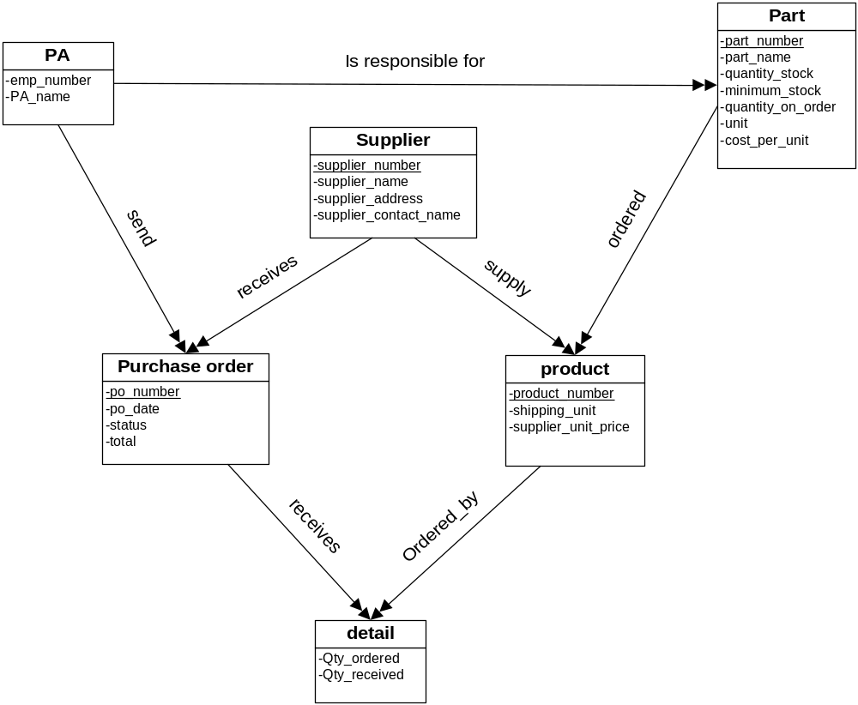

4.3 Partial relational data model (lab2)
PA ( employee_ number , PA_ name )
part ( part_ number, part_ name, qty_ stock, qty_ minimum, qty_ ordered, unit, unit_ price )

supplier ( supplier_ number, supplier_ name , supplier_ address , supplier_ contact_ name )
product ( product_ number, product_ name , product_ unit , supplier_ unit_ price )

PO ( po_ number, po_ date, status, total )
detail ( po_ number, product_ number, qty_ ordered , qty_ received )

responsible(employee_ number, part_ number)
task ( purchase_ order_ number, employee_ number )
business ( purchase_ order_ number, supplier_ number )

potential(part_ number, supplier_ number, product_ number)

4.4 Execution of transactions (lab3)
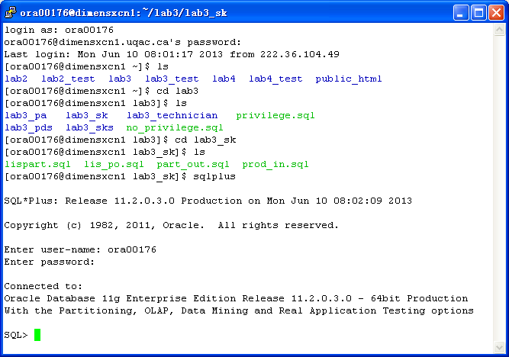

lispart.sql
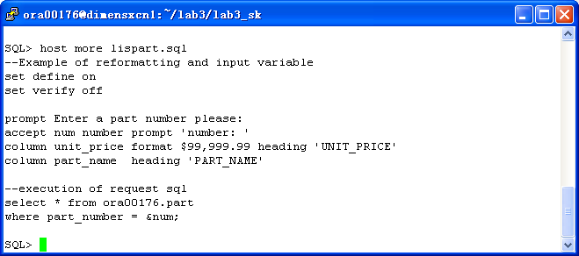

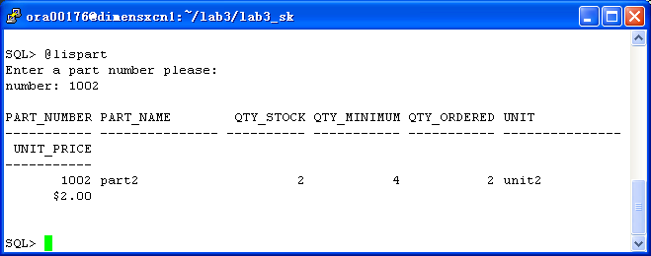

lis_po.sql
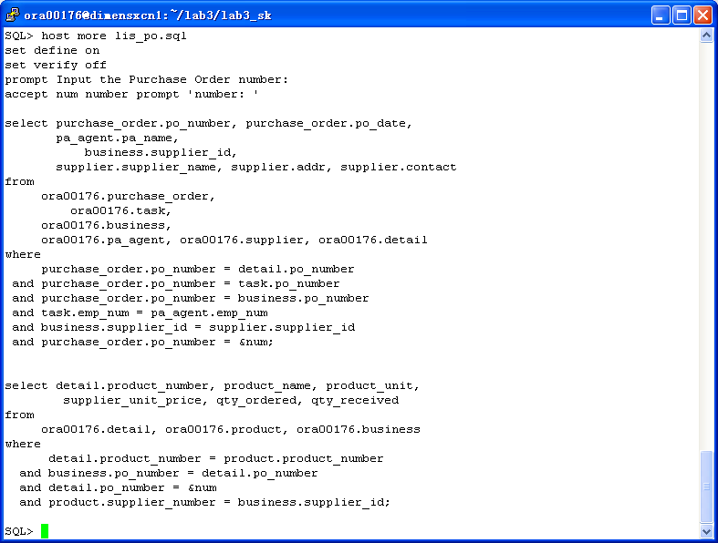
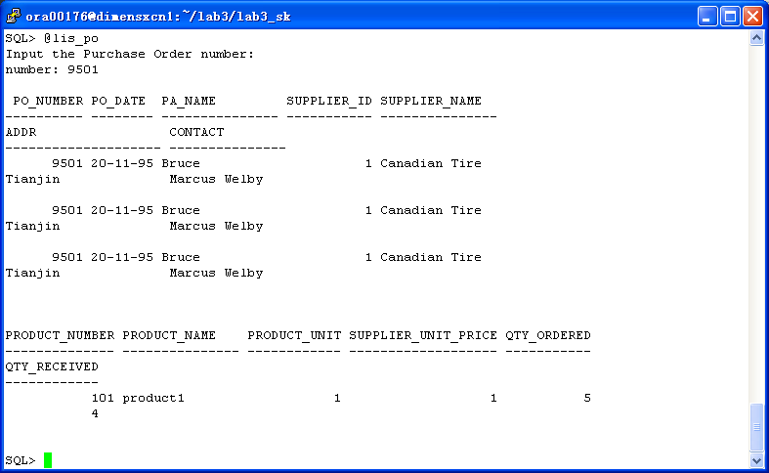

prod_in.sql
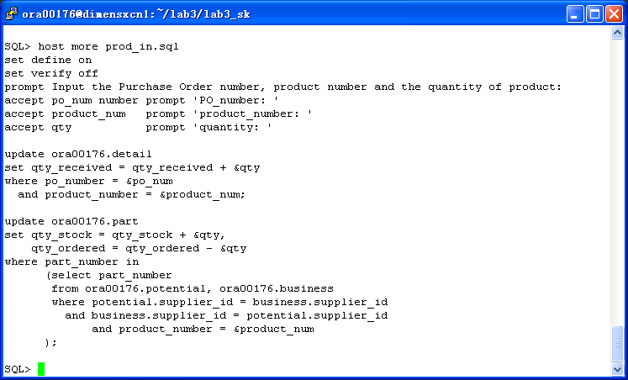
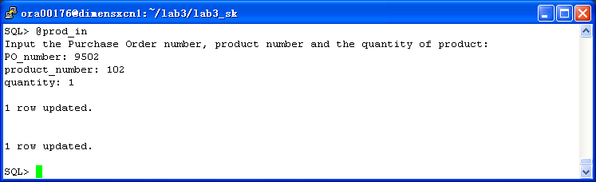

prod_out.sql
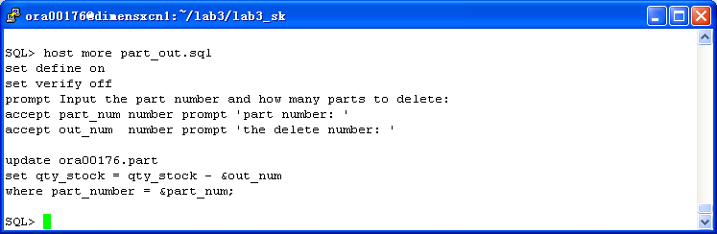
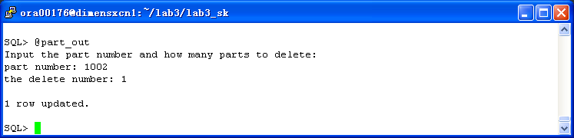

view for purchase_pds:
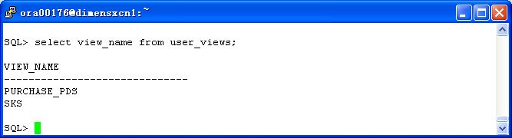
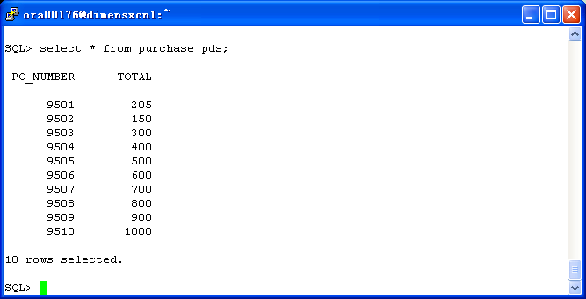

4.5 List and execution in C (lab4)
/*
* Author: Paul Girard Ph.D., UQAC
* Date: March 2008
* Objective: Program using Pro*C/C++ and gcc to show how to use
* different type of PL/SQL blocks & SQL in a C PGM
*
* Step 1: Precompilation with Pro*C/C++
* proc INAME=lab4base.pc CODE=ANSI_C SQLCHECK=semantics MODE=oracle DBMS=v8 USERID=user/password CHAR_MAP=charz
*
* Step 2: Compilation with gcc
* gcc lab4base.c -o lab4base -include /$ORACLE_HOME/precomp/public/sqlca.h -lclntsh -L$ORACLE_HOME/lib/ -B$ORACLE_HOME/lib
*
* modified by ora00176 in may,2013
*/

#include <stdio.h>
#include <stdlib.h>

void sql_error();
void do_connect();
void lispart();
//
void part_out();
void prod_in();
void list_po();
//
int print_menu();

int main()
{
EXEC SQL WHENEVER SQLERROR do sql_error("Error at connect");

do_connect(); /* connection to Oracle instance */

/* Display the program menu
* and execution of the transaction
*/

while (1) /* infinite loop */
{
switch (print_menu())
{
case 1: lispart();
break;
case 2: part_out();
break;
case 3: prod_in();
break;
case 4: list_po();
break;
case 5: puts("\nBye!");
exit(0);
default: puts("\n =====> Enter a digit from the menu please ?");
break;
}
}

EXEC SQL COMMIT WORK RELEASE; /* lib鑢e les verroux et d閏onnecte */

exit(0);
} /* end of main() program */

/* ******************************************************************************************
* Function to display the original error Oracle message
* ******************************************************************************************
*/

void sql_error(char *msg)
{
char ora_msg[512]; /* buffer for Oracle error message */
int buf_len, msg_len;

EXEC SQL WHENEVER SQLERROR continue; /* Prevent an infinite loop */

printf("\n%s\n",msg); /* print the local program message */
buf_len=sizeof(ora_msg);

sqlglm(ora_msg,&buf_len, &msg_len); /* read the Oracle error message */
printf("\n%.*s\n",msg_len, ora_msg); /* print this message */

EXEC SQL ROLLBACK RELEASE; /* free locks */
exit(1);
} /* fin de sql_error */

/* ******************************************************************************************
* Function to do a connection to an Oracle user schema
* ******************************************************************************************
*/

void do_connect()
{
char *uid="ora00176/RFy7qP";

EXEC SQL CONNECT :uid;
printf("Connected to Oracle schema\n");
}

/* ******************************************************************************************
* Function to display the contents of a given part
* ******************************************************************************************
*/

void lispart()
{
char description[16]; /* C needs 1 more octet than Oracle for binary 0
at the end of a C character type */
int my_partid, none=1;
for (;;) /* infinite loop until user enter a 0 */
{
printf("Number of the part (0 to quit )? ");
scanf("%d",&my_partid);

printf("Part Number : %d\n",my_partid);
if (my_partid == 0)
{
EXEC SQL COMMIT;
printf("End of this transaction\n");
break;
}

/*-------------- Beginning the PL/SQL block -----------------*/

EXEC SQL EXECUTE
BEGIN
SELECT part_name INTO :description /* note: description needs 1 octet more */
FROM ora00176.part WHERE part_number = :my_partid;
EXCEPTION
WHEN NO_DATA_FOUND THEN
:none:=0;
END;
END-EXEC;

/*-------------- end of PL/SQL block -----------------*/

if (none==0)
{
printf("Record not found \n");
none=1;
}
else
{
printf("Name of the part\n");
printf("---------------\n");
printf("%s\n",description);
}
EXEC SQL COMMIT;
} /* end of infinite loop */
return;
}

void part_out()
{
int num;
int qty;

printf("Number of the part ? ");
scanf("%d",&num);
printf("How many part to send out ? ");
scanf("%d",&qty);

EXEC SQL update ora00176.part set qty_stock=qty_stock-:qty
where part_number=:num;
EXEC SQL COMMIT;

printf("The update has been completed!\n");
return;
}

void prod_in()
{
printf("This function has not been completed...");
return;
}

/* *************************************************************
* Function to display each part with the responsible agent
* *************************************************************
*/

void list_po()
{
printf("This function has not been completed...");
return;
}

/* ************************************************************
* Function print the menu and choose the transaction
* ************************************************************
*/

int print_menu()
{
int choice; /* id of menu */
printf("\n\t Choose a transaction by entering a number \n");
printf("\t *****************************************\n");
printf("\t (1) LIST PART\n");
printf("\t (2) PART OUT\n");
printf("\t (3) PRODUCT IN\n");
printf("\t (4) LIST PURCHASE ORDER\n");
printf("\t (5) QUIT\n");
printf("Enter your choice ? ");
scanf("%d",&choice); /* read the choice */
return choice;
}

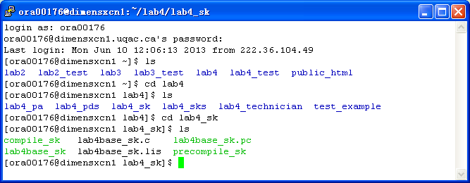
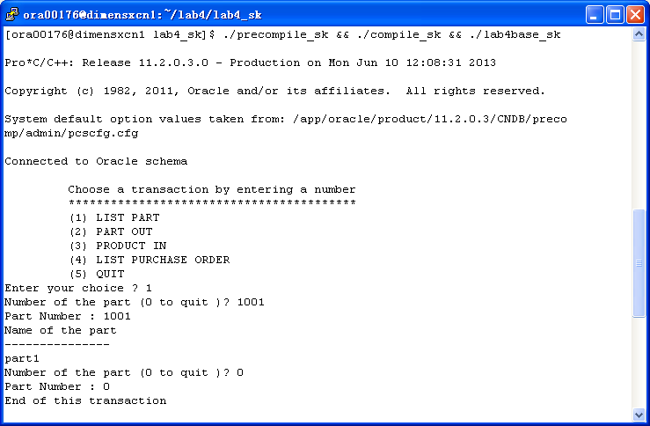
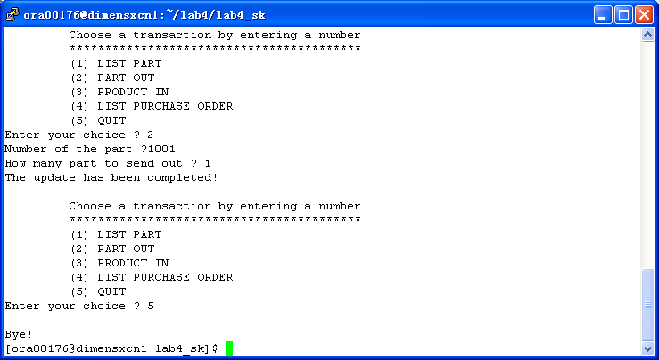

4.6 List and result in html and PHP with URL (lab6)

http://dimensxcn1.uqac.ca/~ora00176/sk/

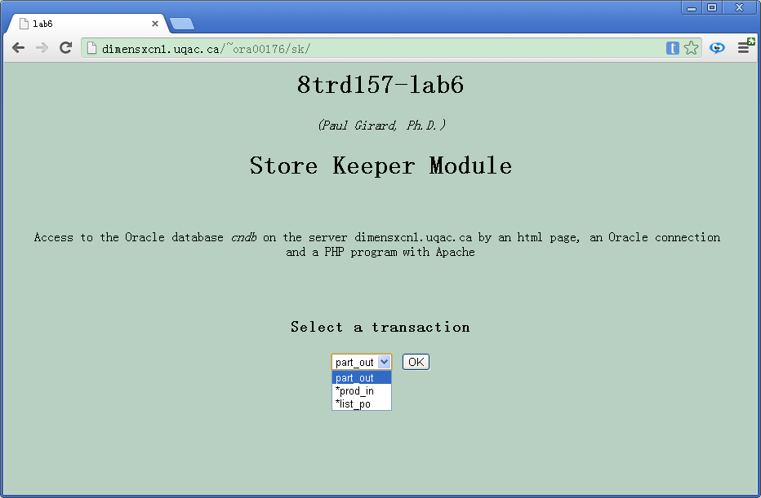

5 SKS

5.1 Transaction table (lab1)
Transaction | Description | Entity | Access | Key | Freq. | Response
 |  |  | type |  |  | time
invent | Display the number of parts | part | read | part_id | 1/week | < 3 sec
 | having a different serial number
 | AND the total number of parts in stock
value | Display the total value of parts in stock | part | read | / | 1/week | < 3 sec

5.2 Partial Conceptual E/R data model (lab1)
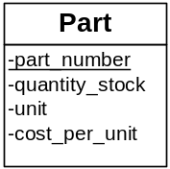

5.3 Partial relational data model (lab2)
part ( part_ number, qty_ stock, unit, unit_ price )

5.4 Execution of transactions (lab3)
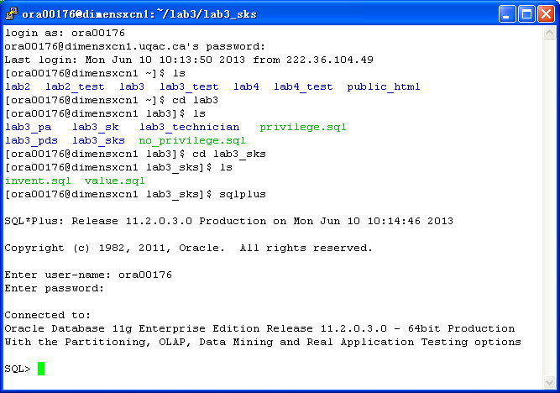

invent.sql
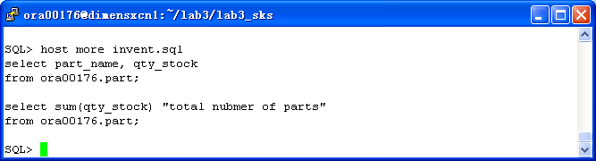
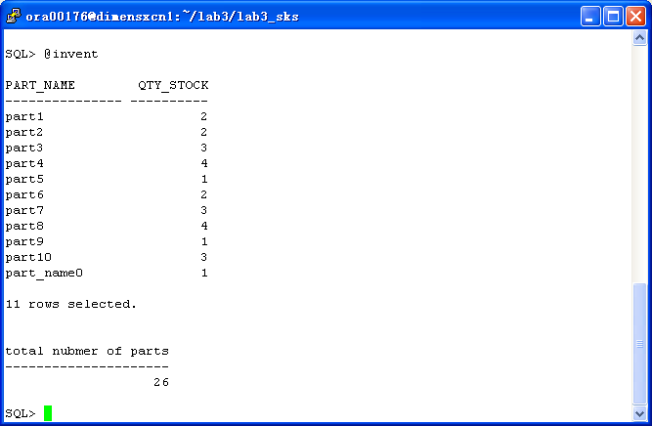

value.sql
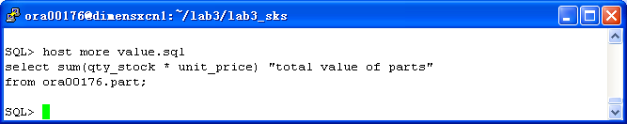
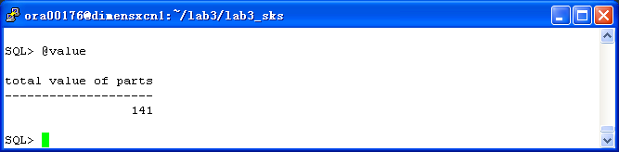

view for sks:
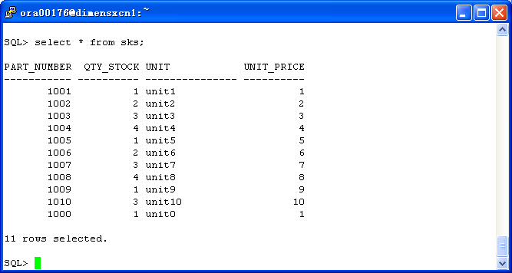

5.5 List and execution in C (lab4)
/*
* Author: Paul Girard Ph.D., UQAC
* Date: March 2008
* Objective: Program using Pro*C/C++ and gcc to show how to use
* different type of PL/SQL blocks & SQL in a C PGM
*
* Step 1: Precompilation with Pro*C/C++
* proc INAME=lab4base.pc CODE=ANSI_C SQLCHECK=semantics MODE=oracle DBMS=v8 USERID=user/password CHAR_MAP=charz
*
* Step 2: Compilation with gcc
* gcc lab4base.c -o lab4base -include /$ORACLE_HOME/precomp/public/sqlca.h -lclntsh -L$ORACLE_HOME/lib/ -B$ORACLE_HOME/lib
*
* modified by ora00176 in may,2013
*/

#include <stdio.h>
#include <stdlib.h>

void sql_error();
void do_connect();
//
void invent();
void value();
//
int print_menu();

int main()
{
EXEC SQL WHENEVER SQLERROR do sql_error("Error at connect");

do_connect(); /* connection to Oracle instance */

/* Display the program menu
* and execution of the transaction
*/

while (1) /* infinite loop */
{
switch (print_menu())
{
case 1: invent();
break;
case 2: value();
break;
case 3: puts("\nBye!");
exit(0);
default: puts("\n =====> Enter a digit from the menu please ?");
break;
}
}

EXEC SQL COMMIT WORK RELEASE; /* lib鑢e les verroux et d閏onnecte */

exit(0);
} /* end of main() program */

/* ******************************************************************************************
* Function to display the original error Oracle message
* ******************************************************************************************
*/

void sql_error(char *msg)
{
char ora_msg[512]; /* buffer for Oracle error message */
int buf_len, msg_len;

EXEC SQL WHENEVER SQLERROR continue; /* Prevent an infinite loop */

printf("\n%s\n",msg); /* print the local program message */
buf_len=sizeof(ora_msg);

sqlglm(ora_msg,&buf_len, &msg_len); /* read the Oracle error message */
printf("\n%.*s\n",msg_len, ora_msg); /* print this message */

EXEC SQL ROLLBACK RELEASE; /* free locks */
exit(1);
} /* fin de sql_error */

/* ******************************************************************************************
* Function to do a connection to an Oracle user schema
* ******************************************************************************************
*/

void do_connect()
{
char *uid="ora00176/RFy7qP";

EXEC SQL CONNECT :uid;
printf("Connected to Oracle schema\n");
}

/* ******************************************************************************************
* Function to display the contents of a given part
* ******************************************************************************************
*/

void invent()
{
printf("This function has not been completed...");
}

/* ******************************************************************************************
* Function modifying the status of a part
* ******************************************************************************************
*/

void value()
{
int total;

EXEC SQL select sum(qty_stock*unit_price) into :total from ora00176.part;
printf("Total Quantity\n");
printf("%d",total);

return;
}

/* ************************************************************
* Function print the menu and choose the transaction
* ************************************************************
*/

int print_menu()
{
int choice; /* id of menu */
printf("\n\t Choose a transaction by entering a number \n");
printf("\t *****************************************\n");
printf("\t (1) INVENT\n");
printf("\t (2) VALUE\n");
printf("\t (3) QUIT\n");
printf("Enter your choice ? ");
scanf("%d",&choice); /* read the choice */
return choice;
}

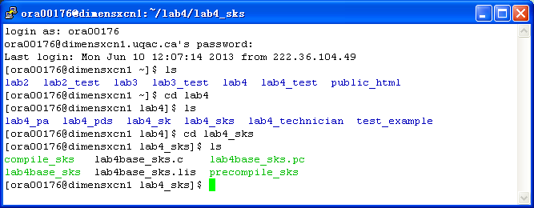
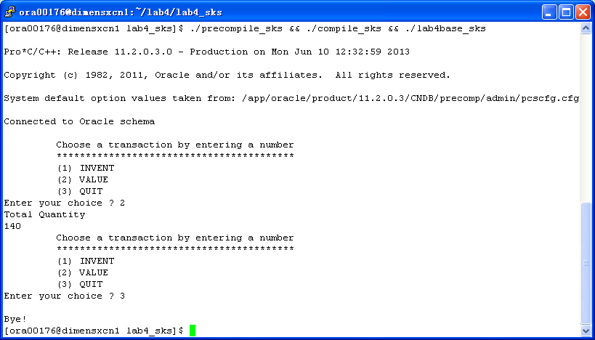

5.6 List and result in html and PHP with URL (lab6)

http://dimensxcn1.uqac.ca/~ora00176/sks/

