一、界面设计
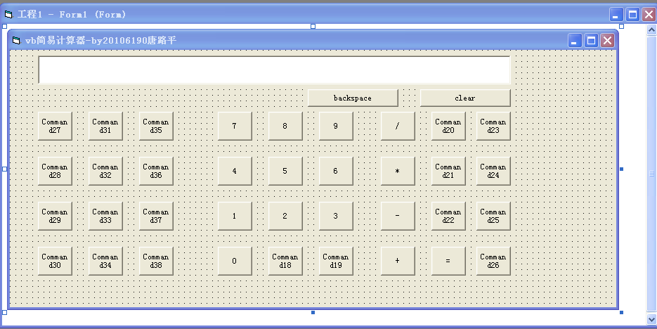

二、属性设置
控件 | 属性 | 属性值 | 控件 | 属性 | 属性值
Command1 | Caption | 1 | Command20 | Caption | Mod
Command2 | Caption | 2 | Command21 | Caption | Or
Command3 | Caption | 3 | Command22 | Caption | Lsh
Command4 | Caption | 4 | Command23 | Caption | And
Command5 | Caption | 5 | Command24 | Caption | Xor
Command6 | Caption | 6 | Command25 | Caption | Not
Command7 | Caption | 7 | Command26 | Caption | Int
Command8 | Caption | 8 | Command27 | Caption | Sin
Command9 | Caption | 9 | Command28 | Caption | Cos
Command10 | Caption | 0 | Command29 | Caption | Tan
Command11 | Caption | clear | Command30 | Caption | Cot
Command12 | Caption | = | Command31 | Caption | Exp
Command13 | Caption | + | Command32 | Caption | x^y
Command14 | Caption | - | Command33 | Caption | x^3
Command15 | Caption | * | Command34 | Caption | x^2
Command16 | Caption | / | Command35 | Caption | Ln
Command17 | Caption | backspace | Command36 | Caption | Log
Command18 | Caption | +/- | Command37 | Caption | n!
Command19 | Caption | . | Command38 | Caption | 1/x
Option1 | Caption | Deg | Option2 | Caption | Rad
Option3 | Caption | Gra

三、程序清单

Option Base 0 '默认数组下标从0开始
Option Explicit
Const PI = 3.14159265358979
Const e = 2.71828182845905

Dim Operation As String '操作符、运算字符串
Dim data1, data2, result As Double '操作数1，操作数2,运算结果

Private Sub Command1_Click() '下面是0~9十个按钮的点击事件
Text1.Text = Text1.Text + "1"
End Sub
Private Sub Command2_Click()
Text1.Text = Text1.Text + "2"
End Sub
Private Sub Command3_Click()
Text1.Text = Text1.Text + "3"
End Sub
Private Sub Command4_Click()
Text1.Text = Text1.Text + "4"
End Sub
Private Sub Command5_Click()
Text1.Text = Text1.Text + "5"
End Sub
Private Sub Command6_Click()
Text1.Text = Text1.Text + "6"
End Sub
Private Sub Command7_Click()
Text1.Text = Text1.Text + "7"
End Sub
Private Sub Command8_Click()
Text1.Text = Text1.Text + "8"
End Sub
Private Sub Command9_Click()
Text1.Text = Text1.Text + "9"
End Sub
Private Sub Command10_Click()
Text1.Text = Text1.Text + "0"
End Sub
Private Sub Command11_Click() '等号

data2 = Val(Text1.Text)

Select Case Operation
Case "+": result = data1 + data2
Case "-": result = data1 - data2
Case "*": result = data1 * data2

Case "/":
If (data2 <> 0) Then
result = data1 / data2
Else
Text1.Text = "除数不能为零"
MsgBox "Error:cannot divided by 0" '除数不能为零
Exit Sub
End If

Case "Mod": result = data1 Mod data2
Case "Or": result = data1 Or data2
Case "Shl": result = data1 * 2 ^ data2
Case "And": result = data1 And data2
Case "Xor": result = data1 Xor data2
Case "Not": result = Not data1
Case "Int": result = Int(data1)

Case "Sin":
If (Option1.Value = True) Then
result = Sin(data1 * PI / 180)
ElseIf (Option2.Value = True) Then
result = Sin(data1)
ElseIf (Option2.Value = True) Then
result = Sin(data1 * 10 / 9)
End If

Case "Cos":
If (Option1.Value = True) Then
result = Cos(data1 * PI / 180)
ElseIf (Option2.Value = True) Then
result = Cos(data1)
ElseIf (Option3.Value = True) Then
result = Cos(data1 * 10 / 9)
End If

Case "Tan":
If (Option1.Value = True) Then
result = Tan(data1 * PI / 180)
ElseIf (Option2.Value = True) Then
result = Tan(data1)
ElseIf (Option3.Value = True) Then
result = Tan(data1 * 10 / 9)

End If
Case "Cot":
If (Option1.Value = True) Then
data1 = data1 * PI / 180
ElseIf (Option2.Value = True) Then
data1 = data1
ElseIf (Option3.Value = True) Then
data1 = data1 * 10 / 9
End If

If (Tan(data1) <> 0) Then
result = 1 / Tan(data1)
Else
Text1.Text = "除数不能为零"
MsgBox "Error:cannot divided by 0" '除数不能为零
Exit Sub
End If

Case "Exp": result = data1 * 10 ^ data2
Case "Power": result = data1 ^ data2
Case "Cube": result = data1 ^ 3
Case "Square": result = data1 * data1
Case "Ln": result = Log(data1)
Case "Log": result = Log(data1) / Log(10)

Case "Fac":
result = 1
For data2 = Int(data1) To 1 Step -1
result = result * data2
Next

Case "Rec":
If (data1 <> 0) Then
result = 1 / data1
Else
Text1.Text = "除数不能为零"
MsgBox "Error:cannot divided by 0" '除数不能为零
Exit Sub
End If

Case Else
Text1.Text = "有错误发生"
MsgBox "有错误发生": End

End Select

Text1.Text = Str(result)
End Sub
Private Sub Command12_Click() '清空
Text1.Text = "" 'clear
End Sub
Private Sub Command13_Click() '加法
data1 = Val(Text1.Text): Operation = "+": Text1.Text = ""
End Sub

Private Sub Command14_Click() '减法
data1 = Val(Text1.Text): Operation = "-": Text1.Text = ""
End Sub

Private Sub Command15_Click() '乘法
data1 = Val(Text1.Text): Operation = "*": Text1.Text = ""
End Sub
Private Sub Command16_Click() '除法
data1 = Val(Text1.Text): Operation = "/": Text1.Text = ""
End Sub
Private Sub Command17_Click() '退格
If (Len(Text1.Text) <> 0) Then Text1.Text = Left(Text1.Text, Len(Text1.Text) - 1)
End Sub
Private Sub Command18_Click() '正负号
If Mid(Text1.Text, 1, 1) = "-" Then
Text1.Text = Right(Text1.Text, Len(Text1.Text) - 1)
Else
Text1.Text = "-" & Text1.Text
End If
End Sub
Private Sub Command19_Click() '小数点
If (InStr(1, Text1.Text, ".", 1) = 0) Then
Text1.Text = Text1.Text + "."
End If
End Sub
Private Sub Command20_Click() '模运算
data1 = Val(Text1.Text): Operation = "Mod": Text1.Text = ""
End Sub
Private Sub Command21_Click() '或运算
data1 = Val(Text1.Text): Operation = "Or": Text1.Text = ""
End Sub
Private Sub Command22_Click() '左移运算
data1 = Val(Text1.Text): Operation = "Shl": Text1.Text = ""
End Sub
Private Sub Command23_Click() '与运算
data1 = Val(Text1.Text): Operation = "And": Text1.Text = ""
End Sub
Private Sub Command24_Click() '异或运算
data1 = Val(Text1.Text): Operation = "Xor": Text1.Text = ""
End Sub
Private Sub Command25_Click() '非运算
data1 = Val(Text1.Text): Operation = "Not": Call Command11_Click
End Sub
Private Sub Command26_Click() '取整运算
data1 = Val(Text1.Text): Operation = "Int": Call Command11_Click
End Sub
Private Sub Command27_Click() '正弦
data1 = Val(Text1.Text): Operation = "Sin": Call Command11_Click
End Sub
Private Sub Command28_Click() '余弦
data1 = Val(Text1.Text): Operation = "Cos": Call Command11_Click
End Sub
Private Sub Command29_Click() '正切
data1 = Val(Text1.Text): Operation = "Tan": Call Command11_Click
End Sub
Private Sub Command30_Click() '余切
data1 = Val(Text1.Text): Operation = "Cot": Call Command11_Click
End Sub
Private Sub Command31_Click() '幂指数函数运算
data1 = Val(Text1.Text): Operation = "Exp": Text1.Text = ""
End Sub
Private Sub Command32_Click() '乘方
data1 = Val(Text1.Text): Operation = "Power": Text1.Text = ""
End Sub
Private Sub Command33_Click() '立方
data1 = Val(Text1.Text): Operation = "Cube": Call Command11_Click
End Sub
Private Sub Command34_Click() '平方
data1 = Val(Text1.Text): Operation = "Square": Call Command11_Click
End Sub
Private Sub Command35_Click() '自然对数
data1 = Val(Text1.Text): Operation = "Ln": Call Command11_Click
End Sub
Private Sub Command36_Click() '常用对数
data1 = Val(Text1.Text): Operation = "Log": Call Command11_Click
End Sub
Private Sub Command37_Click() '阶乘
data1 = Val(Text1.Text): Operation = "Fac": Call Command11_Click 'Factorial
End Sub
Private Sub Command38_Click() '取倒数
data1 = Val(Text1.Text): Operation = "Rec": Call Command11_Click 'Reciprocal
End Sub
Private Sub Form_Load()
Text1.Text = "" '文本区初始为空
Option1.Value = True '默认为角度
Form1.Picture = LoadPicture(".\forest.jpg") '背景图片
End Sub

四、界面效果图
