Module 4 Lab Assignment: Lucy Tyrteos

**NETLAB Lab 5: TCP/IP Protocols - Other Key Protocols**

**Step 7, Page 10 of 35 (before clicking NEXT):**

**

**Step 20, Page 24 of 35:**

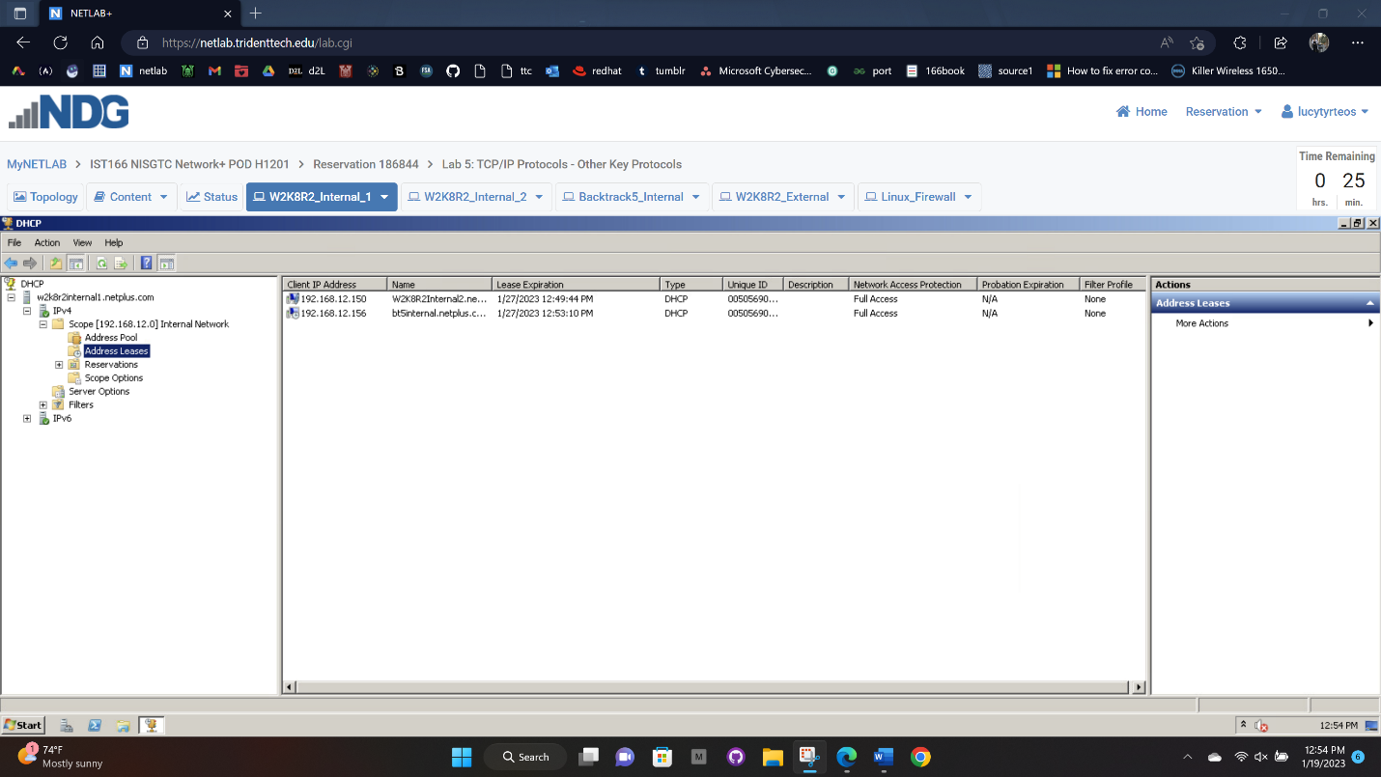

**Step 6, Page 27 of 35 (must show both *ifdown* & *ifup*):**

**Step 14, Page 34 of 35:**

