**Towson University**

**Software Project Management Plan**

for

**COSC 412 Group 2 Project**

Zahra Abdulwahab

Shania Foster

Delilah Andrusko

Tangi Ambe

Danayt Teklu

**Table of Contents**

1.1 Project Overview.........................................................................................................3

1.2 Project Deliverables....................................................................................................3

1.3 Evolution of the SPMP................................................................................................4

1.4 Reference Materials...................................................................................................4

1.5 Definitions……………………………………………….......………………………………4

2.1 Process Model............................................................................................................5

2.2 Organizational Structure.............................................................................................5

2.3 Organizational Interfaces............................................................................................6

 2.4 Project Responsibilities..............................................................................................6

3.1 Management Objectives and Priorities.......................................................................7

3.2 Assumptions, Dependencies and Constraints……………………………………..……7

3.3 Risk Management…………………………………………..………………………………7

3.4 Staffing Plan…………………………………………………………………………………8

3.5 Monitoring and Controlling Mechanisms……………………..…………………………..8

4.1 Methods, Tools and Techniques……………………...…………………………………..8

4.2  Software Documentation……………….………………………………………………….8

 4.3 Project Support Functions…………..……………………………………………………9

 5.1 Work Breakdown Structure (WBS)............................................................................9

**Part 1: Introduction**

* 1.1 Project Overview
  + This project is to create an up-to-date system to assist in matching homeless pets to permanent homes. The goal is to provide an all-inclusive website that will provide updated information on all pets including but not limited to health information and behavior description. This website will also include pet care tips to allow adequate care for the animals in their new home. Donations and paid advertising will be an option for this website as well.
* 1.2 Project Deliverables

|  |  |
| --- | --- |
| **Deliverables** | **Deadline** |
| Group Project Status Presentation | 28 June 2021 |
| Repository | 30 June 2021 |
| Design Review Meeting | 30 June 2021 |
| Tool Selection Review | 30 June 2021 |
| SPMP | 30 June 2021 |
| Group Project Deliverables Submission | 23 July 2021 |
| Final Presentation | 2 August 2021 |

* 1.3 Evolution of the SPMP
  + This project will follow the schedule outlined in the Gantt chart. Any changes to the schedule will be displayed and adjusted in the chart. However, none of the changes will not affect the overall delivery of the project.
* 1.4 Reference Materials
  + <https://wordpress.org/plugins/>
  + https://www.youtube.com/watch?v=nbez42Vtjfs
  + <https://www.petfinder.com/>
  + <https://www.aspca.org/pet-care>
  + <https://www.mypet.com/pet-care-tips.aspx>
  + https://www.hsvma.org/pet_care_tip_sheets#.YNgK6kwpA2w
* 1.5 Definitions and Acronyms
  + **DreamHost**: a hosting platform, domain provider, and database curator.
  + **MAMP**: a local server used to download and work with WordPress. org
  + **WP User Manager**: [WP User Manager](https://wpusermanager.com?utm_source=wordpress.org&utm_medium=free%20plugin%20listing&utm_campaign=WP%20User%20Manager) lets you create highly customizable user profiles together with custom user registration, login, password recovery and account customization forms to your WordPress website.
  + **SPMP**: a detailed document that shows an organized plan for a project
  + **Gantt Chart**: a chart that shows the work done and scheduling for work to be done on a specific project
  + **GitHub**: collaboration platform for software developers; for this project is mainly used for the repository.
  + **Plug-in**: A software component that adds a specific feature to an existing computer program

**Part 2: Project Organization**

2.1 Process Model

This project was initiated on June 1st, 2021 and will be terminated on August 1st, 2021. Major milestones are the deliverables mentioned previously. The development process is organized by various documents, including the SPMP. This project will follow a Gantt chart to stay on schedule. The waterfall method will be used as the process for this project. This will allow the project to move forward step by step.

2.2 Organizational Structure

(Continued on Next Page)

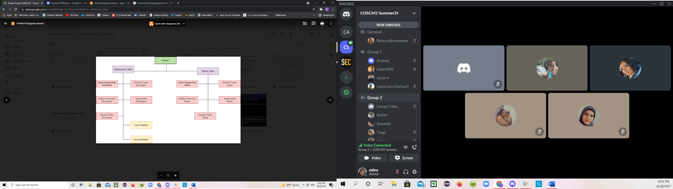

The clients of the project are:

Rebecca Broadwater

The project members are:

Zahra Abdulwahab, Shania Foster, Delilah Andrusko, Tangi Ambe, and Denayt Teklu. All the members are part of the development team, as well as the testing team.

2.3 Organizational Interfaces

The organizational interfaces include Namecheap as the hosting platform and WordPress as the platform to create the website. WordPress plugins will be used as feature assistants.

2.4 Project Responsibilities

|  |  |  |
| --- | --- | --- |
| Project Phase | Description | Responsible Individuals |
| Planning | Develop a plan to manage the project | All members |
| Requirements Analysis | Analyze user needs and requirement specifications | All members |
| Design | Create software design documentation | All members |
| Implementation | Develop the website | All members |
| Integration and Testing | Demonstrate that the developed system meets all of the requirements | All members |
| Presentation | Present the project | All members |

**Part 3: Managerial Process**

3.1 Management Objectives and Priorities

* + Primary goal of the project is to stay on task and complete by deadline. Each week will have a status update on progress made. Communication will be constant throughout the project. This project is working with a very low budget.

3.2 Assumptions, Dependencies and Constraints

· Assumptions:

It is assumed that users will have experience using a website. The project will be completed by July 23rd. The presentation portion of the project should be completed by the date of the presentation, July 19th.

Dependencies:

External dependencies include holidays and scheduled lectures, and group availability. Other external dependencies are the domain and hosting site we are using. We depend on them to stay active past the last day of class.

Constraints:

The time constraint for this project will be that it must be complete and running by July 23rd and this is a low budget project. Finding a suitable meeting time outside of class for our group to get together.

3.3 Risk Management

I. Unable to finish the project by deadline.

Probability: Low

Impact: High

Prevention: Make more higher level features a priority.

II. Loss of critical information, documents, or code.

Probability: Low

Impact: High

Prevention: GitHub will store all code and documents. If one version is lost the older version is available.

3.4 Monitoring and Controlling Mechanisms

GitHub generates documentation for each deliverable up to date of the final submissions. Error logging will keep track of code and notify if issues arise through the process. There will be a status update every week about the process of the project.

3.5 Staffing Plan

* + Project will consist of 5 staff personnel.

**Part 4: Technical Process**

* 4.1 Methods, Tools and Techniques

Some of the main tools we will be using for this website are WordPress, Namecheap, Visual Studio Code. First, We will utilize WordPress for their frontend design/code options which allows us to work off of a template already designed, and we will personalize it for our own website's needs. It has multiple helpful plug-ins that will make our website more interactive for the user rather than static. Next, we will utilize Namecheap as a registrar for its domain hosting services. Namecheap is very accommodating in that they offer specific WordPress hosting, so it will be easy to host our domain with their services. Lastly, Visual Studio Code will be used to design the code for our Pet Matching Quiz that we will implement on the website.

* 4.2 Software Documentation

We will use Google Docs and GitHub to document our website’s plans, schedule, and progress. Google Docs will be used to document important components of this project such as the requirements, deliverables, and necessary diagrams. GitHub will be used to upload these necessary documents and pushed to the repository for each collaborator to have access to as we progress with the development of our website.

* 4.3 Project Support Functions

The quality assurance of our website will continuously and keenly be assessed throughout the design and implementation processes of our website. Each feature added will be evaluated on its functionality, reliability, usability, efficiency, and maintainability to ensure it meets our defined standard before proceeding with development.

**Part 5: Work Elements**

* Work Breakdown Structure (WBS)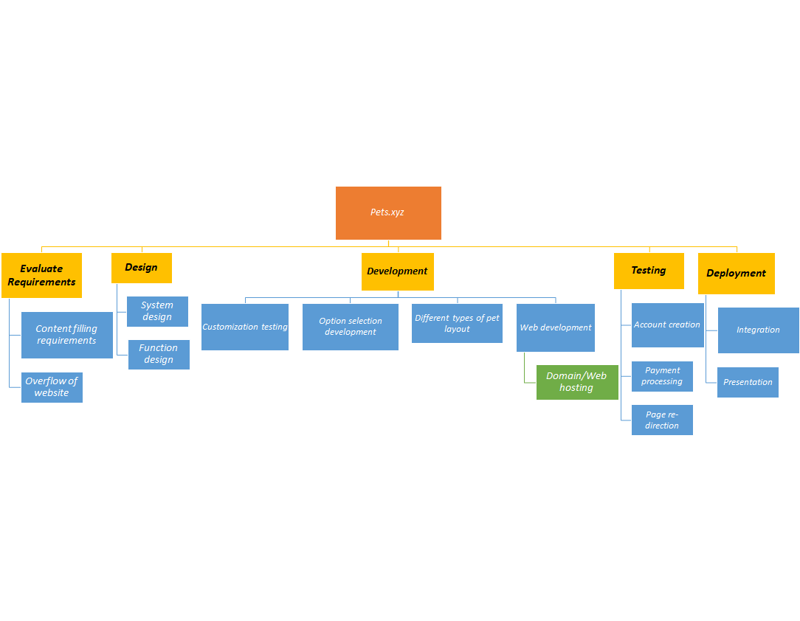

Gantt Chart

