Tangi Ambe

COSC 412-041

July 23, 2021

**Software Project Management Plan**

**(SPMP)**

**Table of Contents**

**1. Introduction** …………………..………………….……… 4

**2. Project Organization** …..……………..…………………. 6

**3. Managerial Process** …………………..……….…………. 8

**4. Technical Process** ……………………..……………….... 10

**5. Description of Work Packages** …………….……….….. 12

**WBS** …………..………………………………….…... 12

**Gannt Chart** …………………..….………………...... 13

1. **Introduction**
   1. **Project Overview**

This website will enable users to acquire knowledge about their hair in order for them to find products that best for them. Users will first take a “Hair Quiz” that will ask questions about their hair and how it behaves. Depending on the answers given, users will be matched with a specific hair type and porosity, which will be displayed after completion of the quiz along with product recommendations that correspond to their hair type and porosity. For users who may already know this information and just want product recommendations, there will be a menu tab where they can go to their specific hair section and see all the products there. The products will include shampoos, conditioners, stylers, and gels, and the pictures of these products will be linked to websites where users can purchase them.

**1.2 Project Deliverables**

|  |  |
| --- | --- |
| **Deliverables** | **Deadline** |
| Topic Proposal | 04 June 2021 |
| Repository | 1 July 2021 |
| Design Review Meeting | 1 July 2021 |
| Tool Selection Review | 1 July 2021 |
| SPMP | 1 July 2021 |
| Milestone Review | 23 July 2021 |
| Final Presentation | 26 July 2021 |

This project will produce a running, functional website that is in alignment with the following requirements:

The website will prompt users to take a “Hair Quiz” to find their hair type and porosity for specific product recommendations.

Select tabs for each hair type/porosity.

Select sub tabs for each product type (i.e., Shampoo, Conditioner, Styler, Gel).

Be redirected to other websites to purchase products they choose.

**1.3 Evolution of SPMP**

This project will strictly follow the schedule outlined in the Gantt chart. Any changes to the schedule will be reflected and displayed in the chart. However, no changes will affect the final deadline of the project.

* 1. **Reference Materials**

[*https://www.naturallycurly.com/quiz*](https://www.naturallycurly.com/quiz)

[*https://www.simplyorganicbeauty.com/hair-porosity-types-tests-and-treatments/*](https://www.simplyorganicbeauty.com/hair-porosity-types-tests-and-treatments/)

[*https://www.carolsdaughter.com/blog/hair/hair-care-tips/hair-porosity-low-and-high.html*](https://www.carolsdaughter.com/blog/hair/hair-care-tips/hair-porosity-low-and-high.html)

[*https://www.beautyempirestore.com/blogs/news/hair-types-porosity-density-we-break-it-down-for-you*](https://www.beautyempirestore.com/blogs/news/hair-types-porosity-density-we-break-it-down-for-you)

*https://www.youtube.com/watch?v=OMUDOyzKoz4*

[*https://wordpress.org/plugins/*](https://wordpress.org/plugins/)

* 1. **Definitions and Acronyms**

**Hair Porosity**: hair’s ability to absorb and retain moisture

**DreamHost**: a hosting platform and domain provider

**Quiz And Survey Master**: an easy-to-use WordPress plug-in to create customizable, engaging quizzes and surveys

**SPMP**: a detailed document that shows an organized plan for a project

**Gantt Chart**: a chart that shows the scheduling of work to be done and work already done

**GitHub**: collaboration platform for software developers; mainly used for the repository for this project

**Plug-in**: A software component that adds a specific feature to an existing computer program

**Waterfall Process**: The waterfall model is a breakdown of project activities into linear sequential phases, where each phase depends on the deliverables of the previous one and corresponds to a specialization of tasks.

**Ultimate Member**: WordPress Plug-in that allows the creation of customizable user profiles together with custom user registration, login, password recovery and account customization forms to your WordPress website.

WooCommerce:

Dropshipping & Affiliation with Amazon:

1. **Project Organization**

**2.1 Process Model**

This project was initiated on May 24th, 2021 and will be presented on July 26th, 2021. This project will follow a Gantt chart to in order to stay on schedule. I will be using the Waterfall method as the process model for this project.

**2.2 Organizational Structure**

All development and testing for the project will be planned, conducted, and completed by me as the main developer and tester. This includes all necessary documentation and user interface development.

**2.3 Organizational Interfaces**

The organizational interfaces include the following: DreamHost as a hosting platform, WordPress as a means to build the website, and WordPress Plug-ins as a means to add functionality to the site and to display items listed on Amazon.com as an e-commerce storefront.

**2.4 Project Responsibilities**

|  |  |
| --- | --- |
| Project Phase | Description |
| System Concept Development Phase | Establish the vision for the project |
| Planning Phase | Develop a plan to manage project, gather requirements, and document a plan. |
| Requirements Analysis Phase | Analyze user needs and requirement specifications. |
| Design Phase | Transform requirements into a software design documentation. |
| Implementation | Develop the website |
| Integration and Testing | Demonstrate that the developed system meets all requirements. |
| Presentation | Present completed functional project. |

All phases will be completed by me.

1. **Managerial Process**
   1. **Management Objectives and Priorities**

The objective for this website is to be an effective, interactive, and attractive platform for users to have a starting point in finding the right products for their hair. The main priorities include creating a detailed, but quick quiz so that users are getting the best match possible. There will also be multiple plug-ins utilized to assist with the gathering and presenting of data on the website.

* 1. **Assumptions, Dependencies, and Constraints**
     1. ***Assumptions***

The project will go live by and will be presented on July 26th, 2021

* + 1. ***Dependencies***

Wordpress Plug-ins, DreamHost’s web hosting, Amazon’s API

* + 1. ***Constraints***

Having Amazon Affiliate account fully approved in time to have access to the Amazon Product Advertising API to integrate into the website.

**3.3 Risk Management**

***3.3.1 Loss of critical information, documents, or code***

Probability: Low

Impact: High

Prevention: Run backups automatically, push code and documents to GitHub repo

Correction: Use latest backups to recover the most recent version of website

***3.3.2 Lack of Experience with Relevant Technologies***

Probability: Medium

Impact: High

Prevention: Do in depth research of all aspects of the project including how to utilize the relevant technologies for my website.

Correction: Ask for help in a timely manner or watch YouTube tutorials/walkthroughs.

**3.4 Monitoring and Controlling Mechanisms**

GitHub generates documentation for each deliverable up to date of the final submissions. Error logging will keep track of code and notify if issues arise through the process.

**4. Technical Process**

**4.1 Tools and Techniques**

* WordPress.org
* DreamHost
* Dropshipping & Affiliation with Amazon (WP Amazon Shop) plug-in
* Ultimate Member plug-in
* WooCommerce plug-in
* GitHub for Repository
* Amazon Product Advertising API

**4.2 Software Documentation**

Excel will be used for the Gantt chart. Microsoft Word will be used for the SPMP, Milestone Report, and all other deliverables. GitHub will be used for the repository which all necessary documents will be pushed to as the development of the site progresses.

**4.3** **Project Support Functions**

***4.3.1 Quality Assurance***

The quality assurance of the website will continuously and keenly be assessed throughout the design and implementation processes of our website.. Each feature added will be evaluated on its functionality, reliability, usability, efficiency, and maintainability to ensure it meets a defined standard before proceeding with development.

***4.3.2 Configuration Management Plan***

The Gantt chart will then be adjusted to reflect any changes, if any, made to the design, implementation, and/or schedule of the project. The website itself will be tested after each new feature is added to ensure it meets the defined standard and does not negatively affect the functionality and feasibility of the website.

**5. Description of Work Packages**

**5.1 Work Breakdown Structure (WBS)**

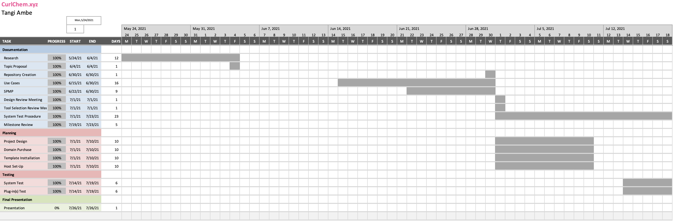**5.2 Gantt Chart**