C O R N E R S P A · W I N D H O E K
Corner Spa Website
Blueprint
Every component of a world-class spa landing page — researched, specified and ready to build

Prepared for the Corner Spa venture team
Oryx Institute · Mendozer Investments CC
Windhoek, Namibia · November 2026

Corner Spa — an Oryx Institute live lab · 2026

Table of Contents
1. Executive Summary
1. Executive Summary 1
2. Project Context: Corner Spa, Oryx Institute and Mendozer 1
2.1 Corner Spa is a live lab, and that is a marketing asset 1
2.2 Who does what on the project 2
2.3 The local competitive set 2
3. Research Basis and Sources 3
4. What the World's Best Spa Websites Do 3
4.1 Seven patterns worth copying 4
4.2 The ten mistakes weak spa sites make 4
5. Recommended Site Map and Page Inventory 5
6. Landing Page Anatomy: Every Section Top to Bottom 6
6.1 The two floating elements 11
7. CTA System and Conversion Strategy 11
7.1 Copy rules for every button 11
7.2 Placement and measurement 12
8. WhatsApp Integration Deep Dive 12
8.1 The click-to-chat link, precisely 13
8.2 Placement and styling of the floating button 14
8.3 Setting up WhatsApp Business properly 14
8.4 Response standards and when to upgrade 15
9. Team and Staff Section Standards 15
9.1 Anatomy of a therapist profile 15
9.2 Individual bio pages and the booking path 15
10. Trust Content: Reviews, Gallery and the First-Visit Guide 16
10.1 The review engine 16
10.2 The gallery brief 16
10.3 The first-visit guide 16
11. Technology Stack and Integrations 16
11.1 Booking platform 16
11.2 Payments in Namibian dollars 17
11.3 Google Business Profile and local SEO 18
11.4 Analytics, foundations and reliability 18
12. Design Direction and Photography Brief 18
12.1 Luxury minimal, in one page of rules 18
12.2 Mobile-first, fast and accessible 19
12.3 The twelve-shot photo brief 19
13. Content Collection Checklist 20
14. Launch Roadmap and KPIs 21
14.1 Three phases to a full site 21
14.2 What success is measured in 21
15. Appendix: Copy Bank and Message Scripts 22
15.1 Hero headlines (choose one) 22
15.2 CTA labels 22
15.3 WhatsApp scripts 22
15.4 FAQ stubs to expand on the Policies page 23

Note: this Table of Contents is generated via field codes. After editing the document, right-click the TOC and choose "Update Field" to refresh page numbers.

1. Executive Summary
Corner Spa is the Oryx Institute's first live lab for wellness and service operations, announced on 1 November 2026 as part of the institute's Ventures programme. Mendozer Investments CC, the multi-sector Namibian group, is working alongside the institute on the project. This blueprint answers the team's brief: research every single piece that belongs on a world-class spa website, from the smallest call-to-action (CTA) to the WhatsApp channel and the staff section, and specify it so the landing page can be built without guesswork.
The research is consistent on one point: a spa website has exactly one job, which is to turn a stressed visitor into a booked guest. The best spa sites of 2025 and 2026, among them Exhale, Woodhouse and Red Door, all do four things well. They place a clear booking CTA above the fold and repeat it down the page. They publish benefit-led treatment menus with durations and prices in plain sight. They show real photographs of their actual rooms and staff instead of stock images. And they make contacting them effortless, which in Namibia means WhatsApp. Reported benchmarks for well-optimised treatment pages run at 4 to 8 percent conversion, while generic homepages often sit near 1 percent; the difference is structure, not budget.
This document specifies a nineteen-block landing page organised into four jobs: capture attention, build desire and trust, convert to booking, and close and retain. It defines the CTA hierarchy (one primary Book Now button, WhatsApp as the ever-present secondary action), a full WhatsApp integration plan built on free click-to-chat links, team-page standards that turn first-timers into guests, and a technology stack chosen for a single-location Windhoek spa: Fresha for scheduling, DPO Pay and PayToday for payments in Namibian dollars, Google Business Profile for local discovery, and GA4 for measurement. The recommended design direction is luxury-minimal, with cream and warm gold tones and generous whitespace, built mobile-first because more than 60 percent of spa traffic is mobile.
The closing chapters turn research into execution: a content collection checklist assigning every asset to an owner, a three-phase launch roadmap with the first phase deliverable in roughly three weeks, key performance targets, and an appendix of ready-to-adapt copy. Where a figure is illustrative rather than sourced, it is marked as such, and every genuinely unknown fact is flagged for the venture team to confirm.

2. Project Context: Corner Spa, Oryx Institute and Mendozer

2.1 Corner Spa is a live lab, and that is a marketing asset
The Oryx Institute describes itself as a new polytechnic for Namibia, working from Windhoek on research, practice, and companies that prove the work. It registered with BIPA on 25 October 2026 and is pursuing accreditation with the NQA and the NTA. Its Ventures programme opens small operating companies to test sectors: when the institute wants to understand a sector, it opens a company inside it, and, in its own words, the customers decide whether it works and the register publishes the result. Corner Spa, announced on 1 November 2026, is that first live lab for wellness and service operations.
This matters for the website because it is a story no other spa in Windhoek can tell. Corner Spa is not just a place to buy a massage; it is a working classroom where service standards are trained, measured and published. The landing page should say this plainly in the brand story block and in the trust strip: an Oryx Institute live lab, where therapists are trained to a documented standard and guest feedback feeds teaching. Honesty about the model, framed confidently, converts curiosity into bookings and gives local media a reason to write about the opening.

2.2 Who does what on the project
The Oryx Institute owns the venture: the brand story, the service-operations curriculum that trains the therapists, and the register that publishes results. Mendozer Investments CC, established in 2009 and operating across six sectors including Construction and Infrastructure, Technology and Systems, Cooling and Cold Chain, Logistics and Support Services, Fuel and Energy Distribution, and Tourism and Agriculture, brings the delivery muscle described in its own tagline, one team from the first brief to the delivered work. For a spa, that translates into premises fit-out, cooling and climate control for treatment rooms, field and telecom systems that keep connectivity stable, and logistics support.
Two website decisions sit directly with the infrastructure partners. First, reliable connectivity: online booking, WhatsApp and a card terminal all fail silently on a dropped line, so the venture should specify a primary and a backup internet path for the premises from day one. Second, point-of-sale hardware: the booking platform, the card machine and the reception computer must work together before launch, which is a Mendozer Technology and Systems conversation, not an afterthought.

2.3 The local competitive set
Windhoek already has an active wellness market. TripAdvisor's Windhoek listing for massage, spas and wellness centres currently features Nomad Wellness Collective, I AM Hair and Beauty, Chakra Body, Health and Skin Care Clinic, and Meraki Wellness, alongside hotel spas serving visitors. None of them can claim the teaching-spa positioning, which gives Corner Spa a clear lane. The practical lesson from the competitive scan is different: most local discovery happens on Google Maps, Facebook and WhatsApp word-of-mouth rather than on spa websites, so local search hygiene (chapter 11) and fast WhatsApp responses (chapter 8) will decide who wins the next booking. The website's job is to close the guest who has already heard the name.

3. Research Basis and Sources
This blueprint was assembled in November 2026 from five strands of research, each chosen because it changes a build decision. First, a teardown of fifteen leading spa websites, including Exhale, Four Seasons Spa, Miraval, Red Door, Burke Williams, Shibui, Bliss, The Ritz-Carlton Spa, Massage Envy, Woodhouse Day Spa, Hand and Stone, Kohler Waters, Wi Spa, Aspira and The Spa at Equinox, as analysed in Bethany Works' 2025 review of best spa website designs, supplemented by the 2026 example collections from Colorlib and GlossGenius. Second, landing page conversion research focused on spa-adjacent businesses, principally the 2026 med spa landing page statistics from Webtonic and the optimisation guide from Sky Highway Marketing, which report the 4 to 8 percent benchmark used in this document.
Third, WhatsApp integration practice, drawn from Infobip's 2026 guide to adding WhatsApp buttons to websites, covering click-to-chat link formats, widget placement and business-hour etiquette. Fourth, booking and payment infrastructure: the 2026 salon and spa software comparisons published by Boulevard, Booksy and Booking Pro, and, for Namibian rails specifically, DPO Pay by Network and PayToday, both of which actively serve Namibian merchants in Namibian dollars. Fifth, local search guidance from Google's own Business Profile documentation, plus direct reviews of oryxinstitute.org, mendozer.com and the TripAdvisor Windhoek spa listings. The limits are stated plainly: the venture has no operating data yet, so all prices, names and review counts in this document are illustrative placeholders to be replaced with real figures, and platform pricing should be re-verified at contract time.
Sources consulted: bethanyworks.com (best spa website designs, 2025); blog.skyhighwaymarketing.com (med spa landing page optimisation, 2026); webtonic.io (med spa landing page statistics, 2026); colorlib.com and glossgenius.com (spa website example collections, 2026); infobip.com (WhatsApp website integration guide, 2026); joinblvd.com, biz.booksy.com and bookingpro.ai (spa software comparisons, 2026); dpogroup.com and site.paytoday.com.na (Namibian payment providers); support.google.com (Business Profile local ranking guidance); oryxinstitute.org; mendozer.com; tripadvisor.com (Windhoek spa listings).

4. What the World's Best Spa Websites Do

4.1 Seven patterns worth copying
Pattern 1 — Benefit-led language. Strong menus sell outcomes, not procedures: Exhale organises its whole site around restore, recharge and renew, and the teardown found the best menus write melt tension where weak menus write 60-minute Swedish massage. Corner Spa's copy should follow the same rule in every treatment card and menu row.
Pattern 2 — Booking is never more than one tap away. The leading sites put a booking CTA in the navigation, above the fold, at the end of every major section, and in a mobile bar that sticks while scrolling. Woodhouse goes further with detailed service menus that always show duration and price next to a booking path.
Pattern 3 — Gift cards live in the main navigation. Burke Williams treats gift cards as a first-class nav item, not a footer afterthought. Vouchers are a revenue stream and an acquisition channel, since the recipient is a first-time guest; chapter 6 gives Corner Spa's voucher block a matching weight.
Pattern 4 — First-visit guides reduce booking anxiety. Red Door and Wi Spa both publish a first-time visitor guide that walks a nervous newcomer through arrival, consultation and etiquette. A large share of spa hesitancy is not price but uncertainty; answering it on the page converts readers who would otherwise close the tab.
Pattern 5 — Real photography everywhere. Every strong site in the teardown uses custom photography of its actual rooms and staff. Generic candle-and-towel stock photos signal a template business; authenticity is the cheapest differentiator a new spa can buy, which is why chapter 12 includes a twelve-shot photo brief.
Pattern 6 — Memberships and packages are visible. Massage Envy's membership model with an aggressive booking CTA on every page, and Hand and Stone's first-time offers, show that recurring programmes belong on the landing page, not buried on a subpage. Packages also give undecided guests a simpler choice.
Pattern 7 — Location and proof do the selling. Hand and Stone wins on location-specific pages and local SEO, while the strongest trust sections pair a star rating with a review count above the fold. For a single-location spa in Windhoek, the same logic applies with Google Business Profile and named guest reviews.

4.2 The ten mistakes weak spa sites make
The same research base is just as clear about what fails. The table below lists the ten recurring mistakes, which doubles as a review checklist for the Corner Spa build: a launch candidate that avoids all ten is ahead of most of the market.
Table 1: Ten common spa website mistakes and their corrections
Mistake | What to do instead
Booking CTAs too subtle or buried | One gold Book Now button visible in the header, hero, mid-page and bottom; plus a sticky mobile bar
Generic stock photography | One photo session covering rooms, therapists and details; no bought imagery
Treatment menus hard to find | Menu block on the landing page with prices; full menu one tap deeper
Hidden or missing pricing | Every treatment shows duration and price; packages show the saving
Not mobile-first | Design at 390 px first; more than 60 percent of spa traffic is mobile
Weak trust signals | Google rating and review count above the fold; named reviews mid-page
Feature-language instead of benefit-language | Write the outcome the guest feels, then the technical name
Cluttered layouts that contradict the calm promise | Generous whitespace, one idea per screen, two fonts maximum
No direct booking integration | Buttons open the live booking calendar, not a contact form
Unclear positioning | Say in one line who the spa is for and why it exists
Compiled from the 2025-2026 spa design teardowns cited in chapter 3.

5. Recommended Site Map and Page Inventory
The landing page specified in chapter 6 does the heavy lifting, but a complete spa website needs a small set of supporting pages so that every deep question has a home. The inventory below keeps the site lean: seven pages, each with a single purpose, phased so that the launch effort concentrates on the pages that close bookings. Everything on this list can ship inside one website build; the phases only decide the order.
Table 2: Page inventory with purpose and priority
Page | Purpose | Must-have elements | Phase
Home (landing page) | Convert first-time visitors | The 19 blocks specified in chapter 6 | 1
Treatments | Full menu with categories and prices | Benefit-led descriptions, durations, prices, Book buttons per row | 1
Team | Introduce the therapists | Profile cards, individual bio pages, Book-with-name links | 2
Gift Vouchers | Sell and deliver vouchers | Value picker, WhatsApp or email delivery, terms | 2
Gallery | Show the real space | 8-12 real photos with captions | 2
Find Us / Contact | Remove arrival friction | Map, hours table, parking note, WhatsApp and call buttons | 1
Policies & FAQ | Answer the anxious questions | Cancellation, etiquette, first-visit guide, privacy | 2
Phase 1 items ship with the landing page launch; Phase 2 within the following month.

6. Landing Page Anatomy: Every Section Top to Bottom
This chapter is the core of the blueprint. It specifies nineteen blocks in scroll order, grouped into four jobs: blocks 1 to 4 capture attention, blocks 5 to 11 build desire and trust, blocks 12 to 14 convert the decision, and blocks 15 to 19 close the visit and set up the next one. Figure 1 maps the full page. Each block below states its purpose, what it must contain, sample copy where wording matters, and the action it should trigger. Sample figures such as prices and review counts are illustrative placeholders; the venture team replaces them with real values from the checklist in chapter 13.
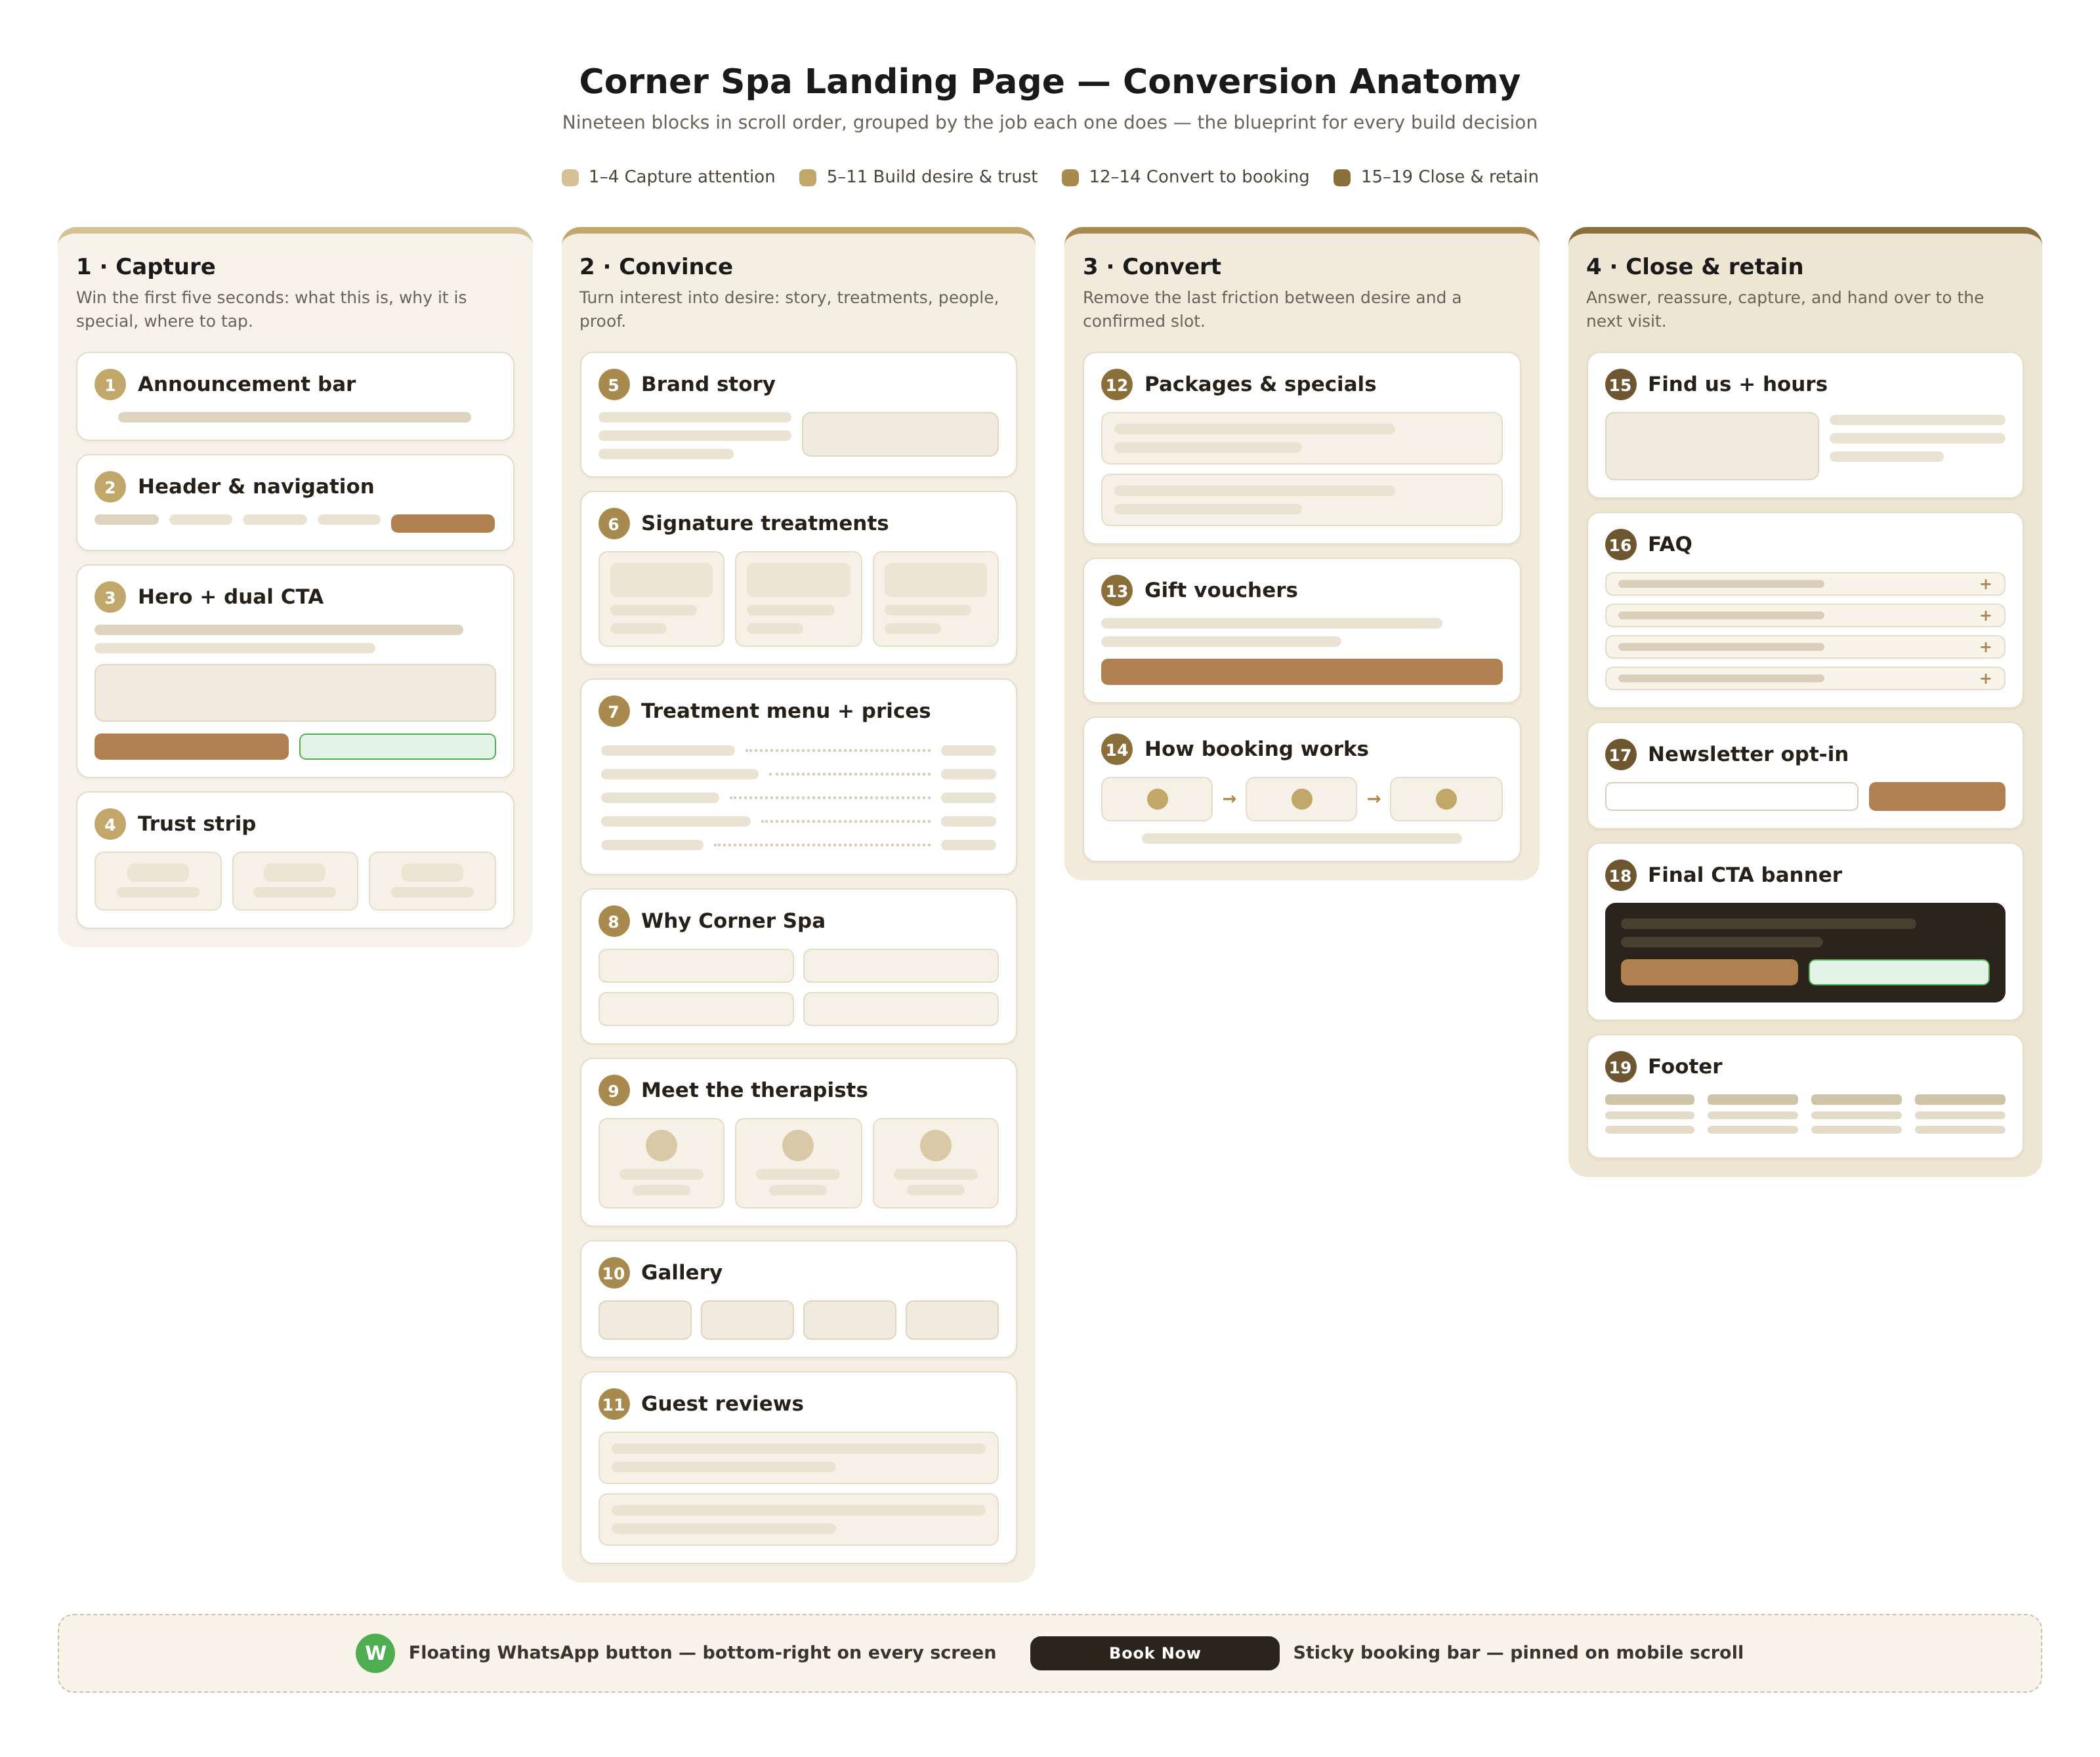
Figure 1: Conversion anatomy of the Corner Spa landing page — nineteen blocks in four job groups
Block 1 — Announcement bar
A single thin strip above the header that carries one live message at a time: an opening offer, seasonal hours or a new ritual. It exists to give returning visitors a reason to look twice, so keep it to one line, rotate it monthly and never stack two messages. Sample copy: Introductory month: 15 percent off your first treatment, booked before 30 November. Link it straight to the booking flow, not to a promotions page.
Block 2 — Header and navigation
Logo left; four links only (Treatments, Team, Gift Vouchers, Find Us); a WhatsApp icon; and one gold Book Now button on the right. Resist adding more links: navigation is where spa sites quietly leak visitors into reading instead of booking. The header shrinks and stays pinned on scroll so the booking button never leaves the screen, and on mobile it collapses into a hamburger with the Book Now button kept visible beside it.
Block 3 — Hero with dual CTA
A full-width photograph of the spa's real best room in warm light, with one headline of ten words or fewer, one supporting line, and two buttons: the primary gold Book Your Treatment, which opens the live booking calendar, and a secondary outline button, Message us on WhatsApp, which opens the prefilled chat from chapter 8. Under the buttons, one trust line: 4.9 out of 5 from 120-plus Google reviews (replace with the live count once real). Sample headline options are in the appendix; the hero must confirm within five seconds what this place is, where it is, and what to tap.
Block 4 — Trust strip
Three quiet stat chips directly under the hero: the Google rating with review count; certified therapists, trained to the Oryx standard; and an Oryx Institute live lab badge. Social proof placed this high shortens the trust decision before the visitor scrolls, which the med spa research identifies as one of the highest-leverage elements on the page. No invented awards and no clip-art certification logos: three true statements are enough.
Block 5 — Brand story
Two columns: a short story on the left, a real photograph on the right. This is where the live-lab positioning earns its keep: Corner Spa exists because the Oryx Institute believes service businesses are learned by running them, so every treatment funds training and every guest shapes the curriculum. Keep it under ninety words, name the neighbourhood, and end with a text link to the team page, Meet the people you will meet.
Block 6 — Signature treatments
Three cards, each with a real photo, a benefit-led name, one line of description, duration, price and a Book link. Illustrative opening trio: Corner Signature Full-Body Massage, 60 minutes, N$450; Radiance Facial, 60 minutes, N$480; Hot Stone Ritual, 75 minutes, N$650. Three is the right number: it reads as curation rather than a catalogue, and each card is one decision the visitor can make without scrolling sideways.
Block 7 — Treatment menu with prices
A compact menu list with dotted leaders between treatment names and prices, organised by category (Massage, Facials, Body, Hands and Feet), each row showing duration and price, closing with a link, View the full treatment menu. Transparent pricing is one of the strongest conversion signals in the research, and it filters enquiries before they reach WhatsApp, saving reception time. Prices here must match the booking platform to the rand.
Block 8 — Why Corner Spa
Four benefit tiles that answer the silent question, why this spa and not the one closer to me. Suggested tiles: qualified, supervised therapists; honest, published prices; calm private rooms in central Windhoek; and booking in under a minute on WhatsApp or online. Each tile is one short sentence, not a paragraph; the claims must be ones the venture can prove on request.
Block 9 — Meet the therapists
Three profile cards with real photographs, first names, roles and one specialty line, linking to the full team page. Guests, especially first-timers, book a person as much as a treatment; showing faces before the visit measurably reduces no-show anxiety. Chapter 9 specifies the full card anatomy and a sample bio; the photographs come from the same session as the gallery shots so lighting and wardrobe stay consistent.
Block 10 — Gallery
A six-to-eight photo grid of the actual space: treatment rooms, the welcome corner, details such as folded towels, stones and tea service. Captions should name what the guest is looking at, since naming rooms helps visitors imagine their own visit. Every image is compressed for speed (chapter 12) and regenerated, never lifted from stock libraries.
Block 11 — Guest reviews
Two or three short named quotes with first name and surname initial, each citing a specific detail such as the pressure of the massage or the quietness of the room, plus a Google reviews badge with the live count. The teardown found specific, named testimonials carry materially more trust than anonymous praise; until real reviews exist, this block stays empty rather than filled with invented quotes. The review-generation engine that fills it is specified in chapter 10.
Block 12 — Packages and specials
Two wide cards, refreshed monthly: for example a Desk Reset combining a 45-minute neck and back massage with an express facial (illustrative price N$520), and a Couples Ritual, 90 minutes (illustrative N$1,350). Packages simplify the choice for undecided guests and raise average ticket value; each card carries its own Book button so the decision and the action sit together.
Block 13 — Gift vouchers
One full-width card: Give an hour of calm. Digital vouchers from N$200, delivered to WhatsApp or email in minutes. Vouchers are both revenue and acquisition, because the recipient arrives as a first-time guest, which is why gift vouchers deserve main-navigation placement per pattern 3. The card states value options, delivery method and validity in one line each, with a Buy a voucher button that opens the voucher flow.
Block 14 — How booking works
Three steps in a row: choose your treatment online or on WhatsApp, any time; confirm your slot and therapist; arrive ten minutes early and we handle the rest. Under it, one reassurance line about the cancellation policy in plain words, for example free rescheduling up to 24 hours before. This block converts the hesitant majority who like the spa but fear a complicated process; it also pre-answers the FAQ that reception otherwise answers by phone.
Block 15 — Find us, hours and map
An embedded Google map beside the address, an hours table, a parking or access note, and two buttons: WhatsApp us and Get directions. The address and pin must be identical everywhere (website, Google Business Profile, Instagram bio) because inconsistency quietly kills map-pack ranking, as chapter 11 explains. Hours shown here must match the WhatsApp away-greeting and the booking platform's availability.
Block 16 — FAQ
Four to six expandable accordions answering the questions first-timers actually type: What should I wear and when should I arrive? How does cancellation work? Do you treat men and pregnant guests? Which products do you use, and what if I have allergies? How do I redeem a gift voucher? Accordion rows keep the page scannable while still hosting the full answers, and each answer ends with the relevant action link rather than a dead end.
Block 17 — Newsletter opt-in
A single email field and button with an honest promise: seasonal rituals and quiet-day offers, once a month, unsubscribe any time. The newsletter is the retention channel that offsets the spa's seasonal rhythm, and its value depends entirely on the promise being kept, so the frequency claim is binding. Entries land in a simple list the team actually exports monthly; an unopened mailing list is not an asset.
Block 18 — Final CTA banner
A dark charcoal band closing the page: one serif line, Ready to slow down? Windhoek moves fast. This corner doesn't. above the same dual buttons as the hero, Book Your Treatment and Message us on WhatsApp. Visitors who scroll this far are the warmest audience on the page, and the last impression should be the action itself, not a corporate paragraph.
Block 19 — Footer
Four columns: brand mark with one-line description and Instagram and Facebook links; Explore links mirroring the header; Visit with address, hours and map link; and Contact with the WhatsApp number, phone and email. A final legal row carries the privacy notice, terms, and the line Corner Spa is an Oryx Institute venture, which also keeps the institutional story crawlable for search engines. No empty columns and no dead links: the footer is the most-crawled block on any site.

6.1 The two floating elements
Two elements ride above all nineteen blocks. The floating WhatsApp button sits bottom-right on every screen: 56 pixels, official WhatsApp green with a white icon, appearing after the visitor has scrolled about a third of the hero on mobile so it never competes with the primary CTA, and always at least 16 pixels clear of content. The sticky mobile booking bar pins to the bottom of the viewport on phones only, split roughly sixty-forty between Book Now and WhatsApp, and it hides itself when the booking widget is open so buttons never stack. Both are specified in detail in chapters 7 and 8.

7. CTA System and Conversion Strategy
The research is blunt about calls-to-action: one primary action per screen, repeated consistently, beats three competing ones. Every extra CTA option introduces hesitation, and hesitation on a phone is a closed tab. Corner Spa therefore runs a strict three-level CTA hierarchy, summarised in Table 3, and every block in chapter 6 draws its buttons from these three levels and nothing else.
Table 3: CTA hierarchy for the Corner Spa landing page
Level | Button and styling | Where it appears | Copy examples
Primary | Solid warm gold, dark text; one per screen | Header, hero, mid-page after menus, final banner, sticky mobile bar | Book Your Treatment; Book now
Secondary | White outline with WhatsApp green icon | Hero, find-us block, final banner, floating button | Message us on WhatsApp
Tertiary | Plain text link or phone icon | Header, find-us block | Call reception
Styling values follow the palette in chapter 12; the gold button is the only solid-colour button on the page.

7.1 Copy rules for every button
Be specific, never generic. Button copy that names the action outperforms Submit every time in the conversion literature: Book Your Treatment tells the thumb exactly what happens next, and Book my free consultation beats Submit in study after study cited in the 2026 landing page guides. Vague labels read as forms; specific labels read as outcomes.
Reduce anxiety under the button. A microcopy line directly beneath a button removes the last hesitation: Book in under a minute. Free rescheduling up to 24 hours before. One sentence, no more, and it must state a policy the spa actually honours.
One primary action per screen. The gold button appears exactly once per viewport; where WhatsApp also appears, it is the outlined secondary. This keeps the hierarchy legible and matches the single-CTA principle that the 2026 research identifies as the difference between pages that book and pages that do not.
Match the message when advertising. If the spa later runs a promotion or social ad, the landing headline should echo the ad's promise word for word, the message-match rule. A visitor who taps a couples-ritual ad and lands on a generic hero has been given five exit doors before reading a word.

7.2 Placement and measurement
The primary button appears above the fold in the hero, again after the treatment menu (the moment desire peaks), and once more in the final banner, with the sticky mobile bar carrying it throughout the scroll on phones. Every button gets a GA4 event (book_now_click, whatsapp_click) so the team can see not just clicks but the block where each click happened. The working target: 4 to 8 percent of landing page visitors starting a booking, the benchmark reported for well-optimised treatment pages, measured weekly after launch. If the number sits below target, the fix sequence is copy first, contrast second, load speed third, never a redesign.

8. WhatsApp Integration Deep Dive
In Namibia, WhatsApp is not an alternative contact channel; it is where business happens. Guests expect to message a spa the way they message a friend, and the businesses that answer fastest win the booking. The strategy below starts free on the WhatsApp Business app with click-to-chat links, and only graduates to the paid Business Platform (API) when message volume genuinely demands automation. Figure 2 shows the full booking flow from tap to confirmed appointment.
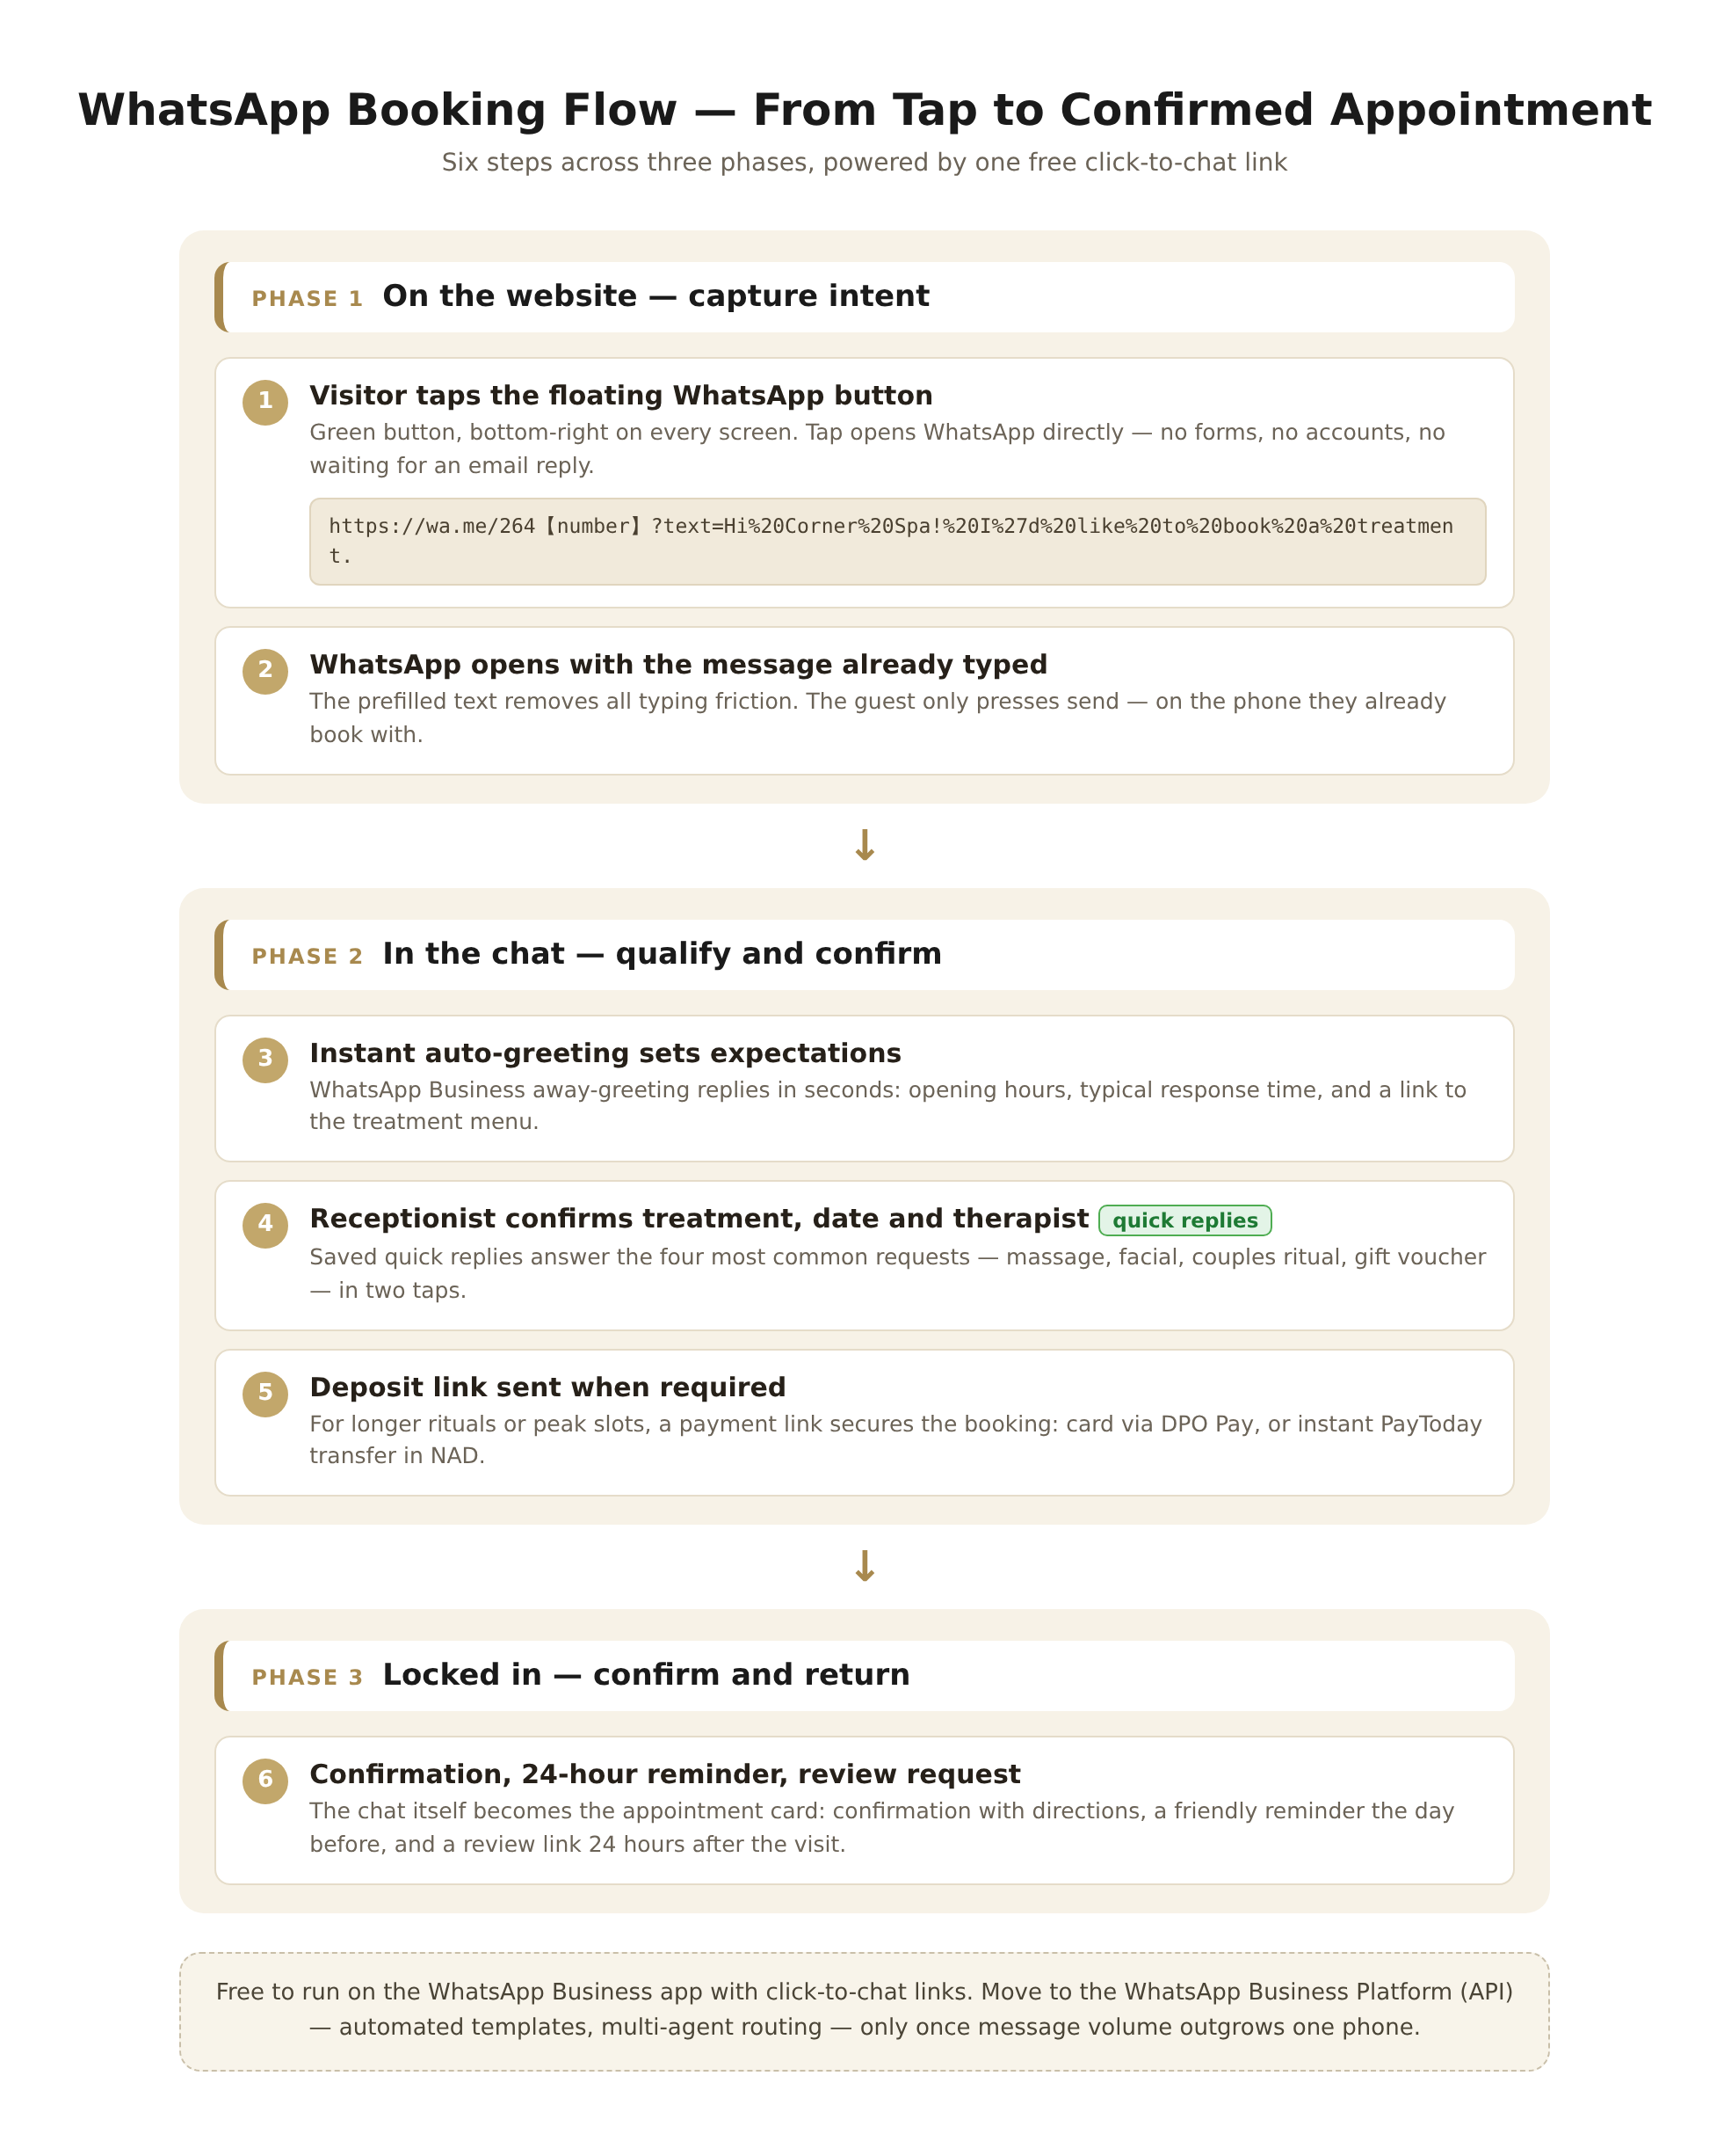
Figure 2: The six-step WhatsApp booking flow across three phases

8.1 The click-to-chat link, precisely
The foundation is a wa.me link: the spa's number in full international format without plus signs, zeros or punctuation, followed by an optional URL-encoded prefilled message. For a Namibian number 081 123 4567, the base is wa.me/264811234567; spaces become percent-20, apostrophes percent-27 and exclamation marks percent-21. A working example for the hero button:
https://wa.me/264811234567?text=Hi%20Corner%20Spa!%20I%27d%20like%20to%20book%20a%20treatment.
Different buttons should carry different prefilled texts, because the prefilled message is free context for reception: the hero button asks about booking, the voucher button says I would like to buy a gift voucher, and the reception QR code says Hi, I am at Corner Spa and would like to rebook. Each variant is one line of HTML; test every link on both a phone and a desktop before launch, as the integration guides recommend.

8.2 Placement and styling of the floating button
The floating button is 56 pixels round, official WhatsApp green with the white glyph, fixed 16 pixels from the bottom-right corner on every screen. Recognisability beats brand purity here: guests see green and know instantly what it does. On mobile it fades in only after roughly a third of the hero has scrolled so it never covers the primary CTA, it carries an aria-label for screen readers, and it never overlaps the sticky booking bar, which reserves its corner. On desktop it can appear immediately.

8.3 Setting up WhatsApp Business properly
The free WhatsApp Business app is the right tool at launch, but it must be set up like a shopfront rather than a spare phone. The business profile needs the exact trading name, the Day Spa category, the physical address, opening hours, the website link, and a catalog of the treatment menu with prices, so guests can browse without leaving the chat. Four built-in tools do most of the work:
- Greeting message: an automatic first reply within seconds, naming opening hours, typical response time and a link to the treatment menu.
- Away message: covers after-hours enquiries honestly, with the hours and the online booking link, so no message sits unanswered overnight.
- Quick replies: saved shortcuts for the four most common requests, massage, facial, couples ritual and vouchers, each with price and a booking link, answered in two taps.
- Labels: New enquiry, Booked, Deposit paid, Visited, Follow-up, so the chat list itself becomes a lightweight customer list.
Print a QR code for the reception desk that opens the rebook link above; a guest paying after a good massage is the cheapest lead the spa will ever get. The number used must be reachable by one accountable person per shift, and the Oryx service-operations curriculum should own the greeting scripts and tone, which keeps the channel on-brand and measurable.

8.4 Response standards and when to upgrade
The standard to publish and keep: first reply within 15 minutes during opening hours. The auto-greeting covers the gap when reception is with a guest, and the away message covers the night. Upgrade to the WhatsApp Business Platform (API) when any of these is true: sustained volume beyond roughly 50 conversations a day, a need for multi-agent routing, or a need for templated outbound reminders at scale. The Platform charges per conversation and requires a business solution provider, so its pricing should be verified with Meta at decision time; until then it is unnecessary cost for a single-location spa. One boundary matters: WhatsApp carries conversations, never payment credentials. Deposits are paid through the link in chapter 11, and card details are never typed into chat.

9. Team and Staff Section Standards
Spa bookings are personal. A first-time guest is not choosing a 60-minute slot; they are choosing whose hands they will lie under, and the teardown found that authentic staff photography and honest bios are among the strongest trust builders on spa sites. The team section therefore gets the same design care as the treatment menu, not a leftovers grid of cropped headshots.

9.1 Anatomy of a therapist profile
Each profile card contains six elements: a real photograph in natural light with the spa's uniform; full name and role; specialty line; years of experience; languages spoken; and one human line in the therapist's own words. The bio should describe what it is like to be on the therapist's table, which the copywriting research identifies as the difference between a bio that blurs into nine thousand others and one a guest remembers. A sample, clearly marked for replacement with real details:
Sample bio (replace with a real team member): Ndapewa, Senior Massage Therapist. Trained through the Oryx Institute's service-operations programme, Ndapewa has spent eight years turning desk-stiff shoulders into quiet afternoons. Her deep-tissue pressure is firm but never a fight; she checks in once, then lets the silence work. Speaks English, Oshiwambo and Afrikaans. Books fastest for: Desk Reset and hot stone rituals.

9.2 Individual bio pages and the booking path
Beyond the shared team page, each therapist gets a simple individual page at its own address such as cornerspa.na/team/ndapewa. This follows current practice for practitioner pages: a page whose main focus is one person can carry profile structured data, it wins searches for that person's name, and it gives referrers a linkable target in a way a twelve-person grid never can. Each bio page carries its own Book with [name] button that opens the booking platform with that therapist preselected, and the title tag reads the name and specialty, not just Profile. Decide the exit policy now: when a therapist leaves, their page is archived with a redirect to the team page rather than deleted, so links and search history do not rot.

10. Trust Content: Reviews, Gallery and the First-Visit Guide

10.1 The review engine
Reviews are the landing page's fuel, and they do not appear by hoping. The ask happens at the peak-delight moment, when tea is served after the treatment: a small card on the tray carries a QR code that opens the Google review form for Corner Spa, and the therapist says one sentence, if you enjoyed it, a Google review helps us enormously. A working target for the first ninety days is 25 or more reviews averaging 4.7 or higher; every review gets a reply within a day, including the critical ones, because replies are read by the next hundred guests. The landing page then displays the live count and two or three named quotes, refreshed monthly.

10.2 The gallery brief
The gallery exists to answer one question: will I feel comfortable there? That is answered by real rooms, real light and real detail, never by stock candles. The photo session in chapter 12 feeds this block and the hero at once; captions name what is shown, and every image ships compressed for the mobile speed budget. Guest-facing treatment shots require consent, collected verbally at booking and honoured without exception; any guest can decline and still get the same warm service.

10.3 The first-visit guide
Red Door and Wi Spa turn first-timer nerves into bookings by publishing exactly what will happen, and Corner Spa should do the same as part of the Policies and FAQ page, linked from the booking steps block. The guide answers, in order: what to wear and what to bring; arriving ten minutes early and why; the short consultation where pressure, allergies and focus areas are asked; what happens with phones and conversation during the treatment; tipping norms in Namibia; and how it feels afterwards, including drinking water and taking the evening slowly. This page also carries the etiquette and cancellation policies in plain words, which protects the therapists' schedules and pre-empts the awkward conversations.

11. Technology Stack and Integrations

11.1 Booking platform
The booking platform is the operational heart of the website: every Book Now button, the calendar, deposits, no-show protection and the guest list live there. Table 4 compares the platforms most relevant to a single-location Namibian spa in 2026; pricing models change often, so figures are indicative and must be verified at contract time.
Table 4: Booking platforms compared for a single-location spa (2026, indicative)
Platform | Pricing model | Strengths | Fit for Corner Spa
Fresha | Free core tools; card-processing and per-booking fees; partner marketplace | 120-plus countries incl. Southern Africa; clean widget; marketplace discovery; no-show protection | Recommended: lowest start cost, proven in the region
Booksy | Subscription from about $19.95/month (solo) | Strong mobile app and marketing tools | Good fallback; monthly cost from day one
Vagaro | Subscription per staff count | Solid all-rounder, US-centric | Regional support weaker
Mangomint | Premium subscription (USD) | Beautiful UX, deep automations | Priced for larger multi-room spas
Boulevard | Premium subscription from about $176/month (list) | Boutique med-spa polish | Over-specified for launch
Mindbody | Subscription, class-oriented | Fitness and class scheduling | Built for gyms; heavy for a day spa
Sources: 2026 comparisons by Boulevard, Booksy and Booking Pro cited in chapter 3; verify Namibia availability and current fees before signing.
Recommendation: start on Fresha. It carries no monthly base fee, its booking widget embeds directly under the landing page's Book Now buttons, its marketplace lists the spa where Windhoek visitors already search, and its card machine pairs with reception. The one action item before commitment: confirm Namibia onboarding and payout timelines with Fresha, and keep Booksy as the documented fallback.

11.2 Payments in Namibian dollars
Three rails cover every guest. DPO Pay by Network is the established card gateway for Namibian merchants, accepting Visa, Mastercard, American Express and Diners in NAD, with online EFT and payment links issued from a dashboard; it powers website payments and deposit links. PayToday is Namibia's instant mobile payment app, familiar to local guests for quick transfers, and a card machine at reception completes the set. Policy: deposits through a DPO payment link secure peak slots and rituals above roughly N$500 (illustrative threshold), credited against the final bill, with the cancellation terms stated in the same message. Card details are never accepted inside WhatsApp chats.

11.3 Google Business Profile and local SEO
For a single-location spa, the Google Business Profile is half the website: it owns the map pack where Windhoek wellness searches are decided, and reported analyses in 2026 attribute roughly a third of local ranking weight to profile signals alone. Launch-day tasks: claim and verify the profile; set the primary category to Day Spa with a second category for Massage Therapist if available; publish the identical name, address and phone used on the website; upload the first ten real photos; and post the opening offer. Weekly rhythm after launch: add photos, answer every review, and keep hours exact, including holidays. On the website itself, the technical basics are a LocalBusiness or DaySpa structured-data block with name, address, geo-coordinates, hours and price range; page titles built on real searches such as spa Windhoek, massage Windhoek and couples massage Windhoek; and one descriptive sentence per treatment type so search engines can rank the Treatments page.

11.4 Analytics, foundations and reliability
GA4 runs from day one with four events that answer the only questions that matter: book_now_click, whatsapp_click, view_treatment and voucher_click, each attributed to the block it fired from. A Meta pixel is installed when the first ad budget is approved, not before. Foundations: a .na domain (verify availability of cornerspa.com.na or an equivalent), a hello@ email on the same domain, TLS on every page, and automated backups. Reliability is an infrastructure matter that sits with Mendozer: the booking system, WhatsApp Web and the card terminal all assume connectivity, so the premises need a primary line and a backup path (LTE failover is the usual answer) agreed before opening week.

12. Design Direction and Photography Brief

12.1 Luxury minimal, in one page of rules
The recommended direction is luxury minimal: the calm of the treatment room translated to the screen. The page runs on warm cream backgrounds, deep charcoal text and a single warm-gold accent reserved for the primary CTA and thin rules, with generous whitespace doing most of the designing. Two typefaces only: a display serif for headlines (Cormorant Garamond is a strong free option) and a clean sans-serif such as Inter for everything else, with body text never below 16 pixels on mobile. The palette below is the working set for both the site and the printed collateral, and the two figures in this document already follow it.
Table 5: Working colour palette
Colour | Hex | Used for
Warm cream | #F7F3EC | Page background, cards
Deep charcoal | #2B241C | Headlines, body text, dark bands
Warm gold | #B08050 | Primary CTA, thin accent rules, number chips
Soft sand | #E5DCC9 | Borders, dividers, skeleton lines
WhatsApp green | #4FAD52 | WhatsApp button and icon only
Gold is the only solid button colour on the page; green appears exclusively where the action is WhatsApp.

12.2 Mobile-first, fast and accessible
The site is designed at a 390-pixel phone width first and widened afterwards, because more than 60 percent of spa traffic is mobile and the sticky booking bar and floating WhatsApp button are mobile-native patterns. The speed budget is a page that is usable in under 3 seconds on mobile data: images in WebP or compressed JPEG under roughly 200 kilobytes, the hero image under 120 kilobytes, and no auto-playing video at launch. Accessibility is part of the aesthetic: contrast ratios meeting WCAG AA, descriptive alt text on every image, visible focus states for keyboard users, and font sizes that never require pinch-zoom. These are also exactly the checks Google's page-experience signals reward in local search.

12.3 The twelve-shot photo brief
One half-day session with a local photographer covers the entire site, provided the shot list is agreed in advance:
- 1. Hero: the best treatment room in warm afternoon light, no people, wide.
- 2-3. Two additional rooms: nail and facial corners, styled and unoccupied.
- 4-6. Three therapist portraits: natural light, uniform, relaxed smile, chest-up.
- 7-8. Two treatment-in-progress shots with a consenting guest, hands and environment only.
- 9-10. Details: stones, folded towels, oil bottles, tea service on the tray.
- 11. The welcome corner with the reception QR card visible.
- 12. The entrance or signage from the street, for the Find Us page and Google profile.
Every shot is delivered in high resolution for print and a compressed web set; the same session refreshes the Google Business Profile, which rewards fresh photos with visibility.

13. Content Collection Checklist
Nothing in chapters 6 to 12 can be built without inputs, so the venture should gather the assets below before build week. Each row names what good looks like and the owner best placed to supply it; the status column is filled as items land, and the build starts when every Phase 1 row is complete.
Table 6: Pre-build asset checklist
Asset | What good looks like | Owner | Status
Logo pack | SVG or PNG, light and dark versions, favicon | Oryx | Pending
Final treatment menu | Names, durations, prices, categories, in NAD | Oryx | Pending
Therapist bios (3-plus) | Written per the chapter 9 anatomy, approved by each therapist | Oryx | Pending
Therapist photos | From the 12-shot session, consent on file | Oryx + photographer | Pending
Space photography | 12 shots per the brief, web-compressed set | Mendozer + photographer | Pending
WhatsApp business number | Namibian number registered on WhatsApp Business, profile completed | Oryx | Pending
Trading address and pin | Exact address, Google Maps pin, parking note | Mendozer | Pending
Opening hours | Full week including holidays for year one | Oryx | Pending
Policies | Cancellation, etiquette, first-visit guide text | Oryx | Pending
Booking platform account | Fresha account, services loaded, widget tested | Oryx + Mendozer | Pending
Payment rails | DPO Pay merchant account or bank facility; PayToday business profile; card machine | Mendozer | Pending
Domain and email | Domain registered, hello@ mailbox live, TLS on | Mendozer | Pending
Google Business Profile | Claimed and verified profile, categories set | Oryx | Pending
Analytics accounts | GA4 property with the four events preconfigured | Build team | Pending
Status values: Pending, In progress, or Delivered. Phase 2 build items (team page, vouchers, gallery) may lag Phase 1 without blocking launch.

14. Launch Roadmap and KPIs

14.1 Three phases to a full site
Phase 1 — Launch the landing page (weeks 1 to 3). Build and ship the nineteen-block landing page with the Fresha widget live, the WhatsApp click-to-chat links and floating button, the Google Business Profile verified, GA4 events firing, and the announcement bar carrying the opening offer. This phase needs every Phase 1 row of Table 6 and produces a site that already takes bookings.
Phase 2 — Deepen and prove (weeks 4 to 8). Add the Treatments, Team, Gift Vouchers, Gallery and Policies pages; start the review engine with the reception QR cards; publish the first-visit guide; and switch the announcement bar to the first monthly special. By week 8 the site is complete by the chapter 5 inventory and the first 25 reviews should be landing.
Phase 3 — Automate and extend (months 3 to 6). Introduce a membership or monthly-ritual pilot, rotate packages seasonally, launch the newsletter with the promised monthly rhythm, and evaluate the WhatsApp Business Platform if volume crosses the thresholds in chapter 8. Content parity in a second language can also mirror the institute's bilingual practice if the venture elects it.

14.2 What success is measured in
Five numbers, reviewed monthly against the register discipline the institute already practises, keep the site honest. Targets below are launch targets for the first six months, not industry claims.
Table 7: KPI targets for the first six months
Metric | Definition | Target | Reviewed
Landing page conversion | Share of visitors starting a booking or WhatsApp thread | 4-8 percent (weekly) | GA4
WhatsApp first response | Median time to first human reply in opening hours | Under 15 minutes | Weekly log
Google rating and count | Public rating, total reviews | 4.7-plus from 25-plus reviews in 90 days | Monthly
Mobile speed | Largest Contentful Paint on mid-range phone data | Under 2.5 seconds | Monthly
Repeat bookings | Share of guests returning within 60 days | 30 percent by month 6 | Fresha reports
Conversion target follows the 2026 treatment-page benchmarks cited in chapter 3; all other targets are venture settings.

15. Appendix: Copy Bank and Message Scripts
Draft copy the team can lift and adapt; every line marked for replacement should be tuned to the venture's real voice before launch.

15.1 Hero headlines (choose one)
- Windhoek moves fast. This corner doesn't.
- An hour of calm on your corner — book in under a minute.
- Wellness, trained to a standard. Corner Spa, an Oryx Institute live lab.

15.2 CTA labels
- Primary: Book Your Treatment · Book now · Reserve my slot
- Secondary: Message us on WhatsApp · Ask us on WhatsApp
- Voucher: Buy a gift voucher · Give an hour of calm

15.3 WhatsApp scripts
- Greeting (auto): Hello from Corner Spa! We answer within 15 minutes during opening hours (Mon-Sat). Meanwhile, our treatment menu lives here: [link]. How can we help?
- Quick reply — massage: Our massages run 45, 60 and 75 minutes, from N$350. The fastest way to lock a slot is here: [booking link]. Which day suits you?
- Quick reply — voucher: Gift vouchers go from N$200 and reach the recipient on WhatsApp or email within minutes. Shall I prepare one, and for which value?
- Quick reply — hours and directions: We are at [address], easy parking behind the building. Open [hours]. Here is the pin: [link].
- Deposit request: Your slot is held! To confirm, a deposit of N$[amount] secures it — card via this secure link: [link], or PayToday to [number]. Free rescheduling up to 24 hours before.
- 24-hour reminder: See you tomorrow at [time]! Arrive ten minutes early, wear anything comfortable, and leave the rest to us. Reply here if anything changed.
- Review request (24 hours after): Thank you for visiting Corner Spa! If the hour did what it promised, a Google review helps our little lab more than you know: [review link].

15.4 FAQ stubs to expand on the Policies page
- What happens at my first visit? Arrive ten minutes early; a short consultation covers pressure, focus areas and allergies before anything begins.
- How does cancellation work? Free rescheduling up to 24 hours before your slot; later than that, deposits cover the therapist's reserved time.
- Do you treat men, and expectant guests? Yes — several treatments are tailored for both; tell us at booking so we prepare the right room and products.
- Which products do you use? We publish our product houses and patch-test on request; mention allergies at consultation and we adjust.
This blueprint is a living document: as the register publishes Corner Spa's early results, the benchmarks in chapter 14 should be replaced with the venture's own numbers, and the blocks that measurably convert should earn more of the page.

