TEMPLATE SYSTEM

How every Oryx document is built
One grid, one type scale, named styles, and a fixed skeleton for each document type.

Five rules
- Use the named styles. Never format by hand.
- Every document is cover, front matter, body, back matter, back cover.
- Headings are numbered and every section starts a new page.
- Full colour is the standard. Black-and-white is for modules and textbooks only.
- Demo data is replaced before anything is printed.

Colour
Name | Value | Use
Oryx maroon | #71111F | Accents, rules, table heads
Ink | #1B1B1B | Headings and body text
Cream | #F5EEE3 | Digital pages, text on dark
Tint | #FAF4EA | Callout and panel fill
Grey | #6E6A63 | Captions and labels
TYPE AND STYLES

Type scale
Radley for headlines, Inter for everything else.
Style (Word) | Font and size | Use
Heading 1 | Radley 26 | Section or chapter title
Heading 2 | Radley 14.5, maroon | Numbered subsection
Heading 3 | Inter 8.5 bold | Minor heading
Oryx Eyebrow | Inter 7.5 bold, spaced | Label above a heading
Oryx Lead | Inter 11, grey | Standfirst under a heading
Oryx Body | Inter 9 / 15 | All running text
Oryx Caption | Inter 7.5 italic | Figure and table captions
Oryx Quote | Radley italic 17 | Pull quote

IN WORD
Open the Styles pane (Home > Styles) and pick a style by name. To update the contents page, right-click it and choose Update Field.
PAGE GRID

Page and grid
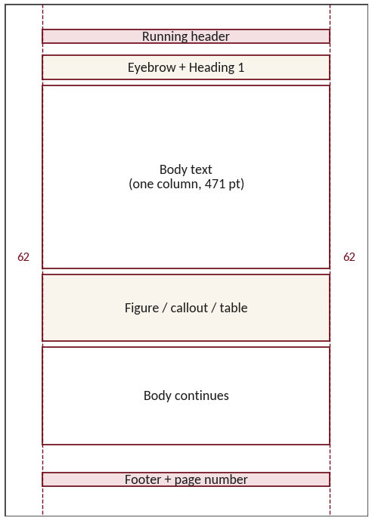 | Page  A4. Side margins 22 mm, top 26 mm, bottom 21 mm.  Column  One text column, 166 mm wide. Tables and figures use the full width.  Rhythm  Body text sits on a 15 pt line. Space between blocks is 8 pt, between sections 24 pt.  Covers  Covers are full bleed. Text sits in the sky or on a solid panel, never over the animal.
SKELETONS

Document skeletons
Document | Front | Body | Back
Annual report | Cover, contents | 6 numbered sections | Back cover
Student module | Cover, welcome, study guide | Units, assessment, notes | Back cover
Textbook | Cover, title, contents, preface | Chapters, appendix, glossary, index | Back cover
Prospectus | Cover, contents | 5 numbered sections | Back cover
Bulletin | Cover, in this issue | Feature, directory | Back cover
Letter and invoice | Letterhead | Reference line, body, signature | Footer

Print rules
- Cover photographs need 300 dpi at A4. The demo photo is about 120 dpi.
- Add 3 mm bleed to covers, cards and the folder before sending to a printer.
- Black-and-white versions use black only, with light grey for tints.
- Name files with a number, a type and a version, e.g. 04_Student_Module_BW.

