

STUDENT MODULE
ORX 1101
Tools of Measurement
Diploma in Applied Engineering
Level 5 · 12 credits · Semester 1
Name ____________________________________
Student no. _________________ Class __________
oryxinstitute.org · P.O. Box 1662, Windhoek

WELCOME

Tools of Measurement
Module code | ORX 1101
Level and credits | Level 5, 12 credits (120 notional hours)
Delivery | Weekly workshop and supervised practical
Prerequisites | None

Contents
How to use this module
Unit 1 Why we measure
1.1 Numbers in the trades
1.2 The measurement cycle
Unit 2 Instruments
Assessment
Notes

What you will be able to do
- Choose the right instrument for a given measurement task.
- Read and record measurements to the correct precision.
- Explain and reduce common sources of error.
- Report results so that another person can repeat them.
STUDY GUIDE

How to use this module
Each unit follows the same four steps.
Step | What you do | Time
Read | Read the unit text and study the figures. | 30 minutes
Do | Complete the activity at your bench. | 60 minutes
Check | Answer the review questions. | 20 minutes
Record | Enter your results in your logbook. | 10 minutes

TIP
Keep your logbook open while you read. A result you do not record on the day is a result you do not have.

Weekly plan
Week | Unit | Focus
1 to 3 | Unit 1 | Why we measure
4 to 6 | Unit 2 | Instruments
7 to 12 | Practical | Logbook and final examination
UNIT 1

Why we measure
IN THIS UNIT
You will learn why measurement matters, follow the five-step measurement cycle, and tell precision from accuracy.

1.1 Numbers in the trades
Every trade begins with a number. A carpenter cuts to a length, an electrician checks a voltage, a nurse reads a dose. When the number is wrong, the work is wrong, however good the hands that did it.

1.2 The measurement cycle
Measuring well is a habit with five steps. You define what you need to know, measure it, record it, check it, and report it. When the result cannot be repeated, you start again.
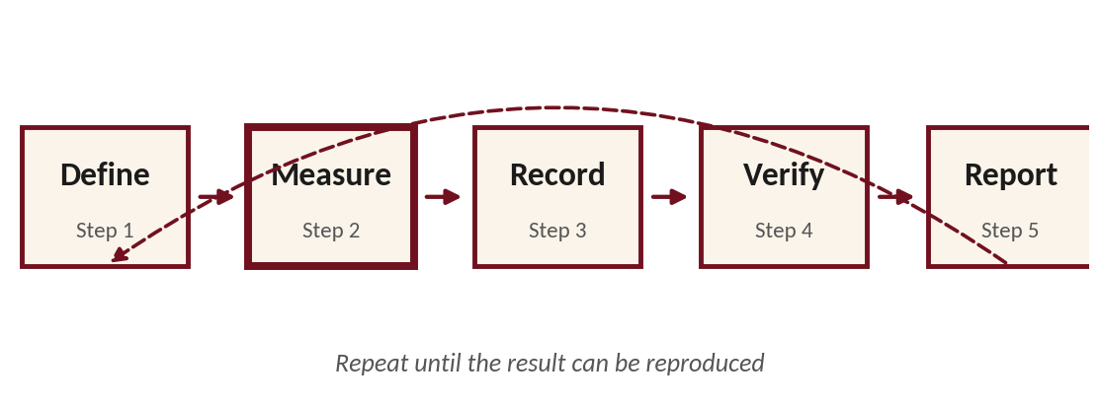
Figure 1.1. The measurement cycle.
KEY TERM
Precision describes how closely repeated measurements agree with each other. Accuracy describes how close they are to the true value.

1.3 Activity
Measure the length of your workbench three times, using a different instrument each time. Record each result and explain any differences.

Unit summary
- Measurement turns a question into a number you can repeat.
- The cycle has five steps: define, measure, record, verify, report.
- Precision is agreement; accuracy is closeness to the truth.

Review questions
- Name the five steps of the measurement cycle.

- Explain the difference between precision and accuracy, using an example from your own trade.

UNIT 2

Instruments
Choosing an instrument means matching its precision to the task. A steel rule is enough for a rough cut; a calliper is needed for a bearing seat.
Instrument | Measures | Typical precision
Steel rule | Length | 1 mm
Vernier calliper | Length, diameter | 0.02 mm
Micrometer | Thickness | 0.01 mm
Multimeter | Voltage, current | Depends on range

REMEMBER
An instrument cannot give you more precision than it was built with.

Activity 2.1
Choose an instrument for each of three tasks in your workshop. Explain your choice.

ASSESSMENT

Assessment
Component | Weight | What is assessed
Practical logbook | 30% | Complete, dated, repeatable records
Workshop test | 20% | Instrument choice and reading
Final practical examination | 50% | The full measurement cycle on a set task

Marking guide
Criterion | Excellent | Competent | Not yet
Records | Complete | Mostly complete | Missing
Precision | Correct | Minor errors | Incorrect
Reporting | Repeatable | Clear | Unclear

SUBMISSION
Hand in your logbook at the start of Week 12. Late work loses ten percent per day.
NOTES

Notes



You are only as good as your tools. We forge them.
Oryx Polytechnic Institute
P.O. Box 1662, Windhoek, Namibia
+264 81 341 1522 · oryxinstitute.org

