
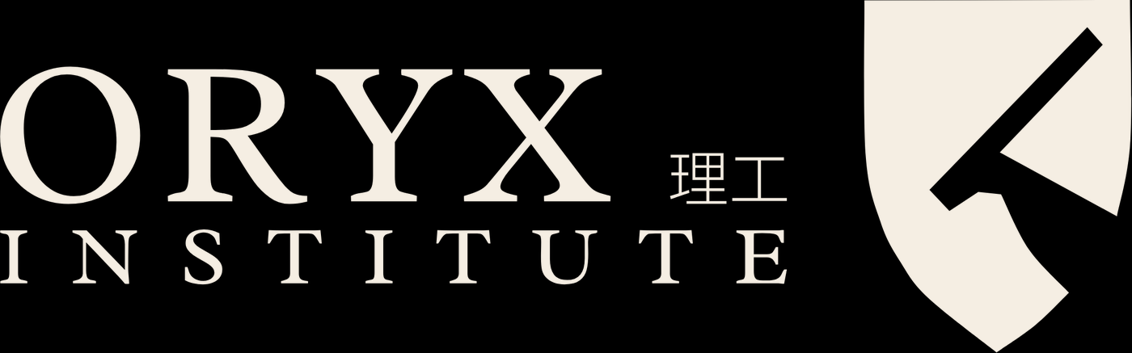
PROSPECTUS
2027
Programmes, admissions and life at Oryx Institute.
oryxinstitute.org

CONTENTS

Contents
1 Why Oryx
2 Programmes
2.1 Applied Engineering (Diploma)
3 How to apply
4 Fees and funding
5 Campus and contact
SECTION 1

Why Oryx
Research. Practice. Ventures.
Oryx Polytechnic Institute is a new polytechnic for Namibia, working from Windhoek. We teach applied skills in engineering, digital work, business and the trades, and we measure ourselves by what our learners build.

Research  We study real problems from Namibian industry and publish what we learn. | Practice  You learn at the bench, with the tools of the trade, from day one. | Ventures  Every course ends in a venture that proves the work.

We forge the tools.
Our programmes are short on lectures and long on making. You will spend most of your week in the workshop, working on briefs set by real partners.
SECTION 2

Programmes
Programme | Level | Duration | Mode
Applied Engineering (Diploma) | 5 | 2 years | Full-time
Digital Skills (Certificate) | 4 | 1 year | Full-time
Business and Ventures (Diploma) | 5 | 2 years | Full-time
Trades and Craft (Certificate) | 3 | 1 year | Part-time

PLEASE NOTE
Programmes are subject to accreditation by the NQA and NTA. Names, levels and durations shown here are placeholders.

2.1 Applied Engineering (Diploma)
A two-year diploma in measurement, materials and workshop practice, finishing in a venture of your own.
Year | Modules | Credits
1 | Tools of Measurement; Materials; Workshop Practice | 120
2 | Design for Making; Partner Project; Final Venture | 120

Entry requirements
- Grade 12 certificate or equivalent.
- A short interview and workshop trial.

Where it leads
Graduates work in workshops, maintenance, fabrication and small enterprise, or continue to further study.
SECTION 3

How to apply
- Choose your programme and read its entry requirements.
- Complete the application form and attach your documents.
- Attend a short interview and workshop trial.
- Receive your offer and confirm your place.

Key dates
Milestone | Date
Applications open | 1 September 2026
Applications close | 30 November 2026
Interviews | January 2027
Term begins | February 2027
SECTION 4

Fees and funding
Item | Per term (N$) | Per year (N$)
Tuition | [amount] | [amount]
Registration | [amount] | [amount]
Toolkit and materials | [amount] | [amount]

FUNDING
Information about bursaries and payment plans will be added here once confirmed.
SECTION 5

Campus and contact
Oryx Polytechnic Institute works from Windhoek, Namibia. Visit us during an open day to see the workshops.
Oryx Polytechnic Institute
P.O. Box 1662, Windhoek, Namibia
+264 81 341 1522 · info@oryxinstitute.org


You are only as good as your tools. We forge them.
Oryx Polytechnic Institute
P.O. Box 1662, Windhoek, Namibia
+264 81 341 1522 · oryxinstitute.org

