

ANNUAL REPORT · 2026
Building the tools Namibia needs
A first full year of research, practice and ventures at Oryx Institute.
Oryx Polytechnic Institute · Windhoek, Namibia
safeman.oryxinstitute.org

CONTENTS

Contents
1 Message from the Principal
2 The year at a glance
3 Programmes
4 Financial summary
5 Governance and people
6 Outlook

ABOUT THIS REPORT
This report covers the year to 31 December 2026. All names and figures are demo data.
SECTION 1

Message from the Principal
Tools first, then the trade.
This was the year we stopped talking about what a polytechnic for Namibia could be and started building one. Every programme in this report began with a simple question: what does a young person need in their hands to be useful on the first day of work?
The answer has not changed. Learners need measurement, craft and judgement, and they need to practise them on real problems for real clients. That is why every course at Oryx ends in a venture rather than a final exam.
You are only as good as your tools. We forge them.
Our thanks go to the partners who opened their workshops, the staff who gave up their weekends, and the first learners who trusted a new name.

Tangi Iigonda
PRINCIPAL
SECTION 2

The year at a glance
212  applications received | 64  learners enrolled | 9  industry partners | 3  ventures launched

Enrolments by programme area
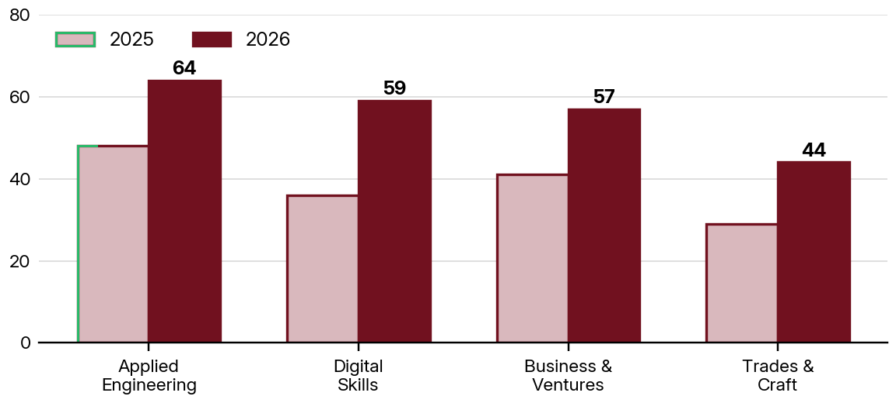
Figure 1. Enrolments by programme area, 2025 and 2026. Demo data.
Applied Engineering remained the largest area, while Digital Skills grew fastest as partners asked for learners who could record and report their own measurements.
SECTION 3

Programmes
Programme | Level | Learners | Partner projects
Applied Engineering | 5 | 27 | 4
Digital Skills | 4 | 17 | 2
Business and Ventures | 5 | 13 | 2
Trades and Craft | 3 | 7 | 1

Highlights
- First workshop cohort completed the measurement module.
- Two partner projects delivered to client briefs.
- The Oryx Directory published its fourth bulletin.
SECTION 4

Financial summary
Income | N$
Tuition and fees | 1,420,000
Grants and partnerships | 860,000
Venture revenue | 310,000
Total income | 2,590,000

Expenditure | N$
Teaching and workshops | 1,150,000
Facilities | 640,000
Equipment and materials | 410,000
Administration | 290,000
Total expenditure | 2,490,000

Surplus carried forward: N$ 100,000
NOTE
Demo data. Replace with audited figures before this report is published.
SECTION 5

Governance and people
Name | Role | Since
Tangi Iigonda | Principal | 2026
[Name] | Registrar | 2026
[Name] | Head of Applied Engineering | 2026
[Name] | Board chair | 2026

The board meets quarterly to review progress against the plan and approve the budget. Minutes are available on request.
SECTION 6

Outlook
What we will do in 2027.
- Open the second workshop and add evening classes.
- Complete accreditation applications with the NQA and NTA.
- Launch three further student ventures.

GET IN TOUCH
Tangi Iigonda, Principal · +264 81 341 1522 · info@oryxinstitute.org


You are only as good as your tools. We forge them.
Oryx Polytechnic Institute
, Namibia
+264 81 341 1522 · safeman.oryxinstitute.org

