

SAFEMAN · TEXTBOOK · LEVEL 5
Foundations of Applied Measurement
A practical course for engineers, makers and builders.
Oryx Institute Faculty of Applied Engineering
Oryx Institute Press · Windhoek, Namibia

FIRST EDITION
Foundations of Applied Measurement
A practical course for engineers, makers and builders.
Oryx Institute Faculty of Applied Engineering

Published by Oryx Institute Press, , Namibia.
First edition 2026. ISBN [to be assigned]
Copyright © 2026 Oryx Polytechnic Institute. All rights reserved. No part of this book may be reproduced without written permission.
Demo content. Replace all text before publication.

CONTENTS

Contents
Preface
1 Why we measure
1.1 Numbers in the trades
1.2 The measurement cycle
1.3 Units and symbols
1.4 Keeping a record
2 Units and standards
Appendix A: Worked solutions
Glossary
Index
PREFACE

Preface
Why this book exists.
This book is for people who work with their hands and their heads. It teaches measurement as a habit rather than a formula: define, measure, record, verify, report.
Each chapter opens with a short list of outcomes, builds the idea in small sections, and closes with a summary, key terms and review questions. Work through the examples at your bench, not only on the page.
We thank the partners and learners whose problems shaped these chapters.

Tangi Iigonda
PRINCIPAL

CHAPTER 1
01

Why we measure
“If you cannot measure it, you cannot repeat it.”

IN THIS CHAPTER
1.1 Numbers in the trades 1.2 The measurement cycle 1.3 Units and symbols 1.4 Keeping a record

What you will be able to do
- Explain why a trade depends on repeatable numbers.
- Follow the five-step measurement cycle.
- Use the base units correctly.
- Keep a record that another person can follow.

1.1 Numbers in the trades
Every trade begins with a number. A carpenter cuts to a length, an electrician checks a voltage, a nurse reads a dose. When the number is wrong, the work is wrong, however good the hands that did it.

1.2 The measurement cycle
Measuring well is a habit with five steps. First, define exactly what you need to know. Then measure it with a suitable instrument, record the result at once, verify it against a second reading, and report it clearly.
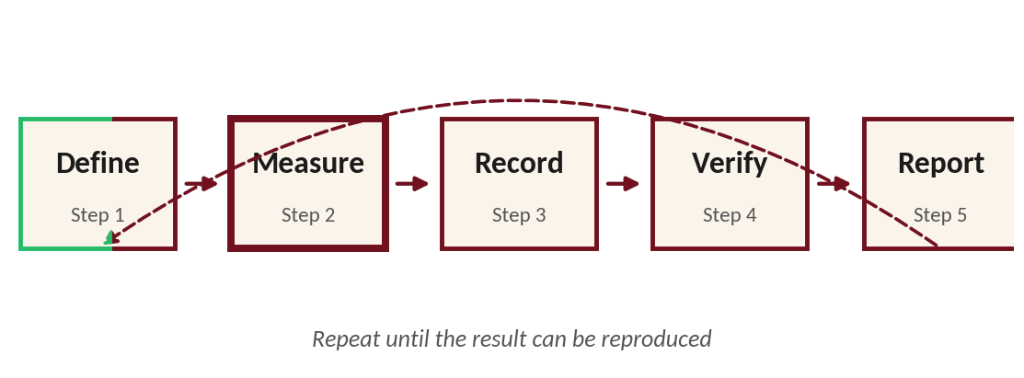
Figure 1.1. The measurement cycle.
WORKED EXAMPLE
A bench is measured three times: 1,200 mm, 1,201 mm and 1,199 mm. The mean is 1,200 mm, and the readings agree within 1 mm.

1.3 Units and symbols
Quantity | Unit | Symbol
Length | metre | m
Mass | kilogram | kg
Time | second | s
Electric current | ampere | A

1.4 Keeping a record
A result you did not write down is a result you do not have. Record the date, the instrument, the reading and your initials. Never rub out an entry; strike it through and write the correction beside it.

Chapter summary
- Measurement turns a question into a number you can repeat.
- The cycle has five steps: define, measure, record, verify, report.
- Always record the date, instrument, reading and initials.

Key terms
Term | Meaning
Precision | How closely repeated measurements agree.
Accuracy | How close a measurement is to the true value.
Verify | Check a result against a second, independent reading.

Review questions
- Name the five steps of the measurement cycle.

- Why must a result be recorded at the moment it is taken?

CHAPTER 2

Units and standards
This chapter is a placeholder. It follows the same structure as Chapter 1.
IN THIS CHAPTER
2.1 The base units 2.2 Prefixes 2.3 Standards and traceability
APPENDIX A

Worked solutions

Chapter 1, question 1
Define, measure, record, verify, report.

Chapter 1, question 2
Because memory fails, and a result that is not recorded cannot be repeated or checked.
GLOSSARY

Glossary
Term | Definition
Accuracy | Closeness of a measurement to the true value.
Calibration | Comparing an instrument with a known standard.
Precision | Agreement between repeated measurements.
Uncertainty | The doubt that remains in a measured value.
INDEX

Index
PLACEHOLDER
Generate the index in Word: mark entries, then References > Insert Index.



You are only as good as your tools. We forge them.
Oryx Polytechnic Institute
, Namibia
+264 81 341 1522 · safeman.oryxinstitute.org

