回顾

Maven的好处
节省空间 对jar包做了统一管理 依赖管理
一键构建
可跨平台
应用在大型项目可提高开发效率

Maven安装部署配置

Maven的仓库
本地仓库
远程仓库（私服）
中央仓库

添加依赖
从网络上搜索
在本地重建索引，以索引的方式搜索

项目构建
- Maven插件
Maven的核心仅仅定义了抽象的生命周期，具体的任务都是交由插件完成的，每个插件都能实现多个功 能，每个功能就是一个插件目标。Maven的生命周期与插件目标相互绑定，以完成某个具体的构建任 务。例如：compile就是插件maven-compiler-plugin的一个插件目标。
1、jdk编译插件
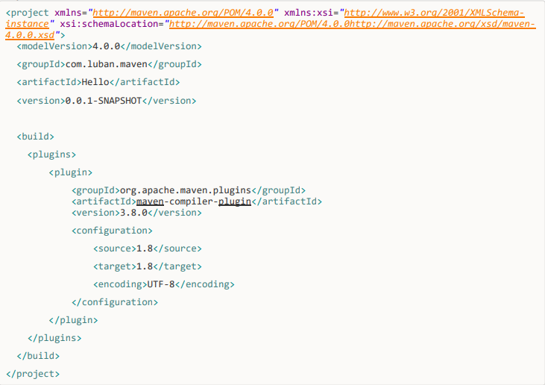
2、源码打包插件
1.解决idea中，创建web项目慢的方式：
在Properties中添加Name:archetypeCatalog和Value:internal,如下图那样 也可以在设置中指定Maven-Runne的VM： -DarchetypeCatalog为internal
2、打包插件pom.xml
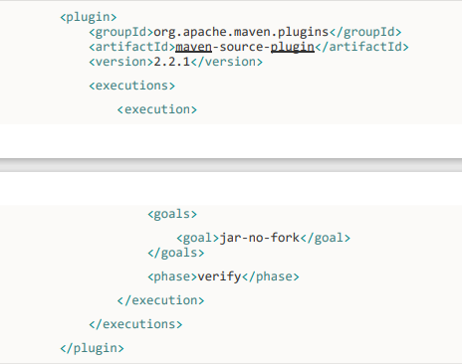
3、Tomcat插件
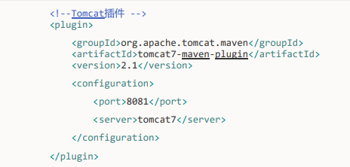

依赖范围
Compile struts2 框架jar
Provided jsp-api.jar 重点
Runtime 数据库驱动包
Test junit.jar

总结
<modelVersion>
坐标 GAV
<groupId>cn.itcast</groupId>
<artifactId>ssh</artifactId>
<version>0.0.1-SNAPSHOT</version>
Packaging 打包方式
Jar war pom
<dependencies>
<dependency>
<build> 里面放的是插件

<plugins>
<plugin>

整合ssh框架

依赖传递
只添加了一个struts2-core依赖，发现项目中出现了很多jar，
这种情况 叫 依赖传递

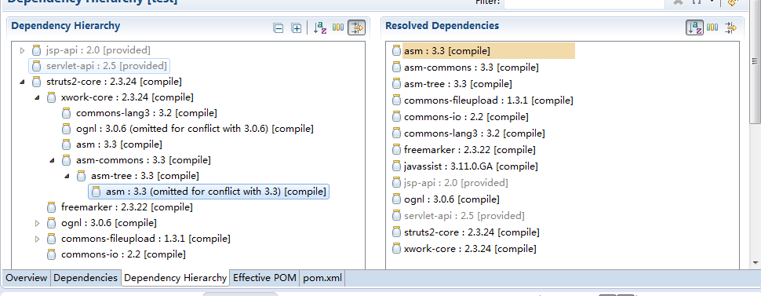

依赖版本冲突的解决
- 第一声明优先原则

<dependencies>
<!-- spring-beans-4.2.4 -->
<dependency>
<groupId>org.springframework</groupId>
<artifactId>spring-context</artifactId>
<version>4.2.4.RELEASE</version>
</dependency>

<!-- spring-beans-3.0.5 -->
<dependency>
<groupId>org.apache.struts</groupId>
<artifactId>struts2-spring-plugin</artifactId>
<version>2.3.24</version>
</dependency>

- 路径近者优先原则
自己添加jar包

<dependency>
<groupId>org.springframework</groupId>
<artifactId>spring-beans</artifactId>
<version>4.2.4.RELEASE</version>
</dependency>

- 排除原则

<dependency>
<groupId>org.apache.struts</groupId>
<artifactId>struts2-spring-plugin</artifactId>
<version>2.3.24</version>
<exclusions>
<exclusion>
<groupId>org.springframework</groupId>
<artifactId>spring-beans</artifactId>
</exclusion>
</exclusions>
</dependency>

- 版本锁定原则

<properties>
<spring.version>4.2.4.RELEASE</spring.version>
<hibernate.version>5.0.7.Final</hibernate.version>
<struts.version>2.3.24</struts.version>
</properties>

<!-- 锁定版本，struts2-2.3.24、spring4.2.4、hibernate5.0.7 -->
<dependencyManagement>
<dependencies>
<dependency>
<groupId>org.springframework</groupId>
<artifactId>spring-context</artifactId>
<version>${spring.version}</version>
</dependency>
</dependencies>
</dependencyManagement>

需求：
传客户ID 页面上显示客户信息
准备数据库

构建项目

- 创建数据库，
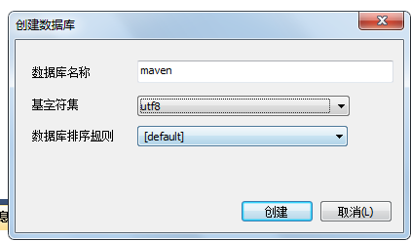

- 执行准备好的sql脚本
Sql脚本的位置：

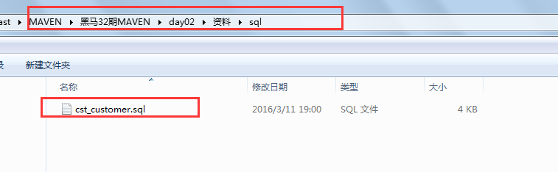

- 完善pom.xml文件，把ssh相关的依赖都添加上去
<!-- 属性 -->
<properties>
<spring.version>4.2.4.RELEASE</spring.version>
<hibernate.version>5.0.7.Final</hibernate.version>
<struts.version>2.3.24</struts.version>
</properties>

<!-- 锁定版本，struts2-2.3.24、spring4.2.4、hibernate5.0.7 -->
<dependencyManagement>
<dependencies>
<dependency>
<groupId>org.springframework</groupId>
<artifactId>spring-context</artifactId>
<version>${spring.version}</version>
</dependency>
<dependency>
<groupId>org.springframework</groupId>
<artifactId>spring-aspects</artifactId>
<version>${spring.version}</version>
</dependency>
<dependency>
<groupId>org.springframework</groupId>
<artifactId>spring-orm</artifactId>
<version>${spring.version}</version>
</dependency>
<dependency>
<groupId>org.springframework</groupId>
<artifactId>spring-test</artifactId>
<version>${spring.version}</version>
</dependency>
<dependency>
<groupId>org.springframework</groupId>
<artifactId>spring-web</artifactId>
<version>${spring.version}</version>
</dependency>
<dependency>
<groupId>org.hibernate</groupId>
<artifactId>hibernate-core</artifactId>
<version>${hibernate.version}</version>
</dependency>
<dependency>
<groupId>org.apache.struts</groupId>
<artifactId>struts2-core</artifactId>
<version>${struts.version}</version>
</dependency>
<dependency>
<groupId>org.apache.struts</groupId>
<artifactId>struts2-spring-plugin</artifactId>
<version>${struts.version}</version>
</dependency>
</dependencies>
</dependencyManagement>
<!-- 依赖管理 -->
<dependencies>
<!-- spring -->
<dependency>
<groupId>org.springframework</groupId>
<artifactId>spring-context</artifactId>
</dependency>
<dependency>
<groupId>org.springframework</groupId>
<artifactId>spring-aspects</artifactId>
</dependency>
<dependency>
<groupId>org.springframework</groupId>
<artifactId>spring-orm</artifactId>
</dependency>
<dependency>
<groupId>org.springframework</groupId>
<artifactId>spring-test</artifactId>
</dependency>
<dependency>
<groupId>org.springframework</groupId>
<artifactId>spring-web</artifactId>
</dependency>
<!-- hibernate -->
<dependency>
<groupId>org.hibernate</groupId>
<artifactId>hibernate-core</artifactId>
</dependency>

<!-- 数据库驱动 -->
<dependency>
<groupId>mysql</groupId>
<artifactId>mysql-connector-java</artifactId>
<version>5.1.6</version>
<scope>runtime</scope>
</dependency>
<!-- c3p0 -->

<dependency>
<groupId>c3p0</groupId>
<artifactId>c3p0</artifactId>
<version>0.9.1.2</version>
</dependency>

<!-- 导入 struts2 -->
<dependency>
<groupId>org.apache.struts</groupId>
<artifactId>struts2-core</artifactId>
</dependency>
<dependency>
<groupId>org.apache.struts</groupId>
<artifactId>struts2-spring-plugin</artifactId>
</dependency>

<!-- servlet jsp -->
<dependency>
<groupId>javax.servlet</groupId>
<artifactId>servlet-api</artifactId>
<version>2.5</version>
<scope>provided</scope>
</dependency>
<dependency>
<groupId>javax.servlet</groupId>
<artifactId>jsp-api</artifactId>
<version>2.0</version>
<scope>provided</scope>
</dependency>
<!-- 日志 -->
<dependency>
<groupId>org.slf4j</groupId>
<artifactId>slf4j-log4j12</artifactId>
<version>1.7.2</version>
</dependency>
<!-- junit -->
<dependency>
<groupId>junit</groupId>
<artifactId>junit</artifactId>
<version>4.9</version>
<scope>test</scope>
</dependency>
<!-- jstl -->
<dependency>
<groupId>javax.servlet</groupId>
<artifactId>jstl</artifactId>
<version>1.2</version>
</dependency>
</dependencies>

<build>
<plugins>
<!-- 设置编译版本为1.7 -->
<plugin>
<groupId>org.apache.maven.plugins</groupId>
<artifactId>maven-compiler-plugin</artifactId>
<configuration>
<source>1.7</source>
<target>1.7</target>
<encoding>UTF-8</encoding>
</configuration>
</plugin>

<!-- maven内置 的tomcat6插件 -->
<plugin>
<groupId>org.codehaus.mojo</groupId>
<artifactId>tomcat-maven-plugin</artifactId>
<version>1.1</version>
<configuration>
<!-- 可以灵活配置工程路径 -->
<path>/ssh</path>
<!-- 可以灵活配置端口号 -->
<port>8080</port>
</configuration>
</plugin>
</plugins>
</build>

- 完成实体类代码
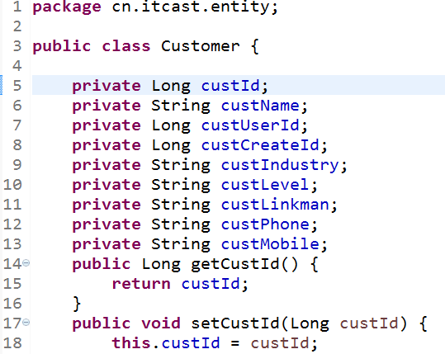

- 完成dao代码
接口
package cn.itcast.dao;

import cn.itcast.entity.Customer;

public interface CustomerDao {

public Customer getById(Long id);

}
实现类
package com.itcast.dao.impl;
import org.springframework.orm.hibernate5.support.HibernateDaoSupport;
import cn.itcast.dao.CustomerDao;
import cn.itcast.entity.Customer;
public class CustomerDaoImpl extends HibernateDaoSupport implements CustomerDao {
@Override
public Customer getById(Long id) {
return this.getHibernateTemplate().get(Customer.class, id);
}
}

- 完成service代码
接口
package com.itcast.service;
import cn.itcast.entity.Customer;
public interface CustomerService {
public Customer getById(Long id);
}

实现类
package com.itcast.service.impl;

import com.itcast.service.CustomerService;

import cn.itcast.dao.CustomerDao;
import cn.itcast.entity.Customer;

public class CustomerServiceImpl implements CustomerService {
private CustomerDao customerDao;
public void setCustomerDao(CustomerDao customerDao) {
this.customerDao = customerDao;
}
@Override
public Customer getById(Long id) {
return customerDao.getById(id);
}
}

- 完成action代码
package cn.itcast.action;
import com.itcast.service.CustomerService;
import com.opensymphony.xwork2.ActionSupport;
import cn.itcast.entity.Customer;
public class CutomerAction extends ActionSupport {
//两个成员变量
private Customer customer;

private Long custId;
public Customer getCustomer() {
return customer;
}
public void setCustomer(Customer customer) {
this.customer = customer;
}
private CustomerService customerService;
public void setCustomerService(CustomerService customerService) {
this.customerService = customerService;
}
public Long getCustId() {
return custId;
}
public void setCustId(Long custId) {
this.custId = custId;
}
public String findById(){
customer = customerService.getById(custId);
return SUCCESS;
}
}

- 拷贝配置文件并修改
从如下图位置拿到配置文件
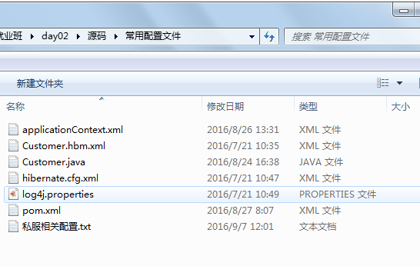
放入到 src/main/resources目录中
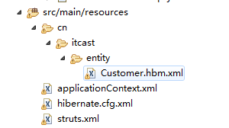

修改内容 略

- 修改web.xml 添加spring的监听

<listener>
<listener-class>org.springframework.web.context.ContextLoaderListener</listener-class>
</listener>
<context-param>
<param-name>contextConfigLocation</param-name>
<param-value>classpath:applicationContext.xml</param-value>
</context-param>

- 运行项目

分模块开发
依赖范围对依赖传递造成的影响（了解）

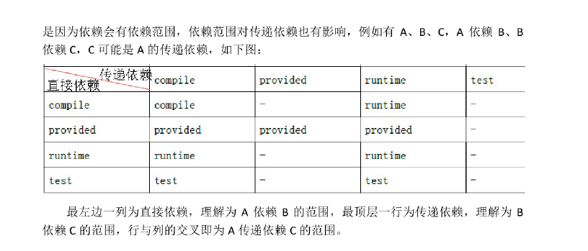
父工程来管理 聚合

创建父工程：
1、
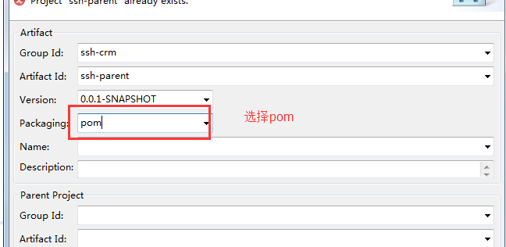
2、创建出的父工程如下

3、在pom.Xml中添加以下信息：

<!-- 属性 -->
<properties>
<spring.version>4.2.4.RELEASE</spring.version>
<hibernate.version>5.0.7.Final</hibernate.version>
<struts.version>2.3.24</struts.version>
</properties>

<!-- 锁定版本，struts2-2.3.24、spring4.2.4、hibernate5.0.7 -->
<dependencyManagement>
<dependencies>
<dependency>
<groupId>org.springframework</groupId>
<artifactId>spring-context</artifactId>
<version>${spring.version}</version>
</dependency>
<dependency>
<groupId>org.springframework</groupId>
<artifactId>spring-aspects</artifactId>
<version>${spring.version}</version>
</dependency>
<dependency>
<groupId>org.springframework</groupId>
<artifactId>spring-orm</artifactId>
<version>${spring.version}</version>
</dependency>
<dependency>
<groupId>org.springframework</groupId>
<artifactId>spring-test</artifactId>
<version>${spring.version}</version>
</dependency>
<dependency>
<groupId>org.springframework</groupId>
<artifactId>spring-web</artifactId>
<version>${spring.version}</version>
</dependency>
<dependency>
<groupId>org.hibernate</groupId>
<artifactId>hibernate-core</artifactId>
<version>${hibernate.version}</version>
</dependency>
<dependency>
<groupId>org.apache.struts</groupId>
<artifactId>struts2-core</artifactId>
<version>${struts.version}</version>
</dependency>
<dependency>
<groupId>org.apache.struts</groupId>
<artifactId>struts2-spring-plugin</artifactId>
<version>${struts.version}</version>
</dependency>
</dependencies>
</dependencyManagement>
<!-- 依赖管理 -->
<dependencies>
<!-- spring -->
<dependency>
<groupId>org.springframework</groupId>
<artifactId>spring-context</artifactId>
</dependency>
<dependency>
<groupId>org.springframework</groupId>
<artifactId>spring-aspects</artifactId>
</dependency>
<dependency>
<groupId>org.springframework</groupId>
<artifactId>spring-orm</artifactId>
</dependency>
<dependency>
<groupId>org.springframework</groupId>
<artifactId>spring-test</artifactId>
</dependency>
<dependency>
<groupId>org.springframework</groupId>
<artifactId>spring-web</artifactId>
</dependency>
<!-- hibernate -->
<dependency>
<groupId>org.hibernate</groupId>
<artifactId>hibernate-core</artifactId>
</dependency>

<!-- 数据库驱动 -->
<dependency>
<groupId>mysql</groupId>
<artifactId>mysql-connector-java</artifactId>
<version>5.1.6</version>
<scope>runtime</scope>
</dependency>
<!-- c3p0 -->

<dependency>
<groupId>c3p0</groupId>
<artifactId>c3p0</artifactId>
<version>0.9.1.2</version>
</dependency>

<!-- 导入 struts2 -->
<dependency>
<groupId>org.apache.struts</groupId>
<artifactId>struts2-core</artifactId>
</dependency>
<dependency>
<groupId>org.apache.struts</groupId>
<artifactId>struts2-spring-plugin</artifactId>
</dependency>

<!-- servlet jsp -->
<dependency>
<groupId>javax.servlet</groupId>
<artifactId>servlet-api</artifactId>
<version>2.5</version>
<scope>provided</scope>
</dependency>
<dependency>
<groupId>javax.servlet</groupId>
<artifactId>jsp-api</artifactId>
<version>2.0</version>
<scope>provided</scope>
</dependency>
<!-- 日志 -->
<dependency>
<groupId>org.slf4j</groupId>
<artifactId>slf4j-log4j12</artifactId>
<version>1.7.2</version>
</dependency>
<!-- junit -->
<dependency>
<groupId>junit</groupId>
<artifactId>junit</artifactId>
<version>4.9</version>
<scope>test</scope>
</dependency>
<!-- jstl -->
<dependency>
<groupId>javax.servlet</groupId>
<artifactId>jstl</artifactId>
<version>1.2</version>
</dependency>
</dependencies>

<build>
<plugins>
<!-- 设置编译版本为1.7 -->
<plugin>
<groupId>org.apache.maven.plugins</groupId>
<artifactId>maven-compiler-plugin</artifactId>
<configuration>
<source>1.7</source>
<target>1.7</target>
<encoding>UTF-8</encoding>
</configuration>
</plugin>

<!-- maven内置 的tomcat6插件 -->
<plugin>
<groupId>org.codehaus.mojo</groupId>
<artifactId>tomcat-maven-plugin</artifactId>
<version>1.1</version>
<configuration>
<!-- 可以灵活配置工程路径 -->
<path>/ssh</path>
<!-- 可以灵活配置端口号 -->
<port>8080</port>
</configuration>
</plugin>

</plugins>
</build>

4、发布到本地仓库

dao service web

创建dao子模块
1、在ssh-parent项目上右击 ，创建时选择 Maven Module
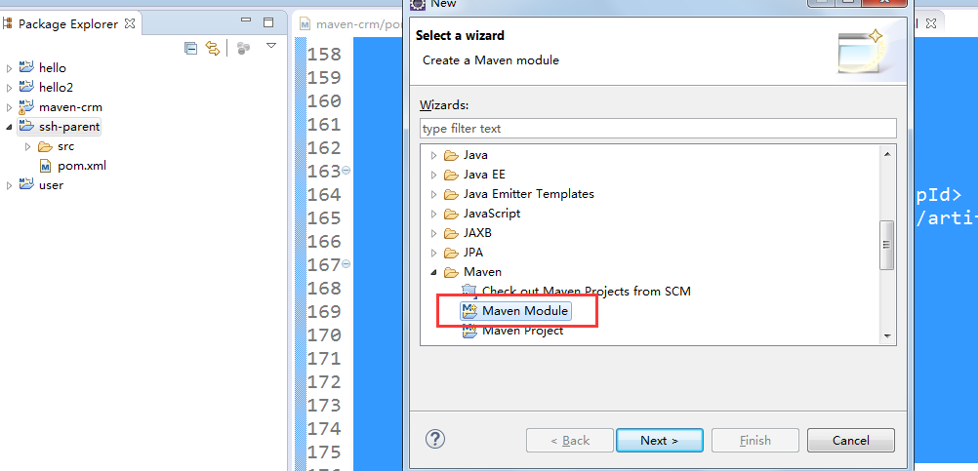
2、填写子模块名称ssh-dao
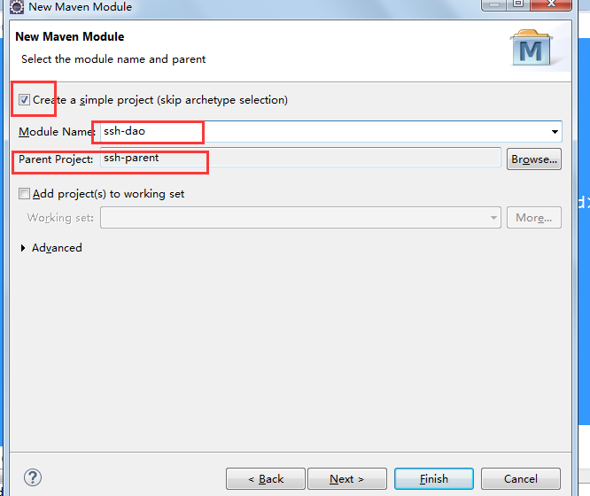
3、把属于dao的代码拷贝到 该模块中：
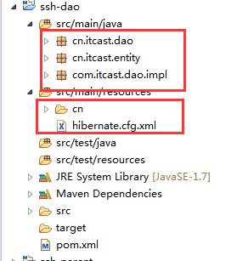
4、完成后发布到本地仓库中

创建service子模块
1、创建方式如上：
2、把属于service的代码拷贝到该工程中
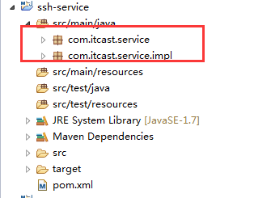
3、发布到本地仓库中

创建Action子模块
1、选择war的打包方式
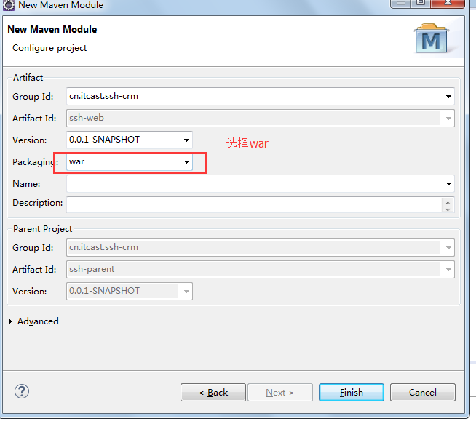
- 拷贝属于action的代码和配置文件
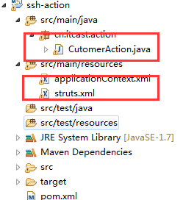
- 修改web.xml 添加spring监听

<listener>
<listener-class>org.springframework.web.context.ContextLoaderListener</listener-class>
</listener>

<context-param>
<param-name>contextConfigLocation</param-name>
<param-value>classpath*:applicationContext-*.xml</param-value>
</context-param>

4、添加页面：
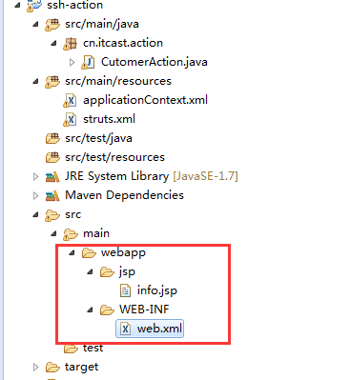

私服 nexus
安装nexus
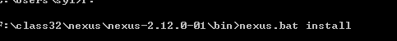
启动服务
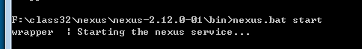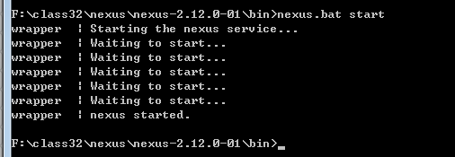
启动失败的解决方法：

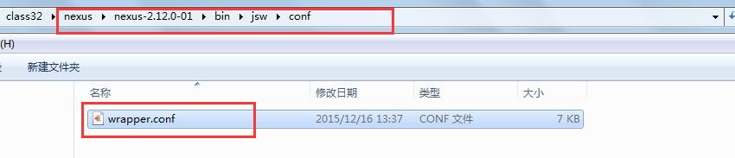
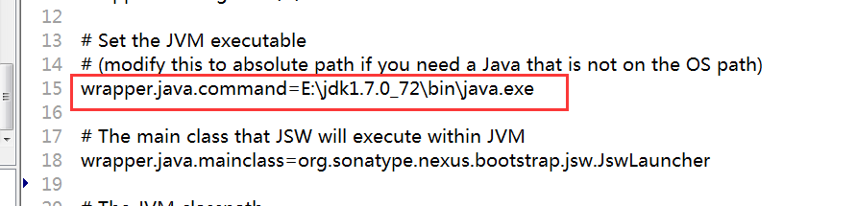

登录nexus
用户名/密码 admin/admin123

仓库类型
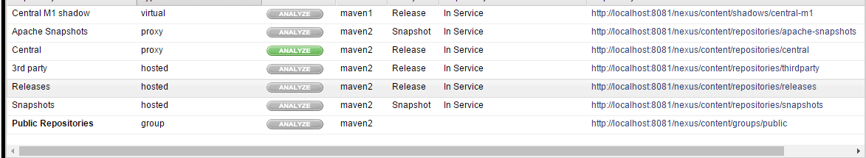

Virtual 虚拟仓库
Proxy 代理仓库
Hosted 宿主仓库 本地仓库
Group 组
需求：
把dao放到私服上，然后service从私服上下载

需求 ：将ssh_dao的这个工程打成jar包，并放入到私服上去.

上传dao
第一步： 需要在客户端即部署dao工程的电脑上配置 maven环境，并修改 settings.xml 文件，配置连接私服的用户和密码 。

此用户名和密码用于私服校验，因为私服需要知道上传都 的账号和密码 是否和私服中的账号和密码 一致。

<server>
<id>releases</id>
<username>admin</username>
<password>admin123</password>
</server>
<server>
<id>snapshots</id>
<username>admin</username>
<password>admin123</password>
</server>

第二步： 配置项目pom.xml

配置私服仓库的地址，本公司的自己的jar包会上传到私服的宿主仓库，根据工程的版本号决定上传到哪个宿主仓库，如果版本为release则上传到私服的release仓库，如果版本为snapshot则上传到私服的snapshot仓库

<distributionManagement>
<repository>
<id>releases</id>
<url>http://localhost:8081/nexus/content/repositories/releases/</url>
</repository>
<snapshotRepository>
<id>snapshots</id>
<url>http://localhost:8081/nexus/content/repositories/snapshots/</url>
</snapshotRepository>
</distributionManagement>

注意：pom.xml这里<id> 和 settings.xml 配置 <id> 对应！

第三步：执行deploy命令发布到私服

下载dao
第一步 修改settings.xml
<profile>
<!--profile的id-->
<id>dev</id>
<repositories>
<repository>
<!--仓库id，repositories可以配置多个仓库，保证id不重复-->
<id>nexus</id>
<!--仓库地址，即nexus仓库组的地址-->
<url>http://localhost:8081/nexus/content/groups/public/</url>
<!--是否下载releases构件-->
<releases>
<enabled>true</enabled>
</releases>
<!--是否下载snapshots构件-->
<snapshots>
<enabled>true</enabled>
</snapshots>
</repository>
</repositories>
<pluginRepositories>
<!-- 插件仓库，maven的运行依赖插件，也需要从私服下载插件 -->
<pluginRepository>
<!-- 插件仓库的id不允许重复，如果重复后边配置会覆盖前边 -->
<id>public</id>
<name>Public Repositories</name>
<url>http://localhost:8081/nexus/content/groups/public/</url>
</pluginRepository>
</pluginRepositories>
</profile>

<activeProfiles>
<activeProfile>dev</activeProfile>
</activeProfiles>

第二步 删除本地仓库中的dao

第三步 update service工程，出现以下信息说明已经成功
