Objects（对象）:

UCLASSKF

Class 1

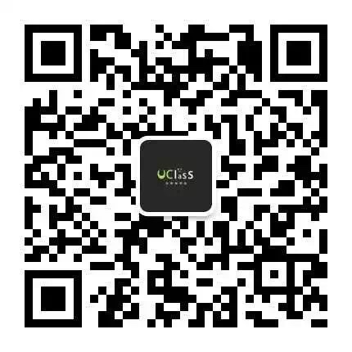

UClass CSC148

2017 Winter

* Python是Object-Oriented Programming language, 所有东西都是Object
* 例如A = person()
* 那么A就是1个object
* Objects可以有很多的attributes，例如age, height, weight,…
* Strings

w1=“word”

w2=w1.lower()

w1和w2有同样的内容，所以w1==w2 TRUE

但是他们并不是同一个object，我们可以用id()来解释

为什么 w1 is w2的结果是FALSE

* Turtles/画图板

<https://docs.python.org/2/library/turtle.html>

Example: tur.py

# Class（类）

用来描述具有相同属性（attributes）和方法（methods）的对象（objects）的集合。

对象是类的实例。 Object is an instance of class。

* Class可以有很多的functions，例如
* 一个名为Person的class可以有eat()，walk()

使用class来创建新的class，以冒号结尾，例如

class student：

things。。。

在class的里面，__init__是用来初始化，当新的class被创立的时候，里面的__init__会自动运行一次。

__str__以及__repr__ 是用来显示print statement

__del__ 删除

https://docs.python.org/3/reference/datamodel.html

# Inheritance/继承

* 让新的class继承旧的class，同时只需要写上与原class不同的地方
* 新的class叫做subclass，母class叫做superclass
* Is-a关系：class dog一定是class animal，所以这里就是一个is-a的关系
* Has-a关系：dog可以有一个method，eat()，这里就是has-a的关系
* 这两种关系可以帮忙决定是否可以继承旧的class
* Is-a可以，has-a不行

Python 继承的几个特点

在subclass中必须手动定义__init__，superclass中的__init__不会被调用

Python总是会在subclass中先查找method，假如没有才回去superclass找

可以用issubclass()来检测

inh.py

Override:

假如superclass中的method不够用，那么可以在subclass重写

Pet.py/ship.py

# Examples:

1. <https://mcs.utm.utoronto.ca/~148/lecture1_dan/building.txt> 解释

2.试着做exercise https://mcs.utm.utoronto.ca/~148/lecture1_dan/handout.pdf

Question 1 Write one or more classes for the following specification. Begin by carrying out an object-oriented analysis to determine the classes, methods, attributes, and interactions. Context: An airline reservation system Each seat on a plane is classified as business class or economy, and has a unique name (like “17C”). Passengers have booking IDs (a mix of letters and numbers). When they book a seat, they request their preferred class (business or economy) and are given any seat in that class. If the chosen class is full, then their booking is unsuccessful. This airline gives passengers no choice about their specific seat. We want to be able to report on how full a flight is: the percentage of seats that are booked in economy, in business class, and overall.

3.解释

4.Q2解释

课件及py文件

https://github.com/tangkaiq/uclass/tree/master/w1