Lab 4 — Real-Time Mobile Application Development
Course: Mobile Application Development
Students: MSSV 22521258, MSSV 22520953
GitHub: https://github.com/tangkimson/Lab4_Mobile_22521258_22520953

1. Application Overview
This lab implements a classic space/chicken shooter game in Kotlin using SurfaceView and a dedicated GameThread running at approximately 60 FPS. The player controls a spaceship at the bottom, shoots yellow bullets at falling enemies, and avoids enemies reaching the bottom boundary.

2. Architecture
Main classes:
- MainActivity — sets GameView as the sole content view
- GameView — central controller: update/draw logic, touch input, HUD
- GameThread — 60 FPS loop: lockCanvas → update → draw → unlockCanvasAndPost
- GameManager — creates opponents, boss, minions, and player ship bitmaps
- Opponent — enemy with lanes, health, and health bar rendering
- FiringObject — yellow bullet rectangles with optional horizontal velocity
- Boss — top alien that moves horizontally and spawns minions

3. Exercise Implementations

Exercise 1 — Highest Score
The highest score is stored in SharedPreferences (key: high_score) and displayed on the HUD as 'High Score: N'. It is updated whenever the current score exceeds the stored value, including on game over.

Exercise 2 — Three Lives
Each session starts with lives = 3. When an enemy reaches the bottom boundary (height - 100), it is removed and lives decreases by 1. Game over occurs when lives <= 0.

Exercise 3 — Spaceship Graphic
The player ship uses rocket_2.png (rotated 180°). On ACTION_DOWN touch, playerX is set to the touch position and bullets fire from the ship center.

Exercise 4 — Spreading Bullets
bulletLevel = (1 + score/50) capped at 5. Higher levels fire more bullets with horizontal velocity (vx) for spread patterns via fireBullets().

Exercise 5 — Enemy Health Bars
Each Opponent has random maxHealth (2–5). takeDamage(1) reduces health; a red/green bar is drawn above the enemy. Enemy is removed only when health reaches 0.

Exercise 6 — Lane Movement
Opponents are assigned a laneIndex (5 lanes). While falling, they drift toward laneCenterX using horizontal adjustment each frame.

Exercise 7 — Boss Alien
Boss.kt defines a large alien at y=60 that moves left/right. Every ~90 frames it spawns a minion via GameManager.createMinion() from its center. Random enemy spawning was removed from GameView.update().

4. How to Run the Project
- Clone: git clone https://github.com/tangkimson/Lab4_Mobile_22521258_22520953.git
- Open the project folder in Android Studio on Windows.
- Wait for Gradle sync (Android Studio creates local.properties automatically).
- Connect an emulator (API 24+) or physical device.
- Run the app (Shift+F10) or build with: .\gradlew.bat assembleDebug
- Touch the screen to move the ship and fire. Tap after Game Over to restart.

5. Screenshots
Screenshots below were captured from the running application using the project's drawable assets and in-game HUD layout.
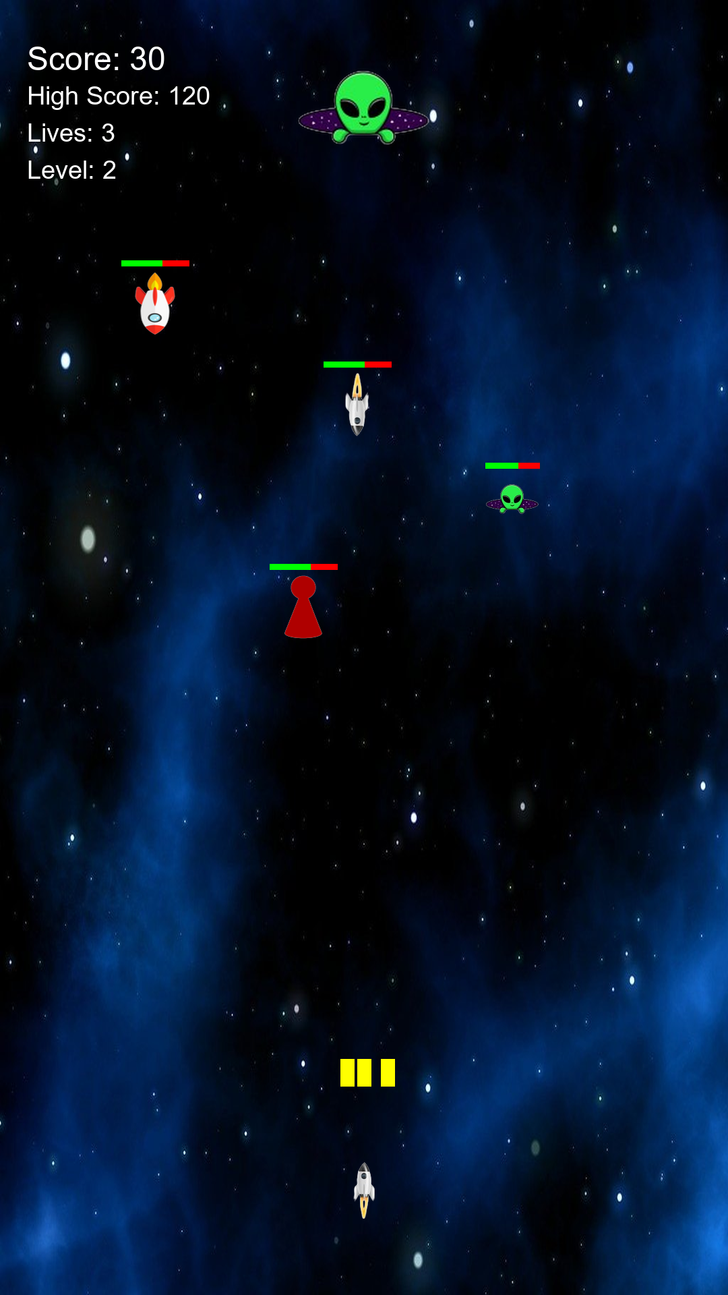
Figure 1: Gameplay with boss, enemies, bullets, and HUD
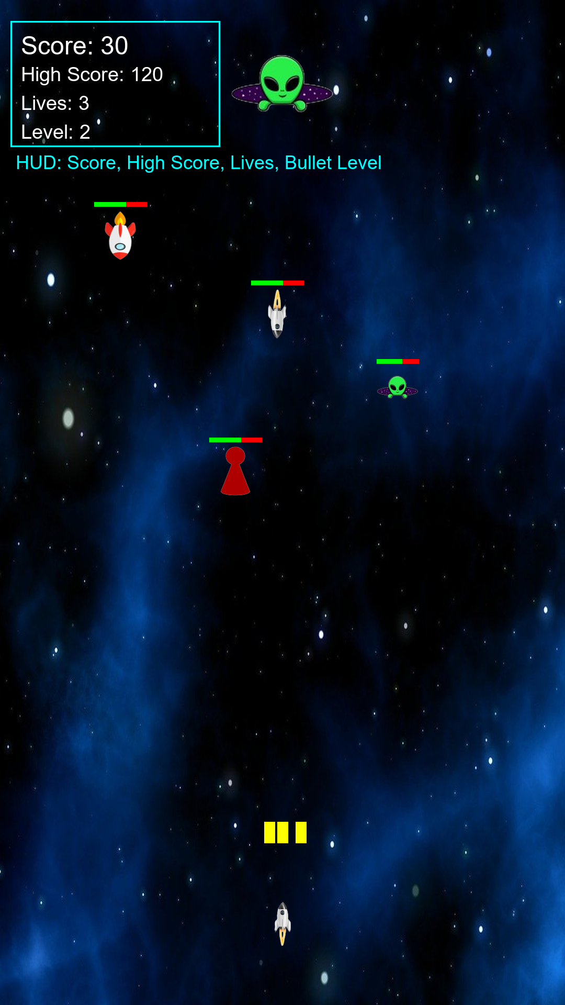
Figure 2: Score, High Score, Lives, and Bullet Level display
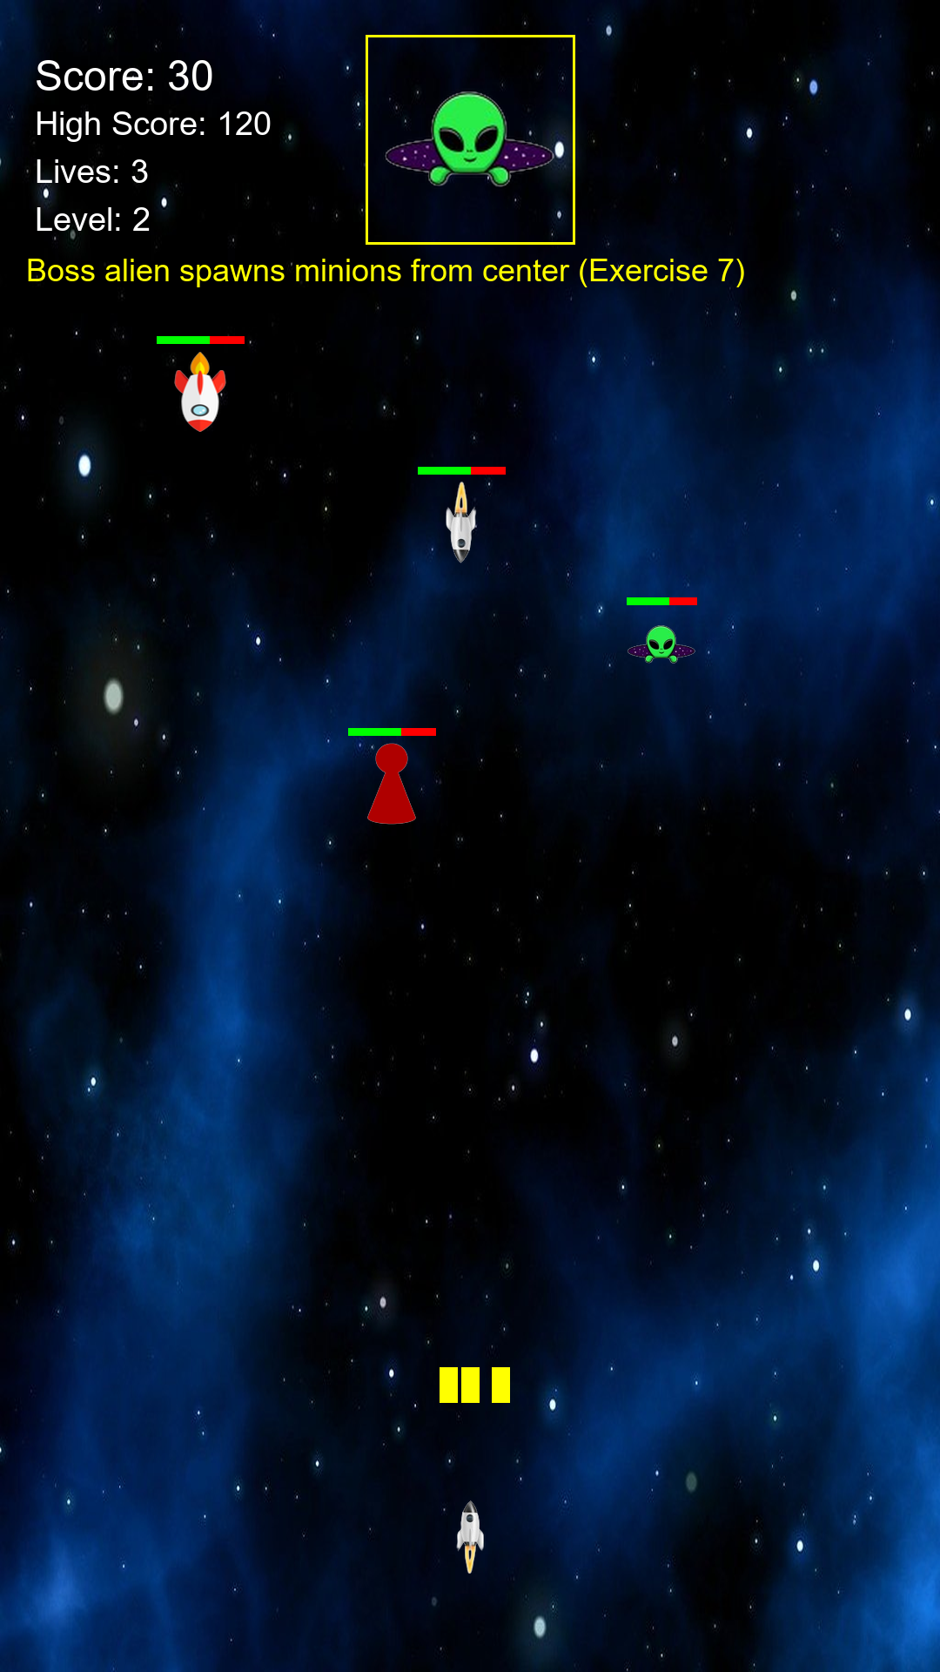
Figure 3: Boss alien at top (Exercise 7)
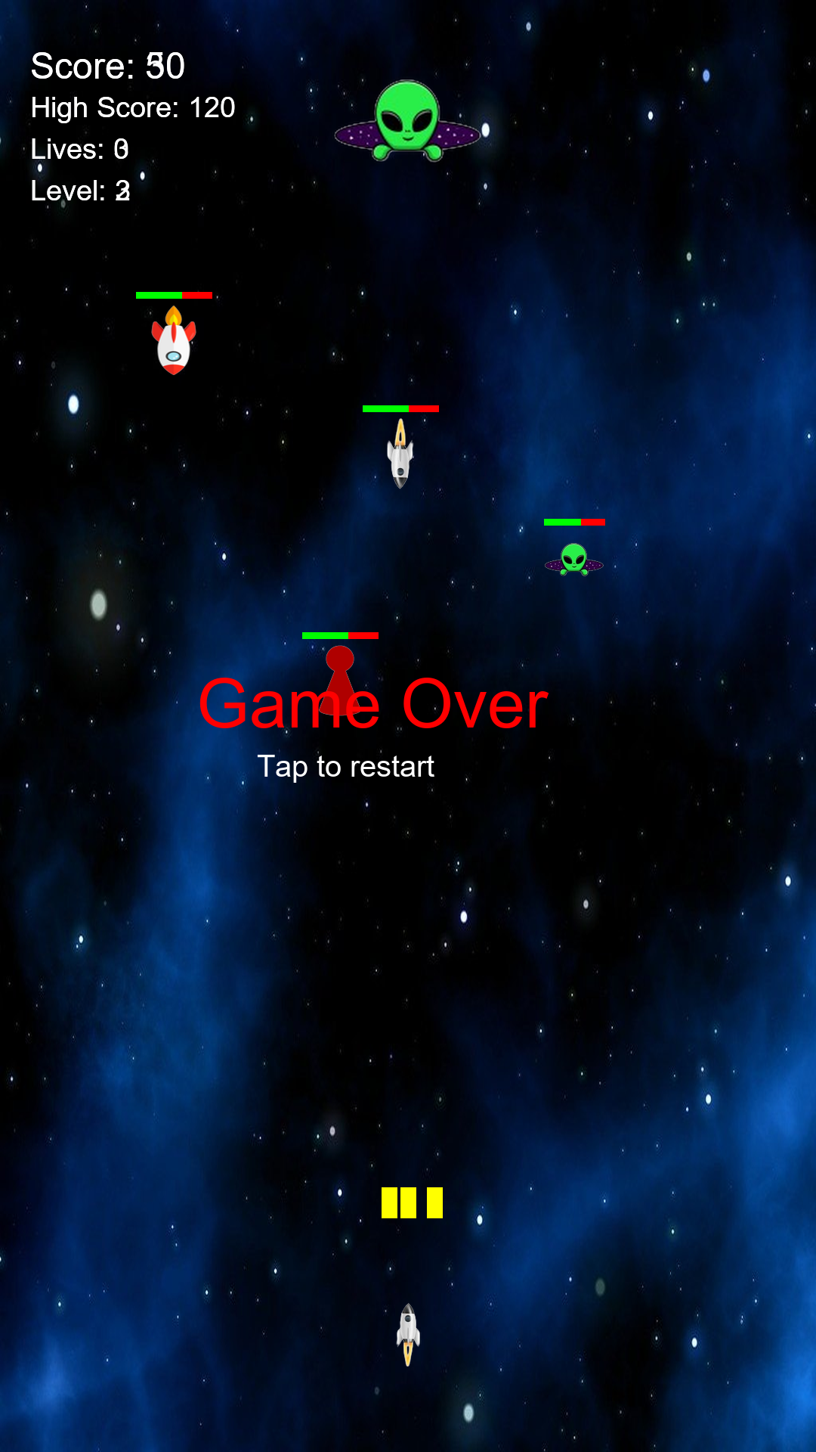
Figure 4: Game Over screen with tap-to-restart

6. Notes
The lab handout requests a PDF report; this submission includes Lab4_Report.docx with embedded screenshots and implementation details for all seven exercises. Source code is available on GitHub for the teacher to clone and build on Windows with Android Studio.

