UNSW-COMP-9331
Tian Huang
20215-Nov-16
LAB 5

Exercise 1:
Question 1:
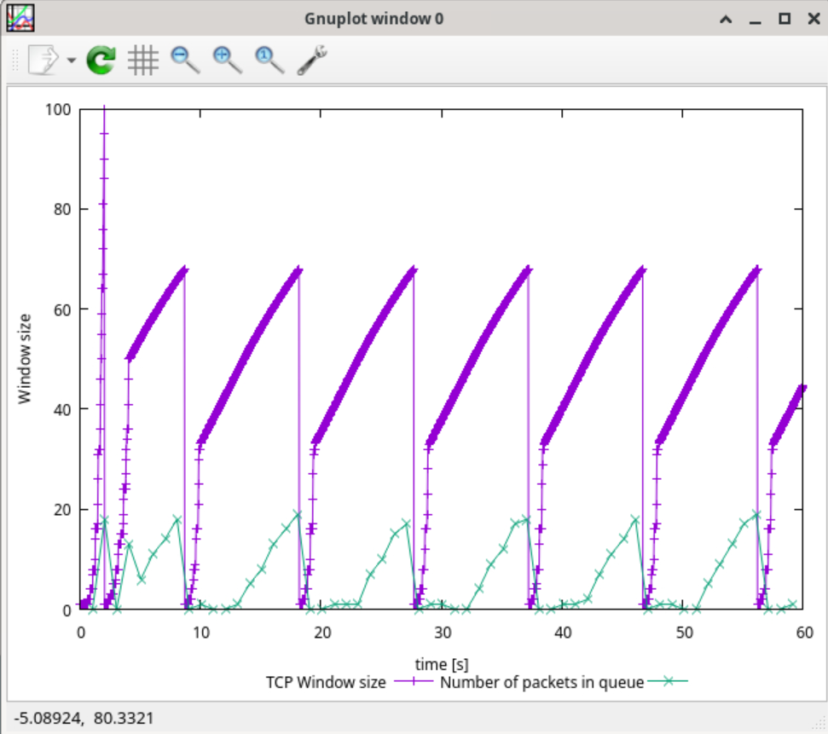
Part A:
Maximum value about 68-70 packets
50 packets in 1 Mbps link with 200ms RTT + 20 packets queue
Part B:
TCP detects the packet loss
The congestion windows drop to 1
The slow start threshold set to half of window size when loss
Part C:
When window collapses 1, sender slow start, congestion window grow
When it reach slow start threshold, switch to congestion avoidance
When windows increase and achieve 70 packets, queue fill up, queue fills, packet loss, windows drop to 1, everything repeat
Question 2:
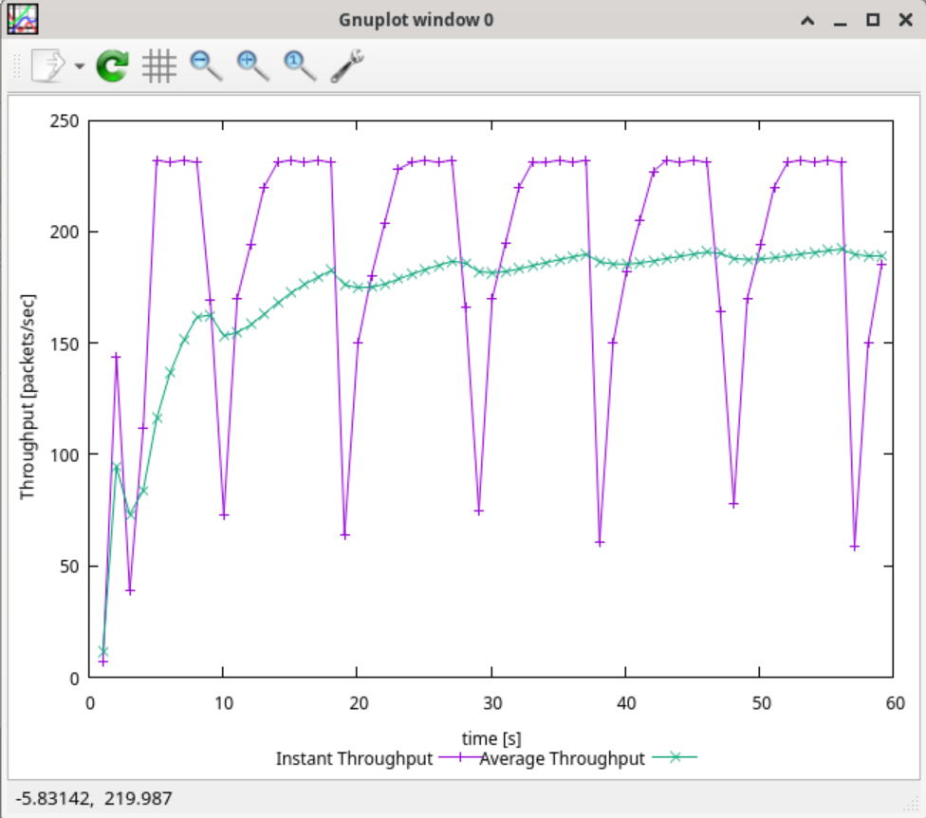
Average throughput 188 packet/s
640 bytes = 4320 bits
188 * 4320 = 812160 bps = 812 kbps
Question 3:
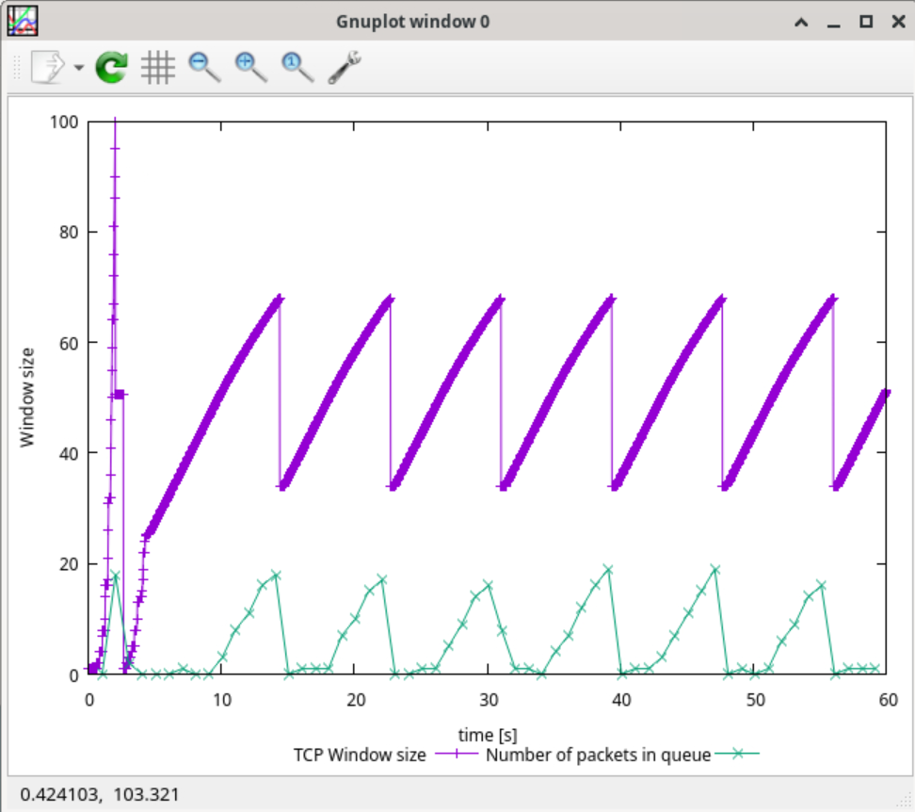
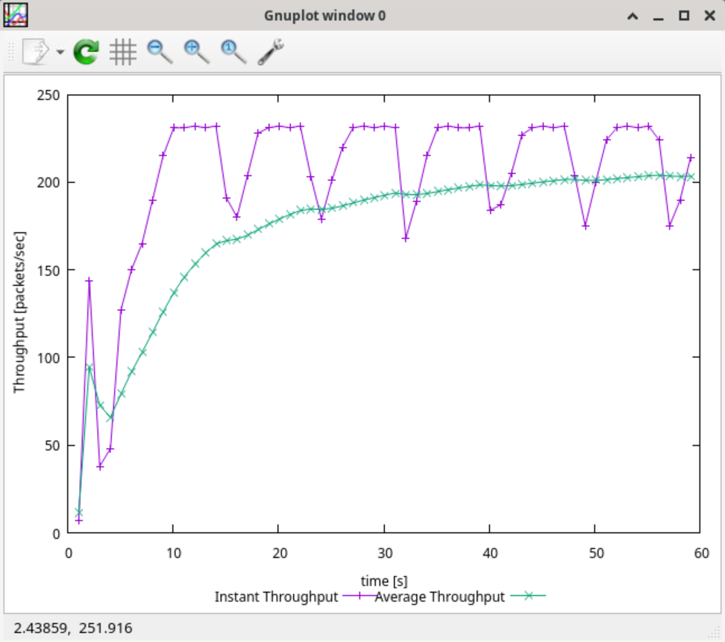
In Tahoe, the window drop to 1 packet every loss
In Reno, when triple duplicate ACK, the congestion window drop to half of current size. The sender then fast recovery instead of slow start
Tahoe average throughput 188 packet/s or 812 kbps
Teno average throughput 205 packets/s or 864 kbps
Reno have higher throughput in that network condition

Exercise 2:
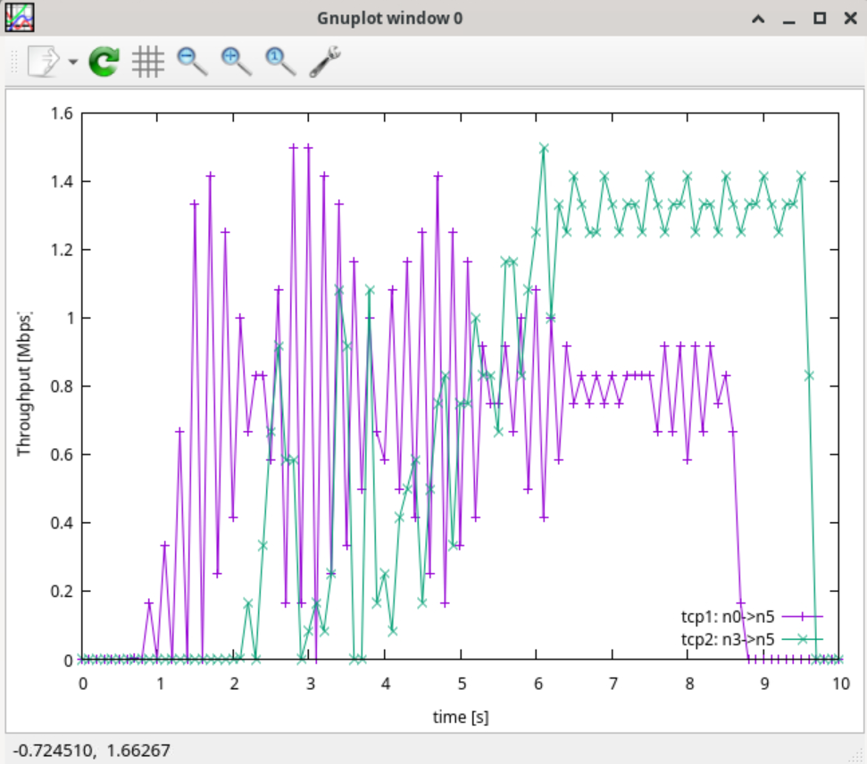
Question 1:
In 6-8s. the TCP from n7 to n0 is active, the flow shares link between n1 and n0 with tcp1. Both flows compete for same link capacity, tcp1 increase congestion, queue delay go higher, and occasional packet drop. So tcp1 throughput drop
Tcp2 does not traverse the congested n0 to n1, the path is independent and have less competition, so the throughput keep higher and stable
Question 2:
Tcp1 starts 0.5s and slow start. During slow start, the congestion windows increase exponentially, make throughput grow fast, and maybe over the capacity. At the same time, queue size and RTT is not stable causing shocks of throughput. So the shock here is tcp slow start situation.

Exercise 3:
Question 1:
N0 to n5
N2 to n5
It will not change
Question 2:
1.0s: n1 to n4 is down
0-1-4-5 will not change to 0-1-2-3-5, packet will be drop
2-3-5 will not been changed
1.2s n1 to n4 is back
It will not change.
Question 3:
1.0s: n1 to n4 down
DV detects the down, change to 0-1-2-3-5
It will change
1.2s: n1 to n4 is back
DV detects the change, 1-4-5 is only hops, it will change back
Question 4:
0-1-4-5: 1+3+1 = 5
0-1-2-3-5: 1+1+1+1 = 4
N1 to n4 will not been selected, because of high cost
N0 to n5 change to 0-1-2-3-5
DV detects the cost and switch to 0-1-2-3-5
2-3-5 will not been changed
Question 5:
Path A 0-1-4-5 1+2+3=6
Path B 0-1-2-3-5 1+1+1+3 = 6
The cost is same for both path
Multipath allows using multiple paths
N0 to n5 will go from both a and b
It will be multipath forwarding
DV will keep multiple paths
Traffic is more average in 2 ways

