NOV 03, 2025
LAB 3
TIAN HUANG

Exercise 3:
Question 1:
CODE USED: dig www.amazon.com.au
RESULT:
In ANSWER SECTION< we found the IP address is 3.175.109.140. The DNS request is A type, searching for IPv4 address.

Question 2:
CODE USED: dig www.amazon.com.au
RESULT:
The canonical name is tp.04f01a85e-frontier.amazon.com.au
The reason of using canonical name is to flexible server switch and could make domain name management easier

Question 3:
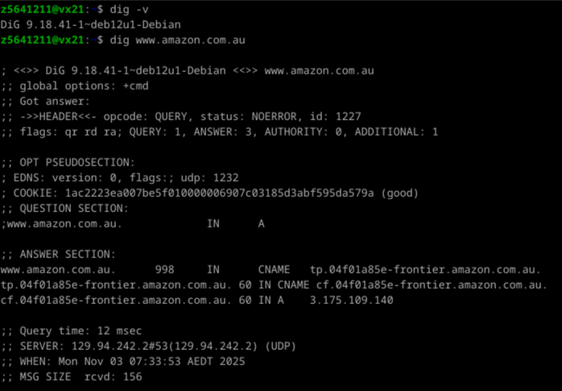
RESULT:
The EDNS part is for extended informing, for security communication and better data capacity
COOKIE is used to prevent spoofed request

Question 4:
CODE USED: cat /etc/resolv.conf
RESULT:
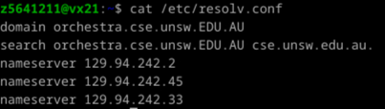

Question 5:
CODE USED: dig NS amazon.com.au
RESULT:
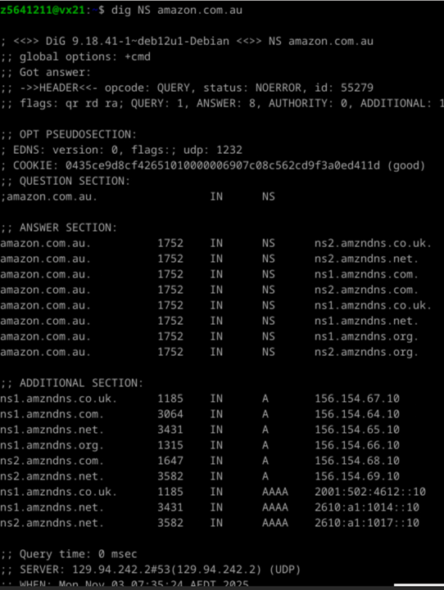
ANSWER:
ns1.amzdns.co.uk | 156.154.67.10
ns2.amzdns.net | 156.154.69.10
ns1.amzdns.org | 156.154.66.10
ns2.amzdns.com | 156.154.68.10

Question 6:
CODE USED: dig -x 9.9.9.9
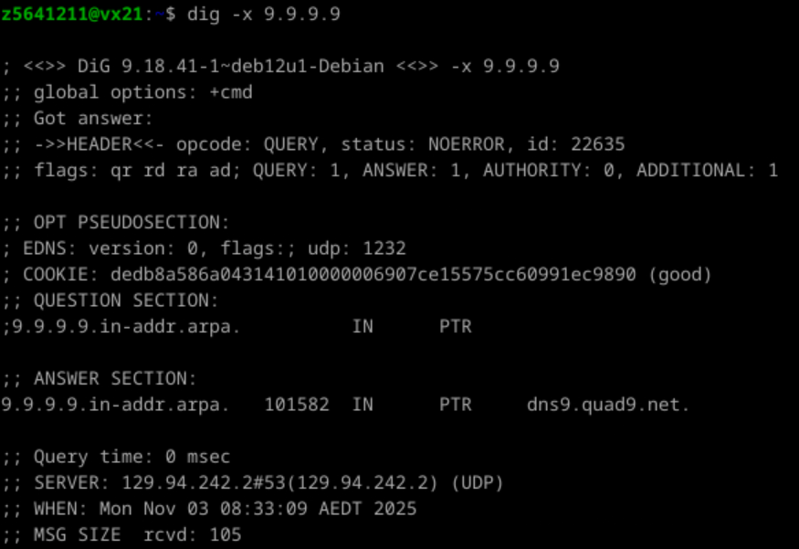
ANSWER:
Domain: dns9.quad9.net
Request type: PTR

Question 7:
CODE USED: dig @129.94.242.2 MX yahoo.com
RESULT:
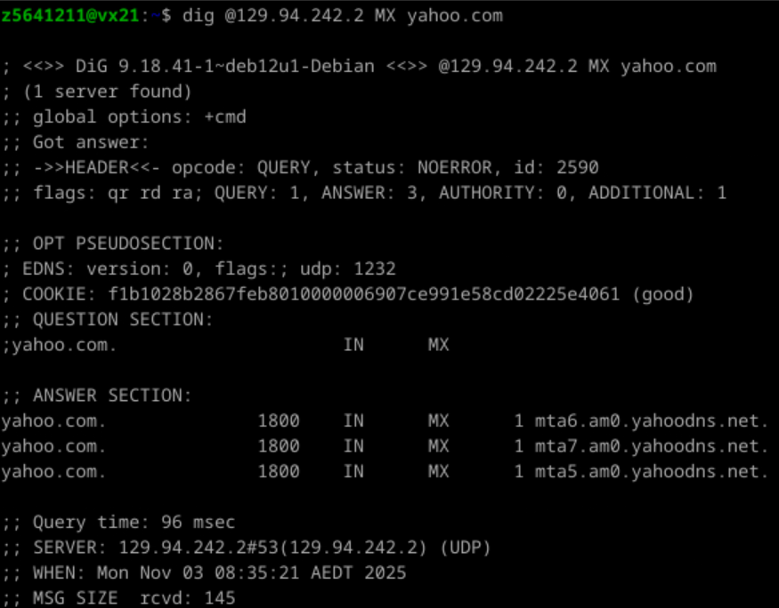
ANSWER:
For lags, there is no aa(authoritative answer), it comes from CSE DNS
Question 8:
CODE USED: dig @156.154.67.10 MX yahoo.com
RESULT:
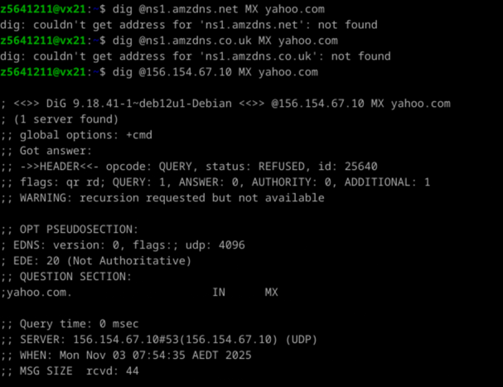
ANSWER:
I tried Amazon DNS server (ns1.amzdns.co.uk, 156.154.67.10) and got a REFUSED and Not Authoritative

Question 9:
CODE USED: dig @ns1.yahoo.com MX yahoo.com
RESULT:
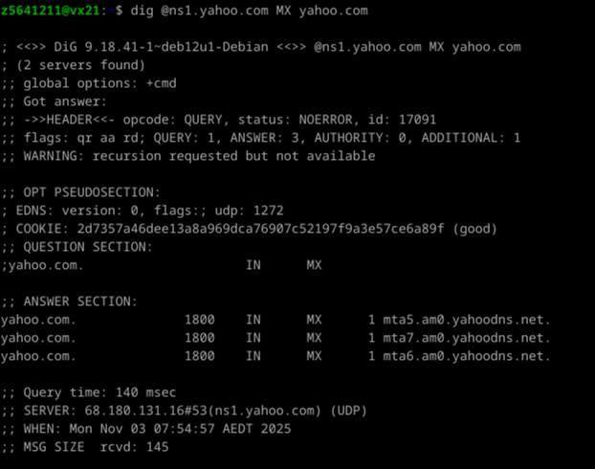
ANSWER:
We got status NOERROR, the DNS query used is MX
Question 10:
STRATEGY:
www.lab.cse.unsw.edu.au
Go root first, then au, then edu, then unsw, then cse
CODE USED:

dig NS .
Search for root servers

dig @a.root-severs.net NS au.
Search for au servers
Got a.au address as 58.65.254.1

dig @58.65.254.1 NS edu.au
Search for edu servers
At this point, we found that au is not a sub domain under au, it is at the same level with au, so we can directly go from au to unse.edu.au, no need to edu.au

dig @58.65.254.1 NS unsw.edu.au
Search for unsw servers
Got ns1-ext unsw.edu.au at 54.79.80.189

dig @54.79.80.189 NS cse.unsw.edu.au
search for cse severs
Got Beethoven at 129.94.242.2

dig @129.94.242.2 A lyre00.cse.unsw.edu.au
Got lyre00.cse.unsw.edu.au at 129.94.210.20

ANSWER:
There are 5 layers required:
. -> au -> unsw.edu.au -> cse.unsw.edu.au -> target
And 6 has been achieved, the one more is edu.au(not required)
The query type include NS and A

Question 11:
ANSWER:
Yes, one machine can have more than one domain names and more than on IP address.
Sometimes there are Virtual Hosting or CNAME using one physical server hosting multiple websites, which come with different domain name for each website. Just like apple.com.us and apple.com might go to same address
Sometimes it could have more than one network interfaces or assigned IP address. Or have one IPv4 and one IPv6 at the same time, like Amazon DNS sever in formal questions

Exercise 4:
See code
As a backup if the file is missing:
https://github.com/tanglehunter00/UNSW-COMP-9331.git
import socket, os, urllib.parse
s = socket.socket(socket.AF_INET, socket.SOCK_STREAM)
s.bind(("", 10000))
s.listen(1)
print("http://127.0.0.1:10000/index.html")
print("http://127.0.0.1:10000/myimage.jpg")
print("http://127.0.0.1:10000/myimage2.jpg")
print("http://127.0.0.1:10000/bio.html")
while True:
c, a = s.accept()
while True:
data = b""
while b"\r\n\r\n" not in data:
chunk = c.recv(4096)
if not chunk:
break
data += chunk
if not data:
break
req_line = data.split(b"\r\n", 1)[0].decode()
m, t, v = req_line.split(" ")
path = urllib.parse.urlsplit(t).path or "/"
if path == "/":
path = "/index.html"
target = os.path.join(os.getcwd(), path.lstrip("/"))
ext = os.path.splitext(target.lower())[1]
if ext not in (".html", ".jpg") or not os.path.isfile(target):
body = b"<h1>404 Not Found</h1>"
resp = (
"HTTP/1.1 404 Not Found\r\n"
"Content-Type: text/html\r\n"
f"Content-Length: {len(body)}\r\n\r\n"
).encode() + body
c.sendall(resp)
continue
with open(target, "rb") as f:
body = f.read()
ctype = "text/html" if ext == ".html" else "image/jpeg"
resp = (
"HTTP/1.1 200 OK\r\n"
f"Content-Type: {ctype}\r\n"
f"Content-Length: {len(body)}\r\n\r\n"
).encode() + body
c.sendall(resp)

