Tian Huang
UNSW-COMP-9331
Nov 10th, 2025
LAB 4
Exercise 1:
Question 1:
Server: IP 128.119.245.12, Port 80(HTTP)
Client: IP 192.168.1.102, Port 1161(source)
Question 2:
The TCP contains HTTP POST command is in Frame 4, Seq Number 1 and Len 565
Question 3:
Part A:
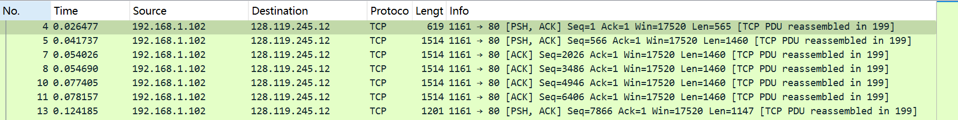

Part B & C:
Frame | Sent Time | Seq | Len | ACK | RTT | Est. RTT
4 | 0.026477 | 1 | 565 | 0.053937 | 0.02746 | 0.02746
5 | 0.041737 | 566 | 1460 | 0.077294 | 0.03556 | 0.02846
7 | 0.054026 | 2026 | 1460 | 0.124885 | 0.07086 | 0.03359
8 | 0.054690 | 3486 | 1460 | 0.169118 | 0.11443 | 0.04310
10 | 0.077405 | 4946 | 1460 | 0.217299 | 0.13989 | 0.05495
11 | 0.078157 | 6406 | 1460 | 0.267802 | 0.18965 | 0.07168

Part D:
The first segment is 565 bytes, the others are 1460 bytes each.

Question 4:
Min advertise windows size 5840 bytes
It does not throttle the sender
Question 5:
No
Question 6:
1460 bytes of data would be receiver typically acknowledge in an ACK
Some ACK acknowledges 2920 bytes, which is 2 times of 1460, there is delayed ACK
Question 7:
Calculation: (171kB * 1000B/kB)/ (5.651s * 1000ms/s) = 30260 bytes/s
= 242kbps
Wireshark data: 241kbps

Exercise 2:
Question 1:
SEQ 2818463618, Frame 295
Question 2:
SEQ 1247095790 Frame 296
ACK 2818463619
It comes from Question 1, the init SEQ + 1
Question 3:
SEQ 2818463619
ACK 1247095791
No
Question 4:
The client(10.9.16.201) done the active close.
Frame 304 client send FIN, ACK to server
It is 4 segment, FIN->ACK->FIN->ACK
Question 5:
Client -> Server: 33 bytes
Server -> Client: 40 bytes
Data acknowledge corresponds to the difference of the final ACK and init SEQ

