**(TS=(plant disease detection) or TS=(plant disease classification) or TS=(plant disease identification) or TS=(crop disease detection) or TS=(crop disease classification) or TS=(crop disease identification)) AND (TS=("Artificial Intelligen*" or "Neural Net*" or "Machine* Learning" or "Expert System$" or "Natural Language Processing" or "Deep Learning" or "Reinforcement Learning" or "Learning Algorithm$" or "*supervised Learning" or "Intelligent Agent*") or (WC=("Artificial Intelligence")))**

**RQ1**: What are the overall publication trends and subject categories in the field of AI for plant disease detection?

**RQ2**: What are the major research themes and topic clusters in the literature on AI techniques for plant disease detection, and how have these themes evolved over time?

**RQ3**: What are the collaboration patterns among countries, institutions, and authors in this field? How do these collaborations contribute to advancements in the research?

**RQ4**: What are the overall publication trends and key contributors in this field?

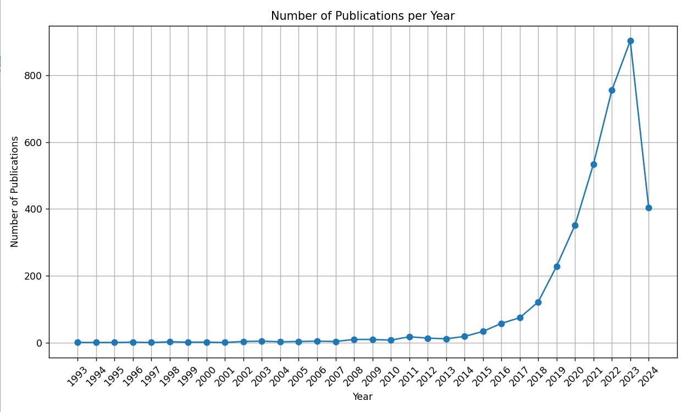

Word cloud (author keyword+keyword plus)

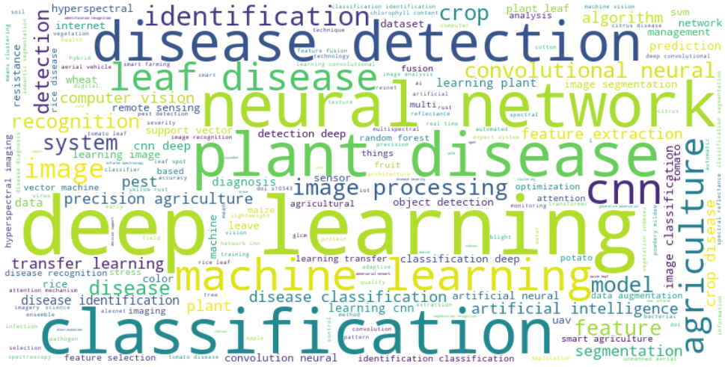

Bibliographic coupling-all keywords-数量>50-手动去除

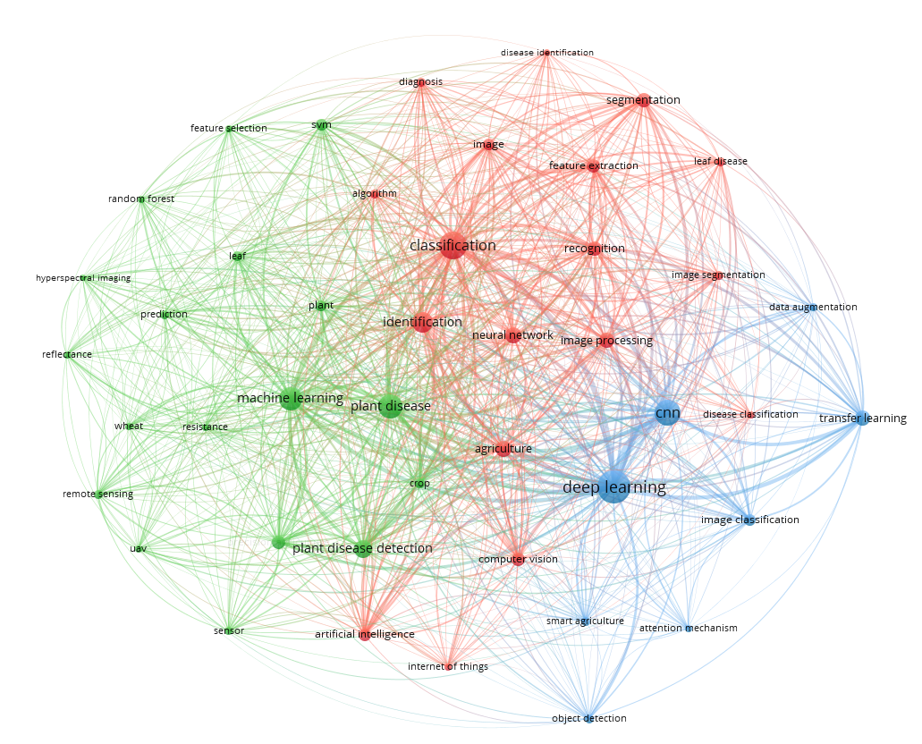

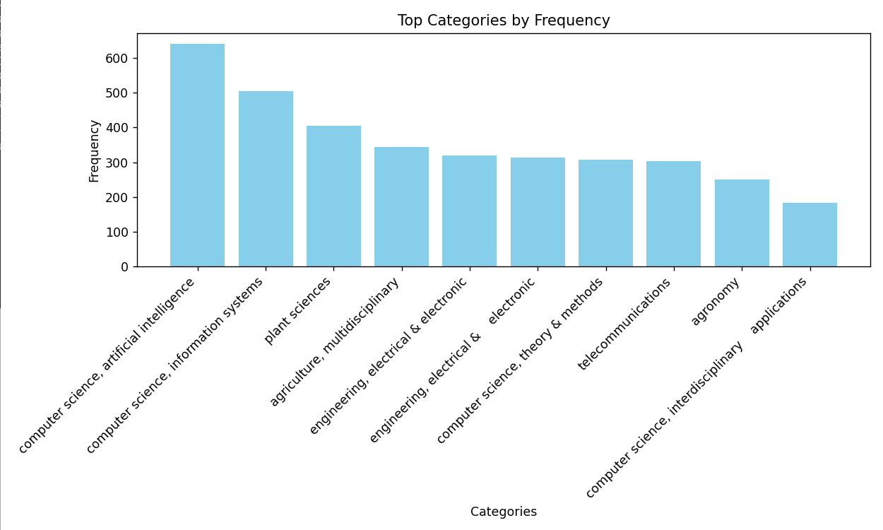

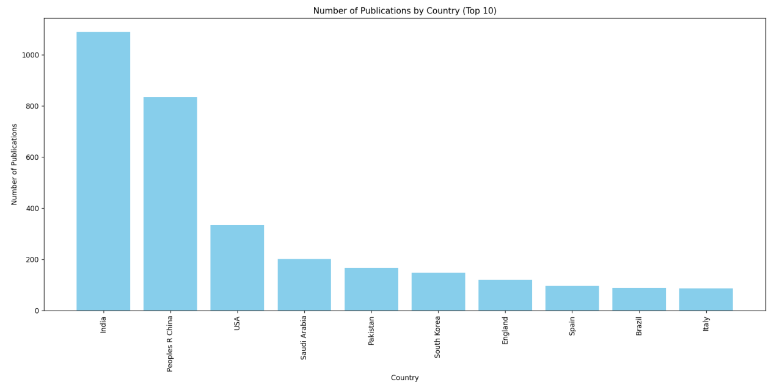

Co-authorship-countries,只留>=10篇的

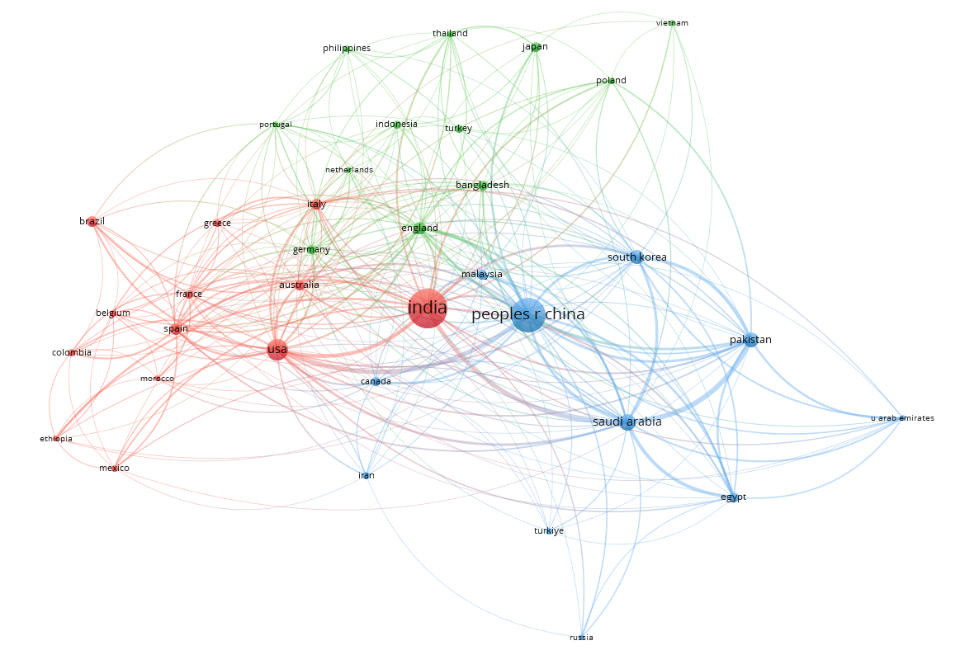

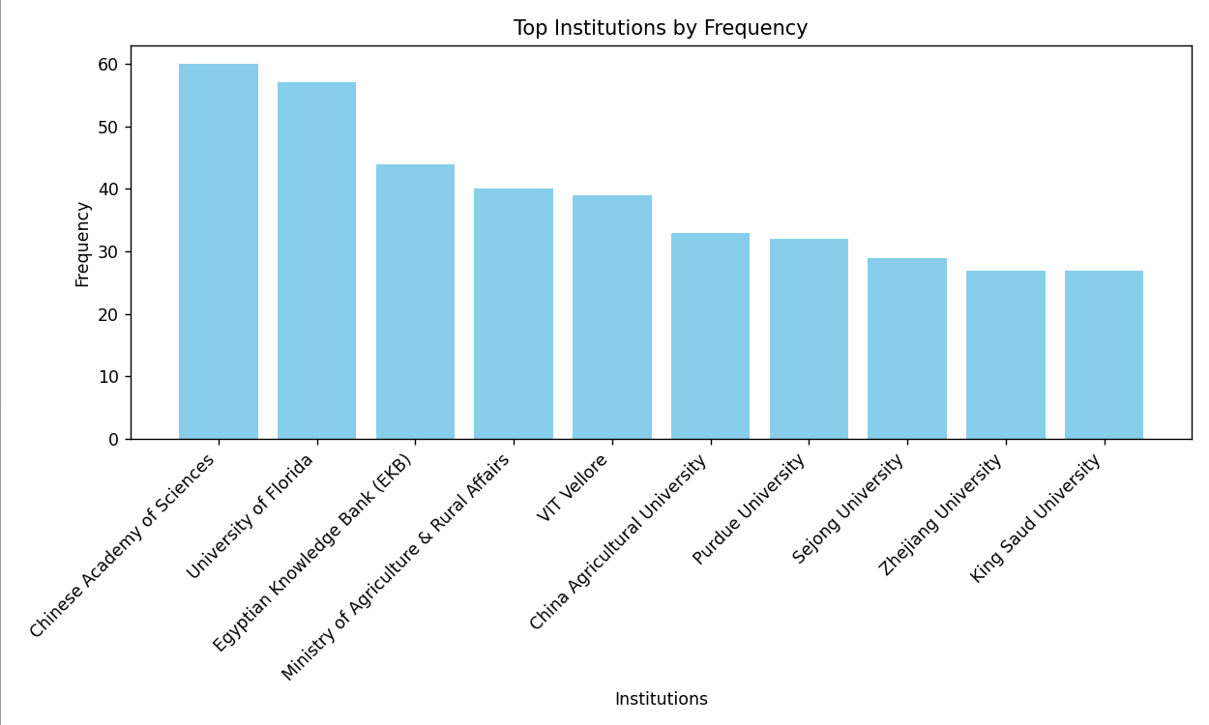

Bibliographic coupling-institutions,只留>=20篇的

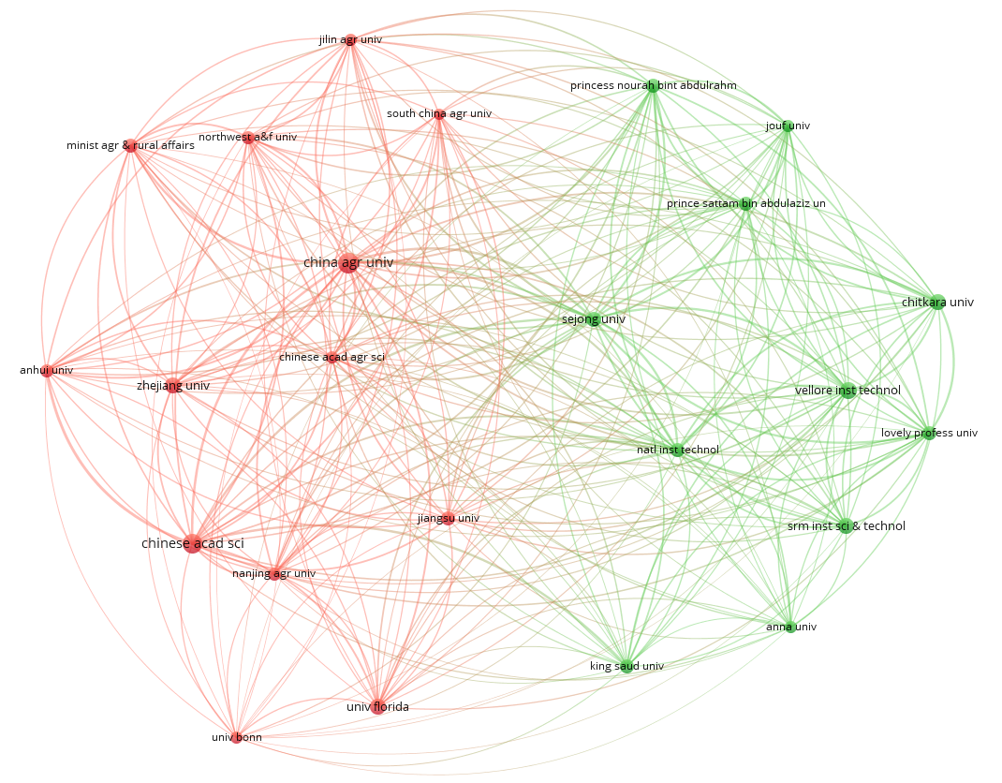

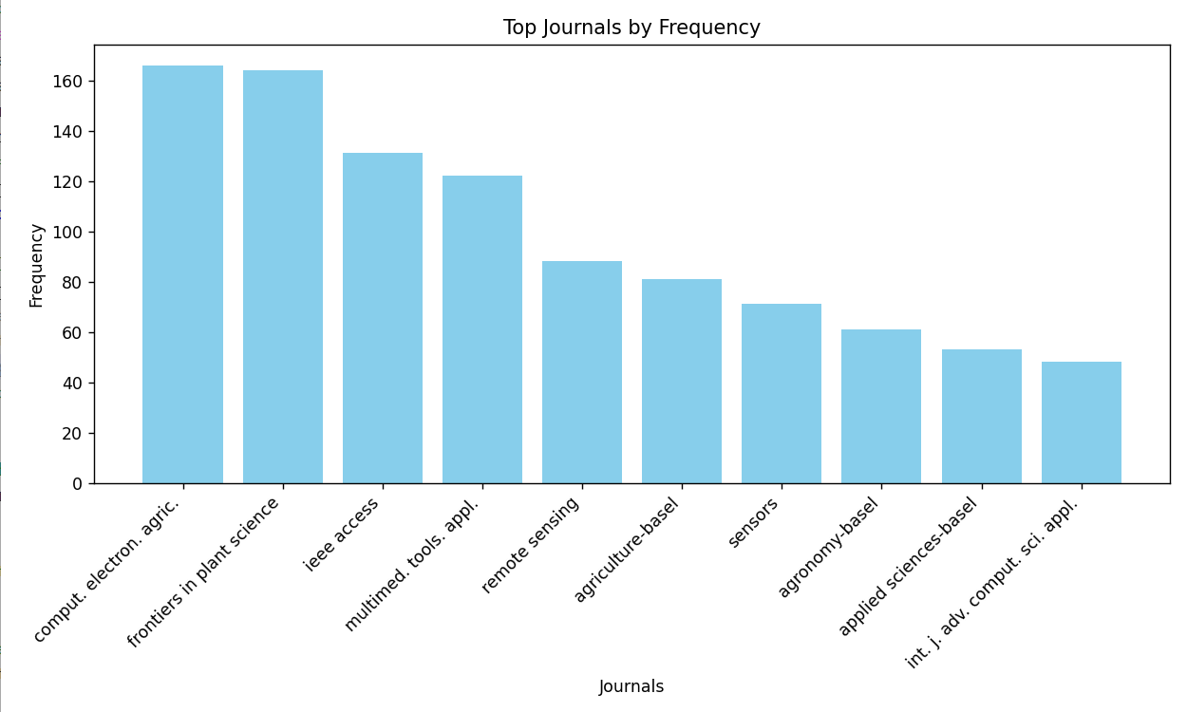

Bibliographic coupling-sources,只留>=15篇的





