**LAB 1**

**Introduction to Software Architecture**

**Name: Tăng Minh Tín**

**Roll Number: CE130438**

1. Simplify the architecture given as below. Black arcs have complexity 1, blue arcs have complexity 3 (two-headed arrows represent two opposite arcs). All vertices (black, yellow, green, blue) have complexity 5.

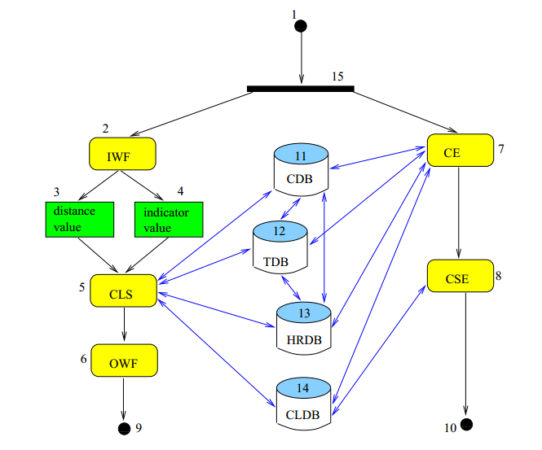

1. What is the most complex architecture among the ones given below? How can they be simplified?

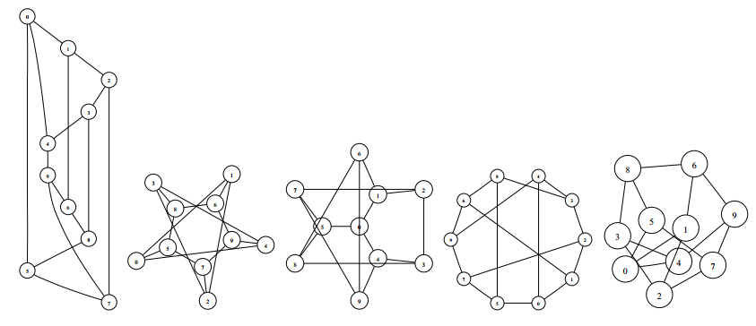

**Answer**

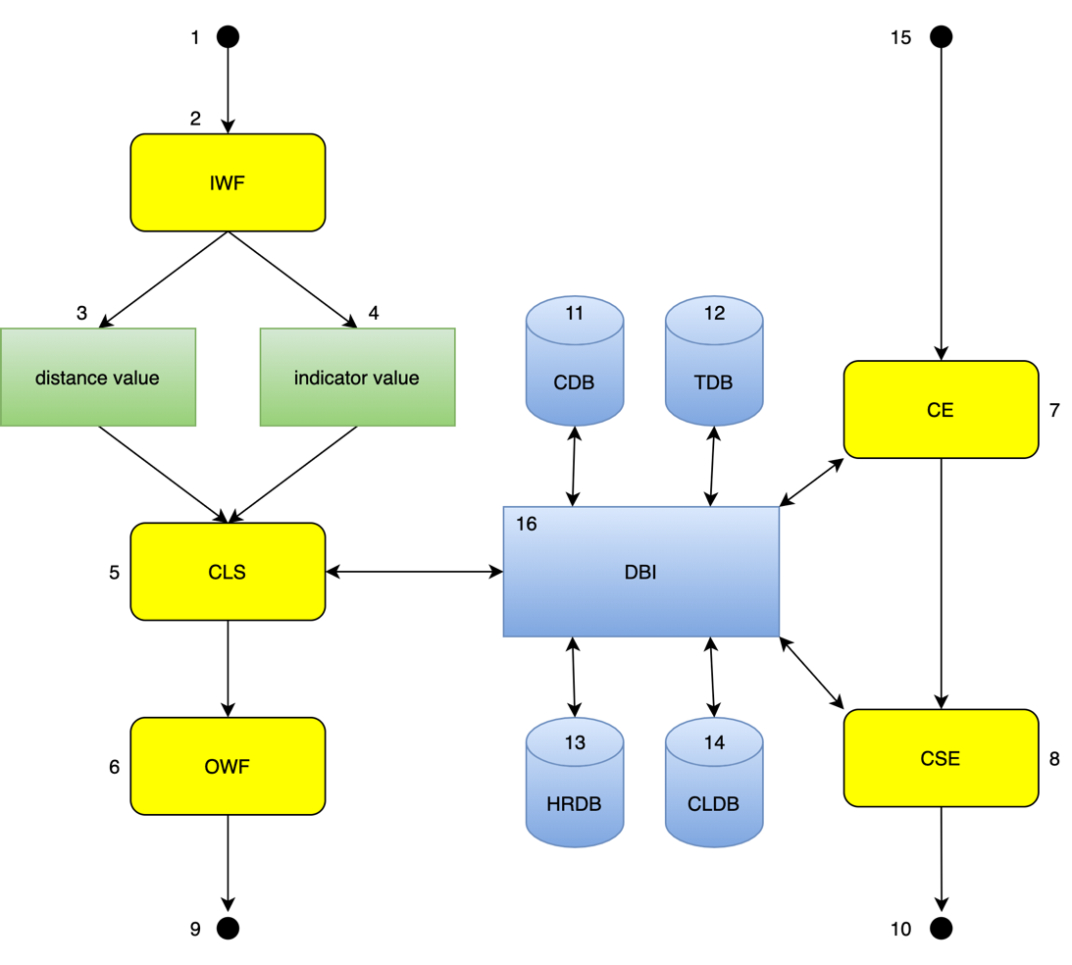

1. The underlying architectures have the same number of vertices and the same connections so they have the same complexity.