**LAB 4**

**Data Flow Architecture**

**Name: Tăng Minh Tín**

**Roll Number: CE130438**

**Class: SE1402**

**Answer**

1. Applying Pipe and Filter architecture to **Java Compiler**

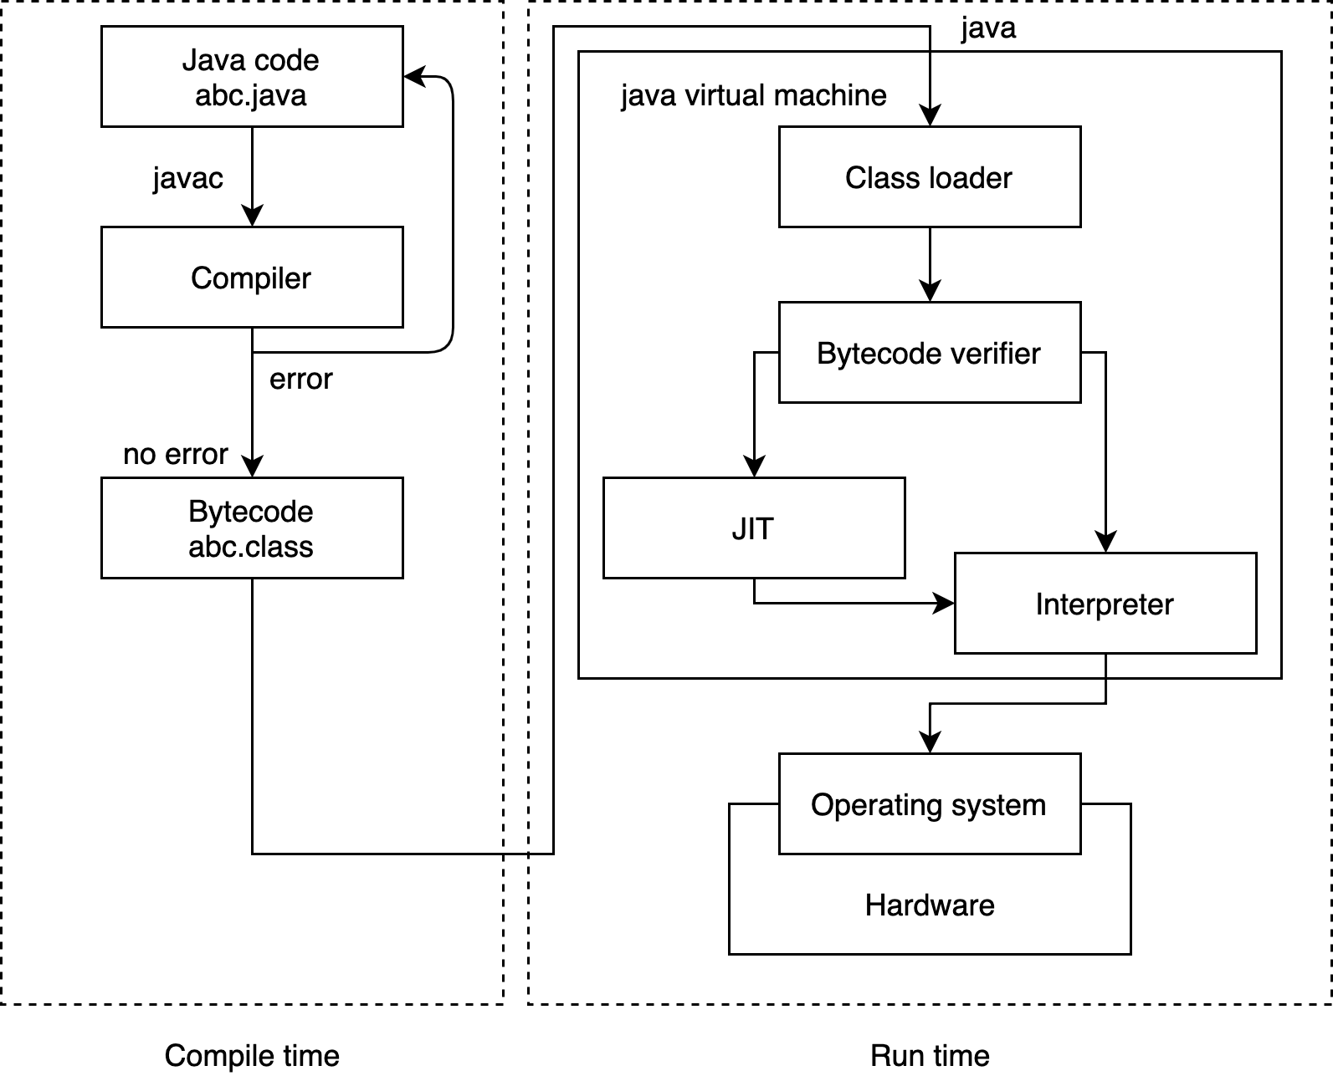

1. Applying Pipe and Filter architecture to **Dex Compiler**

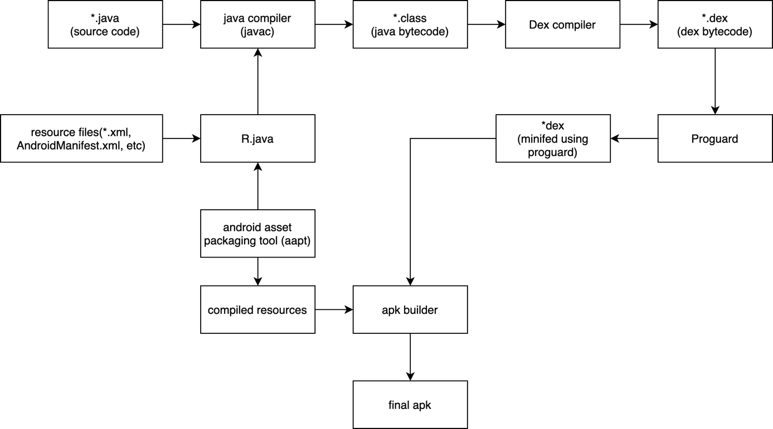

1. For a class a below:

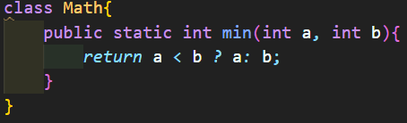

Create a Pipe and Filter architecture for that class in Java.

