Synchrotron Soleil Mambo Manual V2.1
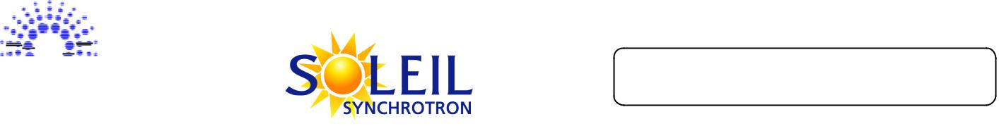

Reference: INF-XXX



Mambo Manual

Diffusion :

Diffusion List

Date | Writer | Auditor | Validation | Modifications | Indication
2005/10/26 | L.Claisse
2005/11/17 | L.Claisse |  |  | Added multi-
 |  |  |  | AC/VC and file
 |  |  |  | system
2006/11/17 | R.Girardot |  |  | Screenshots
 |  |  |  | updated
2012/02/15 | A. Fourneau | G.Abeillé |  | Added tdb long
 |  |  |  | term

“Reference” Last Update : 22 February 2012 Page 1/ 35
 |  |  | Synchrotron Soleil | Mambo Manual V2.1
 |  |  | Index
1. |  | INTRODUCTION .................................................................................................................................................................... |  | 3
2. |  | APPLICATION’S CONTEXT: HISTORIC AND TEMPORARY ARCHIVING ............................................................ |  | 3
3. |  | APPLICATION’S DESCRIPTION AND GOALS ............................................................................................................... |  | 3
 | 3.1. |  | APPLICATION’S GOALS ....................................................................................................................................................... | 3
 | 3.2. |  | A FIRST LOOK AT MAMBO .................................................................................................................................................. | 4
4. |  | CONTROL ARCHIVING ....................................................................................................................................................... |  | 5
 | 4.1. |  | CREATING/MODIFYING AN AC ........................................................................................................................................... | 5
 | 4.2. |  | THE OPENED ACS MENU ................................................................................................................................................... | 11
 | 4.3. |  | STARTING/STOPPING ARCHIVING ON AN AC .................................................................................................................... | 12
 |  |  | 4.3.1.The Current Archiving Configuration detail panel .................................................................................................................... | 12
 |  |  | 4.3.2.Starting/Stopping archiving on an AC ....................................................................................................................................... | 12
 | 4.4. |  | DISPLAYING AN AC ......................................................................................................................................................... | 13
 | 4.5. |  | SAVING/LOADING AN AC ................................................................................................................................................. | 14
 | 4.6. |  | TRANSFER TO VC ............................................................................................................................................................. | 15
5. |  | EXPLOIT ARCHIVED DATA ............................................................................................................................................. |  | 16
 | 5.1. |  | CREATING/MODIFYING AN VC ......................................................................................................................................... | 17
 | 5.2. |  | THE OPENED VCS MENU................................................................................................................................................... | 22
 | 5.3. |  | USING VIEW ON A VC ...................................................................................................................................................... | 22
 | 5.4. |  | DISPLAYING A VC ............................................................................................................................................................ | 23
 | 5.5. |  | SAVING/LOADING A VC ................................................................................................................................................... | 24
 | 5.6. |  | USING THE VARIATIONS FUNCTIONALITY ........................................................................................................................ | 24
6. |  | LONG TERM SNAPSHOT ................................................................................................................................................... |  | 26
 | 6.1. |  | ADD SNAPSHOT ................................................................................................................................................................ | 26
 | 6.2. |  | IMPORT SNAPSHOT ........................................................................................................................................................... | 27
7. |  | OPTIONS ................................................................................................................................................................................ |  | 29
 | 7.1. |  | LOGS OPTIONS .................................................................................................................................................................. | 29
 | 7.2. |  | APPLICATION’S HISTORY SAVE/LOAD OPTIONS................................................................................................................. | 30
 | 7.3. |  | AC OPTIONS ..................................................................................................................................................................... | 31
 | 7.4. |  | VC OPTIONS ..................................................................................................................................................................... | 33
8. |  | THE MAMBO TOOLBAR ................................................................................................................................................... |  | 34
ANNEXES ....................................................................................................................................................................................... |  |  |  | 35
INDEX ............................................................................................................................................................................................. |  |  |  | 35

“Reference” Last Update : 22 February 2012 Page 2/ 35
Synchrotron Soleil Mambo Manual V2.1

1. Introduction

This document is an end-user guide to using the Mambo application, and a brief developer-oriented presentation of the application’s architecture.

2. Application’s context: Historic and Temporary archiving

The goal is automatically archiving the values of a set of Tango Attributes, in a given time range.
In this time range, the value of an attribute is archived:

- Every [given time interval]

AND
- When the attribute’s value meets [given condition on attribute’s value]

where [given time interval] and [given condition on attribute’s value] are user-defined for each attribute (individually or for a group of attributes).

Each attribute value is associated with a time stamp, representing the time when the attribute value was read; this time stamp is archived as well.

Attributes can be archived in two distinct databases:

- the Historical Data Base (HDB henceforth): attributes values are stored forever

- the Temporary Data Base (TDB henceforth): every [given deletion time], the oldest attributes values records are deleted. VERIFIER QUE C’EST BIEN CA

When an attribute is “being archived”, it means that every [base time unit], the archiv ing device tests whether the current value of the attribute has to be stored in HDB (resp. TDB). If the test is positive, a record is added in the table for this attribute.

Later, those values can be exploited (selected from HDB/TDB to be displayed, saved in a file, …).

3. Application’s description and goals

3.1. Application’s goals

Mambo allows the user to define configurations that describe archiving and data exploitation for a group of attributes. Those configurations can be saved as files and modified.

Mambo is thus naturally divided (both in functionalities and display) in two parts:

- The archiving control part

- The archived data exploitation part

“Reference” Last Update : 22 February 2012 Page 3/ 35
Synchrotron Soleil Mambo Manual V2.1

3.2. A first look at Mambo
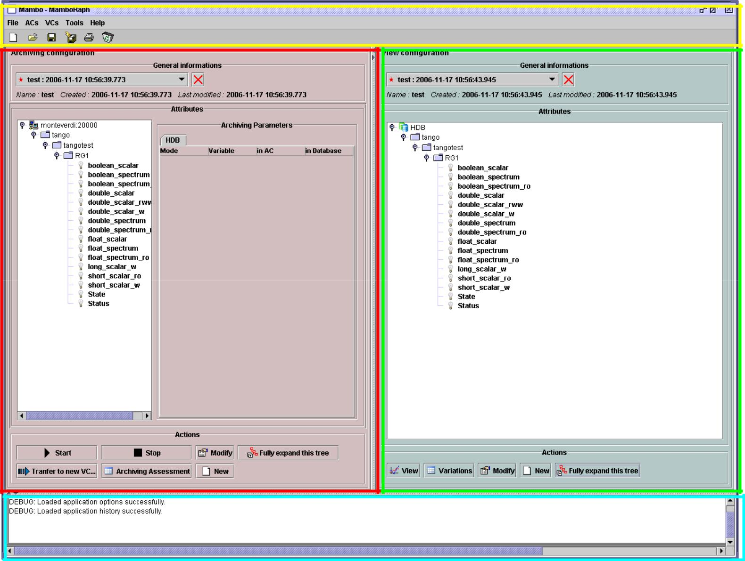

Menu and Tool bar

Archiving Control panel | Data Exploitation panel

Application’s Logs panel

Figure 1: General view of Mambo

- The Archiving Control panel is where the user controls the archiving of Tango attributes to HDB/TDB.

He does so by creating/modifying Archiving Configurations, and calling Start/ Stop on those configurations.

An Archiving Configuration is a list of attributes to be archived, with a list of archiving parameters for each attribute.

- The Data Exploitation panel is where the user exploits the previously stored data, mainly displaying curves and extracting raw data from HDB/TDB.

He does so by creating/modifying View Configurations, and calling View Stop on those configurations. A View Configuration is a list of attributes to be displayed, with a list of displaying parameters for each attribute.

- The Logs panel displays success/failure messages to the user upon realization of an action.

- The Menu and the Tool bar are for actions shortcuts and application’s options.

Each panel will be detailed in its own subsection.

“Reference” Last Update : 22 February 2012 Page 4/ 35
Synchrotron Soleil Mambo Manual V2.1

4. Control archiving

This section deals with controlling archiving of Tango attributes through Archiving Configurations (henceforth AC).
An AC describes which attributes to archive and how, and consists of :

- General information (when the AC was created, …)

- A list of attributes to archive

- For each attribute, a set of HDB/TDB archiving modes

ACs are accessed/used in the AC panel :
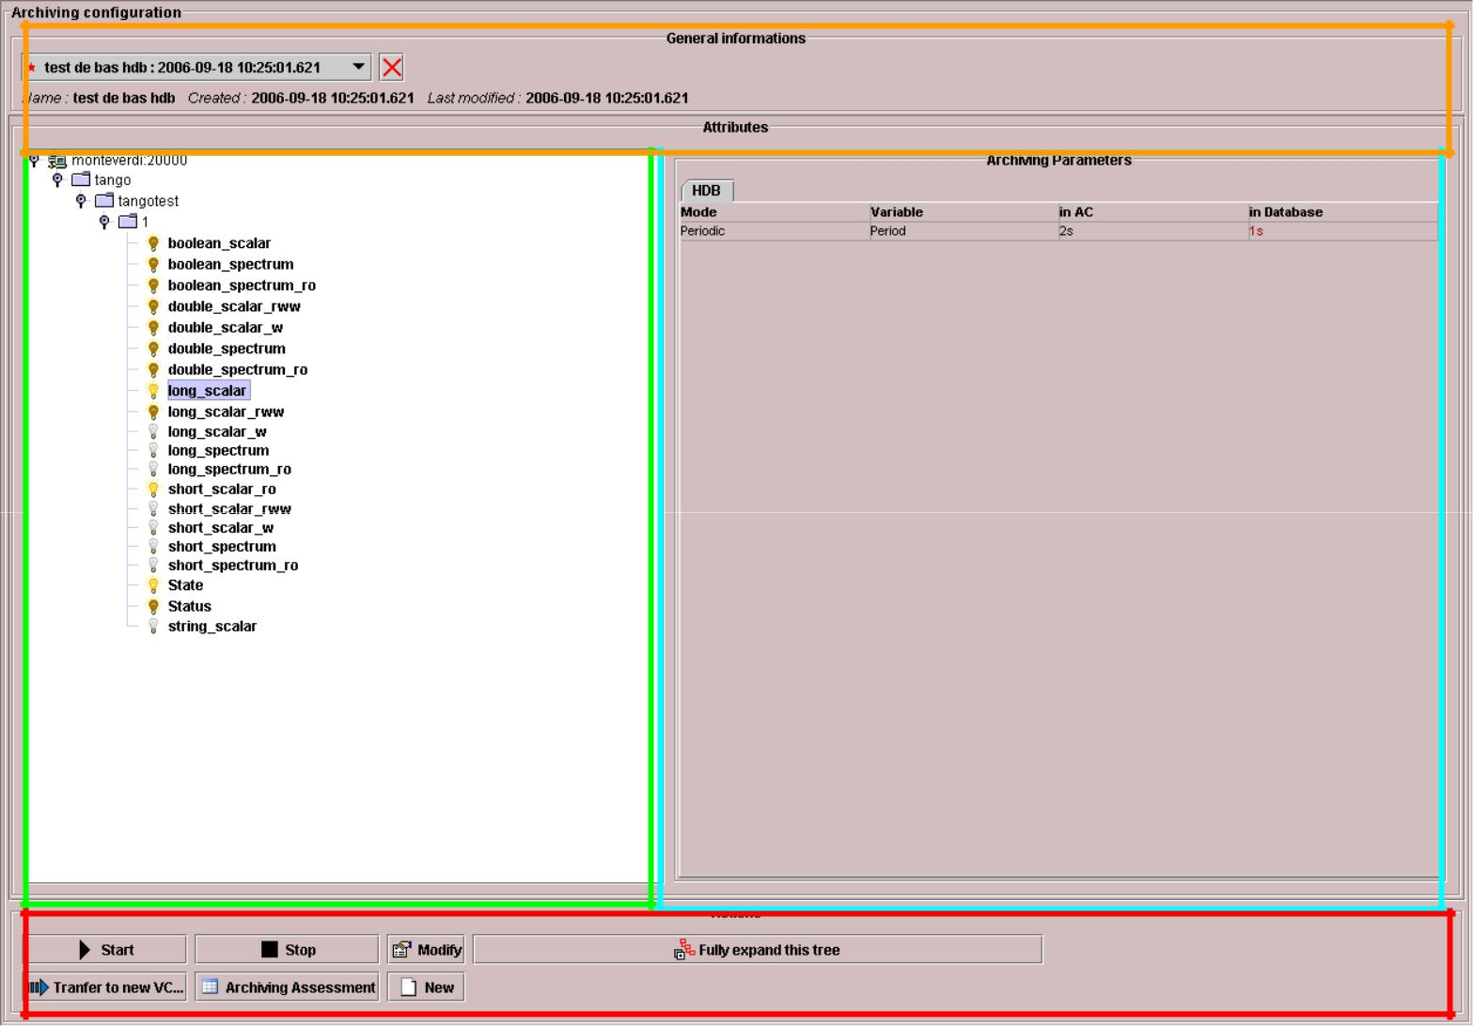

AC selection
General AC properties

The archiving properties (« Modes » of the
highly
ghted attribute )

Current AC attributes

AC actions

Figure 2: The AC panel (black)

4.1. Creating/modifying an AC

Creation or modification of an AC is done the same way, using the New/Modify button respectively. We will see how to load an AC later.

Step 1 : AC general properties

“Reference” Last Update : 22 February 2012 Page 5/ 35
Synchrotron Soleil Mambo Manual V2.1

- Click the New/Modify button in the AC actions panel

- The following dialog appears
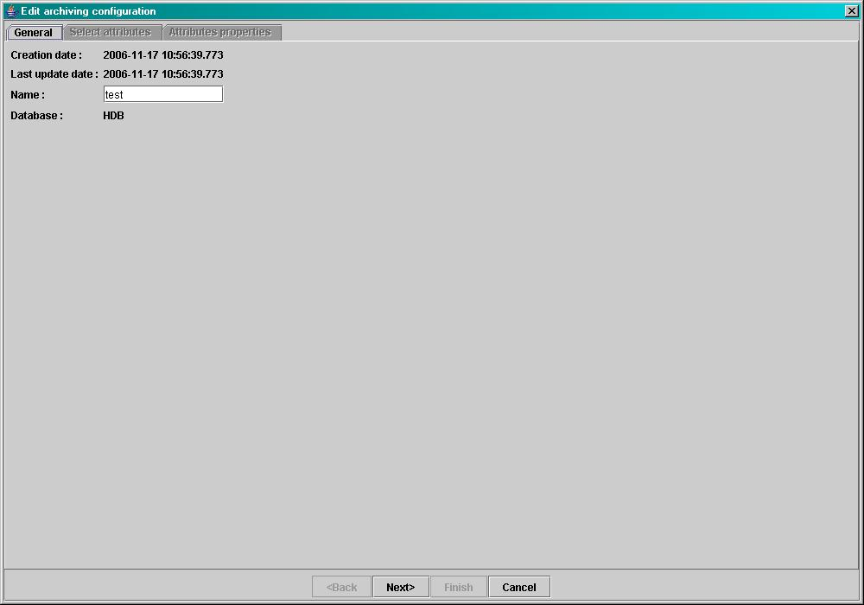

Figure 3: Step1, general properties

- You can choose a name for the AC. This field isn’t mandatory but it is recommended to fill it.

- The creation and update dates are filled or modified automatically upon saving an AC. Click next.

Step 2 : Select the AC attributes

There are 2 ways to select the AC attributes. The user can choose a selection method in the Options.

Step 2, method 1:

“Reference” Last Update : 22 February 2012 Page 6/ 35
Synchrotron Soleil Mambo Manual V2.1
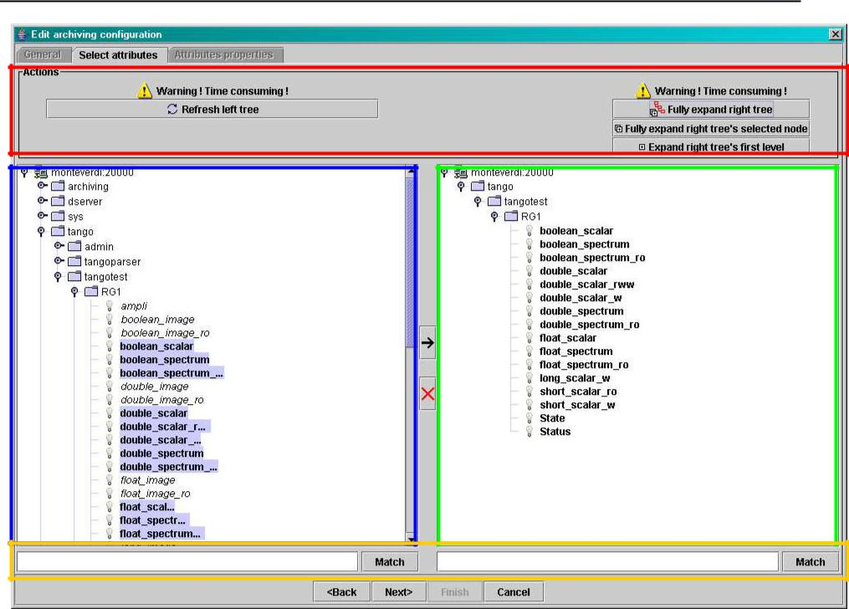

Trees actions

The tree listing all Tango attributes | The tree of the current AC’s attributes

Match boxes

Figure 4: Step 2, select AC attributes (standard method)

- The left tree lists the Tango attributes. The right tree represents the current attributes of the edited AC. Both trees have the same structure of TANGO_HOST/Domains/Families/Members/Attributes.

WARNING The left tree listing the Tango attributes is initially only loaded up to Members level to avoid overloading. The attributes are loaded upon user selection of a Member node

- Adding attributes to the current AC:
- Select a tree node to expand it.
- Select attributes in the left tree then press the right arrow to add them to the current AC.

  - Select a node in the left tree then press the right arrow to add all attributes under this node to the current AC (only works if those attributes were loaded).

- Removing attributes from the current AC:

  - Select attributes in the right tree then press the red X to remove them from the current AC.

  - Select a node in the right tree then press the red X to remove all attributes under this node from the current AC.

- Using “Match” to filter attributes:

The user can enter an expression of the form D/F/M and click match to filter attributes in the left and right trees.

D represents the Domains, F represents the Families, and M the Members. All three can contain the joker character ‘*’.

Since the tree loading is initially only up to Member level, it’s not possible to filter up to Attributes level.

“Reference” Last Update : 22 February 2012 Page 7/ 35
Synchrotron Soleil Mambo Manual V2.1

Step 2, method 2:
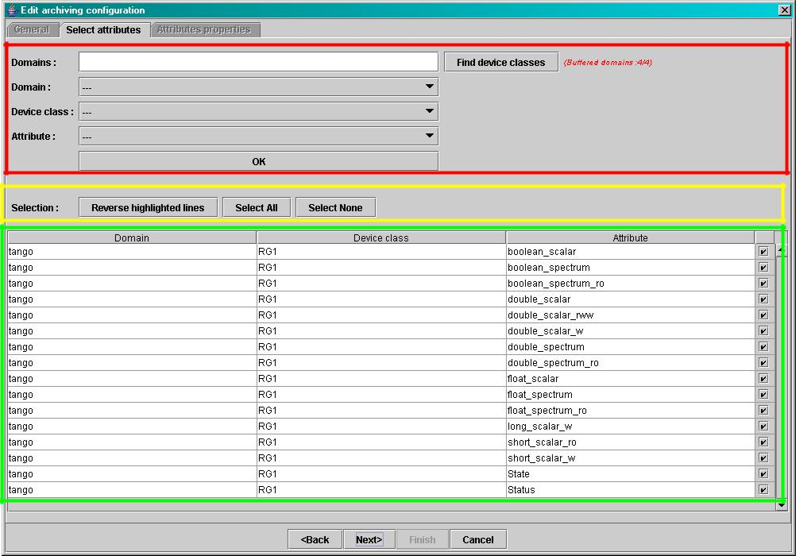

Attributes filtering box

Line-level selection buttons

List of AC attributes (new attributes are red)

Figure 5: Step 2, select AC attributes (alternate method)

- Attribute selection and automatic attributes adding:

- Choose a Domain. This refreshes the list of possible Device classes for this Domain.

- Choose a Device class. This refreshes the list of possible Attributes for this Domain and Device class.

- Choose an Attribute and press OK : o All Attributes
with the selected name

AND

belonging to any Device of the selected Class and Domain are added to the current AC’s list of attributes.

All new attributes are red until the AC is saved.

- Line level sub-selection of loaded attributes:

Each attributes is initially checked, but this check can be removed by the user. When the user clicks on next, all unchecked attributes will be removed from the current AC.

- Click “Select All” to select all lines o Click “Select None” to select no lines

o Select lines in the list (CTRL and SHIFT are usable), then click “Reverse for selected lines” to reverse the checked/unchecked status of all selected lines.

“Reference” Last Update : 22 February 2012 Page 8/ 35
Synchrotron Soleil Mambo Manual V2.1

Step 3 : Set the AC attributes properties
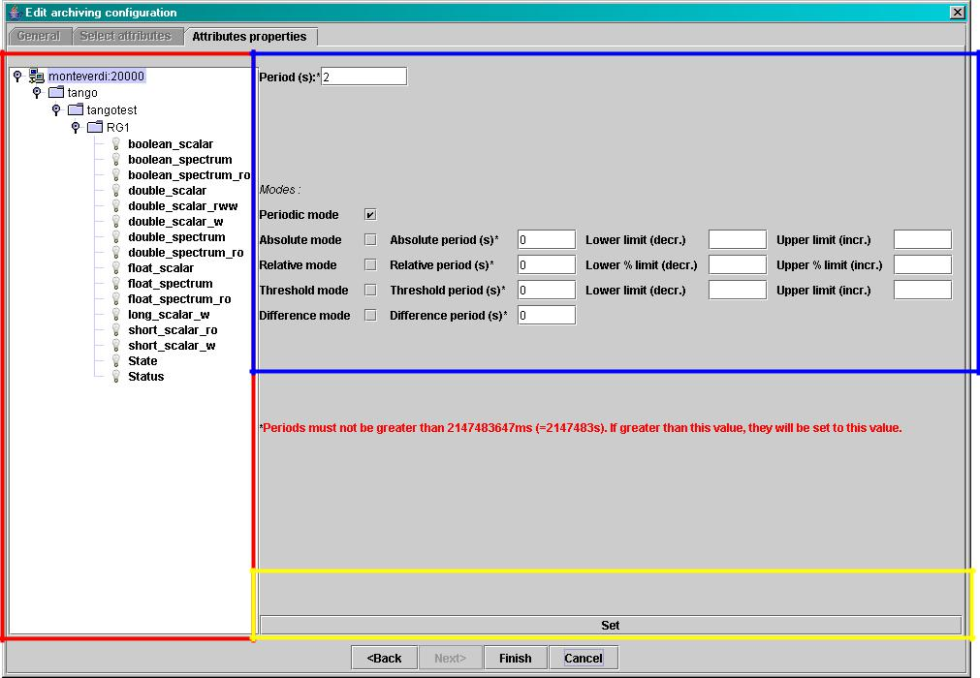

Edit modes

Attributes selection
tree

Apply current modes to selected attributes

Figure 6: Step 3, selecting archiving modes

- A general description of the properties setting process:

The way you set up archiving modes for each attribute is as follows: o Select a group of attributes
o Edit HDB/TDB modes

o Call “Set” for the current group of attributes: the currently displayed modes are applied to all attributes of the selection.

o Repeat with next group of attributes …………………………………… …………….

  - End edition by clicking Finish.

- Attributes selection

The setting up of archiving modes can be “factorize d” for a selection of attributes; all attributes of the selection will be set up with the currently displayed properties when the user presses “Set”.

The multiple selection can consist of :
  - A manual select at Attributes level (CTRL and SHIFT are usable)

- Selection of an upper node level: all Attributes nodes under this node will be set up o A combination of the two.

“Reference” Last Update : 22 February 2012 Page 9/ 35
Synchrotron Soleil Mambo Manual V2.1

- Unset attributes and default values

Attributes which haven’t received any Mode yet (unset) are displayed in Italic. Attributes which have (set) are displayed in Bold.

Clicking on a set attribute displays its archiving modes.
Clicking on an unset attribute displays default archiving modes.

- Controls upon AC validation

The user can not choose any and all combination of modes, nor any and all numeric values for each mode.

Thus, controls are performed upon call to “Finish”:
- If any HDB (resp. TDB) mode is chosen for a given attribute, it must also have the basic HDB (resp.

- Any unset attribute will be removed from the AC; the user is prompted to continue editing the AC, or ignore them.
- Numeric values are controlled for each mode.

When the validation is over, the AC is displayed in the application’s AC panel.

“Reference” Last Update : 22 February 2012 Page 10 /35
Synchrotron Soleil Mambo Manual V2.1

4.2. The opened ACs menu

Mambo can have several opened ACs at once, even if only one is displayed onscreen at a time; a drop-down menu allows the user to choose an AC in the list of opened ACs:

- Each time the user loads an AC, it’s added to the top of the opened ACs list (the older ACs are shifted downwards in the opened ACs list)

- The list identifies ACs by their name and date of last update. When the user selects an AC, it becomes the current AC, and its general information and attributes are displayed.

- To remove an AC from the list, push the red X button (this will do nothing if the list is empty or only has 1 element). The next AC in the reduced list (ie. the one that was added to the list the most recently) is automatically displayed.

- The list can hold no more than [MAX_NUMBER] ACs, this number can be defined in the AC tab of the options panel (default =5). If the list’s length reaches MAX_NUMBER, the oldest AC will be removed from the list when needed.

- ACs that have unsaved modifications are identified by a red star.

If Mambo has the “History save” option turned on, t he list of opened ACs will be saved at shutdown, and loaded at startup.
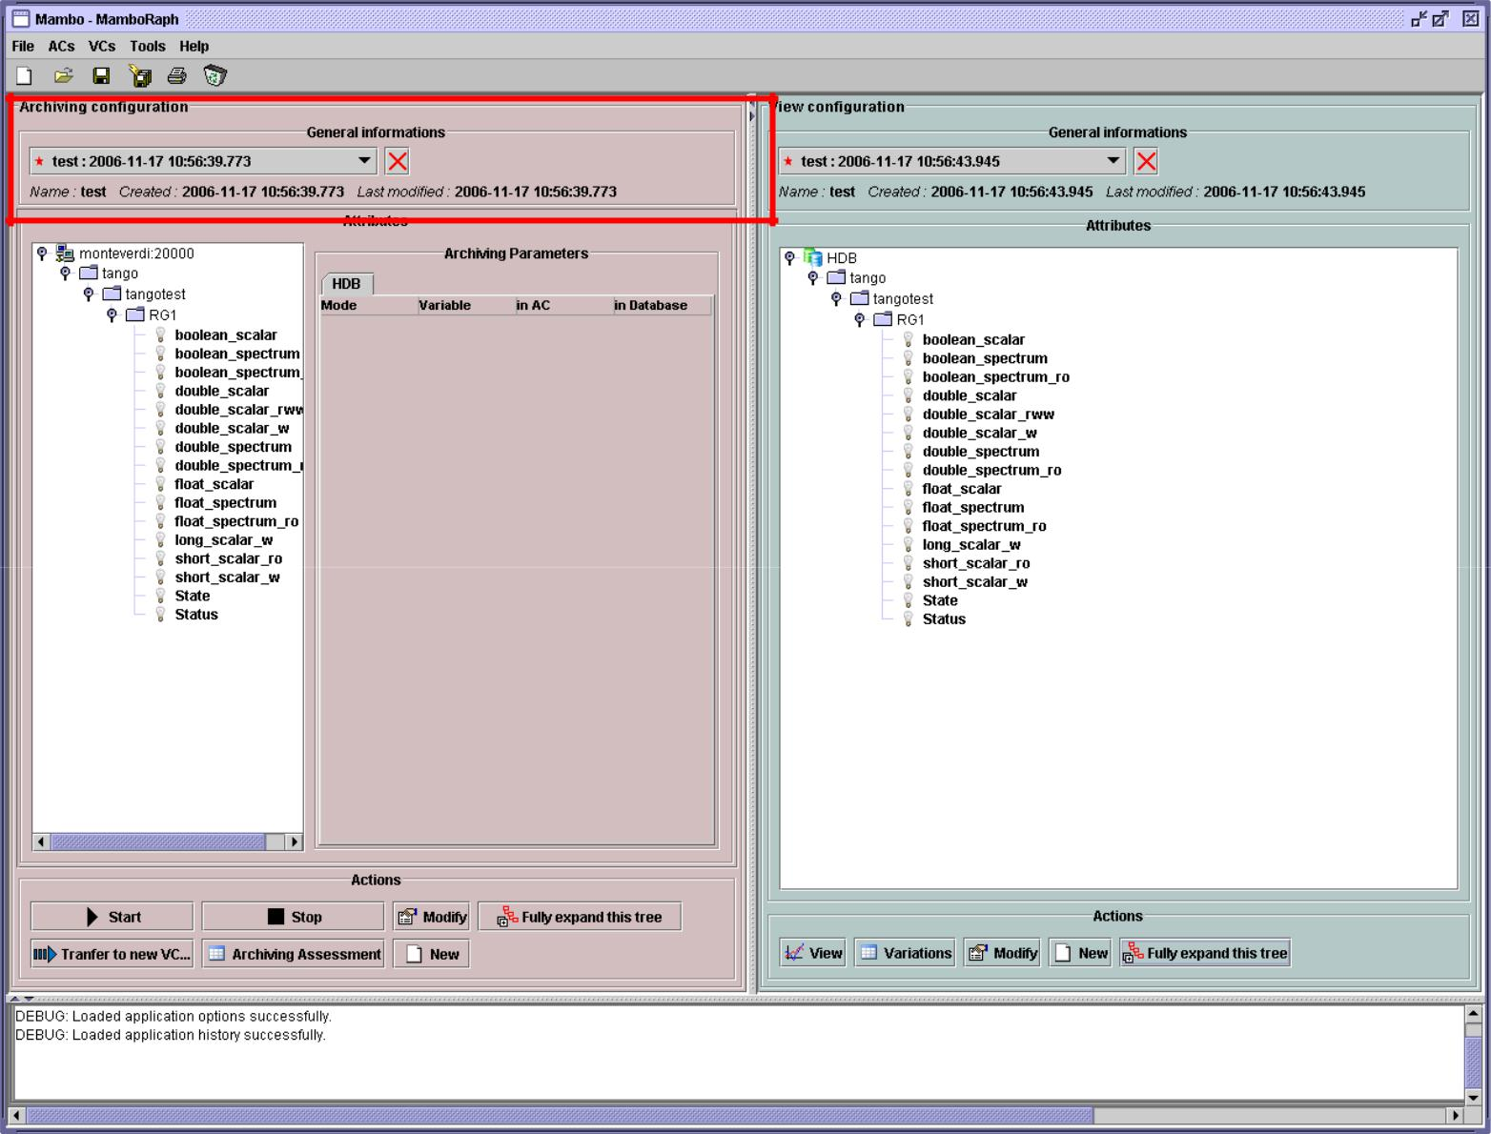

“Reference” Last Update : 22 February 2012 Page 11 /35
Synchrotron Soleil Mambo Manual V2.1

4.3. Starting/Stopping archiving on an AC

4.3.1. The Current Archiving Configuration detail panel

Attributes are displayed differently in selection trees, with respect to their current archiving status. The display shows their current status in DB, not their archiving modes in the current AC.

- Attributes that aren’t being archived are displayed as off bulbs:
- Attributes that are being archived only in HDB are displayed as on, yellow bulbs:
- Attributes that are being archived only in TDB are displayed as on, brown bulbs:
- Attributes that are being archived in HDB and TDB are displayed as on, bicolor bulbs:

4.3.2. Starting/Stopping archiving on an AC

Starting archiving:

- Create/Load an AC or just use the current AC. The AC that will be used is the one displayed in the application’s AC panel.
- Call Start to start archiving each attribute by all its modes

Stopping archiving:

- Create/Load an AC or just use the current AC. The AC that will be used is the one displayed in the application’s AC panel.
- Call Stop to stop archiving of each attribute. All archiving modes will be stopped.

In both cases a success/failure message confirms the action.

The Current Archiving Configuration panel

“Reference” Last Update : 22 February 2012 Page 12 /35
Synchrotron Soleil Mambo Manual V2.1

4.4. Displaying an AC

4.4.1. The Current Archiving Configuration detail panel
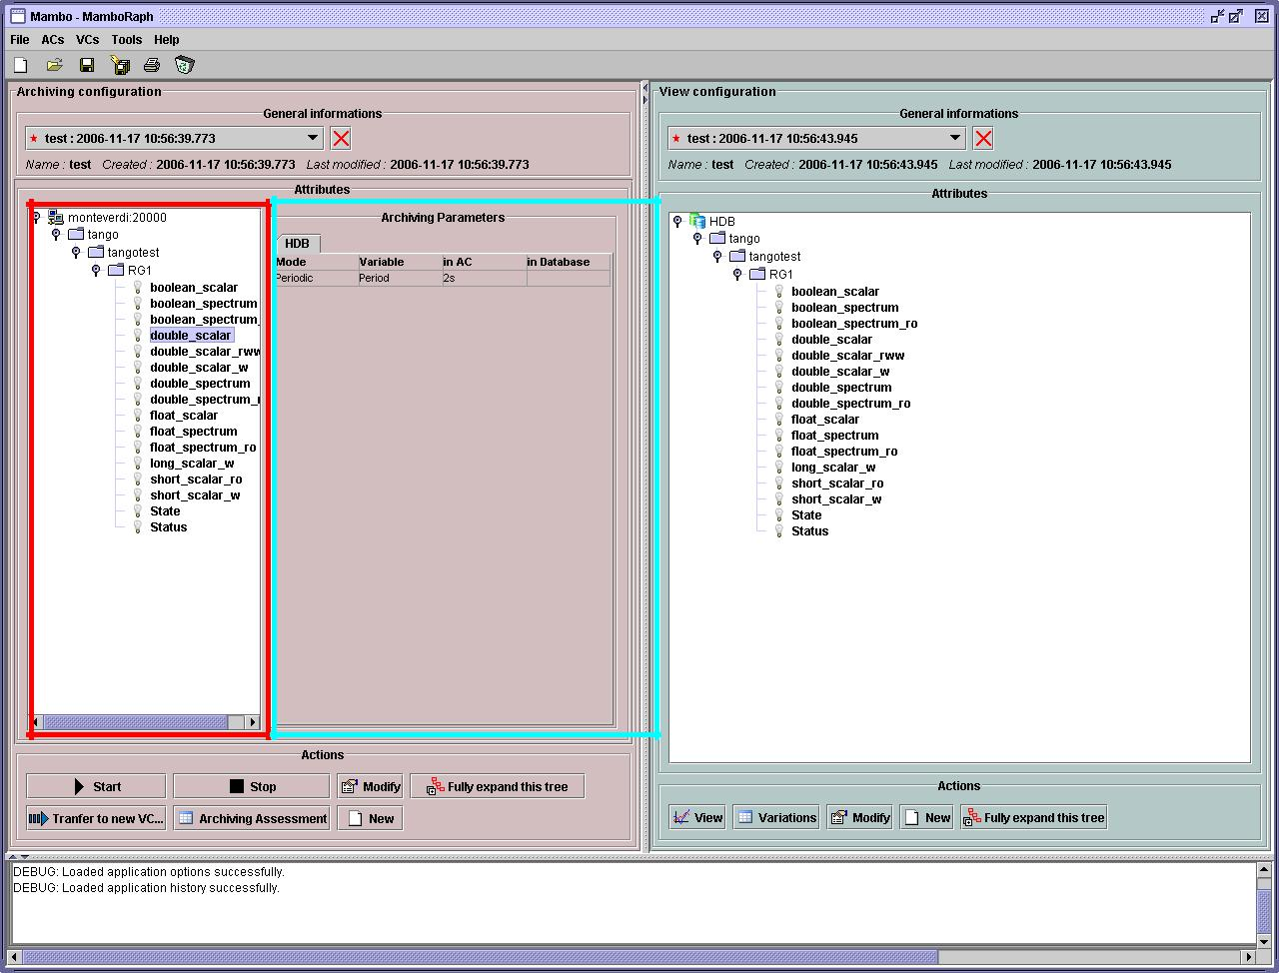

Selection of | Display of the selected
Selection of | Attribute’s archiving
an Attribute | Attribute’s archiving
an Attribute | modes

Figure 7: Detail of the current AC

This panel represents the current Archiving Configuration.
On the left, a tree lists all of the AC’s attributes.
When the user selects a given attribute on this tree, its HDB and TDB modes are displayed on the right sub-panel.

This displays the attributes modes individually; to get a global view of the AC’s Archiving Modes, use the “Archiving assessment” command.

4.4.2. The Archiving assessment window

“Reference” Last Update : 22 February 2012 Page 13 /35
Synchrotron Soleil Mambo Manual V2.1
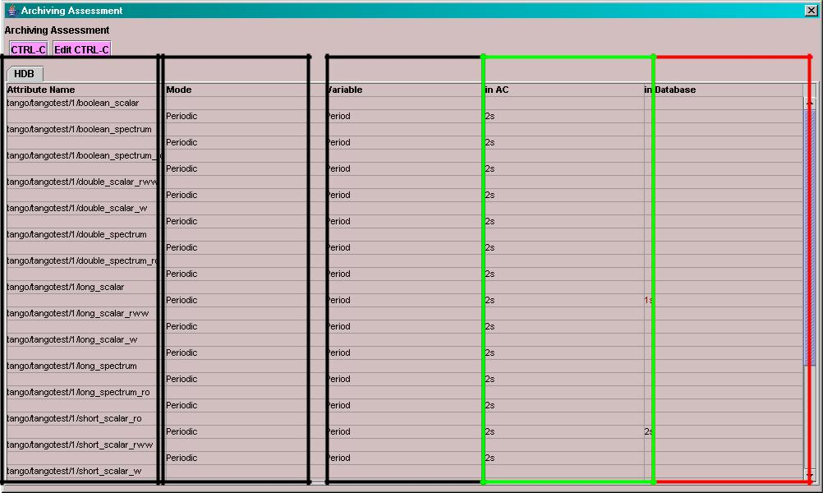

List of attributes | List of modes for | Modes parameters | Mode parameters | Mode parameters
that have at least | each attribute | names | values as read in the | values as read in
one TDB mode in | (“Any” is for |  | current AC | TDB
the current AC | parameters
 | common to all
 | modes)

Figure 8: Global view of all the modes of an AC

This window sums up the current Archiving Configuration in two tabs (one for HDB, one for TDB).

For each attribute contained in the current AC, its archiving modes are detailed, and if the attribute is being archived, can be compared to the modes values found in HDB (resp. TDB).

4.5. Saving/Loading an AC

4.5.1. Saving an individual AC

Archiving Configurations are saved/loaded as XML files, with the .ac file extension.
In the menu, select “ACs/Save” or “File/Save/Archiv ing configuration”:

Save operations work like they do with Word (for example):

- The first time a file is saved, the user is prompted to choose a path and file name; initially the file chooser dialog is in the “ac” subdirectory of the Mambo wo rking directory. The “.ac” file extension is automa tically added if the user doesn’t.

- If a file has already been saved, it will automatically be saved in the same file the next time the “S ave” menu is selected.

- The user can still specify a different file, by using the “ACs /Save as” menu (or “File/Save As/Archiv ing configuration”)

When an AC is loaded, it becomes the current Archiving Configuration., and it is added to the list of opened ACs.

In both cases, a success/failure message confirms the action.

“Reference” Last Update : 22 February 2012 Page 14 /35
Synchrotron Soleil Mambo Manual V2.1

4.5.2. Saving all opened ACs

It is possible to save all opened ACs. Only modified ACs will be saved (ie. the ACs that have a “red s tar”).

In the menu, select “ACs/Save All”:

For each modified AC, the save operation will follow the same rules as an individual save:

- If the file has already been saved before, it will be saved silently.

- Otherwise, the user will be prompted to choose a directory and file.

In this case, the ACs that are being saved are successively selected before each file chooser prompt (so that the user knows what AC he’s choosing a path for).

The generic “Save All” menu item in “File/ Save Al l” does this, plus the same thing for opened VCs.

4.6. Transfer to VC

This functionality is used to quickly create a VC on the same attributes as a given AC; for example, when the user wants to monitor the values of attributes after starting archiving on an AC.

It will create a VC automatically, with the following properties:

- Its attributes list is the same as the AC the “Tran sfer to VC” functionality is used on

- The attributes values are all extracted from HDB, even if some of the AC’s attributes were only archived in TDB (obviously, the display for such an attribute will be empty).
- The date range a 1 hour range ending at the VC’s creation time

- Every Attribute has an automatically determined color (if there are more attributes than colors to choose from, different attributes will have the same color).

“Reference” Last Update : 22 February 2012 Page 15 /35
Synchrotron Soleil Mambo Manual V2.1

5. Exploit archived data

This section deals with controlling exploitation of archived attributes (HDB/TDB) through View Configurations (henceforth VC).

A VC describes which attributes to display and how, and consists of:
• General information (when the VC was created, the date range to extract … )

- A list of attributes to display

- For each attribute, a set of display properties.

The archived attributes of a VC either all come from HDB or all come from TDB, since it wouldn’t make sense to display HDB and TDB attributes in a common plot.

VCs are accessed and used in the VC panel:
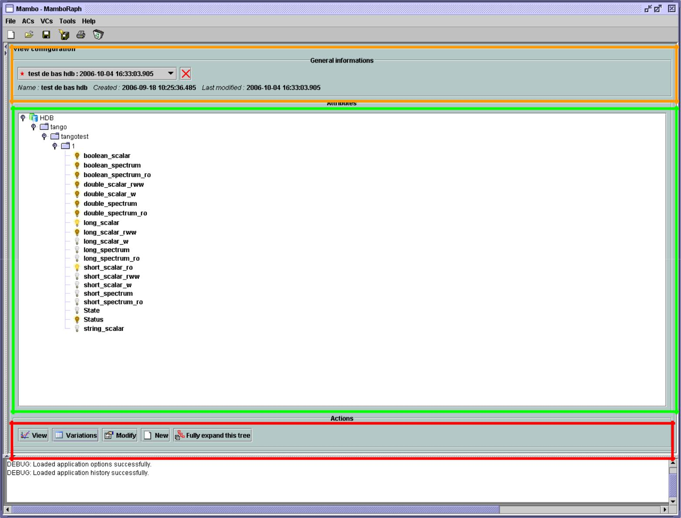

VC selection
General VC properties

Current VC’s attributes

VC actions

Figure 9: The VC panel

“Reference” Last Update : 22 February 2012 Page 16 /35
Synchrotron Soleil Mambo Manual V2.1

5.1. Creating/modifying an VC

Creation or modification of a VC is done the same way, using the New/Modify button respectively. We will see how to load a VC later.

Step 1 : VC general properties

Those properties don’t depend on a specific attribute, they are common to all VC attributes or describe the VC.
Click the New/Modify button in the VC actions panel; the following dialog appears:
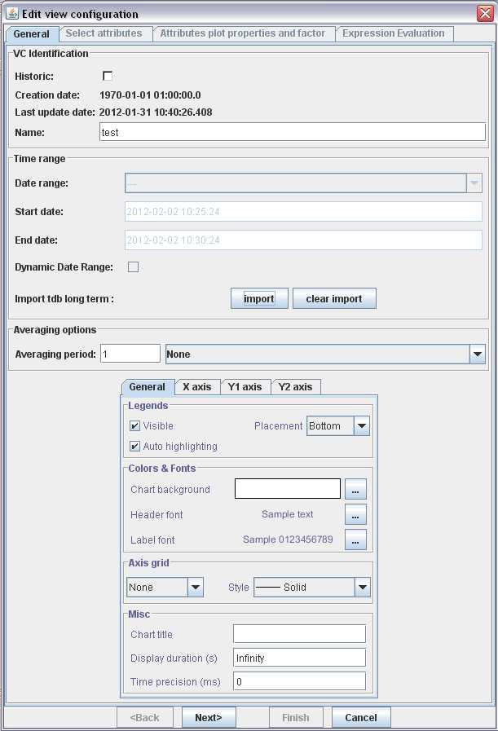

Figure 10: Step 1, general properties

Step 1.1 : VC properties

“Reference” Last Update : 22 February 2012 Page 17 /35
Synchrotron Soleil Mambo Manual V2.1

- You can choose a name for the VC. This field isn’t mandatory but it is recommended to fill it.

- The creation and update dates are filled automatically upon saving the VC.

- The user must define a date range (Start/End dates) to extract data from. This can be done either manually, or by selecting a “Since xxx” item in the “Date range” drop-down menu.

In the latter case, the user can check the “Dynamic date range”. What this option does is recalculate the Start/End dates at each edition of the VC.

Example: At 09:00 the user chose “Last 1 hour” as t he “since option”. The date range will be [08:00-09:00].

If the VC is then edited at 11:00, and “Dynamic dat e range” was checked, the date range will be [10:00 - 11:00]; otherwise it will still be [08:00-09:00].

- If the “Historic” checkbox is checked, VC attribute s will be chosen among HDB attributes (otherwise, TDB).

- If the “Historix” checkbox is not checked, you are in TDB mode so you can import long term snapshot. In this case you can’t modify start and end date because the snapshot configure it himself.

Step 1.2 : General chart properties

- The user can define global chart properties (title, background, …)

“Reference” Last Update : 22 February 2012 Page 18 /35
Synchrotron Soleil Mambo Manual V2.1

Step 1.3 : Y1 axis properties
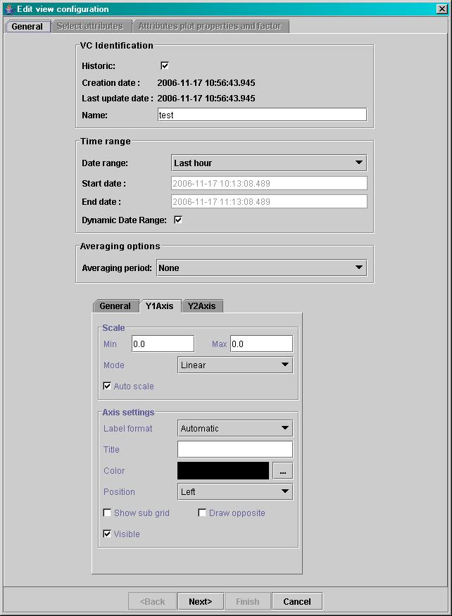

Figure 11: Step 1, general properties (continued)

- The user can define the left vertical axis properties (title, scale, …)

“Reference” Last Update : 22 February 2012 Page 19 /35
Synchrotron Soleil Mambo Manual V2.1

Step 1.4 : Y2 axis properties

- The user can define the right vertical axis properties (title, scale, …) Step 2 : Select the VC attributes

The attributes selection works the same way as an AC attributes selection, except for two differences:

- The only available selection mechanism is the tree selection

- The trees are initially loaded to the attributes level.

“Reference” Last Update : 22 February 2012 Page 20 /35
Synchrotron Soleil Mambo Manual V2.1
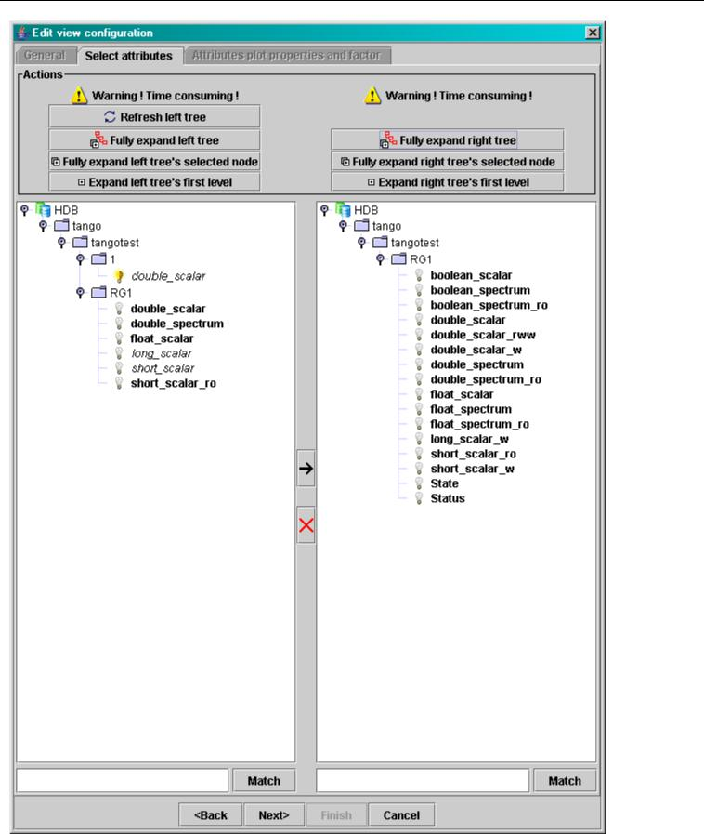

Figure 12: Step 2, selecting attributes

- The left tree lists the HDB (resp. TDB) attributes. The right tree represents the current attributes of the edited VC.

Both tree have the same structure of HDB (resp. TDB)/Domains/Families/Members/Attributes.

WARNING Unlike AC trees, VC trees are initially loaded to the Attributes level since archived attributes are a small subset of all Tango attributes.

- Consequently, the match functionality works up to attributes names: one can use a D/F/M/A criterion.

“Reference” Last Update : 22 February 2012 Page 21 /35
Synchrotron Soleil Mambo Manual V2.1

Step 3 : Set the VC attributes properties

  - General flow See ACs.

  - Attributes selection See ACs.

- Controls upon VC validation

- Any unset attribute will be removed from the VC; the user is prompted to continue editing the VC, or ignore them.
- The VC’s date range is controlled

When the validation is over, the VC is displayed in the application’s VC panel.

5.2. The opened VCs menu

See 4.2 the opened ACs menu.

5.3. Using View on a VC

Once a valid VC has been defined, the “View” button can be used to display a plot showing the VC’s attributes values with respect to time in the specified time range.

“Reference” Last Update : 22 February 2012 Page 22 /35
Synchrotron Soleil Mambo Manual V2.1
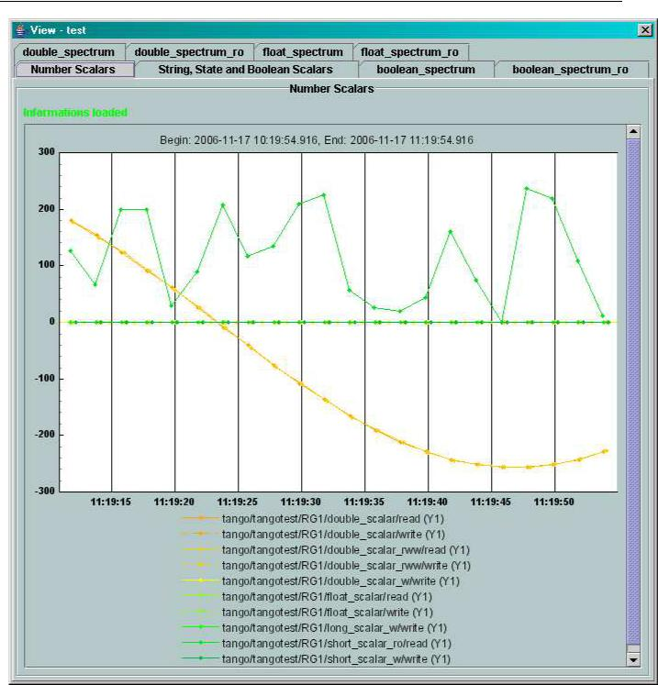

Figure 13: A plot example with 2 read/write attributes

5.4. Displaying a VC

“Reference” Last Update : 22 February 2012 Page 23 /35
Synchrotron Soleil Mambo Manual V2.1
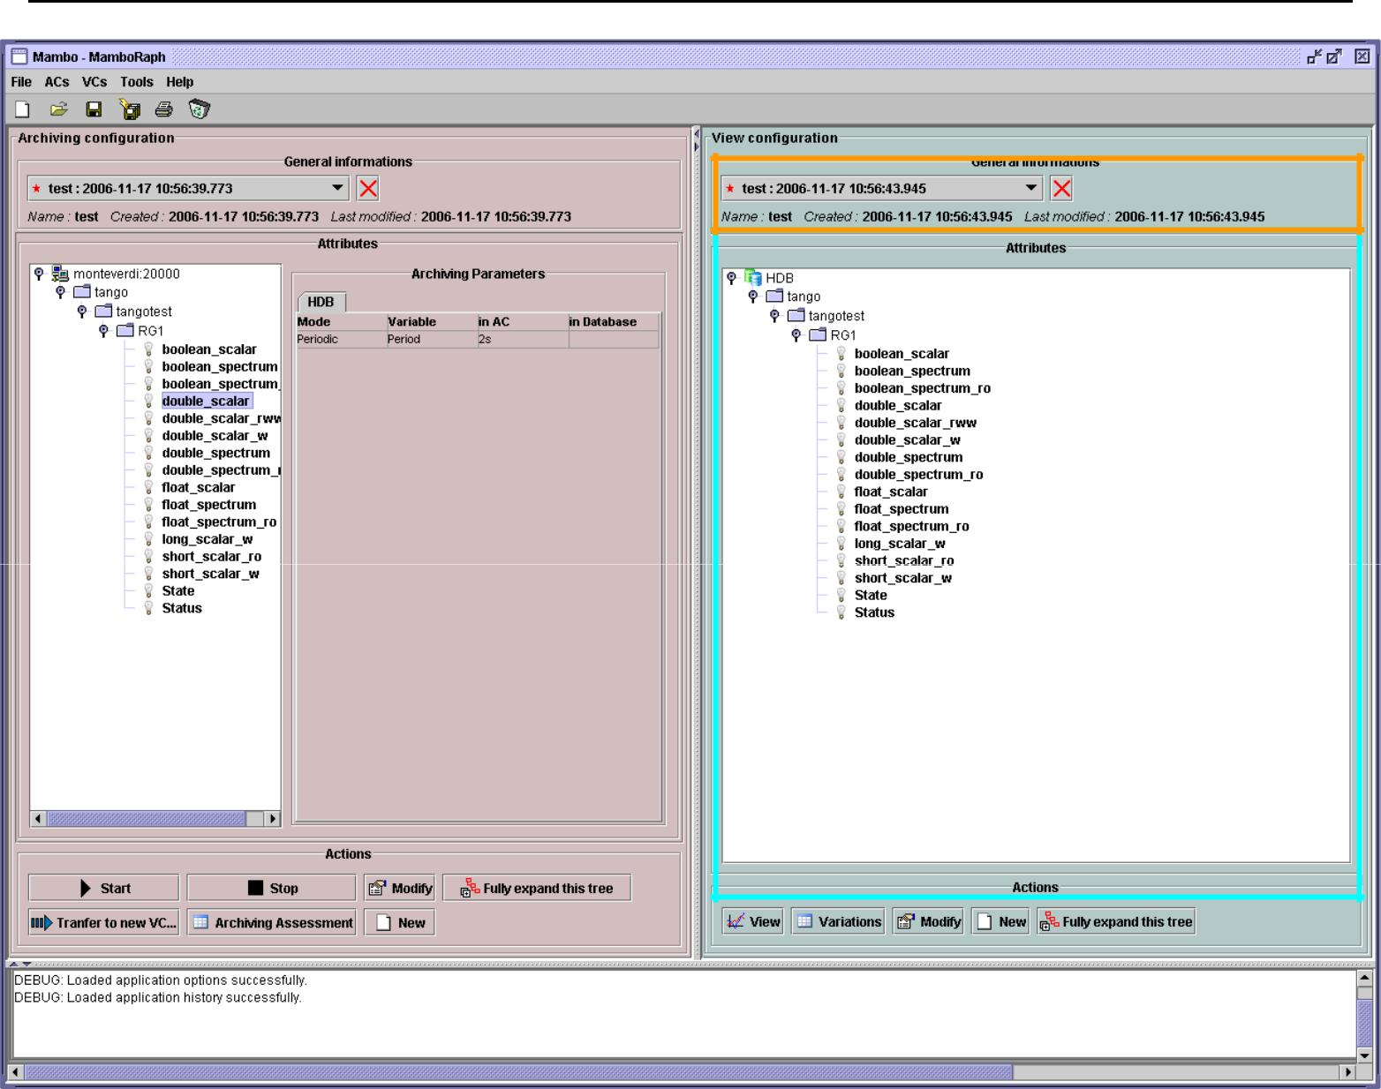

The current VC’s general properties

The current VC’s attributes

Figure 14: The current VC panel

This panel represents the current View Configuration; a tree lists all the VC’s attributes.
To view specific parameters, the user must use the “Modify” button.

5.5. Saving/Loading a VC

See ACs.

5.6. Using the Variations functionality

The Variations functionality is a filter that comes between a VC and the final plot display.

“Reference” Last Update : 22 February 2012 Page 24 /35
Synchrotron Soleil Mambo Manual V2.1
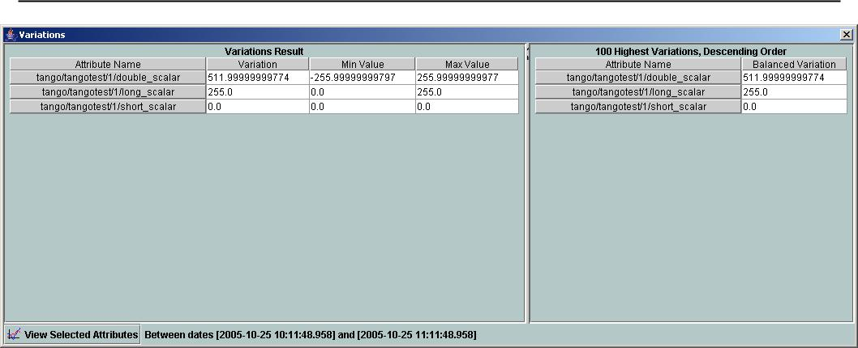

Figure 15: The "variations" attributes selection window

The Variations window lists the VC attributes and their “variation”, which is defined as the differenc e between the min and max values in the VC’s date range.

The user can then select attributes which variations seem abnormal or interesting, and only plot those attributes.

The Variations window is made of two different tables:
The first one shows for every attribute its minimum and maximum values, and its variation.

The second one gives the 100 highest balanced variations (the balancing factor of each attribute having been defined earlier in the VC).

Select lines in the left table, and press “View Sel ected Attributes” to display the filtered plot.

“Reference” Last Update : 22 February 2012 Page 25 /35
Synchrotron Soleil Mambo Manual V2.1

6. Long term snapshot

Mambo allows saving and viewing long term snapshots. A snapshot is limited by a period of 5 minutes maximum.

6.1. Add snapshot
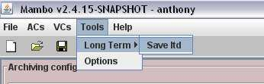

Figure 16: Where to save a new snapshot

If you click on “Save ltd” you will arrive in add v iew:
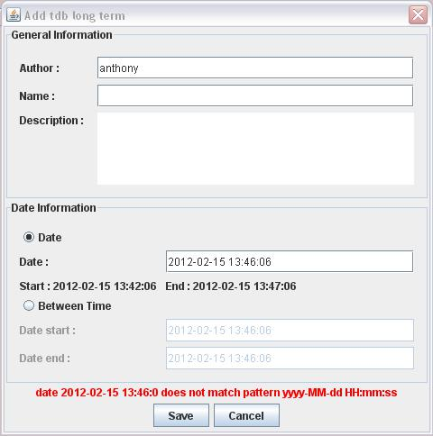

Figure 17: The view to add a new snapshot

You have some fields to fill.

- General Information :

Author: Name of the person who is saving the snapshot. By default the name of the Mambo session. Not required field.

Name: Name of the snapshot. Not required field.
Description: The description of the snapshot. Not required field.

“Reference” Last Update : 22 February 2012 Page 26 /35
Synchrotron Soleil Mambo Manual V2.1

- Date information : Two possibilities:

    - Set one date and the application will calculate the start and end dates. The calculation is:
      - start date = date – 4 minutes

      - end date = date + 1 minute

    - Directly set the start and end date. The difference must not exceed 5 minutes. Otherwise, an error message is displayed.

  - Error information :

If a snapshot badly filled, a red error message will inform what the problem is.

6.2. Import snapshot

When creating/modifying a VC, you can import a snapshot. In case of click to “import” you will have th e list of snapshot.
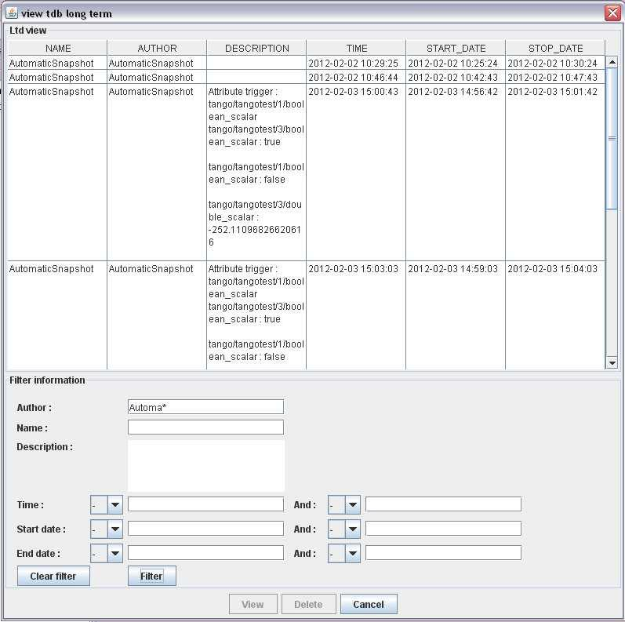

18 View snapshot

“Reference” Last Update : 22 February 2012 Page 27 /35
Synchrotron Soleil Mambo Manual V2.1

- Ltd view :

List of snapshots according to filters. By default only the snapshot of the day are displayed.

- Filters :

You can filter snapshot. You can use zero, one or all the fields.
You can use “*” to search something like.

For date you have a list to precise if you want “le ss” or “greater or equals” than the precise date. M oreover you can precise a period with use of the two fields.

To import a snapshot, you must use the “view” butto n.

“Reference” Last Update : 22 February 2012 Page 28 /35
Synchrotron Soleil Mambo Manual V2.1

7. Options

Mambo manages global options. Those options are saved on application shutdown, and loaded on startup.
The Options menu is located in the Menu bar : Tools Options.

7.1. Logs options

Choose the application’s log level.

Verbosity ranges from DEBUG (highest) to CRITIC (lowest), at least WARNING is recommended.
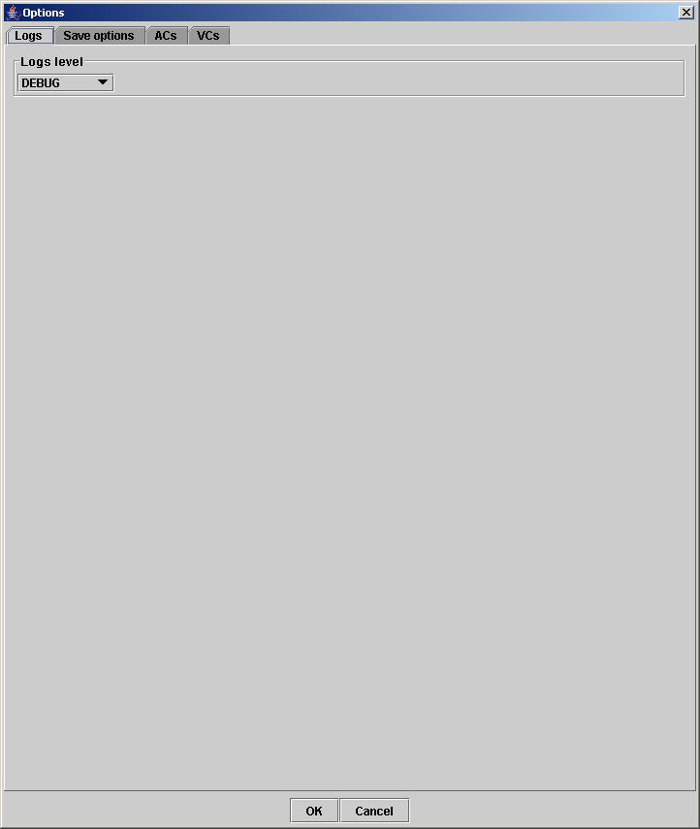

Figure 19: Logs options (setting up verbosity)

“Reference” Last Update : 22 February 2012 Page 29 /35
Synchrotron Soleil Mambo Manual V2.1

7.2. Application’s history save/load options

Define whether Mambo has a history, ie. a persistent state when closed/reopened.

If Yes is checked, a XML History file will be saved in Mambo’s workspace, and on next startup the current AC and VC will be loaded.
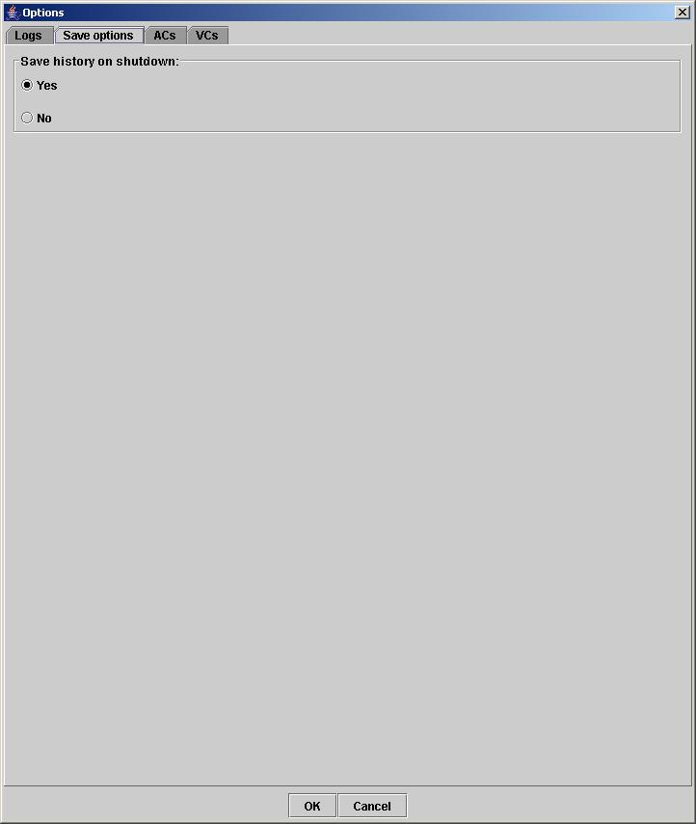

Figure 20: The history options

“Reference” Last Update : 22 February 2012 Page 30 /35
Synchrotron Soleil Mambo Manual V2.1

7.3. AC options

Options for all Archiving Configurations; the user can define:

- An attribute selection mechanism for AC edition (see ACs)

- Default modes selection and values for HDB and TDB archiving (see ACs)
- The selected modes and values will be preset for all unset attributes .
- The default values can be saved to /loaded from an Archiving Configurations Defaults file (.acd

extension)
  - The “Restore defaults” button reloads the defaults with non user-modifiable predefined values.

- The size of the “AC stack”, that is the maximum num ber of opened ACs.

“Reference” Last Update : 22 February 2012 Page 31 /35
Synchrotron Soleil Mambo Manual V2.1
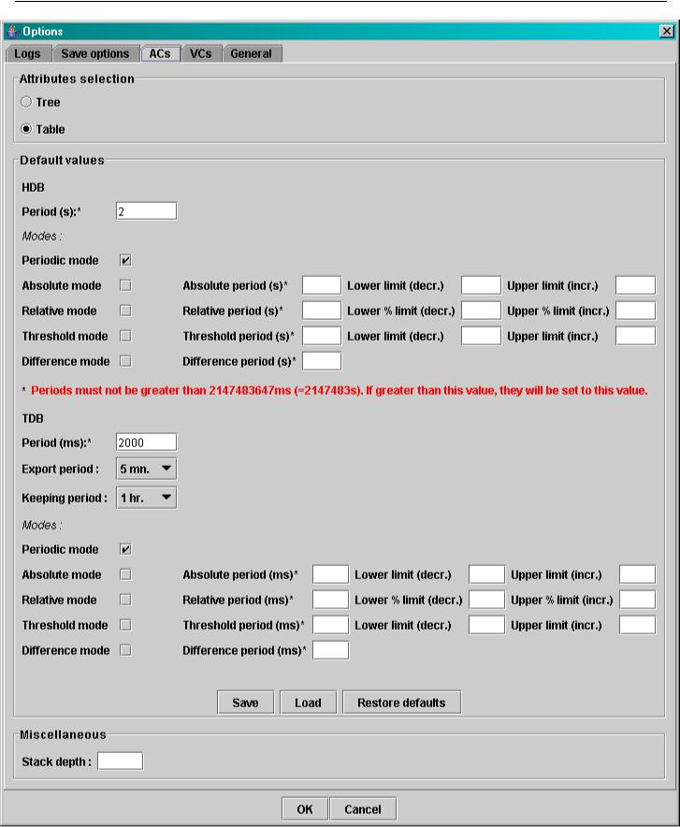

Figure 21: The AC options

“Reference” Last Update : 22 February 2012 Page 32 /35
Synchrotron Soleil Mambo Manual V2.1

7.4. VC options

Options for all View Configurations; the user can define

- Whether he wants to display the Read value of attributes only, the Write value only, or both.

- The size of the “VC stack”, that is the maximum num ber of opened VCs.
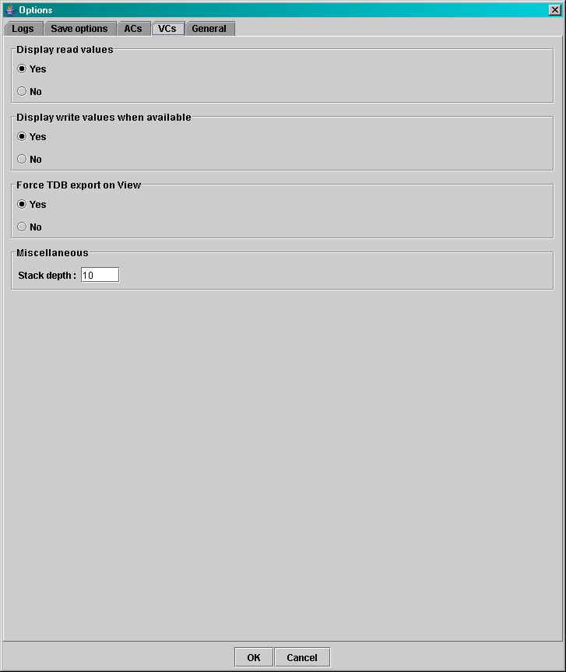

Figure 22: The VC options

“Reference” Last Update : 22 February 2012 Page 33 /35
Synchrotron Soleil Mambo Manual V2.1

8. The Mambo toolbar

The toolbar is located under the menu bar, and consists mainly of a set of shortcuts to often used functionalities.
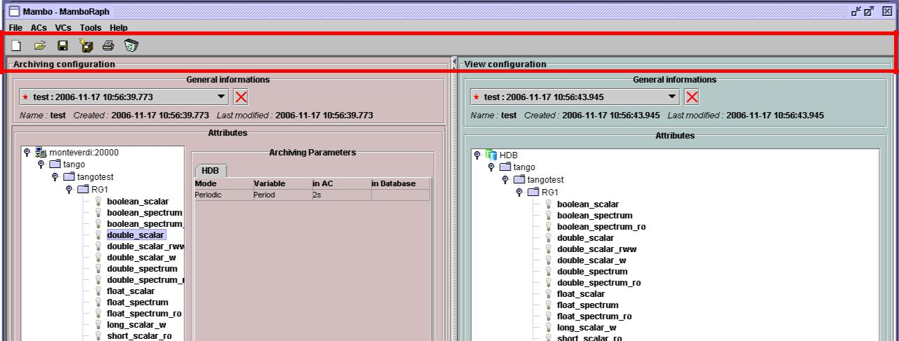

The toolbar
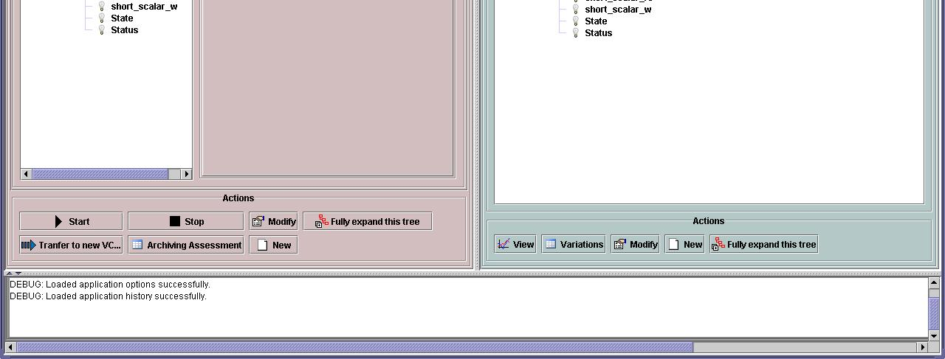

Figure 23: The Mambo toolbar

- is a shortcut to creating a new AC/VC

- is a shortcut to loading an existing AC/VC file into the current AC/VC

- is a shortcut to saving the current AC/VC into an AC/VC file

- is a shortcut to doing a saving all opened ACs and VCs

- is a shortcut to printing the file representation of the current AC/VC

- is a shortcut to removing all opened ACs and VCs from display

“Reference” Last Update : 22 February 2012 Page 34 /35
Synchrotron Soleil Mambo Manual V2.1

Annexes

Index

Archiving

The action of storing in database the values of Tango attributes in a time range, each value being associated with a time stamp.

Archiving mode

An archiving mode is a rule defining when an attribute has to be archived.

The most basic archiving mode is the Periodic archiving mode, where an attribute is archived every N milliseconds, no questions asked.

More elaborate archiving modes like the Threshold archiving mode ask for archiving when the attribute’s value meets certain conditions, but they can only be used in association with the Periodic archiving mode.

AC

Short for an Archiving Configuration
Describes archiving for a set of attributes, by associating a set of archiving modes to each of its attributes.

VC
Short for a View Configuration
Describes plot properties for a set of attributes, by associating a set of plot properties to each of its attributes.

HDB
Short for the Historic Database.
Attributes values archived in HDB are stored forever.

TDB
Short for the Temporary Database.
Attributes values archived in TDB are deleted every [given deletion time].

VERIFIER QUE C’EST BIEN CA

Quick save/Quick load

The action of saving (resp. loading) to a default file. Called “quick” because no user interaction to choose a directory/file name is required.

“Reference” Last Update : 22 February 2012 Page 35 /35

