
collaboration

tutelle


INSTALLATION OF MAMBO DATA ARCHIVING SYSTEM

RESUME

This document is the installation manual for the data archiving system called Mambo.

Type de document : Installation manual

 | REDACTEUR | APPROBATEUR | EMETTEUR
Unité | WP08
Fonction
Nom | Jean-Luc VERAY
Date du visa | 16/09/2011
Visa




avec le soutien

ILE Matrice Rapport

06.dotx/DF/20110829

Installation of Mambo data archiving system | PROJET APOLLON
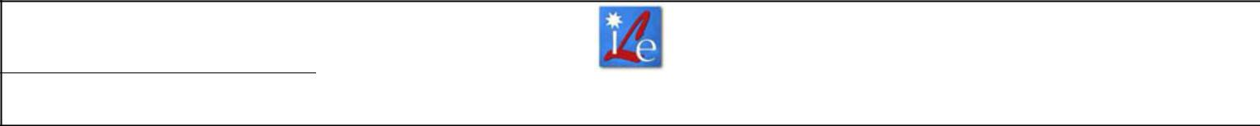

SUMMARY

1 VERSION LIST 2

1.1 MODIFICATIONS 2

1.2 GLOSSARY AND ABBREVIATIONS 2

1.3 REFERENCES 3

2 PURPOSE AND PRELIMINARIES 4

3 DOWNLOAD MAMBO 4

4 INSTALL WAMP 4

5 CREATION OF HDB AND TDB 7

6 CREATE ARCHIVING DEVICES 8

7 CONFIGURE ARCHIVING DEVICES 9

8 START ARCHIVING DEVICES 13

9 START MAMBO 13

10 UNINSTALL 15

10.1 UNINSTALL TANGO 15

10.2 UNINSTALL MYSQL 15

10.3 UNINSTALL MAMBO 15

10.4 UNINSTALL WAMP 15

1 VERSION LIST

1.1 MODIFICATIONS

 |  | INDEX |  |  |  | DATE |  | DESCRIPTION |  |  |  | § |  | PAGES
 |  | INDEX |  |  |  | DATE |  | DESCRIPTION |  |  |  | § |  | MODIFIED

A 14/09/2011 Creation

1.2 GLOSSARY AND ABBREVIATIONS

 | TERME |  | DÉFINITION
 | HDB |  | History Data Base
 | TDB |  | Temporary Data Base
 | ile_wp08_jlv_110
 | 914_installationm |  | ILE_WP08_JLV_110914_InstallationManualMambo_A
 | anualmambo_a.d |  | ILE_WP08_JLV_110914_InstallationManualMambo_A | Page : 2 / 16
 | anualmambo_a.d | document de projet – Institut de Lumière Extrème - Chemin de la Hunière – 91761 Palaiseau cedex |  | Page : 2 / 16
 | oc
 | 16/09/2011

ILE Matrice Rapport

06.dotx/DF/20110829

Installation of Mambo data archiving system | PROJET APOLLON

1.3 | REFERENCES
## | REFERENCE | TITLE | DATE
[R 1] | Formation TANGO - | Installation d’une plateforme TANGO | 01/06/2011
 | Installation Windows.pdf | - Windows
[R 2] | Mambo_Manual_v2_1.pdf | Mambo Manual | 17/11/2006
[R 3]
[R 4]
[R 5]

ile_wp08_jlv_110
914_installationm | ILE_WP08_JLV_110914_InstallationManualMambo_A
anualmambo_a.d | ILE_WP08_JLV_110914_InstallationManualMambo_A | Page : 3 / 16
anualmambo_a.d | document de projet – Institut de Lumière Extrème - Chemin de la Hunière – 91761 Palaiseau cedex | Page : 3 / 16
oc
16/09/2011

ILE Matrice Rapport

06.dotx/DF/20110829

Installation of Mambo data archiving system | PROJET APOLLON

2 PURPOSE AND PRELIMINARIES

This document presents the installation of a part of Mambo data archiving system. This system must be used with Tango framework you need to install before reading the current paper ([R1]). Devices called Extractor and Watcher are not treated in this manual.
More precisely, Mambo is a software used to configure and visualize archived data. The use of Mambo is not described here. If you need to, you can read the manual written by Soleil Synchrotron, privileged member of the Tango community ([R2]).


This paper has been written for Windows XP operating system.

3 DOWNLOAD MAMBO

Mambo archiving system has been developed by Soleil Synchrotron. Last releases are available on a particular webpage of Soleil. You may reach this website by clicking on : http://www.tango-controls.org/download/archiving-1

The current paper has been written with the current version of the archiving system, that is to say 11.4.3 (Mambo current release is 2.4.11). Once you reached the website :

- Download ArchivingRoot-11.4.3.zip,
- Create the file called mambo in the following directory C:\tango-root,
- Extract the archive in C:\tango-root\mambo.

4 INSTALL WAMP

WampServer is a web development platform working on Windows. We are not using it for web applications but we’ll use phpMyAdmin provided by Wamp. The version of MySQL included in Wamp may be different from the version you installed with Tango. So far, tests don’t show any conflict. This needs to be confirmed later.


Here is how to install Wamp :

- Download Wamp : http://www.wampserver.com/download.php. This paper has been written with WampServer 2.1e,
- Process the standard installation,

ile_wp08_jlv_110
914_installationm | ILE_WP08_JLV_110914_InstallationManualMambo_A
anualmambo_a.d | ILE_WP08_JLV_110914_InstallationManualMambo_A | Page : 4 / 16
anualmambo_a.d | document de projet – Institut de Lumière Extrème - Chemin de la Hunière – 91761 Palaiseau cedex | Page : 4 / 16
oc
16/09/2011

ILE Matrice Rapport

06.dotx/DF/20110829

Installation of Mambo data archiving system | PROJET APOLLON
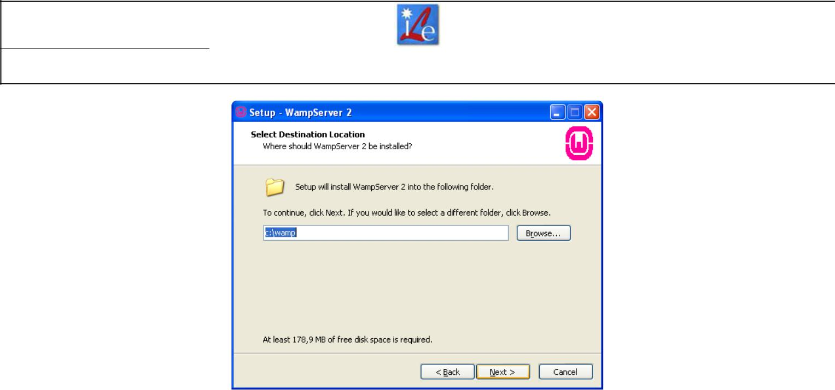

Install Wamp in the default directory
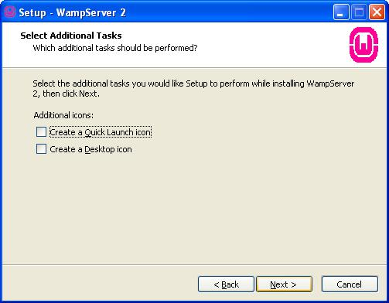

Shortcuts are not necessary
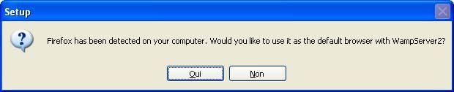

Select « Yes » to allow Wamp to use Firefox (in that event)

ile_wp08_jlv_110
914_installationm | ILE_WP08_JLV_110914_InstallationManualMambo_A
anualmambo_a.d | ILE_WP08_JLV_110914_InstallationManualMambo_A | Page : 5 / 16
anualmambo_a.d | document de projet – Institut de Lumière Extrème - Chemin de la Hunière – 91761 Palaiseau cedex | Page : 5 / 16
oc
16/09/2011

ILE Matrice Rapport

06.dotx/DF/20110829

Installation of Mambo data archiving system | PROJET APOLLON
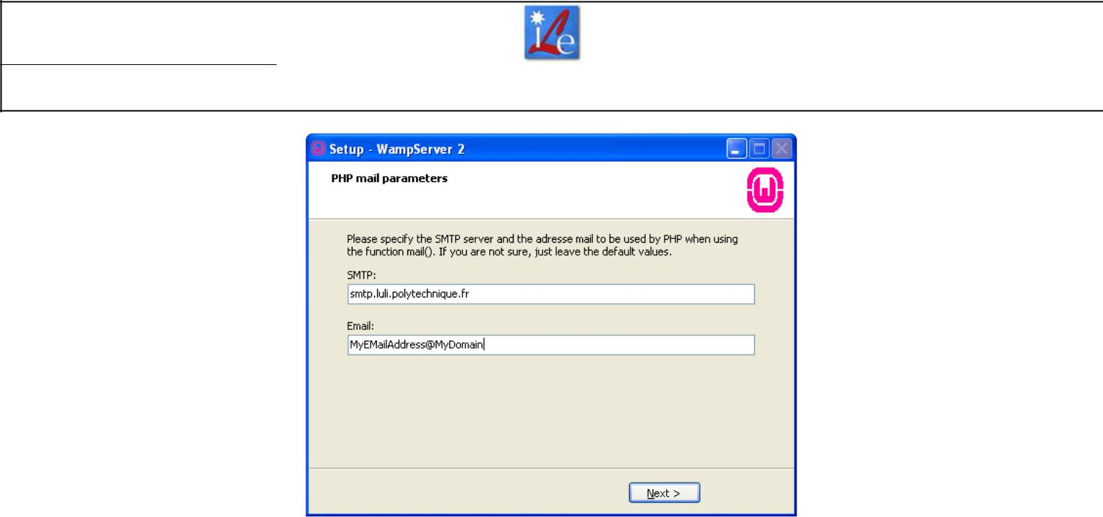

Write data corresponding to your STMP server,
and your email address

- After installing Wamp, you need to configure a password to reach databases with phpMyAdmin :
  - Open the file C:\wamp\apps\phpmyadmin3.3.9\config.inc.php,
  - Enter the following data :
$cfg['Servers'][$i]['user'] = 'root';
$cfg['Servers'][$i]['password'] = 'root';
$cfg['Servers'][$i]['AllowNoPassword'] = false;

Now, we’ll test the connection to databases :

- Start WampServer, an icon appears at the bottom right of your screen,
- Click the icon>phpMyAdmin,
- Your usual browser opens and lists databases (you are able to see databases used by MySQL and those created while installing Tango).
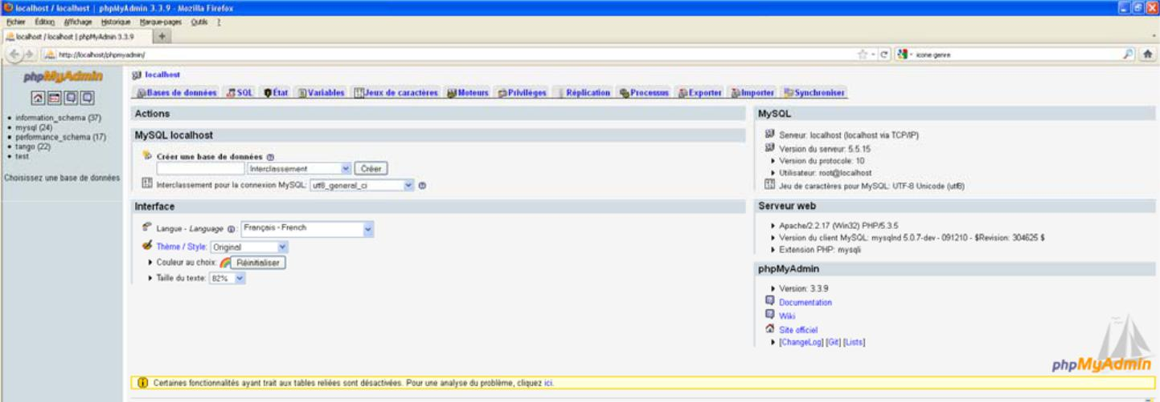

No error : phpMyAdmin is connected to databases

ile_wp08_jlv_110
914_installationm | ILE_WP08_JLV_110914_InstallationManualMambo_A
anualmambo_a.d | ILE_WP08_JLV_110914_InstallationManualMambo_A | Page : 6 / 16
anualmambo_a.d | document de projet – Institut de Lumière Extrème - Chemin de la Hunière – 91761 Palaiseau cedex | Page : 6 / 16
oc
16/09/2011

ILE Matrice Rapport

06.dotx/DF/20110829

Installation of Mambo data archiving system | PROJET APOLLON

5 CREATION OF HDB AND TDB

It is strongly advised to use Notepad++ in order to modify SQL files (different language recognition). Download : http://notepad-plus-plus.org/


Here is how to create HDB et TDB :

- Create the environment variable ARCHIVING_ROOT whose value is C:\tango-root\mambo (directory where you extract ArchivingRoot-11.4.3.zip),

- Open the file C:\tango-root\mambo\ArchivingRoot-11.4.3\db\create-HDB-MyISAM.sql (with Notepad++),
- ReplaceTYPE=MyISAM by ENGINE=MyISAM. This step is necessary if you installed MySQL 5.5 for Tango. You mustn’t do this step if you installed MySQL 5.0. Tests have not been realised with MySQL 5.1.
- Cut/Paste the whole file containing SQL requests in phpMyAdmin,
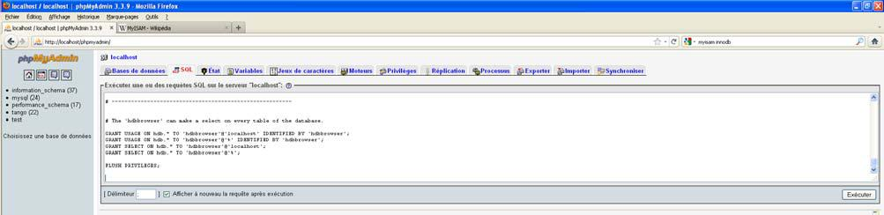

Cut/Paste SQL requests in the SQL tab

5. Execute requests. A message validating requests shows up,
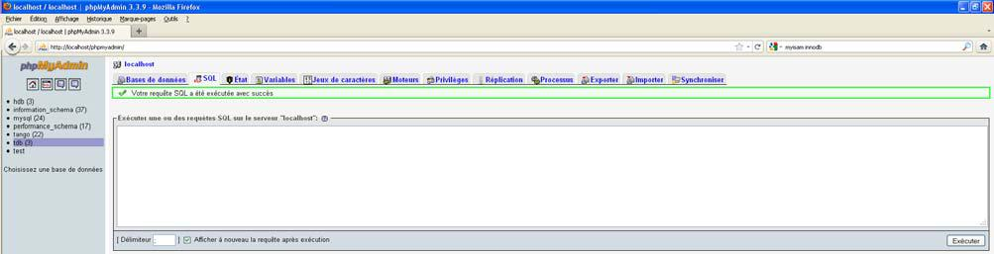

  - Your SQL request has been executed with success »

- Open the file C:\tango-root\mambo\ArchivingRoot-11.4.3\db\create-TDB-MyISAM.sql (with Notepad++),
- Replace TYPE=MyISAM par ENGINE=MyISAM. This step is necessary if you installed MySQL 5.5 for Tango. You mustn’t do this step if you installed MySQL 5.0. Tests have not been executed with MySQL 5.1.
- Cut/Paste the whole file containing SQL requests in phpMyAdmin,
- Execute requests. A message validating requests shows up.

ile_wp08_jlv_110
914_installationm | ILE_WP08_JLV_110914_InstallationManualMambo_A
anualmambo_a.d | ILE_WP08_JLV_110914_InstallationManualMambo_A | Page : 7 / 16
anualmambo_a.d | document de projet – Institut de Lumière Extrème - Chemin de la Hunière – 91761 Palaiseau cedex | Page : 7 / 16
oc
16/09/2011

ILE Matrice Rapport

06.dotx/DF/20110829

Installation of Mambo data archiving system | PROJET APOLLON

MyISAM or InnoDB ? They are storage engines for the MySQL relational database management system. Versions of MySQL 5.5 and greater have switched to the InnoDB engine (source : http://fr.wikipedia.org/wiki/MyISAM) but archiving still works with MyISAM.


- CREATE ARCHIVING DEVICES Here is how to create archiving devices :
  - Open the file C:\tango-root\mambo\ArchivingRoot-11.4.3\doc\sample-hdb-device-installation.sql,
  - Delete SQL requests which create four archiving devices (hdbarchiver.01_02, hbdarchiver.01_03, etc.) we don’t need for our application. Hbdarchiver.01_01 is enough. After this first modification, SQL code should look like to :

-- HdbArchiver

INSERT INTO device SET
name= "archiving/hdb/hdbarchiver.01_01",
domain= "archiving",
family = "hdb",
member = "hdbarchiver.01_01",
exported = 0,
ior = "tbd@rt",
host= "tbd@rt",
server= "HdbArchiver/01",
pid= 0,
class = "HdbArchiver",
version= 0,
started= NULL,
stopped= NULL;

- Delete SQL code specifying archiving device properties implemented to devices we deleted in the previous step. After this second modification, SQL code should look like to :

INSERT INTO property_device (device, name, count, value, updated, accessed, comment) VALUES
('archiving/hdb/hdbarchiver.01_01', 'DbUser', 1, 'cristal', NULL, NULL, NULL), ('archiving/hdb/hdbarchiver.01_01', 'DbPassword', 1, 'cristal', NULL, NULL, NULL), ('archiving/hdb/hdbarchiver.01_01', 'HasThreadedStartup', 1, 'true', NULL, NULL, NULL),
('archiving/hdb/hdbarchiver.01_01', 'hasDiary', 1, 'true', NULL, NULL, NULL), ('archiving/hdb/hdbarchiver.01_01', 'diaryLogLevel', 1, 'INFO', NULL, NULL, NULL),

ile_wp08_jlv_110
914_installationm | ILE_WP08_JLV_110914_InstallationManualMambo_A
anualmambo_a.d | ILE_WP08_JLV_110914_InstallationManualMambo_A | Page : 8 / 16
anualmambo_a.d | document de projet – Institut de Lumière Extrème - Chemin de la Hunière – 91761 Palaiseau cedex | Page : 8 / 16
oc
16/09/2011

ILE Matrice Rapport

06.dotx/DF/20110829

Installation of Mambo data archiving system | PROJET APOLLON

('archiving/hdb/hdbarchiver.01_01', 'diaryPath', 1, '/home/archivage/tango/hdbarchiver/diary/01', NULL, NULL, NULL), ('archiving/hdb/hdbarchiver.01_01', 'isDedicated', 1, 'false', NULL, NULL, NULL), ('archiving/hdb/hdbarchiver.01_01', 'reservedAttributes', 1, '', NULL, NULL, NULL);

- Cut/Paste the whole file containing SQL requests in phpMyAdmin,
- Execute requests. A message validating requests shows up,
- Duplicate file sample-hdb-device-installation.sql and rename the copy to sample-tdb-device-installation.sql,
- Modify the whole SQL code of the new file in order to apply requets to TDB, not HDB
(HDB has already been done in step 5). You need to replace terms « hdb » by
  - tdb » everywhere in the code. Don’t forget to alter comments !
- Cut/Paste the whole file containing SQL requests in phpMyAdmin,
- Execute requests. A message validating requests shows up,
- Close phpMyAdmin.

7 CONFIGURE ARCHIVING DEVICES

Both HDB and TDB have been generated. Archiving devices have been declared. Right now, you need to configure them for our application (by default, parameters are Soleil’s). Here is how to configure them :

- Open Jive,
- Check the presence of device servers dedicated to archiving in the list of device
servers (Tab Device>hdb>hdbarchiver.01_01 and Onglet Device>tdb>tdbarchiver.01_01),
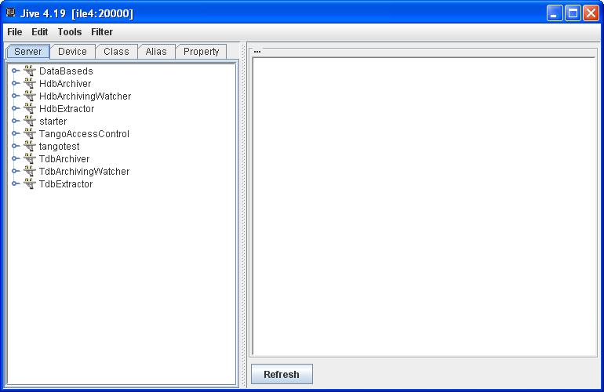

Devices are declared

3. Add missing device server classes,

ile_wp08_jlv_110
914_installationm | ILE_WP08_JLV_110914_InstallationManualMambo_A
anualmambo_a.d | ILE_WP08_JLV_110914_InstallationManualMambo_A | Page : 9 / 16
anualmambo_a.d | document de projet – Institut de Lumière Extrème - Chemin de la Hunière – 91761 Palaiseau cedex | Page : 9 / 16
oc
16/09/2011

ILE Matrice Rapport

06.dotx/DF/20110829

Installation of Mambo data archiving system | PROJET APOLLON
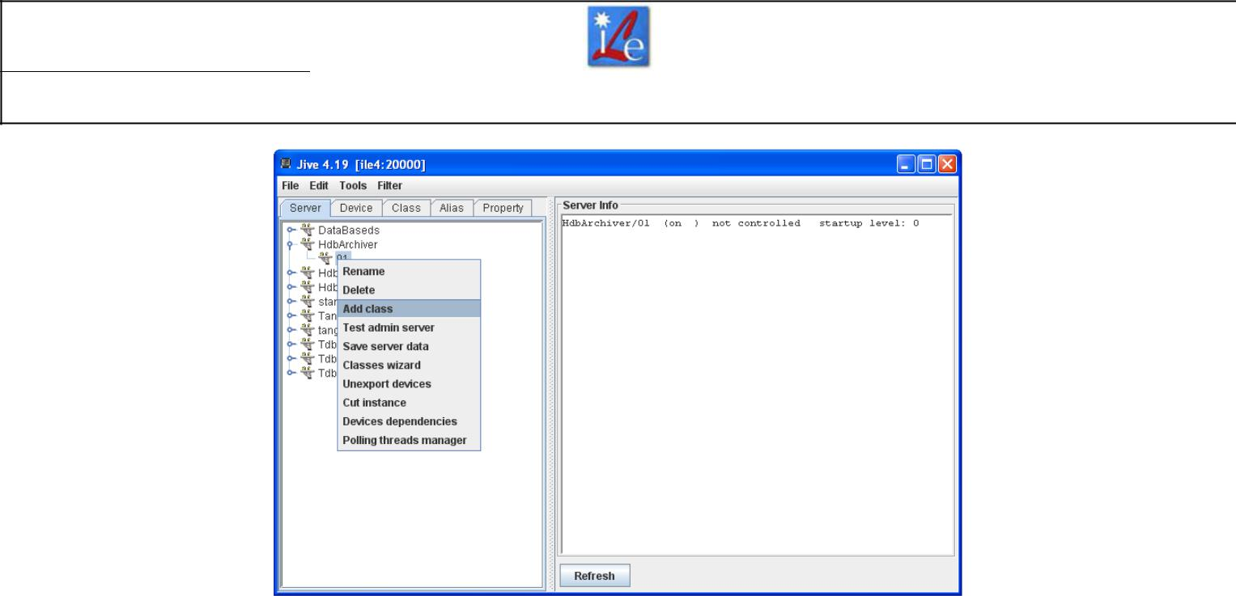

Right click >Add class

4. Created a device identified by t/t/t and click on Register server,
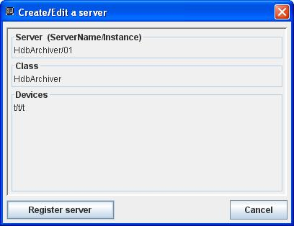

Enter the class name and a temporary device 5. Delete manually the device called t/t/t,

ile_wp08_jlv_110
914_installationm | ILE_WP08_JLV_110914_InstallationManualMambo_A
anualmambo_a.d | ILE_WP08_JLV_110914_InstallationManualMambo_A | Page : 10 / 16
anualmambo_a.d | document de projet – Institut de Lumière Extrème - Chemin de la Hunière – 91761 Palaiseau cedex | Page : 10 / 16
oc
16/09/2011

ILE Matrice Rapport

06.dotx/DF/20110829

Installation of Mambo data archiving system | PROJET APOLLON
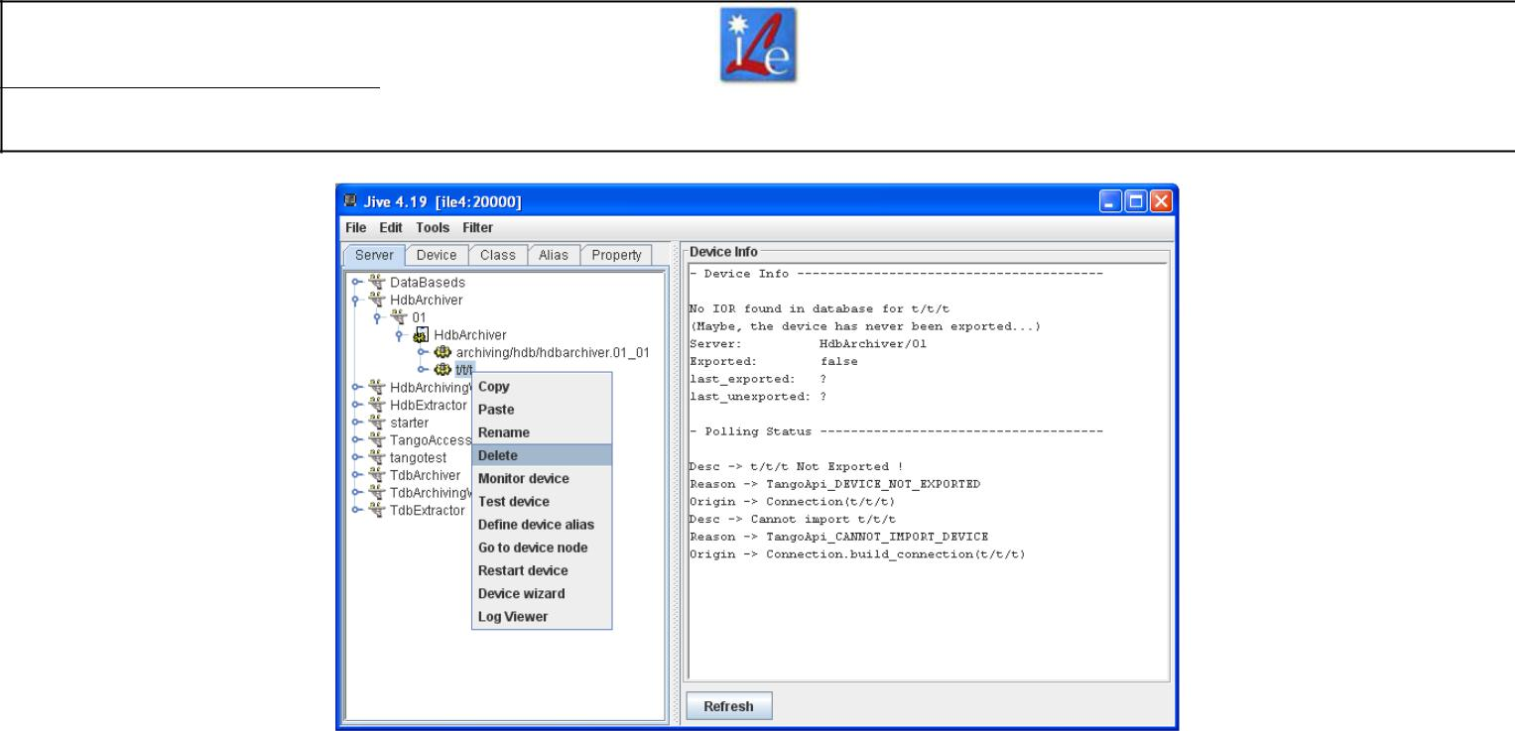

Right click on t/t/t>Delete

- Repeat from step 3 to 5 for others device servers (hdbarchivingwatcher.1, hdbextractor.1),
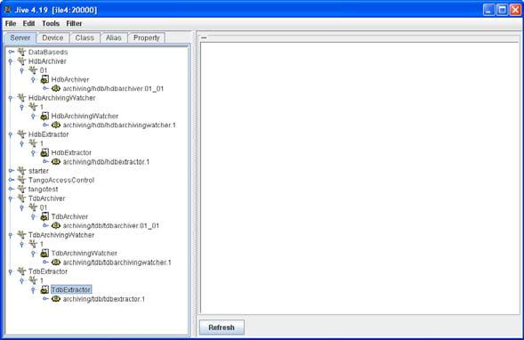

All temporary devices t/t/t have been deleted,
archiving devices are declared.

7. Add/Modify parameters as shown on screenshots below,

ile_wp08_jlv_110
914_installationm | ILE_WP08_JLV_110914_InstallationManualMambo_A
anualmambo_a.d | ILE_WP08_JLV_110914_InstallationManualMambo_A | Page : 11 / 16
anualmambo_a.d | document de projet – Institut de Lumière Extrème - Chemin de la Hunière – 91761 Palaiseau cedex | Page : 11 / 16
oc
16/09/2011

ILE Matrice Rapport

06.dotx/DF/20110829

Installation of Mambo data archiving system | PROJET APOLLON
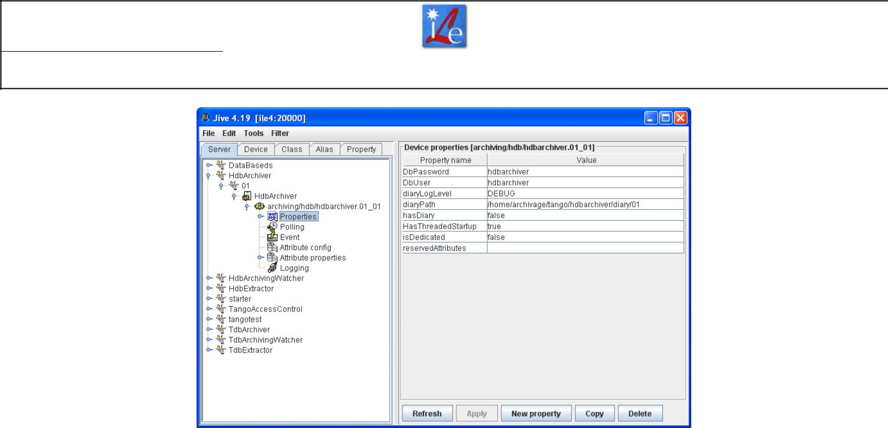

Hdbarchiver.01_01 properties
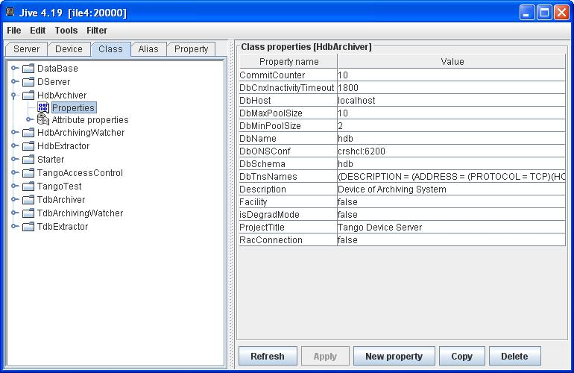

Hdbarchiver class properties 8. Repeat steps 2 to 7 for TDB.
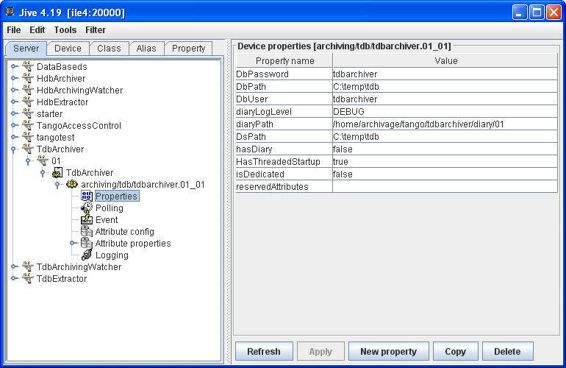

 | Tdbarchiver.01_01 properties
ile_wp08_jlv_110
914_installationm | ILE_WP08_JLV_110914_InstallationManualMambo_A
anualmambo_a.d | ILE_WP08_JLV_110914_InstallationManualMambo_A | Page : 12 / 16
anualmambo_a.d | document de projet – Institut de Lumière Extrème - Chemin de la Hunière – 91761 Palaiseau cedex | Page : 12 / 16
oc
16/09/2011

ILE Matrice Rapport

06.dotx/DF/20110829

Installation of Mambo data archiving system | PROJET APOLLON
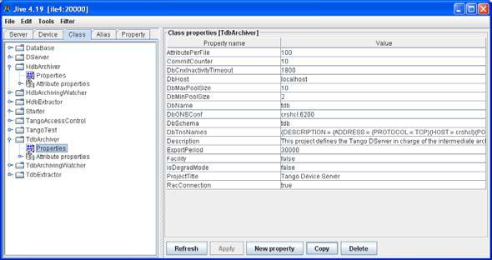

Tdbarchiver class properties

This document only explains how to configure HdbArchiver and TdbArchiver.

Devices Extractor and ArchivingWatcher haven’t been configured nor tested.

8 START ARCHIVING DEVICES

Now that devices are configured, you need to start them because Mambo will call them in order to start to archive data. Here is how to start devices :

- Click on Windows>Start>Execute…
- Type cmd,
- Type C:\tango-root\mambo\ArchivingRoot-11.4.3\device\win32\HdbArchiver.bat 01, that is to say the name of history archiving device and its number. If you read « ConnectionFactory.connect_auto (MySql): hdbarchiver@hdb OK », it means device is well connected to database. Don’t close the window.
- Click on Windows> Start>Execute…
- Type cmd,
- Type C:\tango-root\mambo\ArchivingRoot-11.4.3\device\win32\TdbArchiver.bat 01, that is to say the name of temporary archiving device and its number. If you read « ConnectionFactory.connect_auto (MySql): tdbarchiver@tdb OK », it means device is well connected to database. Don’t close the window.

9 START MAMBO

This paragraph is the last step before using Mambo. Here is how to proceed :

- Open the file C:\tango-root\mambo\ArchivingRoot-11.4.3\bin\win32\mambo-rw.bat,
- Create a user account in the directory you want,

ile_wp08_jlv_110
914_installationm | ILE_WP08_JLV_110914_InstallationManualMambo_A
anualmambo_a.d | ILE_WP08_JLV_110914_InstallationManualMambo_A | Page : 13 / 16
anualmambo_a.d | document de projet – Institut de Lumière Extrème - Chemin de la Hunière – 91761 Palaiseau cedex | Page : 13 / 16
oc
16/09/2011

ILE Matrice Rapport

06.dotx/DF/20110829

Installation of Mambo data archiving system | PROJET APOLLON
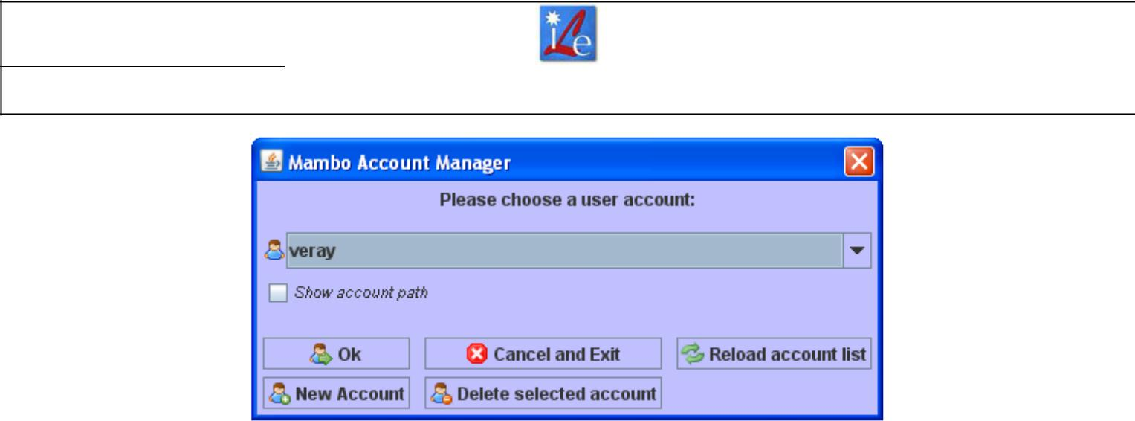

Here, an account has already been created

- When you open Mambo for the first time, two error messages show up. This is normal because Mambo cannot load a previous configuration (since it’s the first time). It won’t appear next time.
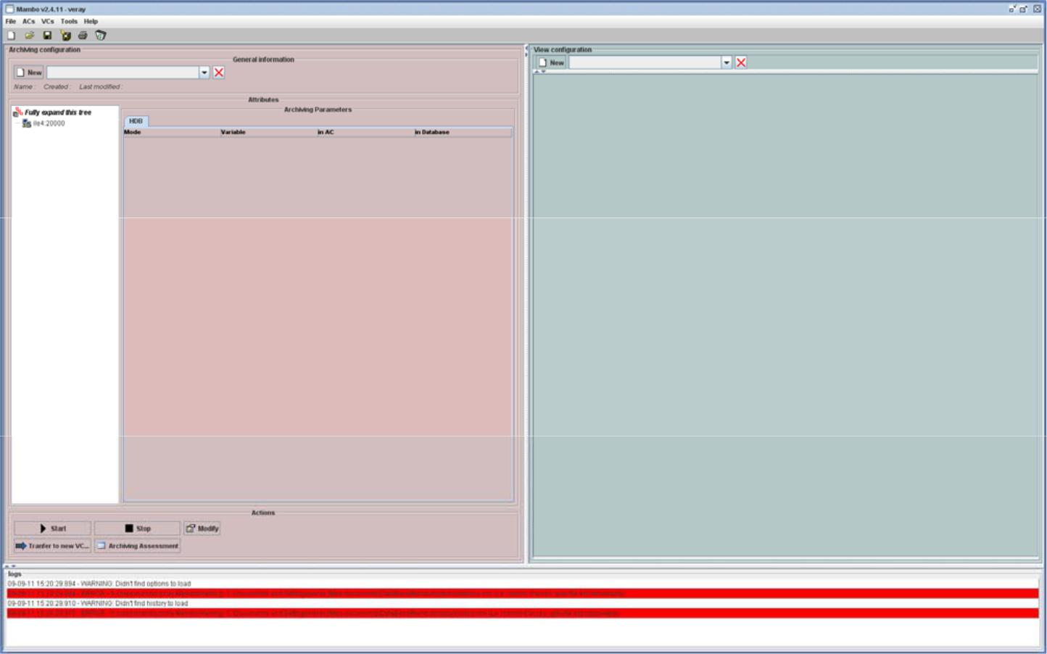

Two error messages when first opening Mambo

Mambo-rw.bat or Mambo.bat ? Mambo-rw.bat allows users to create an Archiving Configuration (AC) and a View Configuration (VC). Mambo.bat only allows users to visualize archived data.


ile_wp08_jlv_110
914_installationm | ILE_WP08_JLV_110914_InstallationManualMambo_A
anualmambo_a.d | ILE_WP08_JLV_110914_InstallationManualMambo_A | Page : 14 / 16
anualmambo_a.d | document de projet – Institut de Lumière Extrème - Chemin de la Hunière – 91761 Palaiseau cedex | Page : 14 / 16
oc
16/09/2011

ILE Matrice Rapport

06.dotx/DF/20110829

Installation of Mambo data archiving system | PROJET APOLLON

10 UNINSTALL

10.1 UNINSTALL TANGO

Use the add/remove program Windows interface in order to remove Tango from your computer. Then, delete environment variables manually. Delete manually the file C:\tango.

If you need to delete the Tango database (without removing MySQL from your computer), delete the file tango located in the following directory C:\Documents and Settings\All Users\Application Data\MySQL\[YourMySQLServer]\data.

10.2 UNINSTALL MYSQL

Use the add/remove program Windows interface in order to remove MySQL from your computer. Then, delete environment variables manually.

If you already removed Tango and its tango database, delete manually the file tango-root located in C:. Now, delete manually the file MySQL in C:\Documents and Settings\All Users\Application Data.

10.3 UNINSTALL MAMBO

Delete manually the file you specified when you created your Mambo account. Delete the file tdb located in C:\TEMP. Delete environment variable.

10.4 UNINSTALL WAMP

Use the add/remove program Windows interface in order to remove Wamp from your computer. Delete manually the file C:\wamp.

ile_wp08_jlv_110
914_installationm | ILE_WP08_JLV_110914_InstallationManualMambo_A
anualmambo_a.d | ILE_WP08_JLV_110914_InstallationManualMambo_A | Page : 15 / 16
anualmambo_a.d | document de projet – Institut de Lumière Extrème - Chemin de la Hunière – 91761 Palaiseau cedex | Page : 15 / 16
oc
16/09/2011

ILE Matrice Rapport

06.dotx/DF/20110829

Installation of Mambo data archiving system | PROJET APOLLON
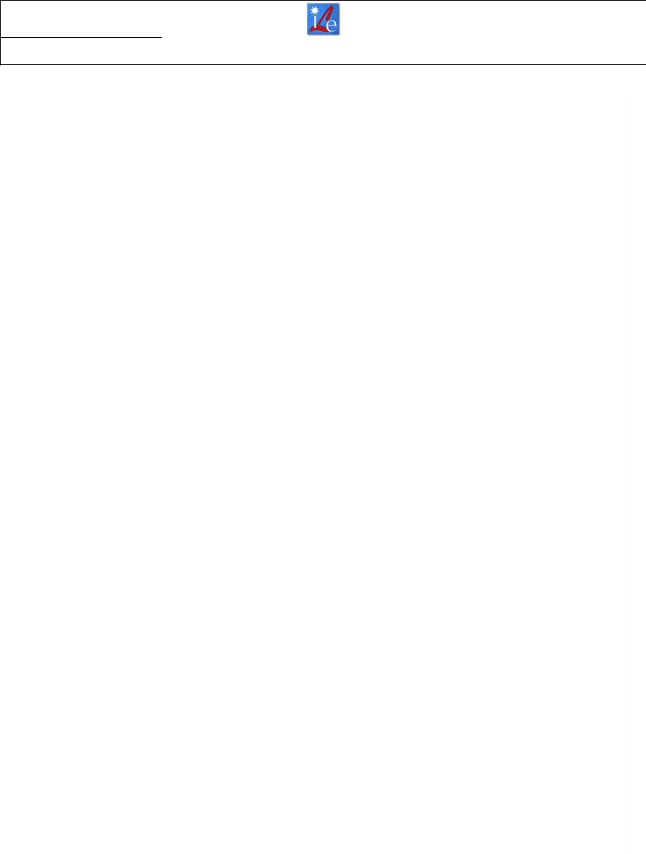

DIFFUSION

LULI WP08

ile_wp08_jlv_110
914_installationm | ILE_WP08_JLV_110914_InstallationManualMambo_A
anualmambo_a.d | ILE_WP08_JLV_110914_InstallationManualMambo_A | Page : 16 / 16
anualmambo_a.d | document de projet – Institut de Lumière Extrème - Chemin de la Hunière – 91761 Palaiseau cedex | Page : 16 / 16
oc
16/09/2011

