Handle Name: reaganl1998

Forked repo: <https://github.com/reaganl1998/cis411_lab0>

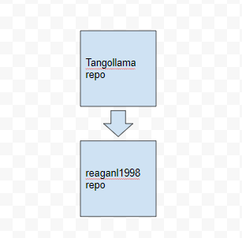

GraphicQL response:

{

"data": {

"mutateAccount": {

"id": "fc6be7ca-fc1e-4084-a347-74bd0be7f6fb",

"name": "YOUR FULL NAME",

"email": "YOUR EMAIL"

}

}

}