Run CinemaSystem

Admin frame. Username is 1, password is 1. You can change in Basic/Admin.txt

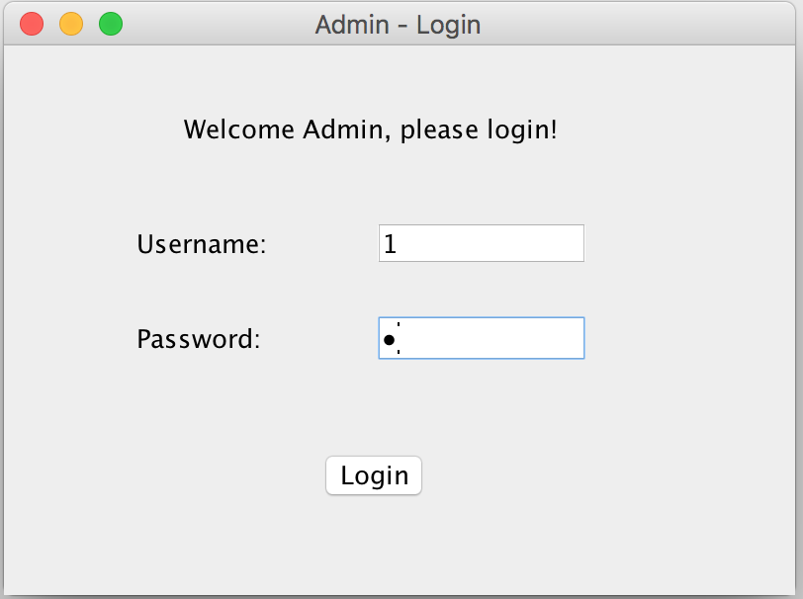

Management frame.

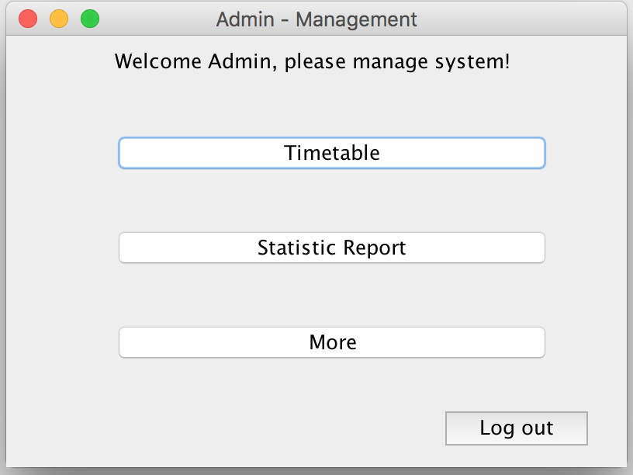

Timetable Management.

Current is empty because it’s beginning of the day. You have to add the timetable manually in specification.

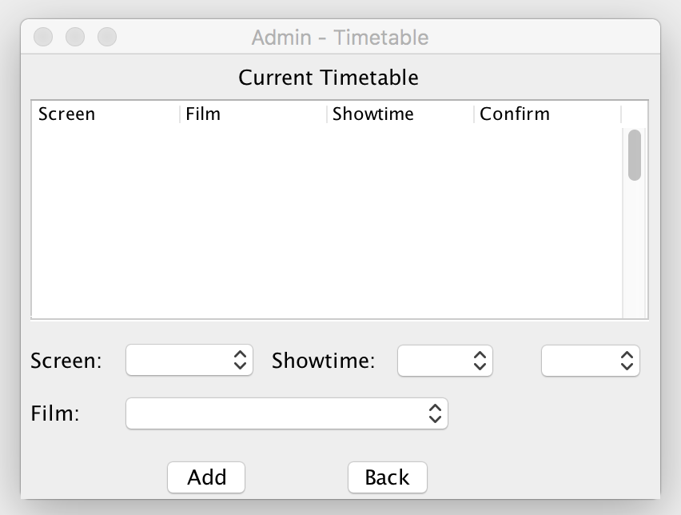

If time conflict, it will show error. Or, add successfully.

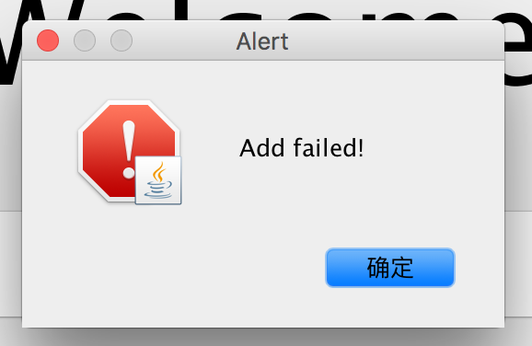

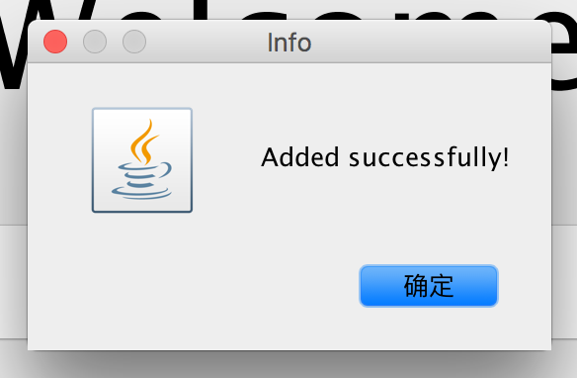

Added Timetable:

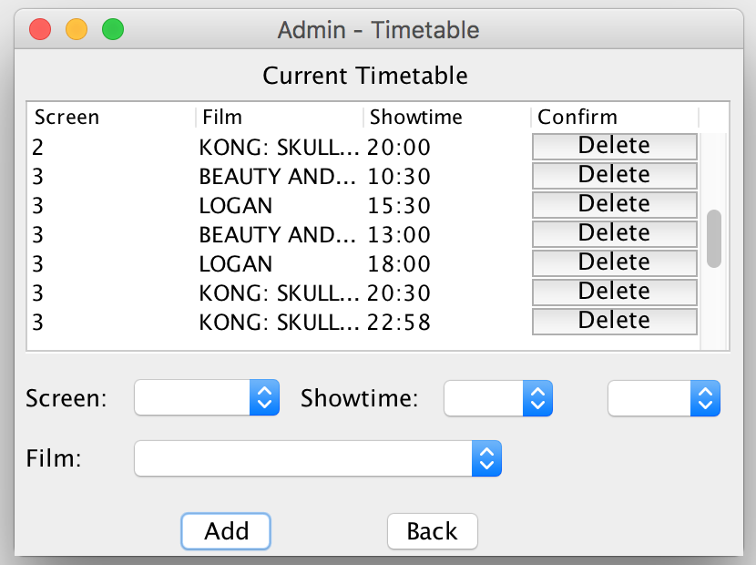

Delete one timetable

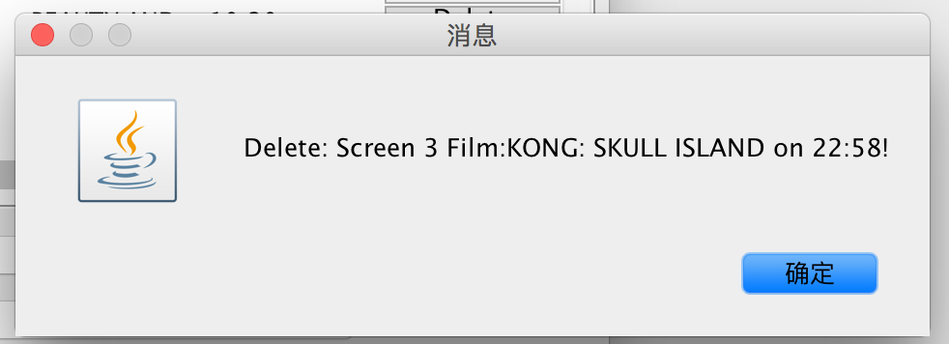

Report frame will show the statistic of yesterday’s sales.

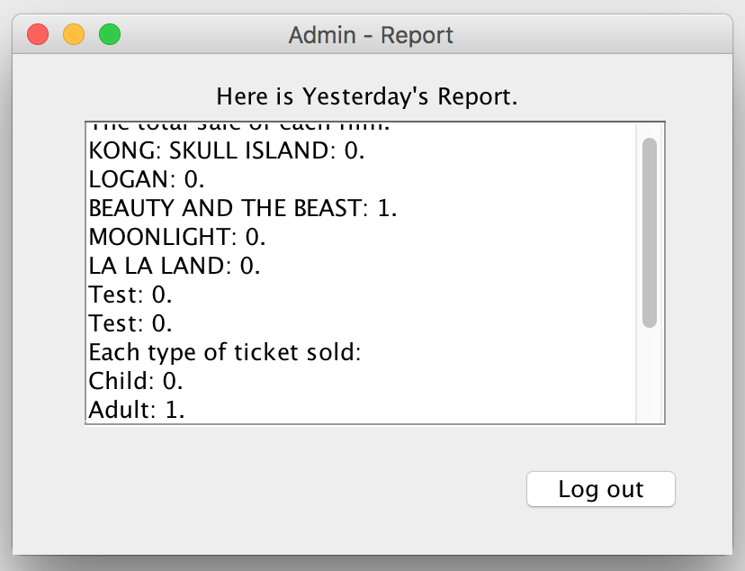

Kiosk:

Welcome, click start to continue

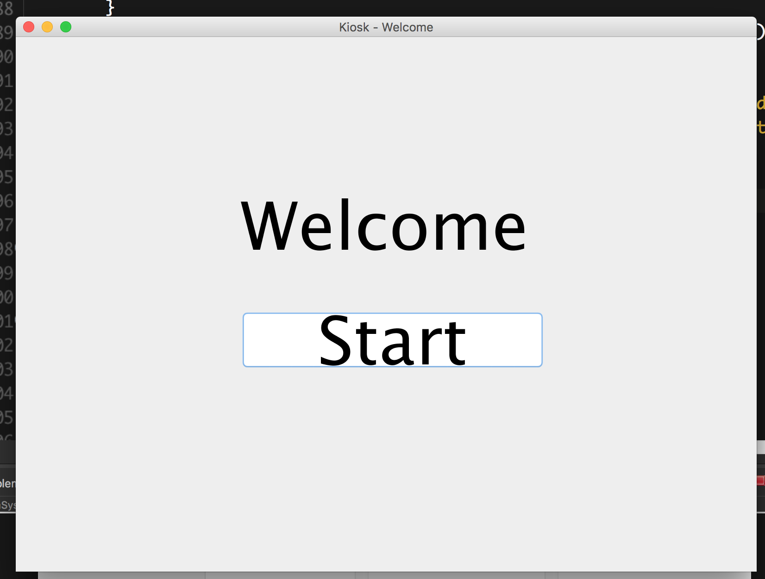

Brief information film list, choose film and click ok

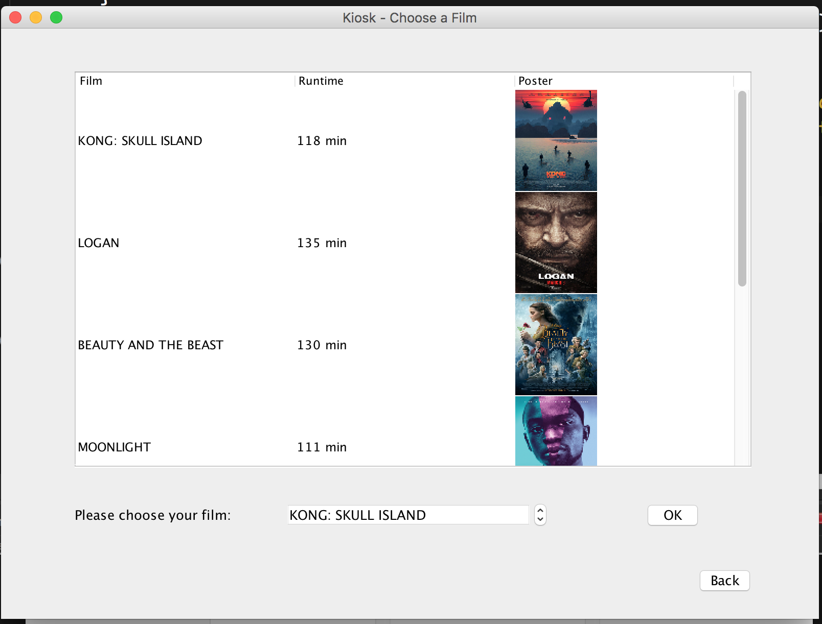

Timetable, it will show the available timetable after current time. Click confirm to choose.

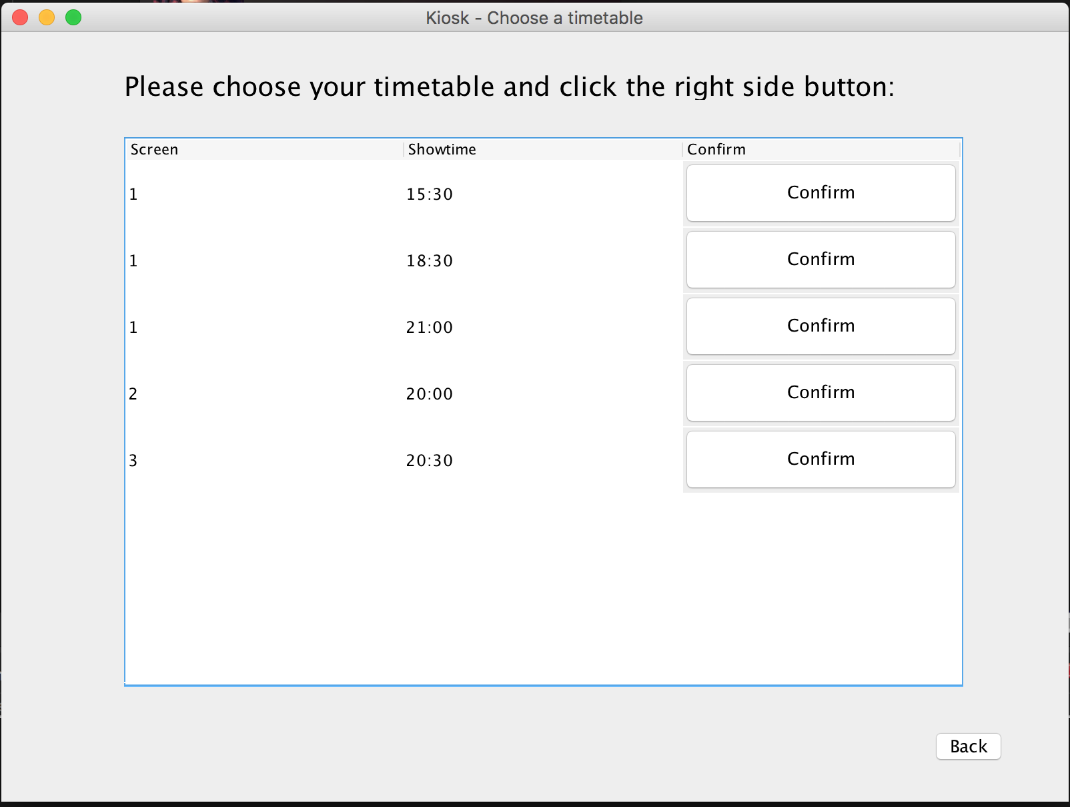

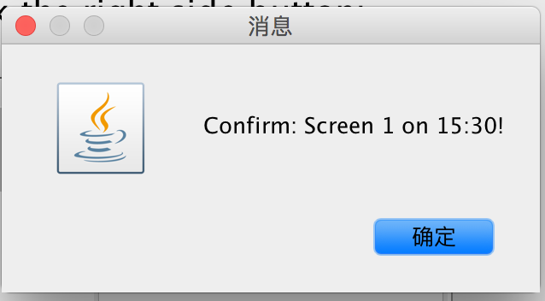

Choose ticket type and number.

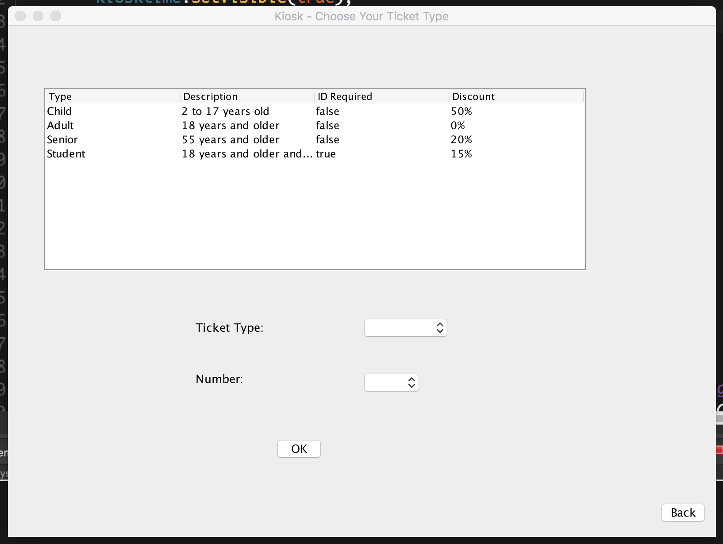

Choose your seat(s). Every seat can only be clicked once, if you click by mistake, please back and reopen its frame.

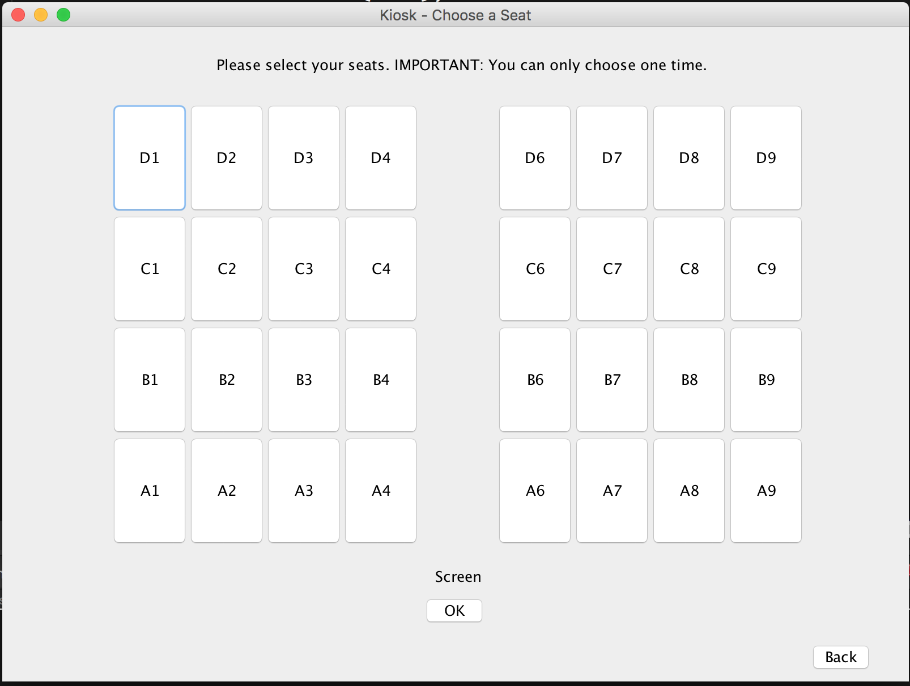

If you order 4 tickets, you only choose 3 seats, a window will pop up.

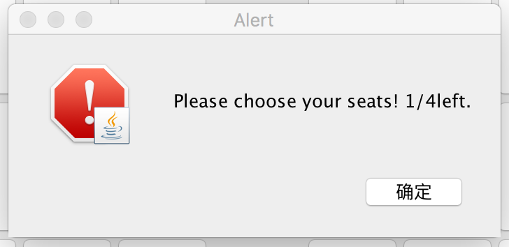

If you over choose your seats, a window will pop up.

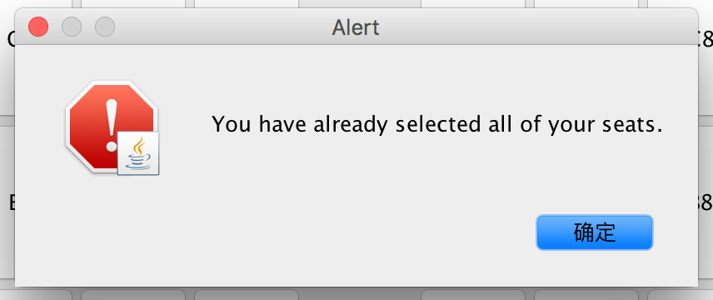

Payment. It will show all of tickets info and total price at the end of table. The ticket number is not created in this step.

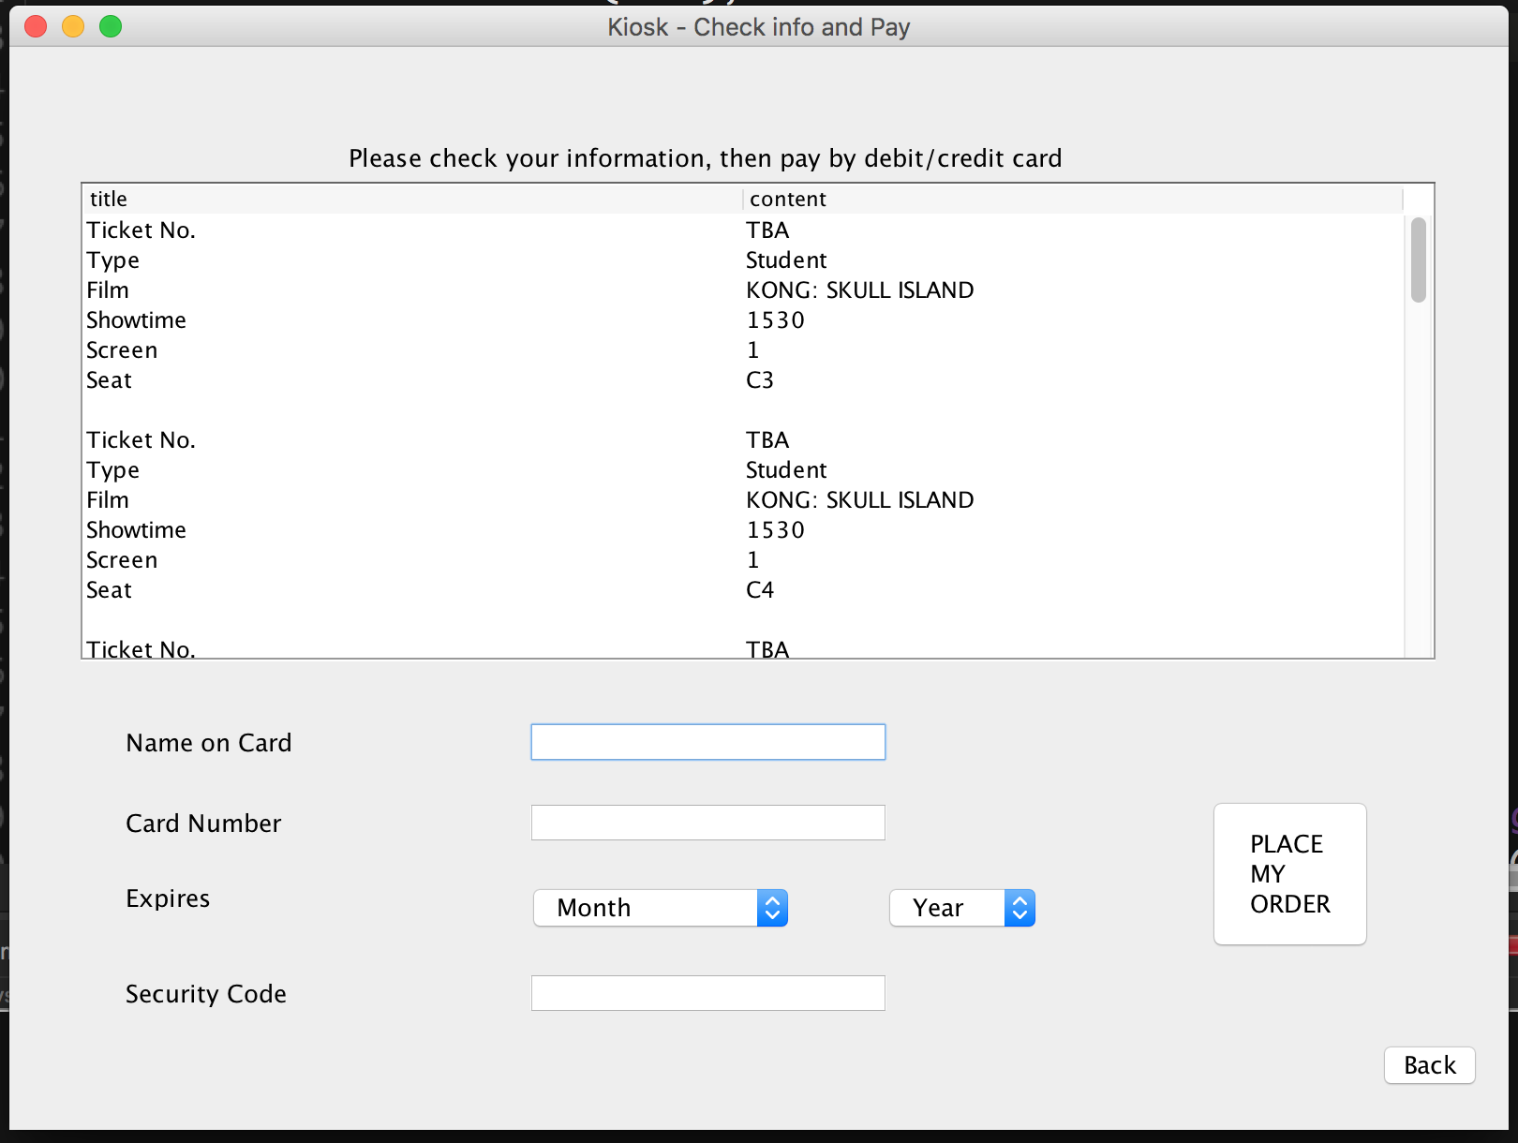

Finish page. Ticket number created. You can order another ticket at same time of same film or just finish your order and go back to welcome page.

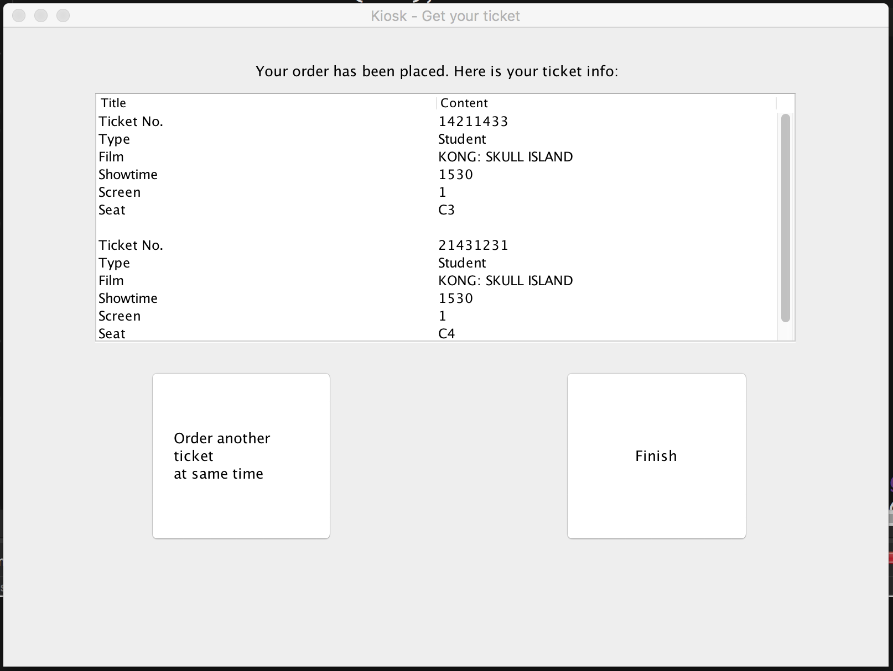

Check gate:

Enter ticket number under current date folder which file name is \*\*\*\*\*\*\*\*.txt

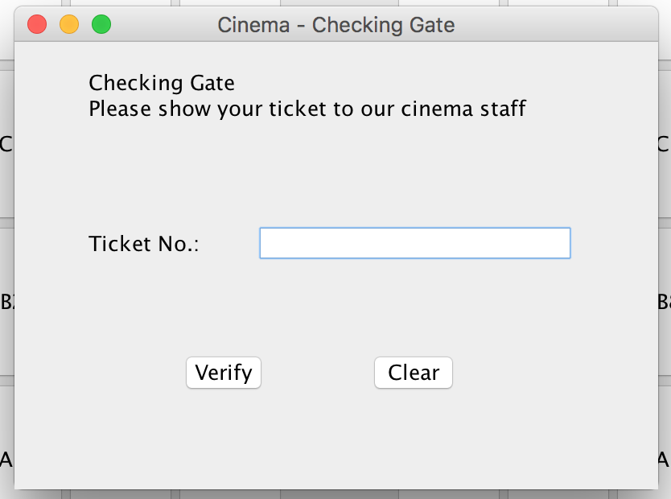

If ticket number is valid, go to ticket info page. Or a window pop up.

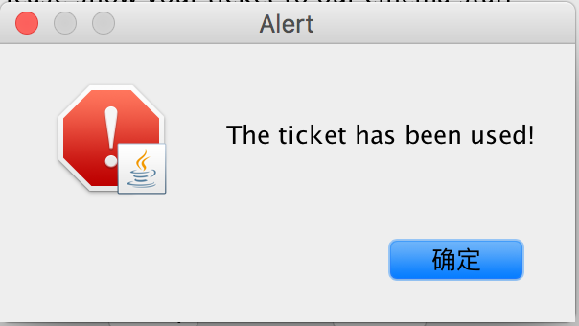

Ticket info

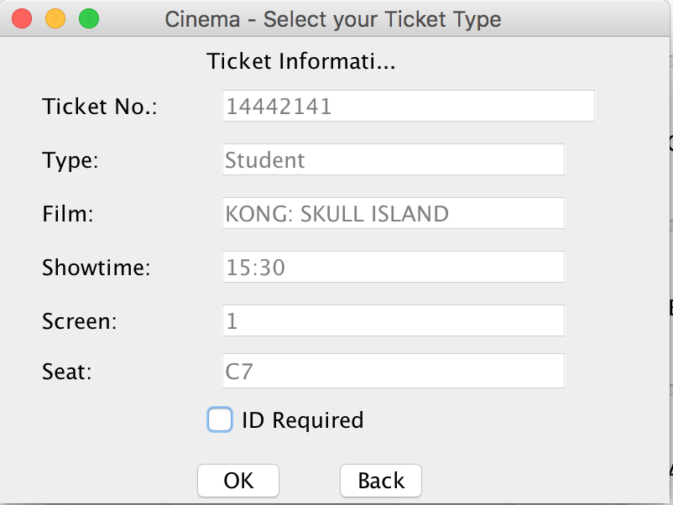

If it is a student ticket, ID must be required. The staff should check ID required box as ID checked, or a window pop up.

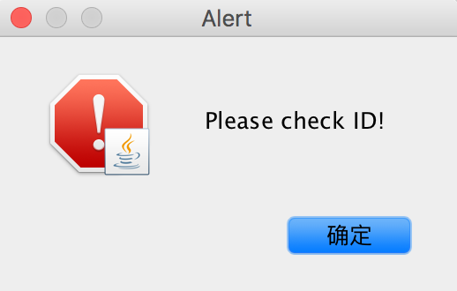

After ID checked

