Topic and Trend:1. Motion segmentation or Video segmentation
2.dynamic estimates for the motion
3. tracking with stereo located camera
4. predefinded element detector for later tracking
5. strong label recognition with machine learning
6. background substraction： median filtering
7.segmentation
ideas:
- Motion detection methods :
- Direct optical flow method or Random sample consensus (RANSAC)
- 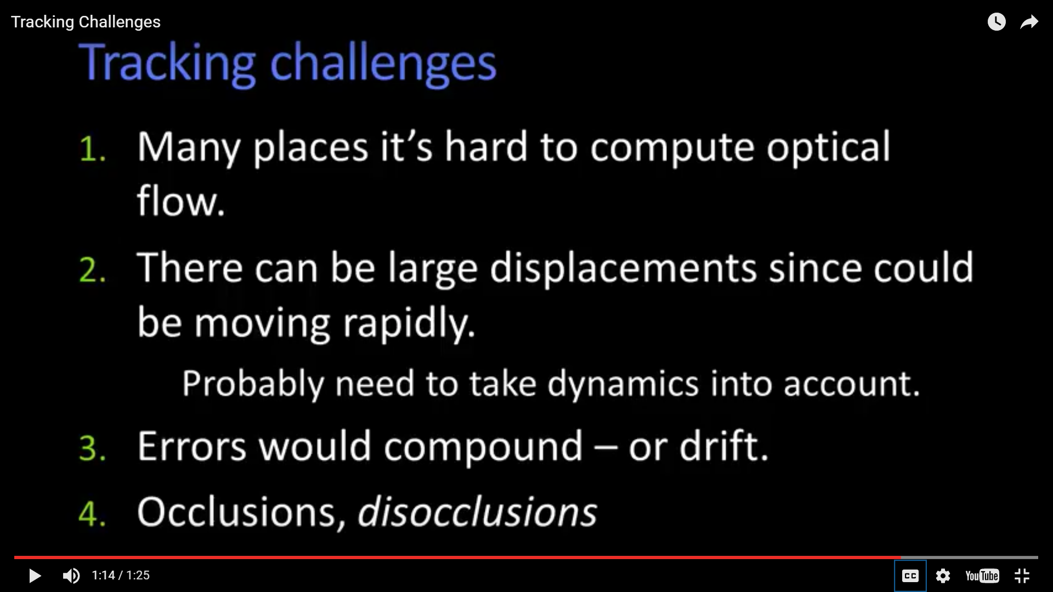
- Dynamic model and observation model
- Generative method of classification challenges :
  - priors and context
  - Huge set of data do not improve accuracy
- The key idea of generative method is to generate a probability distribution model for each category.
- Limitation of PCA: the projected direction is not the best direction for classification
一个老年人，应该为他的无知感到羞耻
- Mean shift segmentation clustering
- Super pixels

