**Ingredients**

(Including Breakfast, Lunch or Dinner)

* Oats 3Kg - Enough for 30 meals
  + Brought from Best Mart 360
  + Approximately $20 per 1kg
  + Price: $60
* Chicken Chops for Curry Chicken (Large) 6 Pieces – Enough for 30 meals
  + Brought from market
  + Approximately ~ $10 per Piece
  + Price: $60

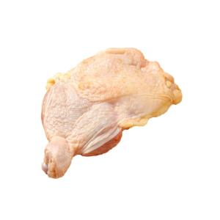

* Longevity Filled Evaporated 3 cans 400GM
  + Brought from welcome supermarket
  + Approximate $11 per can
  + Price: $33

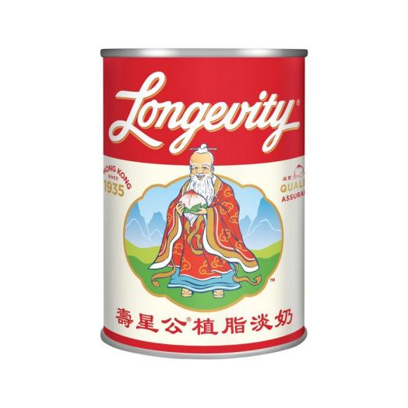

* Eagle Condensed Milk 3 Cans - 350GM per can
  + Brought from welcome supermarket
  + Approximate $13 per Can
  + Price $39

[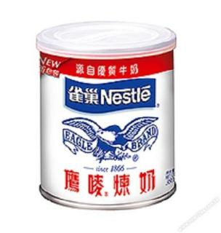](https://www.google.com/url?sa=i&url=https://www.668.com.hk/en/milk-cream/5594-5594-nestle-eagle-sweetened-condensed-milk-350g.html&psig=AOvVaw0KimHsyXHvficfzM83ZuPy&ust=1737682361356000&source=images&cd=vfe&opi=89978449&ved=0CBQQjRxqFwoTCIiO2rDZiosDFQAAAAAdAAAAABAE" \t "/Users/tangsinglun/Library/Containers/com.kingsoft.wpsoffice.mac.global/Data/Library/Application Support/Kingsoft/WPS Cloud Files/userdata/default/filecache/339537895/x/_blank)

* Maggi Seasoning Liquid Sauces - 200ml per bottle
  + Brought from welcome supermarket
  + Approximate $17.9 per bottle
  + Price $17.9

**Total Price: Approximate $209.9 (All in terms of Hong Kong Dollars)**

*Updated:07th February 2025 price subject to change*

**Note:** Some of the photos are Snap from the Huawei Mobile Phone

**Model:** FOA-LX9

**Purchase Location:** Huawei Experience Shop Located at Sha Tin New Town Center

**Ingredients And Menus (Total 60 Meals)**

2 Meals Per Day (Breakfast, Luch or Dinner) for 60 days

**These ingredients are based on portions. In case you don’t how to accurately divide it into portion. You can use a balance to weight the net weight of the ingredients and then divide it into portions base on the net weight.**

* Sweet Oat meal *– (30 meals) (Served for Breakfast)*

1. Fill the pot with water.
2. Add Oat.
3. Add Evaporate Milk.
4. To get sweetness, you can add condensed milk.
5. Stir well and served.

* Oat meal with chicken *– (30 meals) (Served for lunch or dinner)*

1. Fill the pot with water.
2. Add Chicken.
3. Wait till chicken fully cooked and add Oat.
4. To get saltiness, you can add a little bit of maggi seasoning sauces.
5. Stir well and served.

**Recommended Portion for Sweet Oat meal**:

* 50g of Oat.
* 500 ml of water
* Around 40 ml of Evaporated milk
* Around 35 gram of Condensed Milk

**Recommended Portion for Oat meal with chicken**:

* 40g of Oat.
* 500 ml of water
* Around 4 pieces of chicken
* a few drops of Maggi seasoning sauces

***Total 60 meals***