**Ingredients**

(Including Breakfast, Lunch and Dinner)

* Quaker Oats 3Kg - Enough for 30 meals
  + Brought from Best Mart 360
  + Approximately $26 per 1kg
  + Price: $78
* Chicken Chops for Curry Chicken (Large) 6 Pieces – Enough for 30 meals
  + Brought from market
  + Approximately ~ $12 per Piece
  + Price: $72

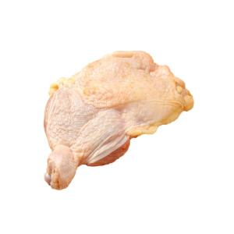

* Longevity Filled Evaporated 3 cans 400GM
  + Brought from welcome supermarket
  + Approximate $9 per can
  + Price: $27

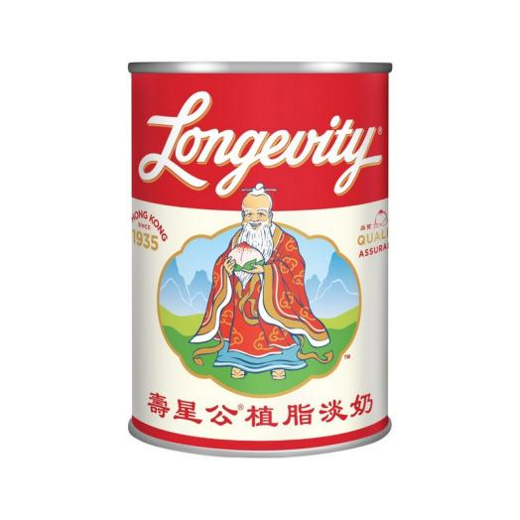

* Sugar
  + Brought from welcome supermarket
  + Approximate $6.5
  + Price $6.5
* Lee Kam Kee Cocunut Flavoured Curry Paste 3 Bottles – Enough for 30 meals
  + Brought from U Store
  + Approximately $16.9 per bottle
  + Price: $50.7

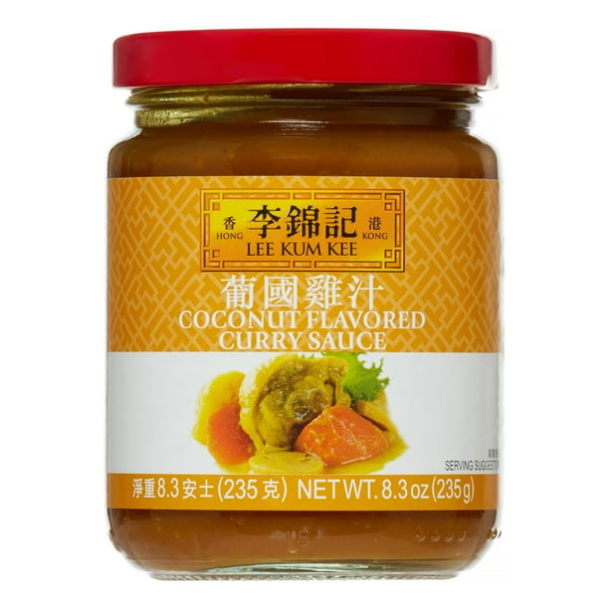

* Potatoes For Curry Chicken 6 potatoes – Enough for 30 meals
  + Brought from market
  + Approximately $2.5 for 1 potato
  + Price: $15

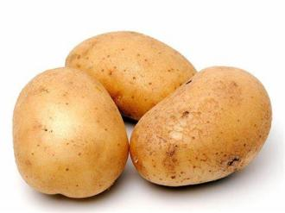

* Egg Plant 6 pieces– Enough for 30 meals
  + Brought from market
  + Approximately $10 for 2 pieces
  + Price: $30

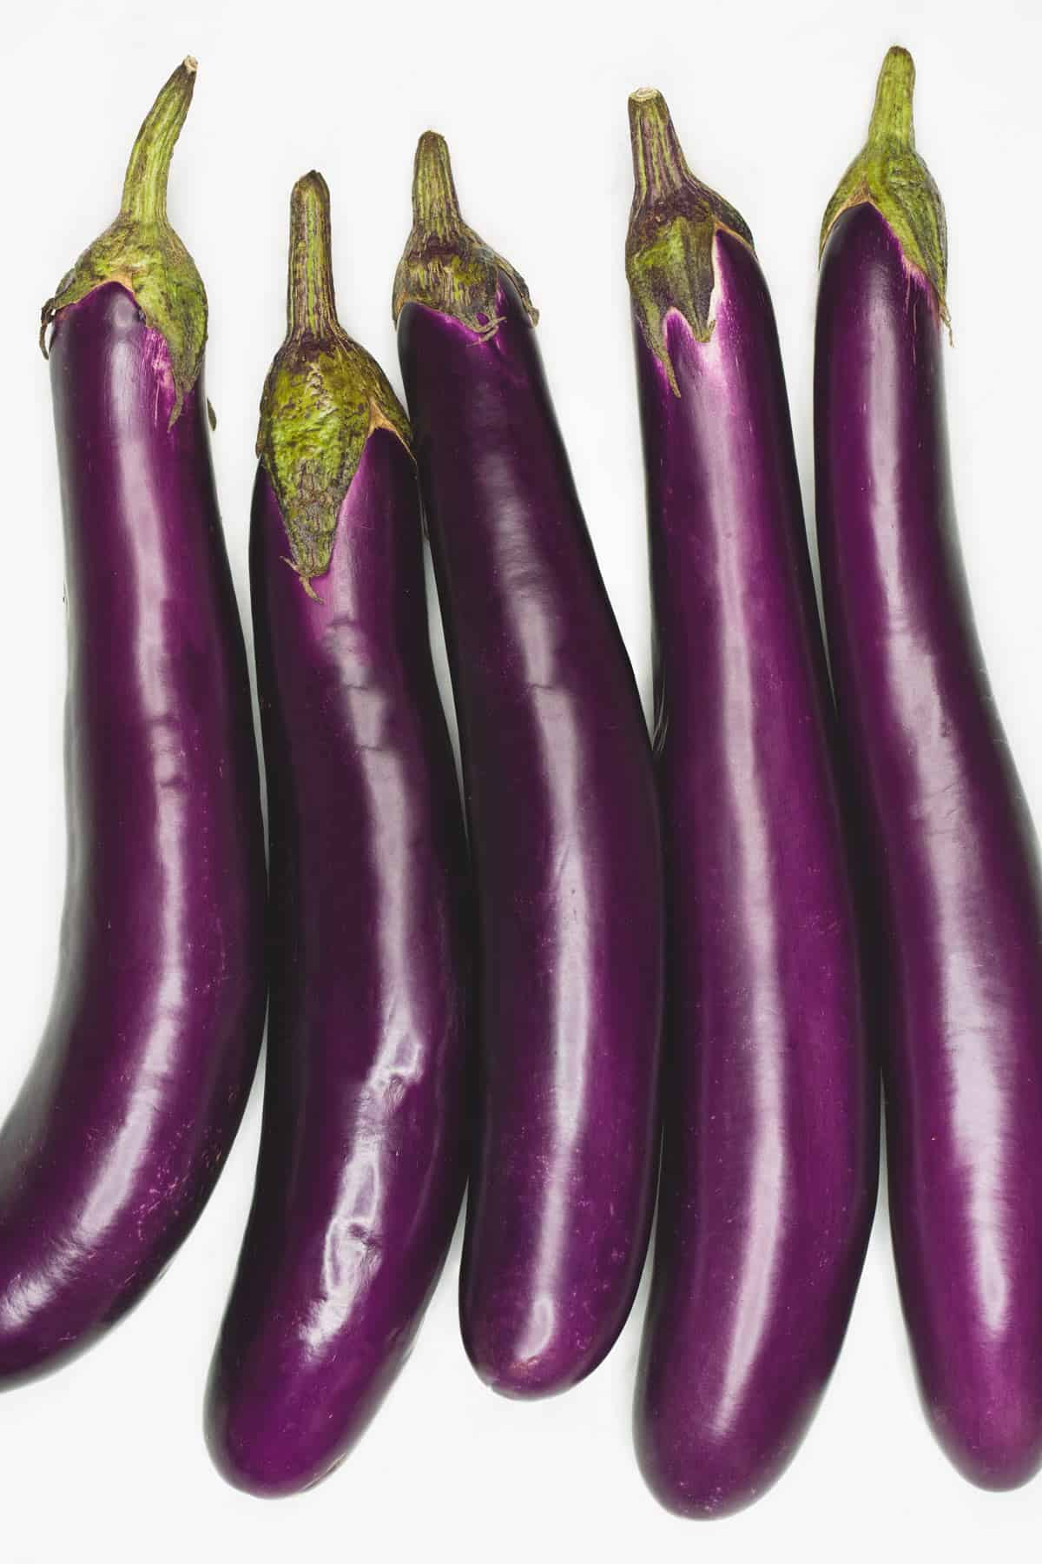

* Best Mart 360 Premium Thai Fragrant Rice 5kg – Enough for 30 meals
  + Brought from Best Mart 360
  + Approximately ~ $49 per packet
  + Price: $49

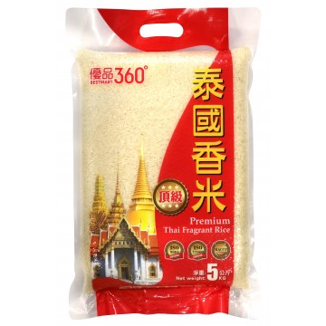

* Red Onion 3 pieces (large)
  + Brought from market
  + Approximately $3.6 for 1
  + Price: $11

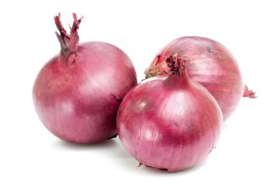

**Total Price: Approximate $339.2 (All in terms of Hong Kong Dollars)**

*Updated:10th February 2025 price subject to change*

**Note:** Some of the photos are Snap from the Huawei Mobile Phone

**Model:** FOA-LX9

**Purchase Location:** Huawei Experience Shop Located at Sha Tin New Town Center

**Ingredients And Menus (Total 90 Meals)**

3 Meals Per Day (Breakfast, Luch and Dinner) for 90 days

**These ingredients are based on portions. In case you don’t how to accurately divide it into portion. You can use a balance to weight the net weight of the ingredients and then divide it into portions base on the net weight.**

* Sweet Oat meal *– (30 meals) (Served for Breakfast)*

1. Fill the pot with water.
2. Add Oat.
3. Add Evaporate Milk.
4. To get sweetness, you can add condensed milk.
5. Stir well and served.

* Oat meal with chicken *– (30 meals) (Served for lunch)*

1. Fill the pot with water.
2. Add Chicken.
3. Wait till chicken fully cooked and add Oat.
4. To get saltiness, you can add a little bit of salt.
5. Stir well and served.

* Lee Kam Kee Cocunut Flavoured Curry (Potato and Egg plant) with Rice *(30 meals) (Served for Dinner)*

1. Peel and Cut the Onion into Slices.
2. Peel the potato. Cut into small bite sizes base on your portion.
3. Fill the pot with water around 1000ml (base on your curry portion).
4. When water starts to boil, based on your portion add one bottle of Curry paste into the pot.
5. Base on your portion, add the potato and onion into the pot. For fast cooking, you can fry the potato and onion in a pan first.
6. Add Salt and sugar when neccesary.
7. Wait till fully cooked.
8. Put inside the fridge when the pot of curry cools down.
9. When serve prepare one curry bowl portion for serving. Add several pieces of egg plant into it, then reheat.
10. Add 150 gram of raw rice, wash it and cook.
11. Serve it with Rice.

**Recommended Portion for Sweet Oat meal**:

* 50g of Oat.
* 500 ml of water
* Around 40 ml of Evaporated milk
* Add sugar when necessary

**Recommended Portion for Oat meal with chicken**:

* 40g of Oat.
* 500 ml of water
* Around 4 pieces of chicken
* add salt when necessary

**Recommended Portion for Curry Potato with egg plant enough for 10 days**:

* 1 bottle of Coconut flavour Curry.
* egg plant 2 pieces cut into to small dices.
* 2 Potatoes.
* 1 Onion.
* Water: 1000ml
* Salt and sugar for flavouring – according to your needs
* Rice per meal (not cooked) 150 gram.

***Total 90 meals***