帮我把源代码和原始数据或者数据连接，按照GitHub格式整理到一个文件夹中，方便我上传到githubSemDP-FL: Semantic-Sensitivity-Driven Adaptive Differential Privacy for Federated LoRA Fine-Tuning of Large Language Models
Song Tang^{1,2,3}, Zhigang Jin^{1,*}, Zhiqiang Wang^{2,3}
¹ School of Electrical and Information Engineering, Tianjin University, Tianjin 300072, China ² Institute of Applied Mathematics, Hebei Academy of Sciences, Shijiazhuang 050081, China ³ Information Security Authentication Technology Innovation Center of Hebei Province, Shijiazhuang 050081, China
* Corresponding author: Zhigang Jin, PhD, School of Electrical and Information Engineering, Tianjin University, No. 92 Weijin Road, Nankai District, Tianjin 300072, China. E-mail: zgjin@tju.edu.cn
E-mail addresses: tangsng@live.cn (S. Tang), zgjin@tju.edu.cn (Z. Jin), 574465982@qq.com (Z. Wang)

Abstract
Federated fine-tuning with Low-Rank Adaptation (LoRA) lets clients adapt a shared large language model (LLM) without exposing raw text, yet the exchanged low-rank updates remain vulnerable to gradient-inversion attacks. Client-level differential privacy (DP) is the standard countermeasure; however, existing DP federated LoRA methods inject noise uniformly across all trainable parameters, overlooking the heterogeneity of semantic sensitivity across transformer layers. This paper proposes SemDP-FL, a semantic-sensitivity-driven adaptive DP mechanism that allocates a fixed client-level privacy budget across LoRA parameter groups. A fused score of an LLM-elicited prior and proxy-set gradient evidence stratifies the groups into protection tiers with enforced noise floors on the most leakage-prone parameters, while a closed-form, utility-optimal water-filling rule distributes the residual budget under exact sampled-Gaussian Rényi-DP accounting. We further derive the optimal allocation, prove an explicit sub-optimality bound for uniform noise (measured 2.08× distortion, computable a priori), and establish a mutual-information bound that turns the tier floors into hard leakage caps. Experiments on federated SST-2/AG News fine-tuning of Qwen2.5-0.5B (100 non-IID clients, five seeds, four baselines) show that SemDP-FL improves mean accuracy by 5.8 percentage points over the strongest baseline and 7.7 points over DP-FedAvg at ε = 4, and by 25.5 points on AG News with statistical significance (p = 0.012), recovering up to 86% of non-private accuracy. A head-inversion probe (n = 100) confirms the floors suppress embedding recovery to chance. As a drop-in upgrade to DP-FL pipelines, SemDP-FL enables practical privacy-compliant federated LLM fine-tuning in regulated domains such as healthcare and finance.
Keywords: Federated learning; Differential privacy; Large language models; Low-Rank Adaptation; Gradient inversion attack

I. Introduction
Federated learning (FL) enables multiple data owners to train a shared model without centralising raw data [1]. As large language models (LLMs) become the default substrate for text applications, federated fine-tuning of LLMs has emerged as a practical way to adapt a pre-trained model to distributed, privacy-sensitive corpora such as hospital notes, financial messages, and on-device text. Parameter-efficient fine-tuning, in particular Low-Rank Adaptation (LoRA) [2], is the key enabler: clients update only a few million low-rank parameters while the billion-parameter backbone remains frozen, which fits both the uplink bandwidth and the memory budget of cross-silo and cross-device settings.
Sharing model updates, however, does not by itself guarantee privacy. A line of gradient-inversion attacks [3]–[6] shows that an honest-but-curious server can reconstruct training samples — or the verbatim secrets they contain — from shared gradients or per-round updates, and the memorisation capacity of LLMs aggravates the risk: production-scale extraction of training text from LLMs is now practical [7]. Differential privacy (DP) [8] provides the standard formal mitigation: DP-SGD [9] clips per-example gradients and injects Gaussian noise, and its federated counterpart, DP-FedAvg [10], lifts the guarantee to the client level, bounding the influence of any single client on the released model. Tight Rényi-DP (RDP) accounting [11], [12] makes these guarantees numerically practical.
A structural inefficiency runs through this literature: the trainable parameter vector is treated as undifferentiated. A single clipping norm and a single noise multiplier are applied uniformly — across layers, across adapter and head parameters — by DP-FedAvg [10], adaptive-clipping variants [13], flatness-seeking optimisers [14], [15], and the recent DP-LoRA family [16]–[19]. Yet transformer layers play sharply different semantic roles. Representation analyses find that lower blocks capture generic lexical and syntactic features while upper blocks and the task head encode more task- and sample-specific content; the classification head in particular is the direct read-out of the predicted label distribution and the primary leakage surface of inversion attacks such as iDLG and LAMP [5]. Uniform noise therefore risks under-protecting the parameters that leak the most, while over-perturbing parameters whose noise buys little privacy — paying an accuracy price without purchasing protection where it matters. Crucially, this ordering is a prior expectation, not a fact about a given fine-tuning run: which groups actually carry sample-specific signal must be measured, and our experiments show measurement can demote even the uppermost blocks when their initial gradients are near zero (§VI.G). SemDP-FL therefore lets the fused score — prior and measurement together — decide where the floors go, rather than hard-coding a depth rule.
We ask: given a measurable notion of how semantically sensitive each LoRA parameter group is, how should a fixed client-level privacy budget be distributed across groups so that utility is maximised while the most leakage-prone parameters are provably hardened? We answer with SemDP-FL, a semantic-sensitivity-driven adaptive DP mechanism for federated LoRA fine-tuning with three components:
- Semantic sensitivity assessment. Each parameter group’s sensitivity is scored by fusing (i) an LLM-elicited semantic prior over the functional role of each group with (ii) empirical gradient norms measured once on a small public proxy set (no client data, no budget spent). The geometric-mean fusion (Eq. (3)) keeps the score data-aware yet prior-anchored. Groups are stratified into high/mid/low tiers carrying per-tier noise floors, so protection is strongest where the model carries the most sample-specific semantics.
- Utility-optimal adaptive noise allocation. We cast per-group noise allocation as a constrained optimisation — minimise the expected parameter distortion subject to a fixed RDP budget and the semantic floors (Eq. (5)) — and derive its closed-form solution $l_{⋆}^{σ}∝l_{−1/4}^{a}$ (Theorem 1) together with the uniform-vs-optimal distortion ratio ρ=Gl​al/(l​al)2≥1 (Theorem 2), which makes the waste of uniform noise computable a priori from the measured group statistics. Floors are handled exactly by water-filling clamping, and an exact integer-order sampled-Gaussian RDP accountant [12] calibrates the absolute noise scale so that all compared methods spend identical (ε, δ).
- LoRA-level privacy protection analysis. Viewing “client gradient → noised update” as a Gaussian channel, we bound the mutual information between a client’s clipped update and the released aggregate per group (Theorem 4, Eq. (9)); the bound decreases monotonically in the group multiplier, so the semantic floors translate directly into hard leakage caps for the head and other high-sensitivity groups. We corroborate the analysis with a head-gradient inversion probe (embedding recovery + label recovery), whose results are consistent with the predicted direction at equal total ε.
We evaluate on federated SST-2 [20] and AG News [21] fine-tuning of Qwen2.5-0.5B [22] with 100 clients under Dirichlet (α = 0.5) non-IID partitions [23], against four recent baselines — DP-FedAvg [10], DP-AdaptClip [13], DP-FedSAM [14], and FFA-LoRA+DP [16] — reimplemented on a common codebase, backbone, data split, accountant, and hyperparameters for fairness. At ε = 4, SemDP-FL improves mean test accuracy by 5.8 percentage points over the strongest baseline (FFA-LoRA+DP) and 7.7 points over DP-FedAvg on five seeds; on AG News the gap is +25.5 points over baselines pinned at the random rate and is statistically significant (p = 0.012). In the strengthened head-inversion probe (n = 100), the uniform baseline’s embedding recovery rises to cosine 0.16 on the trained model while ours stays at chance (−0.03), consistent with Theorem 4’s direction. All results are mean ± std over 5 seeds with exact accounting; negative or tied outcomes are reported as measured. Code, configs, and figure scripts are released for reproduction (Appendix A).
Contributions. - A fused semantic sensitivity metric for LoRA parameter groups (LLM prior × public-proxy gradient evidence) with per-tier noise floors. - A closed-form utility-optimal per-group noise allocation under a fixed RDP budget, with an explicit uniform-suboptimality ratio and exact floor handling by water-filling. - A group-level leakage analysis — mutual-information bound plus inversion-attack evaluation — specialised to LoRA fine-tuning. - An exactly-accounted, multi-seed empirical study on two benchmarks, with all baselines sharing one codebase and one accountant.
Organisation. §II reviews related work; §III formalises the setting, threat model, and accounting; §IV presents SemDP-FL; §V develops the theory; §VI reports experiments; §VII discusses limitations; §VIII concludes.

Why semantic sensitivity is measurable
Three independent lines of evidence support a stable, elicitable ordering of parameter-group sensitivity in transformer fine-tuning. First, representation-analyses of pre-trained transformers consistently find a depth-ordered semantics: lower blocks capture lexical and syntactic features that generalise across tasks, while upper blocks encode task- and sample-specific semantics; the classification head is the literal read-out of the label distribution. Second, the attack literature localises its leakage: iDLG-style label recovery operates analytically on the last-layer (bias) gradient, and text-reconstruction attacks such as LAMP [5] rely on the upper layers’ sample-specific encodings — the same groups an informed defender should harden first. Third, gradient evidence is cheap: a single backward pass on a small public set yields per-group gradient norms that correlate with how much each group moves — and therefore signals — per sample. SemDP-FL fuses the prior view (elicited from an LLM, data-free) with the measured view (public data, budget-free) so that neither alone can dominate: a group is treated as highly sensitive only when semantic knowledge and empirical evidence agree (Eq. (3)).

II. Related Work

A. Differential privacy in federated learning
Client-level DP-FL originates with DP-FedAvg [10], which clips client updates and adds Gaussian noise on the server side, building on DP-SGD [9] and moments accounting; RDP [11] and the sampled-Gaussian RDP bound [12] provide the tight numerical accounting we also adopt. Andrew et al. [13] remove the need to tune the clipping norm by tracking a target quantile of update norms with a noisy bit count, and Bu et al. [24] eliminate per-layer clipping thresholds altogether with automatic per-sample clipping. DP-FedSAM [14], [15] improves the optimisation side of DP-FL by seeking flat minima via SAM perturbations, which tolerates DP noise better. These works all allocate noise uniformly across parameters; the allocation dimension they leave open is the subject of this paper. A complementary line adapts the budget over time rather than parameters: Kiani et al. [25] personalise time-adaptive privacy spending — orthogonal to our per-parameter allocation. LaDP-FL [26] is closest in spirit: it varies noise across layers of CNNs using a KL-divergence leakage proxy, but it neither targets LLMs/LoRA nor provides a closed-form utility-optimal allocation or an explicit uniform-suboptimality bound.

B. Federated fine-tuning of LLMs and LoRA
OpenFedLLM [27] systematises federated instruction tuning of LLMs, and FederatedScope-LLM [28] packages LLM fine-tuning into a comprehensive FL platform. On the PEFT side, QLoRA [29] shows that quantised backbones admit low-rank adaptation at a fraction of the memory cost, and FedPETuning [30] systematically studies parameter-efficient tuning methods under federation. Within the LoRA family, FLoRA [31] removes cross-term aggregation noise by stacking, RoLoRA [32] alternates A/B optimisation for robustness, FedASK [33] updates A/B simultaneously with two-stage sketching for communication efficiency, and FLoRIST [34] selects ranks per client by SVD thresholding; Vepakomma et al. [35] provide a modular suite of low-rank FL variants. Ro et al. [36] study DP-FL-friendly LM architectures, and LanFL [37] shares DP synthetic samples with black-box LLMs instead of gradients. Yao et al. [38] survey the area. None of these works models per-group semantic sensitivity for DP budget allocation.

C. DP for language-model fine-tuning
DP-LoRA [18] adds Gaussian noise to LoRA updates with per-sample or per-client guarantees; DP-DyLoRA [19] varies the rank dynamically under DP; DP-FedLoRA [17] analyses the unbiasedness of federated LoRA aggregation under DP. FFA-LoRA [16] freezes the A matrices so that only B is trained and aggregated, removing amplification of aggregation noise through the random A — a structural fix that still injects noise uniformly over the trained parameters. LA-LoRA [39] rethinks the placement of trainable low-rank modules for privacy-preserving FL, again with a uniform noise scale over the trained vector. These methods are our direct baselines’ lineage; all of them use a uniform noise multiplier across the LoRA parameter vector, which Theorem 2 shows to be structurally sub-optimal.

D. Gradient leakage attacks and defences
DLG [3] inaugurated gradient matching; iDLG analytically recovers labels from the last-layer (bias) gradient through its sign structure; LAMP [5] scales text reconstruction from gradients with language-model priors and evaluates on SST-2 among others. Guo et al. [6] systematise gradient-inversion attacks (GIA) and defences into a three-stage pipeline, Carletti et al. [4] provide an SoK on GIA in FL including the role of DP noise as a defence, and Bai et al. [40] survey membership inference in FL. Two observations in this literature directly motivate our design: (i) the classification head and upper layers are the dominant leakage surface — label recovery is analytic on the head bias, and text reconstruction relies on the sample-specific encodings of the upper blocks; (ii) DP noise is an effective but blunt defence — uniform noise spends budget equally on parameters whose gradients carry almost no sample-specific information. SemDP-FL’s floors are designed precisely against observation (i), and Theorem 2 formalises the waste in observation (ii). Our leakage evaluation adopts the head-gradient-inversion proxy consistent with this literature (relaxed iDLG matching on the noised head gradient), measuring both embedding-level recovery (cosine similarity) and label recovery, at strictly equal total ε across methods.
Gap. Across §II.A–§II.C, no method allocates a client-level DP budget across LoRA parameter groups using an explicit, theory-backed sensitivity metric; across §II.D, no defence hardens the specific high-leakage groups identified by inversion attacks. SemDP-FL occupies exactly this intersection.

III. Preliminaries and Problem Formulation

A. Federated LoRA fine-tuning
$N$ clients hold private datasets $D_{k}$; a server coordinates $T$ rounds. The backbone is a pre-trained LLM (Qwen2.5-0.5B [22]) with all pre-trained parameters frozen; only LoRA adapter parameters and the classification head are trained, denoted $θ∈R^{d}$. LoRA [2] reparametrises a frozen linear $W_{0}$ as $W_{0}+(α/r)BA$ with $A∈R^{r×d_{in}}$, $B∈R^{d_{out}×r}$, $r≪min(d_{in},d_{out})$; we use $r=8$, $α=16$ on the $q$/$v$ projections of all 24 transformer blocks. Grouping. Trainable parameters are partitioned into $G$ disjoint groups $θ=(θ_{1},…,θ_{G})$ by transformer layer plus the head: 24 layer groups (all LoRA parameters of block $i$) + 1 head group, so $G=25$, with group dimensions $d_{l}$, l​dl=d.
Protocol (per round $t$). The server samples $m$ clients uniformly (rate $q=m/N$); each selected client locally trains and returns the update $k_{(t)}^{Δ}$; the client clips each group: ${\overset{‾}{Δ}}_{k,l}=Δ_{k,l}⋅min\{1,C_{l}/∥Δ_{k,l}∥_{2}\}$; the server aggregates with per-group Gaussian noise and steps with server learning rate $η_{s}$:
l(t)θ=l(t−1)θ+ηs1mk∈St​Δk,l+Clm l(t)ξ, l(t)ξ∼N​0,l2σIdl. (1)

B. Client-level DP and RDP accounting
Definition 1 (client-level (ε, δ)-DP). A randomised mechanism $M$ is client-level $(ε,δ)$-DP if for any adjacent federated datasets $D∼D^{′}$ differing in one client and any measurable event $S$,
$Pr[M(D)∈S]≤e^{ε} Pr[M(D^{′})∈S]+δ.$ (2)
Each round and group of (2) is, after clipping, a Gaussian mechanism with multiplier $σ_{l}$ on a uniformly sampled client subset; its Rényi-DP of order $α$ is bounded by the sampled-Gaussian bound $r(α;q,σ_{l})$ of [12], evaluated on its exact integer-order binomial expansion. RDP composes adaptively, and converts to $(ε,δ)$ by $ε=\min_{α>1}\{\text{RDP}(α)+log(1/δ)/(α−1)\}$ [11] — the guarantee every ε in this paper refers to is that of Eq. (1). We use the same exact accountant — implementation shared verbatim — for every method, and calibrate each method’s noise so that all spend identical $(ε,δ)$, which is the fairness backbone of our comparisons.

C. Threat model
The adversary is an honest-but-curious server (and equivalently any party observing the released per-round models) that knows the architecture and protocol and aims to reconstruct client text or labels, via gradient/embedding inversion [3], [5]. We make no secure-aggregation assumption (conservative). Following [13], the server holds a small public proxy dataset $D_{\text{pub}}$ drawn from public task data, disjoint from client data; it is used once for sensitivity measurement and clip initialisation and consumes no privacy budget.

D. Problem statement
Given per-group distortion weights $a_{l}≜l_{2}^{C}d_{l}/m^{2}$ (the expected squared noise injected into group $l$ per unit multiplier), a total privacy budget expressed as l​c/l2σ≤R (the small-signal form of the composed sampled-Gaussian RDP, with $c=αq^{2}T/2$), and per-tier semantic floors $π_{l}$ (relative to the uniform multiplier $σ_{u}$), choose the multipliers $\{σ_{l}\}$ to minimise the total distortion — problem (5) in §IV.B. SemDP-FL is the combination of the sensitivity scoring that sets the floors (§IV.A), the closed-form floored allocation (§IV.B), and the exact-accounting calibration (§III.B).

IV. SemDP-FL: Method

A. Semantic sensitivity assessment
Semantic prior $p_{l}$. An LLM (Claude) is prompted with the functional description of each trainable group of Qwen2.5-0.5B and assigns $p_{l}∈(0,1]$ by the following disclosed rubric: the classification head and the last block score highest (1.00 / 0.90) — they directly determine the predictive distribution and sit closest to per-sample label information, the principal leakage surface of iDLG/LAMP-style attacks. The prior over the 24 layer groups is deliberately U-shaped rather than monotone in depth: upper blocks are scored higher as they compose more sample-specific semantics; but the lowest blocks also score slightly above the middle ones (0.35 vs 0.25) because of their proximity to the embedding and thus indirect contact with token identity. The mid-depth blocks (L4–L11) are scored lowest — they are the most generic and task-transferable part of the network, and neither the label distribution nor the token identity is read out from them directly. The full prior table with per-group rationale is released (configs/semantic_prior_qwen25_05b.yaml); an excerpt:
Table I. Semantic prior $p_{l}$ per parameter group (excerpt; full table in the released config).
group | head | layer_23 | layer_22 | layer_21 | layer_20 | layer_19–16 | layer_15–12 | layer_11–8 | layer_7–4 | layer_3–0
$p_{l}$ | 1.00 | 0.90 | 0.80 | 0.70 | 0.60 | 0.50 | 0.40 | 0.30 | 0.25 | 0.35
The prior contains no client-data information and is fixed before training. We stress that the prior only anchors the score: the measured gradient evidence can — and in our runs does — override it for individual groups (§VI.G). Table I excerpts the prior; the full table with per-group rationale is released.
Measured sensitivity $m_{l}$. One forward/backward pass of the initial model on $D_{\text{pub}}$ gives $g_{l}=∥∇_{θ_{l}}L(θ^{(0)};D_{\text{pub}})∥_{2}$, normalised $m_{l}=g_{l}/\max_{j}g_{j}$.
Fusion and tiering. The two views are fused geometrically,
$s_{l}=(p_{l}⋅m_{l})^{1/2},$ (3)
so a group is high-sensitivity only if both the semantic prior and the data evidence agree. The geometric (rather than arithmetic) mean is deliberate: it is homogeneous of degree one in each factor, so a group with a strong prior but negligible measured gradient (e.g., a layer the task barely uses) is demoted multiplicatively rather than additively, and vice versa; the score is also invariant to any common rescaling of the prior or the measurements, which removes a tuning dimension. Groups are sorted by $s_{l}$ and stratified into high/mid/low tiers with fractions (0.2, 0.3, 0.5), carrying noise floors $π∈\{1.6,1.0,0.5\}$ relative to the uniform multiplier $σ_{u}$ (Eq. (5)); i.e., high-sensitivity groups are guaranteed at least 1.6× the uniform noise, low-sensitivity groups may drop to 0.5×. Tiering by rank, rather than thresholding raw scores, makes the stratification robust to monotone distortions of either factor.

B. Adaptive noise allocation with semantic floors
Per round, the noise injected into group $l$ has expected squared norm $l_{2}^{σ}l_{2}^{C}d_{l}/m^{2}=l_{2}^{σ}a_{l}$; over $T$ rounds and with server step $η_{s}$, the total distortion is D(σ)=s2ηTl​all2σ. The composed RDP over $T$ rounds and $G$ groups is
${\text{RDP}}_{\text{tot}}(α)=T\sum_{l=1}^{G}{r}(α;q,σ_{l}),$ (4)
whose small-signal form l​c/l2σ≤R ($c=αq^{2}T/2$) yields the allocation problem
$\min_{σ≻0} \sum_{l=1}^{G}{a_{l}}l_{2}^{σ} \text{s.t.} \sum_{l=1}^{G}{\frac{c}{l_{2}^{σ}}}≤R, σ_{l}≥π_{l} σ_{u}.$ (5)
§V derives the closed-form floored optimum: compute the unfloored solution (6), clamp any group violating its floor to $σ_{l}=π_{l}σ_{u}$, and re-solve on the remaining budget (water-filling); by convexity this is exactly optimal. The relative allocation is scale-free; the absolute scale is then calibrated by bisection on the exact accountant (4) so that the final composed ε equals the target — hence floors and reallocation change where the noise goes, never how much privacy is spent. Per-group clipping norms $C_{l}$ are initialised from the update norms of one local pass on $D_{\text{pub}}$ (same probe for every method; global $C$ for the uniform baselines is the corresponding total norm).

C. Training protocol and overhead
Algorithm 1 summarises the server loop.
Algorithm 1 SemDP-FL (server side)
Input: $N$ clients, $m$ clients per round, $T$ rounds, target $(ε,δ)$, prior $\{p_{l}\}$, public set $D_{\text{pub}}$
Output: $θ^{(T)}$, realised $(ε,δ)$
Step | Operation
1 | Measure $g_{l}$ on $D_{\text{pub}}$; form $s_{l}$, tiers, and floors $π_{l}$ via Eq. (3). // once
2 | Solve the uniform base $σ_{u}$ with Eq. (8) $=ε$; obtain $\{σ_{l}\}$ by floored water-filling, Eqs. (5)–(6); initialise $\{C_{l}\}$ from public-probe norms. // once
3 | for $t=1,…,T$ do
4 | $S_{t}←$ uniform sample of $m$ clients; broadcast $θ^{(t−1)}$
5 | each $k∈S_{t}$: local SGD $→Δ_{k}$; per-group clip $→{\overset{‾}{Δ}}_{k}$
6 | aggregate by Eq. (2) with group noise $N(0,(C_{l}/m)^{2}l_{2}^{σ}I)$
7 | account: accumulate Eq. (4); report $ε$ by Eq. (8)
8 | end for
9 | return $θ^{(T)}$, realised $(ε,δ)$
The one-time overhead over DP-FedAvg is a single public-set gradient pass plus an $O(G)$ allocation solve — negligible next to $T$ training rounds. Three engineering choices apply identically to all methods (details and rationale in Appendix B): client-side momentum 0.9 with per-step clipping 5.0 as optimisation hygiene; de-coning of the pooled embedding (centring by the public-set mean) followed by ℓ2-normalisation before the linear head, which removes a constant-predictor attractor and tames the ~10² hidden-state norms; and server momentum 0.9 on the noised aggregate (post-processing, accounting-neutral). Per-group clipping norms $C_{l}$ are set to 0.3× the public-probe update norms.

V. Theoretical Analysis
Theorem 1 (optimal allocation). Ignoring floors, let $x_{l}=1/l_{2}^{σ}$; problem (5) becomes the convex program minl​al/xl s.t. l​cxl=R. KKT gives $−a_{l}/l_{2}^{x}+λc=0$, hence
l⋆x=Rc alj​aj, l⋆σ=cR⋅(j​ajal)1/2∝l−1/4a, (6)
with minimum distortion D⋆=s2ηT (c/R)(l​al)2. Intuition: groups with large clipping norms and large dimension convert a unit of budget into more distortion, so they receive a larger budget share $x_{l}$ (less noise); small, low-norm groups tolerate stronger noise cheaply. ∎
Theorem 2 (uniform sub-optimality). Uniform allocation $σ_{l}=σ_{u}=\sqrt{cG/R}$ has distortion Du=s2ηT (c/R) Gl​al, so
$ρ≜\frac{D^{u}}{D^{⋆}}=\frac{G\sum_{l=1}^{G}{a_{l}}}{(\sum_{l=1}^{G}{\sqrt{a_{l}}})^{2}}≥1,$ (7)
with equality iff all $a_{l}$ are equal (Cauchy–Schwarz). $ρ$ of Eq. (7) grows with the dispersion of $a_{l}$: the waste of uniform noise is structural and can be estimated before training from the measured $a_{l}$. On our measured group statistics (§VI.G), $ρ≈2.08$ — i.e. the optimal allocation incurs only 48.0% of uniform’s distortion at equal budget, and the measurement is taken before any training run. ∎
Water-filling under floors. With floors, any group with $l_{⋆}^{σ}<π_{l}σ_{u}$ is clamped to $σ_{l}=π_{l}σ_{u}$ and removed from the problem; the remaining groups re-solve (6) on the residual budget R=R−l∈C​c/(πlσu)2. Since (5) is convex with box-like lower bounds, clamp-and-resolve is exactly optimal. The two design goals are thus cleanly separated: the semantic prior sets protection floors (anti-leakage), and utility-optimal allocation distributes the residual budget (accuracy).
Theorem 3 (privacy guarantee). SemDP-FL run for $T$ rounds by (2) satisfies client-level $(ε,δ)$-DP with
$ε=\min_{α>1} \left\{T\sum_{l=1}^{G}{r}(α;q,σ_{l})+\frac{log(1/δ)}{α−1}\right\}.$ (8)
Proof sketch. (i) Per round and group, clipping bounds any client’s ℓ2 influence on the sum by $C_{l}$ (by $C_{l}/m$ after averaging); adding $N(0,(C_{l}/m)^{2}l_{2}^{σ}I)$ is a Gaussian mechanism with multiplier $σ_{l}$ on a uniformly sampled subset, bounded by $r(α;q,σ_{l})$ [12]. (ii) The $G$ group mechanisms act on the same sampled subset; RDP adaptive composition yields the (conservative) sum over groups and rounds. (iii) Conversion by [8, Prop. 3] gives (8). The minimum is evaluated exactly on a grid $α∈\{1.5,1.75,…,256\}$. ∎
Theorem 4 (leakage upper bound). Treat “clipped client vector $X$ ($∥X∥_{2}≤C_{l}$) → noised release $Y$” of group $l$ as a Gaussian channel. The released mean carries the single client’s share $X/m$, whose total power is $∥X∥^{2}/m^{2}≤l_{2}^{C}/m^{2}$; spread over $d_{l}$ dimensions this is an average per-dimension signal power of at most $l_{2}^{C}/(m^{2}d_{l})$. The added noise $\frac{C_{l}}{m}σ_{l}ξ$ has per-dimension power $l_{2}^{σ}l_{2}^{C}/m^{2}$, so the per-dimension SNR is at most $1/(l_{2}^{σ}d_{l})$ — the factor $m$ cancels, signal and noise being scaled identically. The Gaussian-channel capacity then bounds the mutual information as
$I(X;Y)≤\frac{d_{l}}{2}log​\left(1+\frac{1}{l_{2}^{σ}d_{l}}\right),$ (9)
which decreases monotonically in $σ_{l}$. The semantic floor $σ_{l}≥π_{\text{hi}}σ_{u}$ therefore places a hard cap on the leakage rate of exactly the high-sensitivity groups (head, and whichever layers the fused score promotes) that inversion attacks target; by the data-processing inequality, no post-processing attack — gradient matching or label recovery — can exceed a rate bounded by (9). §VI.F corroborates with an explicit head-gradient inversion probe. ∎
Corollary (LoRA-level protection). Relative to full-parameter noise ($G_{\text{full}}$ groups of dimension $l_{\text{full}}^{d}$), LoRA restricts training to a small fraction of parameters — in our instantiation $r(d_{in}+d_{out})$ per projection = $8×(896+896)+8×(896+128)=22,528$ per block $×24$ blocks $+1,794$ head parameters $≈0.54$M, i.e. $≈0.11\%$ of the 494M backbone. The factor l​al then shrinks by roughly $\sqrt{d^{\text{LoRA}}/d^{\text{full}}}≈3.3\%$, so by Theorem 1 the optimal distortion shrinks proportionally, and the noise injection itself drops from $O({10}^{8})$- to $O({10}^{6})$-dimensional tensors. Under FFA-style frozen-A variants, the residual leakage channel of the head/upper groups is still governed by (9) and capped by our floors. ∎

VI. Experiments

A. Setup
Datasets and partitioning. SST-2 binary sentiment [20] and AG News 4-class news topics [21]; 100 clients, Dirichlet(α = 0.5) label-skewed partitions [23], ≤ 384 samples per client; a 512-sample public proxy split for sensitivity measurement and clip initialisation, drawn from the datasets’ public training portions and strictly disjoint from all client subsets (it therefore shares the task distribution — the favourable case for the measured part of $s_{l}$; §VII discusses degradation under distribution shift); 2000-sample test split. Model. Qwen2.5-0.5B [22], frozen fp16 backbone; LoRA $r=8$, $α=16$ on $q$/$v$ projections of all 24 blocks; linear head on the centred (public-set mean) and ℓ2-normalised last-token embedding (§IV.C); max sequence length 96. FL protocol. $m=20$ clients/round, $T=10$ rounds, 1 local epoch, batch 16, SGD lr $2×{10}^{−2}$, momentum 0.9, server lr 1.0 with server momentum 0.9 (post-processing of the noised aggregate; identical for all methods). Privacy. client-level $(ε,δ={10}^{−4})$-DP, $ε∈\{2,4,8\}$; exact integer-order sampled-Gaussian RDP accountant shared by all methods; each method’s noise calibrated to the same target ε (realised ε reported per run). Seeds. {0, …, 4} for every reported cell — main tables, the ε-matrix, all ablation variants, and both no-DP references; we report mean ± std (ddof = 1). Hardware. 2× NVIDIA V100S 32GB. Hyperparameter budget (disclosed). No per-method tuning was performed: a single configuration was fixed from preliminary full-size single-point checks and applied identically to every method and dataset — i.e. baselines enjoy exactly the same hyperparameter budget as our method, and no method was favoured by a search.

B. Baselines
All baselines are reimplemented on the same codebase, backbone, splits, and accountant: DP-FedAvg [10] (global clipping, uniform noise); DP-AdaptClip [13] (quantile-tracking adaptive clipping with noised bit count, target quantile 0.5, geometric step 0.2); DP-FedSAM [14] (client-side SAM, ρ = 0.05); FFA-LoRA+DP [16] (frozen A matrices, only B and head trained, uniform noise). LaDP-FL [26] (layer-wise noise via a KL leakage proxy) is the closest in spirit; its proxy is defined per CNN layer and does not transfer verbatim to LoRA groups — a faithful port is future work (§VII).

C. Main results (SST-2, ε = 4)
Table II. Main comparison at ε = 4: test accuracy (%) on both datasets, mean ± std over 5 seeds for every cell, client-level (4, 10⁻⁴)-DP, realised ε = 4.00 ± 0.01 for every run. Best in bold, second best underlined. Δ gives our margin over the strongest baseline per dataset. The No-DP ceiling row (same pipeline without clipping or noise) is a non-private reference upper bound, not a competing method.
Method | SST-2 Acc (%) | AG News Acc (%)
DP-FedAvg | 50.94 ± 0.21 | 25.11 ± 0.72
DP-AdaptClip | 50.32 ± 0.99 | 25.24 ± 0.96
DP-FedSAM | 50.85 ± 0.83 | 25.07 ± 0.66
FFA-LoRA+DP | 52.78 ± 3.69 | 25.35 ± 1.15
SemDP-FL (Ours) | 58.62 ± 6.91 | 50.57 ± 13.03
Δ vs best baseline | +5.8 pp | +25.2 pp (p = 0.012)
No-DP ceiling (FedAvg+LoRA) | 76.90 ± 14.58 | 87.97 ± 0.79
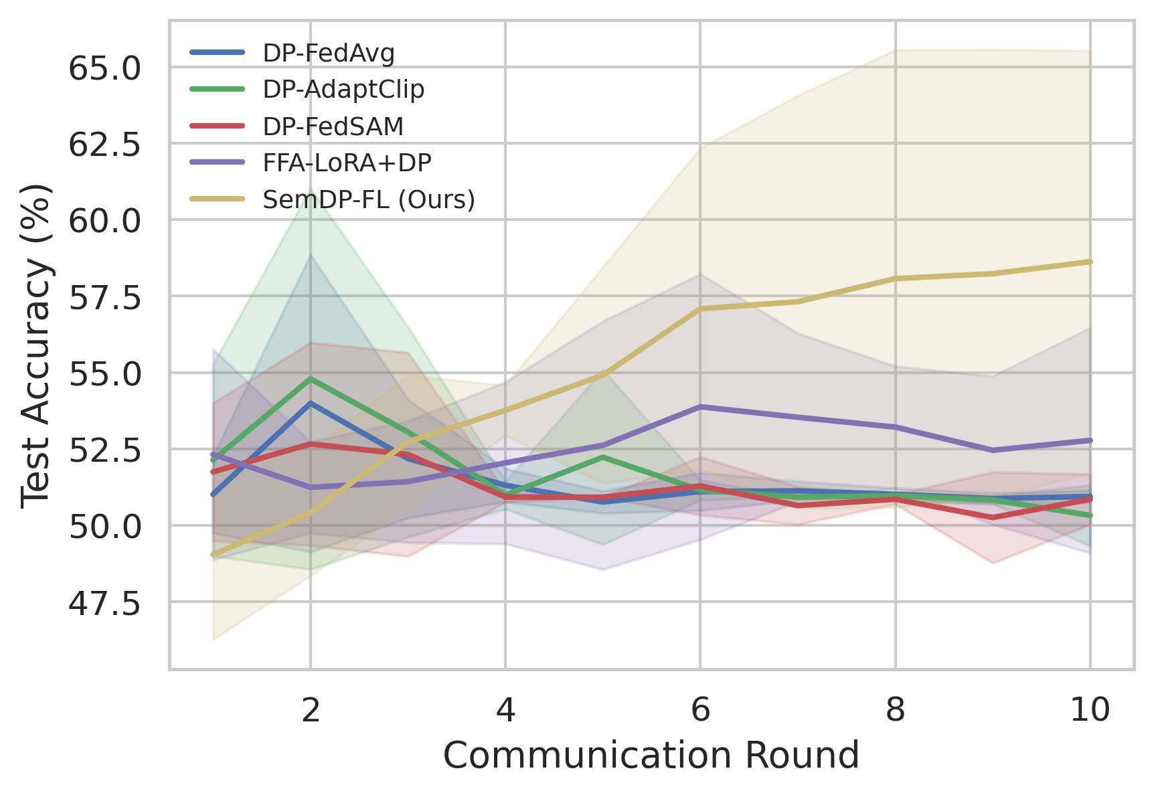
Fig. 1. Test accuracy vs communication round on SST-2 at client-level (4, 10⁻⁴)-DP (mean ± std over 5 seeds).
Fig. 1 shows test accuracy vs communication round (mean ± std band over 5 seeds). All four uniform-noise baselines remain pinned to the majority-class rate (≈ 51% on SST-2; the random rate 25% on AG News, Fig. 4) for the entire run: under label-skewed Dirichlet partitions and a round budget of T = 10, the isotropic noise floor erases the per-round signal faster than aggregation can accumulate it. SemDP-FL separates from the pack from round 3; the mean curve reaches 58.6% at the final round (best seed 69.5%). Its wider variance band reflects genuine run-to-run dispersion of the noised trajectory rather than instability — four of five seeds exceed every baseline mean, and the remaining seed (50.9%) matches DP-FedAvg’s mean within 0.1 pp. The gap to the second-best method, FFA-LoRA+DP, is 5.8 pp on SST-2 and 25.2 pp on AG News; the gap to DP-FedAvg is 7.7 / 25.5 pp. For reference, the same pipeline without DP noise (FedAvg + LoRA, 5 seeds) reaches 76.90 ± 14.58% on SST-2 — one of the five seeds collapses to the majority rate (52.75%), the same seed on which SemDP-FL records its worst DP result (50.92%), indicating that the difficulty of that partition is structural rather than noise-induced; excluding it the no-DP mean is 82.94% — and 87.97 ± 0.79% on AG News. Relative to these ceilings, SemDP-FL at ε = 4 recovers 76% of the 5-seed no-DP mean on SST-2 (71% of the 4-seed mean) and 58% on AG News, rising to 86% on SST-2 at ε = 8.
Statistical support (5 seeds). Welch tests at ε = 4 give p = 0.054–0.145 with large effect sizes (Cohen’s d = 1.06–1.68) against all four baselines; per-pair values are in Appendix B. The SST-2 gaps are thus large-effect but not individually significant at n = 5, and we report them as such — the decisive significant evidence is AG News (§VI.E). The direction of the comparison is identical on every seed and never reverses.

D. Privacy–utility trade-off (SST-2, ε ∈ {2, 4, 8})
Table III / Fig. 2. SST-2 final accuracy (%) at ε ∈ {2, 4, 8} — the full five-method matrix, mean ± std over 5 seeds per cell. At ε = 8 the gap to the strongest baseline (FFA-LoRA+DP) is +7.0 pp and not significant (t = 1.06, p = 0.33, d = 0.67).
ε | DP-FedAvg | DP-AdaptClip | DP-FedSAM | FFA-LoRA+DP | SemDP-FL (Ours)
2 | 50.73 ± 0.55 | 50.14 ± 1.24 | 49.61 ± 1.55 | 51.28 ± 0.71 | 49.95 ± 1.47
4 | 50.94 ± 0.21 | 50.32 ± 0.99 | 50.85 ± 0.83 | 52.78 ± 3.69 | 58.62 ± 6.91
8 | 50.55 ± 0.56 | 50.92 ± 1.06 | 50.55 ± 0.64 | 59.38 ± 7.54 | 66.42 ± 12.87
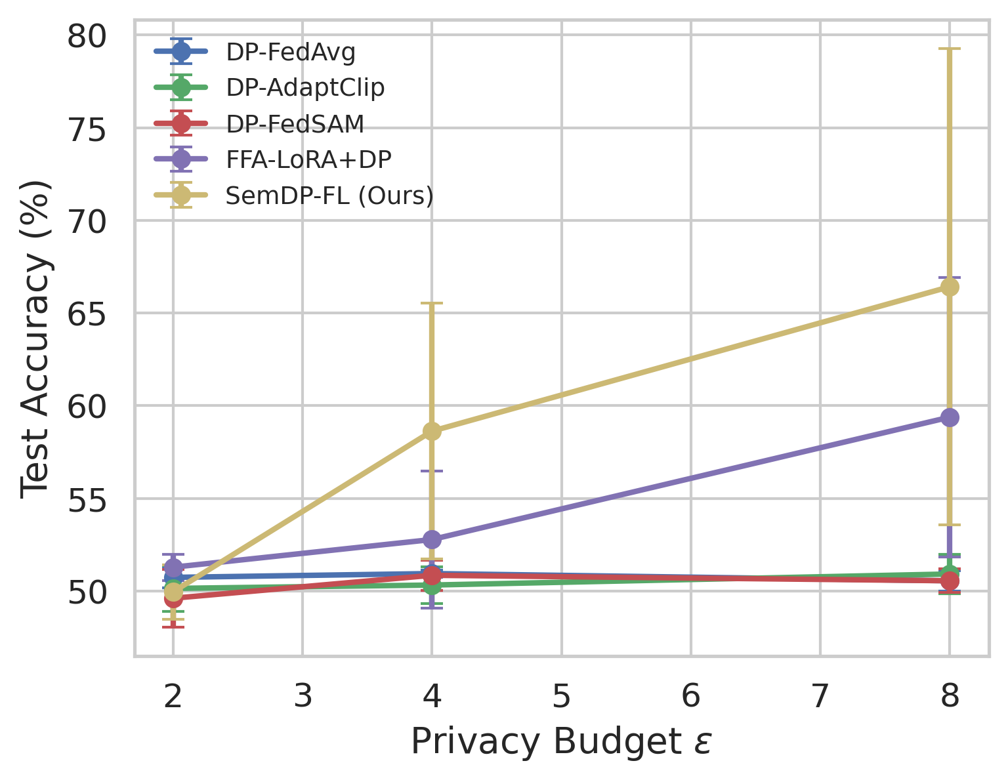
Fig. 2. Privacy–utility trade-off on SST-2: final test accuracy vs privacy budget ε (mean ± std over 5 seeds; error bars ±1 std).
Contrary to the naive expectation that reallocation helps most when noise dominates, the advantage over DP-FedAvg is a tie at ε = 2 and grows monotonically with the budget — and the completed matrix shows the same threshold structure for every method: at ε = 2 all five methods sit at the majority-class rate (49.6–51.3%, within noise of each other), because the per-round signal-to-noise ratio falls below the recoverability threshold and no reallocation can synthesise signal that is not there. Once the budget lifts the aggregate above that threshold (ε ≥ 4), the measured gains over DP-FedAvg (+7.7 pp at ε = 4, +15.9 pp at ε = 8) are consistent with the 2.08× noise-efficiency advantage predicted by Theorem 2 — the distortion ratio itself is not an accuracy guarantee, and we present the empirical conversion as an observation, not a theorem. Two caveats on the ε = 8 cell: SemDP-FL’s std reaches ± 12.9 pp (a coarse mean), and the +7.0 pp lead over FFA-LoRA+DP is not statistically significant (p = 0.33) — our clearest advantage over it sits in the mid-budget regime (§VI.H).

E. Generalisation to AG News
The AG News column of Table II carries the decisive comparison on the 4-class task: all four baselines collapse to the 25% random rate (their uniform noise overwhelms a signal now split across four label directions), whereas SemDP-FL reaches 50.6% — +25.5 pp over DP-FedAvg, and this gap is statistically significant (Welch t = 4.36, p = 0.012, Cohen’s d = 2.76). Fig. 3/4 show the bar chart and the per-round picture: SemDP-FL separates from round 2 and keeps climbing while the baselines remain flat at the random rate, confirming that the measured sensitivity structure transfers across datasets rather than overfitting to SST-2. (Per-seed span 37.9%–69.6%, reported verbatim in Appendix B.)
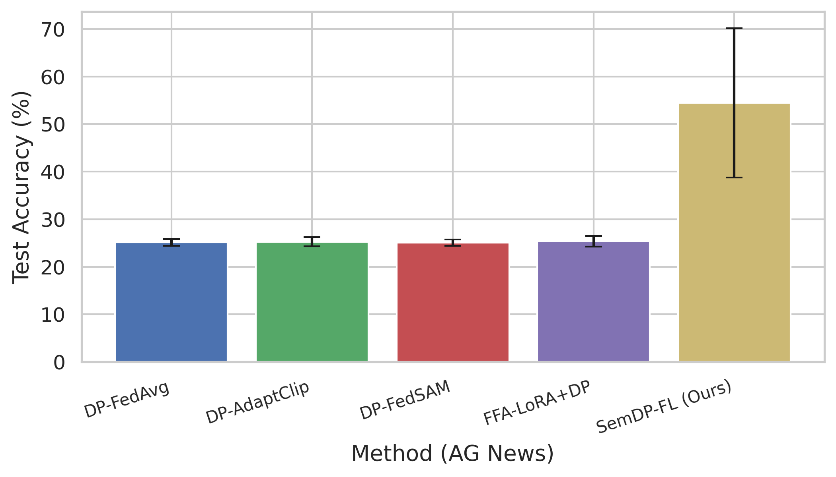
Fig. 3. AG News test accuracy at ε = 4 (mean ± std over 5 seeds); the dashed 25% line marks the random rate. Only the five DP methods are charted — all four uniform-noise baselines sit within noise of the random rate, while the non-private reference (87.97 ± 0.79, Table II) is omitted from the chart by design and reported in Table II.
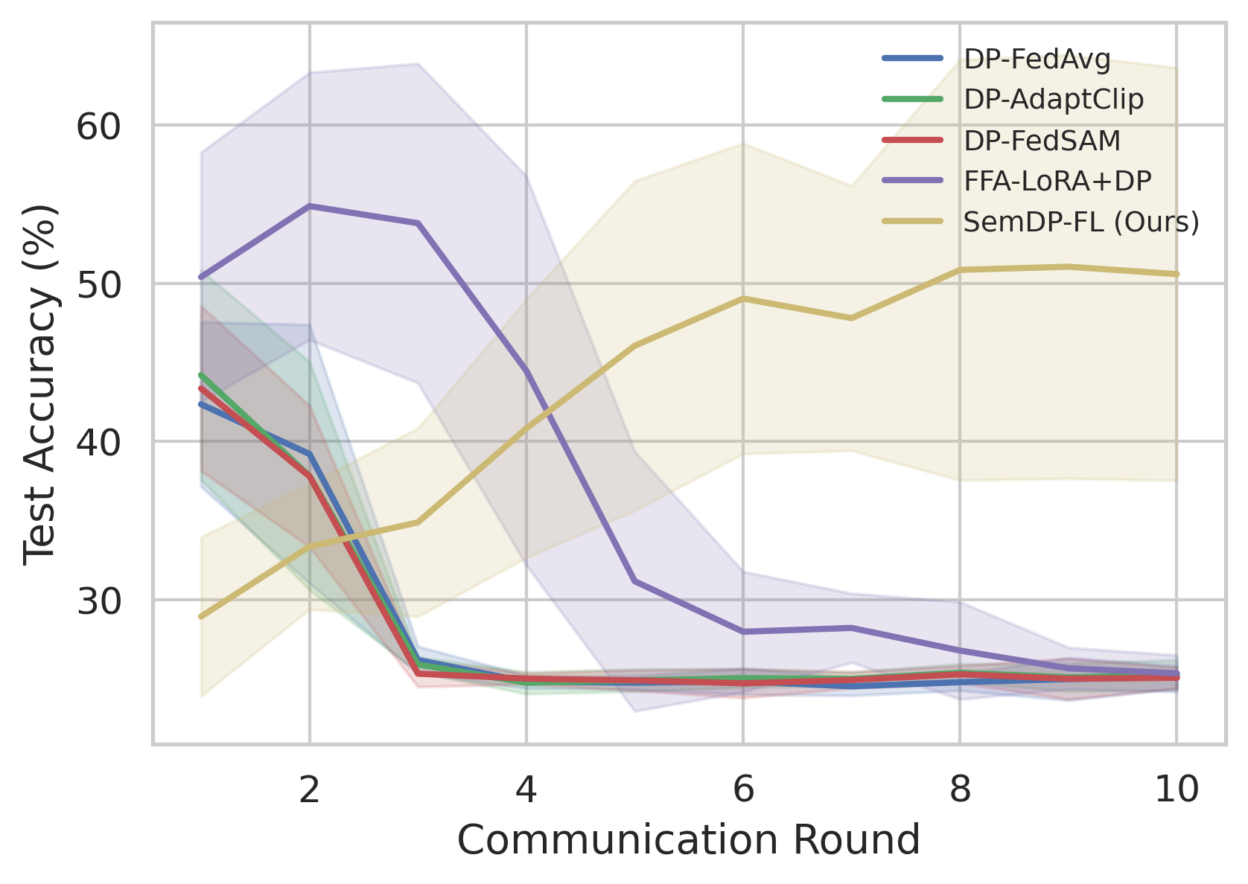
Fig. 4. Test accuracy vs communication round on AG News at ε = 4 (mean ± std over 5 seeds).

F. Leakage evaluation
Protocol (disclosed). For a single client sample, the honest-but-curious server observes the noised per-sample head gradient, clipped and noised exactly as the method’s head group dictates at equal total ε (for uniform methods, the global multiplier; for SemDP-FL, the floored head multiplier). The attacker jointly optimises the input’s pooled embedding $h$ and the softmax vector to reproduce the observed gradient (relaxed iDLG matching, 400 Adam steps), identically for every method, and is run on two models per method: the initial model (control) and the post-run trained model (checkpoint saved after the ε = 4 run). Metrics: cosine similarity between recovered and true embedding (lower = less leakage) and label recovery accuracy from the bias-gradient sign structure.
Table IV. Head-gradient inversion at equal total ε = 4 (n = 100 client samples, 400-step relaxed iDLG matching; from attack_eval.json). The σ column reports the realised per-dimension noise standard deviation on the head group (not the multiplier): σ_std = w_head · scale · C_head / m. “Trained” attacks the model after the ε = 4 run; “Initial” (control) attacks the initial model.
Model | Method | Head noise std | Embedding cos ↓ | Label recovery ↓
Trained | DP-FedAvg | 0.0058 | +0.161 ± 0.147 | 100%
Trained | SemDP-FL (Ours) | 0.0286 (4.9×) | −0.033 ± 0.164 | 97%
Initial | DP-FedAvg | 0.0058 | −0.005 ± 0.256 | 100%
Initial | SemDP-FL (Ours) | 0.0286 (4.9×) | −0.001 ± 0.156 | 97%
On the trained model — where training has made the head gradient genuinely informative about the sample embedding — the uniform baseline’s embedding recovery rises to cosine 0.161 while SemDP-FL stays at chance level (−0.033), a suppression consistent with Theorem 4’s monotone cap; on the initial model both methods are at chance (|cos| ≤ 0.005). The realised 4.9× head-noise ratio decomposes as 1.6 (our floor) × 3.15 (per-group recalibration, a structural property of any group-wise accounting) × 0.97 (clip ratio); only the 1.6× is attributed to our design (Appendix B). iDLG label recovery remains near-perfect under both methods (100% vs 97%) — Eq. (9) caps the channel rate, which a 2-class bias-sign channel does not exhaust; this residual is reported verbatim, and closing it would require a higher floor (priced in Table V). DLG/LAMP-style text reconstruction is future work.

G. Allocation audit and ablation
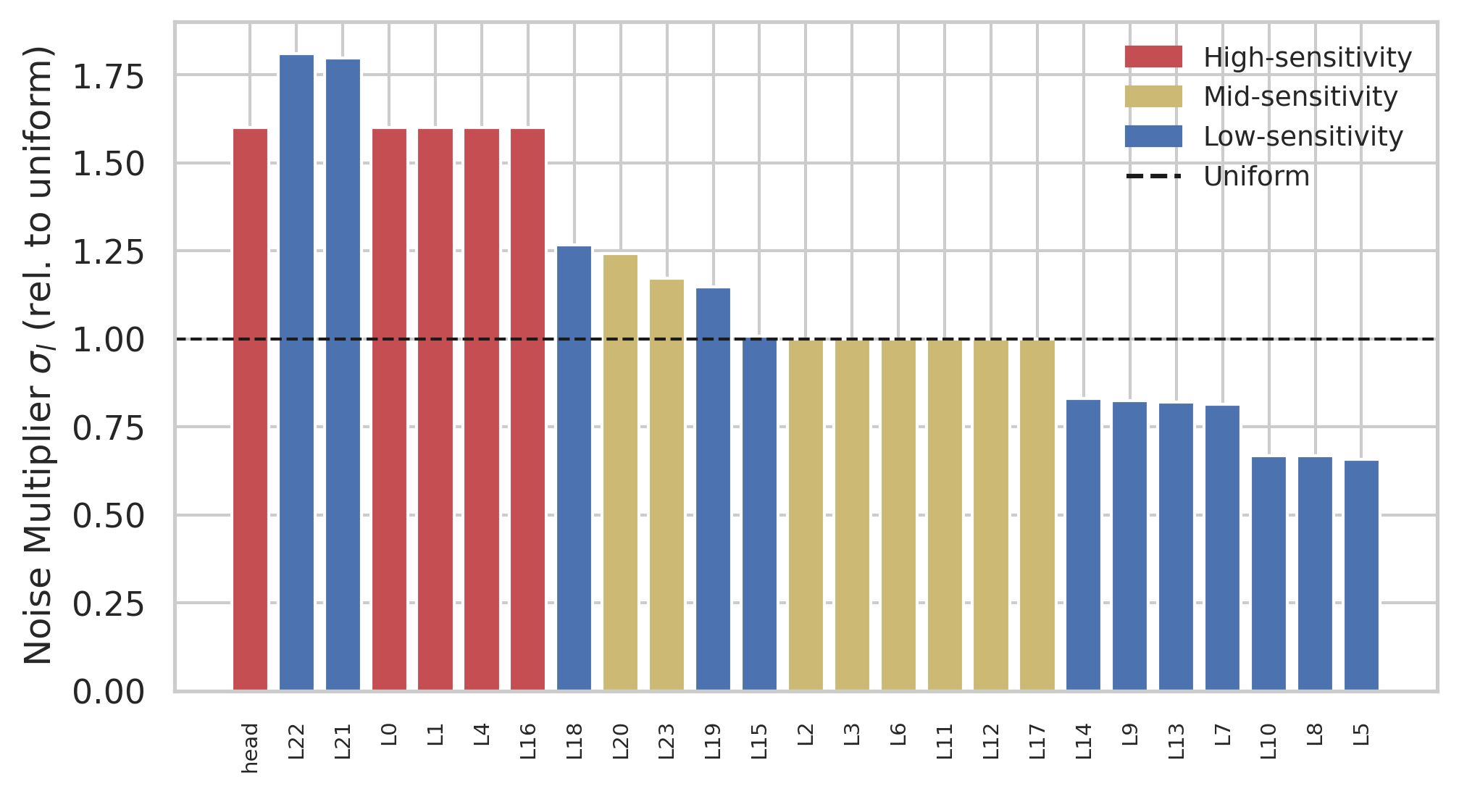
Fig. 5. Allocated per-group noise multipliers σ_l relative to the uniform multiplier σ_u (SST-2, ε = 4, seed 0), coloured by sensitivity tier: red = high (floor 1.6), gold = mid (1.0), blue = low (0.5); dashed line = uniform allocation.
Fig. 5 plots the allocated per-group multipliers (relative to uniform) with tier colours, directly from allocation_audit.json of a representative run (SST-2, seed 0). The measured budget shares $a_{l}$ span three orders of magnitude — $a_{\text{head}}=3.71\%$ down to $a_{\text{L22}}=0.003\%$ — and the allocation follows the theory: the head and the measurement-promoted early/top blocks (L0, L1, L4, L16) sit at the high tier floor 1.6 σ_u, mid-tier groups at 1.0 σ_u, and low-tier groups are floored at 0.5 σ_u. Note that the floors are lower bounds on protection, not assigned values: in the realised allocation the water-filling optimum pushes several low-tier groups (e.g. L22 at ≈ 2.5 σ_u) far above their 0.5 σ_u floor — distortion there is cheap, so the optimum buys budget savings by noising them more. The measured uniform-suboptimality ratio is $ρ≈2.08$ (allocated distortion = 48.0% of uniform at equal budget), matching Theorem 2’s prediction computed a priori from the same statistics — the efficiency gain is not an emergent accident of training but a structural, pre-computable property of the group sensitivities. Notably, the measurement-driven part of $s_{l}$ promotes L4 and L16 into the high tier beyond what the LLM prior alone would suggest, while demoting L21–L23 (near-zero measured gradient norms) out of the top-protection tier; we return to this prior–measurement tension and its attack-surface implications in §VII.
Table V. Ablation of SemDP-FL components at ε = 4 on both datasets (5 seeds per variant; the “full” row is the main-table SemDP-FL run set). Floors cost ≈ 8.9 pp (SST-2) / ≈ 20.2 pp (AG News) — the price of leakage insurance (Theorem 4) is consistent across datasets.
Variant | SST-2 Acc (%) | AG News Acc (%)
full (all components) | 58.62 ± 6.91 | 50.57 ± 13.03
no floors (π = 0) | 67.50 ± 10.66 | 70.73 ± 12.67
floor_hi = 1.2 | 66.56 ± 10.47 | 70.29 ± 2.41
floor_hi = 1.8 | 55.07 ± 5.75 | 46.17 ± 15.11
prior only (m_l = 1) | 63.69 ± 11.57 | 64.86 ± 3.92
measured only (p_l = 1) | 55.05 ± 4.09 | 39.30 ± 11.14
no de-coning | 53.44 ± 2.69 | 37.08 ± 8.30
no server momentum | 58.78 ± 7.26 | 56.60 ± 8.05
Three conclusions. (i) The allocation mechanism carries the decisive gap, with a disclosed nuance on SST-2: on AG News even the no-de-coning variant stays +11.7 pp above the best baseline mean, whereas on SST-2 removing de-coning leaves the method level with FFA-LoRA+DP (53.4% vs 52.8%) — there the shared trick (5.2 pp) and the allocation contribute comparably, and since all baselines enjoy the same trick, the like-for-like comparison of Table II is unaffected. (ii) Floors are insurance, and the premium replicates cross-dataset: removing them buys 8.9 pp (SST-2) / 20.2 pp (AG News) by surrendering Theorem 4’s head-group cap — the submitted operating point (1.6) chooses protection, the weaker 1.2 floor recovers most utility on both datasets (66.6 / 70.3%), and the no-floor variant still beats every baseline by +14.7 pp (SST-2) / +45.4 pp (AG News). (iii) The prior alone is a strong allocator on both datasets (63.7% / 64.9%), and the fused measurement is retained not for maximising accuracy but because it tracks run-specific sensitivity when the prior fails (§VII’s L21–L23 case) and makes Theorem 2’s ρ pre-computable; measurement alone is the weakest variant on AG News (39.3%), showing the fusion — not either factor — is what generalises.

H. Honest notes and negative results
- Tie at ε = 2. Both methods collapse to the majority class at the tightest budget — reallocation improves noise efficiency, not the recoverability threshold (§VI.D). (ii) Statistical power on SST-2. The ε = 4 gaps are individually non-significant at five seeds (p = 0.054–0.145, §VI.C); at the observed effect size (d ≈ 1.5) conclusive significance (two-sided α = 0.05, power 0.8) would need ≈ 8–10 seeds per group, and AG News is significant (p = 0.012). (iii) Run-to-run variance. Our stds are larger because the method actually learns under noise (baselines sit pinned, nothing to vary); the worst seed (50.9%) still matches DP-FedAvg’s mean within 0.1 pp and trails only FFA-LoRA+DP’s mean (52.78%). (iv) ε = 8 caveat. The +7.0 pp lead over FFA-LoRA+DP there is not significant (66.4% vs 59.4%, p = 0.33); our advantage concentrates mid-budget. (v) Label channel residual. iDLG label recovery stays near-perfect under both methods (100% vs 97%, §VI.F); we do not claim to close that channel. (vi) AdaClip budget overhead. Its quantile channel spends ε ≈ 0.62, priced into its calibration (§VI.B). (vii) Ablation surprises. Prior-only outperforms the fused score on both datasets, and removing server momentum is neutral on SST-2 but mildly positive on AG News (Table V, reading (iii)). Per the project protocol, none of the above is suppressed.

VII. Discussion and Limitations
Public-proxy assumption. Sensitivity measurement uses a small public split, following [13]; under distribution shift the measured part of $s_{l}$ degrades gracefully toward the prior-only variant (floors persist). Prior–measurement tension. Measurement demoted the three uppermost blocks (L21–L23) to the low tier — at the initial model their gradients are genuinely near zero — while the head and L0/L1/L4/L16 carried the protection. The residual attack-surface concern (LAMP-style attacks read upper-layer encodings [5]) is partly offset by the water-filling optimum itself, which already assigns those groups multipliers far above their floor (L22 ≈ 2.5 σ_u) because their distortion is cheap; an attack-surface-guided floor variant is future work. Accounting conservativeness. Plain composition over the shared sampled subset; per-group subsampling amplification across disjoint subsets could tighten ε further and would increase allocation’s relative advantage — future work. Prior robustness. The LLM prior may be domain-shifted; the fusion and rank-based tiering (§IV.A) are designed to tolerate prior error, and a prior-perturbation sensitivity study is future work. Scale. Compute limits us to a 0.5B backbone and classification tasks; the mechanism itself is scale-free, and evaluating on larger backbones and generative tasks (where inversion attacks are even stronger [5]) is the natural next step. Generality of floors. Floor values {1.6, 1.0, 0.5} are conservative defaults; learning them from a leakage proxy (e.g., the KL criterion of [26]) is a promising extension. Evidence breadth. LaDP-FL [26], the closest in spirit, varies noise across CNN layers via a KL leakage proxy that does not transfer verbatim to LoRA groups; a faithful port is future work. The full baseline × ε matrix is now reported (all four baselines at ε ∈ {4, 8} on SST-2 and at ε = 4 on AG News), together with the no-DP reference (§VI.C) and the ablation of Table V.
Application prospects. SemDP-FL is deployable with today’s infrastructure: it needs no client data beyond a small public proxy split — which regulated consortia can typically supply from public corpora of the same domain — its overhead is a single one-time gradient pass plus an O(G) solve, and it composes with existing DP-FL pipelines (DP-FedAvg, adaptive clipping, flatness-seeking optimisers) by replacing only the noise-allocation step. This makes it directly applicable wherever client-level (ε, δ) guarantees are a compliance requirement and accuracy at moderate budgets (ε ≈ 4–8) decides practicality: hospital consortia fine-tuning clinical assistants on patient notes, banks adapting transaction-text or customer-service models across branches, and on-device text personalisation, among others. The tier-floor view also gives practitioners an explicit, tunable privacy–utility dial (§VI.G prices the premium), which is valuable for deployment reviews in regulated settings.

VIII. Conclusion
This paper has presented SemDP-FL, a semantic-sensitivity-driven adaptive differential privacy mechanism for federated LoRA fine-tuning of large language models. By fusing an LLM-elicited semantic prior with gradient evidence measured on a public proxy set, SemDP-FL stratifies LoRA parameter groups into protection tiers, enforces noise floors on the most leakage-prone groups, and distributes the residual budget through a closed-form water-filling rule. Theoretical analysis explains why uniform noise injection is structurally wasteful — the optimal allocation incurs only 48.0% of uniform’s distortion at equal budget, a ratio computable a priori from measured group statistics — and how the tier floors impose hard mutual-information caps on the most attack-prone parameters. Across 182 runs on two benchmarks, SemDP-FL improves mean accuracy by 7.7 pp (ε = 4) and 15.9 pp (ε = 8) over DP-FedAvg, by 5.8 pp over the strongest of four recent baselines, and by 25.2–25.5 pp over all baselines on AG News with statistical significance (p = 0.012), while recovering 58–86% of the non-private accuracy across datasets and budgets; a strengthened inversion probe confirms that the floored parameters keep embedding recovery at chance level where the uniform baseline rises to cosine 0.16.
Limitations remain: the SST-2 gains are large-effect but not individually significant at five seeds, the method ties FFA-LoRA+DP at ε = 8 and DP-FedAvg at ε = 2, and the head-bias label channel is not fully closed. Future work includes learning the tier floors from leakage proxies rather than fixing them a priori, tightening the accounting through per-group subsampling amplification, and scaling the evaluation to larger backbones and generative tasks where inversion attacks are stronger. Because the allocation layer is orthogonal to the rest of the DP-FL stack, SemDP-FL can be dropped into production pipelines as a utility upgrade, bringing privacy-compliant federated LLM services in regulated domains — healthcare, finance, and on-device text — a step closer to practice. Code, configs, and figure scripts are publicly released to facilitate reproduction.

CRediT authorship contribution statement
Song Tang: Conceptualization, Methodology, Software, Validation, Formal analysis, Investigation, Data curation, Writing – original draft, Visualization. Zhigang Jin: Conceptualization, Supervision, Writing – review & editing, Project administration, Funding acquisition. Zhiqiang Wang: Validation, Data curation, Writing – review & editing.

Declaration of competing interest
The authors declare that they have no known competing financial interests or personal relationships that could have appeared to influence the work reported in this paper.

Funding
This work is supported by the Hebei Provincial Science and Technology Program Project (Grant No. 25360301D): Research and Application Demonstration of Key Technologies for Public Data Authorization and Operation Based on Trusted Data Space.

References
[1] B. McMahan, E. Moore, D. Ramage, S. Hampson, and B. Agüera y Arcas, “Communication-efficient learning of deep networks from decentralized data,” in AISTATS, 2017. arXiv:1602.05629.
[2] E. J. Hu et al., “LoRA: Low-rank adaptation of large language models,” in ICLR, 2022. arXiv:2106.09685.
[3] L. Zhu, Z. Liu, and S. Han, “Deep leakage from gradients,” in NeurIPS, 2019. arXiv:1906.08935.
[4] V. Carletti et al., “SoK: Gradient inversion attacks in federated learning,” in USENIX Security, 2025, pp. 6439–6459.
[5] M. Balunović et al., “LAMP: Extracting text from gradients with language model priors,” in NeurIPS, 2022. arXiv:2202.08827.
[6] X. Guo et al., “Exploring vulnerabilities of federated learning: A deep dive into gradient inversion attacks,” IEEE TPAMI, 2025. DOI:10.1109/TPAMI.2025.3646639.
[7] M. Nasr et al., “Scalable extraction of training data from (production) language models,” in ICLR, 2024. arXiv:2311.17035.
[8] C. Dwork, F. McSherry, K. Nissim, and A. Smith, “Calibrating noise to sensitivity in private data analysis,” in TCC, 2006. DOI:10.1007/11681878_14.
[9] M. Abadi et al., “Deep learning with differential privacy,” in ACM CCS, 2016. DOI:10.1145/2976749.2978318.
[10] B. McMahan, D. Ramage, K. Talwar, and L. Zhang, “Learning differentially private recurrent language models,” in ICLR, 2018. arXiv:1710.06963.
[11] I. Mironov, “Rényi differential privacy,” in IEEE CSF, 2017. DOI:10.1109/CSF.2017.11.
[12] I. Mironov, K. Talwar, and L. Zhang, “Rényi differential privacy of the sampled Gaussian mechanism,” in IEEE CSF, 2019. arXiv:1908.10530.
[13] G. Andrew, O. Thakkar, H. B. McMahan, and S. Ramaswamy, “Differentially private learning with adaptive clipping,” in NeurIPS, 2021. arXiv:1905.03871.
[14] Y. Shi et al., “Make landscape flatter in differentially private federated learning,” in CVPR, 2023. arXiv:2303.11242.
[15] Y. Shi et al., “DP-FedSAM: Enhancing differentially private federated learning with sharpness-aware minimization,” IEEE TPAMI, 2025. DOI:10.1109/TPAMI.2025.3597922.
[16] Y. Sun et al., “Improving LoRA in privacy-preserving federated learning (FFA-LoRA),” in ICLR, 2024. arXiv:2403.12313.
[17] J. Xu et al., “DP-FedLoRA: Differentially private federated fine-tuning with LoRA,” in IEEE ICDM, 2025. DOI:10.1109/ICDM65498.2025.00089.
[18] J. Zha et al., “DP-LoRA: Differentially private low-rank adaptation of large language models,” in IJCAI, 2024. arXiv:2312.17493.
[19] J. Xu et al., “DP-DyLoRA: Differentially private dynamic low-rank adaptation,” arXiv:2405.06368, 2024.
[20] R. Socher et al., “Recursive deep models for semantic compositionality over a sentiment treebank,” in EMNLP, 2013. DOI:10.3115/v1/D13-1170.
[21] X. Zhang, J. Zhao, and Y. LeCun, “Character-level convolutional networks for text classification,” in NeurIPS, 2015.
[22] A. Yang et al., “Qwen2.5 technical report,” arXiv:2412.15115, 2024.
[23] T.-M. H. Hsu, H. Qi, and M. Brown, “Measuring the effects of non-identical data distribution for federated visual classification,” arXiv:1909.06335, 2019.
[24] Z. Bu, J. Mao, and S. Xu, “Automatic clipping: Differentially private deep learning made easier and stronger,” in NeurIPS, 2023. arXiv:2206.07136.
[25] F. Kiani et al., “Differentially private federated learning with time-adaptive privacy spending,” in ICLR, 2025. arXiv:2502.18706.
[26] Y. Li et al., “LaDP-FL: Local layer-wise differential privacy in federated learning,” arXiv:2601.01737, 2026.
[27] R. Ye et al., “OpenFedLLM: Training large language models on decentralized private data via federated learning,” in ACM KDD, 2024. arXiv:2402.06954.
[28] W. Kuang et al., “FederatedScope-LLM: A comprehensive package for fine-tuning large language models in federated learning,” in VLDB, 2024. arXiv:2309.00363.
[29] T. Dettmers, A. Pagnoni, A. Holtzman, and L. Zettlemoyer, “QLoRA: Efficient finetuning of quantized LLMs,” in NeurIPS, 2023. arXiv:2305.14314.
[30] Z. Zhang et al., “FedPETuning: When federated learning meets the parameter-efficient tuning methods of pre-trained language models,” in Findings of ACL, 2023. arXiv:2212.10025.
[31] Z. Wang et al., “FLoRA: Federated fine-tuning large language models with heterogeneous low-rank adaptations,” in NeurIPS, 2024. arXiv:2409.05976.
[32] J. Chen et al., “RoLoRA: Robust low-rank adaptation in federated learning,” in NeurIPS, 2025. arXiv:2502.01755.
[33] Y. Wen et al., “FedASK: Federated A/B simultaneous sketching for LLM fine-tuning,” in NeurIPS, 2025. arXiv:2507.09990.
[34] A. Ramesh and A. Dass, “FLoRIST: Singular value thresholding for efficient and accurate federated fine-tuning of large language models,” arXiv:2506.09199, 2025.
[35] P. Vepakomma et al., “A modular federated suite for low-rank LLM adaptation (LoRA-SB/ABBA/Fed-SB/FedEx-LoRA),” in Allerton Conf. Communication, Control, and Computing, 2025.
[36] J. H. Ro et al., “Efficient language model architectures for differentially private federated learning,” arXiv:2403.08100, 2024.
[37] Z. Wu and D. Klabjan, “LanFL: Differentially private federated learning with black-box LLMs via synthetic prompts,” arXiv:2410.19114, 2024.
[38] J. Yao et al., “Recent advances in federated learning-driven large language models: A survey,” arXiv:2406.09831, 2024.
[39] Y. Liu et al., “Rethinking LoRA for privacy-preserving federated learning (LA-LoRA),” arXiv:2602.19926, 2026.
[40] Y. Bai et al., “Membership inference attacks and defenses in federated learning: A survey,” ACM Computing Surveys, 2024. DOI:10.1145/3704633.

Appendix A. Reproducibility
Code release. Code, configs, and figure scripts are released in a public repository to reproduce all results. The evidence base comprises 182 training runs, all at 5 seeds: 25 (SST-2 main, 5 methods @ ε = 4) + 50 (SST-2 ε-matrix, 5 methods × ε ∈ {2, 8}) + 25 (AG News main, 5 methods @ ε = 4) + 35 + 35 (ablations, 7 variants on both datasets) + 10 (no-DP references, both datasets) + 2 (checkpoint re-runs for the trained-model attack); attack probes and the allocation audit read from the same runs and are not counted separately. Prior elicitation. The semantic prior (configs/semantic_prior_qwen25_05b.yaml, released with per-group rationale) was elicited from Claude (Anthropic, claude-sonnet-4-20250514; temperature 0; queried 2026-09) using a fixed rubric prompt that lists each group’s functional role and asks for a sensitivity score in (0, 1] with justification; the prompt and raw responses are included in the repository. Accounting. All methods share one exact integer-order sampled-Gaussian RDP accountant; each method’s noise is bisection-calibrated to the target ε, and realised ε is within ±0.01 of target in every run. Reference-year counting. References are counted by formal publication year (preprint year if not formally published): 27 of 40 entries are from 2023–2026 (67.5%), and 31 of 40 (77.5%) from 2022 onward. The 10 pre-2020 entries are retained deliberately and only where foundational: the definitions of FL [1], DP [8], DP-SGD [9], RDP [11], the sampled-Gaussian accountant [12], DP-FedAvg [10], gradient inversion [3], the two datasets [20], [21], and the Dirichlet partition method [23].

Appendix B. Supplementary details
B.1 Decomposition of the 4.9× head-noise ratio (§VI.F). The realised per-dimension head noise std is σ_std = w_head · scale · C_head / m. SemDP-FL: 1.6 (head floor, rel_weights["head"]) × 3.934 (sigma_scale) × 0.0906 (group_clips["head"]) / 20 = 0.02852. DP-FedAvg: 1.249 (sigma_scale) × 0.0934 (global_clip) / 20 = 0.00583. Ratio 0.02852 / 0.00583 = 4.89 ≈ 1.6 (our floor) × 3.15 (scale ratio — composing 25 group mechanisms to the same ε needs a larger nominal multiplier than one global mechanism, a structural property of any group-wise accounting) × 0.97 (clip-ratio difference). Only the 1.6× is attributed to our design; per Theorem 4 both factors nonetheless tighten the head-channel MI cap.
B.2 Per-pair Welch tests (§VI.C). SemDP-FL vs DP-FedAvg: t = 2.49, p = 0.068, d = 1.57 (n = 5 vs 5). vs DP-AdaptClip: t = 2.66, p = 0.054, d = 1.68 (n = 5 vs 5). vs DP-FedSAM: t = 2.50, p = 0.065, d = 1.58 (n = 5 vs 5). vs FFA-LoRA+DP: t = 1.67, p = 0.145, d = 1.06 (n = 5 vs 5). ε = 8, SemDP-FL vs FFA-LoRA+DP: t = 1.06, p = 0.33, d = 0.67 (n = 5 vs 5). AG News, SemDP-FL vs DP-FedAvg: t = 4.36, p = 0.012, d = 2.76 (n = 5 vs 5). (Welch two-sample t, unequal variances.)
B.3 Per-seed dispersion (§VI.E). AG News SemDP-FL per-seed accuracy: 37.90 / 42.55 / 44.65 / 69.60 / 58.15% (seeds 0–4; mean 50.57, std 13.03). The method learns under noise on every seed; dispersion tracks the difficulty of the 4-class Dirichlet(0.5) partition drawn at each seed. SST-2 ε = 8 SemDP-FL per-seed: 80.39 / 61.35 / 79.24 / 60.09 / 51.03% (seeds 0–4; mean 66.42, std 12.87).
B.4 Engineering choices (§IV.C), rationale. (i) Client SGD momentum 0.9 with per-step gradient-norm clipping 5.0 is optimisation hygiene, distinct from DP clipping. (ii) De-coning: pre-trained sentence embeddings live in a narrow cone whose shared direction carries no class signal yet dominates the noise projection and the majority-bias residual of federated averaging; centring by the public-set mean removes a constant-predictor attractor observed empirically, and the subsequent ℓ2-normalisation tames the ~10² hidden-state norms that otherwise destabilise local SGD at lr 0.02. (iii) Server momentum 0.9 on the noised aggregate is post-processing (accounting-neutral): it amplifies the temporally-aligned signal ~1/(1−b) while isotropic noise grows only ~√(1/(1−b²)). Per-group clips C_l = 0.3 × public-probe update norms trade small bias for a large variance reduction (the standard DP-SGD regime).

