Efficient path solution for N workers

Table of Contents
1. Data cleaning 2
2. Path finding solution 4
2.1. Downsample data 5
2.2. Partition data to N worker count in a radial manner with evenly distributed points 7
2.3. Implement actual path search algo for each partition 9
2.4. Optimize the total distance travelled for each worker and their adjacent neighbours 10
2.5. Use optimized path search from downsampled data to find shorter paths for original data 11
2.6. Summary 12
3. Scaling up 13
4. Other recommendations 14

1. Data cleaning
The data cleaning workflow is depicted in the following diagram. This workflow is specific to the data given in the assignment and may not work for other cases.
explore.py
# This script is only for exploratory purposes. Hence, it is not the most optimized, nor has the best practices of
# some "data science" framework (eg. pandas), nor it has any good software engineering practices(variable names, OOPs).
# Nevertheless, it should serve its purpose well. Please read comments/documentation for better understanding
import pandas as pd
import numpy as np
from sklearn.decomposition import PCA

qwe = pd.read_csv('locations.csv', header=None)

# Non numeric Exchange Quare
# Non numeric Exchange Quare

def h1(v):
try:
return float(v)
except:
return False

asd = qwe.applymap(h1) # try casting to float, else False

for c in asd: # filters for each col with non numerical values
asd = asd[asd[c] != False]

asd.reset_index(drop=True, inplace=True)

pcam = PCA(n_components=1)
asd1 = pcam.fit_transform(asd).reshape(-1)

ht = np.histogram(asd1, bins=3)
# bin_count = [1598 2 3] <-- 5 of them are very different from the 1598 others, assuming they are anomalies,
# remove them
# bin_interval [ -0.63874972 74.08144007 148.80162985 223.52181964]

asd2 = pd.Series(asd1)
asd = asd[asd2 < 74.08144007] # filters out possibly anomalous data

asd.to_csv('cleaned.csv', header=None, index=False)

import plotly.graph_objects as go

# Visualization. As expected, distribution is uneven.
fig = go.Figure(data=
[
go.Scatter(x=asd[0], y=asd[1], mode='markers', marker=dict(size=4, color='green', opacity=0.8)),
go.Scatter(x=[11.552931], y=[104.933636], mode='markers', marker=dict(size=8, color='red', opacity=0.8))
]
)

fig.update_layout(margin=dict(l=0, r=0, b=0, t=0))
fig.show()
Load CSV data as pandas dataframe.
1
Filters out non-numerics
2
Used histogram to discover anomalies and PCA to reduce data to 1D for easy anomalous data removal
3
Outputs cleaned data to CSV file and also to Plotly for visualization
4

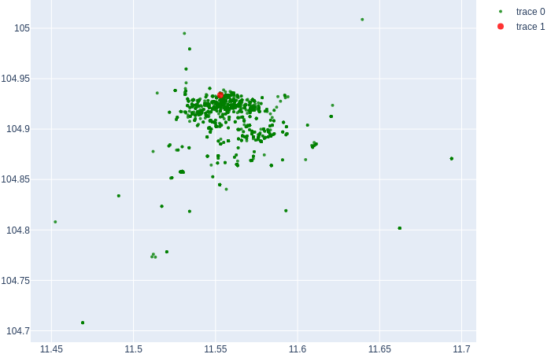
Fig. 1: Visualization of cleaned data

2. Path finding solution
We assume the optimization goal is to ensure total distance travelled by all workers is as short as possible (not the same as evenly distance travelled)
For the purpose of sheer processing speed and multithreading, Golang is used for this part here. The workflow is as follows:
Downsample data
So as to speed up processing. Due to data being unevenly distributed, some heuristics are used for downsampling of data
1
Partition data to N worker count in a radial manner with evenly distributed points
This reduces our search space when we implement our path search algoritm
2
Implement actual path search algo for each partition
Can use the appropriate existing travelling salesman solution out there.
Optimize the total distance travelled for each worker and their adjacent neighbours
This part compares the path of each worker and its neighbours and see if any points along the path can be traded/given away to reduce total distance travelled for this set of workers
Data
Use optimized path search from downsampled data to find shorter paths for original data
This time, path search is done on full dataset. But because grouping of points is done on previously optimized path search of downsampled data, this path search optimization will be faster.
Solution for decently shorter total distance travelled
5
3
4
Might need to run path search algo again with some heuristics
If using downsampled data

2.1. Downsample data
To speed up solution search, downsampling is done. This downsamping method seeks to reduce data points that are similar, while keeping dissimilar data points, hence the downsampled data still maintain a fairly accurate representation of original data
Fig. 2: Possible regions for downsampling
Ideally, downsampling should be done for high density regions (red boxes) while keeping original data for low density regions (green boxes)
Actual algorithm
In the actual algorithm, data’s first principle components and their mean/standard deviation is used for filtering out similar data.
Actual values used:
SelectionRate=0.2
SelectionStandardDeviation=2
pathfinding.go/downsampleSimilar

func downsampleSimilar(d [][]float64, selectionRate float32, selectionStandardDeviation float64) [][]float64 {
rand.Seed(time.Now().UnixNano())
dest := floats2DToDense(d)
rlen, _ := dest.Dims()
pcModel := PrincipalComponentTrain(dest) // get trained PC
transformed := PrincipalComponentTransform(pcModel, dest, 1)
v := transformed.RawMatrix().Data

mean, std := stat.MeanStdDev(v, nil)
keepIndices := []int{}
for i := 0; i < rlen; i++ {
if v[i] < mean+selectionStandardDeviation*std && v[i] > mean-selectionStandardDeviation*std {
if rand.Float32() < selectionRate {
keepIndices = append(keepIndices, i)
}
} else {
keepIndices = append(keepIndices, i)
}
}
newDest := [][]float64{}
for ii := range keepIndices {
pos := keepIndices[ii]
newDest = append(newDest, d[pos])
}
return newDest
}
Principle Component transform
Select those data within selectionStandardDeviation from mean with a selectionRate %.
Any data outside selectionStandardDeviation is considered dissimilar data and must be used in the downsampled dataset
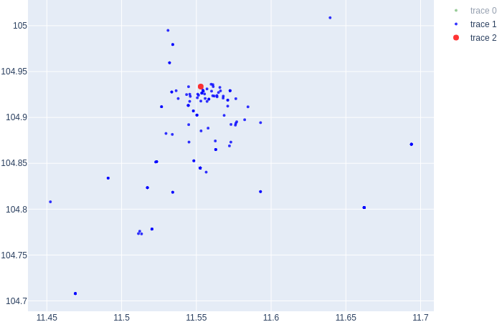
Fig. 3: Visualization of downsampled data(explore2.py)

2.2. Partition data to N worker count in a radial manner with evenly distributed points
The search space for decently shorter path search for N workers at this point is still too big. Hence, it may be ideal if we start the path search on some pre-optimized partitioning heuristics.
The idea is that, the points covered by each worker for decently shorter paths are rather compartmentalized so they have a low chance of cutting through the paths of adjacent workers.
We can work out an estimate of this boundary region for each worker using radial lines for boundary lines for each partition.
We then optimize the angles of these radial lines towards an equal number of nodes for each partiton.

Fig. 4: Optimized radial partitioning for 4 workers
Partition 1
This example shows how optimized radial partitons may look like for a 4 worker problem.
Each partition tries to have an equal number of points
Partition 2
Partition 3
Partition 4
Start
Actual algorithm
2
The flow of the algorithm is as follows:
1
Start from evenly spaced radial partitions

Compares number of points for current parition with its next neighbour (increasing angle). If next neighbour has more points, current partition eats into the space of next neighbour. Otherwise, it gives space to next neighbour.
This is done for all partitions. The last partition is compared with the first partition, forming a complete circle
3
Stops when converged/ max iterations reached
Calculate number of points in each partition
Parallelized
Code
Sample output for 4 worker problem:
pathfinding.go/optimizerAnglePartition

func optimizerAnglePartition(points [][]float64, partitionCount int) []AnglePartition {
// Reduce total distance
wg := sync.WaitGroup{}
intervalAngle := fullRad / float64(partitionCount)
pointsAngle := _getAnglePoints(points)
partitions := []AnglePartition{}
for i := 0; i < partitionCount; i++ {
partitions = append(partitions, AnglePartition{start: float64(i) * intervalAngle, end: (float64(i) + 1) * intervalAngle})
}
for i := range partitions {
wg.Add(1)
go _getPartitionPoints(&partitions[i], pointsAngle, &wg)
}
wg.Wait()
k := 1.0
for iii := 0; iii < 100; iii++ { //converges in ~100
for i := range partitions {
nextP := i + 1
if i+1 == len(partitions) {
nextP = 0
}
ptdiff := len(partitions[nextP].pointsPos) - len(partitions[i].pointsPos)
avchng := 0.0
if ptdiff > 0 { //eats into next
nextAvRng := partitions[nextP].end - partitions[nextP].start
avchng = float64(ptdiff) / 2.0 / float64(len(partitions[nextP].pointsPos)) * nextAvRng

} else if ptdiff < 0 { //eats into cur
curAvRng := partitions[i].end - partitions[i].start
avchng = float64(ptdiff) / 2.0 / float64(len(partitions[i].pointsPos)) * curAvRng
}
partitions[nextP].start += k * avchng
if partitions[nextP].start >= fullRad {
partitions[nextP].start -= fullRad
partitions[nextP].end -= fullRad
} else if partitions[nextP].start < 0 {
partitions[nextP].start += fullRad
partitions[nextP].end += fullRad
}
partitions[i].end += k * avchng
}
k *= 0.99
for i := range partitions {
print(len(partitions[i].pointsPos))
print(",")
}

println("iter:", iii)
for i := range partitions {
wg.Add(1)
go _getPartitionPoints(&partitions[i], pointsAngle, &wg)
}
wg.Wait()
}
return partitions
}
Calculate number of points for each partition using Goroutines (parallelized)
Create an array of partitions for N workers with each partition equal angle apart
Max iteration of 100
Comparison of points with next neighbour is done here. Angles adjust based on whether current partition has more or less points than its next neighbour
“k” is a decaying multiplier for angle changes

3,12,198,144,iter: 0
40,85,106,126,iter: 1
67,91,105,94,iter: 2
74,93,103,87,iter: 3
77,104,82,94,iter: 4
93,85,108,71,iter: 5
41,92,85,139,iter: 6
72,85,110,90,iter: 7
80,95,90,92,iter: 8
...
89,89,90,89,iter: 97
89,90,89,89,iter: 98
89,89,90,89,iter: 99
For last 3 iterations, partition sizes are unchanged. The results have converged.
Columns represent different workers/partitions.
Number of points for partition 1 at each iteration.

2.3. Implement actual path search algo for each partition
Using the partitioned points from 2.2, we can implement a path search for each worker/partition.
In this solution, a naive path search using nearest neighbour approach was used.
This means the solution is not optimal, but reasonable.
However, it is recommended to look for better existing solutions for this (will need time to find Golang implementations, or will have to write my own)

Actual algorithm
The flow of the algorithm is as follows:
Parallelized
2
3
1
Do a double key sort (X,Y axis) on all destinations except for starting position
Find nearest available node to current node and use that as next destination (doubly sorted key reduces the search space)
Repeat 2 until all nodes are traversed.

N partitions

pathfinding.go/_findShortestDistanceWalk

func _findShortestDistanceWalk(startpt []float64, points [][]float64) [][]float64 {
// this assumes walk from 0,0
// double index, sort 1st index, find nearest neigh
// branch-and-bound
sort.Slice(points, func(i, j int) bool {
return points[i][1] < points[j][1]
})
sort.Slice(points, func(i, j int) bool {
return points[i][0] < points[j][0]
})

start := [][]float64{startpt}
points = append(start, points...)
path := make([]int, len(points))
used := make([]bool, len(points))

used[0] = true
for ii := 0; ii < len(points)-1; ii++ {
curPathPos := ii
curNode := path[curPathPos]
shortestDist := -1.0

for i := 1; i < len(points); i++ {
if !used[i] {
if shortestDist < 0 {
shortestDist = _distL2(points[curNode], points[i])
path[curPathPos+1] = i
} else if math.Abs(points[curNode][0]-points[i][0]) < shortestDist {
d := _distL2(points[curNode], points[i])
if d < shortestDist {
path[curPathPos+1] = i
shortestDist = d
}
} else if points[i][0]-points[curNode][0] > shortestDist { //first index already > current shortest dist, ignore rest
break
}
}
}
used[path[curPathPos+1]] = true
}
pathNodes := [][]float64{}
for i := range path {
pathNodes = append(pathNodes, points[path[i]])
}
return pathNodes[1:]
}
Double sort
Nearest neighbour path search using L2 Norm
Sample output for 4 worker problem:
Zero centered nearest neighbour path of worker 0
-9.881747e-004 -1.522353e-003
-2.181221e-003 -2.666762e-003
-2.916504e-003 -9.577773e-004
+9.859312e-004 +1.720140e-003
+3.196548e-003 +4.231431e-004
...

Zero centered nearest neighbour path of worker 1
+5.390953e-003 -2.216627e-003
+5.390953e-003 -2.216627e-003
+7.231544e-003 -4.993727e-003
+6.806206e-003 -5.695631e-003
+6.806206e-003 -5.695631e-003

Zero centered nearest neighbour path of worker 2
+2.107452e-003 -2.857497e-003
+2.107452e-003 -2.857497e-003
+2.108406e-003 -2.857497e-003
+1.387428e-003 -3.788283e-003
+1.387428e-003 -3.788283e-003
...

Zero centered nearest neighbour path of worker 3
-3.444445e-004 -5.131056e-003
+7.169950e-004 -7.145216e-003
+7.169950e-004 -7.145216e-003
-8.313776e-005 -8.564284e-003
-1.050723e-004 -8.564284e-003
...
All these are coordinates relative to the starting point

2.4. Optimize the total distance travelled for each worker and their adjacent neighbours
While decently shorter path is implemented within each partition, the total decently shorter travelled distance by all the workers is still unoptimized. Hence we need this step to reduce global decently shorter travelled distance.
It might be easier for partition/worker 3 to reach this point instead of partition/worker 4.
So we should assign this point to partition/worker 3 instead.

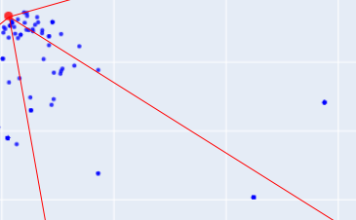
Partition/Worker 4
Partition/Worker 3
Actual algorithm
The flow of the algorithm is as follows:
2
For current partition i, find if it has any points with nearest neighbour in the next partition i+1
If yes, put that nearest neighbour point in the current partition, calculate shortest distance (using some heuristics since most of the path will remain unchange).
Do the same for current point, but put it in the next partition.
1

Original shortest distance d0

Partition/Worker 3
Partition/Worker 4

x
y
Original shortest distance d0

Calculate shortest total distance d1 between 3 & 4
For example, point X from partition 3 has a nearest neighbour Y in partition 4.
Partition/Worker 3
Partition/Worker 4

x
y
Compare & keep shortest distance setup

Calculate shortest total distance d2 between 3 & 4

Partition/Worker 4
Partition/Worker 3

x
y

Actual code not yet implemented.

2.5. Use optimized path search from downsampled data to find shorter paths for original data
Because we used downsampled points to speed up optimization, the result is not entirely reflective of the actual solution.
Now we have an optimized solution from the downsampled points, we use this result to help us find our decently shorter paths solution for the actual dataset.
1
Added the unsampled data from original dataset (lime) to downsampled data with optimized shortest path .

Points in the downsampled dataset previously used for shortest path search
Points that are of original dataset but was previously not used due to downsampling
Create locally nearest neighbour groups where each previously unsampled point is grouped together with its nearest downsampled point non-starting point(A starting point is common to all paths, so it is pointless to put any points together with it) along with all other downsampled points that share the same path
Start
2
Start
3
Do a shortest path search for each group
Start
Start
This will yield a decently “Shorter” path search. To ensure better results, we can perform optimization across neighbouring partitions again as we did in 2.5.

Actual code not yet implemented.

2.6. Summary
The steps taken from 2.1. to 2.5. drastically reduces search space and utilizes parallelism to speed up solution search. The final solution would be a decently shorter total distance travelled. To find actual shortest distance will require computing all possible path permutations for a NP-hard problem, which may not worth to find in reasonable time/resources.

3. Scaling up
1) By using a downsampled approach to this problem, we have added a possibly useful technique to reduce search space for much bigger problems. (eg. Finding decently shorter paths with 1 million data points and 1000 workers but using only 10,000 downsampled points to help us find a decently good solution).
2) Depending on real world constrains/needs, we may be able to change parallelized logic to distributed codes across multiple machines (Spark), as we could also do with the data storage (possibly distributed NoSQL for raw coordinates)
Distributed NoSQL
Raw coordinates
Distributed Processing system

Spark
Kubernetes
???
Outputs can be stored in a cache/ database(NoSQL, Graph) depending on needs/constraints.

4. Other recommendations
1) Data sanitization should be done upstream. Eg. Coordinates should only contain floats if they are stored in a database.
2) Path search solution does not take into account other real life variables such as traffic conditions, laws, personal travelling preference, renumeration package et cetera. So it should not be treated as the only way for delivering packages.

