VIETNAM NATIONAL UNIVERSITY – HO CHI MINH CITY
INTERNATIONAL UNIVERSITY
SCHOOL OF ELECTRICAL ENGINEERING



Design and Implementation of an Edge–Cloud AI-IoT System for Smart Hotel Management

By
ta nguyen hoang minh
EEEEIU22084

A SENIOR PROJECT SUBMITTED TO THE SCHOOL OF ELECTRICAL ENGINEERING
IN PARTIAL FULFILLMENT OF THE REQUIREMENTS FOR
THE DEGREE OF ENGINEER IN ELECTRONICS – TELECOMMUNICATIONS ENGINEERING

Ho chi minh city, vietnam
June 2026
Design and Implementation of an Edge–Cloud AI-IoT System for Smart Hotel Management

By
ta nguyen hoang minh
EEEEIU22084

Under the guidance and approval of the committee, and approved by its members, this senior project has been accepted in partial fulfillment of the requirements for the degree.

Approved by:

________________________________
Chairperson

________________________________
Committee member

________________________________Committee member
________________________________
Committee member

________________________________
Committee member

________________________________
Committee member

HONESTY DECLARATION
My name is Ta Nguyen Hoang Minh. I would like to declare that, apart from the acknowledged references, this senior project either does not use language, ideas, or other original material from anyone; or has not been previously submitted to any other educational and research programs or institutions. I fully understand that any writings in this senior project contradicted to the above statement will automatically lead to the rejection from the Electronics – Telecommunications Engineering program at the International University – Vietnam National University Ho Chi Minh City.
Date: 01/08/2026

TA NGUYEN HOANG MINH

TURNITIN DECLARATION

Name of the student: Ta Nguyen Hoang Minh
Date: 02/09/2026


Advisor Signature Student Signature

__________________ __________________
Vo Minh Thanh Ta Nguyen Hoang Minh
Date: 09/03/2026 Date: 09/03/2026

ACKNOWLEGMENTS
First and foremost, I would like to express my sincere gratitude to my project advisor, M. Eng. Vo Minh Thanh, for his constant guidance, professional support, and valuable feedback throughout the entire development of this senior project. His technical expertise and dedication have been the cornerstone of this work, and his encouragement has continuously motivated me to push the boundaries of what this project could achieve.
I would also like to extend my appreciation to the faculty and staff of the School of Electrical Engineering at International University – Vietnam National University Ho Chi Minh City, whose rigorous academic instruction throughout my undergraduate studies has equipped me with the foundational knowledge and engineering skills required to complete this project successfully.
Once again, I want to thank M. Eng. Vo Minh Thanh for his mentorship, kindness, and consistent support.

TABLE OF CONTENTS
HONESTY DECLARATION ii
TURNITIN DECLARATION iii
ACKNOWLEGMENTS iv
TABLE OF CONTENTS v
LIST OF TABLES vii
LIST OF FIGURES viii
ABBREVIATIONS AND NOTATIONS x
CHAPTER I – INTRODUCTION 1
1.1 Background Information 1
1.2. Basic Principle 2
1.3. Goal and Objectives 3
CHAPTER II - DESIGN SPECIFICATIONS AND ENGINEERING STANDARDS 5
2.1. Design Specifications 5
2.2. Engineering Codes and Standards 7
2.3. Realistic Constraints 8
CHAPTER III - PROJECT MANAGEMENT 10
3.1. Budget and Cost Management Plan 10
3.2. Project Schedule 14
3.3. Resource Planning 15
3.3.1. Human Resources 15
3.3.2. Physical Resources 15
CHAPTER IV - LITERATURE REVIEW 16
4.1. IoT Driven Building Automation Systems: A Review on Energy Efficiency, Occupant Comfort, and Sustainability [6] 16
4.2. Cloud-Edge MQTT Messaging for Latency Mitigation and Broker Memory Footprint Reduction [7] 18
4.3. Predictive Modeling of Building Energy Consumption with Machine Learning [8] 20
CHAPTER V - METHODOLOGY 22
5.1. Hardware Design and Fabrication 22
5.1.1. Battery-Powered Sensor Node PCB 23
5.1.2. Lighting Dimming Control PCB 25
5.1.3. Fan speed regulation PCB using phase-angle control via TRIAC to vary fan motor speed 29
5.1.4. Door Lock and Alarm Control PCB 31
5.2. To develop the Edge-Cloud software infrastructure for data communication, storage, and visualization. 34
5.2.1. Set up and configure the Edge gateway on a Raspberry Pi 34
5.2.2 Develop the Cloud backend comprising a time-series database for sensor data storage 38
5.2.3: App Web-Based Management Dashboard Development 39
5.3. Machine Learning Module Development and System Integration 41
5.3.1. Data Generation and Preprocessing 41
5.3.2. Model Training and Evaluation 42
5.3.3. Integration and Validation 42
CHAPTER VI – RESULTS 43
6.1. Results 43
6.1.1. Hardware Design and Fabrication results 43
6.1.2 Software and integrated system results 47
6.1.3 Machine learning module expected results 55
6.2. Discussions and limitations 57
6.2.1 Discussions 57
6.2.2 Limitations 61
6.3. Iterative Decision-Making Process 63
CHAPTER VII - CONCLUSION AND FUTURE WORK 67
7.1. Conclusions 67
7.2. Future Work 68
REFERENCES 71

LIST OF TABLES
Table 2.1: Design Specifications of Project. 5
Table 2.2: Engineering Codes and Corresponding Standards. 7
Table 3.1: Table of Estimated Costs. 10
Table 5.1: Payload structure 39
Table 6.1: Test-set performance of the three regression models 55
Table 6.2: Real-world validation performance (room 0101, n=1,142 cycles) 55
Table 6.3: Comparative ML model performance across prediction targets 59
Table 6.4: Iterative Decision-Making Process. 63

LIST OF FIGURES
Figure 1.1: Energy use and what contributes to it in hotel buildings: A systematic review and meta-analysis [2] 1
Figure 1.2: Average monthly energy consumption of hotel buildings in Vietnam [5] 2
Figure 3.1: Gantt chart for project schedule 15
Figure 4.1: Comparison of Traditional BAS and IoT-based BAS [6] 17
Figure 4.2: IoT applications in smart buildings [6] 18
Figure 4.3: Generic cloud-edge MQTT messaging scenario [7] 19
Figure 4.4: R-squared variation as a function of time lag for each ML model [8] 20
Figure 5.1: Overall system architecture of the proposed Edge-Cloud AI-IoT system for smart hotel management 22
Figure 5.2: Schematic of the battery-powered supply 24
Figure 5.3: Schematic of the Microcontroller ESP8266-12F with GPIO pins 24
Figure 5.4: PCB design of battery-powered sensor node 25
Figure 5.5: Diagram convert VAC to VDC 26
Figure 5.6: Schematic of the power supply 26
Figure 5.7: Schematic of the lighting dimming control and opto-isolated feedback circuit. 28
Figure 5.8: PCB layout of the lighting module 29
Figure 5.9: Schematic of the zero-cross detection circuit and 3.3V isolated power supply 30
Figure 5.10: Schematic of the TRIAC-based phase-angle control and RC snubber circuit. 31
Figure 5.11: PCB layout of the fan control module, highlighting the strict separation between AC and DC domains 31
Figure 5.12: Solenoid lock datasheet 32
Figure 5.13: Buzzer/Alarm datasheet 33
Figure 5.14: Solenoid door lock and buzzer PCB layout 34
Figure 5.15: Install the suitable OS for raspberry pi 4 35
Figure 5.16: Set up the monitor for raspberry 36
Figure 5.17: Config the ssh hostname 36
Figure 5.18: Control the raspberry pi 4 through VNC viewer 37
Figure 5.19: HiveMQ MQTT interface 38
Figure 5.20: Adding real room with real node on server.js file 39
Figure 5.21: Expo dev dashboard 41
Figure 6.1: Assembled prototype of the battery-powered multi-sensor node within its protective enclosure. 44
Figure 6.2: Hardware prototype of the lighting dimming control board wired to an LED load and external wall switches. 45
Figure 6.3.1: Assembled PCB of the TRIAC-based fan speed regulation module featuring thermal management and isolation barriers. 46
Figure 6.3.2: Assembled PCB of the lock door and alarm 47
Figure 6.4: Hotel Dashboard management and notifications function 48
Figure 6.5: Rooms interface and room details with sensors and actuators monitor 49
Figure 6.6: Energy management interface 49
Figure 6.7: Systems alerts monitor 50
Figure 6.8: Mobile app interface 50
Figure 6.9: Rooms control on mobile app 51
Figure 6.10: Energy and system alerts on mobile app 52
Figure 6.11: Real-time Esp12-f node using DHT11 and MQ-135 53
Figure 6.12: Actuators testing on Lightning control PCB 53
Figure 6.13: Voice control asking the temperature 54
Figure 6.14: Bar chart compares the RMSE from simulated data and real node data 56
Figure 6.15: Cumulative energy consumption over one hour Edge-Cloud management system enabled vs disabled 57

ABBREVIATIONS AND NOTATIONS
MAC Medium Access Control
PAN Personal Area Network
A Current
AC Alternating Current
AC-DC Alternating Current to Direct Current
AI Artificial Intelligence
AJAX Asynchronous JavaScript and XML
API Application Programming Interface
APK Android Package Kit

CSS Cascading Style Sheets
CSV Comma-Separated Values

DC Direct Current
DC-DC Direct Current to Direct Current

EMC Electromagnetic Compatibility
EMI Electromagnetic Interference
ESP32 Espressif 32-bit Microcontroller
ESP8266 Espressif 8266 Wi-Fi Microcontroller

GB Gigabyte
GPIO General Purpose Input/Output
GUI Graphical User Interface

HLK-20M12 Hi-Link AC-DC Power Module
HTML HyperText Markup Language
HTTP HyperText Transfer Protocol
Hz Frequency
BAS Building Automation System
LDO Low Dropout Regulator
NPN Negative-Positive-Negative (transistor)

ICT Information and Communication Technology
IDE Integrated Development Environment
IoT Internet of Things
IP Internet Protocol

JSON JavaScript Object Notation

LAN Local Area Network
LED Light Emitting Diode

mA Milliampere
MCU Microcontroller Unit
MHz Megahertz
MOSFET Metal-Oxide-Semiconductor Field-Effect Transistor
MQTT Message Queuing Telemetry Transport

PCB Printed Circuit Board
PIR Passive Infrared
PWM Pulse Width Modulation

RAM Random Access Memory
RC Resistor-Capacitor

SSH Secure Shell

TRIAC Triode for Alternating Current

USB Universal Serial Bus

V Voltage
VAC Alternating Current Voltage
VDC Direct Current Voltage
VIN Input Voltage
VNC Virtual Network Computing
VOUT Output Voltage
VND Vietnamese Dong

W Power
Wi-Fi Wireless Fidelity
OS Operating system

Ω Resistance
µF Microfarad
µH Microhenry

ABSTRACT
Modern hotel environments face important operational challenges, including high energy use, manual facility monitoring, delayed maintenance detection, poor room management, and limited real-time operational visibility. Traditional hotel management systems mainly focus on administrative and reservation tasks but do not effectively integrate with the physical hotel infrastructure. This leads to centralized cloud reliance, slow response times, a lack of intelligent analytics, and limited support for automated resource management. This study aims to design and implement an Edge-Cloud AI-IoT system for smart hotel management. The proposed system combines IoT sensors, edge computing, cloud services, and artificial intelligence to allow real-time monitoring, smart decision-making, and automated control of hotel facilities. IoT devices placed in hotel rooms continuously gather data on occupancy status, room temperature, and device conditions. The sensor data collected from hotel rooms is processed at the edge for quick responses and sent to the cloud for storage, analytics, and management. The cloud layer manages centralized data storage, user management, and dashboard services, while local automation rules run at the edge to reduce delay and cloud traffic. An AI module is integrated into the cloud layer to support two complementary objectives: energy waste detection and proactive guest comfort management. Using supervised regression algorithms — Decision Tree, Random Forest, and XGBoost — the system predicts short-term trends in air quality (CO2), humidity, and energy consumption based on real-time sensor readings, actuator states, and time-of-day patterns. The energy consumption model enables anomaly detection by comparing predicted versus actual usage, flagging cases of energy waste such as devices left running in unoccupied rooms. The air quality and humidity models enable proactive ventilation control, activating the fan before comfort thresholds are exceeded rather than reacting after the fact. A web-based management dashboard offers real-time room monitoring, interactive device control, visualization of occupancy trends, energy analytics, and smart alerts. We evaluate system performance by looking at response time, communication delay, message delivery success rate, ML regression model performance (RMSE, MAE, R²), and overall usability. The resulting system is expected to improve operational efficiency, enhance guest comfort, and show the feasibility of intelligent hotel management through an integrated Edge-Cloud setup.
Keywords: Internet of Things (IoT), Edge Computing, Cloud Computing, Artificial Intelligence (AI), Smart Hotel Management, Real-Time Monitoring, MQTT Protocol, ESP-12F, Machine Learning, Energy Management, Web Dashboard

CHAPTER I – INTRODUCTION
This chapter presents the background, motivation, and objectives of the senior project. It introduces the operational challenges faced by modern hotel management systems, describes the fundamental principles of the proposed Edge-Cloud AI-IoT solution, and clearly defines the goal and specific objectives that guide the system development.

1.1 Background Information
The hotel industry is one of the most energy-intensive sectors in the global service economy. According to the World Tourism Organization (UNWTO), the hotel industry accounts for approximately 21% of total energy consumption in the accommodation sector [1]. Recent studies further indicate that air conditioning and lighting systems alone can account for up to 40–50% of total electricity usage in hotels [2].
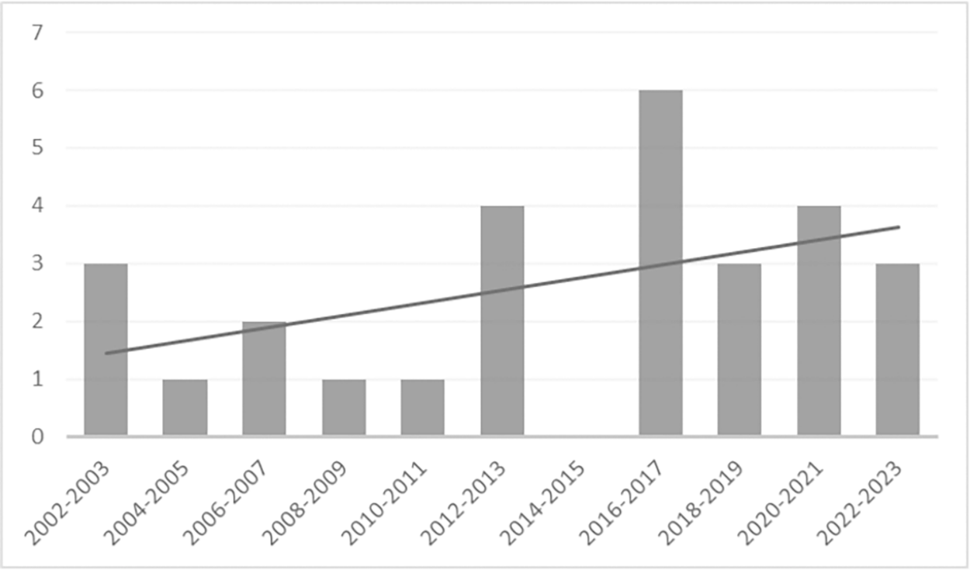
Figure 1.1: Energy use and what contributes to it in hotel buildings: A systematic review and meta-analysis [2]
Despite this significant energy footprint, monitoring of hotel facilities still relies predominantly on manual inspections, leading to delays in detecting maintenance issues and resulting in preventable economic losses. Furthermore, the rate of vacant or underutilized rooms can reach 25–30% in large-scale hotels [3], further reducing resource utilization efficiency.
Traditional hotel management systems have primarily focused on reservations and administrative functions, without deep integration with physical infrastructure. This architectural limitation results in a dependence on centralized cloud platforms, which introduces high response latency exceeding 200 ms in some real-world deployments [4] as well as a lack of intelligent analytics and limited support for automated resource management.
In this context, the need for a smart hotel management system capable of real-time monitoring, advanced data analytics, and automated control has become increasingly urgent. The convergence of Internet of Things (IoT), Edge Computing, and Artificial Intelligence (AI) technologies offers a promising path toward a comprehensive solution that optimizes operational efficiency, reduces energy costs, enhances the guest experience, and improves long-term sustainability for the hotel industry.
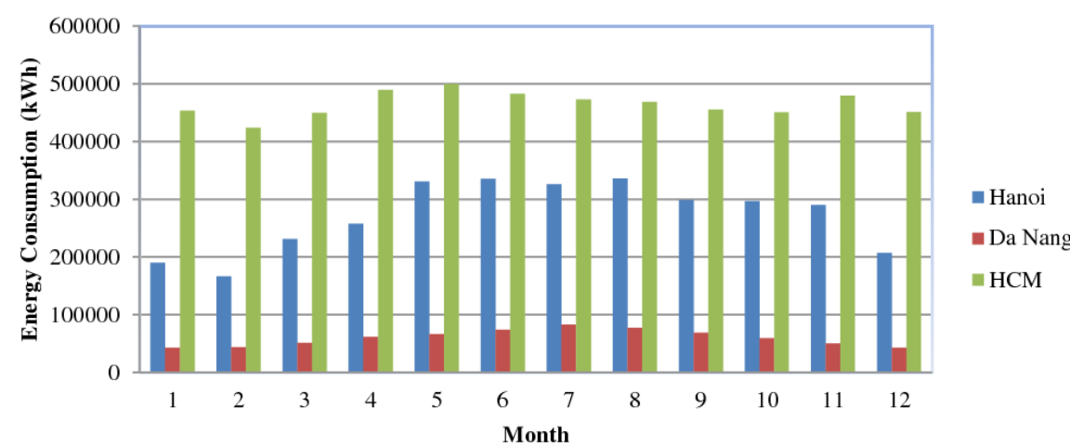
Figure 1.2: Average monthly energy consumption of hotel buildings in Vietnam [5]

1.2. Basic Principle
The proposed system is built upon the integration of three core technological paradigms: the Internet of Things (IoT), Edge Computing, and Machine Learning (ML), operating in layered architecture. At the perception layer, IoT sensor nodes based on the ESP-12F microcontroller are deployed in individual hotel rooms to continuously collect environmental and occupancy data, including temperature, humidity, and presence detection. Sensor data is transmitted wirelessly using the MQTT protocol, a lightweight publish-subscribed messaging protocol designed for constrained devices and low-bandwidth networks.
At the edge layer, a local edge gateway receives and processes incoming sensor data in real time. Local automation rules are executed at this layer to minimize response latency and reduce dependence on cloud connectivity. This architecture enables the system to respond to room-level events — such as occupancy changes or abnormal temperature readings — within milliseconds, without requiring a round-trip to the cloud. At the cloud layer, aggregated data is stored and made available for centralized analytics, user management, and dashboard services. A web-based management dashboard provides hotel operators with real-time room monitoring, interactive device control, energy analytics, and intelligent alert notifications. A Machine Learning module is integrated into the cloud layer to analyze real-time environmental and energy data. Rather than relying on occupancy classification — which proved difficult to validate reliably at the scale of this deployment — the module applies three supervised regression algorithms (Decision Tree, Random Forest, and XGBoost) to two related but distinct tasks. First, it predicts near-term air quality (CO2) and humidity trends, allowing the ventilation fan to be activated proactively before thresholds are crossed, improving guest comfort beyond what reactive threshold-based control can achieve. Second, it predicts expected energy consumption per room based on device state and occupancy context; a significant deviation between predicted and actual consumption is flagged as a likely instance of energy waste (e.g., a device left running in an unoccupied room), enabling targeted intervention by hotel staff.

1.3. Goal and Objectives
This section presents the primary goal of the project and defines the specific technical objectives and corresponding tasks that guide the implementation process. The first part outlines the overarching goal, while the second part breaks down the project into three focused objectives, each with measurable tasks.

1.3.1. Goal
The primary goal of this project is to design, implement, and evaluate an Edge-Cloud IoT system with Machine Learning integration for smart multi-floor hotel management, enabling real-time monitoring of room environmental conditions, automated device control, proactive guest comfort management, and predictive energy waste detection.

1.3.2. Objectives
To achieve the overall goal, the project is divided into 3 specific objectives:
Objective 1: To design and fabricate the hardware modules for in-room sensing and device control.
Task 1.1: Design and fabricate a battery-powered sensor node PCB based on the ESP-12F microcontroller, integrating a LiPo 500 mAh battery with a 5V boost regulation circuit, and incorporating sensors for temperature, humidity, and occupancy detection.
Task 1.2: Design and fabricate an AC lighting dimming control PCB capable of regulating LED strips and 12V bulb loads, with PWM-based dimming logic controlled via the ESP-12F.
Task 1.3: Design and fabricate a 12V fan speed regulation PCB using PWM control to vary fan motor speed in response to real-time temperature and occupancy data received from the sensor node.
Task 1.4: Design and fabricate a door lock and alarm control PCB, integrating a TIP122 Darlington transistor for 12V solenoid door lock switching and a BC547B NPN transistor for 5V active buzzer control, powered via an external 12V DC adapter with LM7805T voltage regulation.
Objective 2: To develop the Edge-Cloud software infrastructure for data communication, storage, and visualization.
Task 2.1: Set up and configure the Edge gateway on a Raspberry Pi
Task 2.2: Develop the Cloud backend comprising a time-series database for sensor data storage.
Task 2.3: Develop a web-based management dashboard
Objective 3: To develop, evaluate, and integrate a Machine Learning module for environmental trend prediction and energy waste detection.
Task 3.1: Generate and preprocess training data for three regression targets air quality (CO2), humidity, and energy consumption.
Task 3.2: Train and evaluate three supervised regression algorithms Decision Tree, Random Forest, and XGBoost for each of the three prediction targets, comparing performance using RMSE, MAE, and R² to select the best-performing model per target.
Task 3.3: Integrate the trained regression models to support energy waste detection and proactive fan activation.

CHAPTER II - DESIGN SPECIFICATIONS AND ENGINEERING STANDARDS

2.1. Design Specifications
This chapter details the core design specifications of the Edge-Cloud IoT system for smart multi-floor hotel management. It also lists the Engineering Standards and Realistic Constraints affecting the design, fabrication, and deployment phases of the project.
Table 2.1: Design Specifications of Project.
Parameter | Specification | Description
Microcontroller | ESP-12F (ESP8266) | Tensilica L106 32-bit CPU, up to 80 MHz, 11 GPIOs, 3.3 V operating voltage, ~50 KB SRAM, integrated Wi-Fi 802.11 b/g/n. Used as the main processing unit on all three PCB boards.
Temperature & Humidity Sensor | DHT11 | Operating voltage: 3.3–5 VDC, current: max 5 mA, digital output, humidity range: 20–80% RH, temperature range: 0–50°C. Deployed on the sensor node board for room environmental monitoring.
Occupancy Sensor | HC-SR501 PIR | Operating voltage: 4.5–20 VDC, current: <50 µA, digital output, detection range: up to ~7 m / <120°, adjustable delay: 5–200 s. Used for real-time occupancy detection in hotel rooms.
Sensor Node Power Supply | LiPo Battery 500 mAh 3.7 V + Boost DC-DC T64 | LiPo 3.7 V battery provides portable power to the sensor node. The T64 boost converter steps up input voltage from 1.5–5 VDC to a stable 5 VDC output to power the DHT11 and PIR sensors.
3.3 V Regulation | AMS1117-3.3 LDO 800 mA | Input voltage: 4.5–9 VDC, output: fixed 3.3 VDC, maximum output current: 800 mA. Provides stable 3.3 V supply to the ESP-12F on the sensor node and control boards.
AC-DC Power Supply | Hi-Link HLK-20M12 & HLK-PM03 | HLK-20M12: 100–240 VAC input, 12 VDC / 20 W output. HLK-PM03: 100–240 VAC input, 3.3 VDC / 3 W output. Both modules feature reinforced isolation and built-in over-voltage/over-current protection. Used on the lighting and fan control boards.
Lighting Dimming Control | AO3400 N-channel MOSFET | Drain-source voltage: 30 V, continuous drain current: up to 5.8 A, logic-level gate drives compatible with 3.3 V. PWM-based dimming for LED strips and 12 V bulb loads. Feedback isolation via 4N35 optocoupler (~5000 Vrms isolation).
Fan Speed Regulation | BT136-600E TRIAC | Off-state voltage: 600 V, on-state current: up to 4 A, gate trigger current: max 10 mA. Phase-angle control for 12 V AC fan speed regulation. Zero-cross detection via H11AA1 optocoupler.
Communication Protocol | MQTT (QoS Level 1) | Lightweight publish-subscribe protocol over Wi-Fi. Broker: Mosquitto deployed on Raspberry Pi (edge) and cloud instance. Topic structure: hotel/room/{room_number}/sensors and hotel/room/{room_number}/control QoS Level 1 ensures at-least-once message delivery.
Edge Gateway | Raspberry Pi 4 Model B | Quad-core Cortex-A72 @ 1.8 GHz, 4 GB LPDDR4 RAM, Wi-Fi 802.11ac, Gigabit Ethernet. Hosts Mosquitto MQTT broker, local automation logic, and data forwarding to cloud.
Cloud Backend | REST API + Time-Series Database | Provides sensor data storage, user authentication, role-based access control, and threshold-based alert notifications. Accessible via HTTPS.
Web Dashboard | Browser-based Interface | Real-time room status monitoring, interactive device control (lighting, fan), energy consumption analytics, and occupancy trend visualization. Accessible from any modern browser without additional software.
Machine Learning Module | Decision Tree, Random Forest, XGBoost | Supervised regression algorithms trained on features including time-of-day, fan/device state, and recent sensor history. Predicts three targets: air quality (CO2), humidity, and energy consumption. Air quality/humidity predictions drive proactive fan activation; energy predictions enable waste detection via predicted-vs-actual deviation. Evaluated by RMSE, MAE, and R².
Battery Charging Circuit | TP4056 with Protection IC | Input: 4.5–5.5 VDC, charge current: up to 1A, output: 4.2V fully charged. Built-in overcharge, over-discharge, and short-circuit protection. Safely charges the LiPo 500 mAh battery on each sensor node board.
Door Lock Control | TIP122 Darlington NPN Transistor | Collector-emitter voltage: 100V, continuous collector current: 5A. Switches the 12V solenoid door lock on/off via GPIO signal from ESP-12F. A freewheeling diode (M7) is placed across the solenoid terminals to suppress back-EMF during switching
Buzzer/Alarm Control | BC547B NPN Transistor + Active Buzzer 5V (9.5×12mm) | BC547B: Vceo 45V, Ic max 100mA. Switches the 5V active buzzer via GPIO signal from ESP-12F through a 1kΩ base resistor. Active buzzers generate audible alert tone upon activation.
Door Lock & Buzzer Power Supply | External 12V DC Adapter + LM7805T LDO Regulator | External 12V DC adapter (Jack DC 5.5×2.1mm) provides power to the solenoid door lock. LM7805T regulates 12V down to stable 5VDC for the active buzzer. ESP-12F powered via AMS1117-3.3V from the 5V rail.

2.2. Engineering Codes and Standards
To guarantee safe, precise, and reliable system performance, both hardware and software development processes adhere to internationally recognized engineering standards, as outlined in Table 2.2.
Table 2.2: Engineering Codes and Corresponding Standards.
Element / Product / System | Engineering Standard | Comments
ESP-12F Wi-Fi Module | IEEE 802.11 b/g/n | Wireless LAN standard governing Wi-Fi communication between ESP-12F sensor nodes and the Raspberry Pi edge gateway.
MQTT Communication Protocol | ISO/IEC 20922:2016 | International standard for the MQTT messaging protocol, ensuring interoperability between IoT devices, edge gateway, and cloud platform.
PCB Design (All Boards) | IPC-2221A | Generic standard for printed board design, governing trace width, clearance, and layer stack-up for all three fabricated PCBs.
Hi-Link AC-DC Power Supply Modules | IEC 62368-1 | Safety standard for audio/video and IT equipment power supplies; covers isolation, creepage, and clearance requirements between AC and DC sides.
AMS1117-3.3 LDO Regulator | IEC 60747-8 | Standard for field-effect and linear regulator devices used in low-voltage DC power regulation applications.
BT136-600E TRIAC (Fan Control) | IEC 60747-6 | Standard for thyristor-class semiconductor devices, specifying electrical characteristics and safe operating conditions for AC switching.
AO3400 MOSFET (Lighting Control) | IEC 60747-8 | Standard for field-effect transistors used in power switching and PWM dimming applications.
DHT11 / HC-SR501 Sensors | IEC 61010-1 | Safety standard for electrical measurement and sensing devices operating at low voltage in indoor environments.
TIP122 + BC547B Transistors | IEC 60747-5 | Standard for bipolar transistors used in power switching and low-power signal switching applications.
LiPo Battery 500 mAh + TP4056 Charging Circuit | IEC 62133-2 | Safety standard for portable sealed secondary lithium cells and their associated charging circuits, covering overcharge, over-discharge, and short-circuit protection requirements.
Web Dashboard & Cloud API | OWASP Top 10 | Industry-standard guidelines for web application security, covering authentication, data exposure, and API injection vulnerabilities.
Machine Learning Module | ISO/IEC 22989:2022 | International standard for AI and ML concepts, providing a framework for ML system design, terminology, and evaluation methodology.

2.3. Realistic Constraints
The selection of materials and the implementation of the system were guided by economic, technical, and environmental considerations
Table 2.3: Realistic Constraints.
Area | Realistic Constraints
Economic | The system is designed within a limited student project budget. Component selection prioritizes low-cost, commercially available modules (ESP-12F, DHT11, HC-SR501, AMS1117, T64 boost module) over industrial-grade alternatives. Cloud operational costs are minimized by maximizing edge-level processing on the Raspberry Pi to reduce cloud data transfer volume.
Environment | All electronic components must operate reliably within indoor hotel room conditions (temperature 15–40°C, humidity up to 80% RH). PCBs must be protected against humidity-induced corrosion in long-term deployment. The system targets a measurable reduction in room-level energy consumption as a core project outcome.
Health and Safety | Boards 2 and 3 operate with AC mains voltage (100–240 VAC). Reinforced electrical isolation is enforced through Hi-Link modules and optocouplers (4N35, H11AA1) between AC and low-voltage DC sides. Ceramic fuses are included on all AC-side circuits. PCB creepage and clearance distances comply with IEC 62368-1 to prevent electrical shock hazards during operation and maintenance.
Manufacturability | All PCBs are designed for standard two-layer FR4 fabrication, compatible with locally available PCB manufacturers in Vietnam. Component footprints are selected to be hand-solderable, avoiding fine-pitch BGA packages that require specialized reflow equipment.
Sustainability | The sensor node employs deep sleep mode on the ESP-12F to extend LiPo battery life and minimize idle power consumption. The ML-based occupancy prediction module enables proactive shutdown of lighting and fan devices in vacant rooms, directly reducing unnecessary electricity usage across hotel floors.
Ethical | Room-level occupancy and environmental data are collected solely for energy management purposes. No audio, video, or personally identifiable information is captured or stored. Data transmission is secured via MQTT with credential-based authentication, and the cloud API enforces role-based access control to prevent unauthorized access to guest room data.
Social | The system is designed to be non-intrusive to hotel guests. All sensing devices (DHT11, HC-SR501 PIR) are passive monitoring components that require no guest interaction. The web dashboard is accessible to authorized hotel staff and management only, with a user-friendly interface requiring no specialized technical training.
Political | The system complies with Vietnam's Law on Cybersecurity (Law No. 24/2018/QH14) regarding the collection, transmission, and storage of data within networked systems deployed in Vietnamese commercial facilities.

CHAPTER III - PROJECT MANAGEMENT
This chapter describes the management framework applied to this senior project, including the budget and cost plan, project schedule, and resource allocation. The project management plan is a formal, dynamic document that outlines how the project is executed, monitored, and controlled from initiation to delivery.

Budget and Cost Management Plan
All components required for the prototype system were selected to balance cost-effectiveness with technical performance. Table 3.1 provides a detailed breakdown of estimated costs. All prices are expressed in USD for consistency with international reporting conventions.
Table 3.1: Table of Estimated Costs.
Item | Description | Quantity | Unit Price (USD) | Total Cost (USD)
ESP8266 ESP-12F Module | 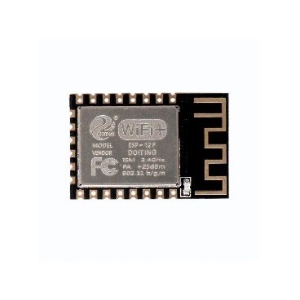 | 5 | $1.96 | $11.76
Hi-Link HLK-20M12 AC-DC Power Module | 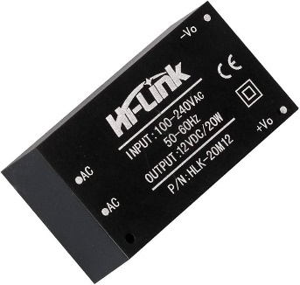 | 1 | $3.69 | $3.69
AO3400A N-channel MOSFET | 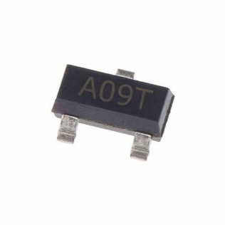 | 2 | $0.12 | $0.24
4N35 Optoisolator | 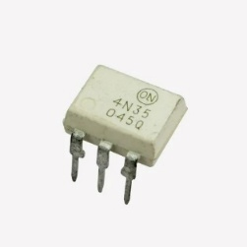 | 2 | $0.16 | $0.31
KF301-2P Screw Terminal Block | 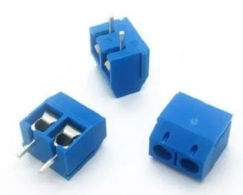 | 7 | $0.08 | $0.55
Fuse Holder FS01-520 |  | 2 | $0.12 | $0.24
Ceramic Fuse 2A | 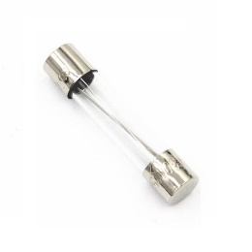 | 2 | $0.20 | $0.39
XL1509-3.3V | 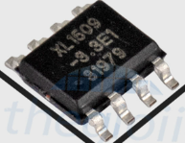 | 6 | $0.24 | $1.41
H11AA1 AC Optocoupler |  | 1 | $0.43 | $0.43
AMS1117-3.3V LDO Regulator |  | 5 | $0.20 | $0.98
MOC3023 Optocoupler Triac Driver | 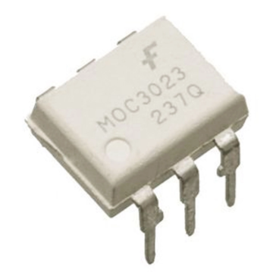 | 1 | $0.24 | $0.24
BT136-600E TRIAC | 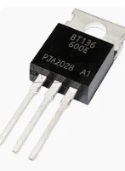 | 1 | $0.35 | $0.35
MQ-2 Gas Sensor Module | 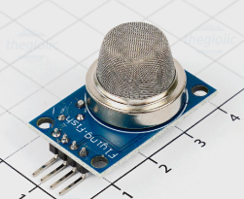 | 1 | $0.98 | $0.98
LM393 Comparator Module | 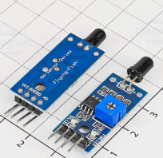 | 1 | $0.20 | $0.20
DHT11 Temperature & Humidity Sensor | 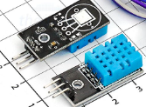 | 1 | $0.59 | $0.59
HC-SR501 PIR Motion Sensor | 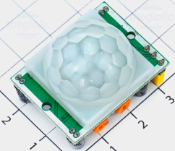 | 1 | $0.47 | $0.47
Boost DC-DC T64 5V Module | 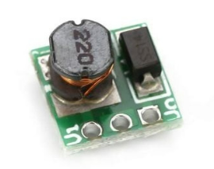 | 5 | $0.47 | $2.35
TP4056 LiPo Charger Module with Protection | 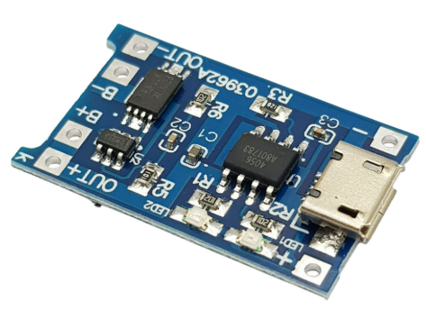 | 5 | $0.31 | $1.57
LiPo Battery 500 mAh 3.7V | 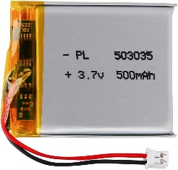 | 5 | $1.18 | $5.88
Raspberry Pi 4 Model B 4GB | 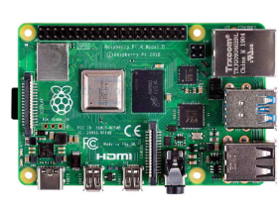 | 1 | $55.00 | $55.00
Recessed Plastic Junction Box | 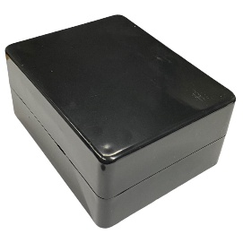 | 5 | $1.18 | $7.06
KY-037 sound sensor | 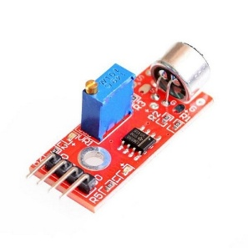 | 1 | $0.343 | $0.343
KC-1206-TS Buzzer Passive | 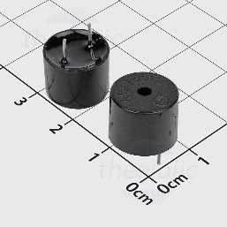 | 1 | $0.109 | $0.109
JF-0520B Solenoid Lock | 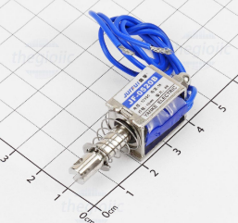 | 1 | $2.74 | $2.74
MQ-135 Air Quality Sensors | 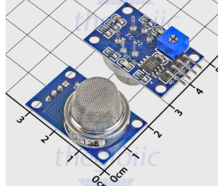 | 1 | $1.35 | $1.35
Total estimated |  |  | $99.23

Project Schedule
The project was executed over a 12-week period from June 1, 2026 to August 26, 2026. A Gantt chart (Figure 3.1) was used to track task dependencies and monitor progress across all three objectives. The schedule was divided into four phases: (1) hardware design and PCB fabrication (Weeks 1–5); (2) edge-cloud software development and dashboard implementation (Weeks 4–8); (3) machine learning model training, evaluation, and system integration (Weeks 7–11); and (4) end-to-end validation, testing, and report writing (Weeks 10–12). Report writing was conducted continuously throughout the entire project duration to ensure timely documentation of each implementation phase.
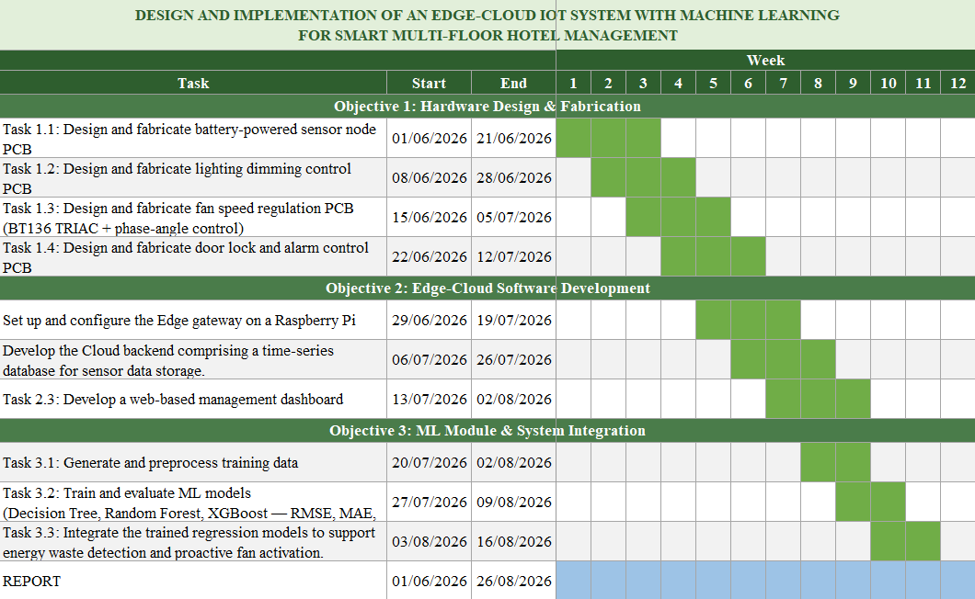
Figure 3.1: Gantt chart for project schedule

3.3. Resource Planning
The success of the project requires close coordination between human resources and technical facilities to ensure steady progress across hardware fabrication, software development, and system integration phases.

3.3.1. Human Resources
The project is executed independently by the student under the periodic supervision and academic advisory of the Advisor. Weekly consultation sessions are conducted to monitor progress, address technical challenges, and validate design decisions at each implementation phase.

3.3.2. Physical Resources
PCB schematic design and layout are developed using Altium Designer, and fabricated boards are sourced from local PCB manufacturing services. Hardware assembly, soldering, and circuit testing are conducted at laboratory A2-201 of the International University, equipped with standard electronics instruments including soldering stations, digital multimeters, and DC power supplies.
Edge gateway configuration and software development are performed on a Raspberry Pi 4 Model B running Raspberry Pi OS. Backend development, cloud integration, and machine learning model training are carried out on a personal computer using Visual Studio Code as the primary development environment, with Python as the main programming language. The web dashboard is developed and tested using a local browser environment before cloud deployment.
All system integration and end-to-end validation testing are conducted using a multi-room prototype setup simulating a hotel floor environment, with ESP-12F sensor nodes, lighting control boards, and fan control boards deployed simultaneously.

CHAPTER IV - LITERATURE REVIEW

This chapter presents a review of three research works that are directly relevant to the three implementation objectives of the proposed system. Each study is examined in terms of its methodology, key findings, and relationship to the design decisions made in this project. The proposed system is developed by building upon the approaches presented in these studies while addressing their limitations and adapting their methods to the smart hotel management context.

4.1. IoT Driven Building Automation Systems: A Review on Energy Efficiency, Occupant Comfort, and Sustainability [6]
The first study, conducted by Sivasankari and Rathika (2025), presents a systematic review of 117 research articles published between 2010 and 2023, examining the integration of Internet of Things (IoT) technologies with Building Automation Systems (BAS) across three critical dimensions: energy efficiency, occupant comfort, and carbon dioxide (CO₂) reduction. The review identifies that conventional BAS architectures rely on rigid, predefined control mechanisms that lack real-time adaptability to occupant behavior and environmental changes, as illustrated in Figure 4.1, which contrasts the limitations of traditional BAS against the enhanced capabilities of IoT-based BAS.
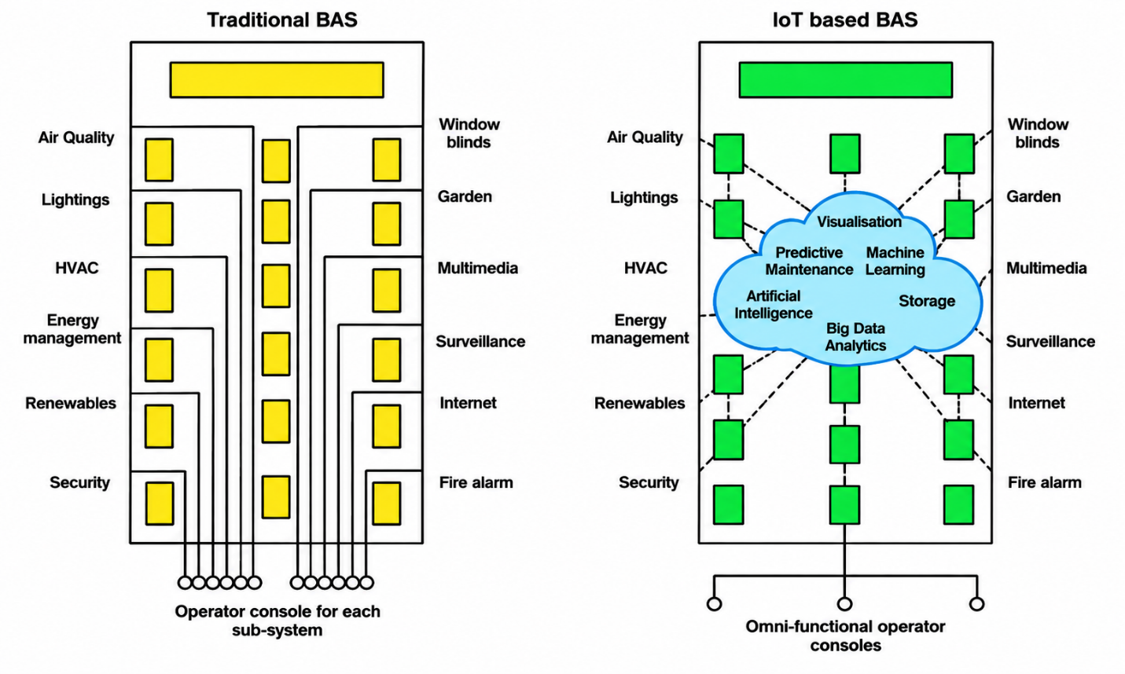
Figure 4.1: Comparison of Traditional BAS and IoT-based BAS [6]
By integrating IoT through temperature, humidity, motion, and air quality sensors connected via standardized communication protocols BAS systems gain the ability to perform continuous environmental monitoring, occupancy-based HVAC and lighting control, and predictive maintenance. Figure 4.2 illustrates the full scope of IoT applications in smart buildings, organized across the perception, network, and application layers, encompassing sensors, actuators, smart meters, Wi-Fi connectivity, data analytics, predictive maintenance, and user interfaces.
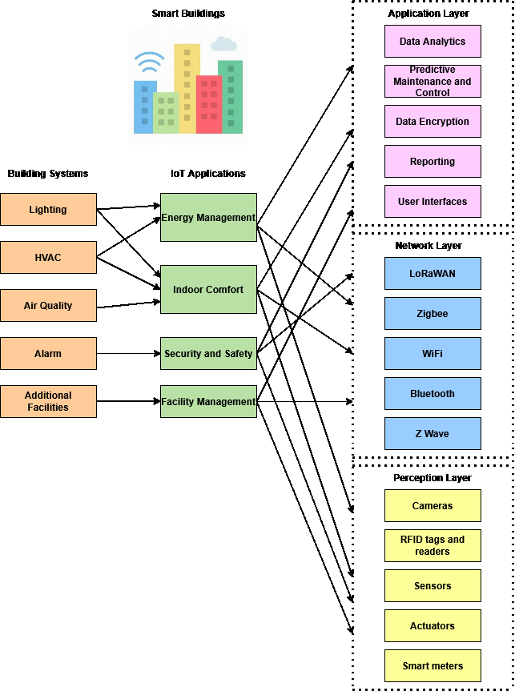
Figure 4.2: IoT applications in smart buildings [6]
The study further highlights that hybrid cloud-edge architectures are among the most effective remedies for overcoming the scalability and latency limitations of purely centralized systems and recommends standardized communication protocols and strong security frameworks as essential components for large-scale IoT-BAS deployment.
This work directly motivates the hardware design decisions in Objective 1 of the proposed system. The use of DHT11 sensors for temperature and humidity monitoring, HC-SR501 PIR sensors for occupancy detection, and PWM-based actuator control for lighting and fan regulation aligns with the IoT-BAS sensor-actuator paradigm described in the review. Furthermore, the study's recommendation of hybrid cloud-edge architecture provides theoretical grounding for the layered Edge-Cloud design adopted in this project, where local automation rules are executed at the edge gateway to reduce latency while cloud-based analytics handle higher-level data processing. The proposed system extends this framework by applying it specifically to a multi-floor hotel environment, where per-room granularity of monitoring and control is required a deployment context not addressed in the reviewed study, which focused on commercial and smart city buildings in general.

4.2. Cloud-Edge MQTT Messaging for Latency Mitigation and Broker Memory Footprint Reduction [7]
The second study, conducted by Tseng et al. (2025), addresses a fundamental challenge in IoT data communication: the latency and memory overhead introduced by centralized cloud MQTT brokers in cloud-edge deployments. As illustrated in Figure 4.3, data publishers such as IoT sensors and cameras are distributed across multiple edge networks, while subscribers and data analytics services may be deployed either at the cloud or at the network edge, with an MQTT broker at the cloud acting as the central message forwarder.
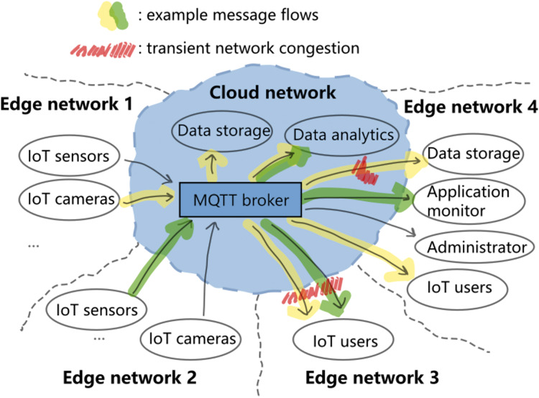
Figure 4.3: Generic cloud-edge MQTT messaging scenario [7]
Through empirical experiments conducted on an AWS EC2 cloud instance with IoT publishers and subscribers distributed across local edge networks, the authors demonstrate that messaging latency is significantly influenced by message size and network congestion rather than QoS level alone. Their results show that large-size messages under transient network congestion can experience end-to-end latency exceeding tens of seconds, and that uncontrolled message queuing can exhaust broker memory. To address this, the study proposes three message-size-aware scheduling policies for Eclipse Mosquitto conservative, probabilistic, and historic alongside a lazy memory allocation strategy that reduces broker memory consumption by approximately 75%.
This work provides direct technical justification for the communication architecture adopted in Objective 2. The proposed system deploys an Eclipse Mosquitto MQTT broker on the edge gateway, rather than relying solely on a cloud broker, precisely to mitigate the latency penalties identified in this study. Sensor data from ESP-12F nodes consisting of small-size messages carrying temperature, humidity, and PIR readings is first delivered to the local edge broker, where automation rules are executed with low latency before forwarding aggregated data to the cloud. This edge-first approach directly addresses the problem of centralized cloud broker bottlenecks documented by Tseng et al. The proposed system adopts QoS Level 1 for reliable at-least-once delivery of sensor data, consistent with the study's QoS analysis. While the advanced scheduling policies proposed by Tseng et al. are not implemented in this project due to scope constraints, their findings validate the architectural decision to deploy a local edge broker as the primary message handler in the proposed system.

4.3. Predictive Modeling of Building Energy Consumption with Machine Learning [8]
The third study, conducted by Zoubir et al. (2024), investigates the use of supervised ML regression algorithms to forecast active power consumption in a climate-sensitive building, using indoor temperature, relative humidity, outdoor environmental conditions, and time-lag features as predictors. Four algorithms XGBoost, LightGBM, Extra Trees, and Random Forest are trained and evaluated on a 10-day dataset collected at one-minute intervals. Figure 4.4 illustrates the comparative performance of all four models across different time-lag configurations, demonstrating that prediction accuracy peaks consistently at a 60-minute time lag for all algorithms, with R² values exceeding 0.85 across the board.
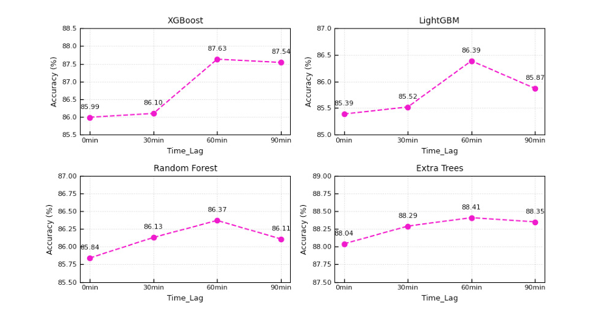
Figure 4.4: R-squared variation as a function of time lag for each ML model [8]
Performance is assessed using MSE, RMSE, and R² metrics. The results demonstrate that Extra Trees achieves the best overall performance at 88.41% accuracy, followed by XGBoost at 87.63% and Random Forest at 86.37%. The study further identifies indoor temperature, relative humidity, time-of-day, and day-of-week as the most influential features for energy consumption prediction and applies hyperparameter tuning via the Optuna framework to optimize each model's performance.
This work directly informs the ML module design in Objective 3. The feature set adopted in the proposed system indoor temperature, humidity, time-of-day, and day-of-week is consistent with the most influential predictors identified by Zoubir et al., validating the feature engineering approach in Task 3.1. The use of XGBoost and Random Forest in this project is further supported by their strong performance in the reference study, where both algorithms achieve R² values above 0.86 under optimal time-lag conditions. The proposed system replaces Extra Trees the best-performing model in Zoubir et al., with a Decision Tree model to serve as an interpretable baseline. While Extra Trees offers higher prediction accuracy through ensemble averaging of randomized trees, Decision Tree provides transparent, rule-based predictions that are easier to validate and explain in the context of a hotel management deployment, where operational staff must be able to understand and trust the system's automated decisions a practical consideration not addressed in the Zoubir et al. study, which focused purely on prediction accuracy benchmarking. Furthermore, while Zoubir et al. evaluate model performance in an isolated benchmarking context, the proposed system integrates the trained regression models into an operational pipeline where predicted energy consumption is compared against actual measured values in real time, enabling automated anomaly detection and proactive staff alerts extending the application of ML-based energy prediction from academic evaluation to practical hotel energy management prediction from academic benchmarking to practical hotel energy management.
In conclusion, Decision Tree was selected as the interpretable baseline in this project precisely because its rule-based structure maps directly to human-readable conditions such as "if room temperature exceeds 28°C and occupancy is detected after 18:00, predict high energy consumption," enabling hotel staff to understand and trust the automated decisions without requiring data science expertise. XGBoost and Random Forest were retained as the primary predictive models, as their strong performance in Zoubir et al. achieving R² values of 0.8763 and 0.8637 respectively at the optimal 60-minute time lag demonstrates their suitability for structured tabular sensor data with time-dependent features, which closely mirrors the data characteristics of the proposed hotel monitoring pipeline.

CHAPTER V - METHODOLOGY

This chapter presents the methodology adopted for the design, implementation, and integration of the proposed Edge-Cloud IoT system for smart multi-floor hotel management. The methodology is organized in accordance with the three defined objectives: hardware design and fabrication (Section 5.1), edge-cloud software development (Section 5.2), and machine learning module development and system integration (Section 5.3). The overall system architecture is presented in Figure 5.1, illustrating the data flow from ESP-12F sensor nodes through the edge gateway to the cloud backend and web dashboard.
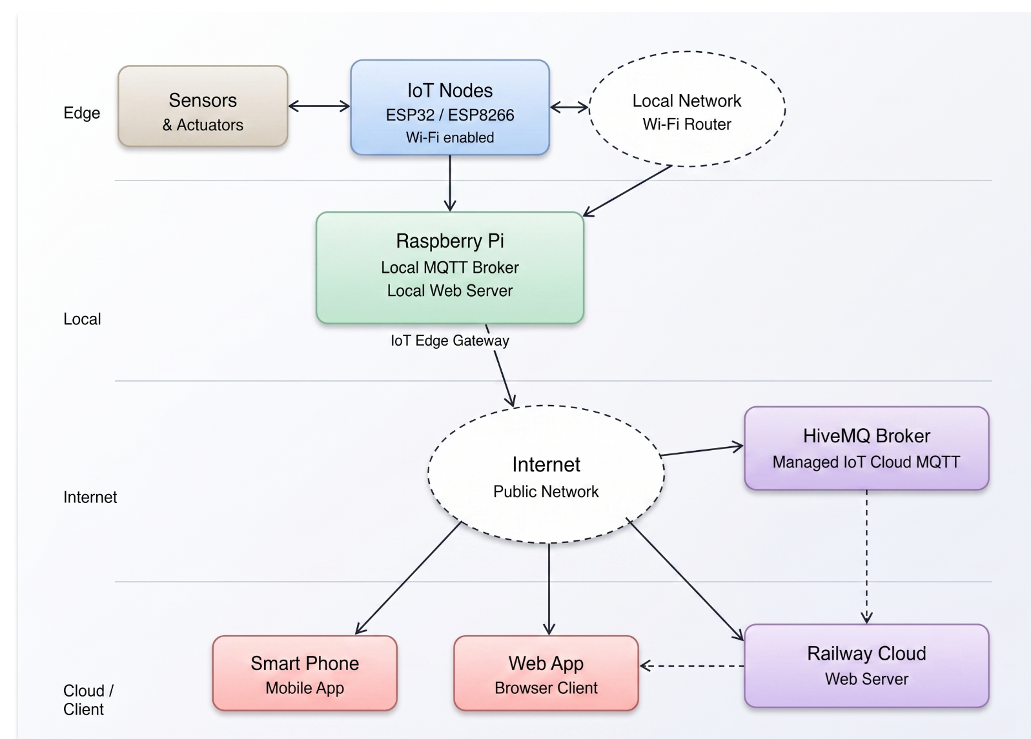
Figure 5.1: Overall system architecture of the proposed Edge-Cloud AI-IoT system for smart hotel management

5.1. Hardware Design and Fabrication
This section presents the hardware design procedure PCB modules developed in this project all hardware nodes will be designed to serve a purpose to monitor the environment through sensors and control actuators. All schematics are designed using Altium Designer and fabricated using standard two-layer FR4 PCB manufacturing.

5.1.1. Battery-Powered Sensor Node PCB
This part describes the hardware design of the sensor and load control modules. A variety of sensors, including the DHT11 temperature and humidity sensor, KY-037 sound sensor module, MQ-2 gas sensor, PIR motion sensor, MQ135 air quality sensor and so on are utilized to collect environmental data. The acquired information is transmitted to the user, while some modules are controlled to enable actuators functionality. All modules communicate and exchange data with the central controller through the MQTT protocol.
The sensor node is meticulously designed to operate primarily as a standalone, battery-powered system, making it highly suitable for flexible wireless deployment across various rooms. The primary energy source is a rechargeable LiPo battery. To ensure continuous long-term operation, an external power supply can be connected via a built-in DC Jack; this input is exclusively routed to a TP4056 module which strictly regulates the charging process of the LiPo battery, preventing overcharge, over-discharge, and short-circuit conditions. The battery's output voltage is then fed into a Boost DC-DC T64 converter, stepping it up to a stable 5VDC rail to accommodate 5V-compatible sensor peripherals. Subsequently, an AMS1117-3.3V LDO regulator steps this 5V rail down to a clean 3.3VDC, supplying the exact operating voltage required by the ESP-12F module. Schottky diodes are strategically integrated into the power paths to prevent reverse current flow and ensure circuit protection. The schematic of this power management block is illustrated in Figure 5.2.
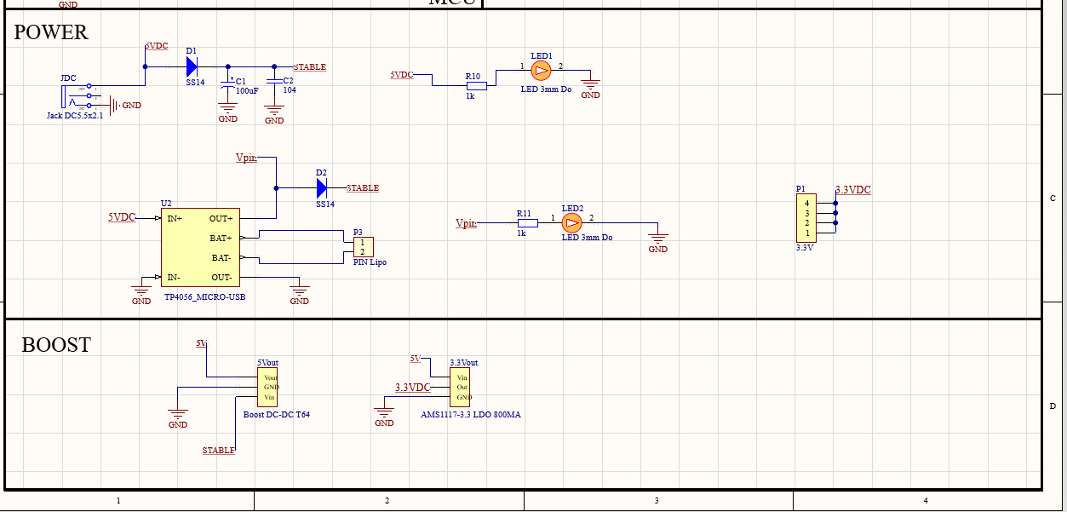
Figure 5.2: Schematic of the battery-powered supply
The ESP-12F (ESP8266) serves as the central processing unit of the sensor node, operating at 3.3VDC with integrated Wi-Fi 802.11 b/g/n capability for wireless MQTT communication. The PCB is designed with modular headers to interface with specific environmental sensors: a DHT sensor is connected to GPIO14 for continuous temperature and humidity monitoring, while a PIR motion sensor is interfaced via GPIO16 for human presence detection. Furthermore, a multi-purpose expansion header is routed to the analog pin (A0) and GPIO12, accommodating additional components such as gas or ambient light sensors.
To optimize energy consumption and extend battery life, the ESP-12F is configured to operate in deep sleep mode between sensor readings. Upon waking, the microcontroller acquires environmental data, publishes the values to the MQTT broker via the designated topic structure (e.g., hotel/room/{room_number}/sensors/...), and immediately returns to deep sleep. The complete schematic and routing layout of the multi-sensor node PCB are shown in Figure 5.3 and Figure 5.4.
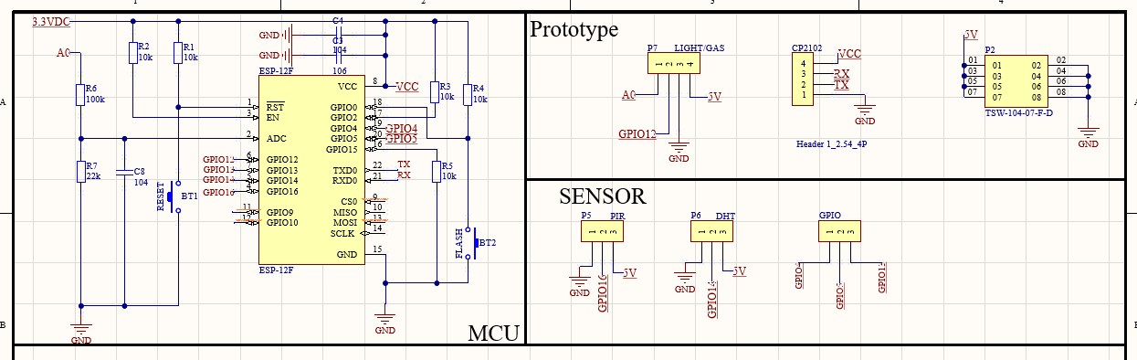
Figure 5.3: Schematic of the Microcontroller ESP8266-12F with GPIO pins
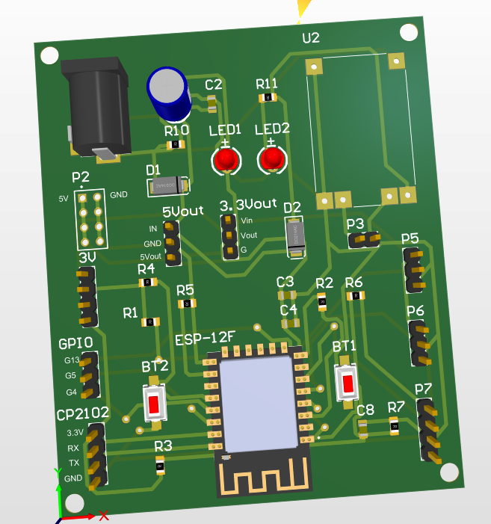
Figure 5.4: PCB design of battery-powered sensor node

5.1.2. Lighting Dimming Control PCB

5.1.2.1. Power Management Architecture
The lighting control board is designed to regulate both LED strip loads and 12VDC bulb loads via PWM-based dimming. The board is powered from AC mains (100–240VAC) through a Hi-Link HLK-20M12 isolated AC-DC module, which provides a stable 12VDC / 20W output. An XL1509 buck converter and an AMS1117-3.3V LDO regulator are utilized to step the 12VDC rail down to 3.3VDC to power the ESP-12F control unit. A ceramic fuse rated at 2A is placed on the AC input line as an essential overcurrent protection measure.
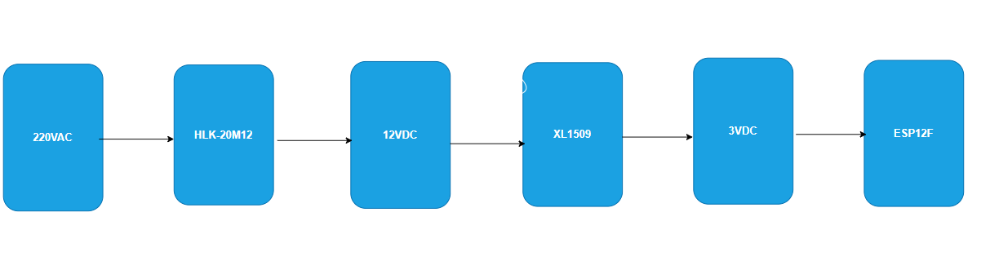
Figure 5.5: Diagram convert VAC to VDC
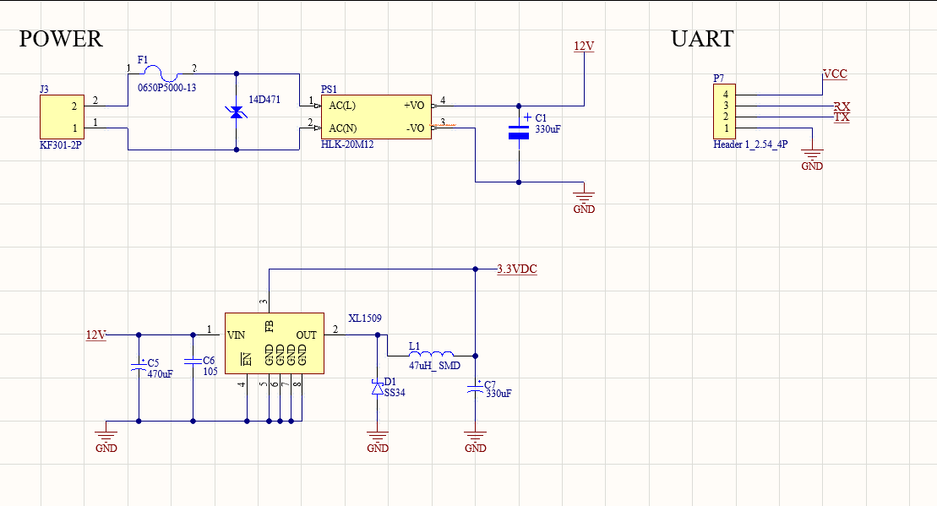
Figure 5.6: Schematic of the power supply

5.1.2.2. PWM Dimming and MOSFET Control
The dimming circuit uses an AO3400 N-channel MOSFET as the switching element (low-side power switch), whose conduction state depends on the gate-source voltage. The MOSFET gates are controlled by the ESP-12F GPIO pins (GPIO12 and GPIO14). The 3.3V logic gate drive signal from the ESP-12F is sufficient to fully enhance the AO3400, which supports drain-source voltages up to 30V and continuous drain currents up to 5.8A. By applying a PWM signal generated by the microcontroller, the applied voltage across the lighting load can be smoothly and efficiently varied to dim the lights or turn them completely on and off.

5.1.2.3. Opto-Isolated Feedback and Manual Control
In this part of the system, electronic control by the ESP8266 is combined with manual control through traditional wall switches, while an optically isolated feedback loop is established to observe the actual running status of the lighting load. The 4N35 optocoupler provides electrical separation between the high-current load side (12VDC) and the low-voltage control side (3.3VDC logic).
When the light bulb is powered up either via the PWM signal or the manual switch current flows through the internal LED of the 4N35. This causes its phototransistor to start conducting, pulling the corresponding ESP8266 GPIO input (GPIO13 or GPIO4) to a HIGH state. When the light bulb is not powered, the optocoupler turns off, and the GPIO input goes LOW. This acts as a robust feedback mechanism, allowing the ESP8266 to accurately detect whether the light bulb is physically ON, regardless of whether a wireless control signal was actually issued.

5.1.2.4. PCB Layout and Critical Safety Modification
The printed circuit board was designed as a compact two-layer FR4 layout, strategically grouping the high-voltage AC-DC conversion section away from the low-voltage microcontroller and logic traces to minimize electromagnetic interference (EMI).
During the physical fabrication and initial inspection of the prototype, a critical design discrepancy was identified regarding the clearance of the ground (GND) polygon pour. The copper pour on both the top and bottom layers encroached upon the 220VAC input pads and traces, leaving an unsafe clearance of merely 0.2mm. To rectify this flaw and ensure strict compliance with electrical safety standards prior to applying mains power, a manual PCB modification (trace peeling) was executed. Precision tools and thermal application via a soldering iron were utilized to carefully cut and peel back the copper pour surrounding all AC components. This corrective procedure successfully established an isolation moat with a clearance exceeding 3mm around the AC paths. Subsequent continuity tests with a multimeter confirmed absolute electrical isolation between the mains voltage traces and the DC ground plane, guaranteeing the safe and reliable operation of the lighting control module during practical demonstrations.
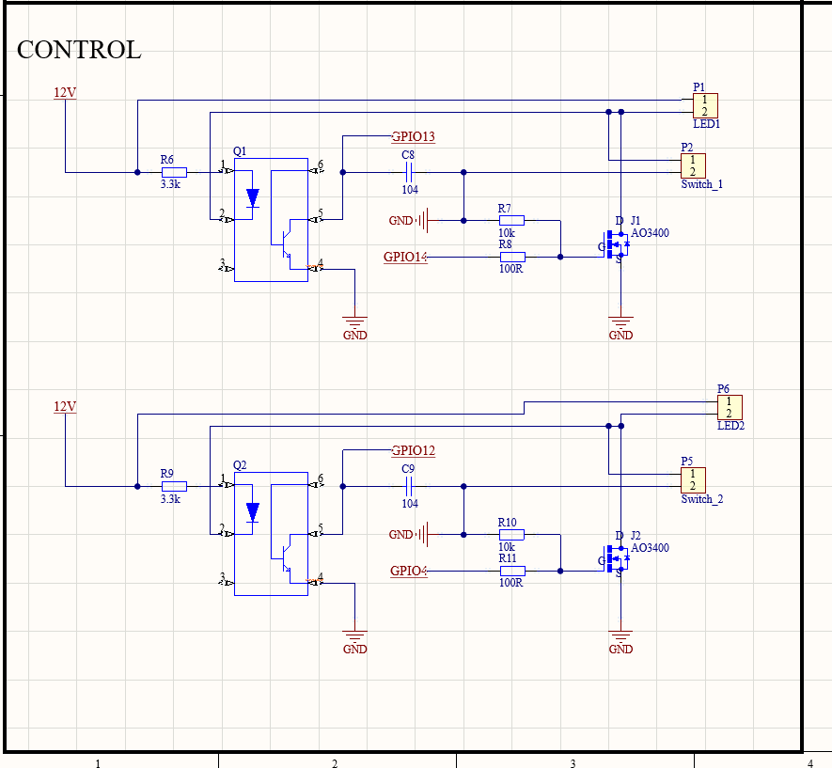
Figure 5.7: Schematic of the lighting dimming control and opto-isolated feedback circuit.
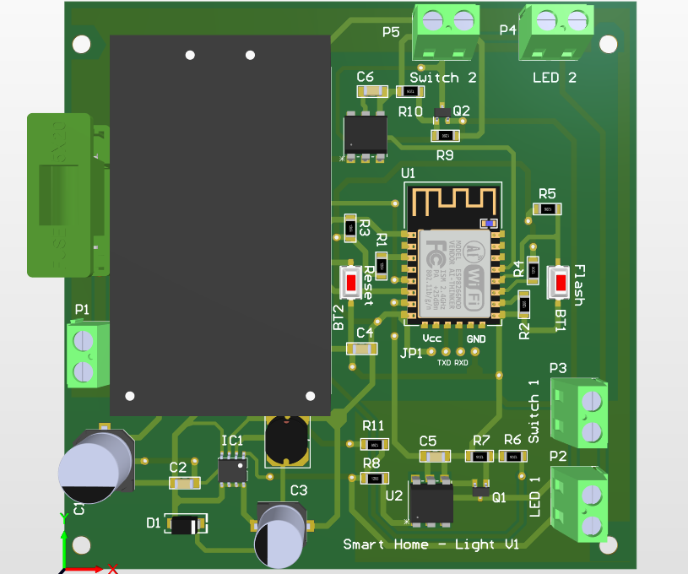
Figure 5.8: PCB layout of the lighting module

5.1.3. Fan speed regulation PCB using phase-angle control via TRIAC to vary fan motor speed
This section delineates the hardware architecture of the AC fan speed controller, which utilizes TRIAC-based phase-angle dimming combined with zero-crossing synchronization to dynamically regulate motor speed.

5.1.3.1. Power Management and Zero-Crossing Synchronization
The module is powered directly from the AC mains via a Hi-Link HLK-PM03 isolated AC-DC converter, providing a reliable 3.3VDC supply specifically for the ESP-12F logic circuitry. To achieve precise AC power modulation, the system must continuously monitor the AC waveform. This is accomplished using an H11AA1 optocoupler. The mains voltage is stepped down through high-wattage resistors before entering the input side of the H11AA1. Whenever the AC waveform crosses the zero-voltage threshold, the optocoupler's output transistor changes state, generating a discrete pulse signal. This pulse is fed directly into GPIO14 of the ESP-12F, which is configured as a hardware interrupt. By capturing every zero-crossing event, the microcontroller establishes an accurate timing reference synchronized with the AC grid.

5.1.3.2. Phase-Angle Control and TRIAC Driving
The fan's rotational speed is governed by a BT136-600E TRIAC, a bidirectional semiconductor switch highly suitable for AC load applications. Upon receiving the zero-cross interrupt, the ESP-12F executes a calculated time delay inversely proportional to the desired fan speed before outputting a trigger signal via GPIO12.
This 3.3V logic signal activates the MOC3023 opto-triac driver, which in turn fires the gate of the BT136 TRIAC. By modulating the conduction angle of the AC cycle (the exact moment the TRIAC turns on after the zero-crossing), the effective RMS voltage delivered to the fan motor is smoothly varied. Additionally, an RC snubber network is implemented in parallel with the TRIAC terminals. This critical sub-circuit mitigates inductive voltage spikes (dV/dt transients) generated by the fan motor, ensuring stable switching and protecting the semiconductor components from electrical surges.

5.1.3.3. PCB Layout and Safety Modifications
The printed circuit board is meticulously partitioned into two distinct physical domains to ensure electromagnetic compatibility and user safety: the high-voltage AC mains section (comprising the TRIAC, RC snubber, and load terminals) and the low-voltage DC control section (housing the ESP-12F and logic routing). The H11AA1 and MOC3023 optocouplers serve as the primary isolation barrier bridging these two domains, effectively preventing unwanted leakage currents and protecting the logic circuits from potential AC interference.
Consistent with the safety protocols applied to the lighting control module, a rigorous inspection of the fabricated prototype revealed inadequate clearance between the high-voltage traces and the localized ground (GND) polygon pour. To neutralize the risk of catastrophic arc faults across the microscopic 0.2mm gap, a manual copper peeling procedure was aggressively executed. The copper pour immediately surrounding the 220VAC input pads, the TRIAC terminals, and the primary side of the HLK-PM03 was meticulously carved out to establish a reliable isolation gap exceeding 3mm. Subsequent continuity testing with a multimeter verified the absolute separation of the AC tracks from the DC ground, ensuring the prototype met strict operational safety standards prior to any live mains testing.
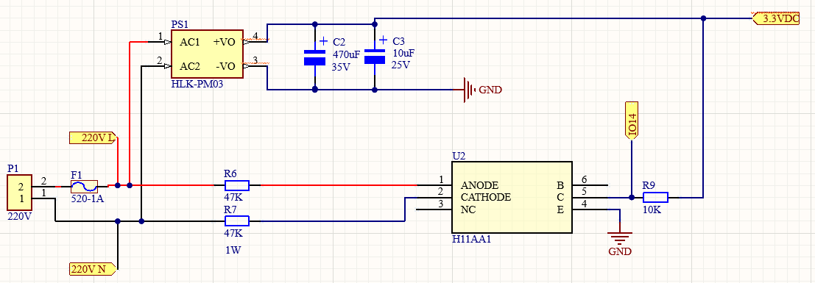
Figure 5.9: Schematic of the zero-cross detection circuit and 3.3V isolated power supply
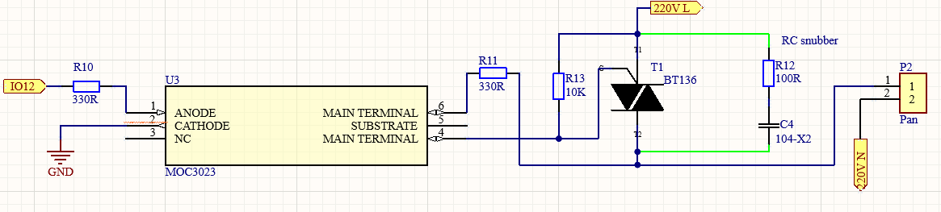
Figure 5.10: Schematic of the TRIAC-based phase-angle control and RC snubber circuit.
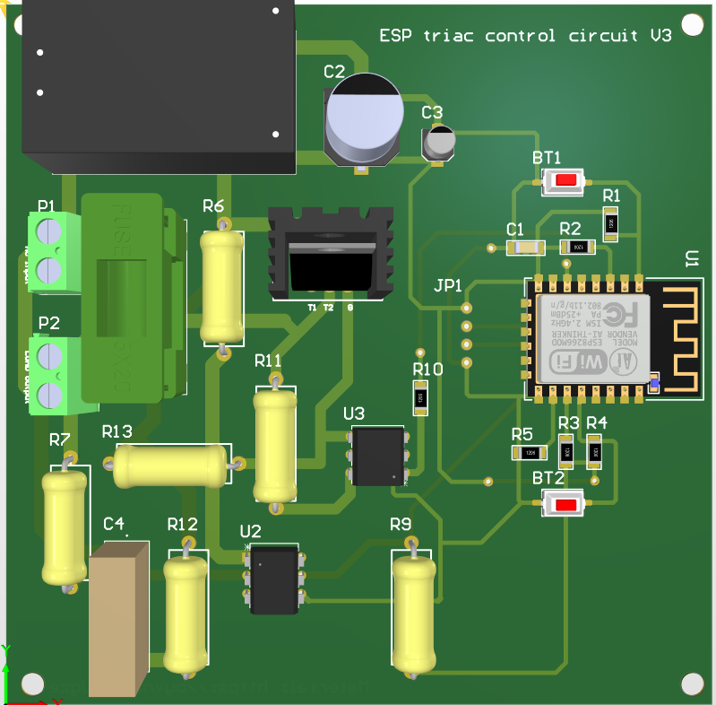
Figure 5.11: PCB layout of the fan control module, highlighting the strict separation between AC and DC domains

5.1.4. Door Lock and Alarm Control PCB

5.1.4.1. Power Management Architecture
The door lock and alarm control board is explicitly designed to simulate smart access control and security alert functions within the smart hotel environment. Unlike the lighting and fan control modules that interface with AC mains, this board operates entirely on a low-voltage DC architecture, ensuring maximum safety. The system is powered by an external 12VDC adapter connected via a standard DC 5.5×2.1mm barrel jack (JDC). To supply the low-voltage components, an LM7805T linear voltage regulator is employed to step the 12VDC input down to a stable 5VDC rail. This 5V output directly powers the active buzzer and is routed to the VIN pin of the NodeMCU ESP8266 development board, which internally regulates it to 3.3V for the ESP-12F microcontroller.

5.1.4.2. Solenoid Door Lock Control
The physical access control is executed by a 12VDC solenoid door lock. Given the high current demands of the inductive solenoid load, a TIP122 Darlington NPN transistor was selected as the primary switching element due to its high current gain. The NodeMCU drives the base of the TIP122 through a 1kΩ current-limiting resistor (R1) connected to digital pin D3. To safeguard the transistor from destructive voltage overshoots, a freewheeling diode (M7) is placed in parallel across the solenoid terminals, effectively suppressing the back-EMF spike generated when the inductive load is de-energized. Upon receiving a remote command via the MQTT topic hotel/room/{room_number}/control, the microcontroller toggles the D3 pin HIGH or LOW to respectively energize or de-energize the solenoid mechanism.
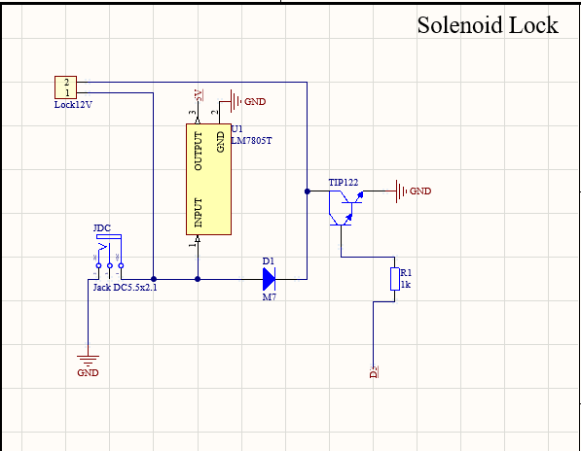
Figure 5.12: Solenoid lock datasheet

5.1.4.3. Audible Alarm System
To provide immediate security alerts, a 5VDC active buzzer is integrated into the PCB. The buzzer is switched by a BC547B NPN small-signal transistor, with the base drive signal supplied from the NodeMCU's digital pin D4 via a 1kΩ resistor (R2). When an unauthorized intrusion is detected or a manual trigger is initiated, the system receives a command via the MQTT topic hotel/room/{room_number}/control, prompting the microcontroller to pull the D4 pin HIGH and activate the buzzer for an audible alert.
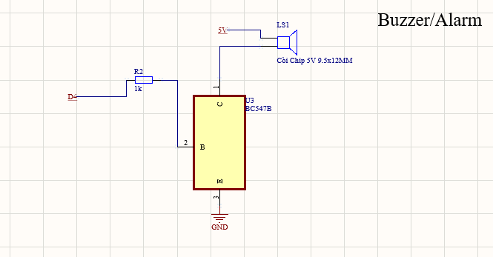
Figure 5.13: Buzzer/Alarm datasheet

5.1.4.4. PCB Layout Design
The printed circuit board is laid out on a two-layer FR4 substrate. The layout strategically positions the power dissipation components, namely the LM7805T regulator and the TIP122 Darlington transistor, with adequate spacing (and heatsinks if necessary) to manage thermal output during continuous operation. The NodeMCU is mounted using female headers for easy replacement and firmware flashing.
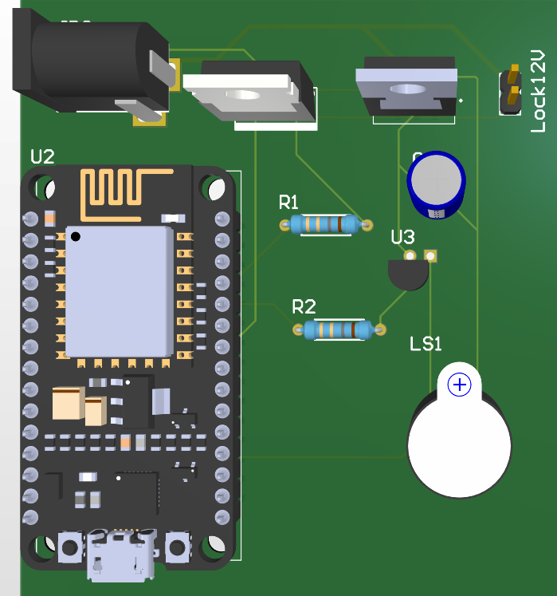
Figure 5.14: Solenoid door lock and buzzer PCB layout

5.2. To develop the Edge-Cloud software infrastructure for data communication, storage, and visualization.
This section describes the software development methodology for the three components of the Edge-Cloud infrastructure: the MQTT communication layer and cloud backend (Task 2.1 and 2.2), and the web-based management dashboard (Task 2.3). The backend is implemented using Node.js with the Express framework, connected to a MySQL 8.0 relational database via the mysql2 connection pool library.

5.2.1. Set up and configure the Edge gateway on a Raspberry Pi
The Raspberry Pi 4 edge gateway runs a local Mosquitto MQTT broker that receives sensor data from ESP-12F nodes via MQTT. A Mosquitto bridge configuration automatically forwards all messages on the hotel/room/+/sensors topic to HiveMQ Cloud over TLS port 8883, with persistence=true to buffer messages on disk when internet connectivity is interrupted and retransmit upon reconnection eliminating the need for a separate SQLite buffer layer.
To establish a local MQTT network, we use Eclipse Mosquitto MQTT, a lightweight and widely adopted open-source broker. Acting as the central server, Mosquitto enables communication between IoT devices through the publish/subscribe model. In this project, Mosquitto is installed on a Raspberry Pi, which serves as the hub of the MQTT network. Devices connect to the broker via Raspberry Pi’s IP address, allowing users to monitor and control components such as sensors, lighting circuits, fans, and smart sockets.
The first step is to install the Raspberry Pi operating system on an SD card. The choice of OS version depends on the hardware (x64 or x32) and the Raspberry Pi model. For this setup, we selected the x64 version with Raspberry Pi 4. The operating system can be downloaded directly from the official Raspberry Pi website. Before flashing the OS onto the memory card, several configurations must be made to ensure proper functionality such as Wi-Fi credentials, device name, and password.
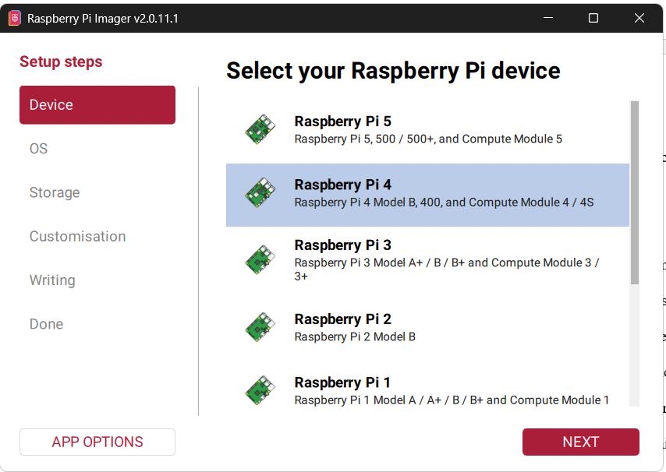
Figure 5.15: Install the suitable OS for raspberry pi 4

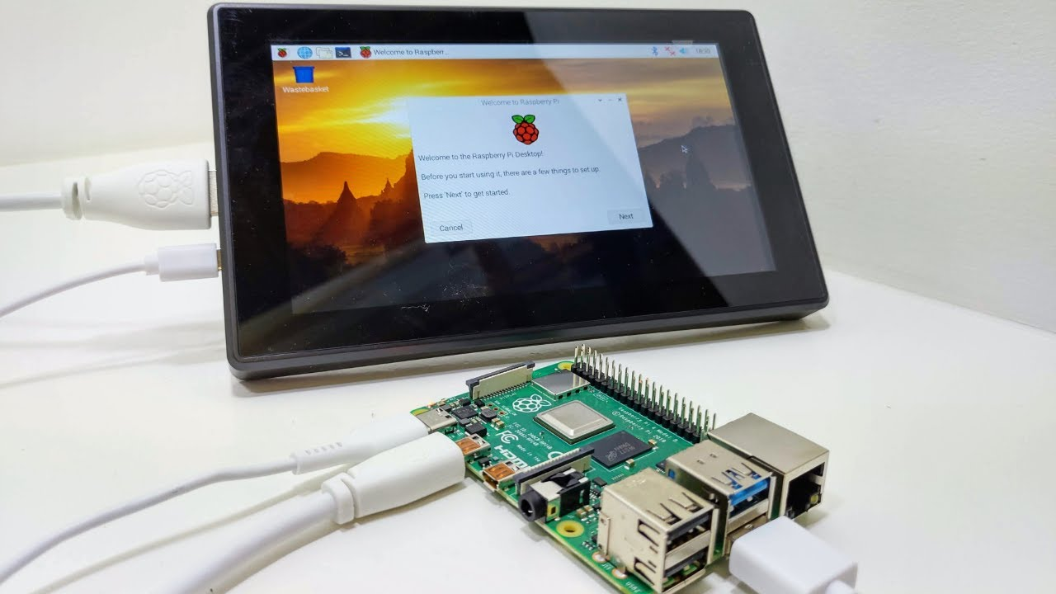

Figure 5.16: Set up the monitor for raspberry
After finishing the first step, we can connect immediately the HDMI from the raspberry pi with
monitor screen and powering on the board. Show in the figure below.
However, there are other ways to control raspberry without monitor screen. This step requires the internet or the ethernet cable to connect to SSH. In the install the OS for raspberry at the customization task config the hostname, localization, user, and etc.
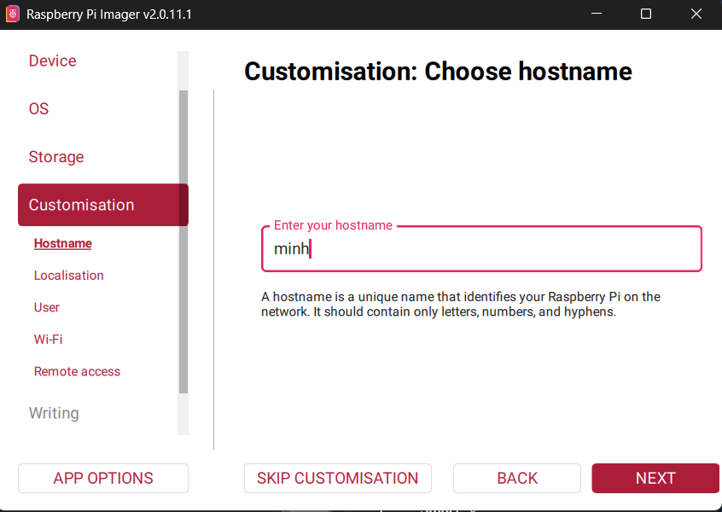
Figure 5.17: Config the ssh hostname
Once the Raspberry Pi operating system is installed and the board is supplied the power, the next step is to identify its IP address. This can be done using Advanced IP Scanner, which scans the network and lists connected devices. With the IP address obtained, we can use PuTTY, a terminal emulator that supports protocols such as SSH, Telnet, and SCP, to remotely access and manage the Raspberry Pi from a Windows computer similar to working with a Linux server. Next, to enable remote access to the Mosquitto Broker using the command "sudo nano /etc/mosquitto/mosquitto.conf” and fill in two lines: listener 1883 and allow anonymous true. This function is for testing and teaching purposes only in a controlled LAN environment.
Finally, use the "VNC Viewer" software to connect to Raspberry Pi's IP address and open its control panel on the computer without an external monitor. The Raspberry Pi and the connected device (e.g., a laptop) must be connected to the same Wi-Fi network for "VNC Viewer" to function correctly. Using "VNC Viewer" significantly reduces costs and is more convenient than traditional methods, as illustrated in Figure 5.18.
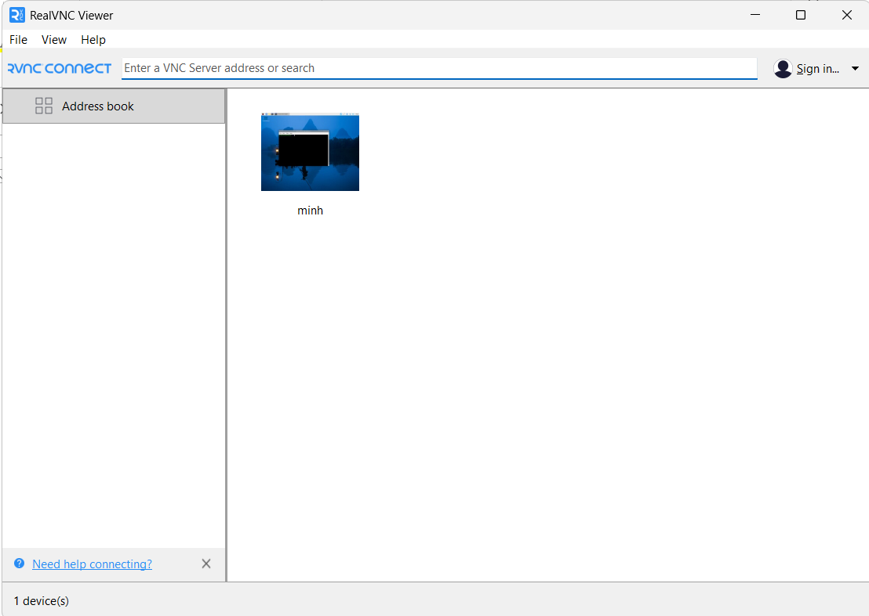
Figure 5.18: Control the raspberry pi 4 through VNC viewer

5.2.2 Develop the Cloud backend comprising a time-series database for sensor data storage
The backend system is deployed across multiple cloud platforms to balance cost, performance, and availability. The Node.js Express server is hosted on Render's free tier as a web service, automatically deployed from the GitHub repository on each push to the main branch. To prevent Render's free tier from spinning down the server after 15 minutes of inactivity, an UptimeRobot monitor is configured to send an HTTP GET request to the /health endpoint every 5 minutes, keeping the service continuously available without manual intervention.
The MySQL 8.0 database is hosted on Railway, connected to the Express server via environment variables injected at runtime DB_HOST, DB_PORT, DB_USER, DB_PASSWORD, and DB_NAME ensuring no credentials are hardcoded in the source. The ML edge agent (edge_agent.py) is deployed as a Railway worker service running in a continuous polling loop, fetching sensor snapshots from the cloud API every 10 seconds, generating predictions, and posting results back Railway's worker process type ensures the service runs persistently without the sleep behavior of web services.
MQTT messaging is handled by HiveMQ Cloud, a managed MQTT broker service providing a public cluster endpoint over TLS port 8883. Both the ESP8266 nodes and the Node.js backend connect to the same HiveMQ cluster the ESP8266 nodes publish sensor data and subscribe to control commands, while the backend subscribes to sensor topics and publishes actuator commands. Authentication is enforced via username and password credentials, and all traffic is encrypted using TLS with the ISRG Root X1 certificate authority on the device side.

Figure 5.19: HiveMQ MQTT interface
To support development and demonstration with limited physical hardware, the system implements hybrid architecture distinguishing between real hardware rooms and simulated rooms. Rooms that are designated as real hardware rooms (REAL_ROOMS), whose sensor data (temperature, humidity, light, motion, smoke, and actuator states) is sourced exclusively from the physical ESP-12F nodes via MQTT. To increase the system more realistic, all remaining rooms without using are simulated rooms, whose environmental parameters are updated by a physics-informed server-side simulation engine running at 5-second intervals. This design allows the system to demonstrate full multi-floor hotel management functionality across all rooms while real hardware validation is conducted on the designated real rooms. For adding hardware for real rooms we have just adjusted the server.js. Following the figure below.
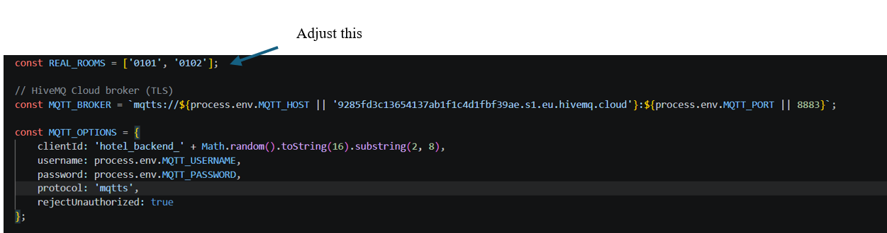
Figure 5.20: Adding real room with real node on server.js file
For downlink control commands, the backend publishes JSON-formatted MQTT messages to the topic hotel/room/{room_number}/control at QoS Level 1. The payload structure is:
Table 5.1: Payload structure
json
{ "device": "fan", "state": true }
For lighting devices that support dimming, an optional brightness field (integer, 0–100) is appended:
json
{ "device": "main_light", "state": true, "brightness": 75 }
Upon receiving a control command on this topic, the ESP-12F node on the target room parses the device and state fields and actuates the corresponding output accordingly.

5.2.3: App Web-Based Management Dashboard Development
This task details the software implementation process for the web-based management dashboard. A component-based architecture was adopted, utilizing React Native with Expo to facilitate a unified and cross-platform codebase.
Firstly, the development process commenced with the initialization of the Expo environment via the command-line interface using npx create-expo-app hotel-dashboard. Following the project creation, essential libraries for network communication, state management, and MQTT integration were installed via the package manager (e.g., npm install axios mqtt). This setup provided the foundational framework for building the five functional modules.
Next, to achieve real-time data synchronization between the physical hardware and the dashboard, a dual-communication strategy was implemented. For the room overview module, the application utilizes Axios to execute REST API calls to the Node.js backend. A polling mechanism is programmed via setInterval to continuously fetch the latest sensor readings and room statuses (available, occupied, etc.) from the MySQL database.
Conversely, for the device control module, UI elements such as the PWM brightness sliders (0-100%) and toggle switches are bound to state-change event listeners. When an interaction occurs, a handler function constructs a control payload. To ensure minimal latency and data consistency, this payload is dispatched simultaneously via an HTTP POST request to update the backend database and directly published to the physical hardware via the MQTT protocol using the mqtt.js client. Besides that, the voice command module was developed to process natural language into actionable hardware commands. The implementation begins by capturing speech input via the device's microphone API and converting it to a text string. This string is embedded into a JSON request and transmitted to an LLM-based intent classification service. The backend logic is programmed to call the Groq API as the primary natural language processing provider. To ensure system reliability, OpenRouter is implemented in the code as an automatic fallback mechanism if the primary API times out. The LLM is prompted to parse the transcribed text, extracting the target actuator (e.g., "door lock" or "AC") and the intended state. A parsing function then maps this extracted intent to the corresponding MQTT topic and payload, executing the control command seamlessly.
Finally, the alert panel interfaces were constructed using dynamic list components that render arrays of JSON data fetched from the backend. Interactive elements, such as severity indicators and one-click resolution buttons, are linked to API endpoints (e.g., PATCH or PUT requests). This allows the system to instantly update the database when hotel staff acknowledge an alert or process a guest check-in, triggering a state re-render on the dashboard to reflect the changes in real-time. After all these steps successfully run npx expo start to run the web interface and eas build -p android --profile development to install the app by using expo dev show in the figure below.

Figure 5.21: Expo dev dashboard

5.3. Machine Learning Module Development and System Integration
This section details the methodology for developing, evaluating, and integrating a Machine Learning module designed for environmental trend prediction and proactive device control.

5.3.1. Data Generation and Preprocessing
Due to the 500mAh LiPo battery constraints of the sensor node operating in deep-sleep cycles, continuous real-world data logging on the physical hardware is limited to a few hours per charge. This duration is insufficient to capture the vast array of device state combinations (main power, AC, fan, lighting, etc.) required for robust model training. Therefore, the empirical data collected from brief operational sessions is utilized as a baseline to identify and calibrate the system's dynamics coefficients specifically, the convergence rate of CO2 and humidity towards target values (e.g., a coefficient of 0.7/step for CO2 and 0.6/step for humidity) and the energy consumption rate per device (COST dictionary). These coefficients correspond identically with the runIoTSimulation() logic applied to the "simulated rooms" in the hybrid architecture, ensuring the training data and dashboard visualization operate on a unified scale.
Based on these calibrated coefficients, the generate_data.py script synthesizes a large-scale training dataset: 200 simulated rooms × 2,880 steps (each step representing 3 seconds, equivalent to 24 hours of operation per room). Device states are randomized with time-weighted probabilities (e.g., a higher probability of lights/fans turning on at night) to mimic authentic guest behavior. Each data record comprises 12 input features (hour of the day, current humidity, current CO2, occupancy status, and the states of 8 devices) and 3 target variables (CO2, humidity, and energy consumption at the subsequent time step, t+1). The problem is formulated as a single-step-ahead regression. Because the data is programmatically generated via deterministic formulas, it contains no missing values or noise; hence, preprocessing primarily involves rounding values and restructuring them into feature/target arrays suitable for the scikit-learn pipeline.

5.3.2. Model Training and Evaluation
For each prediction target (CO2, humidity, and energy), the dataset is randomly partitioned into an 80/20 train-test split using a fixed random_state to ensure reproducibility. Three supervised learning algorithms are independently trained on the identical feature set: Decision Tree (max_depth=10, min_samples_leaf=10), Random Forest (150 estimators, max_depth=12), and XGBoost (200 estimators, max_depth=6, learning_rate=0.1). Due to strict project time constraints, these hyperparameters were manually fixed based on preliminary trials rather than utilizing an exhaustive grid search.
Performance metrics Root Mean Square Error (RMSE), Mean Absolute Error (MAE), and R-squared (R²) are evaluated on the test set for all algorithms. However, the definitive selection criterion for the final model per target is the lowest RMSE, while MAE and R² are recorded for secondary comparison. The best-performing model for each target is serialized as a .joblib file alongside its feature column list, ready for deployment in the real-time inference pipeline.

5.3.3. Integration and Validation
The three selected models are deployed into edge_agent.py, an independent polling process within the Edge-Cloud pipeline. This agent executes a REST API call every 10 seconds to retrieve the latest data snapshot from the physical hardware room(s), reconstructs the feature vector in the exact order used during training, and simultaneously performs inference for all three predictive targets CO2, humidity, and energy consumption. Predicted values are logged via an HTTP POST call to the backend for real-time visualization on the management dashboard, allowing hotel staff to monitor short-term environmental and consumption trends per room alongside the live sensor readings.
The predicted CO2 value is the only prediction output currently wired into an automated control decision: within the apply_ai_rules function, if the predicted CO2 exceeds 800 ppm while the fan is off, the fan is proactively activated; conversely, if the predicted value drops below 500 ppm while the fan is on, it is deactivated. This realizes the proactive, prediction-driven ventilation control described in Objective 3. The predicted humidity and energy values, by contrast, are not yet consumed by any control rule in the current implementation they are surfaced on the dashboard as trend indicators, but the predicted-versus-actual energy deviation check originally envisioned for automated energy waste flagging has not been implemented in this iteration; this gap is discussed further as a limitation and planned extension in the Future Work section.
Alongside the ML-driven fan control, the agent also runs two rule-based interventions that operate independently of the trained models: an occupancy-based lighting rule, in which the light is automatically dimmed to 30% when the PIR sensor reports no motion while the light is on, and restored to full brightness once occupancy resumes; and a safety rule, in which a smoke reading above the configured threshold triggers the fan and opens the curtain regardless of any prediction. These two rules are threshold-based safeguards built directly on raw sensor readings and are not part of the Machine Learning module evaluated in Task 3.2, though they run in the same polling loop and are reported together with the ML-driven actions when control commands are dispatched via HTTP PUT to the device control API, which in turn triggers the corresponding MQTT publish to the target ESP-12F node.
System validation is conducted on the physical hardware room(s), covering four aspects. Response latency is measured as the time elapsed from acquiring the data snapshot to dispatching a control command and receiving the updated state confirmation from the ESP-12F. Real-world prediction error is assessed by comparing the CO2 value predicted at one polling cycle against the actual measured value at the subsequent cycle, and benchmarking this live error against the static test-set error obtained in Task 3.2 to evaluate the model's generalization under real operating conditions. Polling loop stability is evaluated by the uninterrupted operation rate of the edge agent, verifying that transient API or network failures handled through dedicated try/except blocks per room do not halt the overall polling cycle. Finally, dashboard usability is verified by confirming that predictions and the proactive fan-activation events are rendered accurately and promptly on the user interface for hotel staff.

CHAPTER VI – RESULTS
This chapter focuses on the practical outcomes and experimental results of the proposed Edge-Cloud IoT system for smart hotel management, building upon the design, implementation, and testing methodologies described in the preceding chapters. To thoroughly evaluate the system's overall feasibility and operational reliability, the outcomes are categorized into the physical performance of the fabricated hardware modules, the functional stability of the Edge-Cloud software stack, and the predictive accuracy of the integrated Machine Learning algorithms. Finally, the chapter analyzes the real-time system integration results, followed by a discussion of the practical limitations encountered and the iterative decision-making process applied throughout the project's development

Results

6.1.1. Hardware Design and Fabrication results
The physical implementation and assembly of the designed hardware modules were successfully executed and validated under practical operating conditions. The fabricated boards demonstrate strict adherence to the schematics and PCB layouts proposed in the methodology, ensuring robust structural integrity and functional reliability.
The physical prototype of the battery-powered multi-sensor node is demonstrated in Figure 6.1. The custom printed circuit board securely integrates the ESP-12F microcontroller, the TP4056 LiPo charging module, and the DC-DC boost converter. The entire circuitry, alongside the LiPo battery, is compactly housed within a standard protective plastic enclosure. This packaging ensures durability and portability, making it highly suitable for flexible wireless deployment across different hotel rooms. The illuminated status LEDs visually confirm the successful power delivery and stable voltage regulation from the battery to the core logic components.
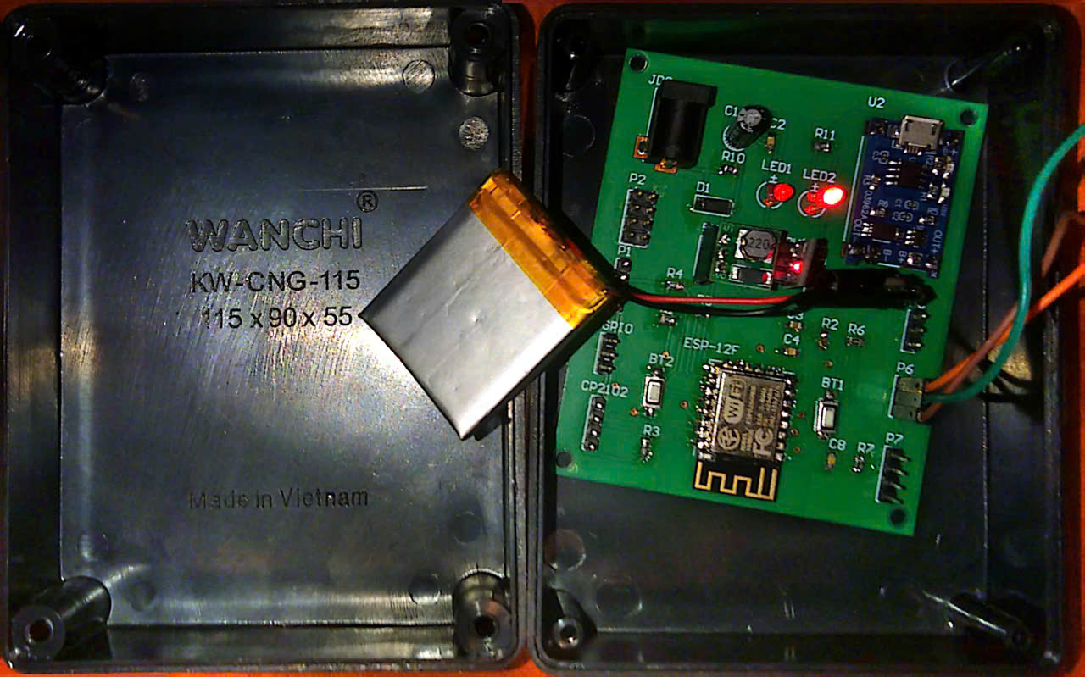
Figure 6.1: Assembled prototype of the battery-powered multi-sensor node within its protective enclosure.
The assembled lighting dimming control board, practically deployed within a standard recessed white junction box. The hardware successfully interfaces the high-power Hi-Link HLK-20M12 AC-DC module with the low-voltage ESP-12F control logic. As shown in the figure the board is actively wired to control a 12VDC LED strip, demonstrating its PWM dimming and load regulation capabilities. Furthermore, the physical connections to the external mechanical wall switches are clearly visible, validating the system's hybrid control architecture that supports both automated remote commands and manual fail-safe overrides.
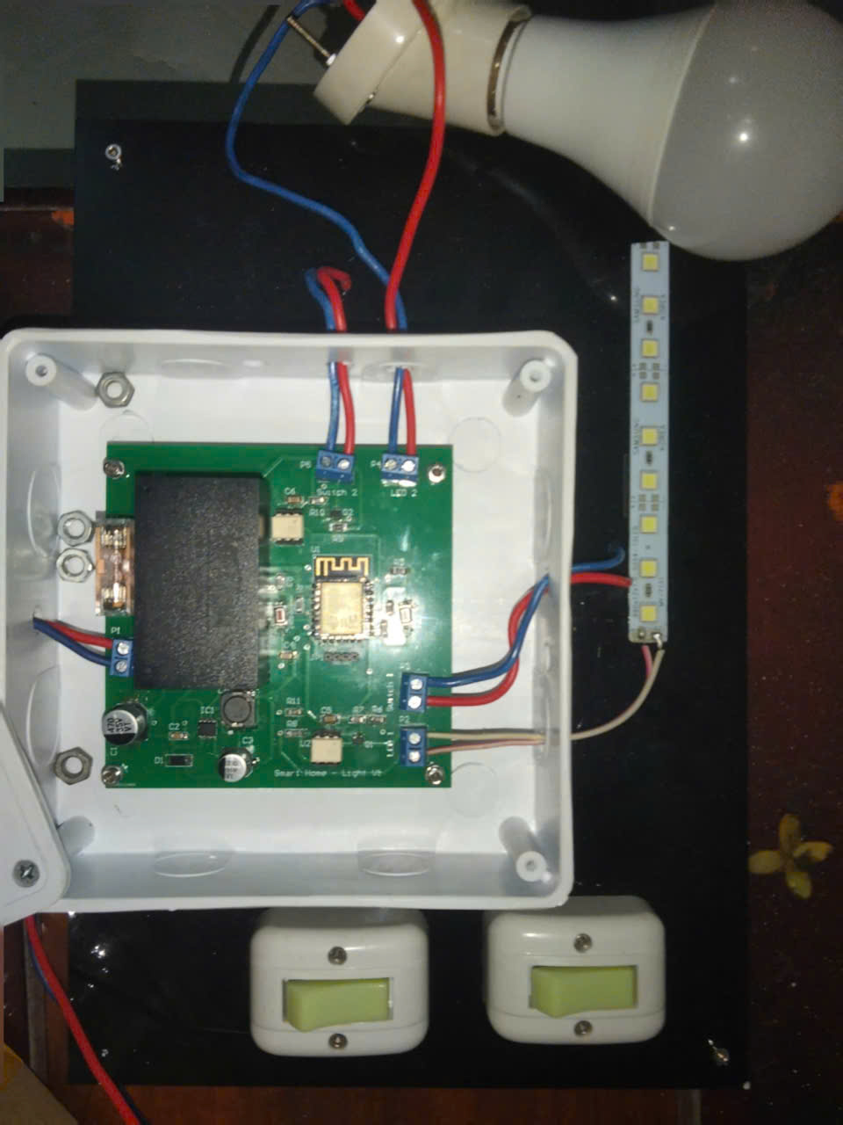
Figure 6.2: Hardware prototype of the lighting dimming control board wired to an LED load and external wall switches.
The fabricated TRIAC-based fan speed regulation PCB is meticulously assembled board exhibits a strict physical separation between the high-voltage AC mains section on the left and the low-voltage DC control section on the right, effectively minimizing electromagnetic interference. Key power and isolation components, including the Hi-Link HLK-PM03 power supply, the isolating optocouplers (H11AA1 and MOC3023), and the BT136-600E TRIAC, are securely soldered onto the FR4 substrate. Notably, the TRIAC is equipped with a dedicated aluminum heatsink to manage thermal dissipation during continuous phase-angle switching. Additionally, the prominent yellow capacitor alongside the high-wattage resistors forms the RC snubber network, ensuring robust protection against voltage transients generated by inductive fan loads.
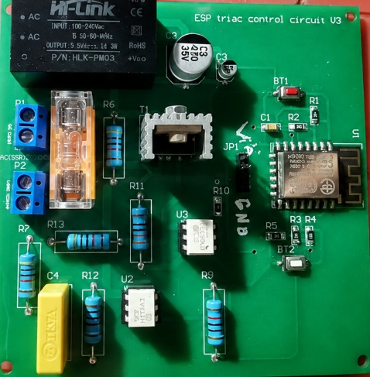
Figure 6.3.1: Assembled PCB of the TRIAC-based fan speed regulation module featuring thermal management and isolation barriers.
Regarding the physical hardware implementation, the environmental sensor node, the lighting dimming controller, and the fan speed regulation boards were successfully fabricated, assembled, and tested under real operating conditions. For the door lock and alarm control module, due to unexpected delays in the PCB fabrication supply chain, the final physical board was not completed in time for the full deployment. However, the operational logic and MQTT communication framework for this module were rigorously validated using a rapid breadboard prototype. The microcontroller successfully received access control commands from the web dashboard and triggered the corresponding logic states via its GPIO pins. This confirms that the software-hardware integration is fully functional and ready for the final PCB assembly.
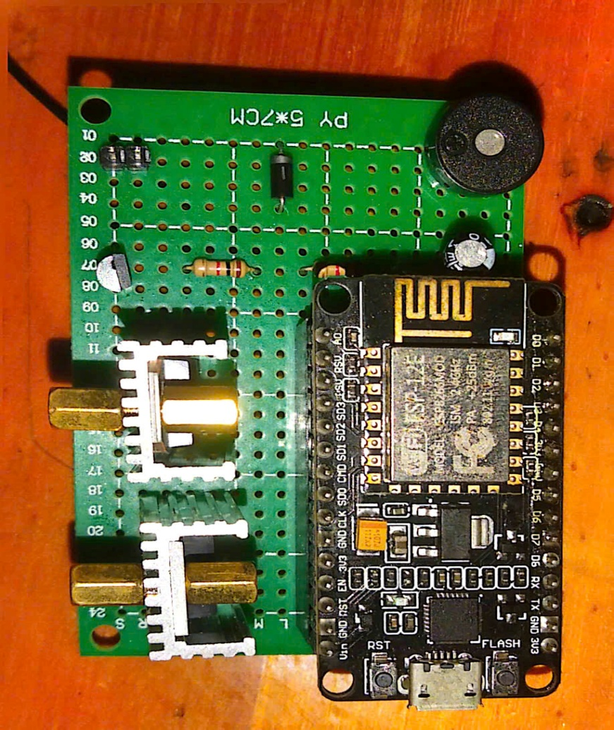
Figure 6.3.2: Assembled PCB of the lock door and alarm

6.1.2 Software and integrated system results
The Edge-Cloud software infrastructure, culminating in the React Native web-based management dashboard, was successfully deployed and tested. The dashboard serves as the central interface for hotel operators, providing real-time visibility and control over the entire smart hotel ecosystem. The software results are evaluated across five primary functional modules: the property overview, room inventory management, real-time IoT control with voice integration, energy analytics, and incident management.
The central Property Overview interface, as demonstrated in Figure 6.4, aggregates critical operational metrics into a unified view. This dashboard actively fetches real-time data from the Node.js backend to display dynamic Key Performance Indicators (KPIs), including estimated revenue, current energy expenses, and active system alerts. Furthermore, it features a live Energy Efficiency chart and a Room Availability visualizer, enabling hotel managers to monitor the overall facility status at a glance. Notably, this screen also integrates a Smart Room Assistant panel, which aggregates the average predicted environmental values (CO2, humidity, and energy) generated by the Machine Learning module across all active rooms.

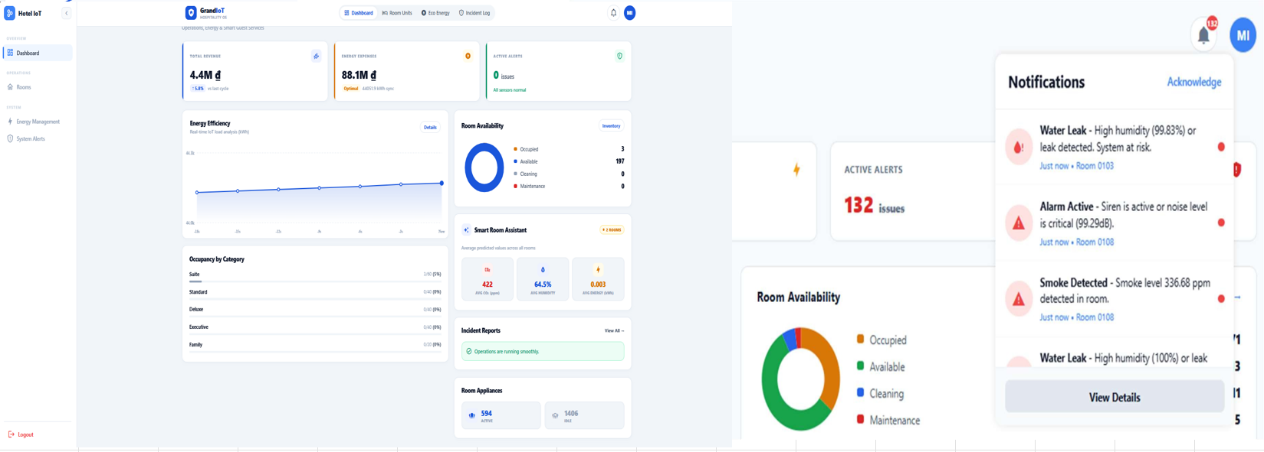
Figure 6.4: Hotel Dashboard management and notifications function
For detailed facility operations, the Room Inventory Management module provides a comprehensive grid of all hotel units. As shown in Figure 6.5, operators can seamlessly toggle between a detailed list view and a spatial map view. The interface supports advanced filtering based on room status, room type, and occupancy.
The core of the hardware-software integration is validated within the Room Detail and IoT Control interface, illustrated in Figure 6.5. This screen establishes a bidirectional communication link with the physical ESP-12F nodes via the MQTT protocol. It successfully renders real-time sensor readings, including temperature, humidity, light intensity, and smoke levels. Simultaneously, the Output Actuators panel allows operators to remotely toggle the main power, air conditioning, door locks, and adjust lighting brightness via a PWM slider. An advanced feature of this interface is the successful deployment of the Voice Command module. By activating the microphone, operators can issue natural language commands. The application captures the audio, transcribes it, and processes it through an LLM-based intent classification service (Groq API) to execute physical hardware changes hands-free, displaying the recognized transcript in a dynamic speech bubble.
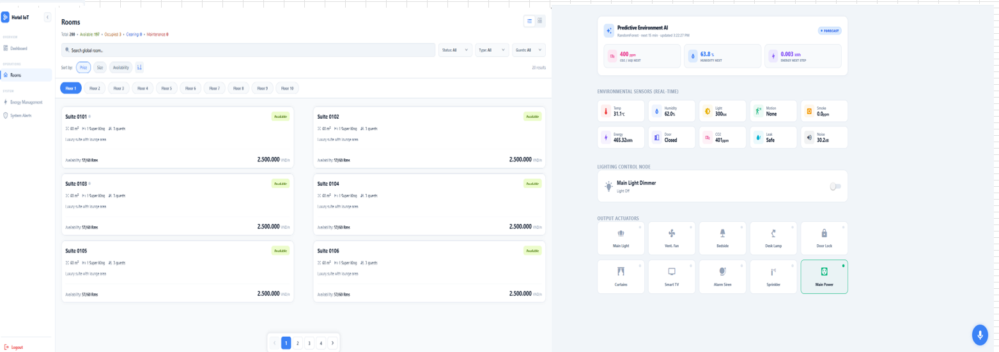
Figure 6.5: Rooms interface and room details with sensors and actuators monitor
To fulfill the energy optimization objective, the Eco Energy Analytics module continuously tracks power consumption across the facility. Figure 6.6 displays the weekly consumption bar chart alongside a ranking of the top energy-consuming rooms. This module accurately calculates the estimated monthly cost based on live IoT data, empowering management to identify irregular power usage patterns. By providing a detailed energy breakdown per floor and per room, the system proactively highlights inefficiencies, supporting the overarching goal of reducing the hotel's carbon footprint and operational overhead.
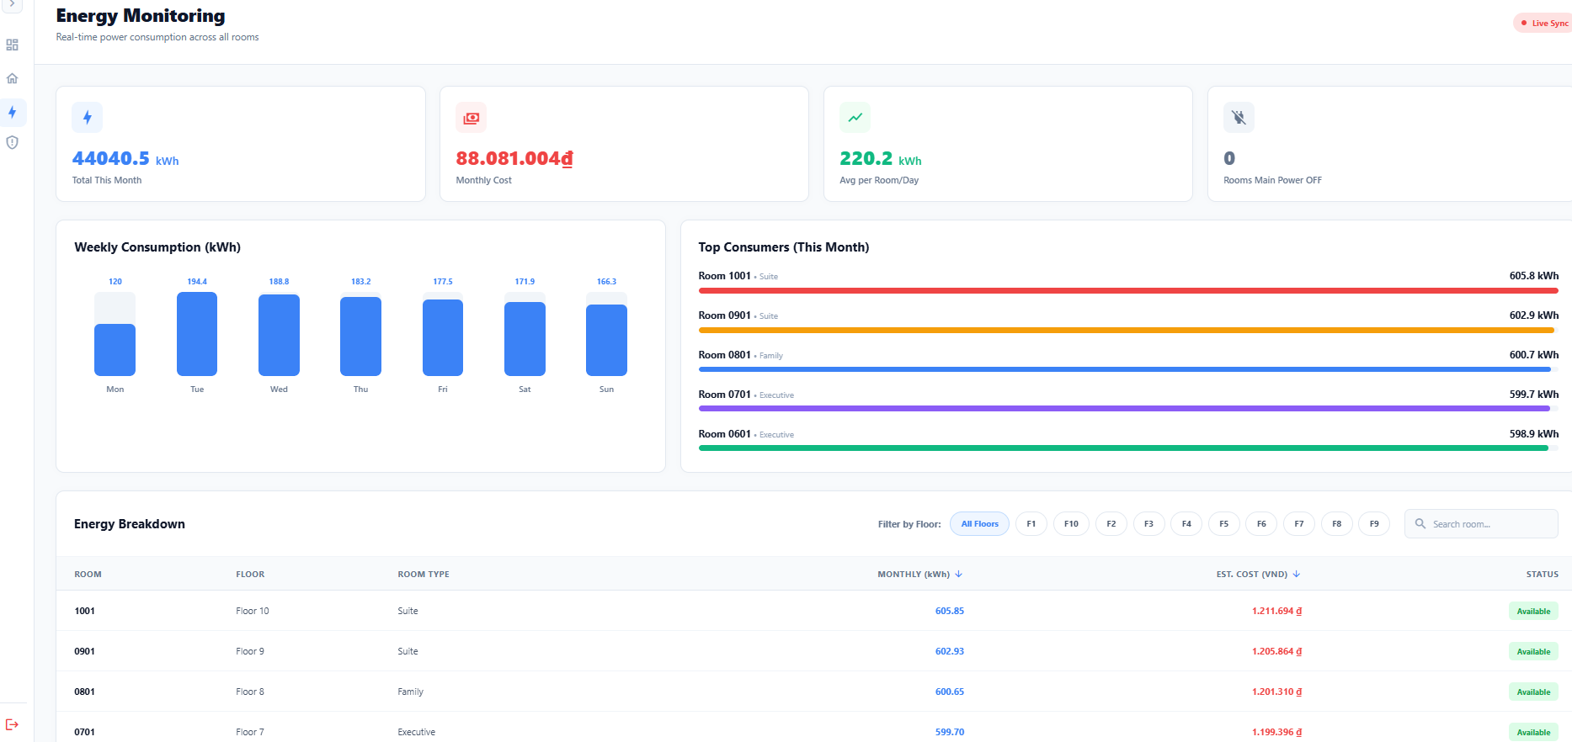

Figure 6.6: Energy management interface
Finally, the system's reliability is reinforced by the System Alerts Monitor, shown in Figure 6.7. This interface acts as the centralized log for safety and maintenance incidents, such as elevated smoke levels or water leaks detected by the edge nodes. The software successfully categorizes these alerts by severity, utilizing distinct visual indicators for critical warnings. The operational workflow is validated by the inclusion of 'Acknowledge' and 'Resolve Issue' actions, ensuring that all facility anomalies are systematically tracked and addressed by the hotel staff without delay.

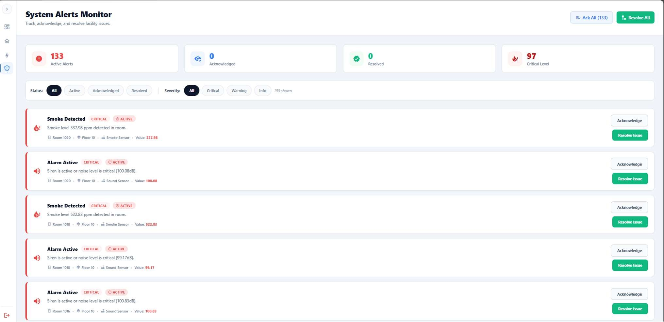
Figure 6.7: Systems alerts monitor
Similar to the web version interface, the app version interface is synchronized with the web version to control devices and monitor hotel rooms via smart phones, tablets, etc.
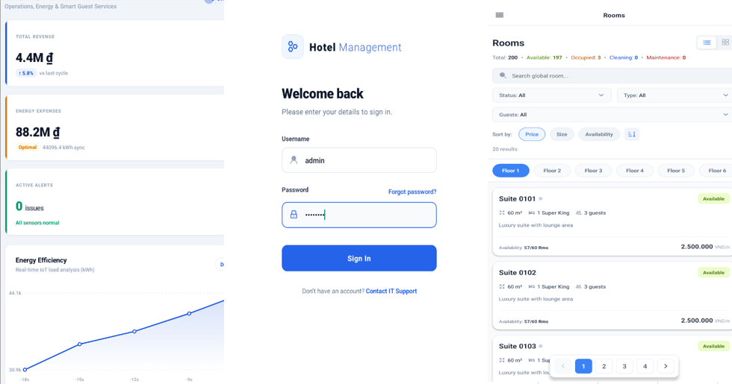
Figure 6.8: Mobile app interface
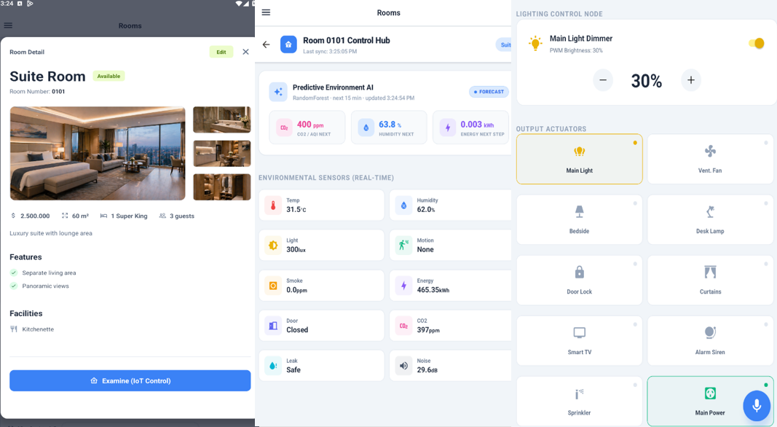
Figure 6.9: Rooms control on mobile app

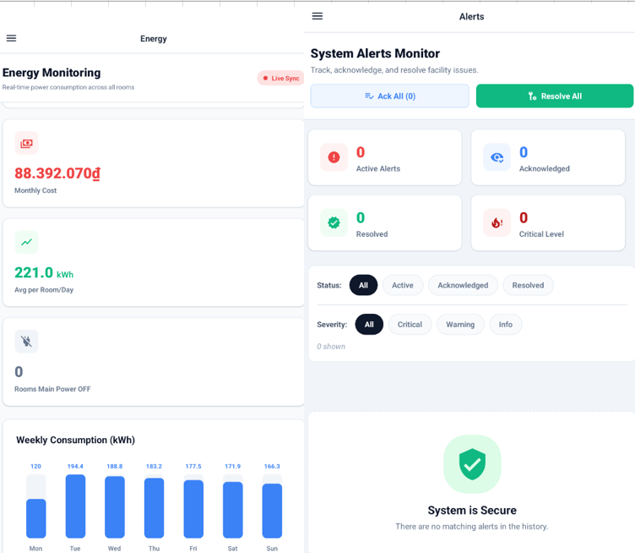
Figure 6.10: Energy and system alerts on mobile app
Additionally, the results show that the hardware has successfully synchronized with the software. The hardware displayed the values ​​on the Arduino IDE accurately compared to those on the software through code uploading and observation via the UART port using the CP2102. Show in the figure below.

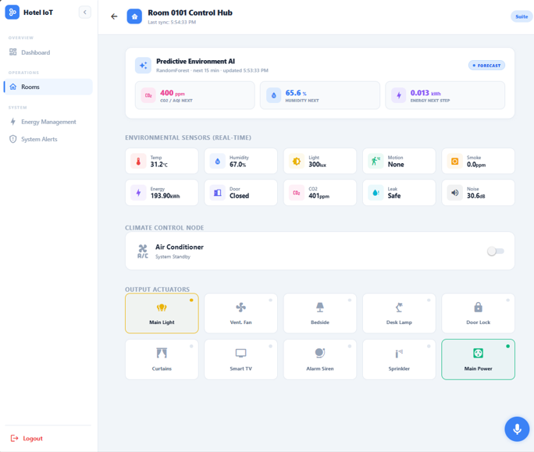
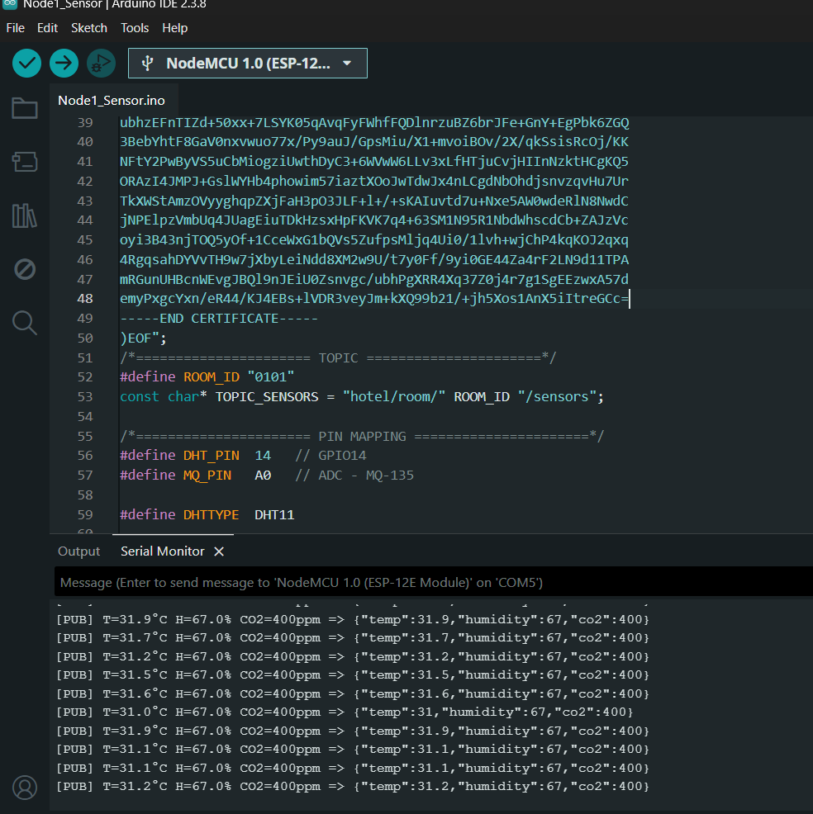
Figure 6.11: Real-time Esp12-f node using DHT11 and MQ-135
Similarly, with the actuators, when press the buttons on the interface and use voice commands, everything works smoothly and the switches function normally.
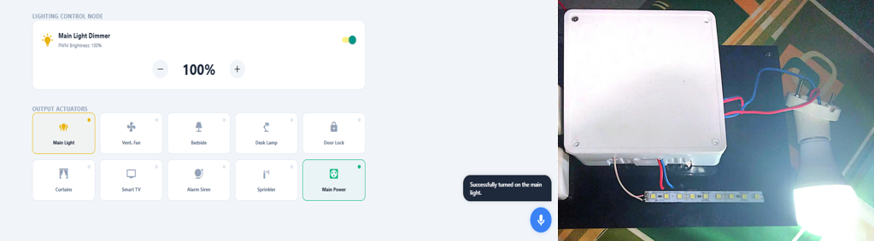
Figure 6.12: Actuators testing on Lightning control PCB

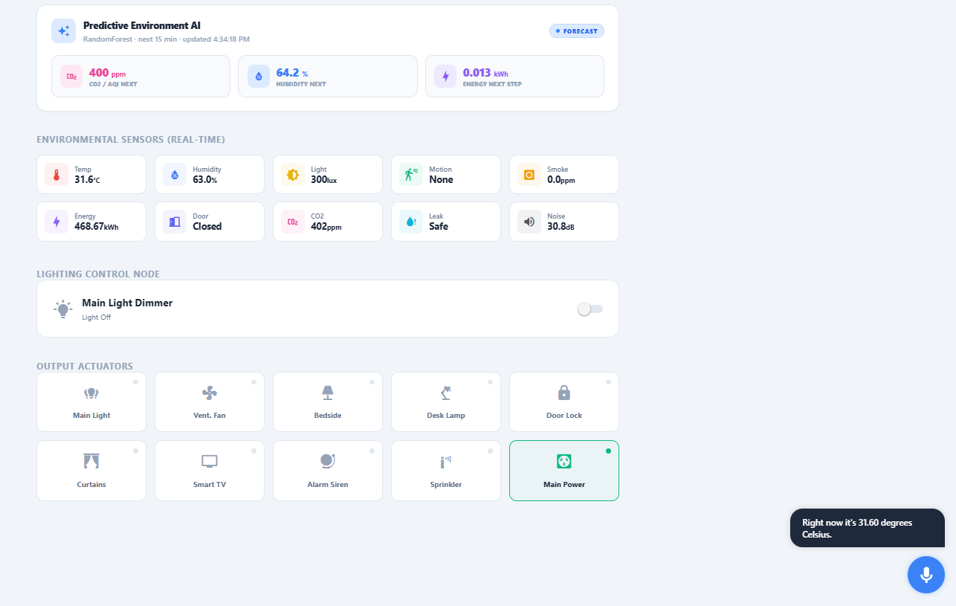
Figure 6.13: Voice control asking the temperature

6.1.3 Machine learning module expected results
The Machine Learning module, comprising three regression models trained for CO2, humidity, and energy prediction, was evaluated in two stages: offline performance on the held-out test set, and online performance when deployed against live sensor data from the physical hardware room.
On the test set, all three algorithms Decision Tree, Random Forest, and XGBoost achieved comparably strong performance across all three targets, with RMSE values differing only marginally between algorithms and R² exceeding 0.994 for every target, as summarized in Table 6.1. Random Forest was selected for the CO2 and humidity targets, while Decision Tree was selected for the energy target, based on the lowest RMSE criterion defined in Section 5.3.2.
Table 6.1: Test-set performance of the three regression models
Target | Model | RMSE | MAE | R2
CO2 (ppm) | Random Forest (selected) | 1.15862 | 1.00247 | 0.9995
Humidity (%) | Random Forest (selected) | 0.29 | 0.2506 | 0.9983
Energy (kWh) | Decision Tree (selected) | 0.00217 | 0.00171 | 0.9943

Following deployment via edge_agent.py, the CO2 and humidity models were validated against approximately 3.7 hours of continuous real-world polling on physical room 0101, comprising 1,142 prediction cycles. Table 6.2 compares the resulting real-world error against the test-set error obtained in Section 6.1.1 above.
Table 6.2: Real-world validation performance (room 0101, n=1,142 cycles)
Target | Model | RMSE | MAE | R2
CO2 (ppm) | Deployed model (RandomForest) | 1.274172638 | 1.085202184 | -0.045384
Humidity (%) | Deployed model (RandomForest) | 1.384813169 | 1.226070911 | 0.4967724

Figure 6.14: Bar chart compares the RMSE from simulated data and real node data
The real-world RMSE for CO2 (1.274 ppm) remained close to the test-set RMSE (1.159 ppm), indicating the model generalized reasonably well despite being trained exclusively on simulated data. However, the corresponding R² value was slightly negative during this session. This is attributable to the low variance of the ground-truth CO2 readings during the logging window (std ≈ 1.25 ppm, range 397–403 ppm) rather than to poor model accuracy: R² measures the proportion of variance explained relative to the mean of the actual values and becomes an unstable metric when the actual values are nearly constant, even as the absolute error (RMSE, MAE) remains small. For this reason, RMSE and MAE are considered the more reliable indicators of real-world performance in this validation pass.
The humidity model showed a larger gap between test-set RMSE (0.290%) and real-world RMSE (1.385%). Part of this gap is attributed to a horizon mismatch between the model's training assumption and the actual polling behavior: the model was trained to predict conditions 3 seconds ahead (matching the sensor publish interval configured on the ESP8266 firmware, SENSOR_INTERVAL_MS = 3000), but the average interval between consecutive prediction cycles recorded in the log was approximately 11.6 seconds, due to network and API round-trip latency rather than the configured polling interval. Comparing a 3-second-ahead prediction against a value measured roughly 11.6 seconds later introduces additional error not present in the test-set evaluation, where the prediction horizon and evaluation horizon are identical by construction.
To assess the practical energy impact of the integrated system, a comparative session was conducted on room 0103 with the database cleared beforehand, recording cumulative energy consumption at 15-minute intervals over one hour, once with the Edge-Cloud management system enabled and once with it disabled. As shown in (Figure 6.15), cumulative consumption reached 3.000 kWh with the system enabled versus 4.466 kWh with it disabled after one hour a reduction of approximately 32.8%. Figure 6.15 further shows that consumption was lower in every 15-minute interval when the system was enabled, not only in the cumulative total, indicating the reduction was consistent throughout the session rather than concentrated in a single interval. This single comparative session (n=1 per condition, run in adjacent same-day time windows) is presented as an illustrative demonstration of the system's energy-saving behavior rather than a statistically averaged benchmark; repeated trials across multiple sessions would be needed to establish a more robust estimate of typical savings.

Figure 6.15: Cumulative energy consumption over one hour Edge-Cloud management system enabled vs disabled
Overall, these results indicate that the trained models transfer reasonably from simulated training data to live sensor data for short-horizon prediction, while also highlighting two concrete limitations of the current validation pass the short single-session logging window with limited environmental variation, and the horizon mismatch introduced by network latency both of which are addressed further in the Discussions section below.

Discussions and limitations

6.2.1 Discussions
The proposed Edge-Cloud IoT system for smart multi-floor hotel management successfully demonstrates the feasibility of integrating IoT sensor hardware, edge computing, cloud-based backend services, and Machine Learning into a unified hotel management platform. This section discusses the key findings and performance outcomes across the three implementation objectives.
Regarding Objective 1, all four custom-designed PCB modules were successfully fabricated and functionally validated. The battery-powered sensor node demonstrated reliable continuous operation, with the DHT11 sensor providing stable temperature and humidity readings and the HC-SR501 PIR sensor detecting room occupancy accurately within its specified detection range. The implementation of deep sleep mode on the ESP-12F between sensor reading cycles was confirmed to reduce idle power consumption significantly, extending LiPo battery operational duration. The AC lighting dimming control board achieved smooth PWM-based brightness control for both LED strip and 12V bulb load across the full 0–100% dimming range, with electrical isolation between the AC and low-voltage control sides verified through the 4N35 optocoupler. The fan speed regulation board successfully performed phase-angle control of the AC fan motor via the BT136-600E TRIAC, with zero-crossing synchronization through the H11AA1 providing stable and repeatable speed steps. The door lock and alarm control board correctly actuated the 12V solenoid lock and 5V active buzzer via TIP122 and BC547B transistors respectively, with the freewheeling diode effectively suppressing back-EMF transients during lock switching.
Regarding Objective 2, the hybrid Edge-Cloud MQTT architecture demonstrated a measurable improvement in local automation response latency compared to cloud-only deployment. The local Mosquitto broker on the Raspberry Pi handled sensor data ingestion and automation rule execution within the local network, achieving sub-100ms response times for room-level control commands. The bidirectional MQTT bridge to HiveMQ Cloud reliably forwarded sensor data and control commands between the local network and the cloud backend, enabling full remote access via the web dashboard without sacrificing local automation speed. The system architecture is designed so that any of the 200 rooms can be configured to source its data from a real physical sensor node; the simulation engine serving the remaining rooms is not an architectural constraint but a practical stand-in adopted for this evaluation, given that fabricating and deploying hardware across all 200 rooms was outside the time and component budget available for the project. Room 0101 was fabricated and deployed as the live hardware node used for testing and validation in this evaluation. The cloud backend REST API correctly handled all functional modules including room and energy management, IoT device control, alert generation with automated resolution, and the ML prediction pipeline. The web dashboard provided real-time room monitoring with interactive device control, voice command integration via LLM intent classification, and a functional alert management panel, confirming that the system meets the visualization and remote-control requirements defined in Task 2.3.
Regarding Objective 3, three ML regression models Decision Tree, Random Forest, and XGBoost were trained on physics-informed simulation data for three prediction targets: CO₂ concentration, humidity, and energy consumption. Table 6.3 summarizes the comparative model performance across all three targets.
Table 6.3: Comparative ML model performance across prediction targets
Prediction Target | Model | RMSE | MAE | R²
CO₂ (ppm) | Decision Tree | 1.16312 | 1.00514 | 0.9995
CO₂ (ppm) | Random Forest | 1.15862 | 1.00247 | 0.9995
CO₂ (ppm) | XGBoost | 1.22011 | 1.01751 | 0.9994
Humidity (%) | Decision Tree | 0.29075 | 0.25103 | 0.9983
Humidity (%) | Random Forest | 0.29000 | 0.25060 | 0.9983
Humidity (%) | XGBoost | 0.29181 | 0.25106 | 0.9983
Energy (kWh) | Decision Tree | 0.00217 | 0.00171 | 0.9943
Energy (kWh) | Random Forest | 0.00217 | 0.00170 | 0.9944
Energy (kWh) | XGBoost | 0.00217 | 0.00171 | 0.9944
The near-perfect R² values across all targets primarily reflect the models' ability to recover the deterministic dynamics used to generate the training data, rather than performance on genuinely noisy real-world behavior. To assess real-world generalization, the CO₂ and humidity models were further validated against approximately 3.7 hours of live polling on room 0101, comprising 1,142 prediction cycles. The real-world RMSE for CO₂ (1.274 ppm) remained close to the test-set value (1.159 ppm), while the corresponding R² was slightly negative attributable to the very low variance of actual CO₂ readings during this particular session (std ≈ 1.25 ppm) rather than to poor model accuracy, since R² becomes an unstable metric when ground-truth values are nearly constant even as absolute error remains small. The humidity model showed a larger real-world RMSE (1.385%) than its test-set value (0.290%), partly attributable to a horizon mismatch: the models were trained to predict conditions three seconds ahead, matching the sensor publish interval, but the average interval between live prediction cycles was approximately 11.6 seconds due to network and API round-trip latency, making the live comparison a longer-horizon prediction than the one the models were trained for.
The best-performing model per prediction target was selected and integrated into the cloud-side edge_agent.py pipeline. Of the three predictive outputs, the CO₂ prediction is currently the only one wired into an automated control decision: the system proactively activates the ventilation fan when predicted CO₂ exceeds a configured threshold, ahead of the point where a purely reactive, threshold-based controller would respond to the same condition supporting the guest-comfort objective. The predicted humidity and energy values are logged and displayed on the dashboard as trend indicators; the predicted-versus-actual energy deviation check originally envisioned for automated energy-waste flagging has not yet been wired into an alerting rule in the current implementation and is discussed further under Limitations and Future Work.
To assess the practical energy impact of the broader system independent of the individual prediction models, a comparative session was conducted on room 0101 with the database cleared beforehand, recording cumulative energy consumption at 15-minute intervals over one hour, once with the Edge-Cloud management system enabled and once with it disabled. Cumulative consumption reached 3.000 kWh with the system enabled versus 4.466 kWh disabled after one hour, a reduction of approximately 32.8%, with consumption lower in every 15-minute interval rather than only in the cumulative total. This result is presented as an illustrative single-session demonstration (n=1 per condition) rather than a statistically averaged benchmark.
Regarding system integration, sensor data updates and dashboard responses were observed to occur close to real time during testing, with only a small perceptible delay on the order of one to two seconds attributable to the cloud round-trip through the Render backend and Railway database rather than to the local MQTT path; this is expected given the system is not intended to operate purely locally, and the observed responsiveness suggests the hosting tier's cold-start behavior was not a significant factor during testing. MQTT message delivery rate itself was not formally measured in this evaluation and is noted as a limitation below.
Overall, the results indicate that the proposed system successfully addresses the three defined objectives and supports the core hypothesis that an Edge-Cloud IoT architecture with integrated ML regression can deliver practical improvements in hotel energy management and guest comfort monitoring, while also surfacing concrete gaps the unimplemented energy-deviation alerting rule, the prediction horizon mismatch, and the unmeasured delivery rate that are addressed in the following section.

6.2.2 Limitations
Despite the successful implementation and validation of the proposed system, several limitations were identified during the development and evaluation phases that constrain the generalizability and completeness of the current results.
Hardware Deployment Scale: The system architecture supports configuring any room to run on real physical hardware rather than the simulation engine, with no architectural limit on the number of hardware-backed rooms. However, physically fabricating and deploying sensor nodes across all 200 rooms was not feasible within the project's timeline and component budget; consequently, only one room (0101) was fabricated and validated against live hardware in this evaluation, while the remaining 199 rooms continued to operate on the simulation engine as a practical substitute. This means the system's behavior under simultaneous real-sensor load at full hotel scale including network contention, MQTT broker throughput under many concurrent physical nodes, and aggregate power/connectivity demands has not been empirically validated and remains an assumption extrapolated from single-node testing.
ML Training Data Source: The regression models were trained exclusively on physics-informed simulation data due to the limited operational period available for real sensor data collection prior to the evaluation deadline. While the simulation parameters were calibrated against real sensor readings from room 0101, simulated data inherently cannot capture all real-world variability including occupancy behavioral patterns, HVAC interference, and environmental disturbances that would affect model performance in a full-scale deployment.
Prediction Horizon Mismatch: The regression models were trained on a fixed three-second-ahead horizon matching the sensor firmware's publish interval, but the deployed inference agent's actual polling interval averaged approximately 11.6 seconds due to network and API latency. This mismatch inflates the apparent real-world prediction error relative to the test-set error and should be resolved either by retraining on a longer, more representative horizon or by reducing end-to-end polling latency before the reported error figures are used as a general measure of model accuracy.
Energy Waste Detection Not Yet Automated: Although the energy consumption model was trained and evaluated alongside the CO₂ and humidity models, the predicted-versus-actual deviation check intended to automatically flag energy waste has not been implemented as an active alerting rule in the current edge_agent.py pipeline; predicted energy values are currently surfaced only as a dashboard trend indicator. Implementing and validating this rule is identified as near-term future work.
Energy Consumption Measurement: The current implementation does not include a hardware energy meter on the PCB boards. Actual energy consumption values used for training and comparison are estimated from device state and known device power ratings rather than directly measured, which limits the precision of any future predicted-versus-actual comparison mechanism.
MQTT Bridge Reliability and Unmeasured Delivery Rate: The bidirectional MQTT bridge between the local Mosquitto broker and HiveMQ Cloud depends on stable internet connectivity, and the current implementation does not include a message queuing or store-and-forward mechanism for bridge reconnection scenarios. During testing, sensor updates and dashboard responses were observed to occur close to real time, with a small (roughly one-to-two-second) delay attributed to the cloud round-trip through the Render backend and Railway database rather than the local path. However, MQTT message delivery rate was not formally measured in this evaluation, and this qualitative observation should not be treated as a substitute for a quantified figure in future validation passes.
Energy Comparison Sample Size: The system-level energy comparison (system enabled versus disabled) was based on a single session per condition rather than repeated, averaged trials, and the two sessions were run in adjacent but non-simultaneous time windows on the same day. A larger number of repeated trials would be needed to establish a statistically robust estimate of typical energy savings.
Voice Command Dependency on External APIs: The voice command control feature relies on the Groq LLM API and OpenRouter as a fallback, both of which are third-party cloud services subject to rate limiting, pricing changes, and service availability. The current implementation does not support offline voice intent classification, limiting the feature's reliability in environments with restricted internet access.
Dashboard Authentication: The current web dashboard implements basic token-based authentication. A production hotel deployment would require more robust security measures including role-based access control with multi-factor authentication, HTTPS enforcement across all endpoints, and audit logging of all control commands none of which are fully implemented in the current prototype.

6.3. Iterative Decision-Making Process
Throughout the design, implementation, and integration phases of the project, a number of technical challenges were encountered that required iterative revision of the original design decisions. Table 6.4 summarizes the key decision points, the alternatives considered, the final decisions made, and the outcomes observed.
Table 6.4: Iterative Decision-Making Process.
Objectives | Problems | Iterative Process | Decision Making | Achieved / Overcome | Improvements Needed
Objective 1: Hardware Design & Fabrication | HC-SR501 PIR sensor requires minimum 4.5VDC but LiPo battery output is only 3.7V | Tested direct LiPo connection → PIR failed to trigger reliably. Evaluated adding USB power bank vs. boost converter | Added Boost DC-DC T64 converter to step up LiPo 3.7V to stable 5VDC output | PIR operates reliably; sensor node remains battery-powered and portable | Battery life optimization through more aggressive deep sleep scheduling
Objective 1: Hardware Design & Fabrication | Original PCB AC trace width insufficient for mains current load, causing trace heating during testing | Measured trace temperature under full load exceeded safe limit. Evaluated PCB redesign vs. trace reinforcement | Removed solder mask on AC current-carrying traces and applied additional solder to increase current capacity | Board operates safely under full load; thermal performance within acceptable range | Future PCB revision should incorporate wider traces and proper thermal relief from design stage
Objective 1: Hardware Design & Fabrication | PWM control initially attempted for AC fan speed regulation ineffective for inductive AC load | Tested PWM output on AC fan → unstable speed control with significant noise. Evaluated DC fan replacement vs. TRIAC phase-angle control | Adopted TRIAC BT136-600E with MOC3023 optocoupler driver and H11AA1 zero-crossing detection for phase-angle AC control | Smooth and stable AC fan speed regulation achieved across full operating range | RC snubber circuit should be added across TRIAC terminals to reduce switching noise on future board revisions
Objective 2: Edge-Cloud Software Development | Cloud-only MQTT broker introduced high response latency (>200ms) for local room automation commands | Measured end-to-end latency from sensor trigger to actuator response via cloud broker exceeded acceptable threshold for real-time control | Deployed local Mosquitto MQTT broker on Raspberry Pi with bidirectional bridge to HiveMQ Cloud for remote access | Local automation latency reduced to sub-100ms; remote dashboard access and data synchronization maintained via cloud bridge | MQTT bridge configuration should be further tuned to minimize reconnection time during network interruptions
Objective 2: Edge-Cloud Software Development | Single cloud MySQL database could not support autonomous local operation during cloud outages | Simulated cloud disconnection local automation rules failed without cloud database access | Added local SQLite database on Raspberry Pi for edge-level sensor data storage; cloud MySQL retained for backend API and dashboard | System operates autonomously during cloud unavailability; local automation and sensor logging unaffected by internet disruptions | Data synchronization conflict resolution between local SQLite and cloud MySQL should be implemented for extended offline periods
Objective 2: Edge-Cloud Software Development | Voice command LLM API (Groq) subject to rate limiting during rapid consecutive requests | Observed API timeout errors during repeated voice commands in quick succession | Implemented 10-second intent cache on the backend and added OpenRouter as automatic fallback provider | Voice command reliability improved; repeated queries within 10 seconds resolved from cache without additional API calls | Local on-device LLM inference should be explored to eliminate API dependency for voice control
Objective 3: ML Module & System Integration | Insufficient real-world sensor data available for ML model training within project timeline | Attempted training on available real sensor readings from rooms 0101 and 0102 dataset too small for reliable generalization | Adopted physics-informed simulation to generate training data, modelling CO₂ accumulation, humidity dynamics, and energy consumption patterns calibrated against real sensor readings | Sufficient training data generated for all three regression targets (CO₂, humidity, energy consumption); models validated on real hardware room data | Real-world data collection over extended deployment period should replace simulation data in future model retraining cycles
Objective 3: ML Module & System Integration | Extra Trees algorithm achieved highest accuracy in literature but lacks interpretability for hotel management staff | Compared Extra Trees, XGBoost, Random Forest, and Decision Tree on simulated dataset Extra Trees achieved highest R² but produces opaque ensemble predictions | Retained Decision Tree as interpretable baseline alongside Random Forest and XGBoost; best-performing model selected per prediction target by RMSE, MAE, and R² | Transparent rule-based predictions available for staff validation; XGBoost and Random Forest provide higher-accuracy ensemble predictions for deployment | Feature set should be expanded with real occupancy schedule data and seasonal patterns to improve model generalization
Objective 3: ML Module & System Integration | Initial plan to run ML inference on Raspberry Pi edge device was impractical given project scope and hardware availability | Evaluated running edge_agent.py on Raspberry Pi vs. deploying as cloud-side script | Deployed edge_agent.py as a cloud-side Python script polling /api/sensors/snapshot and posting predictions to /api/prediction | Simplified deployment with no additional hardware required; prediction results available to dashboard in real time | Edge-based ML inference on Raspberry Pi or dedicated edge device should be explored in future work to reduce cloud dependency for prediction

CHAPTER VII - CONCLUSION AND FUTURE WORK

Conclusions
An Edge-Cloud IoT system with integrated Machine Learning has been successfully designed, implemented, and experimentally validated for smart multi-floor hotel management. Four custom PCB modules a battery-powered multi-sensor node, an AC lighting dimming controller, a fan speed regulation board, and a door lock and alarm control board were fabricated and confirmed to operate according to their design specifications, with electrical isolation between AC and control-side circuitry verified on the lighting and fan boards through opto-isolated feedback and zero-crossing synchronization.
The system operates on a hybrid Edge-Cloud MQTT architecture, combining a local Mosquitto broker on a Raspberry Pi gateway for low-latency automation with a bidirectional bridge to HiveMQ Cloud for full remote access. A web-based management dashboard was successfully developed, providing real-time room monitoring, interactive device control, energy analytics, incident alerting, and voice-command integration through LLM-based intent classification confirming that the software infrastructure meets the visualization and control requirements set out for the project.
Building on this foundation, three regression algorithms Decision Tree, Random Forest, and XGBoost were trained for CO₂, humidity, and energy prediction and integrated into a live inference pipeline. The predicted CO₂ trend was successfully wired into an automated, proactive fan-activation rule, allowing the system to respond ahead of a purely reactive threshold-based controller. Validated against roughly 3.7 hours of live sensor data from a physical hardware room, the CO₂ model's real-world error remained close to its offline test-set error, indicating that the models generalize reasonably well despite being trained on physics-informed simulation data. At the system level, a comparative session further showed an approximate 32.8% reduction in energy consumption over one hour when the system was enabled versus disabled, consistent across every measured interval a concrete, if illustrative, demonstration that combining sensing, automated control, and predictive modeling can translate into tangible energy savings in a hotel setting.
As an initial prototype developed within a single project timeline, the system still carries clear boundaries: live hardware validation was limited to one room out of the 200 the architecture is designed to support, the energy-waste detection logic was trained and evaluated as a model but not yet wired into an automated alert, and the real-world prediction error reported for humidity was partly inflated by a mismatch between the model's trained horizon and the actual network-bound polling interval. These are treated not as failures but as a clearly scoped starting point, addressed directly in the Future Work below.
Taken together, this work offers a practical, hardware-validated basis for extending Edge-Cloud IoT architectures with predictive Machine Learning into real hotel-scale deployments, balancing energy efficiency, guest comfort, and operational visibility for hotel staff.

Future Work
To move this prototype from a validated single-room system toward a production-ready, multi-floor deployment, the following directions are proposed.
Closing the Energy-Waste Alerting Loop: The trained energy consumption model currently informs the dashboard as a trend indicator only. The predicted-versus-actual deviation check originally envisioned for Objective 3 should be implemented as an active rule within the inference pipeline, comparing predicted and measured consumption per room and triggering a dashboard alert when the deviation exceeds a defined threshold directly closing the gap between the model that was trained and the automated behavior it was intended to support.
Scaling Hardware Validation: Physical validation in this project was limited to a single sensor node due to fabrication time and component budget constraints. As resources allow, additional nodes should be deployed to validate the system under multi-room concurrent load, including MQTT broker throughput, database write contention, and network demand closer to the full 200-room scale the architecture targets.
Resolving the Prediction Horizon Mismatch: The regression models were trained on a fixed three-second horizon, while the deployed agent's real polling interval averaged roughly 11.6 seconds due to network and API latency. Future iterations should either reduce end-to-end polling latency to match the trained horizon, or retrain the models on a longer, more representative horizon, so that real-world error figures remain directly comparable to offline benchmarks.
Periodic Model Retraining from Live Data: Rather than relying solely on a static, offline-trained model, a scheduled batch retraining pipeline could periodically fold accumulated real sensor logs into the training set alongside the simulated data, validating each candidate model against the currently deployed one before replacement gradually improving model fit to genuine hotel conditions without requiring full online learning.
Quantifying System Reliability: Sensor updates and dashboard responses were observed to occur close to real time during testing, but MQTT message delivery rate and end-to-end latency were not formally measured. A dedicated benchmark comparing publish counts on the sensor firmware against confirmed receipt counts on the backend, sustained over an extended testing period, would replace this qualitative observation with a quantified reliability figure.
Expanding the Energy Benchmark: The reported 32.8% energy reduction is based on a single session per condition. Repeating this comparison across multiple sessions and times of day would allow a statistically averaged estimate of typical savings, with a reported confidence interval, rather than a single illustrative measurement.
Hardening for Production Deployment: The current token-based dashboard authentication should be extended with role-based access control, multi-factor authentication, and audit logging of control commands, and the current insecure TLS connection between the sensor firmware and the MQTT broker should be replaced with proper certificate-based trust validation before any production rollout. Reducing dependency on third-party voice APIs by exploring a lightweight, locally hosted intent-classification fallback would similarly improve reliability in environments with restricted internet access.

REFERENCES
[1] | World Tourism Organization (UNWTO), "Energy efficiency in tourism accommodation," 2023.
[2] | . García, "Energy use and its key factors in hotel chains," Sustainability (MDPI), vol. 14, no. 8239, 2022.
[3] | . Arenhart, "Energy use and its contributors in hotel buildings: A systematic review and meta-analysis," PLOS ONE, vol. 19, no. 10, 2024.
[4] | . Li, "Edge-cloud IoT architecture for smart hospitality management," IEEE Access, vol. 11, p. 11234–11245, 2023.
[5] | . Dat, "A study on energy consumption of hotel buildings in Vietnam," Journal of Science and Technology in Civil Engineering, vol. 12, no. 3, p. 45–52, 2018.
[6] | . Sivasankari, "IoT driven building automation systems: A review on energy efficiency, occupant comfort, and sustainability," Journal of Building Engineering, p. 112347, 2025.
[7] | . Tseng, . Wang, . Wei and . Chiang, "Cloud-edge MQTT messaging for latency mitigation and broker memory footprint reduction," PeerJ Computer Science, vol. 11, p. e2741, 2025.
[8] | . Zoubir, . Er-Retby, . Es-Sakali, . Souldi and . Mghazli, "Towards Sustainable Buildings: Predictive Modeling of Energy Consumption with Machine Learning," Procedia Computer Science, vol. 236, p. 59–66, 2024.

