VIETNAM NATIONAL UNIVERSITY – HO CHI MINH CITY
INTERNATIONAL UNIVERSITY
SCHOOL OF ELECTRICAL ENGINEERING



CAPSTONE DESIGN 2

SMART DRUM FILTER

Submitted By Group 06:
ta nguyen hoang minh - eeeeiu22084
le duc minh - eeeeiu22074
le Huu thang - eeeeiu22081
vuong thanh tung - eeeeiu22079
nguyen van vinh - eeaciu22174

Ho chi minh city, vietnam
May 26
SMART DRUM FILTER

SUBMITTED BY

TẠ NGUYỄN HOÀNG MINH – EEEEIU22084
LÊ ĐỨC MINH – EEEEIU22074
LÊ HỮU THẮNG – EEEEIU22081
VƯƠNG THANH TÙNG – EEEEIU22079
NGUYỄN VĂN VĨNH – EEACIU22174

Under the guidance and approval of the committee, and approved by its members, this report has been accepted as part of the requirements for Capstone Design 2.

Approved by:

________________________________
Chairperson

________________________________
Committee member

________________________________Committee member

________________________________
Committee member

________________________________
Committee member

________________________________
Committee member

HONESTY DECLARATION
We, the undersigned members of Group 06, would like to declare that, apart from the acknowledged references, this report does not use language, ideas, or other original material from anyone else; and has not been previously submitted to any other educational or research programs or institutions. We fully understand that any content in this report that contradicts the above statement will automatically lead to the rejection of our Capstone Design 2 project by the School of Electrical Engineering, International University – Vietnam National University Ho Chi Minh City.
Date: 29/05/2026
Full name | Student ID | Signature
Ta Nguyen Hoang Minh | EEEEIU22084 | __________________
Le Duc Minh | EEEEIU22074 | __________________
Le Huu Thang | EEEEIU22081 | __________________
Vuong Thanh Tung | EEEEIU22079 | __________________
Nguyen Van Vinh | EEACIU22174 | __________________

TURNITIN DECLARATION

Names of the students: Ta Nguyen Hoang Minh, Le Duc Minh, Le Huu Thang, Vuong Thanh Tung, Nguyen Van Vinh
Date: 29/05/2026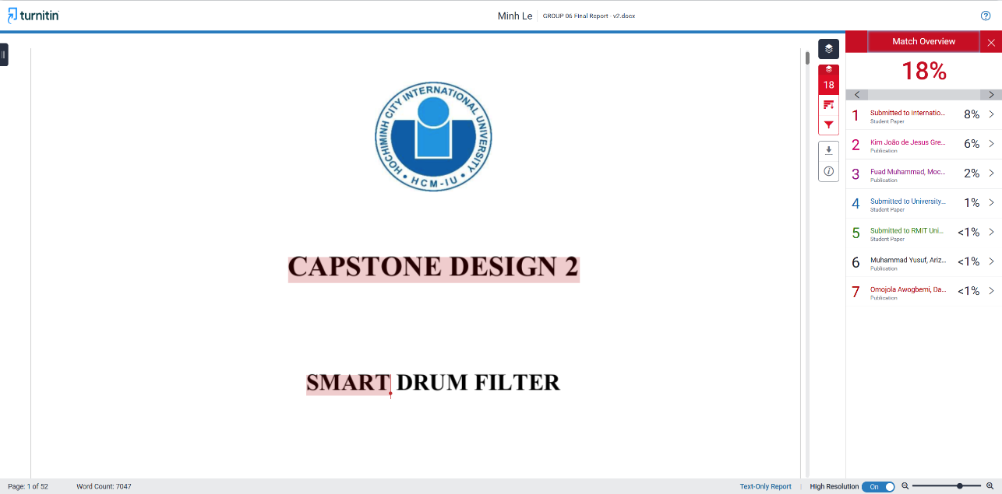

Advisor Signature Group Leader Signature
(on behalf of the group)

(Signature) (Signature)
__________________ __________________
M. Eng. Vo Minh Thanh Ta Nguyen Hoang Minh
Date: 29/05/2026 Date: 29/05/2026

ACKNOWLEGMENTS
We, the members of Group 06, would like to express our sincere gratitude to M. Eng. Vo Minh Thanh for his invaluable guidance, encouragement, and support throughout the completion of our Capstone Design 2 project. His professional mentorship and insightful feedback consistently inspired us to improve and overcome challenges during the development process.
We also wish to thank the faculty and staff of the School of Electrical Engineering, International University – VNU-HCM, for providing us with the academic foundation and resources to carry out this project successfully.

TABLE OF CONTENTS
HONESTY DECLARATION ii
TURNITIN DECLARATION iii
ACKNOWLEGMENTS iv
TABLE OF CONTENTS v
LIST OF TABLES vii
LIST OF FIGURES viii
ABBREVIATIONS AND NOTATIONS ix
ABSTRACT x
CHAPTER I - INTRODUCTION 1
1. Issue 1
1.1. The causes of water pollution in aquaculture 1
1.2. The problem with water pollution in aquaculture 4
1.2.1. Waste generation and treatment in aquaculture 4
1.2.2. External factors affecting the water environment in aquaculture 4
2. Problem Statement 6
3. Goal And Objectives 6
a. Goal 6
b. Objectives 6
CHAPTER II - DESIGN SPECIFICATIONS AND ENGINEERING STANDARDS 8
2.1. Design Specifications 8
2.2. Engineering Codes and Standards 8
2.3. Realistic Constraints 9
CHAPTER III - PROJECT MANAGEMENT 11
3.1. Budget and Cost Management Plan 11
3.2. Project Schedule 12
3.3. Resource Planning 12
CHAPTER IV - LITERATURE REVIEW 13
4.1. Optimizing community-based aquaponics: Evaluating the impact of rotary drum filter implementation on water conservation and operational efficiency [8] 13
4.2. Effect of drum filter mesh size on RAS water quality [9] 15
4.3. ESP32 Based Implementation of Water Quality and Quantity Regulating System [10] 18
CHAPTER V - METHODOLOGY 22
5.1. Objective 1: To design the overall system architecture, focus on the mechanical structure 22
5.2. Objective 2: To develop and implement the electric circuit controllable system 26
CHAPTER VI – RESULTS 29
6.1 Results 29
Objective 1: To design the overall system architecture, focus on the mechanical structure 29
Objective 2: To develop and implement the electric circuit controllable system 30
6.2 Discussions 35
CHAPTER VII - CONCLUSION AND FUTURE WORK 36
7.1. Conclusions 36
7.2. Future Work 36
REFERENCES 40
APPENDICES 41

LIST OF TABLES
Table 1: Engineering Codes and Corresponding Standards 8
Table 2: Realistic Constraints 9
Table 3: Table of Estimated Costs. 11
Table 4: Resource Planning for Project 12
Table 5: Filtration Specifications 13
Table 6: 8-week FCRs data and Water Quality parameters (3-week trial average data – full replicating) 15
Table 7: Filtration efficiency of smart drum filter operates with various type of fish waste with a stainless stell mesh size is 53μm 34

LIST OF FIGURES
Figure 1: Compares the percentage of annual increase of world population and aquaculture production, considering year 2004 as the basepoint [1] 2
Figure 2: Aquaculture ponds showing signs of organic pollution: turbid water, floating scum, reflecting surrounding construction [3]. 3
Figure 3: Fish dead by water pollution in aquaculture [6] 5
Figure 4: Gantt Chart for Project Schedule 12
Figure 5: Architecture of Water Quality and Quantity Regulating System using ESP32 19
Figure 6: Wi-Fi connection and Water flow control flowchart 20
Figure 7: Completed Frame 3D Design of Drum Filter 23
Figure 8: 3D Design of Drum Cage 24
Figure 9: Illustration of stainless steel 316 [11] 25
Figure 9: Flowchart of Programming setup washing schedule 27
Figure 10: Timer interface on the Blynk.console 28
Figure 11 Smart Drum Filter - General Mechanical Part 29
Figure 12 Smart Drum Filter - Integrated Electrical Component 30
Figure 13 Control Interface on Blynk 31
Figure 14 Control Interface using HTTP protocol 33
Figure 15 Prototype of addition external Pump control and Wattmeter (Rear view) 37
Figure 16 Prototype of addition external Pump control and Wattmeter (Front view) 38

ABBREVIATIONS AND NOTATIONS
AC Alternative Current
AES Advanced Encryption Standard
AP Access Point
BOD Biochemical Oxygen Demand
DC Direct Current
FAO Food and Agriculture Organization of the United Nations
GPIO General Purpose Input/Output
H Height
HTTP Hypertext Transfer Protocol
IoT Internet of Things
L Length
NAT Network Address Translation
PCB Printed Circuit Board
PSK Pre-Shared Key
RAS Rotary Aquaculture System
RDF Rotary Drum Filter
RL Relay
VAC Root-mean-square Voltage
W Width
Wi-Fi Wireless Fidelity
WPA Wi-Fi Protected Access

ABSTRACT
With the increasing demand for seafood consumption worldwide, the concept of Aquaculture is increasing, and the need to sustain the quality of water in the RAS has therefore emerged to be a challenge. Of the different types used, the RDF is identified to be one of the most efficient and effective mechanical filters used to remove suspended matter. Yet, the most efficient ones are relatively pricey, and there are no open-source options currently available for the small-scale implementation that the project addresses. The project, therefore, aims to design and implement the Smart Rotary Drum Filter and IoT-Based Control System. The system will make use of the ESP32 microcontroller, which will enable the automated backwashing process depending upon the real-time levels obtained from sensors and the programmed timer. Moreover, the system will also enable remote controlling and monitoring through the use of a mobile app, thereby increasing efficiency and minimizing the manpower aspect.
Keywords: RAS, RDF, Suspended Solids Removal, IoT-based Control, ESP32 Microcontroller, Automated Backwash, Remote Monitoring.

CHAPTER I - INTRODUCTION
In this chapter, there are three main sections: Issue, Problem Statements, Goal and Objectives. The first section considers the current problem concerned, the second section provides solutions for the first section, and the last one gives out expected goal and objectives needed to be carried out to complete the goal.
- Issue
This part will analyse the causes of water pollution issues in aquaculture, which lead to the aquatic species mortality such as shrimp, fish....
  - The causes of water pollution in aquaculture
Aquaculture, the farming of aquatic organisms, has been the agro-industrial activity with the highest growth rate worldwide in the last four decades [1]. From 1970 to 2008 the production of aquaculture organisms grew at a rate of 8.3% per year, compared to less than 2% of fisheries, and 2.9% of livestock [1]. The annual aquaculture production is at present over 60 million tons (including marine plants), with an approximate value of 85 billion dollars. The FAO report (Fig.1) revealed that the world population increased by 6.3% from 2004 to 2009, whereas the production of aquatic organisms by aquaculture increased by 31.5% in the same period [1].
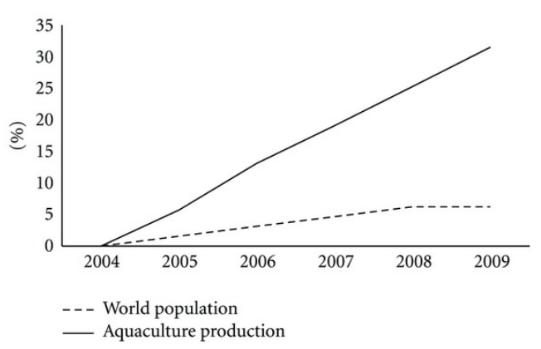
Figure 1: Compares the percentage of annual increase of world population and aquaculture production, considering year 2004 as the basepoint [1]
In recent years, fisheries and aquaculture production has reached record levels, with total production from 2022 reaching 223.2 million tonnes, of which aquaculture for the first time surpassed natural fishing, reaching 130.9 million tonnes and accounting for more than half of the total aquatic animal production [2]. This growth reflects the increasingly important role of aquaculture in meeting global food and nutrition needs, as per capita consumption has increased at 9.1 kg/year (1961) up to 20.7 kg/year (2022) [2]. However, developing rapidly in aquaculture also led to many factors many factors causing environmental changes on an increasingly large and diverse scale.
Waste from aquaculture includes sludge containing feces from aquatic species such as shrimp and fish, decaying and decomposed leftover feed, residues of materials used in aquaculture such as chemicals, lime and minerals like diatomite, dolomite, and sulfuric deposits, and toxic substances found in acidic soil. This waste is a product of anaerobic decomposition in water, and includes sediment deposited in aquaculture ponds during cleaning and dredging. Farming models with high stocking densities, such as intensive and industrial farming, generate even larger amounts of waste and have a greater impact on environmental pollution [3].
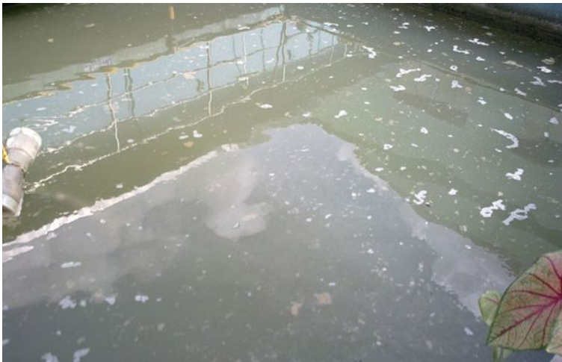
Some research results show that only 17% of the dry weight of feed supplied to aquaculture ponds is converted into biomass; the rest is released into the environment as manure and decaying excess organic matter [3]. For industrial ponds, waste can contain over 45% nitrogen and 22% other organic matter [3]. High levels of nitrogen and phosphorus in the waste cause eutrophication, leading to the growth of toxic algae in aquaculture environments [3]. This waste spreads rapidly in cage fish farming systems on rivers, and in cage fish farming in flooded wetlands... along with the spread of sediment, which can cause environmental pollution and aquatic diseases [3]. Besides that, the external environmental factors such as weather, waste from industrial production and processing, and domestic wastewater from residential and urban areas also contribute to affecting water quality in aquaculture, leading to more serious environmental pollution and causing significant economic and ecological damage.
Figure 2: Aquaculture ponds showing signs of organic pollution: turbid water, floating scum, reflecting surrounding construction [3].
The consequence of poor water quality and pollution include mass fish and shrimp mortality in coastal areas, which has occurred for many years. This has led to many shrimp farmers and some large-scale shrimp farming businesses to face financial ruin due to debt and bankruptcy. Furthermore, when seafoods get diseased, the consumers have to face with some risks such as exposure to antibiotic residues, antibiotic-resistant bacteria, and reduced nutritional quality. This not only affect human health, but also contributes to antibiotic resistance, and reduce confidence in the safety of food from sea.
  - The problem with water pollution in aquaculture

1.2.1. Waste generation and treatment in aquaculture
Aquaculture systems generate significant amounts of biological waste, primarily from leftover feed, fish feces, and dissolved nutrients derived from feed and fish metabolism. According to A. B. Dauda, A. Ajadi, A. S. Tola-Fabunmi, and A. O. Akinwole, fish feces contain 3.6–35% Nitrogen (N) and 15–70% Phosphorus (P), while excretory products contribute an additional 37–72% N and 1–62% P [4]. These waste components accumulate in aquaculture ponds as organic-rich sediments and dissolved nutrient loads [4]. The accumulation of these substances increases BOD, disrupts water chemistry, and leads to oxygen depletion [4]. It also causes changes in microbial and plankton populations, increasing the risk of eutrophication and degrading pond bottom quality [4]. These changes negatively affect fish health, reduce pond productivity, and impair ecosystem services [4]. Although farmed fish can tolerate certain nutrient concentrations, the discharge of untreated wastewater into natural water sources can seriously affect surrounding aquatic life [4].

1.2.2. External factors affecting the water environment in aquaculture
Besides internal waste from the farming system, aquaculture is also seriously affected by external factors such as industrial, agricultural, and domestic wastewater, and climate change. These sources of waste often carry heavy metals, toxic chemicals, pesticides, and organic matter, altering environmental parameters such as pH, salinity, and dissolved oxygen content, thereby degrading water quality in the ponds.
Agricultural waste, including pesticides, chemical fertilizers, and herbicides, can be washed into ponds, poisoning aquatic organisms [5]. If not treated promptly, these chemicals can cause mass mortality and degrade the farming environment [5].
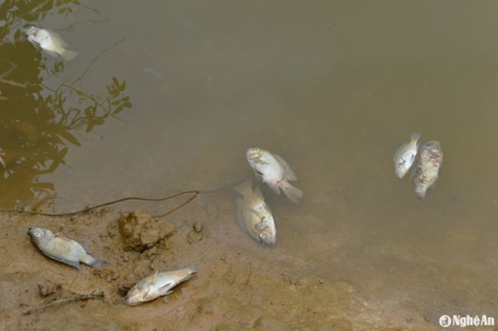
Industrial wastewater from food processing, seafood processing, paper, and dyeing factories often contain heavy metals, toxic chemicals, and organic matter. In Hanoi, it has been observed that approximately 350,000–400,000 m³ of wastewater and over 1,000 m³ of solid waste are discharged daily, but only about 10% is treated [6]. The remainder is discharged directly into rivers and streams, causing serious pollution and leading to mass fish deaths in West Lake, affecting six inner-city districts [6]. In Ho Chi Minh City, the Thanh Luong industrial cluster is a prime example, with approximately 500,000 m³ of wastewater per day from detergent, paper, and dye factories [6].
Figure 3: Fish dead by water pollution in aquaculture [6]
Climate change is also a worrying external factor. Changes in temperature, pH, and dissolved oxygen levels in water exceed the tolerance threshold of aquatic life, causing stress or death [7]. Simultaneously, these factors increase the toxicity of certain compounds such as NH₃, H₂S, NO₂, etc., creating favourable conditions for disease development [7]. Without close monitoring and the application of appropriate technical measures, the risk of disease outbreaks and spread is very high, leading to mass fish deaths and water pollution in aquaculture ponds due to decomposing carcasses.
- Problem Statement
To solve one part of these problems: how to remove the waste generated during aquaculture. Our group will design a drum filter system that can effectively remove solid waste such as fish feces, leftover feed, and organic matter before they accumulate and degrade water quality.
- Goal And Objectives
  - Goal
To design and develop a smart drum filter system capable of remote control and monitoring to optimize operational costs.
  - Objectives
  - Objective 1:
To design the overall system architecture, focus on the mechanical structure (drum, supporting frame, and water flow system…).
- Task 1.1: Design the mechanical structure – drum, supporting frame, housing
- Task 1.2: Searching and select suitable materials – mesh size, cleaning pump, motor.
- Task 1.3: Assemble the prototype
  - Objective 2:
To develop and implement the electric-controllable system
- Task 2.1: Develop a hardware that using microcontrollers for remote control and monitoring.
- Task 2.2: Coding and integrating the electronic circuit into the drum filter system

CHAPTER II - DESIGN SPECIFICATIONS AND ENGINEERING STANDARDS

2.1. Design Specifications
Drum Cross-sectional Area: $P=πr^{2}=π{(0.11)}^{2}=0.0121π \left(m^{2}\right)$
Volume of the Rotatable Strainer :
$$V=430×390×370×{10}^{-9}=0.062049 m^{3}(=62.049 l)$$
Flow Velocity: $v=\frac{Q}{A}=\frac{5}{0.0121π}≈131.533 \frac{m}{h}=0.036 \frac{m^{3}}{s}$
Retention Time: $t=\frac{V}{Q}=\frac{0.062049}{5}=0.0124098 h=44.67528 s$
Deposition Rate: $R_{d }=k_{d}CA={10}^{-7}×0.0121×π×C=121×{10}^{-11 }πC$
- C is concentration of cultured species $\left(\frac{kg}{m^{3}}\right)$

Engineering Codes and Standards
Table 1: Engineering Codes and Corresponding Standards
Element/Product/System | Engineering Standards | Comments
4058Z-555 Motor | IEC 60034-1 | Defines the physical performance and rating for rotating DC machines.
ESP8266 NodeMCU | IEEE 802.11 b/g/n | Wi-Fi 2.4GHz communication protocols.
Pump (OEM) | IEC 60529 | The international standard that defines the testing for its IP68 submersible rating.
Songle Relay | IEC 61810-1 | The core standard for low-voltage electromechanical relays
Float Sensor (OEM) | IEC 60529 | Defines the IP68 waterproof enclosure rating for the plastic housing and seal.
Power Supply | IEC 60950-1 | The legacy standard that generic metal-mesh power supplies are modeled after.

Realistic Constraints
Table 2: Realistic Constraints
Area | Realistic Constraints
Economicity | <200 USD – Cost-effective materials and minimum electric components
Environment | - Sound: Mechanical actuators and fluid pumps generate acoustic noise that may be disruptive in isolated or quiet environments.  - Aquatic: Submerged operational components require durable, non-toxic, and corrosion-resistant materials to prevent water contamination.  - Ecological: System design necessitates the use of RoHS-compliant electronics and recyclable structural frame materials.  - Aerial: Brushed DC mechanical actuators emit trace carbon dust particulates during extended operation.
Health and Safety | Inherent risk of electrical shock when integrating low-voltage sensory circuits with high-voltage mains power in wet environments. Potential fire hazards exist due to improper thermal management or unregulated power supplies driving continuous-duty microcontrollers.
Manufacturability | Supply chain reliance on imported semiconductor fabrication for wireless IoT communication modules. Ensuring consistent waterproof sealing (IP68) and mechanical tolerance reliability during the assembly of submerged electromechanical sensors.
Sustainability | Electromechanical sensors and mechanical relays possess a finite operational lifespan due to physical wear and contact degradation. While automation reduces physical waste, the demand for specialized electronic circuit maintenance increases.
Ethicality | Global environmental and labor implications concerning the extraction of raw materials required for semiconductor manufacturing. Potential data privacy vulnerabilities regarding unauthorized access to connected IoT management dashboards and sensor telemetry.
Social | System automation significantly reduces manual maintenance labor, promoting overall operational efficiency. However, a strict reliance on web-based IoT interfaces and digital dashboards may alienate end-users with limited technical literacy.
Political | Global trade regulations, tariffs, and semiconductor export restrictions impacting the procurement of wireless communication modules. Mandatory compliance with regional electrical safety directives (e.g., Vietnam TCVN, IEC standards) for safe domestic or industrial deployment.
Measurement | Dimensions: 430 (L) x 390 (W) x 370 (H) mm  Weight: <6 kg - Portable

CHAPTER III - PROJECT MANAGEMENT

Budget and Cost Management Plan
This part includes a details description about how cost of the project may be managed, listed with all the required components and devices.
Table 3: Table of Estimated Costs.
Item | Description | Quantity | Unit Price (USD) | Total Cost (USD)
MCU | ESP8266 NodeMCU Modded (Micro USB) | 1 | $2.99 | $2.99
Sensors | Float Switch 40cm (OEM)  (2 wire, 110 V - 220 VAC, deactivate threshold 10MΩ, 20-80 Celcius operational threshold) | 1 | $1.82 | $1.82
Relay | SRD-05VDC-SL-C | 2 | $0.33 | $0.66
Motor | 4058Z-555 | 1 | $8.16 | $8.16
Pump | DC 12V/24V Brushless Submersibe Pump (800L/H, 5m lift) | 1 | $6.96 | $6.96
Board | PCB (Green) manufactures | 1 | $2.09 | $2.09
Frame | PP, PVC, manufactures | 1 | $120 | $120
Miscellaneous | Screws, adhesive, headers, etc. | - | $10.00 | $10.00
Total Estimated Cost (Exclude Shipment fees) |  |  |  | $152.68

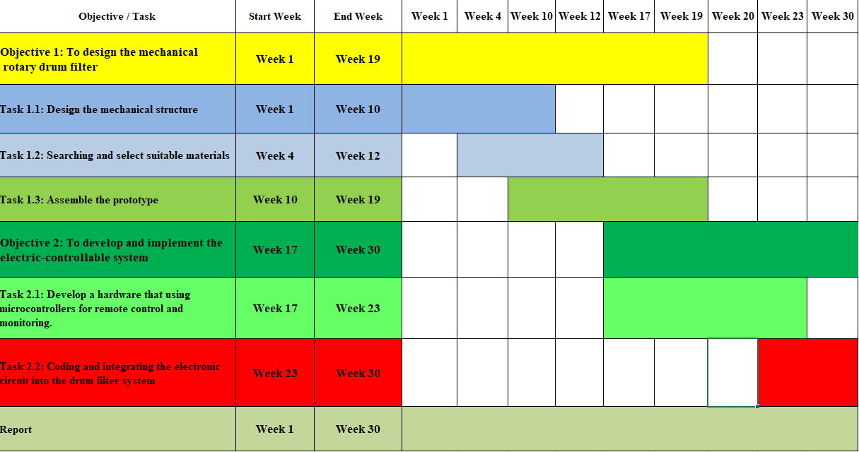
3.2. Project Schedule
Figure 4: Gantt Chart for Project Schedule

3.3. Resource Planning
Table 4: Resource Planning for Project
Number | Full name | Student ID | Role | Tasks
1 | Tạ Nguyễn Hoàng Minh | EEEEIU22084 | Group  Leader | Management group's work, writing report, design the mechanical structure, coding and integrating
2 | Lê Đức Minh | EEEEIU22074 | Member | Writing report, assemble the prototype, verify and perform product
3 | Lê Hữu Thắng | EEEEIU22081 | Member | Coding and integrating, design the mechanical structure, verify and perform product
4 | Nguyễn Văn Vĩnh | EEACIU22174 | Member | Develop the hardware, assemble the prototype, verify and perform all tests
5 | Vương Thanh Tùng | EEEEIU22079 | Member | Writing report, Presentation slide, Searching for materials

CHAPTER IV - LITERATURE REVIEW
Following a review of articles related on drum filter innovations in aquaculture, it is identified with several studies that are particularly relevant to the project. Initially, the first study case, “Optimizing community-based aquaponics: Evaluating the impact of rotary drum filter implementation on water conservation and operational efficiency” (2025) [8], shows the efficiency of the rotary-typed drum filters along the general parameters for such choice, while the second, “Effect of drum filter mesh size on RAS water quality” (2025) [9], implemented with the mesh size comparison over their specific treatment efficiency. Additionally, it may be profound that integration of a microcontroller is used to compatibly communicate between analogue encounter and the toggle of the system’s function through digital platform and it is entirely entitled to is “ESP32 Based Implementation of Water Quality and Quantity Regulating System” [10].

4.1. Optimizing community-based aquaponics: Evaluating the impact of rotary drum filter implementation on water conservation and operational efficiency [8]
In this study case the researchers were investigating the application of rotary drum filter in aquaponic system (combine between aquaculture and hydroponics). The rotary drum filter utilized in this study is equipped with several technical specifications designed to optimize efficiency in water filtration process in Table 5.
Table 5: Filtration Specifications
Filtration Component | Specification
Type | Rotary Drum filter
Water Flow | Max. 5m³/h
Cleaning Pump | 80W
Drum Motor | 15W
Screw Mesh | 200 mesh, SS 316 material
Water inlet | 32 mm x 2
Water outlet | 40 mm x 2
Sewage Outlet | 32 mm
Body Dimensions | 430 x 390 x 370 mm
Roller Diameter | 220mm
Roller Length | 200mm
Screw Material | SS316L
Case Material | PP
Based on several months of operational experience in the community, the researchers concluded that alternative from RDF would provide significant benefits on environment, technique, and finance. But more notable improvement was the complete elimination of routine water replacement, resulting in full reductant as water use. This translates into substantial cost savings and improved system sustainability.
Additionally, the RDF consistently maintained high water quality to avoid water population in aquaculture by the incessant removal of most impurities and suspended solids. This automated filtration process also reduced labour needs, minimizing the time required for manual cleaning and monitoring of the system. However, the high cost to investment for rotary drum filter, which relatively high energy consumption due to continuous drum rotation and backwashing. Besides that, the devices like timer and cleaning pump can consume amount of power so it can be reducing operational flexibility Not only that as it requires strong and precision mechanical component because these components must be under the water in long-term. Notwithstanding, these disadvantages are not too significant and can be overcome by using smart integrated electronic devices.

4.2. Effect of drum filter mesh size on RAS water quality [9]
The research paper shows that the system of RAS with drum filter, inseparable with a role in recirculating aquaculture systems by removing suspended solids production subject, is partial for its optimization of performance due to the fact that it directly affects water quality as well as investment and operating costs. The most from significant parameters influencing drum filter performance is the mesh size of the filter screen. The study investigated using three divergent stainless steel mesh categories by 70-45-30 (µm) in size and a control system apart from rotary encasement to filtration, applying an eight-week trial with all treatments run in triplicate [9].
In this experiment, all systems were set up to operate under the same conditions, and added make-up water no such additional, was despite backwashing. This allowed the researchers to isolate the effect of mesh size on water quality.
Table 6: 8-week FCRs data and Water Quality parameters (3-week trial average data – full replicating)
Treatment | Control |  | 70um |  | 45um |  | 30um
Empty Cell | Average | Std. Dev. | Average | Std. Dev. | Average | Std. Dev. | Average | Std. Dev.
Nitrate  (mg NO3-N l−1) | 43.3 | 1.2 | 40.1 | 1.7 | 40.1 | 1.3 | 40.4 | 0.4
Nitrite  (µg NO2-N l−1) | 193.6 | 47.8 | 268.2 | 37.2 | 136.3 | 28.7 | 167.5 | 30.1
Ammonium  (µg NH4-N l−1) | 120.9 | 1.1 | 109.7 | 15.3 | 90.6 | 7.1 | 84.2 | 5.9
Orto-phosphate (mg PO4-P l−1) | 1.60 | 0.12 | 1.29 | 0.08 | 1.13 | 0.07 | 1.14 | 0.12
Total phosphate (mg PO4-P l−1) | 1.83 | 0.15 | 1.49 | 0.03 | 1.24 | 0.08 | 1.24 | 0.14
Num. of particles (million ml−1) | 2.89 | 1.51 | 2.19 | 0.90 | 1.14 | 0.64 | 1.27 | 0.69
Vol. of particles (mm3 ml−1) | 0.026 | 0.007 | 0.012 | 0.004 | 0.099 | 0.007 | 0.008 | 0.005
S. A. of particles (mm2 ml−1) | 27.7 | 9.0 | 21.9 | 3.9 | 13.0 | 6.8 | 12.7 | 5.7
β value | 3.87 | 0.12 | 4.44 | 0.21 | 4.17 | 0.37 | 4.31 | 0.22
Turbidity  (FNU) | 6.3 | 1.7 | 3.4 | 0.9 | 2.4 | 0.6 | 2.5 | 0.6
UV transmission (%) | 55.3 | 3.1 | 53.9 | 1.2 | 56.3 | 1.7 | 55.5 | 1.9
H2O2  (k−1) | 0.72 | 0.28 | 0.50 | 0.15 | 0.36 | 0.21 | 0.35 | 0.13
Bactiquant | 82862 | 27861 | 63039 | 26531 | 60318 | 41990 | 57405 | 25994
BOD5-Tot  (mg l−1) | 6.66 | 1.25 | 5.04 | 0.82 | 3.39 | 1.00 | 3.53 | 0.81
BOD5-Diss  (mg l−1) | 1.29 | 0.21 | 1.33 | 0.19 | 1.40 | 0.25 | 1.25 | 0.18
BOD5-Part  (mg l−1) | 5.37 | 1.22 | 3.71 | 0.84 | 2.00 | 1.06 | 2.29 | 0.82
CODTot  (mg l−1) | 36.5 | 3.1 | 33.1 | 1.4 | 28.6 | 1.9 | 29.1 | 1.8
CODDiss  (mg l−1) | 25.0 | 1.8 | 27.9 | 1.0 | 26.0 | 0.9 | 26.4 | 1.2
CODPart  (mg l−1) | 11.5 | 2.6 | 5.2 | 1.3 | 2.6 | 1.4 | 2.7 | 1.0
FCR | 0.86 | 0.02 | 0.85 | 0.02 | 0.79 | 0.02 | 0.82 | 0.01
Based on the results (Table 6), the research demonstrated that mechanical filtration significantly improved water quality parameters compared to the control. Reducing the size of the mesh at the number that in the range of 70-45 (µm) has repulse to the result of noticeable advances in most collating categories, including ammonium, nitrite, phosphate, turbidity, and particle count. However, restrain the mesh size down to 30 micrometres did not provide additional improvement in water quality. Instead, it increased operational costs due to more frequent backwashing and reduced flow capacity. This experiment demonstrates that a filter mesh with a size of 45 µm is the most effective.
The study also highlighted that while smaller mesh sizes improve the removal of fine suspended solids, extremely small meshes can cause practical problems. These include reduced water flow, a higher chance of clogging, increased particle breakage, and more frequent cleaning cycles. Such issues lead to greater energy consumption, higher water usage, and more maintenance. Therefore, choosing a suitable mesh size requires balancing filtration efficiency with long-term system stability and operating cost.

4.3. ESP32 Based Implementation of Water Quality and Quantity Regulating System [10]
Following the articles, the research groups propose a model using to monitor the water quality and quantity of elevated reservoirs in cities, residential areas, universities, and other locations. It is decided to use iOT method by using the microcontroller ESP32 with Blynk to communicate data with the help of a phone/PC. Water quality is monitored by the various parameter of chemical on water like pH and electrical conductivity and parameter of physical on water like temperature and turbidity. Based on the evaluation of these authors, ESP32, which is used in this work has the advantages of low cost, high frequency, and built-in sensors (temperature, hall effect sensors like touch sensors), both WAN and PAN integrations are present, speed up to 150 megabit per second, ten pin ADC, module of power management, low-noise amplyfing receiver, security, filtering, etc. and install easily. Besides that, the researchers also integrated some sensors so that it can easily be monitoring water quality and quantity. Eventually, there is Figure 5 to show the flowchart of how the circuit function.
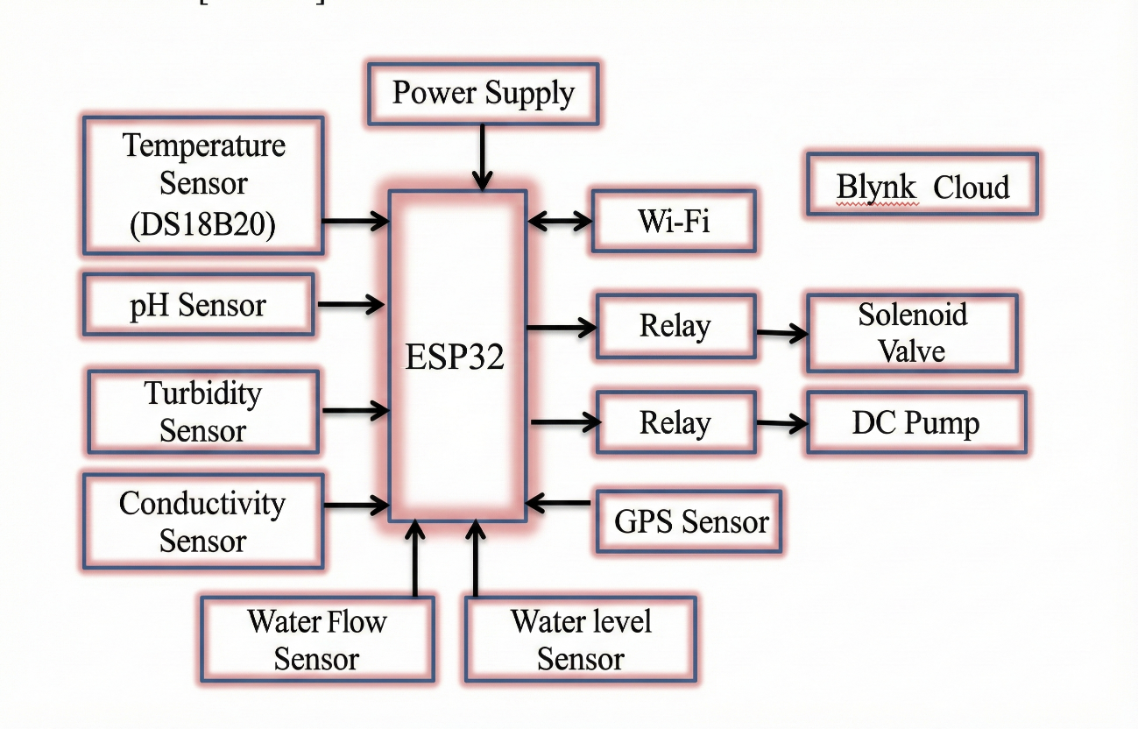
Figure 5: Architecture of Water Quality and Quantity Regulating System using ESP32
Additionally, this studies case has presented the use of microcontrollers combined with Wi-Fi modules to monitor and control water supply systems. Specifically, the water level in the tank is measured by sensors, when the water level falls below the allowable threshold, the solenoid valve and pump will be activated to add water (Fig.6). The measurement data is transmitted to the cloud platform at a predetermined cycle, allowing users to monitor and manage remotely via smart devices. This case study shows that the ESP32 can easily connect and link with other electronic devices, such as various types of sensors and control by using Wi-Fi module. In spite of the fact that sensors were applied to quality monitor such as pH sensors, GPS sensor, but this confirm ESP32 can connect with float switch, relay, DC pump to remote monitor and control.
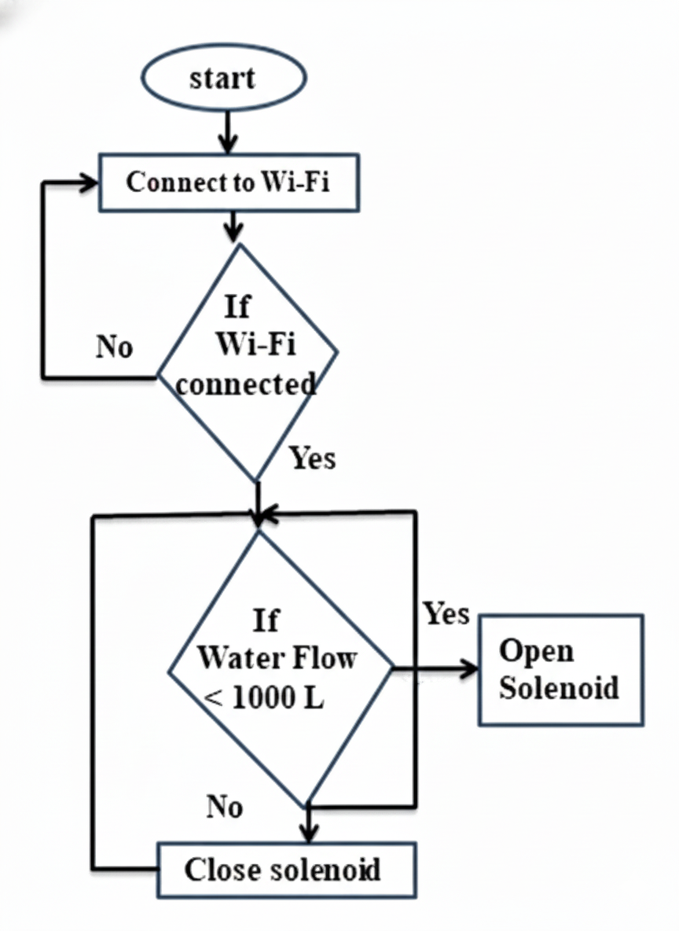
Figure 6: Wi-Fi connection and Water flow control flowchart
Following the research papers, the results of using ESP32 and Blynk for communication is positive. The effectiveness of this microcontroller is not only easy to connect with other components but also cost-effective and beneficial for monitoring the water quality. Additionally, the ESP32 widely used because it is integrated available Wi-Fi and Bluetooth, low power consumption and cost effectively, eliminating the additional hardware require. Although, the study case is focus on water quality monitor, but this approach shows the potential in integrating iOT technology to remote monitoring and controlling mechanical processes, such as drum filter operation in water treatment systems.

CHAPTER V - METHODOLOGY
Aiming to improve aquaculture efficiency, minimize environmental impact, and enhance water quality management. The goal of our group is to design and develop a smart drum filter system to remote control and monitoring to reduce waste and operational cost in aquaculture. The methodology included two main objectives. The first one is designing a mechanical structure for drum filter so that it can operation normally by deductive minimize the waste in aqua ponds. The second is develop an electric circuit using ESP32 to remote and monitoring the drum filter.

5.1. Objective 1: To design the overall system architecture, focus on the mechanical structure
Task 1: Design the mechanical structure – drum, supporting frame, housing
Based on the rotary drum filter that using in an article "Optimizing community-based aquaponics: Evaluating the impact of rotary drum filter implementation on water conservation", the mechanical structure of the drum filter will be designed with some parameter adjustments.
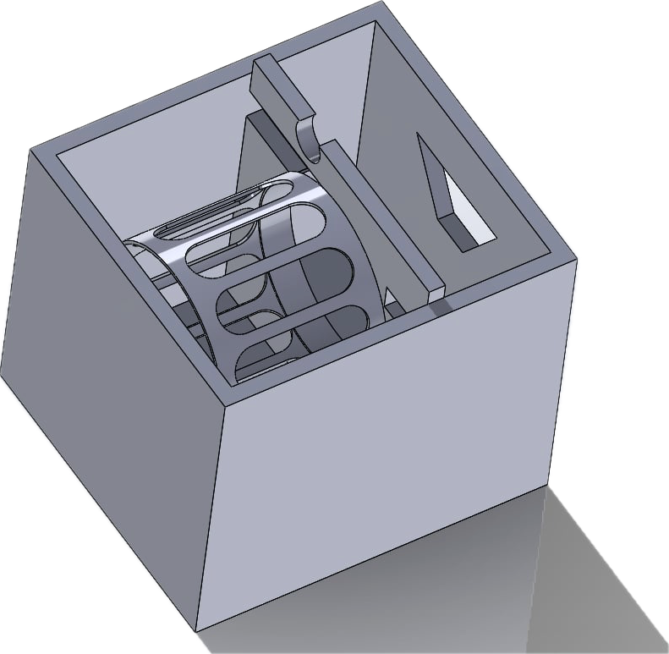
Figure 7: Completed Frame 3D Design of Drum Filter
The filter drum components are designed in 3D using SolidWorks software, with a body size of 430mm (Length) x 390mm (Width) x 370mm (Height). Additionally, sewage outlet on the body frame has a radius of 32mm, and the water inlet has been adjusted from two 32mm radius holes to one 30mm radius hole. The water outlet has also been slightly modified to two 30mm radius holes.
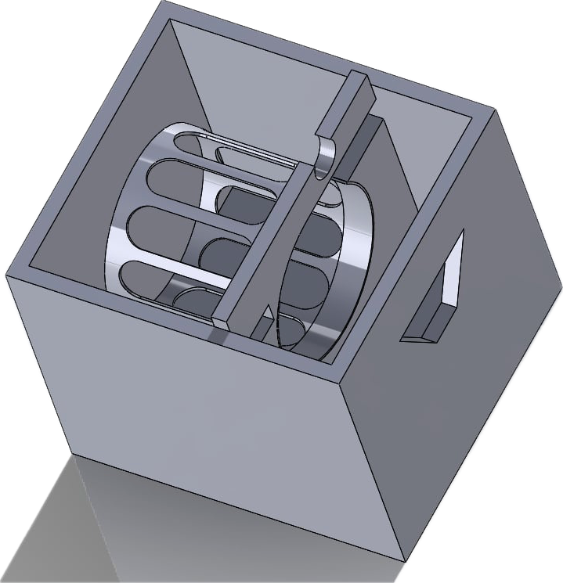
Additionally, the rotating drum cage has a diameter of 220mm and a length of 250mm. This size was chosen to strike a balance between practicality and performance: it provides a sufficiently large surface area for efficient filtration while keeping the prototype compact and lightweight. The chosen dimensions ensure that the drum can be easily fabricated, meet the motor's torque requirements, and be tested under laboratory conditions without excessive energy consumption.
Figure 8: 3D Design of Drum Cage
Task 2: Searching and select suitable materials – mesh size, cleaning pump, motor
According to the related research (Literature Review 4.2), the result has shown the mesh size of 45μm getting the most significant efficiency of filtering out the toxicity in the term of concentration unit. Therefore, the parameter of mesh size should be in the range from 70μm to 45μm. For the system to be stabled, the mesh size should be 53μm, made from Stainless Steel 316 (Fig.9), ensuring corrosion resistance and durability over extended use.
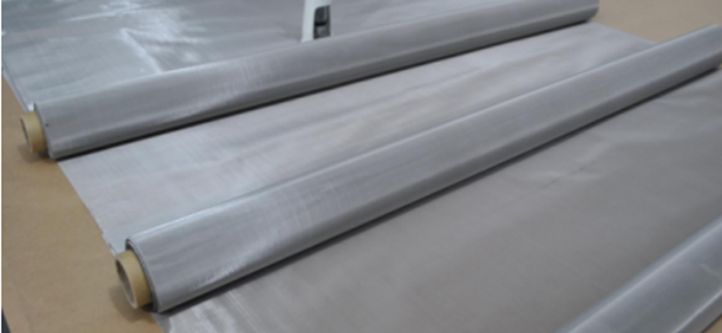
Figure 9: Illustration of stainless steel 316 [11]
Besides that, Polypropylene (PP) was chosen for the main housing and frame of the drum filter due to its superior chemical resistance and durability in wet environments. Polyvinyl Chloride (PVC) was selected for auxiliary parts such as piping and protective casings, where rigidity and low cost are prioritized.
Task 3: Assemble the prototype
In this task, a prototype rotary drum filter was assembled based on the mechanical structure in Task 1.1 and the components in Task 1.2. For the assembly, the components, drum, frame, motor, and water delivery system were assembled to form a complete system. Additionally, to ensure sturdy and water resistance, several components were used, such as bracing to maintain the slope of the trough and prevent sediment accumulation, stainless steel bolts to securely fix the drum frame, and rubber gaskets to prevent leaks and reduce vibration. Furthermore, the prototype was tested to ensure correct alignment and the ability to filter dirty water.

5.2. Objective 2: To develop and implement the electric circuit controllable system
Task 1: Develop a hardware that using microcontrollers for remote control and monitoring.
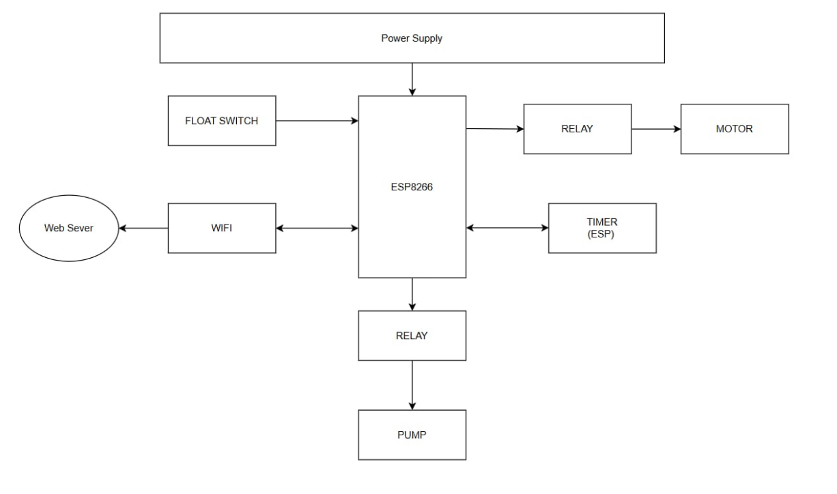
Figure 8: Flowchart of the electric circuit
In this part, our group will use the ESP8266 as the main microcontroller to enable control and remote monitoring of the system. A float switch will be connected to the ESP8266 through a digital input pin, allowing the microcontroller to detect the water level status. We also establish relay into motor and pump then will be connected to the digital output pins of the ESP8266, and these relays will in turn control external devices such as the pump and the motor. By using relays, the system can safely separate the higher voltage required by the pump and motor from the low‑voltage logic of the ESP8266 which only tolerate below 5V, thus preventing any damage to the microcontroller.
The Wi-Fi module and the timer were integrated into ESP8266. Therefore, through a host web server Blynk, enabling users to monitor the water level and remotely control the pump or motor from a smartphone or computer. The timer functionality will support scheduling or automation tasks, making the system more efficient and reliable.

Task 2: Coding and integrating the electronic circuit into the drum filter system
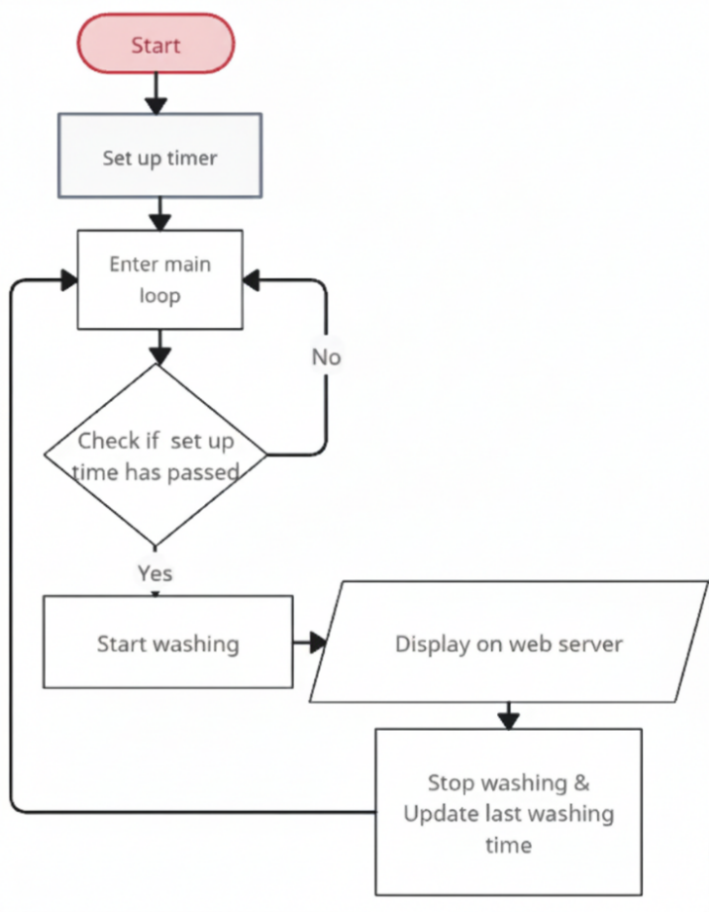-
Figure 9: Flowchart of Programming setup washing schedule
In this section, our group will program a system where the user sets a schedule in advance through a web server “Blynk” for automatic cleaning. When the set time is reached, the system will automatically activate, and the cleaning pump and rotating drum will begin operating. After the cleaning process is complete, the system will update the rinsing time and repeat the process. Besides that, we also code some function to control the motor and cleaning pump. Additionally, the status of rotary drum filter will display on Blynk.console, which interface has many available functions and is easy to use.then we can easily monitor water level.
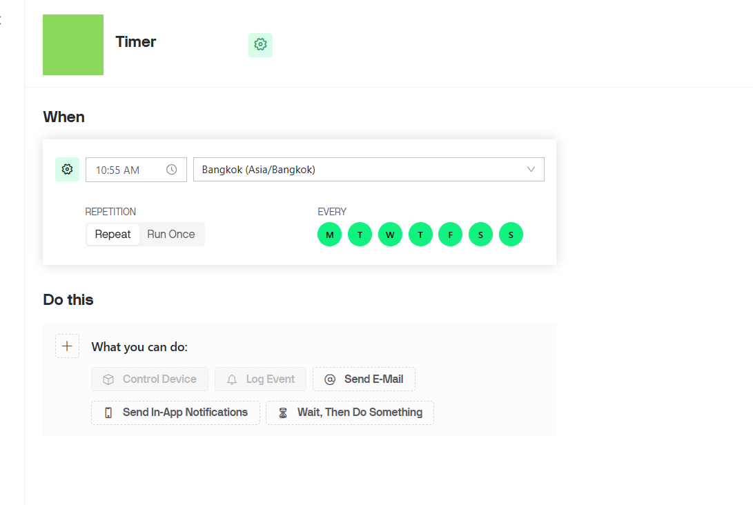
Figure 10: Timer interface on the Blynk.console

CHAPTER VI – RESULTS

Results

Objective 1: To design the overall system architecture, focus on the mechanical structure
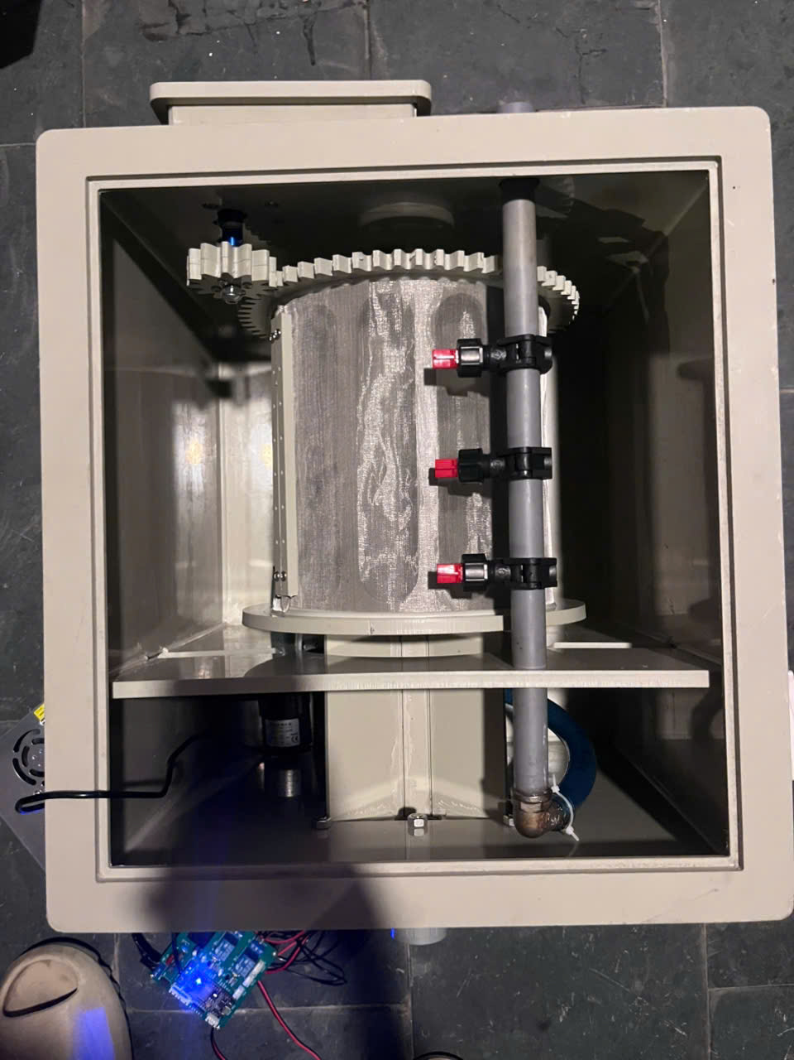
Figure 11 Smart Drum Filter - General Mechanical Part

In Figure 11, as the matter of verification from Methodology – Part 5, all components have been being assembling and completed. The checklist includes Housing Frame, Rotary Frame and its compatibly functional components. In general, with the required voltage from power regulatory (24V), the filtration affirms the flawlessness in sustenance of operation with the DC Pump and DC Motor.

Objective 2: To develop and implement the electric circuit controllable system
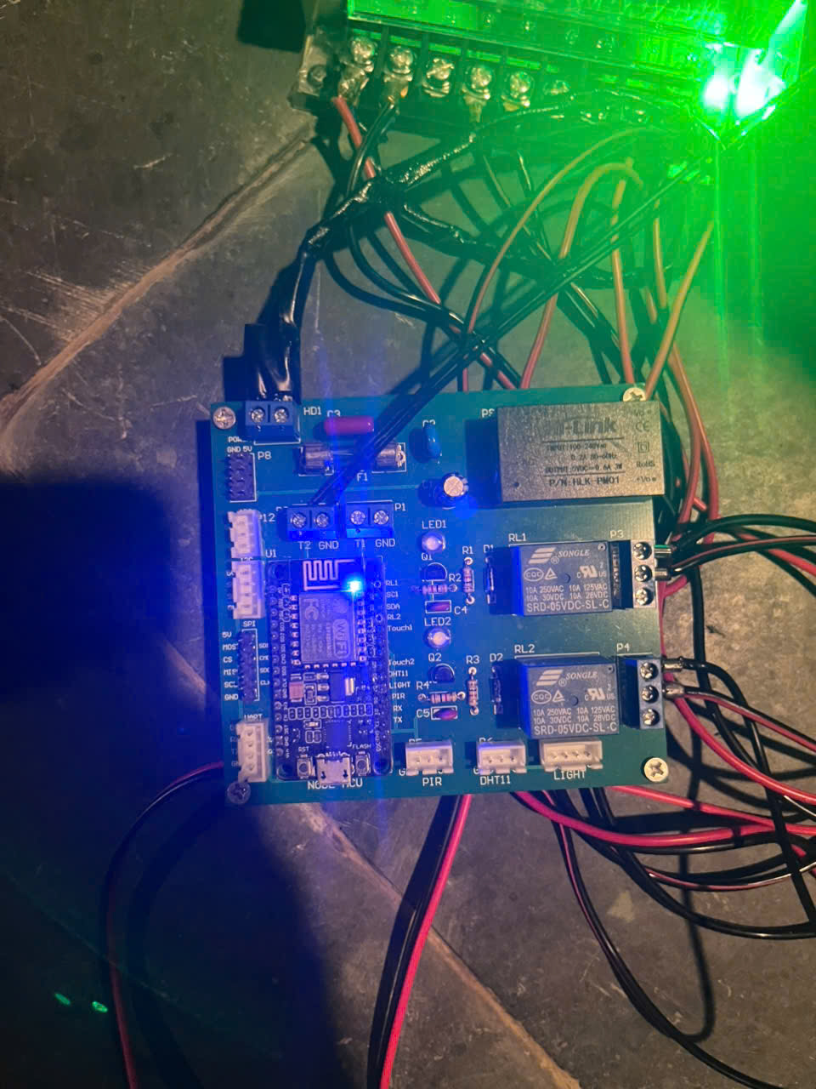
Figure 12 Smart Drum Filter - Integrated Electrical Component
In Figure 12, Relay 1 (RL1) is used to toggle Pump and Relay 2 (RL2) is Motor. Upon any of these components’ activation, indicators LED1 and LED2 are responsible for Pump and Motor, respectively, in the physical aspect. While in virtual side, the blue-shining indicator (Figure 12) shows in real-time, the status of Wi-Fi connection. This circuit practically uses 220 VAC, so it will not be dependence on the Power Regulator.
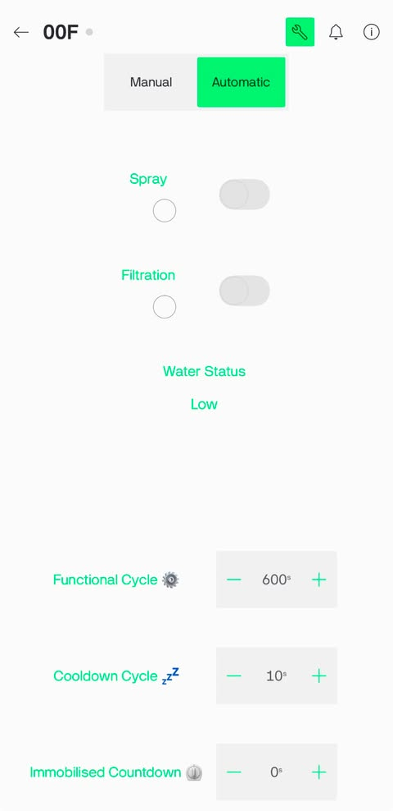
Figure 13 Control Interface on Blynk
Switching to Virtual Platform, Figure 13 shows User Interface on Blynk console app on Takeaway Device or it can be accessed by Fixed Platform on Devices - Blynk.Console using this login certificate Vlimenether101@gmail.com/V1im3n3t43r3o3.
Automatic mode, which includes 3 Timers (seconds):
  - Functional Cycle: set Motor and Pump on (Interval of activating)
  - Cooldown Cycle: set Motor and Pump off (Interval of waiting for the external Pump’s activate)
  - Immobilised Countdown: deactivate all and switching back to Manual mode as the timing ends
This mode only activates under the condition of Water Status: Sufficient
Manual mode:
  - Spray: toggle Pump
  - Filtration: toggle Motor
In Figure 13, the respective indicators under the denotation “Spray” and “Filtration” are the physical feedback of real-time.
This mode’s Water Status is barely a notification but none of constrain to the control and these switches may be disabled if Automatic mode is ON.
Blynk is a global network communication interface, promises with its messaging protocol of the security of TLS 1.2/1.3 certificate, and used for the convenience of remote control. However, within the inference of doubt, here transfers the local-network communicating intersection.
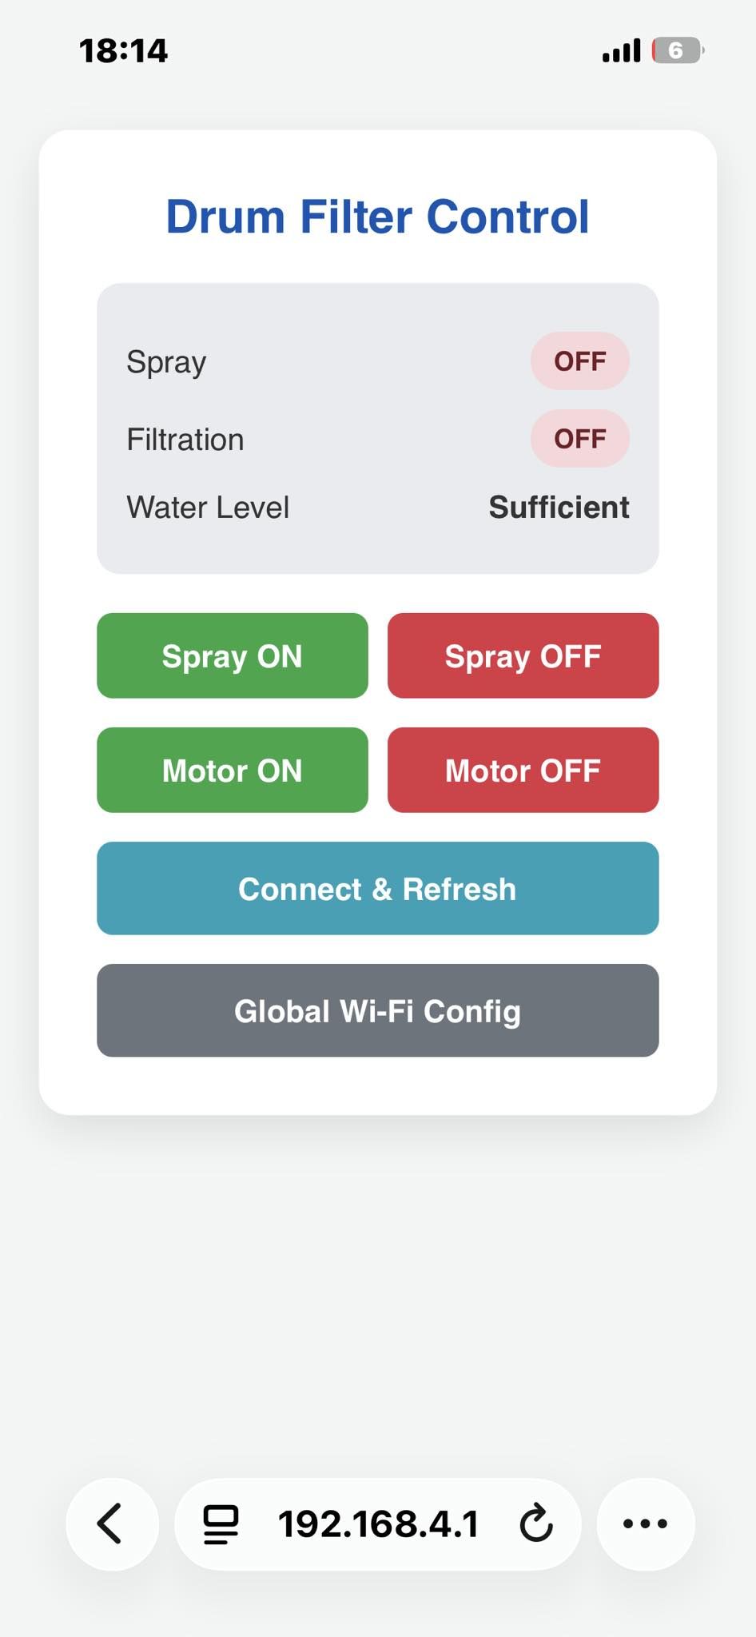
Figure 14 Control Interface using HTTP protocol
In Figure 14, this interface can also replace as internal control platform and concurrently, network bridging configuration for Blynk. It merely transfers HTTP onto microcontroller over its broadcast AP AES/PSK using login certificate WPA Drum Filter System Configuration/V1im3n3t43r3o3.
Alternatively: http://drumfilter.local / 192.168.4.1
As the matter of security, in spite of unsecured HTTP protocol, this practically is an isolated communication form by the cutout of NAT. Therefore, no global network connection (Usually household Wi-Fi connection) can control (Crash as “No network connection” immediately) and only hold the ability as the fact that the controlling device submits to the previous WPA certificate.
Table 7: Filtration efficiency of smart drum filter operates with various type of fish waste with a stainless stell mesh size is 53μm
Scenerio | Run | Input | Sewage Output  (5 minutes) | Filtration efficiency (%)
Fish feeds,  (large medium-sized residue, easily disintegrated) | 1 | 1,2g | 1.08g | 90%
 | 2 | 1,2g | 1.05g | s87.50%
 | 3 | 1,2g | 1.07g | 89.16%
 | Average | 1.2g | 1.07g | 89%
Fish Waste / Organic Sludge  (Small particles, suspended) | 1 | 20g | 16g | 80%
 | 2 | 18.2g | 15.2g | 83,52%
 | 3 | 17.6g | 14.1g | 80.11%
 | Average | 30g | 15.1g | 81.21%
Mixture | 1 | 23.6g | 14.2g | 60.17%
 | 2 | 21.2g | 12.9g | 60.85%
 | 3 | 20.4g | 12.4g | 60.78%
 | Average | 21.7g | 13.17g | 60.61%

In Table 7, the results show the smart drum filter operate stable and effective with the fish pellets has reached very high residue recovery in 5 minutes about 89%, the filtration can be removed totally the sewage in a long-time range. Besides that, fish waste/organic sludge also retains over 80%, while the simulated mixture maintains a stable efficiency around 60%. This proves that the device has the ability to handle a variety of waste types, particularly effectively with easily settling solid particles and organics.

Discussions
As observed from the result figures, the system demonstrated functional performance across both its mechanical and electronic subsystems. In the control experiment, the collected data from the filtration infirmed the functionality of the system. Two independent remote-control interfaces were confirmed operational: the Blynk mobile application successfully displayed real-time water status and allowed toggling of the Spray and Filtration functions over a cloud connection, while a local web interface provided an alternative control channel via internal-hosted AP, offering manual ON/OFF control for the pump and motor without relying on internet connectivity. The PCB has operated successfully with minimal delay control and error-free over minimal-priced microcontroller ESP8266 and isolated-protecting layer. This design is to be adaptive to control any power continuous actuators and voltage regulator so it is convenience for any replacement or even an upgrade. Furthermore, there are reserved headers for additional sensors indicating the board's expandability for future development and an analogue GPIO of microcontroller is used.

CHAPTER VII - CONCLUSION AND FUTURE WORK

7.1. Conclusions
This project successfully achieved its main objective: designing and implementing an intelligent rotary drum filtration system with an integrated IoT control system. The system utilizes a robust mechanical structure (using 316 53 µm stainless steel mesh) and an ESP8266 microcontroller to efficiently and automatically remove suspended solids from aquaculture water. Leveraging the Blynk platform, users can remotely control the system and seamlessly schedule backwash cycles via smart devices, significantly reducing labour and operating costs. Furthermore, the project was successfully completed within a budget of $200. In conclusion, this intelligent drum filtration system provides a practical, economical, and sustainable solution for recirculating aquaculture systems (RAS), minimizing water pollution and maintaining high water quality.

7.2. Future Work
While the current prototype has effectively automated the mechanical filtration process, future improvements could significantly enhance its automation by integrating the external pump onto Automatic mode with real-time turbidity sensor as feedback to optimize operational sustenance (in finance) and optimize the ESP8266 potential of Analogue GPIO integrating with a Wattmeter to record monthly the power consumption of the system.

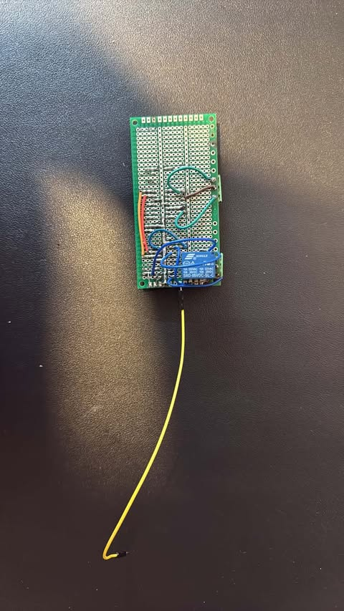
Figure 15 Prototype of addition external Pump control and Wattmeter (Rear view)
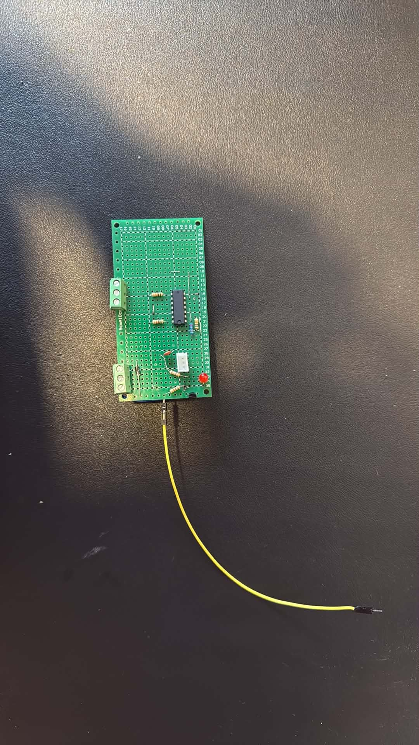
Figure 16 Prototype of addition external Pump control and Wattmeter (Front view)

In Figure 15 and Figure 16, this is an integrated logical Wattmeter (no real-time display) and the logical circuit to trigger the external pump (no feedback) in Automatic mode only. However, the Wattmeter’s weakness is only applicable on the case the Voltage Require of all continuous actuators such as Pumps and Motor must be the same and DC. Concurrently, it is a protector layer to separate the AC component from dangerous mistouching.
Aside from lucid-oriented improvement, algorithm of timer should be included on the list for future operation to be automized with Machine Learning ability, choosing what best time to run and stop, rather than just a mere fixed timers so that it could optimize the operation. About power, renewable energy sources such as solar panels may be applied for optimized consumption and a replacement, in case that the household power is down. About network, it must be integrated with the module of backup mobile internet to reconnect to global control (Blynk), in case that the network provider is down.

REFERENCES
[1] | M. Martínez-Porchas, L. R. Martínez-Córdova and R. Ramos-Enriquez, "World Aquaculture: Environmental Impacts and Troubleshooting Alternatives," The Scientific World Journal, vol. 2012, 2012.
[2] | F. a. A. O. o. t. U. Nations, "FAO Report: Global fisheries and aquaculture production reaches a new record high," 7 June 2024. [Online]. Available: https://www.fao.org/newsroom/detail/fao-report-global-fisheries-and-aquaculture-production-reaches-a-new-record-high/en.
[3] | C. T. T. S. x. T. m. T. h. T. Gia, "Những ảnh hưởng tiêu cực của ngành nuôi trồng thủy sản đến môi trường," 6 October 2020. [Online]. Available: https://luoitrangia.com/blogs/news/nhung-anh-huong-tieu-cuc-cua-nganh-nuoi-trong-thuy-san-den-moi-truong.
[4] | S. Melaku, S. Mengestou, A. Getahun, A. Geremew and A. Belay, Environmental Impacts of Wastes and Contaminants from Aquaculture and Their Remediation Techniques, IntechOpen, 2024.
[5] | T. c. T. s. V. Nam, "Phòng ngừa và khắc phục ô nhiễm nước trong nuôi thủy sản," 6 May 2025. [Online]. Available: https://thuysanvietnam.com.vn/phong-ngua-va-khac-phuc-o-nhiem-nuoc-trong-nuoi-thuy-san/.
[6] | Biogency, "Thực trạng ô nhiễm môi trường nước trong nuôi trồng thủy sản hiện nay," 30 September 2024. [Online]. Available: https://biogency.com.vn/o-nhiem-moi-truong-nuoc-trong-nuoi-trong-thuy-san/.
[7] | A. Corp, "Nuôi trồng thủy sản và những rủi ro của biến đổi khí hậu," 21 November 2023. [Online]. Available: https://atpro.com.vn/nuoi-trong-thuy-san-va-nhung-rui-ro-cua-bien-doi-khi-hau/.
[8] | F. Muhammad, M. A. Budihardjo, A. Shofwan, A. Sumartono, B. Setyawan and P. I. Nabiha, " Optimizing community-based aquaponics: Evaluating the impact of rotary drum filter implementation on water conservation and operational efficiency," E3S Web of Conferences, vol. 605, p. 03033, 2025.
[9] | K. J. de Jesus Gregersen, P. Olsson, C. Pellicer-Nàcher and P. B. Pedersen, "Effect of drum filter mesh size on RAS water quality," Aquacultural Engineering, vol. 109, p. 102508, 2025.
[10] | T. S. Rao, P. Pranay, S. Narayana, Y. Reddy, Sunil and P. Kaur, "ESP32 Based Implementation of Water Quality and Quantity Regulating System," in 3rd International Conference on Integrated Intelligent Computing Communication & Security (ICIIC 2021), 2021.
[11] | N. M. (. t. c. c. lưới, "Lưới inox 325 mesh," [Online].

APPENDICES
The Appendices section in a report includes supplementary materials that provide additional information but are not essential to the main content. It may contain raw data, detailed calculations, extended tables, code snippets, questionnaires, or any supporting documents referenced in the report. Appendices help keep the main text concise while allowing readers to access extra details if needed. Each appendix is labelled (e.g., Appendix A, Appendix B) and referenced in the main document for clarity.

