SpringMVC第3天笔记

课程计划。

今日学习目标：
掌握ssm整合（SpringMVC+spring+mybatis）（第2章）

SSM整合

搭建整合环境
1：整合说明：SSM整合可以使用多种方式，咱们会选择XML（第三方对象） + 注解（自己new的对象）的方式
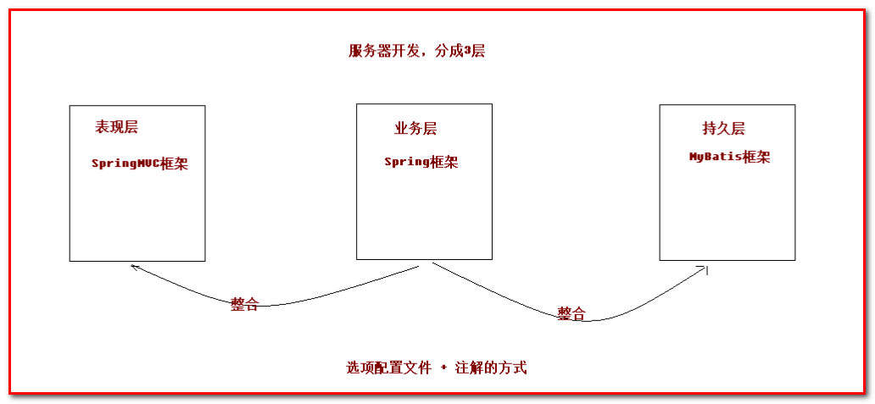
2：整合的思路

（1）：先搭建整合的环境

（2）：先把Spring的配置搭建完成

（3）：再使用Spring整合SpringMVC框架

（4）：最后使用Spring整合MyBatis框架

3：创建数据库和表结构

语句

create database itcastspringmvc;
use itcastspringmvc;
create table account(
id int primary key auto_increment,
name varchar(20),
money double
);

4：创建maven的工程

开发准备

第一步：创建web工程
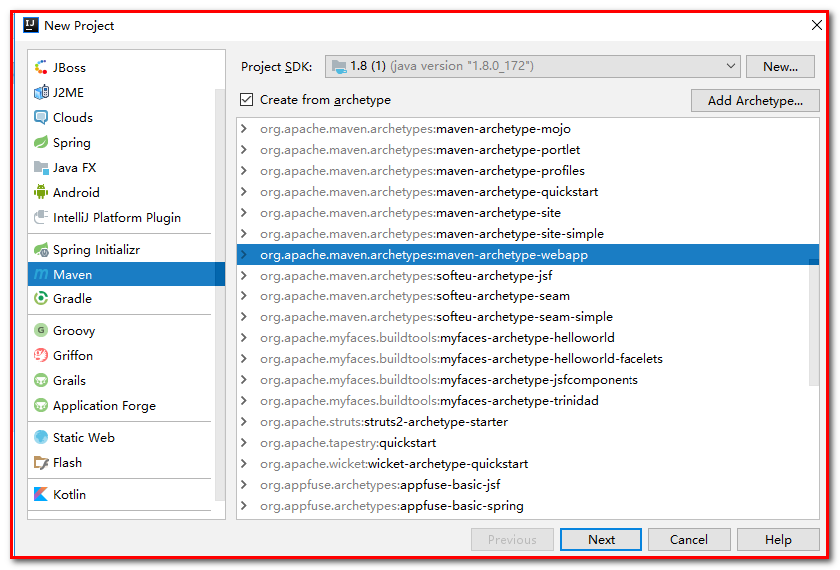
项目名：springmvc_day03_ssm
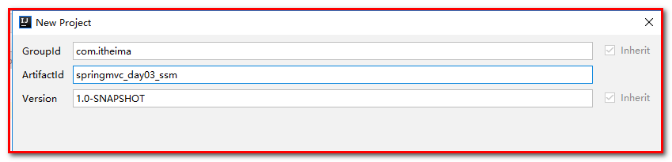
指定：
Key：archetypeCatalog
Value：internal
解决web项目使用idea创建工程后，加载过慢的问题。
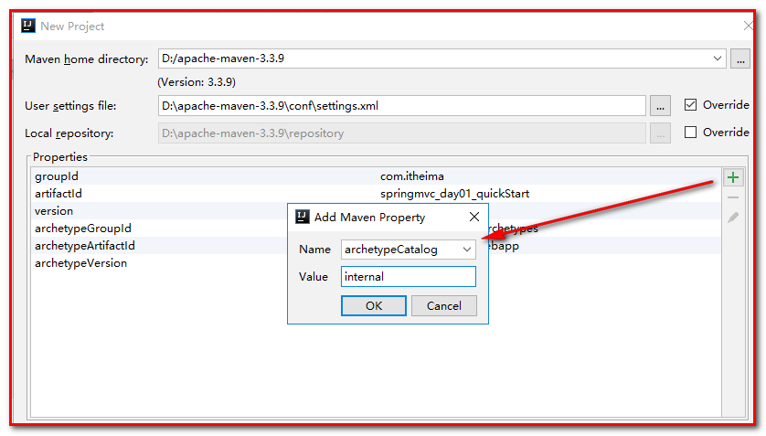

第二步：导入jar包
<properties>
<project.build.sourceEncoding>UTF-8</project.build.sourceEncoding>
<maven.compiler.source>1.8</maven.compiler.source>
<maven.compiler.target>1.8</maven.compiler.target>
<spring.version>5.0.2.RELEASE</spring.version>
<slf4j.version>1.6.6</slf4j.version>
<log4j.version>1.2.12</log4j.version>
<mysql.version>5.1.6</mysql.version>
<mybatis.version>3.4.5</mybatis.version>
</properties>
<dependencies>
<!-- spring -->
<dependency>
<groupId>org.aspectj</groupId>
<artifactId>aspectjweaver</artifactId>
<version>1.6.8</version>
</dependency>
<dependency>
<groupId>org.springframework</groupId>
<artifactId>spring-aop</artifactId>
<version>${spring.version}</version>
</dependency>
<dependency>
<groupId>org.springframework</groupId>
<artifactId>spring-context</artifactId>
<version>${spring.version}</version>
</dependency>
<dependency>
<groupId>org.springframework</groupId>
<artifactId>spring-web</artifactId>
<version>${spring.version}</version>
</dependency>
<dependency>
<groupId>org.springframework</groupId>
<artifactId>spring-webmvc</artifactId>
<version>${spring.version}</version>
</dependency>
<dependency>
<groupId>org.springframework</groupId>
<artifactId>spring-test</artifactId>
<version>${spring.version}</version>
</dependency>
<dependency>
<groupId>org.springframework</groupId>
<artifactId>spring-tx</artifactId>
<version>${spring.version}</version>
</dependency>
<dependency>
<groupId>org.springframework</groupId>
<artifactId>spring-jdbc</artifactId>
<version>${spring.version}</version>
</dependency>
<dependency>
<groupId>junit</groupId>
<artifactId>junit</artifactId>
<version>4.12</version>
<scope>test</scope>
</dependency>
<dependency>
<groupId>mysql</groupId>
<artifactId>mysql-connector-java</artifactId>
<version>${mysql.version}</version>
</dependency>
<dependency>
<groupId>javax.servlet</groupId>
<artifactId>servlet-api</artifactId>
<version>2.5</version>
<scope>provided</scope>
</dependency>
<dependency>
<groupId>javax.servlet.jsp</groupId>
<artifactId>jsp-api</artifactId>
<version>2.0</version>
<scope>provided</scope>
</dependency>
<dependency>
<groupId>jstl</groupId>
<artifactId>jstl</artifactId>
<version>1.2</version>
</dependency>
<!-- log start -->
<dependency>
<groupId>log4j</groupId>
<artifactId>log4j</artifactId>
<version>${log4j.version}</version>
</dependency>
<dependency>
<groupId>org.slf4j</groupId>
<artifactId>slf4j-api</artifactId>
<version>${slf4j.version}</version>
</dependency>
<dependency>
<groupId>org.slf4j</groupId>
<artifactId>slf4j-log4j12</artifactId>
<version>${slf4j.version}</version>
</dependency>
<!-- log end -->
<dependency>
<groupId>org.mybatis</groupId>
<artifactId>mybatis</artifactId>
<version>${mybatis.version}</version>
</dependency>
<dependency>
<groupId>org.mybatis</groupId>
<artifactId>mybatis-spring</artifactId>
<version>1.3.0</version>
</dependency>
<dependency>
<groupId>c3p0</groupId>
<artifactId>c3p0</artifactId>
<version>0.9.1.2</version>
<type>jar</type>
<scope>compile</scope>
</dependency>
</dependencies>
<build>
<finalName>ssm</finalName>
<plugins>
<plugin>
<groupId>org.apache.maven.plugins</groupId>
<artifactId>maven-compiler-plugin</artifactId>
<version>3.2</version>
<configuration>
<source>1.8</source>
<target>1.8</target>
<encoding>UTF-8</encoding>
<showWarnings>true</showWarnings>
</configuration>
</plugin>
</plugins>
</build>

第三步：创建实体类
创建包com.itheima.ssm.domain，创建类Account.java
public class Account implements Serializable {
private Integer id;
private String name;
private Double money;
}

第四步：创建Dao
创建包com.itheima.ssm.dao，创建类AccountDao.java
/**
* AccountMapper接口，不用编写实现类，框架生成代理对象
*/
public interface AccountDao {
public List<Account> findAll();
public void saveAccount(Account account);
}

第五步：创建Service
创建包com.itheima.ssm.service，创建接口AccountService.java
public interface AccountService {
public List<Account> findAll();
public void saveAccount(Account account);
}

创建类AccountServiceImpl，实现接口
/**
* 账号的实现类
*/
public class AccountServiceImpl implements AccountService {
private AccountDao accountDao;
public List<Account> findAll() {
System.out.println("业务层：查询所有的帐户...");
return accountDao.findAll();
}
public void saveAccount(Account account) {
System.out.println("业务层：保存帐户...");
accountDao.saveAccount(account);
}
}

第六步：创建Controller
创建包com.itheima.ssm.controller，创建类AccountController.java
/**
* 帐户
*/
public class AccountController {
private AccountService accountService;
/**
* 查询所有
* @return
*/
public String findAll() {
System.out.println("表现层：查询所有账户...");
List<Account> list = accountService.findAll();
for (Account account : list) {
System.out.println(account);
}
return "success";
}
/**
* 保存
* @return
*/
public String saveAccount(Account account) {
System.out.println("表现层：保存账户...");
accountService.saveAccount(account);
return "success";
}
}

最终包和类的结构是：
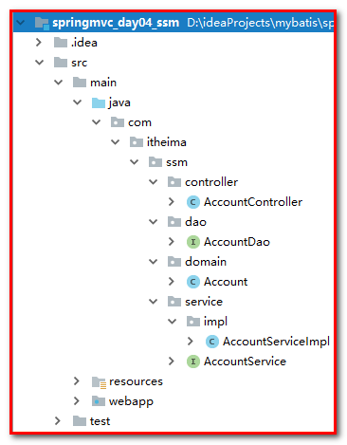

搭建Spring的环境

applicationContext.xml
在项目中的resources文件夹下创建applicationContext.xml的配置文件，编写具体的配置信息。
<?xml version="1.0" encoding="UTF-8"?>
<beans xmlns="http://www.springframework.org/schema/beans"
xmlns:xsi="http://www.w3.org/2001/XMLSchema-instance"
xmlns:context="http://www.springframework.org/schema/context"
xmlns:aop="http://www.springframework.org/schema/aop"
xmlns:tx="http://www.springframework.org/schema/tx"
xsi:schemaLocation="http://www.springframework.org/schema/beans
http://www.springframework.org/schema/beans/spring-beans.xsd
http://www.springframework.org/schema/context
http://www.springframework.org/schema/context/spring-context.xsd
http://www.springframework.org/schema/aop
http://www.springframework.org/schema/aop/spring-aop.xsd
http://www.springframework.org/schema/tx
http://www.springframework.org/schema/tx/spring-tx.xsd">
<!-- 开启注解扫描 -->
<context:component-scan base-package="com.itheima.ssm">
<!-- 忽略某些注解，把Controller给忽略了 -->
<context:exclude-filter type="annotation" expression="org.springframework.stereotype.Controller"/>
</context:component-scan>
</beans>

log4j.properties文件
# Set root category priority to INFO and its only appender to CONSOLE.
#log4j.rootCategory=INFO, CONSOLE debug info warn error fatal
log4j.rootCategory=info, CONSOLE, LOGFILE
# Set the enterprise logger category to FATAL and its only appender to CONSOLE.
log4j.logger.org.apache.axis.enterprise=FATAL, CONSOLE
# CONSOLE is set to be a ConsoleAppender using a PatternLayout.
log4j.appender.CONSOLE=org.apache.log4j.ConsoleAppender
log4j.appender.CONSOLE.layout=org.apache.log4j.PatternLayout
log4j.appender.CONSOLE.layout.ConversionPattern=%d{ISO8601} %-6r [%15.15t] %-5p %30.30c %x - %m\n
# LOGFILE is set to be a File appender using a PatternLayout.
log4j.appender.LOGFILE=org.apache.log4j.FileAppender
log4j.appender.LOGFILE.File=d:/axis.log
log4j.appender.LOGFILE.Append=true
log4j.appender.LOGFILE.layout=org.apache.log4j.PatternLayout
log4j.appender.LOGFILE.layout.ConversionPattern=%d{ISO8601} %-6r [%15.15t] %-5p %30.30c %x - %m\n

AccountService.java
/**
* 账号的实现类
*/
@Service("accountService")
public class AccountServiceImpl implements AccountService {
}

测试类
在项目中编写测试方法，进行测试
创建测试类：com.itheima.test.TestService.java
public class TestService {
/**
* 测试Service层
*/
@Test
public void testService(){
ApplicationContext ac = new ClassPathXmlApplicationContext("classpath:applicationContext.xml");
AccountService as = (AccountService) ac.getBean("accountService");
as.findAll();
}
}
测试结果：
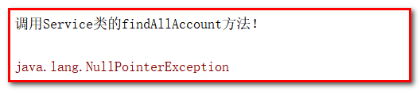

SpringMVC框架

web.xml
1：在web.xml中配置DispatcherServlet前端控制器
<!-- 配置前端控制器：服务器启动必须加载，需要加载springmvc.xml配置文件 -->
<servlet>
<servlet-name>dispatcherServlet</servlet-name>
<servlet-class>org.springframework.web.servlet.DispatcherServlet</servlet-class>
<!-- 配置初始化参数，创建完DispatcherServlet对象，加载springmvc.xml配置文件 -->
<init-param>
<param-name>contextConfigLocation</param-name>
<param-value>classpath:springmvc.xml</param-value>
</init-param>
<!-- 服务器启动的时候，让DispatcherServlet对象创建 -->
<load-on-startup>1</load-on-startup>
</servlet>
<servlet-mapping>
<servlet-name>dispatcherServlet</servlet-name>
<url-pattern>/</url-pattern>
</servlet-mapping>

2：在web.xml中配置CharacterEncodingFilter过滤器解决post请求中文乱码
<!-- 配置解决中文乱码的过滤器 -->
<filter>
<filter-name>characterEncodingFilter</filter-name>
<filter-class>org.springframework.web.filter.CharacterEncodingFilter</filter-class>
<init-param>
<param-name>encoding</param-name>
<param-value>UTF-8</param-value>
</init-param>
</filter>
<filter-mapping>
<filter-name>characterEncodingFilter</filter-name>
<url-pattern>/*</url-pattern>
</filter-mapping>

springmvc.xml
在resources下，创建springmvc.xml
创建springmvc.xml的配置文件
<?xml version="1.0" encoding="UTF-8"?>
<beans xmlns="http://www.springframework.org/schema/beans"
xmlns:mvc="http://www.springframework.org/schema/mvc" xmlns:context="http://www.springframework.org/schema/context"
xmlns:xsi="http://www.w3.org/2001/XMLSchema-instance"
xsi:schemaLocation="
http://www.springframework.org/schema/beans
http://www.springframework.org/schema/beans/spring-beans.xsd
http://www.springframework.org/schema/mvc
http://www.springframework.org/schema/mvc/spring-mvc.xsd
http://www.springframework.org/schema/context
http://www.springframework.org/schema/context/spring-context.xsd">
<!-- 扫描controller的注解，别的不扫描 -->
<context:component-scan base-package="com.itheima.ssm">
<context:include-filter type="annotation" expression="org.springframework.stereotype.Controller"/>
<!-- 排除Service注解的扫描，让spring扫描，否则事务可能会失效 -->
<context:exclude-filter type="annotation" expression="org.springframework.stereotype.Service"></context:exclude-filter>
</context:component-scan>
<!-- 配置视图解析器 -->
<bean id="viewResolver" class="org.springframework.web.servlet.view.InternalResourceViewResolver">
<!-- JSP文件所在的目录 -->
<property name="prefix" value="/WEB-INF/pages/" />
<!-- 文件的后缀名 -->
<property name="suffix" value=".jsp" />
</bean>
<!-- 设置静态资源不过滤，可以使用：-->
<mvc:default-servlet-handler></mvc:default-servlet-handler>

<!--
<mvc:resources location="/css/" mapping="/css/**" />
<mvc:resources location="/images/" mapping="/images/**" />
<mvc:resources location="/js/" mapping="/js/**" />
-->
<!-- 开启对SpringMVC注解的支持 -->
<mvc:annotation-driven />
</beans>

其中：
<context:include-filter type="annotation" expression="org.springframework.stereotype.Controller"/>
表示springmvc的注解包含@Controller的注解。
为什么要包含@Controller注解呢？
1）SpringMVC IOC容器 存在Controller的实例对象
2）Spring IOC容器 存在Controller的实例和Service层实例以及Dao层实例

重叠会引发一些问题：
例如：事务失效、相关注解失效
解决方案一：
SpringMVC只扫描 @Controller 注解、不扫描@Service注解
Spring不扫描 @Controller 注解

解决方案二：（建议使用）
只让SpringMVC扫描，不让Spring扫描
在springMVC的配置中添加<import resource="applicationContext.xml"></import>

AccountController.java
/**
* 帐户
*/
@Controller
@RequestMapping(path = "account")
public class AccountController {
@Autowired
private AccountService accountService;
/**
* 查询所有
* @return
*/
@RequestMapping(path = "/findAll")
public String findAll() {
System.out.println("表现层：查询所有账户...");
return "success";
}
}

index.jsp
<body>
<h3>账号操作</h3>
<a href="account/findAll">查询所有账号</a>
</body>

success.jsp（WEB-INF/pages/success.jsp）
<body>
<h1>访问成功</h1>
</body>
发布到tomcat，进行测试

Spring整合SpringMVC框架
目的：在controller中能成功的调用service对象中的方法。（由spring创建对象，注入到Action中使用）
在项目启动的时候，就去加载applicationContext.xml的配置文件，在web.xml中配置ContextLoaderListener监听器（默认该监听器只能加载WEB-INF目录下的applicationContext.xml的配置文件）。使用contextConfigLocation的属性让它加载类路径下的applicationContext.xml。

web.xml
目的：web容器启动，加载spring容器
<!-- 配置Spring的监听器，默认加载WEB-INF下的applicationContext.xml -->
<listener>
<listener-class>org.springframework.web.context.ContextLoaderListener</listener-class>
</listener>
<!-- 该监听器默认只加载WEB-INF下的applicationContext.xml配置文件，通过contextConfigLocation改变位置 -->
<context-param>
<param-name>contextConfigLocation</param-name>
<param-value>classpath:applicationContext.xml</param-value>
</context-param>

AccountController.java
@Controller
@RequestMapping(path = "account")
public class AccountController {
@Autowired
private AccountService accountService;
/**
* 查询所有
* @return
*/
@RequestMapping(path = "/findAll")
public String findAll() {
System.out.println("表现层：查询所有账户...");
List<Account> list = accountService.findAll();
System.out.println(list);
return "success";
}
}

测试：
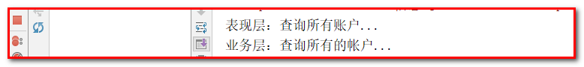

Mybatis框架

SqlMapConfig.xml
在web项目中编写SqlMapConfig.xml的配置文件，放置到resources下，编写核心配置文件
<?xml version="1.0" encoding="UTF-8"?>
<!DOCTYPE configuration
PUBLIC "-//mybatis.org//DTD Config 3.0//EN"
"http://mybatis.org/dtd/mybatis-3-config.dtd">
<configuration>
<environments default="mysql">
<environment id="mysql">
<transactionManager type="JDBC"/>
<dataSource type="POOLED">
<property name="driver" value="com.mysql.jdbc.Driver"/>
<property name="url" value="jdbc:mysql:///itcastspringmvc"/>
<property name="username" value="root"/>
<property name="password" value="root"/>
</dataSource>
</environment>
</environments>
<!-- 使用的是注解 -->
<mappers>
<!-- <mapper class="com.itheima.ssm.dao.AccountDao"/> -->
<!-- 该包下所有的dao接口都可以使用 -->
<package name="com.itheima.ssm.dao"/>
</mappers>
</configuration>
Xml的回顾：我们采用的是注解
<?xml version="1.0" encoding="UTF-8"?>
<!DOCTYPE mapper
PUBLIC "-//mybatis.org//DTD Mapper 3.0//EN"
"http://mybatis.org/dtd/mybatis-3-mapper.dtd">
<mapper namespace="com.itheima.ssm.dao.AccountDao">
<!--查询所有-->
<select id="findAll" resultType="com.itheima.ssm.domain.Account">
select * from account
</select>
<!--保存-->
<insert id="save" parameterType="com.itheima.ssm.domain.Account">
insert into account(name,money) values (#{name},#{money})
</insert>
</mapper>

AccountDao.java
在AccountDao接口的方法上添加注解，编写SQL语句
/**
* AccountDao接口，不用编写实现类，框架生成代理对象
*/
public interface AccountDao {
@Select(value = "select * from account")
public List<Account> findAll();
@Insert(value = "insert into account (name,money) values (#{name},#{money})")
public void saveAccount(Account account);
}

TestMybatis.java
在测试环境下，com.iteheima.test中，编写测试方法
public class TestMybatis {
@Test
public void testFindAll() throws Exception {
// 加载配置文件
InputStream in = Resources.getResourceAsStream("sqlMapConfig.xml");
// 创建工厂
SqlSessionFactory sessionFactory = new SqlSessionFactoryBuilder().build(in);
// 创建sqlSession对象
SqlSession sqlSession = sessionFactory.openSession();
// 获取代理对象
AccountDao accountDao = sqlSession.getMapper(AccountDao.class);
// 获取查询所有的方法
List<Account> list = accountDao.findAll();
for(Account account:list){
System.out.println(account);
}
// 释放资源
sqlSession.close();
in.close();
}
@Test
public void testSave() throws Exception {
Account account = new Account();
account.setName("小菲");
account.setMoney(400d);
// 加载配置文件
InputStream in = Resources.getResourceAsStream("sqlMapConfig.xml");
// 创建工厂
SqlSessionFactory sessionFactory = new SqlSessionFactoryBuilder().build(in);
// 创建sqlSession对象
SqlSession sqlSession = sessionFactory.openSession();
// 获取代理对象
AccountDao accountDao = sqlSession.getMapper(AccountDao.class);
accountDao.saveAccount(account);
// 提交事务
sqlSession.commit();
// 释放资源
sqlSession.close();
in.close();
}
}

Spring整合MyBatis框架

applicationContext.xml
目的：把SqlMapConfig.xml配置文件中的内容配置到applicationContext.xml配置文件中
<!-- 配置C3P0的连接池对象 -->
<bean id="dataSource" class="com.mchange.v2.c3p0.ComboPooledDataSource">
<property name="driverClass" value="com.mysql.jdbc.Driver"></property>
<property name="jdbcUrl" value="jdbc:mysql:///itcastspringmvc" />
<property name="user" value="root" />
<property name="password" value="root" />
</bean>
<!-- 配置SqlSession的工厂 -->
<bean id="sqlSessionFactory" class="org.mybatis.spring.SqlSessionFactoryBean">
<property name="dataSource" ref="dataSource" />
</bean>
<!-- 配置扫描dao的包 -->
<bean id="mapperScanner" class="org.mybatis.spring.mapper.MapperScannerConfigurer">
<property name="basePackage" value="com.itheima.ssm.dao"/>
</bean>
SqlMapConfig.xml配置文件可以删除。

AccountDao.java
在AccountDao接口中添加@Repository注解，也可以不填加。
@Repository
public interface AccountDao {
@Select(value = "select * from account")
public List<Account> findAll();
@Insert(value = "insert into account (name,money) values (#{name},#{money})")
public void saveAccount(Account account);
}

TestSpringMybatis
【测试】可选测试
Service调用Dao
@Test
public void testFindAllSpring() throws Exception {
ApplicationContext ac = new ClassPathXmlApplicationContext("applicationContext.xml");
AccountDao accountDao = ac.getBean(AccountDao.class);
List<Account> list = accountDao.findAll();
for(Account account:list){
System.out.println(account);
}
}

AccountServiceImpl.java
在service中注入dao对象
/**
* 账号的实现类
*/
@Service("accountService")
public class AccountServiceImpl implements AccountService {
@Autowired
private AccountDao accountDao;
public List<Account> findAll() {
System.out.println("业务层：查询所有的帐户...");
return accountDao.findAll();
}
public void saveAccount(Account account) {
accountDao.saveAccount(account);
}
}

AccountController.java
@Controller
@RequestMapping(path = "account")
public class AccountController {
@Autowired
private AccountService accountService;
/**
* 查询所有
* @return
*/
@RequestMapping(path = "/findAll")
public String findAll(Model model) {
System.out.println("表现层：查询所有账户...");
List<Account> list = accountService.findAll();
System.out.println(list);
model.addAttribute("list",list);
return "success";
}
/**
* 保存
* @return
*/
@RequestMapping(path = "/save")
public String saveAccount(Account account) {
accountService.saveAccount(account);
return "success";
}
}

success.jsp
<%@ page contentType="text/html;charset=UTF-8" language="java" isELIgnored="false" %>
<%@taglib prefix="c" uri="http://java.sun.com/jsp/jstl/core" %>
<html>
<head>
<title>Title</title>
</head>
<body>
<h1>访问成功</h1>
<c:forEach items="${list}" var="account">
${account.id}---
${account.name}---
${account.money}<br>
</c:forEach>
</body>
</html>

测试：
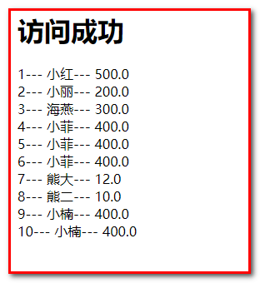

配置Spring的声明式事务管理

applicationContext.xml
Spring的声明式事务处理（配置文件）
<!-- 配置事务管理器 -->
<bean id="transactionManager" class="org.springframework.jdbc.datasource.DataSourceTransactionManager">
<property name="dataSource" ref="dataSource"/>
</bean>
<!-- 配置事务通知 -->
<tx:advice id="txAdvice" transaction-manager="transactionManager">
<tx:attributes>
<tx:method name="*" read-only="true"/>
<tx:method name="save*" isolation="DEFAULT" propagation="REQUIRED" read-only="false"/>
<tx:method name="update*" isolation="DEFAULT" propagation="REQUIRED" read-only="false"/>
<tx:method name="delete*" isolation="DEFAULT" propagation="REQUIRED" read-only="false"/>
</tx:attributes>
</tx:advice>
<!-- 配置AOP增强事务 -->
<aop:config>
<aop:advisor advice-ref="txAdvice" pointcut="execution(* com.itheima.ssm.service..*.*(..))"/>
</aop:config>
Spring的声明式事务处理（注解方式）
第一步：applicationContext.xml
<!--使用注解的方式，配置spring的声明式事务处理-->
<bean id="transactionManager" class="org.springframework.jdbc.datasource.DataSourceTransactionManager">
<property name="dataSource" ref="dataSource"></property>
</bean>
<!--开启注解的方式使用事务-->
<tx:annotation-driven transaction-manager="transactionManager"></tx:annotation-driven>
第二步：在Service的类上，配置@Transactional
@Service
@Transactional
public class AccountServiceImpl implements AccountService {
}

index.jsp
测试保存帐户的方法
<hr>
<form action="account/save" method="post">
姓名：<input type="text" name="name"/><br/>
金额：<input type="text" name="money"/><br/>
<input type="submit" value="保存"/><br/>
</form>

AccountController.java
/**
* 保存
* @return
*/
@RequestMapping(path = "/save")
public void saveAccount(Account account, HttpServletRequest request, HttpServletResponse response) throws Exception {
System.out.println("表现层：保存账户...");
accountService.saveAccount(account);
response.sendRedirect(request.getContextPath()+"/account/findAll");
return;
}
或者：
建议使用redirect关键字
@RequestMapping(path = "/save")
public String saveAccount(Account account) throws Exception {
System.out.println("表现层：保存账户...");
accountService.saveAccount(account);
return "redirect:/account/findAll";
}

测试：
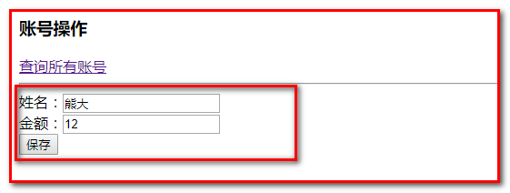
重定向到：
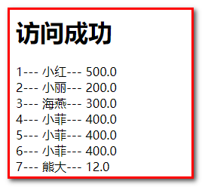

让SpringMVC扫描，不让Spring扫描
第一步：配置springmvc.xml
<?xml version="1.0" encoding="UTF-8"?>
<beans xmlns="http://www.springframework.org/schema/beans"
xmlns:mvc="http://www.springframework.org/schema/mvc" xmlns:context="http://www.springframework.org/schema/context"
xmlns:xsi="http://www.w3.org/2001/XMLSchema-instance"
xsi:schemaLocation="
http://www.springframework.org/schema/beans
http://www.springframework.org/schema/beans/spring-beans.xsd
http://www.springframework.org/schema/mvc
http://www.springframework.org/schema/mvc/spring-mvc.xsd
http://www.springframework.org/schema/context
http://www.springframework.org/schema/context/spring-context.xsd">
<!-- 开启注解扫描 -->
<context:component-scan base-package="com.itheima.ssm">
</context:component-scan>
<!-- 配置视图解析器 -->
<bean id="viewResolver" class="org.springframework.web.servlet.view.InternalResourceViewResolver">
<!-- JSP文件所在的目录 -->
<property name="prefix" value="/WEB-INF/pages/" />
<!-- 文件的后缀名 -->
<property name="suffix" value=".jsp" />
</bean>
<!-- 设置静态资源不过滤 -->
<mvc:resources location="/css/" mapping="/css/**" />
<mvc:resources location="/images/" mapping="/images/**" />
<mvc:resources location="/js/" mapping="/js/**" />
<!-- 开启对SpringMVC注解的支持 -->
<mvc:annotation-driven />
<!-- 加载springMVC的同时，同时加载spring -->
<import resource="applicationContext.xml"></import>
</beans>

第二步：applicationContext.xml
去掉所有的组件扫描
<?xml version="1.0" encoding="UTF-8"?>
<beans xmlns="http://www.springframework.org/schema/beans"
xmlns:xsi="http://www.w3.org/2001/XMLSchema-instance"
xmlns:context="http://www.springframework.org/schema/context"
xmlns:aop="http://www.springframework.org/schema/aop"
xmlns:tx="http://www.springframework.org/schema/tx"
xsi:schemaLocation="http://www.springframework.org/schema/beans
http://www.springframework.org/schema/beans/spring-beans.xsd
http://www.springframework.org/schema/context
http://www.springframework.org/schema/context/spring-context.xsd
http://www.springframework.org/schema/aop
http://www.springframework.org/schema/aop/spring-aop.xsd
http://www.springframework.org/schema/tx
http://www.springframework.org/schema/tx/spring-tx.xsd">
<!-- 删除组件扫描的配置 -->
<!-- 配置C3P0的连接池对象 -->
<bean id="dataSource" class="com.mchange.v2.c3p0.ComboPooledDataSource">
<property name="driverClass" value="com.mysql.jdbc.Driver"></property>
<property name="jdbcUrl" value="jdbc:mysql:///itcastspringmvc" />
<property name="user" value="root" />
<property name="password" value="root" />
</bean>
<!-- 配置SqlSession的工厂 -->
<bean id="sqlSessionFactory" class="org.mybatis.spring.SqlSessionFactoryBean">
<property name="dataSource" ref="dataSource" />
</bean>
<!-- 配置扫描dao的包 -->
<bean id="mapperScanner" class="org.mybatis.spring.mapper.MapperScannerConfigurer">
<property name="basePackage" value="com.itheima.ssm.dao"/>
</bean>
<!-- 配置事务管理器 -->
<bean id="transactionManager" class="org.springframework.jdbc.datasource.DataSourceTransactionManager">
<property name="dataSource" ref="dataSource"/>
</bean>
<!-- 配置事务通知 -->
<tx:advice id="txAdvice" transaction-manager="transactionManager">
<tx:attributes>
<tx:method name="find*" read-only="true"/>
<tx:method name="save*" isolation="DEFAULT" propagation="REQUIRED" read-only="false"/>
<tx:method name="update*" isolation="DEFAULT" propagation="REQUIRED" read-only="false"/>
<tx:method name="delete*" isolation="DEFAULT" propagation="REQUIRED" read-only="false"/>
</tx:attributes>
</tx:advice>
<!-- 配置AOP增强事务 -->
<aop:config>
<aop:advisor advice-ref="txAdvice" pointcut="execution(* com.itheima.service..*.*(..))"/>
</aop:config>
</beans>

第三步：去掉web.xml中的监听器
<!-- 配置Spring的监听器，默认加载WEB-INF下的applicationContext.xml -->
<listener>
<listener-class>org.springframework.web.context.ContextLoaderListener</listener-class>
</listener>
<!-- 该监听器默认只加载WEB-INF下的applicationContext.xml配置文件，通过contextConfigLocation改变位置 -->
<context-param>
<param-name>contextConfigLocation</param-name>
<param-value>classpath:applicationContext.xml</param-value>
</context-param>

SSM用户注册登录案例

ssm配置

web.xml
<!-- 配置前端控制器：服务器启动必须加载，需要加载springmvc.xml配置文件 -->
<servlet>
<servlet-name>dispatcherServlet</servlet-name>
<servlet-class>org.springframework.web.servlet.DispatcherServlet</servlet-class>
<!-- 配置初始化参数，创建完DispatcherServlet对象，加载springmvc.xml配置文件 -->
<init-param>
<param-name>contextConfigLocation</param-name>
<param-value>classpath:springmvc.xml</param-value>
</init-param>
<!-- 服务器启动的时候，让DispatcherServlet对象创建 -->
<load-on-startup>1</load-on-startup>
</servlet>
<servlet-mapping>
<servlet-name>dispatcherServlet</servlet-name>
<url-pattern>/</url-pattern>
</servlet-mapping>
<!-- 配置解决中文乱码的过滤器 -->
<filter>
<filter-name>characterEncodingFilter</filter-name>
<filter-class>org.springframework.web.filter.CharacterEncodingFilter</filter-class>
<init-param>
<param-name>encoding</param-name>
<param-value>UTF-8</param-value>
</init-param>
</filter>
<filter-mapping>
<filter-name>characterEncodingFilter</filter-name>
<url-pattern>/*</url-pattern>
</filter-mapping>

applicationContext.xml
<?xml version="1.0" encoding="UTF-8"?>
<beans xmlns="http://www.springframework.org/schema/beans"
xmlns:xsi="http://www.w3.org/2001/XMLSchema-instance"
xmlns:context="http://www.springframework.org/schema/context"
xmlns:aop="http://www.springframework.org/schema/aop"
xmlns:tx="http://www.springframework.org/schema/tx"
xsi:schemaLocation="http://www.springframework.org/schema/beans
http://www.springframework.org/schema/beans/spring-beans.xsd
http://www.springframework.org/schema/context
http://www.springframework.org/schema/context/spring-context.xsd
http://www.springframework.org/schema/aop
http://www.springframework.org/schema/aop/spring-aop.xsd
http://www.springframework.org/schema/tx
http://www.springframework.org/schema/tx/spring-tx.xsd">
<!-- Spring整合Mybatis -->
<!-- 配置C3P0的连接池对象 -->
<bean id="dataSource" class="com.mchange.v2.c3p0.ComboPooledDataSource">
<property name="driverClass" value="com.mysql.jdbc.Driver"></property>
<property name="jdbcUrl" value="jdbc:mysql:///itcastspringmvc" />
<property name="user" value="root" />
<property name="password" value="root" />
</bean>
<!-- 配置SqlSession的工厂 -->
<bean id="sqlSessionFactory" class="org.mybatis.spring.SqlSessionFactoryBean">
<property name="dataSource" ref="dataSource" />
</bean>
<!-- 配置扫描dao的包 -->
<bean id="mapperScanner" class="org.mybatis.spring.mapper.MapperScannerConfigurer">
<property name="basePackage" value="com.itheima.ssm.dao"/>
</bean>
<!-- spring的声明式事务处理 -->
<!-- 配置事务管理器 -->
<bean id="transactionManager" class="org.springframework.jdbc.datasource.DataSourceTransactionManager">
<property name="dataSource" ref="dataSource"/>
</bean>
<!-- 配置事务通知 -->
<tx:advice id="txAdvice" transaction-manager="transactionManager">
<tx:attributes>
<tx:method name="find*" read-only="true"/>
<tx:method name="save*" isolation="DEFAULT" propagation="REQUIRED" read-only="false"/>
<tx:method name="update*" isolation="DEFAULT" propagation="REQUIRED" read-only="false"/>
<tx:method name="delete*" isolation="DEFAULT" propagation="REQUIRED" read-only="false"/>
</tx:attributes>
</tx:advice>
<!-- 配置AOP增强事务 -->
<aop:config>
<aop:advisor advice-ref="txAdvice" pointcut="execution(* com.itheima.ssm.service..*.*(..))"/>
</aop:config>
</beans>

springmvc.xml
<?xml version="1.0" encoding="UTF-8"?>
<beans xmlns="http://www.springframework.org/schema/beans"
xmlns:mvc="http://www.springframework.org/schema/mvc" xmlns:context="http://www.springframework.org/schema/context"
xmlns:xsi="http://www.w3.org/2001/XMLSchema-instance"
xsi:schemaLocation="
http://www.springframework.org/schema/beans
http://www.springframework.org/schema/beans/spring-beans.xsd
http://www.springframework.org/schema/mvc
http://www.springframework.org/schema/mvc/spring-mvc.xsd
http://www.springframework.org/schema/context
http://www.springframework.org/schema/context/spring-context.xsd">
<!-- 开启注解扫描 -->
<context:component-scan base-package="com.itheima.ssm"></context:component-scan>
<!-- 配置视图解析器 -->
<bean id="viewResolver" class="org.springframework.web.servlet.view.InternalResourceViewResolver">
<!-- JSP文件所在的目录 -->
<property name="prefix" value="/WEB-INF/pages/" />
<!-- 文件的后缀名 -->
<property name="suffix" value=".jsp" />
</bean>
<!-- 设置静态资源不过滤 -->
<!--<mvc:resources location="/css/" mapping="/css/**" />-->
<!--<mvc:resources location="/img/" mapping="/img/**" />-->
<!--<mvc:resources location="/plugins/" mapping="/plugins/**" />-->
<!--静态资源一律不拦截，包括html-->
<mvc:default-servlet-handler />
<!-- 开启对SpringMVC注解的支持 -->
<mvc:annotation-driven />
<import resource="applicationContext.xml"></import>
</beans>

用户注册

数据库表设计
表结构：
number varchar // 登录名
name varchar
password varchar // 密码
mobile varchar
qq varchar
email varchar
create table `user` (
`number` varchar(40) not null,
`name` VARCHAR(20) DEFAULT NULL,
`password` VARCHAR(60) DEFAULT NULL,
`mobile` VARCHAR(11) DEFAULT NULL,
`qq` VARCHAR(11) DEFAULT NULL,
`email` VARCHAR(60) DEFAULT NULL,
primary key (`number`)
) ENGINE=INNODB DEFAULT CHARSET = utf8;

登录名number作为主键，具有业务含义的主键叫做自然主键；我们把自增长的id主键称之为代理主键

创建工程导入jar包

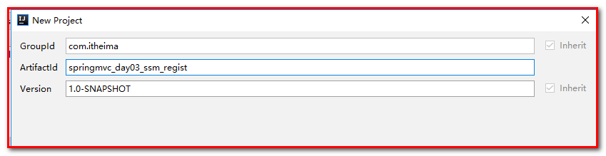
指定：
Key：archetypeCatalog
Value：internal

pom.xml
<properties>
<project.build.sourceEncoding>UTF-8</project.build.sourceEncoding>
<maven.compiler.source>1.8</maven.compiler.source>
<maven.compiler.target>1.8</maven.compiler.target>
<spring.version>5.0.2.RELEASE</spring.version>
<slf4j.version>1.6.6</slf4j.version>
<log4j.version>1.2.12</log4j.version>
<mysql.version>5.1.6</mysql.version>
<mybatis.version>3.4.5</mybatis.version>
</properties>
<dependencies>
<!-- spring -->
<dependency>
<groupId>org.aspectj</groupId>
<artifactId>aspectjweaver</artifactId>
<version>1.6.8</version>
</dependency>
<dependency>
<groupId>org.springframework</groupId>
<artifactId>spring-aop</artifactId>
<version>${spring.version}</version>
</dependency>
<dependency>
<groupId>org.springframework</groupId>
<artifactId>spring-context</artifactId>
<version>${spring.version}</version>
</dependency>
<dependency>
<groupId>org.springframework</groupId>
<artifactId>spring-web</artifactId>
<version>${spring.version}</version>
</dependency>
<dependency>
<groupId>org.springframework</groupId>
<artifactId>spring-webmvc</artifactId>
<version>${spring.version}</version>
</dependency>
<dependency>
<groupId>org.springframework</groupId>
<artifactId>spring-test</artifactId>
<version>${spring.version}</version>
</dependency>
<dependency>
<groupId>org.springframework</groupId>
<artifactId>spring-tx</artifactId>
<version>${spring.version}</version>
</dependency>
<dependency>
<groupId>org.springframework</groupId>
<artifactId>spring-jdbc</artifactId>
<version>${spring.version}</version>
</dependency>
<dependency>
<groupId>junit</groupId>
<artifactId>junit</artifactId>
<version>4.12</version>
<scope>compile</scope>
</dependency>
<dependency>
<groupId>mysql</groupId>
<artifactId>mysql-connector-java</artifactId>
<version>${mysql.version}</version>
</dependency>
<dependency>
<groupId>javax.servlet</groupId>
<artifactId>servlet-api</artifactId>
<version>2.5</version>
<scope>provided</scope>
</dependency>
<dependency>
<groupId>javax.servlet.jsp</groupId>
<artifactId>jsp-api</artifactId>
<version>2.0</version>
<scope>provided</scope>
</dependency>
<dependency>
<groupId>jstl</groupId>
<artifactId>jstl</artifactId>
<version>1.2</version>
</dependency>
<!-- log start -->
<dependency>
<groupId>log4j</groupId>
<artifactId>log4j</artifactId>
<version>${log4j.version}</version>
</dependency>
<dependency>
<groupId>org.slf4j</groupId>
<artifactId>slf4j-api</artifactId>
<version>${slf4j.version}</version>
</dependency>
<dependency>
<groupId>org.slf4j</groupId>
<artifactId>slf4j-log4j12</artifactId>
<version>${slf4j.version}</version>
</dependency>
<!-- log end -->
<dependency>
<groupId>org.mybatis</groupId>
<artifactId>mybatis</artifactId>
<version>${mybatis.version}</version>
</dependency>
<dependency>
<groupId>org.mybatis</groupId>
<artifactId>mybatis-spring</artifactId>
<version>1.3.0</version>
</dependency>
<dependency>
<groupId>c3p0</groupId>
<artifactId>c3p0</artifactId>
<version>0.9.1.2</version>
<type>jar</type>
<scope>compile</scope>
</dependency>
</dependencies>
<build>
<finalName>ssm</finalName>
<plugins>
<plugin>
<groupId>org.apache.maven.plugins</groupId>
<artifactId>maven-compiler-plugin</artifactId>
<version>3.2</version>
<configuration>
<source>1.8</source>
<target>1.8</target>
<encoding>UTF-8</encoding>
<showWarnings>true</showWarnings>
</configuration>
</plugin>
<plugin>
<groupId>org.apache.tomcat.maven</groupId>
<artifactId>tomcat7-maven-plugin</artifactId>
<version>2.2</version>
<!--插件使用的相关配置-->
<configuration>
<!--端口号-->
<port>18881</port>
<!--写当前项目的名字(虚拟路径),如果写/，那么每次访问项目就不需要加项目名字了-->
<path>/</path>
<!--解决get请求乱码-->
<uriEncoding>UTF-8</uriEncoding>
</configuration>
</plugin>
</plugins>
</build>

创建User.java
public class User implements Serializable {
private String number;
private String name;
private String password;
private String mobile;
private String qq;
private String email;
}

注册页面
拷贝页面到项目。
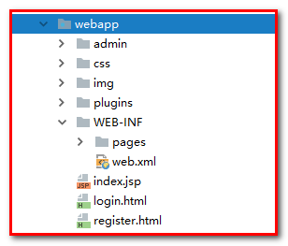

创建UserController.java
页面数据发送到Controller，创建Controller
@Controller
@RequestMapping(value = "/user")
public class UserController {
@Autowired
private UserService userService;
/***
* 增加用户
* @param user
* @return
*/
@RequestMapping(value = "/save")
public String save(User user){
//增加
int acount = userService.saveUser(user);
if(acount>0){
//新增成功，返回登录页面
return "redirect:/login.html";
}else{
//新增失败，返回注册页面
return "redirect:/register.html";
}
}
}

创建接口UserService.java和实现类UserServiceImpl.java
UserService.java
public interface UserService {
/***
* 增加用户
* @param user
* @return
*/
int saveUser(User user);
}

UserServiceImpl.java
@Service
public class UserServiceImpl implements UserService {
@Autowired
private UserDao userDao;
public int saveUser(User user) {
return userDao.save(user);
}
}
如果是注解的方式配置声明式事务处理，需要添加在UserServiceImpl的类上添加：@Transactional

创建接口UserDao.java
并编写SQL语句
public interface UserDao {
/***
* 增加操作
* @param user
* @return
*/
@Insert("insert into user(number,password,mobile)values(#{number},#{password},#{mobile})")
int save(User user);
}

register.html测试
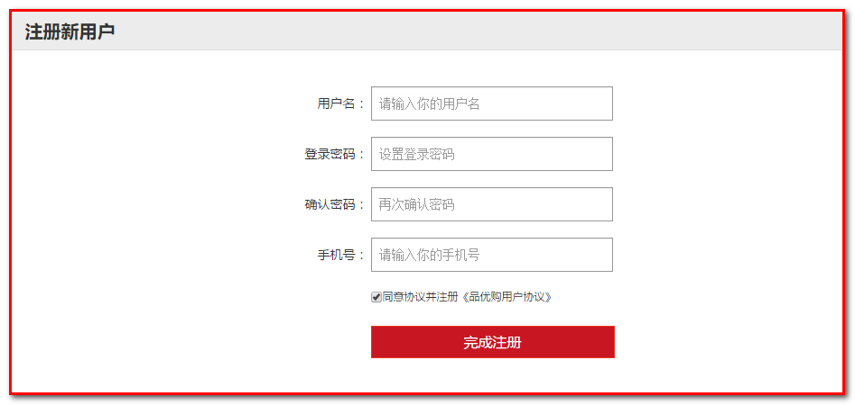

修改页面
<form id="subform" action="/user/save" method="post" class="sui-form form-horizontal">
<div class="control-group">
<label class="control-label">用户名：</label>
<div class="controls">
<input type="text" name="number" placeholder="请输入你的用户名" class="input-xfat input-xlarge">
</div>
</div>
<div class="control-group">
<label for="inputPassword" class="control-label">登录密码：</label>
<div class="controls">
<input type="password" id="pwd" name="password" placeholder="设置登录密码" class="input-xfat input-xlarge">
</div>
</div>
<div class="control-group">
<label for="inputPassword" class="control-label">确认密码：</label>
<div class="controls">
<input type="password" id="rpwd" placeholder="再次确认密码" class="input-xfat input-xlarge">
</div>
</div>
<div class="control-group">
<label class="control-label">手机号：</label>
<div class="controls">
<input type="text" name="mobile" placeholder="请输入你的手机号" class="input-xfat input-xlarge">
</div>
</div>
<div class="control-group">
<label for="inputPassword" class="control-label">&nbsp;&nbsp;&nbsp;&nbsp;&nbsp;&nbsp;</label>
<div class="controls">
<input name="m1" type="checkbox" value="2" checked=""><span>同意协议并注册《品优购用户协议》</span>
</div>
</div>
<div class="control-group">
<label class="control-label"></label>
<div class="controls btn-reg">
<button class="sui-btn btn-block btn-xlarge btn-danger" type="button" id="btn">完成注册</button>
</div>
</div>
</form>

实现密码输入框的页面校验
register.html
<script src="plugins/jQuery/jquery-2.2.3.min.js"></script>
<script>
$(function () {
/*
* 点击注册按钮
* 判断2次密码是否一致
* 如果一致，提交到后台，否则提示错误
* */
$('#btn').click(function () {
//获取2次密码
var pwd = $('#pwd').val();
var rpwd=$('#rpwd').val();
if(pwd==rpwd){
//提交到后台
$('#subform').submit();
}else{
//提示
alert("2次密码输入有误")
}
});
});
</script>

启动tomcat
使用tomcat插件（tomcat7-maven-plugin）
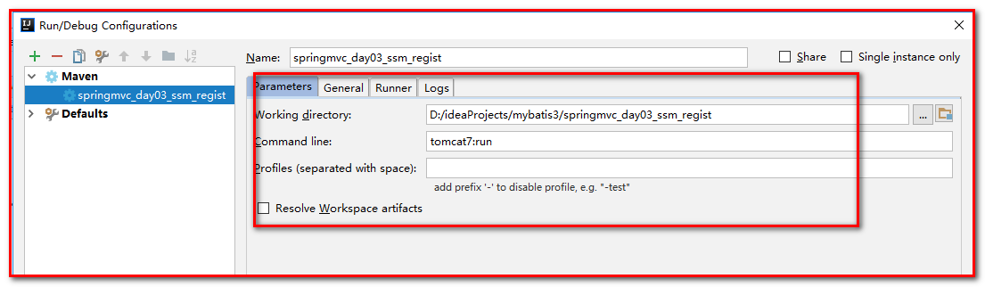

测试：保存成功
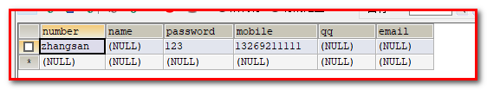

用户登录

login.html登录页面
<form class="sui-form" action="/user/login" method="post">
<div class="input-prepend"><span class="add-on loginname"></span>
<input id="prependedInput" type="text" name="number" placeholder="邮箱/用户名/手机号" class="span2 input-xfat">
</div>
<div class="input-prepend"><span class="add-on loginpwd"></span>
<input id="prependedInput" type="password" name="password" placeholder="请输入密码" class="span2 input-xfat">
</div>
<div class="setting">
<label class="checkbox inline"><input name="m1" type="checkbox" value="2" checked="">自动登录</label>
<span class="forget">忘记密码？</span>
</div>
<div class="logined">
<button class="sui-btn btn-block btn-xlarge btn-danger" type="submit">登&nbsp;&nbsp;录</button>
</div>
</form>

UserController.java
/***
* 用户登录
* @return
*/
@RequestMapping(value = "/login")
public String login(User user, HttpSession session){
//数据库查询登录
User loginUser = userService.findByNumberAndPassword(user);
//判断loginUser是否为空
if(loginUser!=null){
//登录成功跳转到欢迎页
session.setAttribute("loginUser",user);
return "redirect:/index/welcome";
}else{
//为空，登录失败，继续登录
return "redirect:/login.html";
}
}

UserServiceImpl.java
public User findByNumberAndPassword(User user) {
return userDao.findByNumberAndPassword(user);
}

UserDao.java
/****
* 登录
* @param user
* @return
*/
@Select("select * from user where number=#{number} and password=#{password}")
User findByNumberAndPassword(User user);

或者：
@Select(value = "select * from user where number = #{number} and password=#{password}")
User findByNumberAndPassword(@Param("number") String number, @Param("password") String password);

登录成功--->重定向到欢迎页

WelcomeController.java
@Controller
@RequestMapping(value = "/index")
public class WelcomeController {
/***
* 欢迎页
* @return
*/
@RequestMapping(value = "/welcome")
public String welcome(){
return "index";
}
}

index.html
将admin下的index.html拷贝到WEB-INF\pages下
同时创建index.jsp，将index.html的内容放置到index.jsp
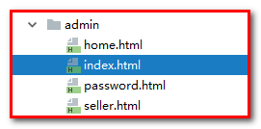
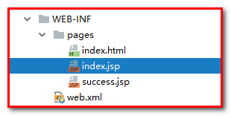
在index.jsp中获取登录信息
<!-- Sidebar toggle button-->
<a href="#" class="sidebar-toggle" data-toggle="offcanvas" role="button">
<span class="sr-only">Toggle navigation</span>
</a>
欢迎你：${sessionScope.loginUser.number}

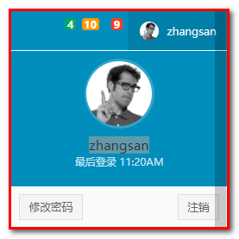

整合拦截器
【需求】：用户如果已经登录
用户如果没有登录，则不能访问欢迎页

LoginInterceptor.java
第一步：声明拦截器
创建包com.itheima.ssm.interceptor
创建类LoginInterceptor.java
public class LoginInterceptor implements HandlerInterceptor {
@Override
public boolean preHandle(HttpServletRequest request, HttpServletResponse response, Object handler) throws Exception {
/****
* 用户是否在线
* 如果不在线，不允许访问欢迎页
*/
Object loginUser = request.getSession().getAttribute("loginUser");
if(loginUser==null){
response.sendRedirect(request.getContextPath()+"/login.html");
return false;
}
return true;
}
}

springmvc.xml
第二步：配置拦截器
<!--配置拦截器-->
<mvc:interceptors>
<mvc:interceptor>
<!--指定拦截路径-->
<mvc:mapping path="/**"/>
<mvc:exclude-mapping path="/*.html"></mvc:exclude-mapping>
<mvc:exclude-mapping path="/user/login"></mvc:exclude-mapping>
<mvc:exclude-mapping path="/user/save"></mvc:exclude-mapping>
<!--
指定处理请求的拦截器
-->
<bean class="com.itheima.ssm.interceptor.LoginInterceptor" />
</mvc:interceptor>
</mvc:interceptors>

【测试】重新启动，在没有Session的情况下，访问/index/welcome，此时重定向到登录页面。

