OA单点登录
因上微信企业号需要跟HR系统进行数据交互，而企业微信号必须要用80端口，因此HR系统的端口也必须改为80端口。HR系统新的访问地址如下
http://183.62.39.99/hr/NoLogin/SSOLogin.aspx?A0190=user&EnStrID=169B447B-0DF5-4D36-A166-D2300A86AEC5

参数1：A0190=user
参数2：EnStrID=169B447B-0DF5-4D36-A166-D2300A86AEC5
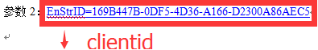

HR系统配置
1、往参数表插入参数'SSOWebUrl'
insert into WebParams(ParamName,ParamValue)
select 'SSOWebUrl','http://183.62.39.99/HRWebApp'

2、生成人员登陆账号编码
insert into WebSOAKey(A0188,KeyStr)
select A0188,rtrim(cast(NEWID() as varchar(40)))+A0190+rtrim(cast(NEWID() as varchar(40))) from a01

- 登记OA服务器IP地址
insert into WebClientAllowSetting(ClientID,IP,MAC,AllowAccess)
select newid(),'172.16.10.22',NULL,1
4. 请问免验证码登录要怎么弄？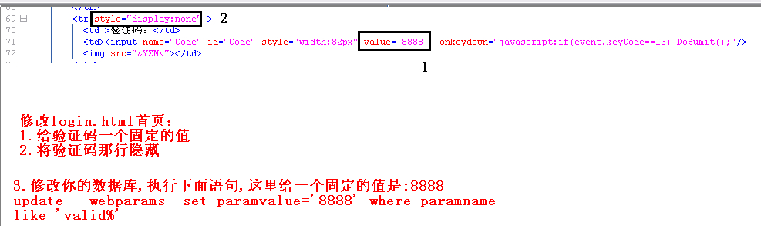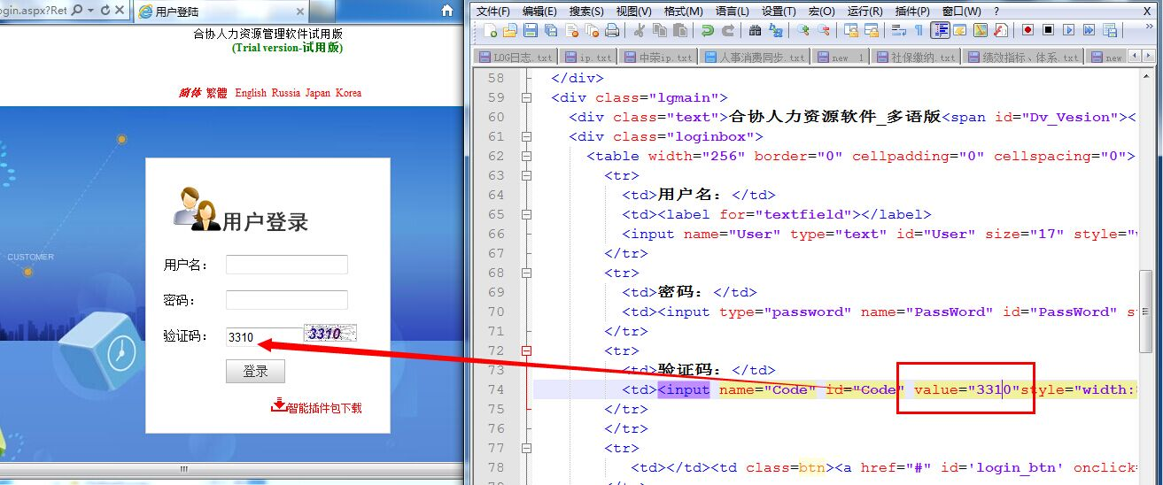
--不显示输入框
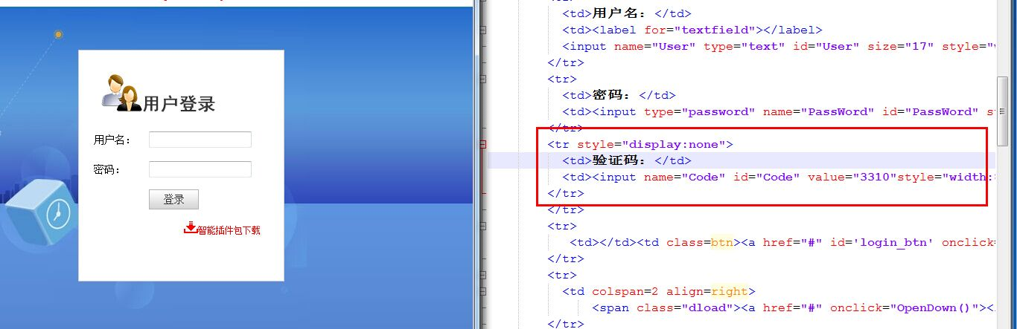
--回车登录
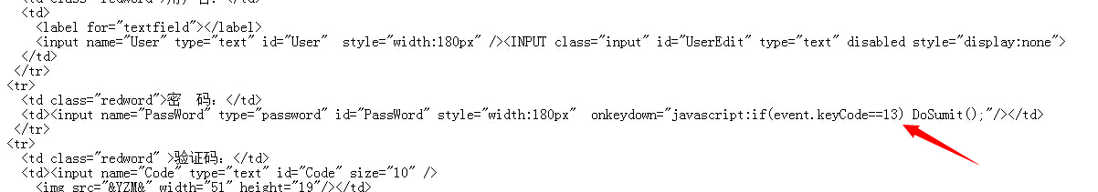

5.存储过程
create procedure [dbo].[SOALogin](@A0190 VarChar(50))
as
declare @KeyStr VarChar(400)
declare @A0188 int
select @A0188=A0188 from A01 where A0190=@A0190
set @KeyStr=rtrim(cast(NEWID() as varchar(40)))+rtrim(cast(@A0190 as varchar(10)))+rtrim(cast(NEWID() as varchar(40)))
insert into WebSOAKey(A0188,KeyStr,LogDate) values(@A0188,@KeyStr,GETDATE())
select @KeyStr
6.测试
http://【HRIP地址】/NoLogin/SSOLogin.aspx?a0190=【oa登陆用户名】&EnStrID=AFB51B0E-F636-48F7-BF51-F388936B0B27
--------------------------------------------------------------------
http://192.168.2.242/hrwebapp/NoLogin/SSOLogin.aspx?A0190=001150&EnStrID=AFB51B0E-F636-48F7-BF51-F388936B0B27

