1. 在参数表增加参数 ：K07MobileTable，并添加值为流程主表：K07MobileTable

（语句在下方）

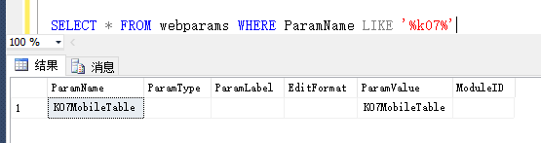

1. 创建流程（K07MobileTable）



查询显示字段：

图片地址表：K07Corder

图片展现sql《图片展示3》

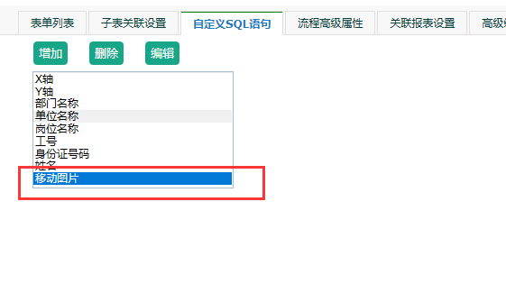

1. 图片展示

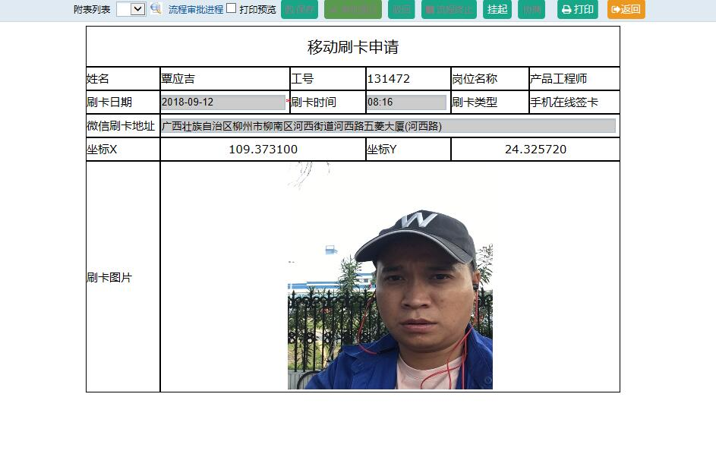

UPDATE FlowFlowModelHtmlBrand SET SelectText= 'select ''<img src="../V12/Kq/WeiXinKqCard_Photo.aspx?K07_Kguid=''+KGUID+''" width=300 height=300/>'' from

K07MOBILETABLE where K07MOBILETABLE.kguid=[K07MOBILETABLE_KGUID]' WHERE Brand_Name LIKE '%移动图片%'

4、创建实体表

CREATE TABLE [dbo].[K07MobileTable](  
[CHKFLAG] [int] NULL,  
[PX_PLANIMLY_KGUID] [varchar](40) NULL,  
[K07010] [varchar](300) NULL,  
[INPUTDATETIME] [datetime] NULL,  
[OPDATE] [datetime] NULL,  
[OPNAME] [varchar](50) NULL,  
[K07ADDR] [varchar](100) NULL,  
[RECORDID] [int] IDENTITY(1,1) NOT NULL,  
[A0188] [int] NOT NULL,  
[KGUID] [varchar](38) NULL,  
[K0700] [datetime] NULL,  
[FLAG] [int] NULL,  
[K0701] [datetime] NULL,  
[K0702] [varchar](50) NULL,  
[K0703] [varchar](20) NULL,  
[K0704] [varchar](20) NULL,  
[K0705] [varchar](50) NULL,  
[MBUNID] [varchar](50) NULL,  
[signed] [int] NULL  
) ON [PRIMARY]  
  
GO  
  
SET ANSI_PADDING OFF  
GO  
  
ALTER TABLE [dbo].[K07MobileTable] ADD  CONSTRAINT [DF__K07Mobile__KGUID__05A8B77D]  DEFAULT (newid()) FOR [KGUID]  
GO  
  
ALTER TABLE [dbo].[K07MobileTable] ADD  CONSTRAINT [DF__K07MobileT__FLAG__069CDBB6]  DEFAULT ((0)) FOR [FLAG]  
GO  
  
ALTER TABLE [dbo].[K07MobileTable] ADD  CONSTRAINT [DF__K07Mobile__signe__59952B15]  DEFAULT ((0)) FOR [signed]  
GO'

---创建webtables内容

insert WebTables(TableName,TableTypeID,TableOrder,TableLabel,TableLabelEng,TableLabelCht,Acessable,ACessModule,TableVisible,ModuleID,TableDes,Grades,Presere,TableGroup,TABLELABEL4,TABLELABEL5,TABLELABEL6) values('K07MobileTable','27','0','微信刷卡数据表',NULL,'刷卡數據表','111','111111000101110001110111000000','2','05',NULL,'2','EC930474-5C59-4972-8CDF-CF4C35F2BD82',NULL,NULL,NULL,NULL)

---添加webcolumns

(TableName,ColName,ColOrder,ColType,ColWidth,ColPrecision,ColNull,ColDefault,DisplayLabel,DisplayWidth,DisplayFormat,EditFormat,ColVarify,VarifyMsg,ColVisible,ColProperty,DisplayLabelEng,DisplayLabelCht,ColGroup,ColSaveChanged,DISPLAYLABEL4,DISPLAYLABEL5,DISPLAYLABEL6) values('K07MobileTable','A0188','0','INT','10','0','0',NULL,'人员ID','12',NULL,NULL,NULL,NULL,'0','2',NULL,'人員ID','員工刷卡數據表','0',NULL,NULL,NULL)

insert WebColumns(TableName,ColName,ColOrder,ColType,ColWidth,ColPrecision,ColNull,ColDefault,DisplayLabel,DisplayWidth,DisplayFormat,EditFormat,ColVarify,VarifyMsg,ColVisible,ColProperty,DisplayLabelEng,DisplayLabelCht,ColGroup,ColSaveChanged,DISPLAYLABEL4,DISPLAYLABEL5,DISPLAYLABEL6) values('K07MobileTable','CHKFLAG','0','INT','10','0','0',NULL,'审批标识','6',NULL,'CODE(BM_FlowExecFlag|0)',NULL,NULL,'2','2',NULL,'审批标识',NULL,'0',NULL,NULL,NULL)

insert WebColumns(TableName,ColName,ColOrder,ColType,ColWidth,ColPrecision,ColNull,ColDefault,DisplayLabel,DisplayWidth,DisplayFormat,EditFormat,ColVarify,VarifyMsg,ColVisible,ColProperty,DisplayLabelEng,DisplayLabelCht,ColGroup,ColSaveChanged,DISPLAYLABEL4,DISPLAYLABEL5,DISPLAYLABEL6) values('K07MobileTable','inputdatetime','21','DATETIME','8','0','0',NULL,'录入时间','10',NULL,NULL,NULL,NULL,'2','2',NULL,'錄入時間',NULL,'0',NULL,NULL,NULL)

insert WebColumns(TableName,ColName,ColOrder,ColType,ColWidth,ColPrecision,ColNull,ColDefault,DisplayLabel,DisplayWidth,DisplayFormat,EditFormat,ColVarify,VarifyMsg,ColVisible,ColProperty,DisplayLabelEng,DisplayLabelCht,ColGroup,ColSaveChanged,DISPLAYLABEL4,DISPLAYLABEL5,DISPLAYLABEL6) values('K07MobileTable','k0700','3','DATETIME','8','0','0',NULL,'刷卡日期','10',NULL,NULL,NULL,NULL,'1','2',NULL,'刷卡日期','員工刷卡數據表','0',NULL,NULL,NULL)

insert WebColumns(TableName,ColName,ColOrder,ColType,ColWidth,ColPrecision,ColNull,ColDefault,DisplayLabel,DisplayWidth,DisplayFormat,EditFormat,ColVarify,VarifyMsg,ColVisible,ColProperty,DisplayLabelEng,DisplayLabelCht,ColGroup,ColSaveChanged,DISPLAYLABEL4,DISPLAYLABEL5,DISPLAYLABEL6) values('K07MobileTable','K0701','4','DATETIME','8','0','0',NULL,'刷卡时间','10',NULL,'TIME',NULL,NULL,'1','2',NULL,'刷卡時間','員工刷卡數據表','0',NULL,NULL,NULL)

insert WebColumns(TableName,ColName,ColOrder,ColType,ColWidth,ColPrecision,ColNull,ColDefault,DisplayLabel,DisplayWidth,DisplayFormat,EditFormat,ColVarify,VarifyMsg,ColVisible,ColProperty,DisplayLabelEng,DisplayLabelCht,ColGroup,ColSaveChanged,DISPLAYLABEL4,DISPLAYLABEL5,DISPLAYLABEL6) values('K07MobileTable','K07010','9','VARCHAR','300','0','1',NULL,'原因说明','10',NULL,NULL,NULL,NULL,'1','3',NULL,'原因說明',NULL,'0',NULL,NULL,NULL)

insert WebColumns(TableName,ColName,ColOrder,ColType,ColWidth,ColPrecision,ColNull,ColDefault,DisplayLabel,DisplayWidth,DisplayFormat,EditFormat,ColVarify,VarifyMsg,ColVisible,ColProperty,DisplayLabelEng,DisplayLabelCht,ColGroup,ColSaveChanged,DISPLAYLABEL4,DISPLAYLABEL5,DISPLAYLABEL6) values('K07MobileTable','K0702','5','VARCHAR','50','0','1',NULL,'考勤机号','10',NULL,NULL,NULL,NULL,'1','2',NULL,'考勤機號','員工刷卡數據表','0',NULL,NULL,NULL)

insert WebColumns(TableName,ColName,ColOrder,ColType,ColWidth,ColPrecision,ColNull,ColDefault,DisplayLabel,DisplayWidth,DisplayFormat,EditFormat,ColVarify,VarifyMsg,ColVisible,ColProperty,DisplayLabelEng,DisplayLabelCht,ColGroup,ColSaveChanged,DISPLAYLABEL4,DISPLAYLABEL5,DISPLAYLABEL6) values('K07MobileTable','K0703','6','VARCHAR','20','0','0',NULL,'操作者','10',NULL,NULL,NULL,NULL,'2','2',NULL,'操作者','員工刷卡數據表','0',NULL,NULL,NULL)

insert WebColumns(TableName,ColName,ColOrder,ColType,ColWidth,ColPrecision,ColNull,ColDefault,DisplayLabel,DisplayWidth,DisplayFormat,EditFormat,ColVarify,VarifyMsg,ColVisible,ColProperty,DisplayLabelEng,DisplayLabelCht,ColGroup,ColSaveChanged,DISPLAYLABEL4,DISPLAYLABEL5,DISPLAYLABEL6) values('K07MobileTable','K0704','7','VARCHAR','20','0','1',NULL,'刷卡类型','10',NULL,'CODE(K_CardData|0)',NULL,NULL,'1','2',NULL,'刷卡類型','員工刷卡數據表','0',NULL,NULL,NULL)

insert WebColumns(TableName,ColName,ColOrder,ColType,ColWidth,ColPrecision,ColNull,ColDefault,DisplayLabel,DisplayWidth,DisplayFormat,EditFormat,ColVarify,VarifyMsg,ColVisible,ColProperty,DisplayLabelEng,DisplayLabelCht,ColGroup,ColSaveChanged,DISPLAYLABEL4,DISPLAYLABEL5,DISPLAYLABEL6) values('K07MobileTable','K0705','8','VARCHAR','50','0','1',NULL,'补卡原因','50',NULL,'CODE(K_ADDCARD|0)',NULL,NULL,'1','2',NULL,'補卡原因','員工刷卡數據表','0',NULL,NULL,NULL)

insert WebColumns(TableName,ColName,ColOrder,ColType,ColWidth,ColPrecision,ColNull,ColDefault,DisplayLabel,DisplayWidth,DisplayFormat,EditFormat,ColVarify,VarifyMsg,ColVisible,ColProperty,DisplayLabelEng,DisplayLabelCht,ColGroup,ColSaveChanged,DISPLAYLABEL4,DISPLAYLABEL5,DISPLAYLABEL6) values('K07MobileTable','K07ADDR','22','VARCHAR','100','0','1',NULL,'微信刷卡地址','10',NULL,NULL,NULL,NULL,'1','3',NULL,NULL,'刷卡数据表','0',NULL,NULL,NULL)

insert WebColumns(TableName,ColName,ColOrder,ColType,ColWidth,ColPrecision,ColNull,ColDefault,DisplayLabel,DisplayWidth,DisplayFormat,EditFormat,ColVarify,VarifyMsg,ColVisible,ColProperty,DisplayLabelEng,DisplayLabelCht,ColGroup,ColSaveChanged,DISPLAYLABEL4,DISPLAYLABEL5,DISPLAYLABEL6) values('K07MobileTable','Kguid','2','VARCHAR','38','0','1',NULL,'序号','6',NULL,NULL,NULL,NULL,'0','2',NULL,'序號','員工刷卡數據表','0',NULL,NULL,NULL)

insert WebColumns(TableName,ColName,ColOrder,ColType,ColWidth,ColPrecision,ColNull,ColDefault,DisplayLabel,DisplayWidth,DisplayFormat,EditFormat,ColVarify,VarifyMsg,ColVisible,ColProperty,DisplayLabelEng,DisplayLabelCht,ColGroup,ColSaveChanged,DISPLAYLABEL4,DISPLAYLABEL5,DISPLAYLABEL6) values('K07MobileTable','MBUNID','12','VARCHAR','50','0','1',NULL,'打卡手机ID','10',NULL,NULL,NULL,NULL,'1','2',NULL,'打卡手機ID','員工刷卡數據表','0',NULL,NULL,NULL)

insert WebColumns(TableName,ColName,ColOrder,ColType,ColWidth,ColPrecision,ColNull,ColDefault,DisplayLabel,DisplayWidth,DisplayFormat,EditFormat,ColVarify,VarifyMsg,ColVisible,ColProperty,DisplayLabelEng,DisplayLabelCht,ColGroup,ColSaveChanged,DISPLAYLABEL4,DISPLAYLABEL5,DISPLAYLABEL6) values('K07MobileTable','OPDATE','20','DATETIME','50','0','0',NULL,'操作时间','9',NULL,NULL,NULL,NULL,'2','1',NULL,'操作時間','z.系統欄目','0',NULL,NULL,NULL)

insert WebColumns(TableName,ColName,ColOrder,ColType,ColWidth,ColPrecision,ColNull,ColDefault,DisplayLabel,DisplayWidth,DisplayFormat,EditFormat,ColVarify,VarifyMsg,ColVisible,ColProperty,DisplayLabelEng,DisplayLabelCht,ColGroup,ColSaveChanged,DISPLAYLABEL4,DISPLAYLABEL5,DISPLAYLABEL6) values('K07MobileTable','OPNAME','20','VARCHAR','50','0','0',NULL,'操作者','9',NULL,NULL,NULL,NULL,'2','1',NULL,'操作者','z.系統欄目','0',NULL,NULL,NULL)

insert WebColumns(TableName,ColName,ColOrder,ColType,ColWidth,ColPrecision,ColNull,ColDefault,DisplayLabel,DisplayWidth,DisplayFormat,EditFormat,ColVarify,VarifyMsg,ColVisible,ColProperty,DisplayLabelEng,DisplayLabelCht,ColGroup,ColSaveChanged,DISPLAYLABEL4,DISPLAYLABEL5,DISPLAYLABEL6) values('K07MobileTable','PX_PLANIMLY_KGUID','0','VARCHAR','40','0','1',NULL,'培训签到KGUID','10',NULL,NULL,NULL,NULL,'0','1',NULL,'培訓簽到KGUID',NULL,'0',NULL,NULL,NULL)

insert WebColumns(TableName,ColName,ColOrder,ColType,ColWidth,ColPrecision,ColNull,ColDefault,DisplayLabel,DisplayWidth,DisplayFormat,EditFormat,ColVarify,VarifyMsg,ColVisible,ColProperty,DisplayLabelEng,DisplayLabelCht,ColGroup,ColSaveChanged,DISPLAYLABEL4,DISPLAYLABEL5,DISPLAYLABEL6) values('K07MobileTable','RECORDID','0','INT IDENTITY','4','0','0',NULL,'RECORDID','4',NULL,NULL,NULL,NULL,'0','1',NULL,'RECORDID','刷卡數據表','0',NULL,NULL,NULL)