**流程节点审批通过后，自动添加签名**

/*1、在流程节点设置存储过程*/

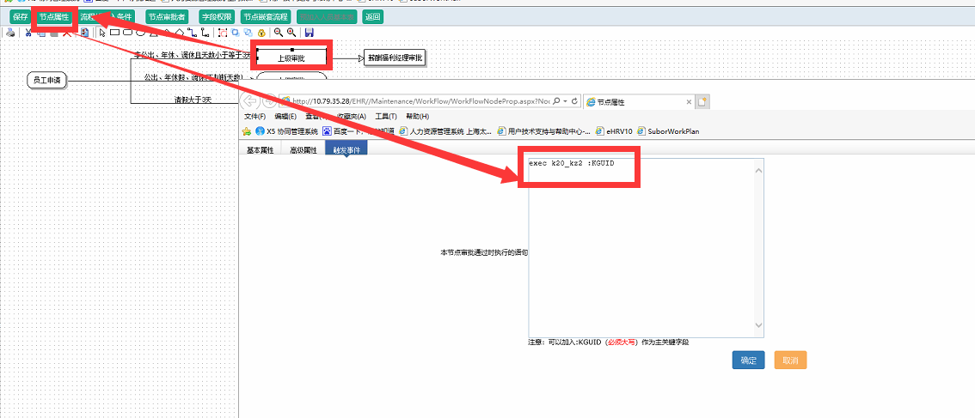

/*2、去FLOWNODE表中找出对应节点的RECORDID*/

Select * from flownode where proj_id=115

/*3、根据RECORDID在节点存储过程中添加，自动INSERT到FlowSealUsed表中*/

ALTER procedure [dbo].[k20_kz2] (@kguid varchar(50))

AS

DECLARE @A0188 INT ,@KeyFieldValue VARCHAR(50) ,@FlowSealID Int ,@TABLENAME VARCHAR(50)

set @a0188=(select FLOWEXECUTEDETAIL.ApproveA0188

from FLOWEXECUTEDETAIL, FLowNode,FLowExecuteMain,k20

where FLOWEXECUTEDETAIL.flowexecutemainid=FLowExecuteMain.proj_id

and FLOWEXECUTEDETAIL.flownodeid=flownode.nodeid

and FLOWEXECUTEDETAIL.nodetype<>3

and FLOWEXECUTEMAIN.KEYFIELDVALUE=k20.KGUID

and k20.KGUID=@KGUID AND flownode.RECORDID in ('531','533','658')

AND FLOWEXECUTEDETAIL.IsPass=1)

set @KeyFieldValue=(select TOP 1 FLowExecuteMain.KeyFieldValue

from FLOWEXECUTEDETAIL, FLowNode,FLowExecuteMain,k20

where FLOWEXECUTEDETAIL.flowexecutemainid=FLowExecuteMain.proj_id

and FLOWEXECUTEDETAIL.flownodeid=flownode.nodeid

and FLOWEXECUTEDETAIL.nodetype<>3

and FLOWEXECUTEMAIN.KEYFIELDVALUE=k20.KGUID

and k20.KGUID=@KGUID AND flownode.RECORDID in ('531','533','658')

AND FLOWEXECUTEDETAIL.IsPass=1)

SET @TABLENAME=(SELECT 'k20' )

SET @FlowSealID=(SELECT max(FlowSealID)+1 FROM FlowSealUsed )

insert into FlowSealUsed(KGUID,TableName,KeyFieldValue,Modal_Name,FlowSealID,A0188,Left_Pos,Right_Pos,Tag_Name)

select NEWid(),@TABLENAME,@KeyFieldValue,'请假及公出申请单',@FlowSealID,@a0188,0,0,'[SIGNA13]'

----注意 Modal_Name为建立表单时的表单名称

------[SIGNA13]表示当前节点签名代码（即表单中的签名代码）

UPDATE FlowSealUsed SET SEAL_FILE=WebSignature.Signature

FROM WebSignature WHERE WebSignature.A0188=@A0188 AND WebSignature.A0188=FlowSealUsed.A0188 AND KeyFieldValue=@KeyFieldValue