哈尔滨工业大学（深圳）
Harbin Institute of Technology ,Shenzhen

Interim Assessment of the Thesis
for the Master’s Degree

Name Yao Tang
Entrance Date 2015-09-10
Thesis Title Research on Stock Investment
Strategy Based on Heterogeneous Information Processing
Discipline Computer technology
Supervisor Xiaolong Wang
Report Date 2017-03-15

- Does the thesis progress according to the research objectives and schedule as stated in the primary report? (at least 100 words)
Yes,By monitoring the daily limit stocks to find investors in favor of the stock collection, the use of financial text information combined with the time series given the recommended stock collection for investors reference. The research on stock investment strategy based on heterogeneous information processing is divided into two parts: the popular stock candidate set through text information and the dynamic time Warping algorithm and SVR forecasting model to find out the larger correlation stock from the candidate set. The acquisition of popular stock selections: Grab the top ten controlling shareholder information of all stocks in Shenzhen, and build a stock relationship network based on the controlling shareholder. Will be all the stock in Shenzhen in accordance with the concept of the classification of the plate based on the plate of the stock relationship network. Will be the daily limit of stock into the stock relationship network can get the associated stock candidate. Linked stock screening: Use Dynamic Time Warping algorithm to calculate the similarity of the stock of the candidate stock and the daily limit, remove and limit the stock with low stock correlation, and use the SVR forecasting model to screen out the possible associated stock.
- The completed work and its related outcomes (at least 1500 words) .
2.1Research on Financial Timing Information Based on Text
2.1.1 Financial text and timing information preprocessing
The subject is currently used in the financial text information from Sohu Securities Shenzhen stock all the top ten controlling shareholder information and Sina Finance Shenzhen stock all the data according to the concept of the plate classification. Including a total of new energy, biological vaccines, super bacteria automotive electronics and other 159 concept plate.
(1) stock - the controlling shareholder of the pretreatment: the original data from the Sohu Securities as shown in Figure 2-1, Shenzhen stock top ten controlling shareholder information, the original data information after processing as a stock - the controlling shareholder txt file format such as Figure 2-2 shows.
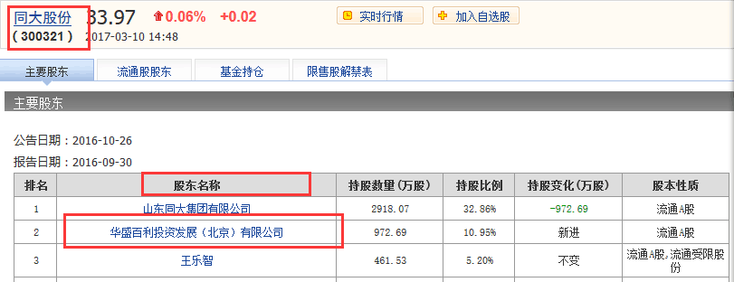
Figure 2-1 Original shareholder information
After preprocessing, the text information is available as follows:
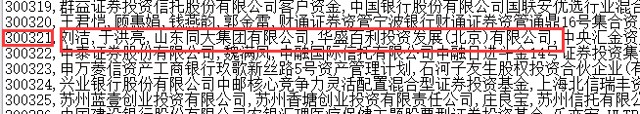
Figure 2-2 Shareholder Information
stock - concept plate preprocessing: the original data from Sina Finance As shown in Figure 2-3, a total of 129 concept plate classification, the original data information after processing as a stock - concept txt file format as shown in Figure 2 -4.
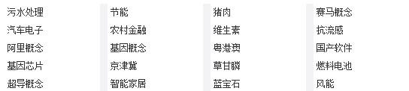
Figure 2-3 Stock concept plate
The pre-processed stock-concept plate storage format is as follows:
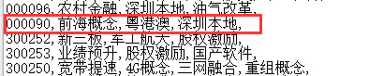
Figure 2-4 Concept plate text
financial timing information preprocessing: financial time series data from Sina Finance, according to the need to retain the following characteristics to retain, opening, closing, the highest, lowest, volume, price changes, The average number of daily turnover, a total of ten features as shown in Figure 2-5.
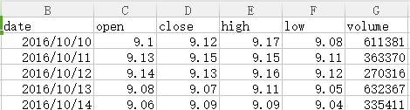
Figure 2-5 Timing files
2.1.2 build a relationship between the controlling shareholder and the concept of plate stock network
After the pretreatment of the financial text information format for the stock - the top ten shareholders; stock - owned plate; for the construction of stockholders based on the relationship between the stock network, which is conducive to pretreatment stocks - top ten shareholder file to build shareholder - holding stock dictionary. Received 1,1008 controlling shareholders - stock list records and 159 concept plates - stock list records. It is believed that there is a relationship between the shareholders holding shares, converted into the shares of the same shareholder holding the edge of the stock to get based on the controlling shareholder of the stock relationship network, the same can be based on the concept of plate stock network. Figure 2-6 shows the stock relationship network based on the controlling shareholder.
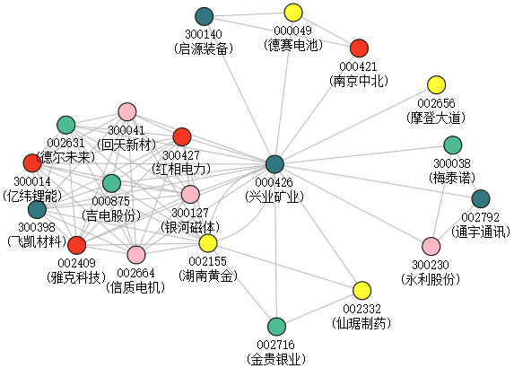
Figure 2-6 Network diagram of the stock relationship based on the controlling shareholder
(Figure 2 - 7) 002155 (Hunan Gold) and 002716 (Jinguui Silver) two stocks at the same time by the shareholders - Industrial and Commercial Bank of China in the sea energy strategy mixed securities investment Fund holdings. The same relationship is based on the concept of plate classification of the relationship between the two stocks in the stock between the sides on behalf of the two belong to the same concept between the plate.
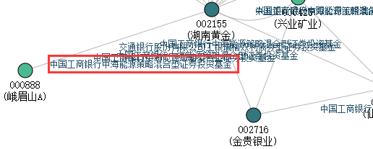

Figure 2-7 Local relational network diagram
2.1.3 Dynamic Time Warping algorithm is used to calculate the correlation degree of stock trend
Dynamic Time Warping (DTW) is a measure of the similarity of two different time series. The DTW calculates the similarity between two time series by extending and shortening the time series. Compared with the Euclidean distance, the DTW obtains an optimal path by adjusting the corresponding elements at different time points of the time series, and the final accumulated distance is the DTW metric distance. The DTW distance algorithm is as follows. Suppose the time series and the two time series of length n and m, respectively, where the points and dots of the two sequences form a matrix representing the distance between the midpoint of the sequence and the point. It is necessary to find a bending path with the smallest cumulative cost among the sequences and the distance matrix.
DTW algorithm is mainly used in isolated speech recognition, gesture recognition and other fields. The algorithm applies to two time series as much as the whole, but the sequence is misaligned on the x-axis state. The time series is extended and shortened by warping one of the sequences in warping at the time axis to calculate the similarity between the two temporal sequences. The core idea is to extend and shorten the two time series to obtain the two time sequence distance is the shortest is the most similar to a warping, the shortest distance is the two time series of the final distance measurement. Here, we have to do is choose a path, so that the final total distance from the smallest.
In the field of financial research, financial time series is a common form of expression. For a time series process, a common task is to compare the similarity of two sequences. In the comparison of similarity of financial time series, the length of two time series which needs to be similarity may not be equal due to the existence of suspension phenomenon, and there is some delay effect in the linkage relation between stocks. In particular, Short time interval when the stock trend sequence. DTW algorithm can be used to avoid the time delay effect of financial time series and the inconsistency of the sequence length in the case of suspension, so as to calculate the similarity between the stocks.
Is the Shenzhen stock all the stock 2016-09-20 to 2016-11-08 during the closing price curve for example, according to 2016-11-09 daily limit situation. 2016-11-09 Hunan gold daily limit, according to the stock exchange based on the controlling shareholder of the network we can find and Hunan gold-related stock candidates as shown, the candidate stock and Hunan gold closing price curve similarity can be found 000426 (Societe Generale) and 002716 (Jinguui Silver) two stocks and Hunan gold from 2016-09-20 to 2016-11-08 during the trend is very close, as shown in Figure 2-8.
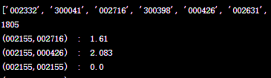
Figure 2-8 DTW calculation result set
Which 002155 (Hunan gold) and 002716 (gold and silver industry) DTW value of 1.61, from the closing price curve trend 002155 (Hunan gold) and 002716 (gold and silver industry) is basically the same. 002716 (Jinguui silver) rose 10.02% the same day, as shown in Figure 2-9.
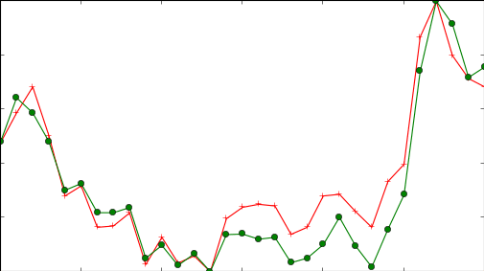
Figure 2-9 gold and silver banking charts
Xingye Mining 21-27 between the suspension. Now calculate it is 2.083
002155 (Hunan Gold) and 000426 (Societe Generale) DTW value of 2.083, but the trend of the two stocks from the point of view seems to be very low, of which 000426 (Industrial Mining) 2016-09-21 to 2016-09-27 period The DTW algorithm eliminates the time lag between the two stocks, and the DTW algorithm eliminates the delay effect on the x-axis, resulting in an exact similarity calculation. 000426 (Societe Generale) rose 3.94%
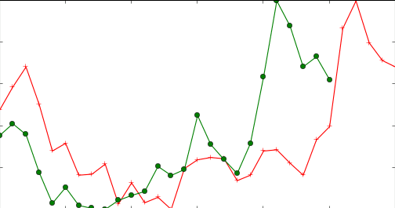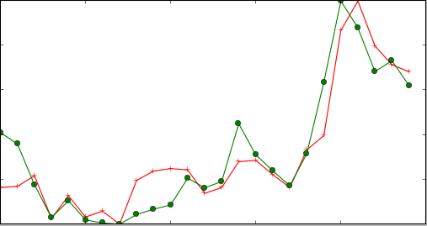
Figure 2-10 Xingye Mining Chart
We think that the linkage between the candidate set and the daily limit is poor, and the candidate set will be discarded when the DTW value between the stock and the daily limit is too large. Try to use the stock relationship network based on the concept plate to retrieve the associated stock. 000980 (Kinmen and Matsu shares) 2016-11-09 daily limit, through the concept of the plate based on the stock relationship network we can find and 000980 (Kinmen and Matsu shares) belong to the same plate of the stock, as shown in the change limit stocks are Wanjiang region and performance preliminaries Two concept plates, through the dynamic time can be found in the Wanjiang regional plate with the trend of the two stocks similar to 002538 (Stuart) and 000887 (Zhong Ding shares) as shown in Figure 2-11, which shares 002538 ( Stewart) rose 2.85%, 000887 (in the tripod shares) rose 1.59%.
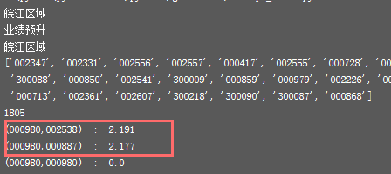
Figure 2-11 Concept plate candidate set
The role of DTW here is to remove the stock that is actually irrelevant to the daily limit of the stock. The DTW can eliminate the suspension problem at both ends, but the calculation of the similarity with the intermediate suspension is still to be improved. To adapt to the financial time series trend similarity calculation.
2.2 Construction prediction model based on SVR
2.2.1 Constructs a forecasting model based on SVR based on the characteristics of financial timing
With regard to the processing of financial time series, the researchers made a lot of attempts from a single model to a hybrid model. The classical model approach includes SVM (support vector machine), ARMA (SVM), SV (support vector regression), BP neural network, GA (genetic algorithm), FL (fuzzy logic), and various models Mixed model and so on. We crawl stock from Yahoo! Finance from 2015.06 to 2016.05 days for years of historical transaction data. Linear regression, BP algorithm, SVM (support vector machine), SVR (support vector regression) were compared. It is not ideal to predict the SVR and BP algorithm, but the SVR prediction curve is similar to the actual curve trend from the observation and prediction curve. Finally, we try to scale the predicted closing price to the forecasted opening price to the actual price After the range, with the forecast closing price minus the forecast opening price, more than zero to rise, less than zero to fall. The final results are as follows, the classification of SVM and linear regression accuracy are not high, and the classification results vary widely. However, the SVR prediction curve is similar to the actual curve trend. Finally, it tries to scale the predicted closing price with the forecasted opening price to the range of the actual price. After the forecast is closed, the SVR and BP algorithm are not allowed to be calculated. Price minus the forecast opening price, more than zero when the rise, less than zero to fall. The results found that the accuracy of classification can generally reach about 70 percent. Up to 73.3%. The experiment was conducted using the data from 2015.06.01 to 2016.04.19 as the training set, 2015.04.19 to 2016.05.31 for 30 days as the test set. The characteristics here are selected to forecast the transaction data for the first five days of the day. The transaction data includes the opening price, the closing price, the highest price, the lowest price, the volume and other basic data characteristics plus the week characteristics. Although purely pure data processing effect is not ideal, but it can be used as a final result of a reference. In the future research will further optimize the feature extraction, improve the performance of the algorithm. As shown in Figure 2-12, it can be seen from the figure that the accuracy of the SVR prediction model is higher than that of other algorithms.
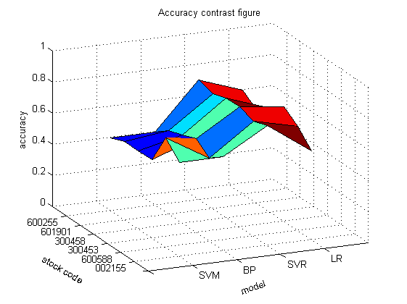
Figure 2-12 Comparison of accuracy
Some of the experimental results are shown in the figure, the blue bar shows the actual ups and downs, the red bar chart shows the forecast ups and downs, when the forecast ups and downs consistent with the actual ups and downs when the blue column and the red bar will point in the same direction, The blue bar and the red bar will point in different directions when the ups and downs are not consistent with the actual ups and downs. The results are shown in Figure 2-13.

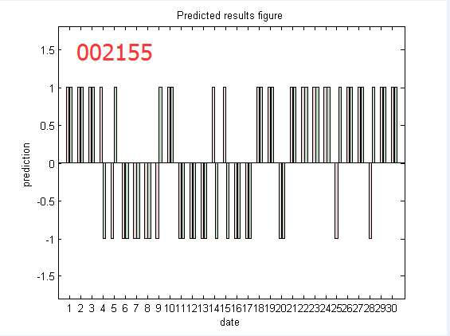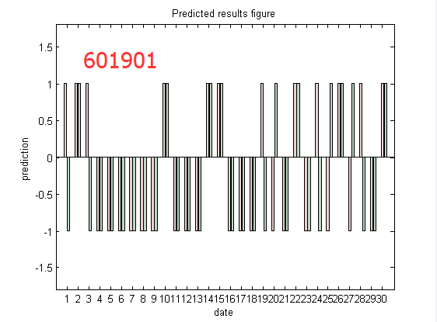
Figure 2-13 Classification results
Compared with the experimental comparison, SVR forecasting model is proposed to give the stock trend trend value. At present, each stock has a corresponding SVR data forecasting model, which improves the trend forecast performance of the model by finding the optimal parameters. The first part is to find a chain of stock based on the concept of the relationship between the network, the next will try to Shenzhen plate training forecast model to give the stock trend value. As an important reference for investment strategy. The current characteristics of the selection of a single, follow-up will increase the price, the average price of 5, 10 average price, 10 daily average, turnover and other data characteristics to further optimize the SVR forecasting model.
In order to verify the effectiveness of the investment strategy, the experiment selected from 2016-11-07 to 2016-11-11 between the data for the stage of the test evaluation, the results shown in Figure 2-14, 2016-119 as an example , The day (002155) Hunan gold daily limit, the relationship between the network candidate 000426 (Industrial Mining) trend trend DTW value and 002155 for the 2.083, the two stocks similar trend is very high, 000426 (Industrial Mining) SVR forecast model gives the day up Discrimination, of which 000426 over the past month test accuracy rate of 63.3%. From the week to select the linkage stock point of view, the results are all rising, although the stock as 000036 the day the rise is not large. But in general, the linkage stock set has a certain reference value for stock investors.
 | Limit shares | Linkage stocks | DTW | SVR | p_change
2016-11-07 | 000707 | 002286 | 2.499 | 63.3% | 5.98%
2016-11-08 | 000927 | 000800 | 2.871 | 67.7% | 3.13%
2016-11-09 | 002155 | 000426 | 2.083 | 63.3% | 3.94%
2016-11-10 | 000018 | 000036 | 1.937 | 67.7% | 1.11%
2016-11-11 | 000751 | 002540 | 2.066 | 73.3% | 5.10%
Figure 2-14Evaluation results
- The work to be completed and its schedule .
Subsequent work needs to be done mainly to optimize the SVR forecasting model and system evaluation for financial timing.
Specific schedule is as follows:
March 2017 - April 2017: Continue to complete the SVR prediction model by concept plate.
April 2017 - May 2017: Optimize model characteristics Simultaneous real-time operational results.
June 2017 - October 2017: Optimized model performance, experimental evaluation test
November 2017 - December 2017: Written papers, ready to reply.
- The existing or expected difficulties and problems.
There are problems and difficulties
(1) based on the text of the relationship between the network construction is not perfect.
(2) DTW algorithm computational complexity is too high.
(3) Optimization based on SVR prediction model.
solution
In view of the existing problems and difficulties, the following solutions are proposed:
(1) refine the concept of the plate of the stock classification information, to identify the industry's leading stocks
(2) try to use different concept plates to train SVR prediction models and optimize features to improve predictive model performance
- The considerations on the possibility of completing the thesis on-time (at least 100 words).
This paper has completed the stock relationship network based on the controlling shareholder and the concept plate classification, and then constructs the stock trend curve composed of the closing price. The DTW algorithm can be used to calculate the similarity of the stock. Single stock SVR forecasting model for selection of candidate stock.Through the filter on the stock screening, get the result set, to provide a reference for investors.
At present, the SVR forecasting model is used to screen the candidate stock, and the results will be evaluated in real time by the financial knowledge service platform.
In summary, the paper can be completed on schedule, and made some research results.
Supervisor Suggestion:
Signature:
Date:2017-03-15

