//变量及集合的解释,写到原先的算法前面。

*lv* is the shortest link in L, *lw* are the links which are not in the section of the interference angle. *La* means the shortest link in the set of *I*.

*L* = {*l*1, *l*2, ..., *l*n} denotes a set of links in the increasing order of length. L1 includes the links having intolerable effects to link lv. And I is the set of links after filtering the links in L1 from L. Then Ia represents the set of links whose distance are shorter than SD2 (we will give the definition in next paragraph).The set S covers the links that are preserved.

After we have chosen a link *l* to be preserved, we must delete all links whose affect can’t be tolerated by link *l*. In this process, we use the definition of SD, which denotes in a circle with a radius of C\*D, there should not exists any links. Another variable SD2 equals 1/2\*D. For we have to ensure the overall effect of whole links in set *I* can also be tolerated by link lv, we use SD2 to restrict the distance between each two links in *I*;

The algorithm:

…

把c\*dvv换成SD, daa/2换成 SD2

第17行删去

第20行改成L<-L\Ia

…

Nowadays most of the researches about OSML problem are under unidirectional communication model which is more idealized and easy to tackle. However when it comes to the full-duplex transmissions, i.e. every note is able to send and receive signal at the same time, things are more complex. Because all links can behave as the sender and the receiver, the former definition ofΨ is inappropriate. So we need to redefine some symbols and put forward a new algorithm which is suitable for the full-duplex transmissions situation.

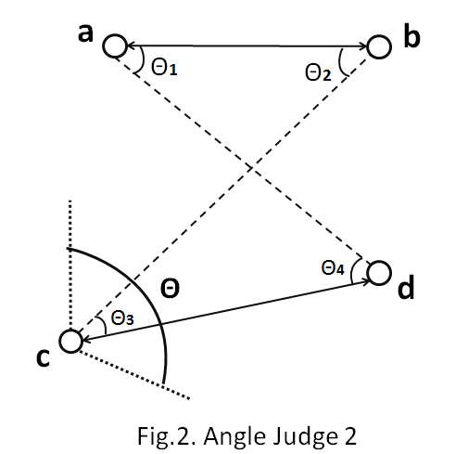First of all, we redefine the distance of the link *lu* between the sending note and the receiving note as d(*lu*)=d(s(*lu*),r(*lu*)). Then we define the distance between two links lu and lv as d(*lulv*)=min{d(s(*lu*),s(*lv*)),d(s(*lu*),r(*lv*)),d(r(*lu*),s(*lv*)),d(r(*lu*),r(*lv*))}. And to simplify the algorithm that we will mention later, we also redefine the Ψ as:

Ψ= $\left\{\begin{aligned}0,\min\left\{θ1,θ2,θ3,θ4\right\}>\frac{1}{2}*θ, \\ 1,\min\left\{θ1,θ2,θ3,θ4\right\}≤\frac{1}{2}*θ\end{aligned}\right.$

After that, we can rewrite the formula(3) as

The new algorithm which has taken full-duplex transmissions into consideration can be described as follows:

Input: A link set *L*{*l1,l2,···,ln*}, the link in which are ranked from the shortest to the longest

Output: A link set S, the links in which can transmit at the same time.

(a)Make sure the links in S are sorted incrementally.

(b)Choose the shortest link *lu* in *L* to S as the first feasible link and delete it from *L*.

(c)Delete all the links the distance of which to the lu are shorter than SD1(*lu*).

(d)Pick up the links in *L* whoseΨ with *lu* is *1* as link set *I*.

(e)Choose the shortest link *lv* in *L* and delete the links In I the distance of which to the lv is shorter than SD2(*lv*). Record the links that are deleted from the *I* as *Ia*

(f)Repeat (e) until there is no link that still exists in I and has never been chosen.

(g)Delete all the links in *L* which are in the *Ia* and links whose As(*l*)>=2/3.

(h)Repeat (a) until all the links are deleted or chosen to *S*.

The main idea is similar to the algorithm mentioned above, the difference lies in the different definition of Ψ.