**Team 03 Project 1: Climate Service Management**

Step 1: using git clone command to your computer (git clone). Repository link: https://github.com/cmusv-sc/SOC-Fall-2015-Team3-Lead-Jiyu-Shi.git

Step 2: Install IntelliJ IDEA Ultimate Edition, you can use your student account to get the free edition (Figure 2). Download link: <https://www.jetbrains.com/idea/buy/#discounts>.

Figure

Step 3: Import Both ApacheCMDA-Backend AND to ApacheCMDA-Frontend IntelliJ. Open IntelliJ, select Import Project, browse to the ApacheCMDA-Backend and ApacheCMDA-Frontend directory under the folder SOC-Fall-2015-Team3-Lead-Jiyu-Shi, click OK (Figure 1)

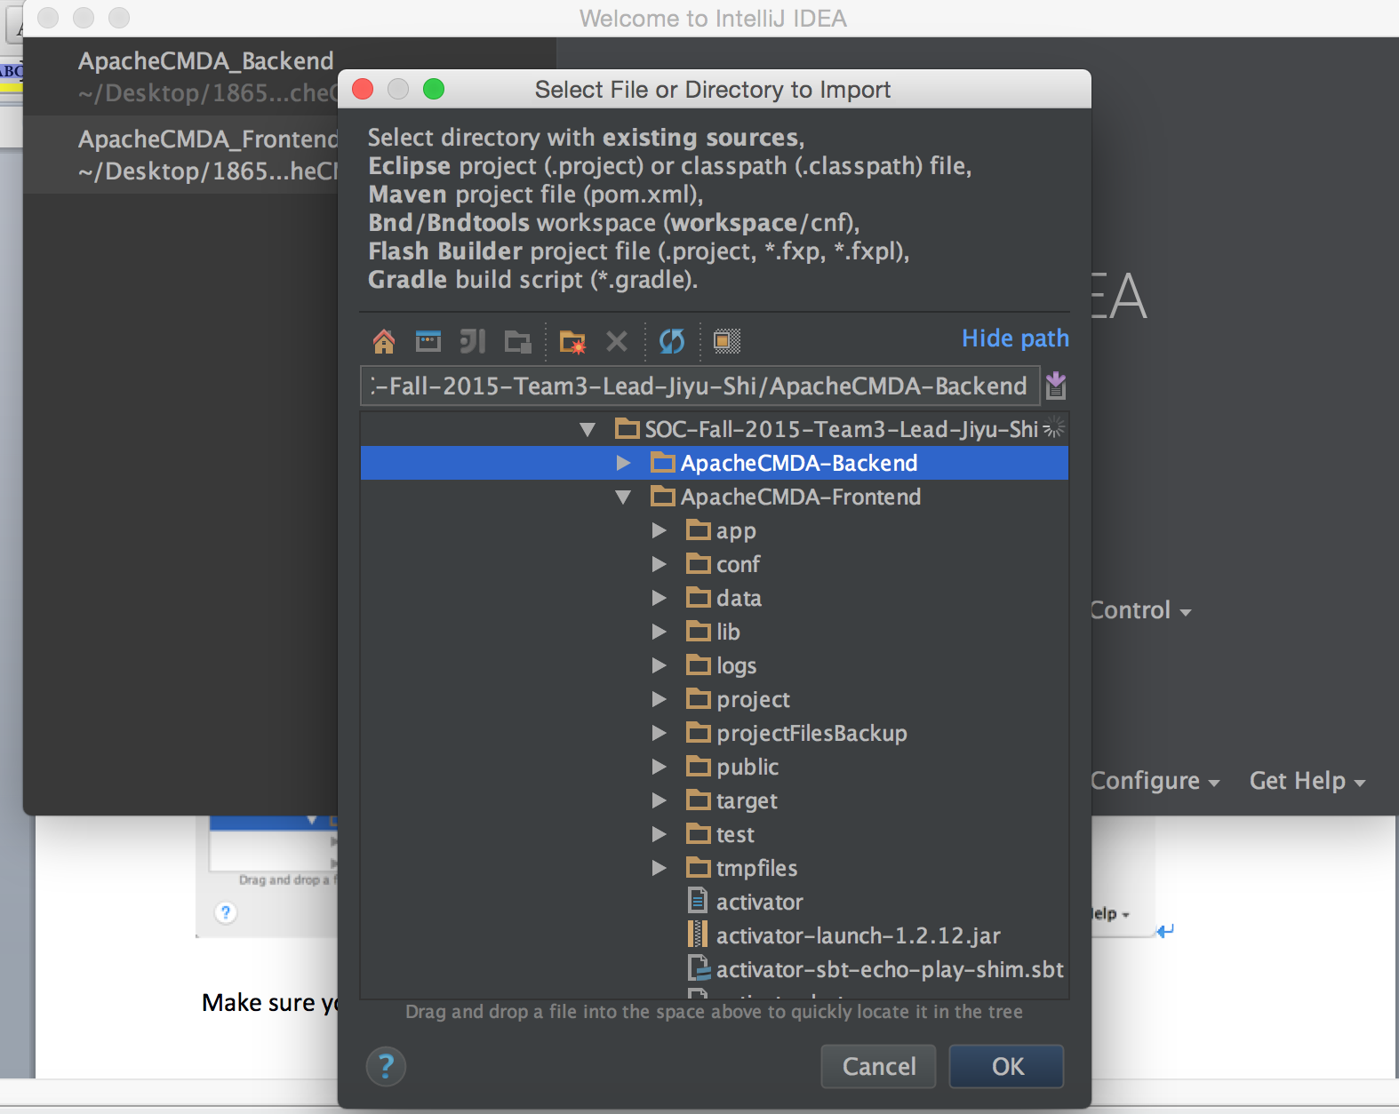

Figure 1

Make sure you Import project from external model of SBT (Figure 2)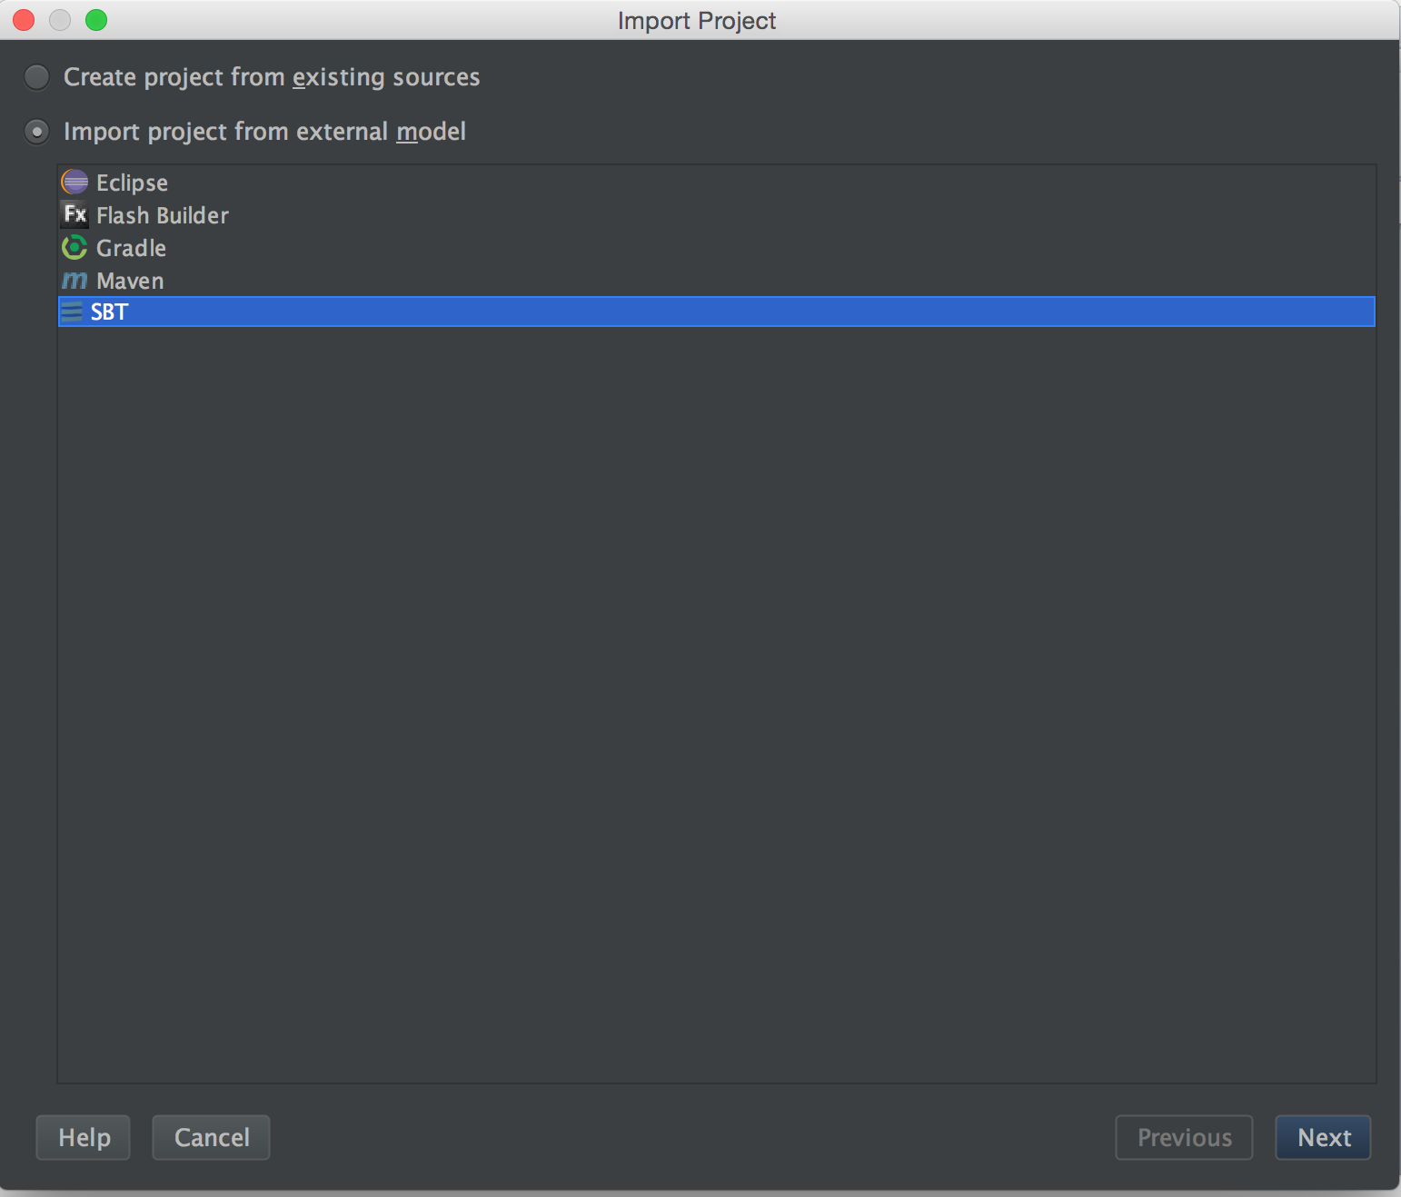

Figure 2

Click Next, check “Use auto-import”, “Download sources and docs” and “Download SBT sources and docs” (Figure 3), then click Finish.

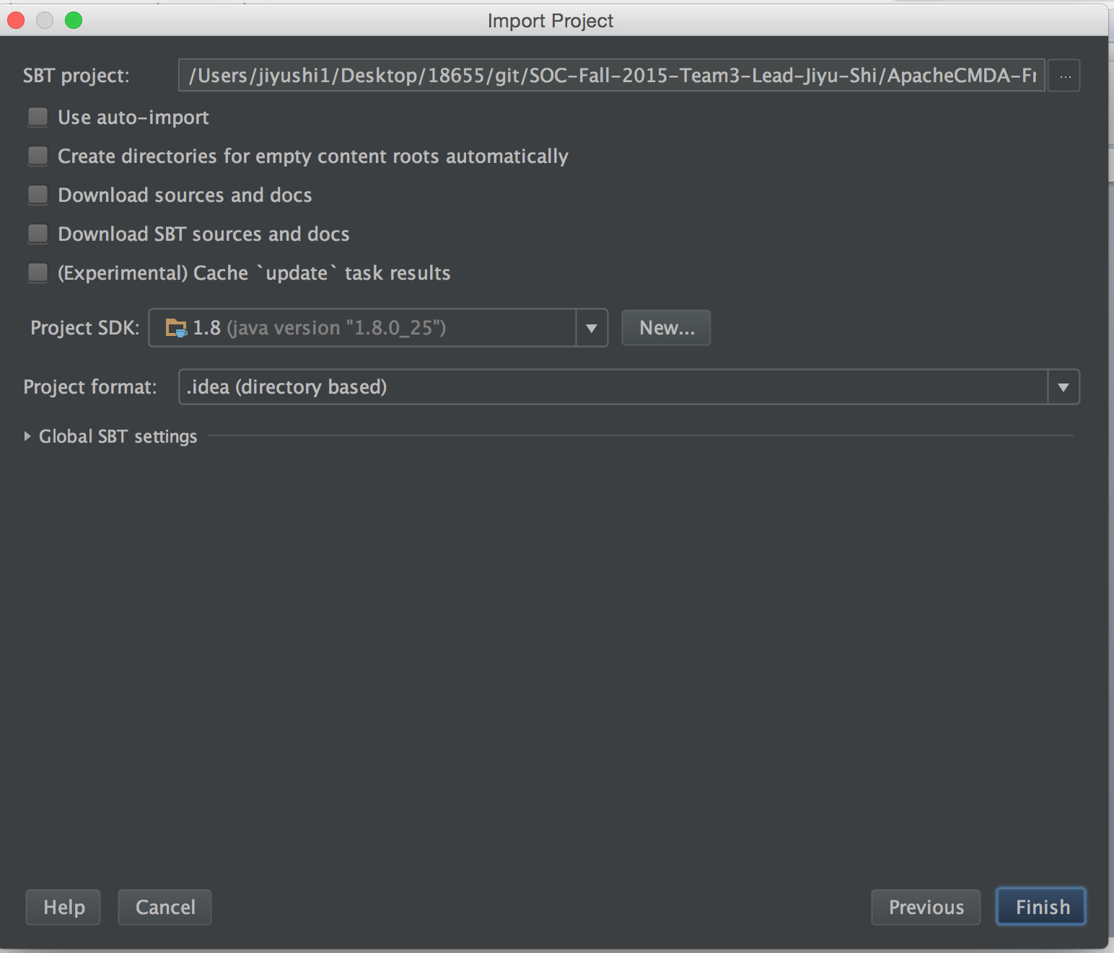

Figure 3

Under IntelliJIDEA menu, choose “Preferences”, choose Play2 under the Languages & Frameworks, check “Use Play 2 complier for this project” (Figure 9), then click OK. The project now is successfully imported.

Step 4: Setup Docker environmente: <http://docs.docker.com/mac/step_one/>

Step 5: Open Docker quick start terminal, run docker pull cmusvsc/apachecmda:1.0,in order to pull the image from Docker Hub, then use docker images command to check whether the image is pulled successfully (Figure 4).

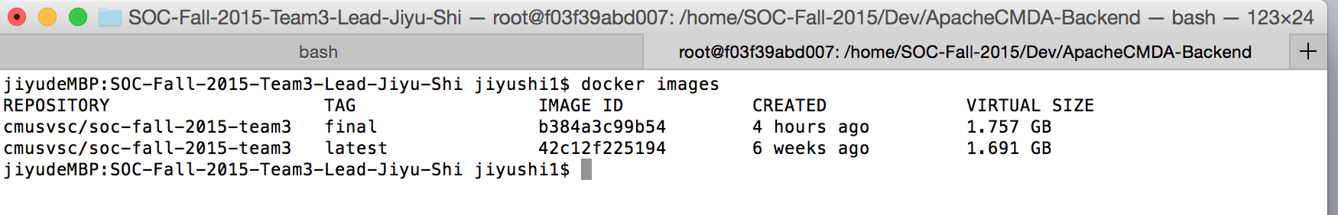

Figure 4

Step 6: Mount your local directory to the /home/SOC-Fall-2015 directory inside the container:

docker run -it -p 9034:9034 -v /Users/jiyushi1/Desktop/18655/git/SOC-Fall-2015-Team3-Lead-Jiyu-Shi/:/home/SOC-Fall-2015/Dev cmusvsc/soc-fall-2015-team3:final

Step 7: Start MySQL service using “service mysql start” (Figure 5)



Figure 5

Step 8: Start the backend. Use command cd into the ApacheCMDA-Backend directory, start the backend by using ./activator “run 9034”, now the backend has started (Figure 6)

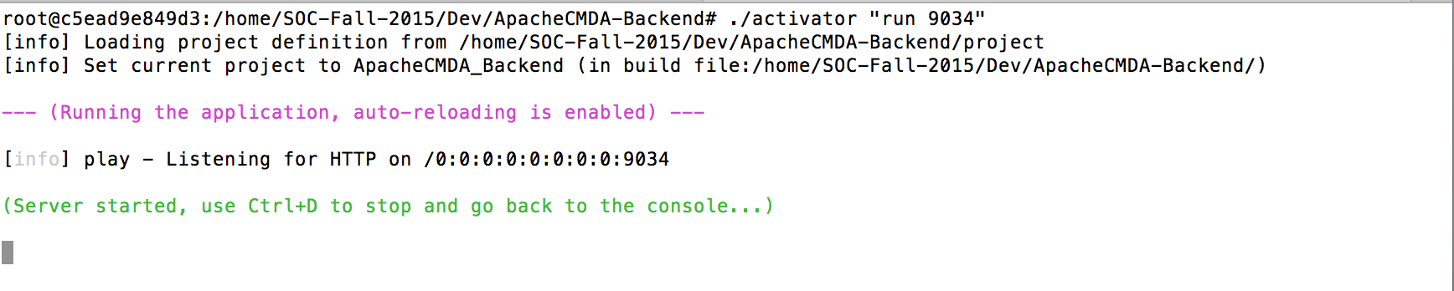

Figure 6

Step 9: Use the similar method to start Frontend at the local.(Fig 7)

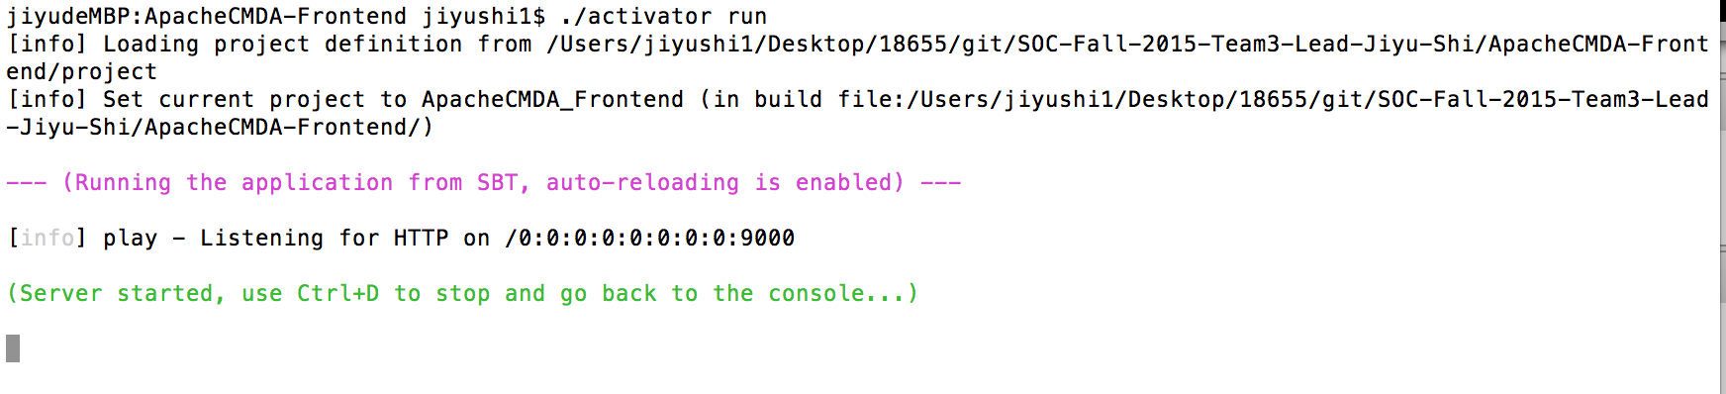

Figure 7

Step10: Before all of this remember to put related map relationship in virtual box.(Fig 8)

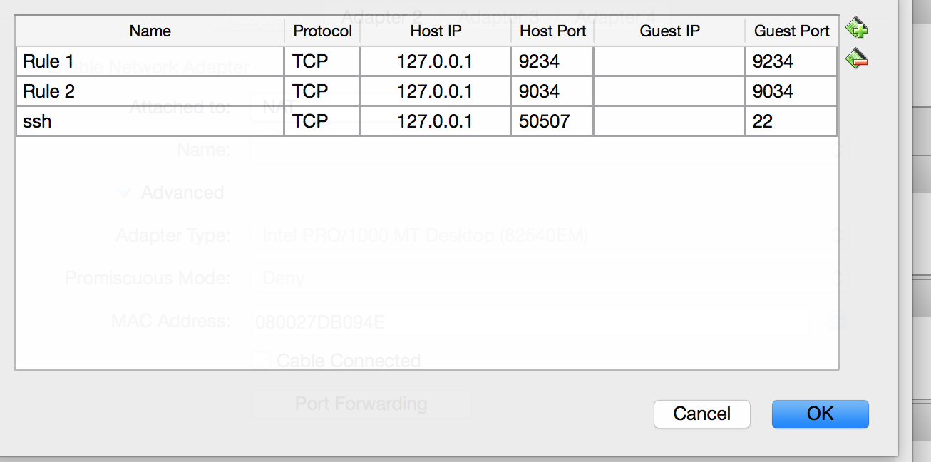Figure 8

Finally, both the Frontend and backend are built and you can test and modify your code in intelliJ and test it on the website by typing: <http://localhost:9000>.

**Tips:**

Download a plugin in chrome named Allow-Control-allow-Origin.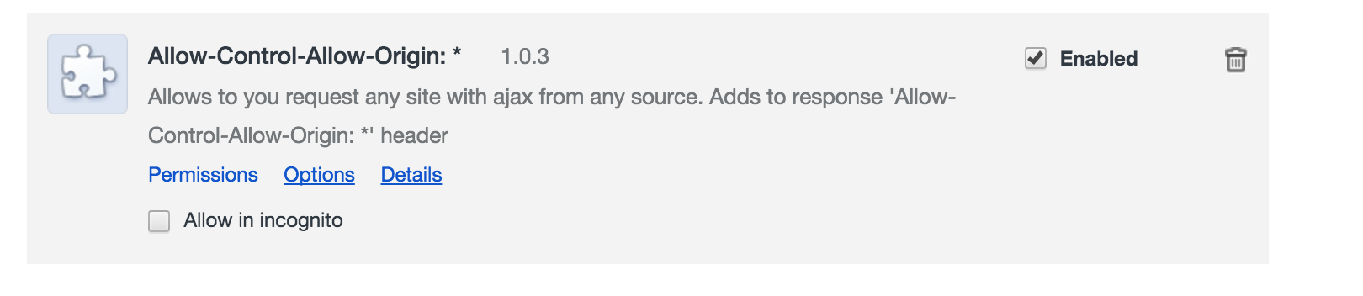

Using Chrome with command :open -a Google\ Chrome --args --disable-web-security

This ensures the ajax and javascript runs in the right way because we need to send data to our own server locally.