***Access Information***

1.First type localhost:9000

2.Sign-up page

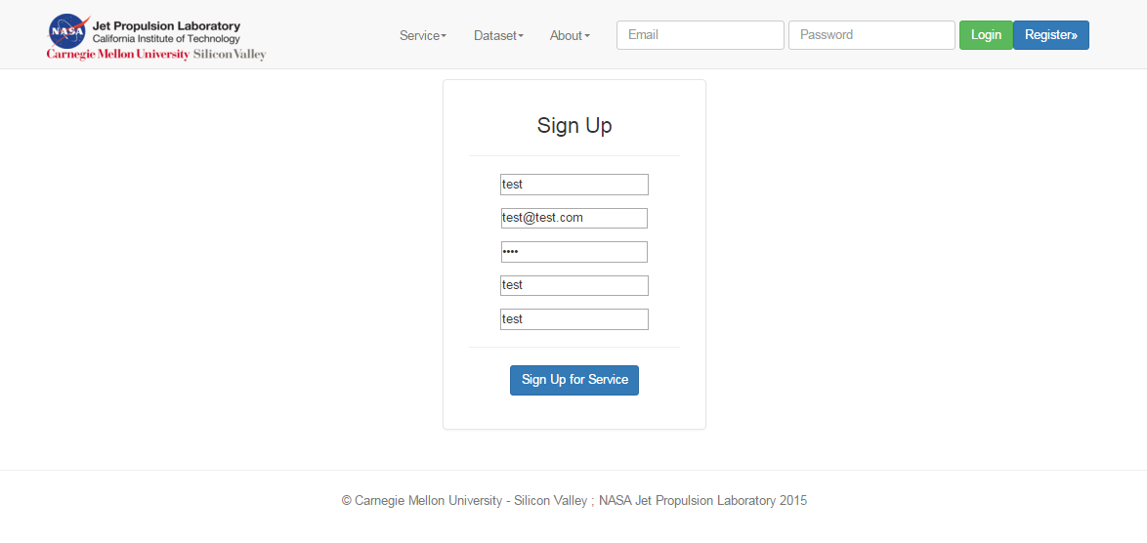

3.Registered successfully

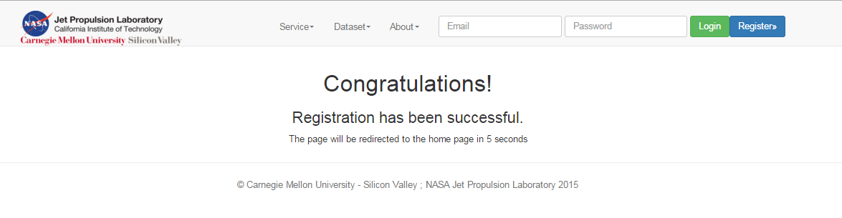

4.Login :

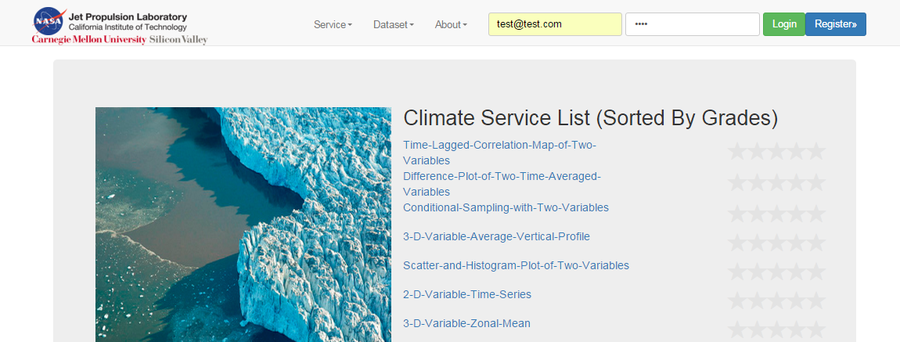

Successfully login the website:

