**1. background**

Climate service management is a project for collecting a bunch of climate web services and building a mash up to publish those services.

To provide a user friendly web service, we implement 7 basic functionalities and 3 extra features as follows:

1). Implement a Climate Service main page to list all climate services.

- Show climate service URL, name, and brief description.

- When one user clicks the name of a service, e.g. “ServiceMap 2D”, the website will jump to the chosen climate service page.

- Under this climate service page, user can comment this page.

- The posts carry information like post contents, post time, author etc.

2). A user can discover a climate web service

- User can search for a climate service using keywords.

- The first 3 search results will be listed.

3). A user can view a climate web service (version control)

- All the previous versions are shown this Climate Service’s page.

4). A user can evaluate a climate web service

- User can grade a climate web service (scale: 1-5; 1 is lowest and 5 is highest).

- Climate Service public main page shows the overall grade of every service.

5). Show popular climate services in Climate Service public main page

- Rank the top 3 grades climate service.

- Rank the top 3 most recently used climate service.

6). Within a user’s comment, a user can mention a friend using sign “@”

-e. g. When user input “@”, all of his/her friends will be listed and user can choose one of his/her friend

7). Within a user’s comment, a user can mention a climate service using sign “#”

- User can search for a hashtag e.g. search “@cmu” in search box.

Three extra features:

1). A user can sign up an account and sign in.

2). A user can add a friend when he/she knows another user’s account e-mail.

3). Service can be ranked based on popularity, in another word, clicking frequency.

**2. Motivation**

There are many different climate services. These services or applications can be provided by different service providers, with different business models, technologies, and different user experience. This requires a user switch between different user interfaces in a complex way to compare services.

As the Web 2.0 mashup technology is rising and becoming popular, we build our service as a mashup. Users like normal customers, scientists can now only visit one portal, which integrates a various services from different providers, without knowing where the services come from. The service is thus provided in a consistent way.

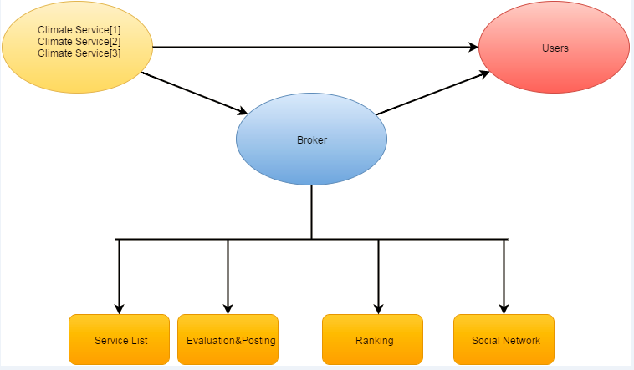

As shown in the figure above, our service can be seen as a broker, providing all climate services in one stop.

There are a lot of benefits to provide such a web service. First, it is an information-centralized system. Instead of publishing all of the services in different places, we collect them together, thus providing more information and utility to users. Second, since the services are collected in one place, it will be more efficient to manage them. Maintenance cost will be greatly deducted in this way. Most importantly, it is a user-friendly system, because a user can now have an easier way to access multiple services in one stop.