For simplification, the whole system is designed to be two parts, front end and back end, classified by its functionality.

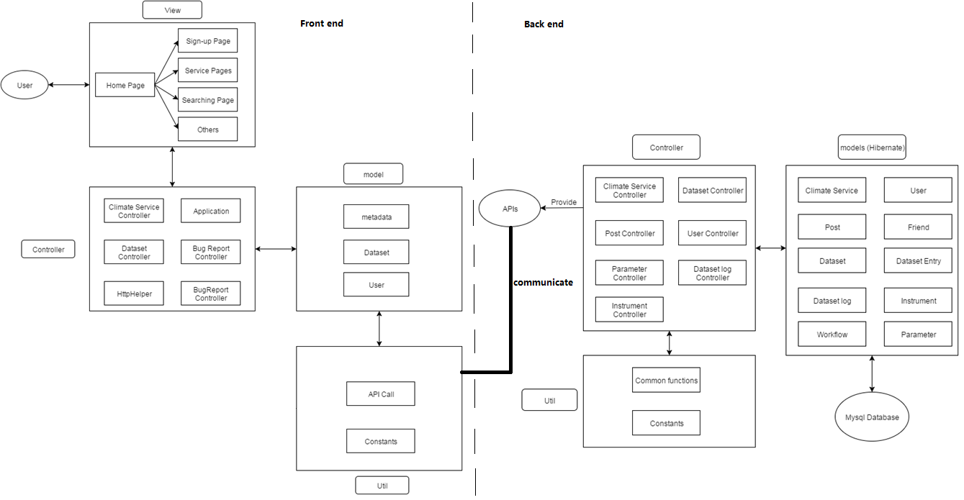

Front end is mainly about user interface, not only includes the graphical web page, but also includes some functionality such as comment, “@” tag, and communication with back end.

Back end receive data from front end and store them in to data base. When receiving requests, it fetches data from data base and give back to front end.

Both in front end and back end, we further divide the design into Model, Control, and View.

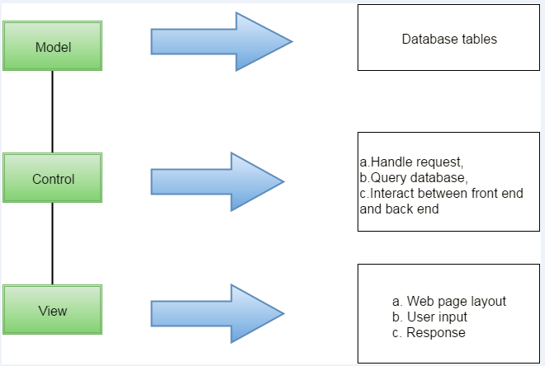

As illustrated in the graph, MVC design divide the work into three independent part.

Model layer is mainly about database structure design and CRUD method implementation. All database information are managed in this layer.

Control layer is the interaction part for front end and back end. It basically handle requests and query database for information.

View mainly deals with the interaction with users. Web page layout is designed in this part. Further, it receives the user inputs and send back the response after business logic.