We have provided a tutorial for how to test this project. First, ensure that you have successfully installed Docker and related software.

1) Load the provided image which has already configured the environment for this project. In addition, mount the back-end server directory into a directory into Docker. An example is given as follows:

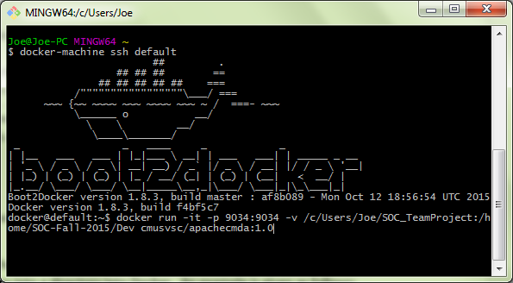

2) Change the directory in the Docker image to the directory mapped to the back-end directory in local machine. An example is given as follows:

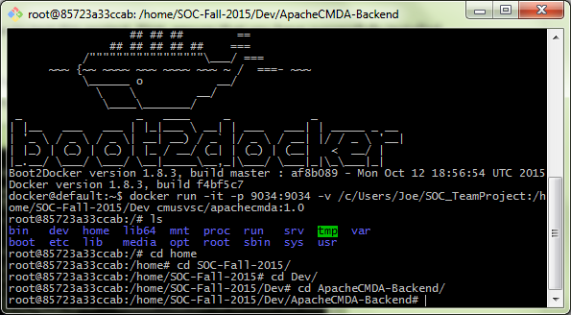

3) Start the mysql service and start the back-end server at port 9034 with the command: ./activator “run 9034”. An example is given as follows:

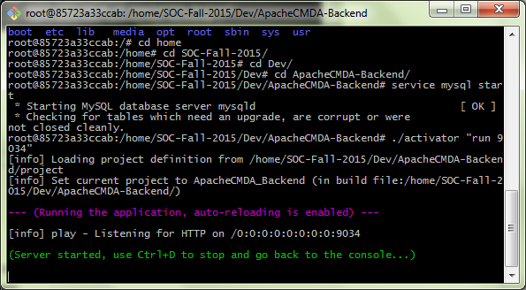

4) Start front-end server in its directory at local machine, and an example is given as follows:

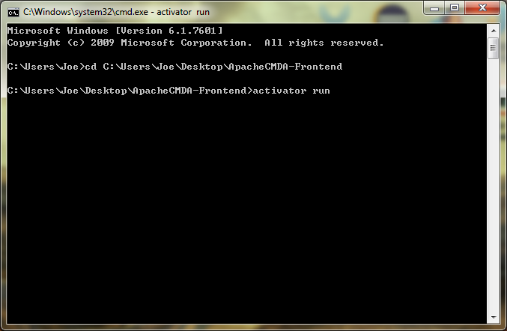

5) Now you can test our website in local port “9000”, please disable the web-security and enable cross-origin resource sharing of your browser because it might block our local AJAX request to back-end server. An example is given as follows:

Run the chrome browser in windows system:

chrome.exe --user-data-dir="C:/Chrome dev session" --disable-web-security

Following is the example graph:

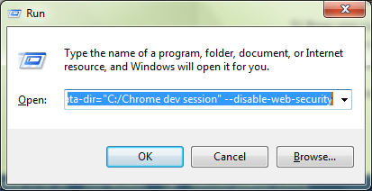

6) Test the website at the browser and the URL is <http://localhost:9000/>, and the following is an example:

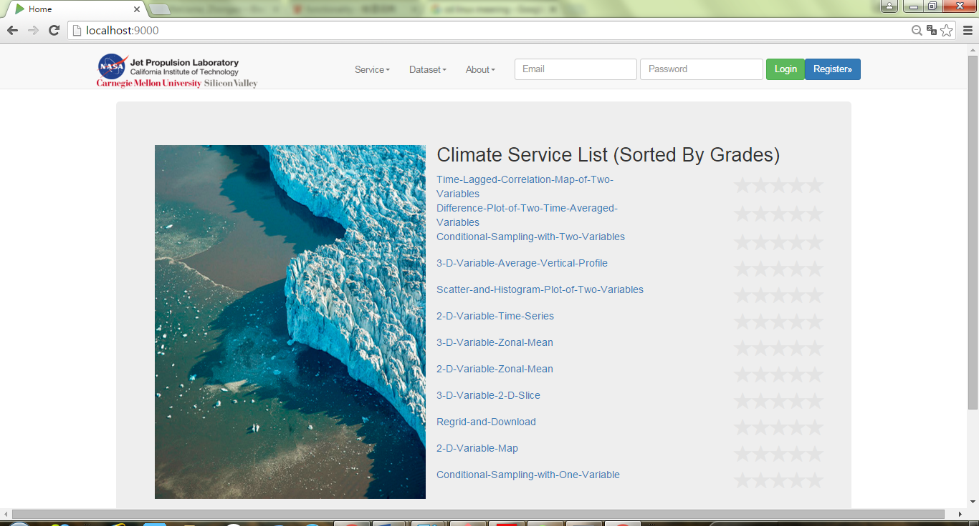

Analysis Me