https://github.com/tanhkoi/kiem-tra-lt-java-buoi-8.git

1. Giao diện login

1. Giao diện đăng ký

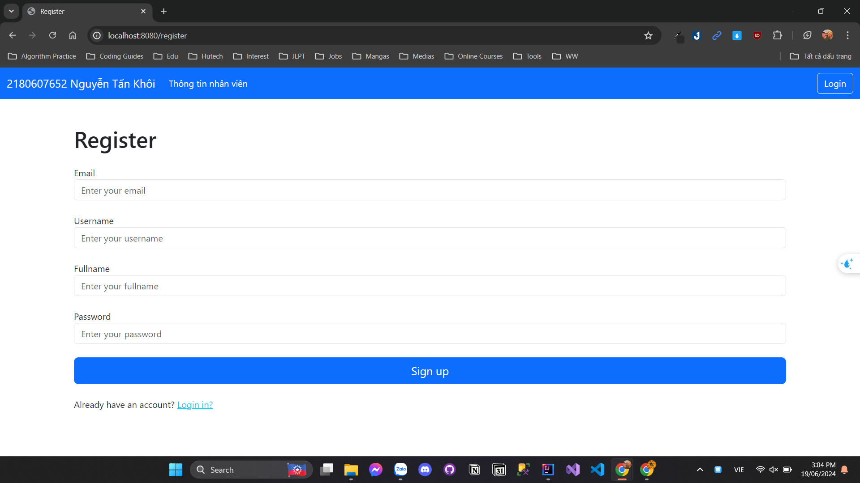

1. Danh sách sinh viên(admin)

1. Danh sách sinh viên(user)

1. Phân trang

1. Tạo nhân viên mới

1. Sửa thông tin nhân viên

1. Xóa nhân viên



