Use DE Claude plugin Plugin
REQUIREMENT ASSESS GENT (FSD to Requirement)
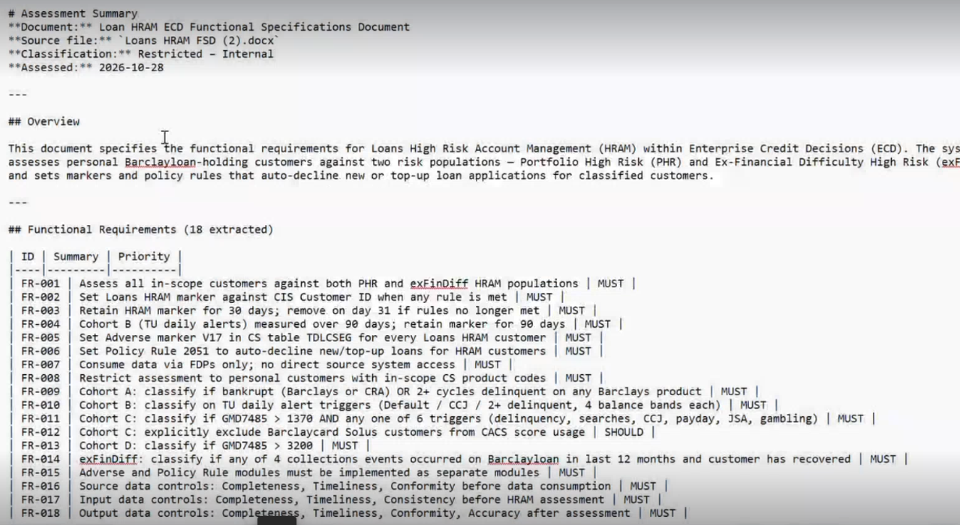
DATAMODELLER AGENT
1.
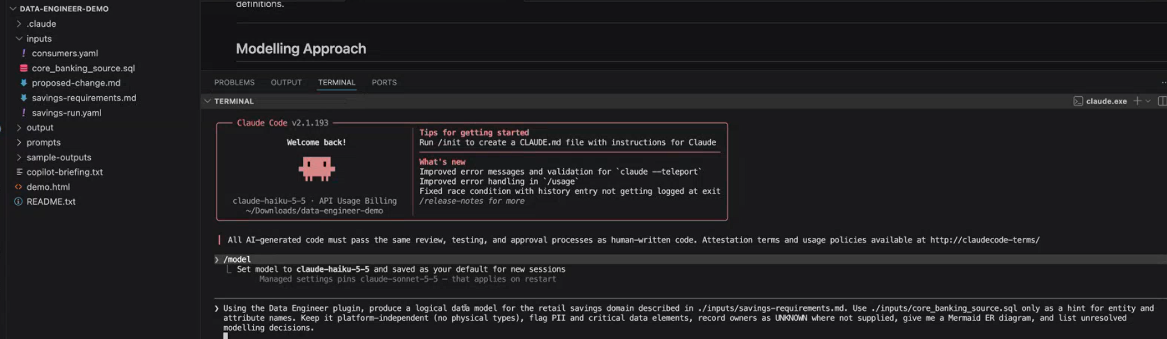

2. 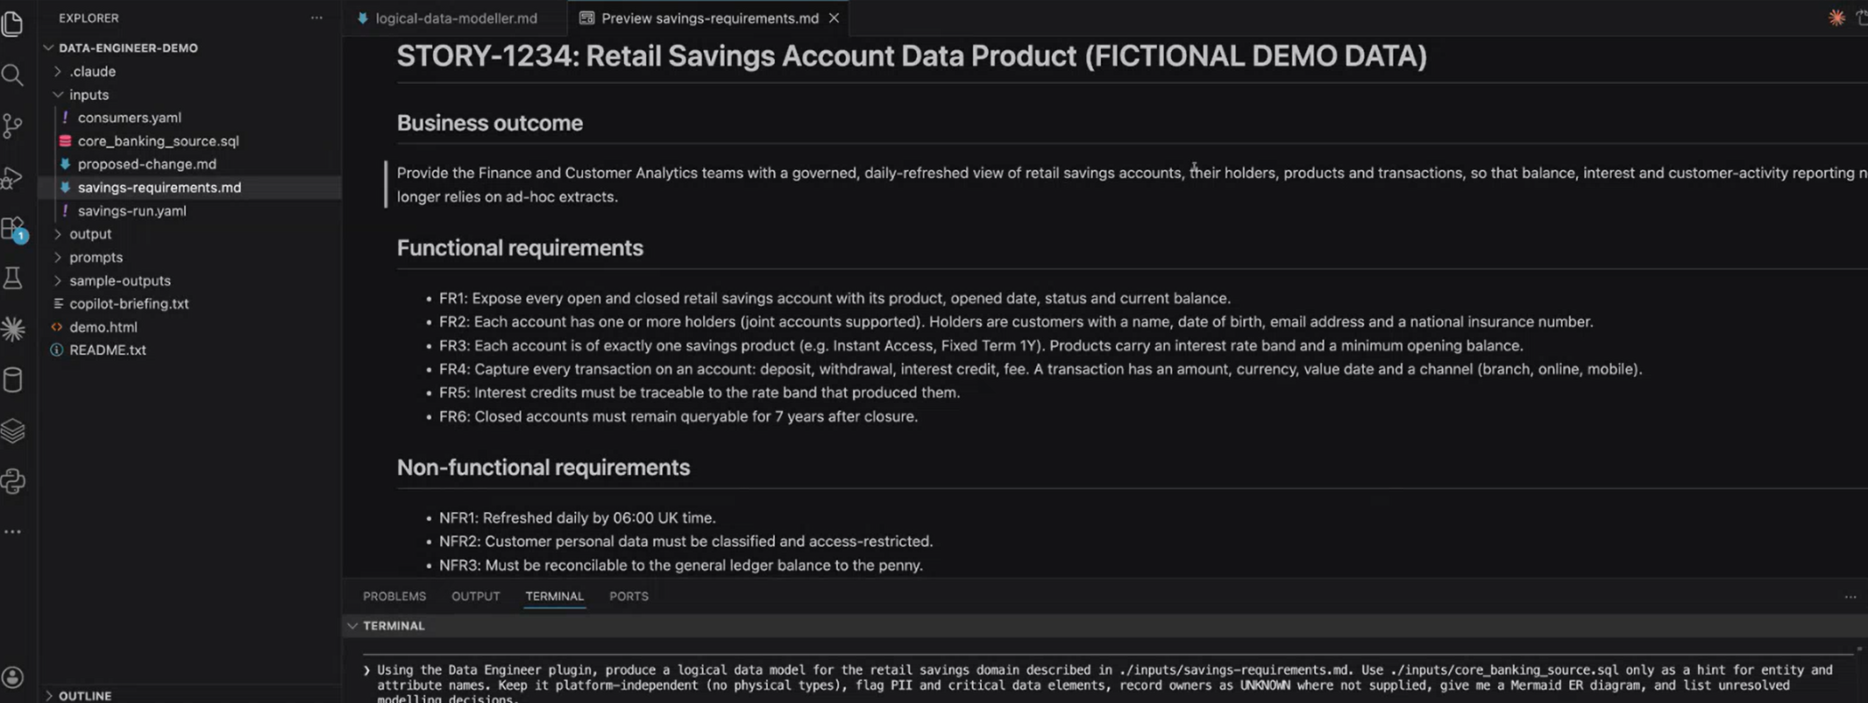

3.


4. 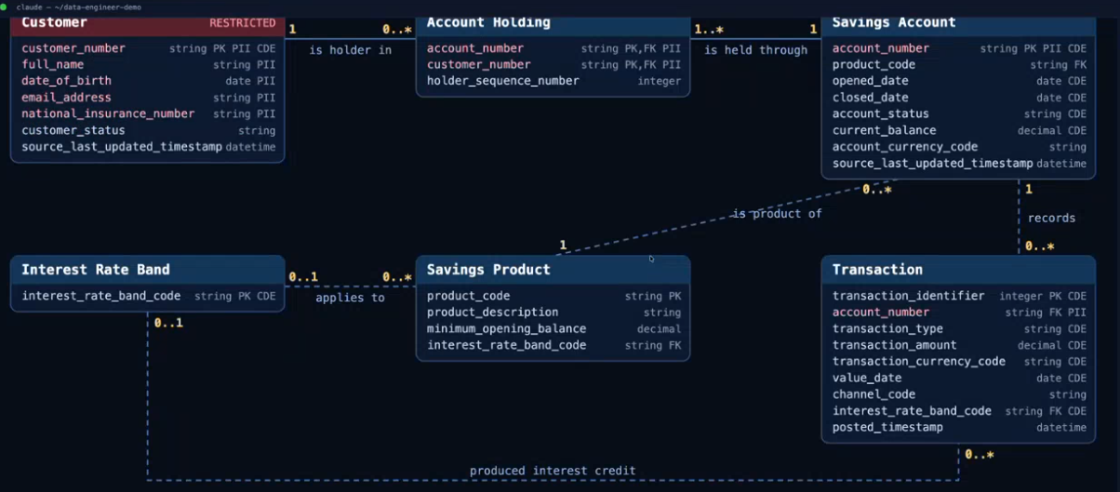
5. In draw.io ->Arrange paste the code for mermaid diagram prepared by claude
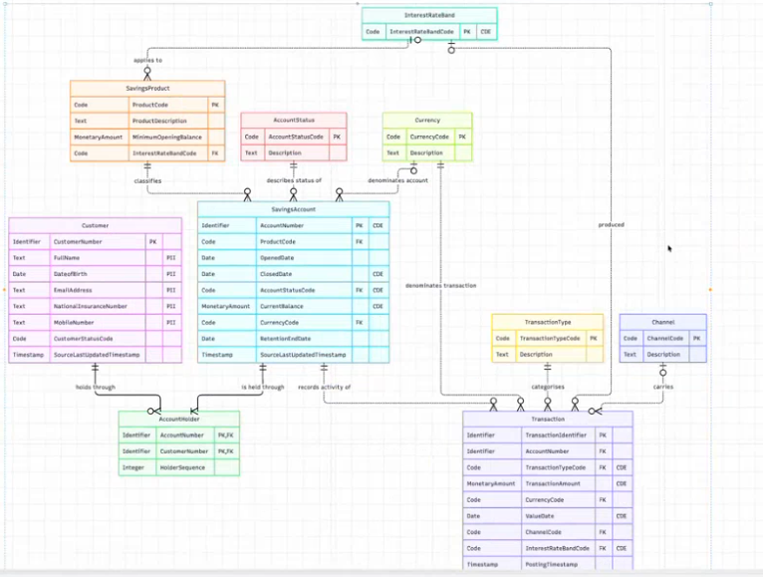

REVIEWER AGENT
