# Differentiation – Product Rule: using trigonometric functions

This tutorial is on differentiation, specifically the product rule, using trigonometric functions.

The product rule will be explained as to why it is needed in differentiation. The rule itself will be presented and two trigonometric examples will be used to demonstrate the application.

Product Rule is used in differentiating two or more functions that are being multiplied together. It is used to determine the derivative of the product of two functions, the product rule is written as follows.

**Product Rule**

If $y = uv$ where *u* and *v* are functions of *x*, then

$$\frac{dy}{dx}=u\frac{dv}{dx}+v\frac{du}{dx}$$

## Example 1

Here, we will differentiate the following function

$y=$ $e^{3x}cos⁡(x)$

First, we will break out each part of the rule,



$$\frac{du}{dx}={3e}^{3x}$$

$$v=cos⁡(x)$$

$$\frac{dv}{dx}=-sin⁡(x)$$

Now, we'll put each part of the rule together.

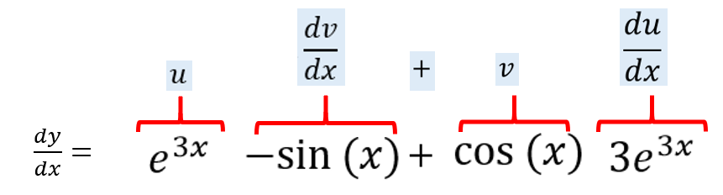

After that, we're multiplying out each section.

$\frac{dy}{dx}=-e^{3x}sin⁡(x)+$ 3 $e^{3x}cos⁡(x)$

You can also reorder the answer. If you do not want to begin with the minus sign

$\frac{dy}{dx}=\text{3}e^{3x}cos⁡(x)$ $-e^{3x}sin⁡(x)$